ARM® Cortex®- M
32-bit Microcontroller

NuMicro® ISP Programming Tool
User Manual

The information described in this document is the exclusive intellectual property of
Nuvoton Technology Corporation and shall not be reproduced without permission from Nuvoton.

Nuvoton is providing this document only for reference purposes of NuMicro microcontroller based system design. Nuvoton assumes no responsibility for errors or omissions.
All data and specifications are subject to change without notice.

For additional information or questions, please contact: Nuvoton Technology Corporation.
www.nuvoton.com

Table of Contents
1 Overview 3
2 Using the ISP Programming Tool in Windows 4
2.1 Connecting Interface Selection 4
2.2 Connection Interface via Nu-Link2-Pro 5
2.3 Connecting to the target chip 6
2.4 Load File 7
2.5 Setting the User Configuration Bits 8
2.6 Programming Options 9
3 ISPTOOL COMMAND LINE INTERFACE 10
3.1 Command Format 10
3.2 Script Examples 10

Overview
The NuMicro® Family microcontroller (MCU) supports In-System-Programming (ISP) function allowing the embedded Flash memory to be reprogrammed under software control. ISP is performed without removing the microcontroller from the system through the firmware and on-chip connectivity interface, such as UART, USB, I²C, SPI, CAN, LIN, Wi-Fi and BLE.

Before using the ISPTool, user needs to program the ISP code into LDROM by using a universal programmer or Nuvoton NuMicro® ICP Programming Tool, and the User Configuration bit ‘CBS’ configured as Boot from LDROM.

ISPTool came with two different modes. One is the GUI mode, which is more user friendly, with an easily to use front end allowing user to control with simple mouse click. The other one is command line mode, this mode is suitable to combine with shell script for automation control. These two modes will be introduced in Chapter 2 and Chapter 3.

ISP code can be found in the board support package (BSP). Take M480BSP for example, we supplied ISP_CAN, ISP_HID, ISP_HID_20, ISP_I2C, ISP_RS485, ISP_SPI and ISP_UART samples as shown in the following link.
https://github.com/OpenNuvoton/M480BSP/tree/master/SampleCode/ISP

The ISPTool repository is available on GitHub, Gitee and GitLab.
Please check the following link to get the latest update.
https://github.com/OpenNuvoton/ISPTool
https://gitlab.com/OpenNuvoton/nuvoton-tools/ISPTool

Using the ISP Programming Tool in Windows
The ISP Programming Tool is contained in the folder [Application Program].

Connecting Interface Selection
Before using the ISP function, users need to select the appropriate ISP connection interface and ensure that the I/O pins used for communication are correctly connected. It's important to note that not all interfaces are supported by every type of microcontroller.
Different interfaces require distinct connection settings. For instance, when using the ISP USB interface, an extra entry pin must be tied to the ground pin to activate ISP mode. For the ISP Wi-Fi and ISP BLE interfaces, ensure that Wi-Fi and BLE access are enabled on the PC. For specifics on supported interfaces and connection pins, please consult the BSP sample codes.
For the ISP UART interface, information about the Virtual COM port is necessary. Meanwhile, for the ISP Wi-Fi interface, you'll need the IP address and port details.
Lastly, users should verify that the target board is compatible with their chosen interface. For example, a CAN transceiver is essential for the ISP CAN interface. Likewise, a module supporting both Wi-Fi and BLE, such as the ESP32 or ESP8266, is necessary for the ISP Wi-Fi and BLE interface. The module mentions above usually connected with target chip by UART, and work as an Access Point in Wi-Fi interface, and work as a BLE device in BLE interface.

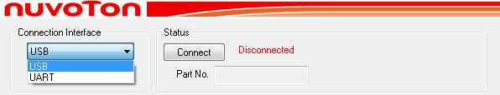
Figure 2-1 Connection via USB Interface
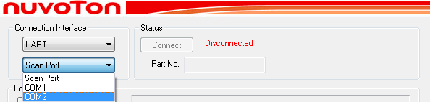
Figure 2-2 Connection via UART Interface using specific COM port
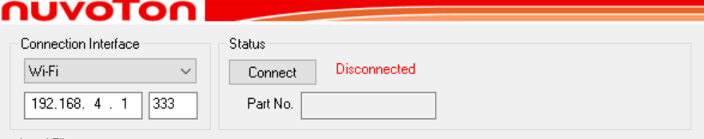
Figure 2-3 Connection via Wi-Fi Interface

Connection Interface via Nu-Link2-Pro
Since version 3.00, there are more connection interfaces available for customer’s product decision. A Nu-Link2-Pro adapter is necessary to use these interfaces. For now, SPI, I2C, RS485, CAN and LIN interfaces is supported by using Nu-Link2-Pro. Users can either use the Nu-Link2 firmware by setting BRIDGE-MODE to ISP_LDROM or opt for the ISP Bridge firmware.
Please check the Chapter 3 of the Nu-Link2-Pro Debugger and Programmer User Manual for the interface connection details. Nu-Link2-Pro Debugger and Programmer User Manual can be downloaded from Nuvoton Official Website, or by the following link mentioned in Github: OpenNuvoton/Nuvoton_Tools:
https://www.nuvoton.com/resource-download.jsp?tp_GUID=UG1320200319174043
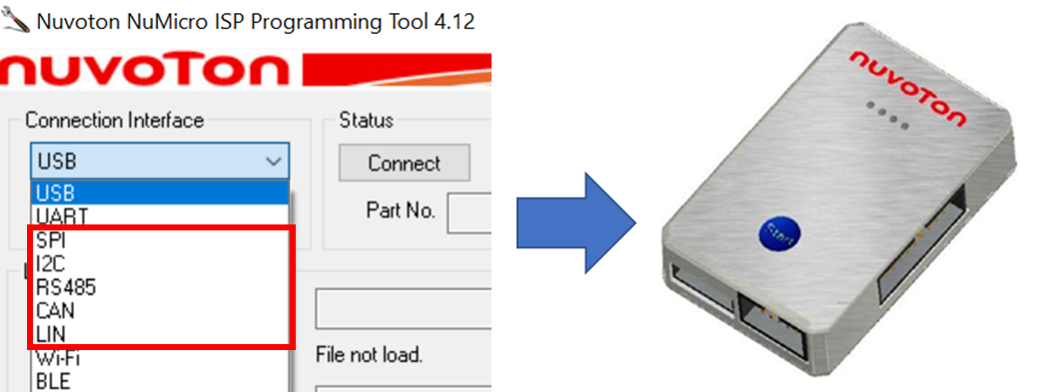
Figure 2 4 Connection Interface via Nu-Link2-Pro ISP-Bridge functionality
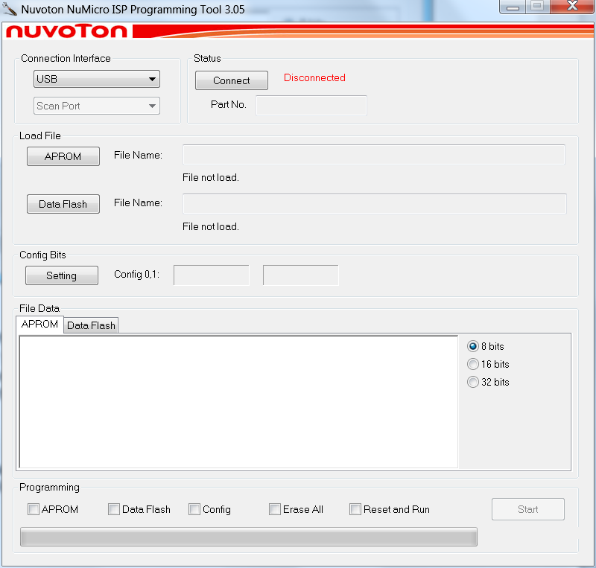
Figure 2-5 Main Dialog

Connecting to the target chip
After clicking the “Connect” button, the ISP tool will keep trying to connect to a target board every 40 mini seconds (200 mini seconds for LIN, Wi-Fi and BLE interfaces) until the target board is successfully connected or the “Stop” button is clicked. If there is no response from the target board during connection, please reset the MCU to execute the ISP code.
If the connection is successful, the ISP tool should display information about the target's part number, APROM size, and Data Flash size. If the information shown on the ISP tool differs from the target, there might be a connection error. Please try to connect again.

Load File
Click the “APROM” or “Data Flash” button to select the image from the pop-up window. Or using drag & drop function from Windows Explorer to select the image file.
For now, binary file (.bin) is the only acceptable image file type for ISPTool.
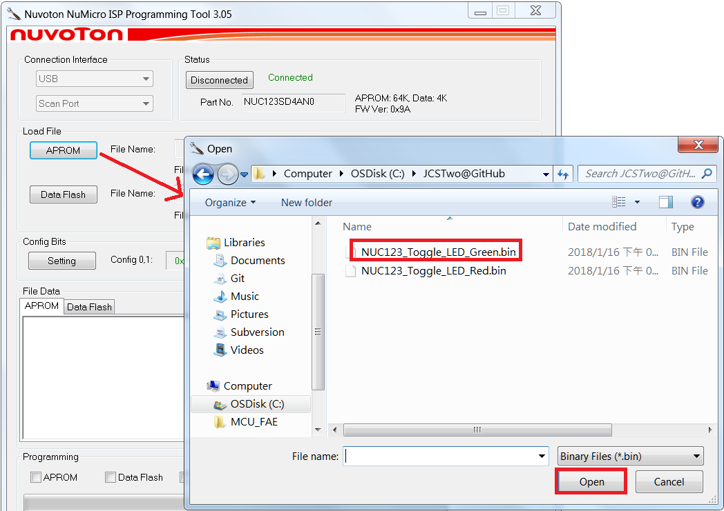
Figure 2-6 Click Button to Load Image file
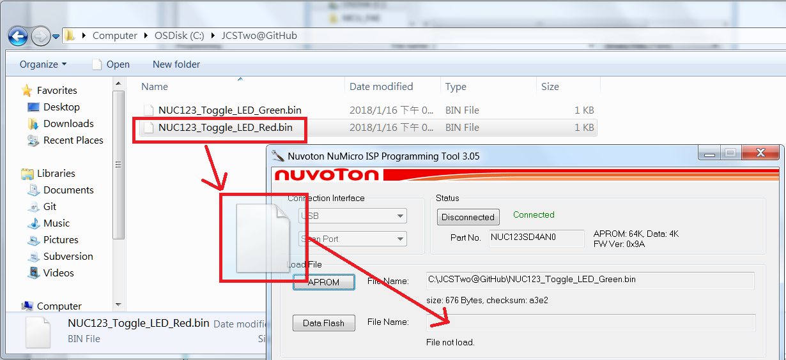
Figure 2-7 Drag image file from explorer window

Setting the User Configuration Bits
When the ISPTool connects to the target chip, it reads the User Configuration settings from the target board. These settings are then displayed in the Config Bits Group Box in green text.

After clicking the “Setting” button, a “User Configuration” dialog appears, showing all User Configuration settings. The specific “User Configuration” dialog displayed corresponds to the MCU currently connected. For instance, Figure 2.8 illustrates the “User Configuration” settings for the NUC123AN series MCU.

It's important to note that the ISP tool does not permit users to modify the target board's boot selection. The “Boot Select” displayed in the User Configuration form is purely informational. To update this setting, users should utilize the Nuvoton NuMicro® ICP Programming Tool.

If users modify settings in the “User Configuration” dialog and then click the “OK” button, it doesn't immediately alter the config values on the board. Any changed values will be highlighted in the Config Bits Group Box in red text. These modified config values will be written only when users proceed with ISP Programming, using the config option mentioned in Chapter 2.6.
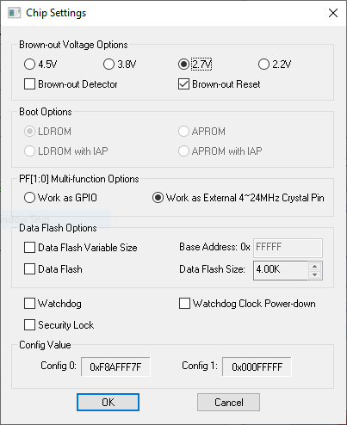
Figure 2-8 User Configuration Dialog

Programming Options
The following table lists the ISP actions for different programming options. The SPI Programming options are available for specific series like M487KMCAN. Please refer to the ISP_UART_SPIFLASH_M487KM sample for more detailed information.
Programming Options | ISP Actions
APROM | APROM will be updated.
Data Flash | Data Flash will be updated.
Config | User Configuration will be updated while target chip is not in write protected mode.  - User Configuration is in write protected mode when security lock is enabled.  - Program APROM or Erase All option can remove write protection of User Configuration.  Note: Any change on User Configuraion block will take effect after system reboot.
Erase All | APROM and Data Flash will be erased.  The Security Lock in User Configuration will be disabled.
Reset and Run | The system reset is issued and the chip is running user application on APROM.
SPI Flash | SPI Flash will be updated.
Erase SPI Flash | SPI Flash will be erased.
Table 2-9 ISP Programming Options

ISPTOOL COMMAND LINE INTERFACE

Command Format
The command format of ISPTool is shown as follows:

> NuvoISP.exe [-aprom BINFILE] [-nvm BINFILE] [-interface INTF] [-run] [-batch]
Note: The command format is case sensitive

Where user can use “-aprom” or “-nvm” to update ARPOM or Data Flash and the BINFILE is the image file. “-interface” is to specify the connection interface INTF, currently only USB and UART interfaces are supported. For UART interface, user should specify the port number, for example as “COM5”. For USB interface, user should assign INTF as “HID”. “-run” is used to trigger the system reset and force the chip to execute the application on APROM. “-batch” is used to batch programming multiple devices.

Script Examples
The first example shows how to program ARPOM through UART interface. The batch file contains only two lines as follows and is put together with the image file “USBD_HID_Mouse.bin”.

NuvoISP.exe -aprom USBD_HID_Mouse.bin -interface COM10 -run
pause

Double click the batch file shows the following result.
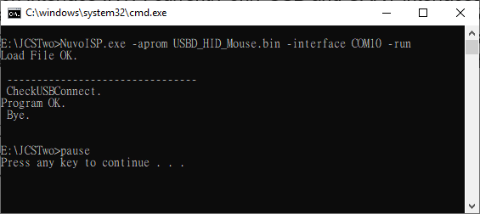
Figure 3-3 programming result

The second example shows how to program aprom through USB interface in batch mode.
NuvoISP.exe -aprom USBD_MassStorage_CDROM.bin -interface HID -batch
pause

Double click the batch file shows the following result. In batch mode, the ISPTool will repeat to execute the script command until user closes the console window.
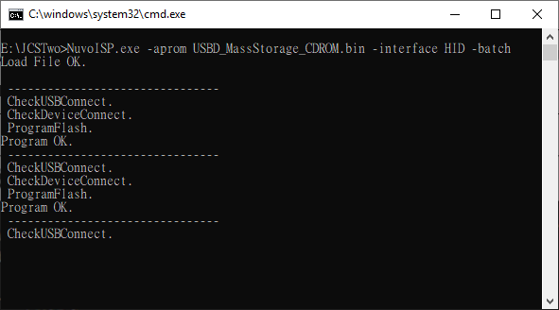
Figure 3-4 batch programming result

Important Notice
Using this software indicates your acceptance of the disclaimer hereunder:
THIS SOFTWARE IS FOR YOUR REFERENCE ONLY AND PROVIDED "AS IS" AND ANY EXPRESS OR IMPLIED WARRANTIES, INCLUDING, BUT NOT LIMITED TO, THE IMPLIED WARRANTIES OF MERCHANTABILITY AND FITNESS FOR A PARTICULAR PURPOSE ARE DISCLAIMED. YOUR USING THIS SOFTWARE/FIRMWARE IS BASED ON YOUR OWN DISCRETION, IN NO EVENT SHALL THE COPYRIGHT OWNER OR PROVIDER BE LIABLE TO ANY DIRECT, INDIRECT, INCIDENTAL, SPECIAL, EXEMPLARY, OR CONSEQUENTIAL DAMAGES (INCLUDING, BUT NOT LIMITED TO, PROCUREMENT OF SUBSTITUTE GOODS OR SERVICES; LOSS OF USE, DATA, OR PROFITS; OR BUSINESS INTERRUPTION) HOWEVER CAUSED AND ON ANY THEORY OF LIABILITY, WHETHER IN CONTRACT, STRICT LIABILITY, OR TORT (INCLUDING NEGLIGENCE OR OTHERWISE) ARISING IN ANY WAY OUT OF THE USE OF THIS SOFTWARE, EVEN IF ADVISED OF THE POSSIBILITY OF SUCH DAMAGE.

