ARM® Cortex®- M
32-bit Microcontroller

NuMicro® ISP Python Tool
User Manual

The information described in this document is the exclusive intellectual property of
Nuvoton Technology Corporation and shall not be reproduced without permission from Nuvoton.

Nuvoton is providing this document only for reference purposes of NuMicro microcontroller based system design. Nuvoton assumes no responsibility for errors or omissions.
All data and specifications are subject to change without notice.

For additional information or questions, please contact: Nuvoton Technology Corporation.
www.nuvoton.com

Table of Contents
1 Overview 3
2 INSTALLATION 4
2.1 Python3 4
2.2 Python Modules 4
2.3 ISP Library 4
3 Using the ISP Python Tool 5
3.1 Connecting Interface Selection 5
3.2 Setting the User Configuration Bits 7
3.3 Programming Options 8

Overview
The NuMicro® Family microcontroller (MCU) supports In-System-Programming (ISP) function allowing the embedded Flash memory to be reprogrammed under software control. ISP is performed without removing the microcontroller from the system through the firmware and on-chip connectivity interface, such as UART, USB, I²C, SPI, and CAN.
ISP Python Tool is a cross platform tool developed with Python language. So it can be use on Windows, Linux and Mac OS platform. User can use this tool on whichever operating system they are familiar with.
Before using the ISP Python Tool, user needs to program the ISP code into LDROM by using a universal programmer or Nuvoton NuMicro® ICP Programming Tool, and the User Configuration bit ‘CBS’ configured as Boot from LDROM.
ISP code can be found in the board support package (BSP). Take M480BSP for example, we supplied ISP_CAN, ISP_HID, ISP_HID_20, ISP_I2C, ISP_RS485, ISP_SPI and ISP_UART samples as shown in the following link.
https://github.com/OpenNuvoton/M480BSP/tree/master/SampleCode/ISP

INSTALLATION
ISP Python Tool is released in both source format and executable form. The executable file can execute directly without installation. But to execute from the python script, some required packages are described below.

Python3
ISP Python Tool is developed with Python3. Theirs is no guarantee to work with Python2. Please install python 3 in order to execute ISP Python Tool source code. In an Ubuntu system, use the command below to install Python3.
$ sudo apt install python3 python3-pip
For Windows user, the Python3 package could be download from Python’s official web site https://www.python.org/downloads/windows/.

Python Modules
After install Python3, please use following command to install required modules for NuWriter command line tool.
$ pip3 install ctypes pyserial hidapi PyQt5

ISP Library
ISP Python Tool use ISP Library to implement the ISP progress. The ISP Library dynamic-link library (.dll) file is provided for Windows platform. For Linux and Mac OS platform, ISP Library shared-object library (.so) file is provided.
However, if the existed ISP Library file didn’t fit the user environment and didn’t work correctly, it is recommended to compile the ISP Library source code in their local environment.

Using the ISP Python Tool
The ISP Python Tool can be start by running the execution file in Windows Platform or running the ISP_Sample.py in Windows, Linux and Mac OS platform.

Connecting Interface Selection
User needs to select the ISP connection interface before using the ISP function and makes sure the I/O pins used for communication are connected correctly. For USB interface, an extra entry pin must be tied to ground pin to enter ISP mode. A Nu-Link2-Pro adapter is necessary to use SPI, I2C, RS485 and CAN interface.
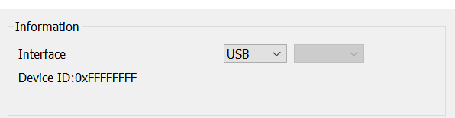
Figure 3-1 Connection via USB Interface
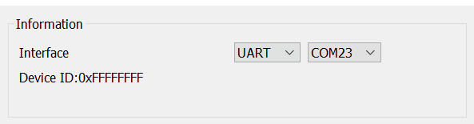
Figure 3-2 Connection via UART Interface using specific COM port
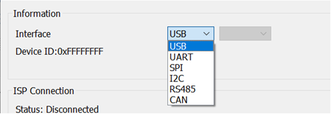
Figure 3-3 Connection Interface via Nu-Link2-Pro ISP-Bridge functionality

Connect to the target chip
After clicking the “Connect” button, the ISP Python Tool will attempt to connect to the target chip. If the connection is successful, the tool will begin retrieving information from the target chip, such as its part number, APROM size, and Data Flash size. If the connection fails, a warning message box will appear.
Currently, the ISP Python Tool supports the NuMicro® Family of microcontrollers (MCUs) on Windows, Linux, and Mac OS platforms. On the other hand, the NuVoice™ series is only supported on the Windows platform.

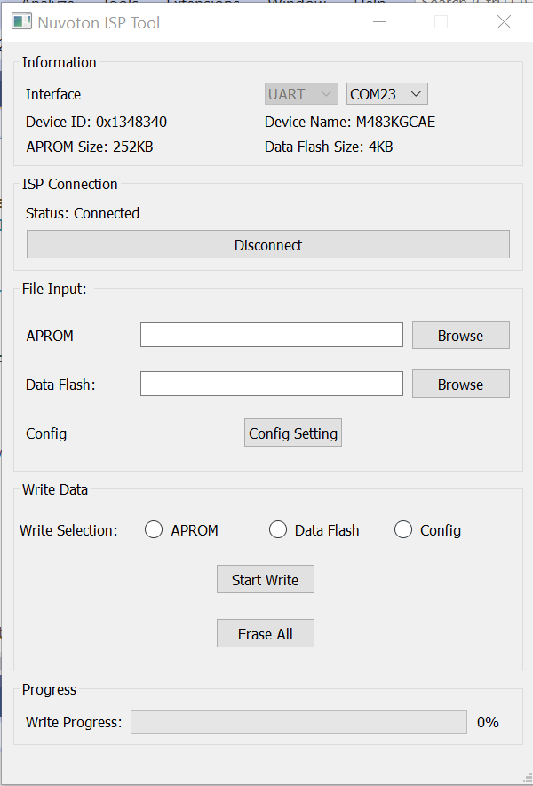
Figure 3-4 Main Dialog

Setting the User Configuration Bits
After clicking the “Config Setting” button, a “User Configuration” dialog will open to display all User Configuration settings. The corresponding “User Configuration” dialog will be displayed according to the MCU currently connected. Figure 3-5 shows the “User Configuration” setting of the NUC123AN series MCU.
The ISP tool does not allow user to modify target board boot selection, either. The “Boot Select” shown in the User Configuration form is for informative purpose only. This setting can be updated with Nuvoton NuMicro® ICP Programming Tool.
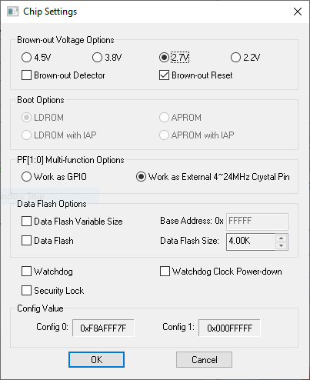
Figure 3-5 User Configuration Dialog

Programming Options
The following table lists the ISP actions provided in ISP Python Tool for different programming options. To do the APROM, Data Flash or config programming option, choose the radio button and press the “Start Write” button. To do the erase all programming option, press the “Erase All” button.
These functions are exclusive in ISP Python Tool, means that ISP Python Tool only execute one of the programming option at the same time.
Programming Options | ISP Actions
APROM | APROM will be updated.
Data Flash | Data Flash will be updated.
Config | User Configuration will be updated while target chip is not in write protected mode.  - User Configuration is in write protected mode when security lock is enabled.  - Program APROM or Erase All option can remove write protection of User Configuration.  Note: Any change on User Configuraion block will take effect after system reboot.
Erase All | APROM and Data Flash will be erased.  The Security Lock in User Configuration will be disabled.
Table 3-6 ISP Programming Options

Important Notice
Using this software indicates your acceptance of the disclaimer hereunder:
THIS SOFTWARE IS FOR YOUR REFERENCE ONLY AND PROVIDED "AS IS" AND ANY EXPRESS OR IMPLIED WARRANTIES, INCLUDING, BUT NOT LIMITED TO, THE IMPLIED WARRANTIES OF MERCHANTABILITY AND FITNESS FOR A PARTICULAR PURPOSE ARE DISCLAIMED. YOUR USING THIS SOFTWARE/FIRMWARE IS BASED ON YOUR OWN DISCRETION, IN NO EVENT SHALL THE COPYRIGHT OWNER OR PROVIDER BE LIABLE TO ANY DIRECT, INDIRECT, INCIDENTAL, SPECIAL, EXEMPLARY, OR CONSEQUENTIAL DAMAGES (INCLUDING, BUT NOT LIMITED TO, PROCUREMENT OF SUBSTITUTE GOODS OR SERVICES; LOSS OF USE, DATA, OR PROFITS; OR BUSINESS INTERRUPTION) HOWEVER CAUSED AND ON ANY THEORY OF LIABILITY, WHETHER IN CONTRACT, STRICT LIABILITY, OR TORT (INCLUDING NEGLIGENCE OR OTHERWISE) ARISING IN ANY WAY OUT OF THE USE OF THIS SOFTWARE, EVEN IF ADVISED OF THE POSSIBILITY OF SUCH DAMAGE.

