Arm® Cortex®-M
32-bit Microcontroller

NuBridge2 Terminal Tool
User Manual

The information described in this document is the exclusive intellectual property of
Nuvoton Technology Corporation and shall not be reproduced without permission from Nuvoton.

Nuvoton is providing this document only for reference purposes of NuMicro microcontroller based system design. Nuvoton assumes no responsibility for errors or omissions.
All data and specifications are subject to change without notice.

For additional information or questions, please contact: Nuvoton Technology Corporation.
www.nuvoton.com

Table of Contents
1 Overview 4
1.1 About NuBridge2 Firmware 4
1.2 About NuBridge2 Terminal 4
2 Using the NuBridge2 Terminal Tool in Windows 5
2.1 Main Screen 5
2.2 Connect Settings 6
2.2.1 Can Settings 6
2.2.2 I²C Settings 7
2.2.3 SPI Settings 8
2.2.4 Log File 9
2.3 CAN Bridge 10
2.4 I²C Bridge 11
2.5 SPI Bridge 12
3 Revision History 13

List of Figures
Figure 2-1 Main Screen 5
Figure 2-2 Connection Settings for CAN 6
Figure 2-3 Connection Settings for I²C 7
Figure 2-4 Connection Settings for SPI 8
Figure 2-5 NuBridgeLog.txt 9
Figure 2-6 CAN Bridge Main Screen 10
Figure 2-7 I²C Bridge Main Screen 11
Figure 2-8 SPI Bridge Main Screen 12

Overview
The Nu-Link2-Pro® dongle supports various bridge functions allowing the PC to interface with the embed bus, including RS485, I²C, SPI and CAN. (Only CAN Bridge, ^{I2}C Bridge and SPI Bridge are supported in NuBridge2 terminal, For RS485 NuBridge2 firmware, user can use any off-the-shelf serial port terminal, e.g. Tera term) In the following chapter, the word NuBridge2 adapter but not NuLink-2® dongle will be used for clarity or NuBridge2 will be used for short. All the bridges application acted as a general USB communications device class (USB CDC), so user can access the NuBridge2 with many programming language or with any third party terminal software. The following chapter will focus on using the NuBridge2 terminal to access NuBridge2.
Before using the NuBridge2 terminal, user needs to program the NuBridge2 firmware into APROM by using a universal programmer and Nuvoton’s NuMicro® ICP Programming Tool.
The source code of NuBridge2 firmware and NuBridge2 terminal can be found in the following repositories hosted by Nuvoton.
https://github.com/OpenNuvoton/NuBridge2_Firmware
https://github.com/OpenNuvoton/NuBridge2_Terminal

About NuBridge2 Firmware
The NuBridge2 firmwares are referenced from the HSUSBD_VCOM_SerialEmulator which is a ready to use USB to UART Bridge. The UART part can be replaced with other desired interface to become a new bridge application. The desired interface includes RS485, CAN, SPI and I²C. Since the USB part is unchanged and follows the specification defined by USB-IF, so the NuBridge2 can benefit from any exist resource. For example, user can use pip command to install pyserial for python language, or use npm command to install serialport for node.js to access NuBridge2.

About NuBridge2 Terminal
The NuBridge2 terminal is referenced from the Terminal Example supplied by Qt. Qt is a cross-platform application development framework for desktop, embedded and mobile. Supported Platforms include Linux, OS X, Windows, VxWorks, QNX, Android, iOS, BlackBerry, Sailfish OS and others. By using QT, the NuBridge2 terminal is a free software under LGPL license.

Using the NuBridge2 Terminal Tool in Windows
Since Qt is a Cross-platform framework, user can compile this sample for Linux, OSX and Windows without any further modification. The executable file for Windows is supported only, and the demo on Windows will be presented only.

Main Screen
When the NuBridge2 terminal starts, a main screen, as shown in Figure 2-1, will be displayed on the monitor. The main screen is divided into three parts. First, user can issue connect, disconnect or clear log messages from the Menu or tool bar. Besides the menu and tool bar, there are two frames for sending and received data. If NuBridge2 is configured as input only mode like CAN Silent mode, I²C Monitor, or SPI Monitor mode, only the Received message frame is shown in such mode.
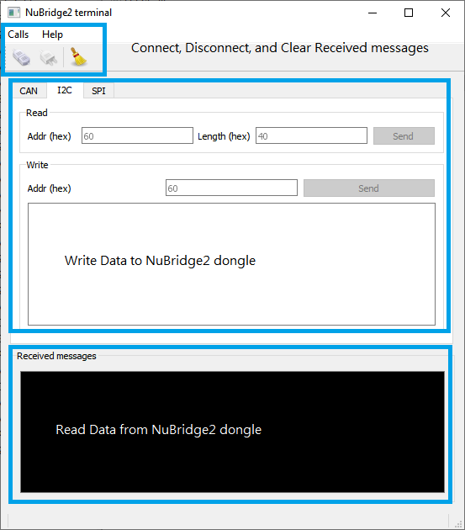
Figure 2-1 Main Screen

Connect Settings
Before connecting to the NuBridge2, please make sure the dedicated bridge application is already programmed in the NuBridge2 adapter. When user issues connect from the menu or from the tool bar, a setting window pops up as shown in Figure 2-2. In the left part, user should select the serial port for specific NuBridge2. In the right part, user can configure the setting for each interface. After the setting is ready, click OK to connect to the NuBridge2 adapter or click Cancel to abort connection. In the bottom, user can log the received data from NuBridge2 to a text file.
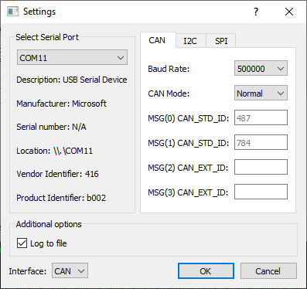
Figure 2-2 Connection Settings for CAN

Can Settings
The Baud Rate setting must be consistent with the connecting network. Also, CAN Bridge can be configured as Normal mode or Silent mode due to user’s purpose.

In Normal mode, user can listen to four CAN devices at most in the same CAN bus. The first two objects are reserved for CAN_STD_ID and others are reserved for CAN_EXT_ID. In such mode, user can also send a frame to any CAN device, which can be set in the main screen.

In Silent mode, CAN Bridge can monitor any data from any CAN device in the same network. This mode is used to debug the CAN Bus communication.

I²C Settings
The I²C Bridge can be set to I²C Master with specific bus clock. A special mode called Monitor mode is provided. I²C Monitor mode is a special feature of the USCI_I2C design. It is actually an I²C salve variation. The I²C Bridge can read any data in the I²C bus without affecting the bus in Monitor mode. The sending frame in main screen is hidden in I²C Monitor mode.
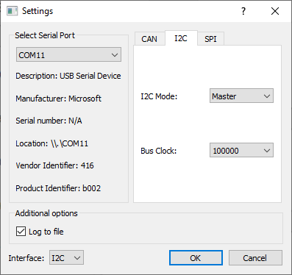
Figure 2-3 Connection Settings for I²C

SPI Settings
All the SPI setting options are relative to the SPI waveform. Please refer to the Technical Reference Manual for further details. The SPI Monitor mode is implemented by combination of two SPI Slave without MISO pin, thus it won’t output any data. It is recommended to tie as many ground pins from a target device and SPI Bridge together to reduce noise affection if you found the SPI Bridge will affect the SPI bus.
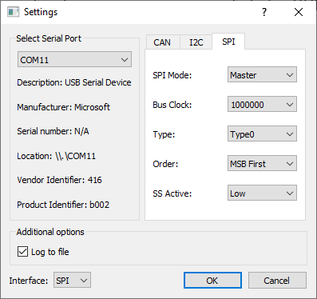
Figure 2-4 Connection Settings for SPI

Log File
If the “Log to file” option is selected in connect settings, there will be a text file named “NuBridgeLog.txt” generated automatically. All the raw data from NuBridge2 adapter is stored in this file. The NuBridge2 terminal converts the raw data from binary to hexadecimal characters, so it can be opened by any text editor like notepad++. Please note that, the timestamp in the log file is generated by NuBridge2 terminal, not NuBridge2 adapter and the data length is the read length by NuBridge2 terminal. The read length may not equal the real output length by NuBridge2 adapter.
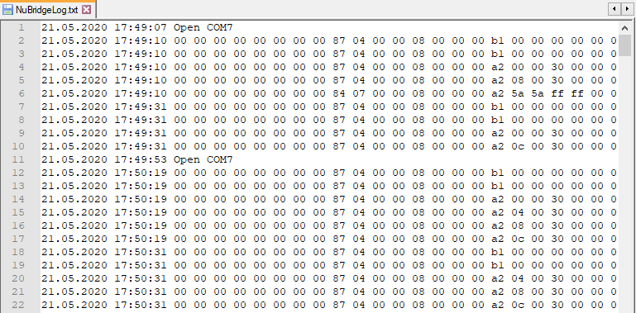
Figure 2-5 NuBridgeLog.txt

CAN Bridge
When NuBridge2 is configured as a CAN Bridge, user can send and receive data in CAN normal mode, and can only receive data in CAN silent mode.
User must set frame type correctly and specifies the Frame ID and 8-Byte Payload before click Send button. In Can silent mode, the sending functionality is not available.
The received message will display message from the CAN device ID specified by user in the connect settings. For CAN silent mode, it displays all data from all CAN devices in the same network.
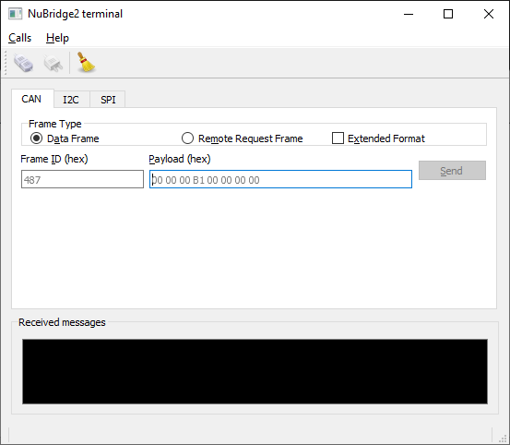
Figure 2-6 CAN Bridge Main Screen

I²C Bridge
The I²C Bridge supports I²C Read and I²C Write operations and only 7-bit I²C address is supported. After I²C Read Address and Read Length is sent, the received read data will be displayed in the Received messages frame. In I²C Monitor mode, it reads all data from all I²C devices in the same I²C bus. Besides raw data, it also monitors the I²C control bit like I²C Start, I²C Stop, I²C ACK and I²C NACK.
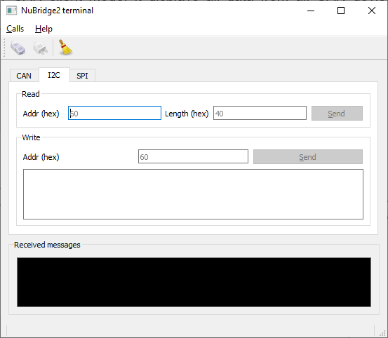
Figure 2-7 I²C Bridge Main Screen

SPI Bridge
Since SPI is a Full-duplex synchronous interface, SPI Bridge only supports one I/O operation. After fill in the data and click the Send button, all the data are sending out through SPI MOSI pin and some data coming in at the same time through SPI MISO pin. All the data is displayed in the Received messages frame.
In SPI Monitor mode, two SPI Slaves are used to monitor the SPI Bus data. Since the data is log from two different pins, it displays interleaving not continuous. That is to say, the odd byte data comes from MOSI and the even byte data comes from MISO.
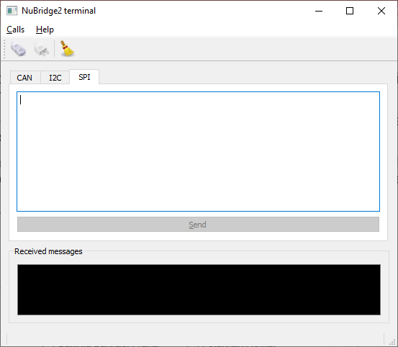
Figure 2-8 SPI Bridge Main Screen

Revision History
Date | Revision | Description
2020.06.02 | 1.00 | First version.

Important Notice
Nuvoton Products are neither intended nor warranted for usage in systems or equipment, any malfunction or failure of which may cause loss of human life, bodily injury or severe property damage. Such applications are deemed, “Insecure Usage”.
Insecure usage includes, but is not limited to: equipment for surgical implementation, atomic energy control instruments, airplane or spaceship instruments, the control or operation of dynamic, brake or safety systems designed for vehicular use, traffic signal instruments, all types of safety devices, and other applications intended to support or sustain life.
All Insecure Usage shall be made at customer’s risk, and in the event that third parties lay claims to Nuvoton as a result of customer’s Insecure Usage, customer shall indemnify the damages and liabilities thus incurred by Nuvoton.
