

**Specification**



**OpenPeppol AISBL**

**Peppol Transport Infrastructure**

**ICT - Models**

**Service Metadata Locator (SML)**

**Version: 1.2.0**

**Status: In use**

**Editors:**

**Gert Sylvest (NITA/Avanade)  
 Jens Jakob Andersen (NITA)  
 Klaus Vilstrup Pedersen (DIFI)  
 Mikkel Hippe Brun (NITA)  
 Mike Edwards (NITA/IBM)**

|  |  |  |
| --- | --- | --- |
| **Project co-funded by the European Commission within the ICT Policy Support Programme** | | |
| **Dissemination Level** | | |
| **P** | **Public** | **X** |
| **C** | **Confidential, only for members of the consortium and the Commission Services** |  |

**Revision History**

|  |  |  |  |
| --- | --- | --- | --- |
| Version | Date | Description of changes | Author |
| 1.0.0 | 2010-02-15 | First version (pending EC approval) | Mike Edwards, NITA/IBM |
| 1.0.1 | 2010-10-01 | EC approved | Klaus Vilstrup Pedersen, DIFI |
| 1.2.0 | 2020-06-25 | Updated the references  Improved layout  Linking external XSD and WSDLs in the Appendix  Updated rules for migration key | Philip Helger, OpenPeppol OO |

**Statement of originality**

This deliverable contains original unpublished work except where clearly indicated otherwise. Acknowledgement of previously published material and of the work of others has been made through appropriate citation, quotation or both.

**Statement of copyright**



*This deliverable is released under the terms of the Creative Commons Licence accessed through the following link: http://creativecommons.org/licenses/by-nc-nd/4.0/.*

*You are free to:*

***Share*** *— copy and redistribute the material in any medium or format.*

*The licensor cannot revoke these freedoms as long as you follow the license terms.*

# Contributors

**Organisations**

DIFI (Direktoratet for forvaltning og IKT)[1], Norway, [www.difi.no](http://www.difi.no)

NITA (IT- og Telestyrelsen)[2], Denmark, www.itst.dk

BRZ (Bundesrechenzentrum)[3], Austria, www.brz.gv.at

Consip, Italy

OpenPeppol

**Persons**

Bergthór Skúlason, NITA

Carl-Markus Piswanger, BRZ

Christian Uldall Pedersen, NITA/Accenture

Dennis Jensen Søgaard, NITA/Accenture

Gert Sylvest, NITA/Avanade

Hans Guldager Knudsen, NITA/Lenio

Jens Jakob Andersen, NITA

Joakim Recht, NITA/Trifork

Kenneth Bengtsson, NITA/Alfa1lab

Klaus Vilstrup Pedersen, DIFI

Mike Edwards, NITA/IBM (editor)

Mikkel Hippe Brun, NITA

Paul Fremantle, NITA/WSO2

Philip Helger, BRZ/ OpenPeppol Operating Office

Thomas Gundel, NITA/IT Crew

# Table of contents

Contributors 4

Table of contents 5

1 Introduction 6

1.1 Objective 6

1.2 Scope 6

1.3 Goals and non-goals 6

1.4 Terminology 7

1.4.1 Notational conventions 7

1.4.2 Normative references 7

1.4.3 Non-normative references 7

1.5 Namespaces 8

2 The Service Discovery Process 9

2.1 Discovery flow 9

2.2 Flows Relating to Service Metadata Publishers 10

3 Interfaces and Data Model 14

3.1 Service Metadata Locator Service, logical interface 14

3.1.1 Format of Participant Identifiers 14

3.1.2 ManageParticipantIdentifier interface 14

3.1.3 ManageServiceMetadata interface 18

3.1.4 Fault Descriptions 20

3.2 Service Metadata Locator - data model 21

3.2.1 ServiceMetadataPublisherService datatype 21

3.2.2 ServiceMetadataPublisherServiceForParticipant datatype 21

3.2.3 ParticipantIdentifier datatype 21

3.2.4 ParticipantIdentifier format 22

3.2.5 ParticipantIdentifierPage datatype 22

3.2.6 MigrationRecord 22

4 Service Bindings 24

4.1 Services Provided as Web services - characteristics 24

4.2 ManageParticipantIdentifier service - binding 24

4.2.1 Transport binding 24

4.2.2 Security 24

4.3 ManageServiceMetadata service - binding 24

4.3.1 Transport binding 24

4.3.2 Security 24

5 DNS Spoof Mitigation 25

6 Appendix A: XML Schema (non-normative) 26

6.1 peppol-sml-types-v1.xsd 26

7 Appendix B: WSDLs (non-normative) 28

7.1 peppol-sml-manage-participant-identifier-service-v1.wsdl 28

7.2 peppol-sml-manage-service-metadata-service-v1.wsdl 33

# Introduction

## Objective

This document defines the profiles for the discovery and management interfaces for the Business Document Exchange Network (BUSDOX) Service Metadata Locator service.

The Service Metadata Locator service exposes three interfaces:

* Service Metadata discovery interface  
  This is the lookup interface which enables senders to discover service metadata about specific target participants
* Manage participant identifiers interface  
  This is the interface for Service Metadata publishers for managing the metadata relating to specific participant identifiers that they make available.
* Manage service metadata interface  
  This is the interface for Service Metadata publishers for managing the metadata about their services, e.g. binding, interface profile and key information.

This document describes the physical bindings of the logical interfaces in section 3.1.

## Scope

This specification relates to the Technical Transport Layer i.e. BusDox specifications. The BusDox specifications can be used in many interoperability settings. In the Peppol context, it provides transport for procurement documents as specified in the Peppol Profiles.

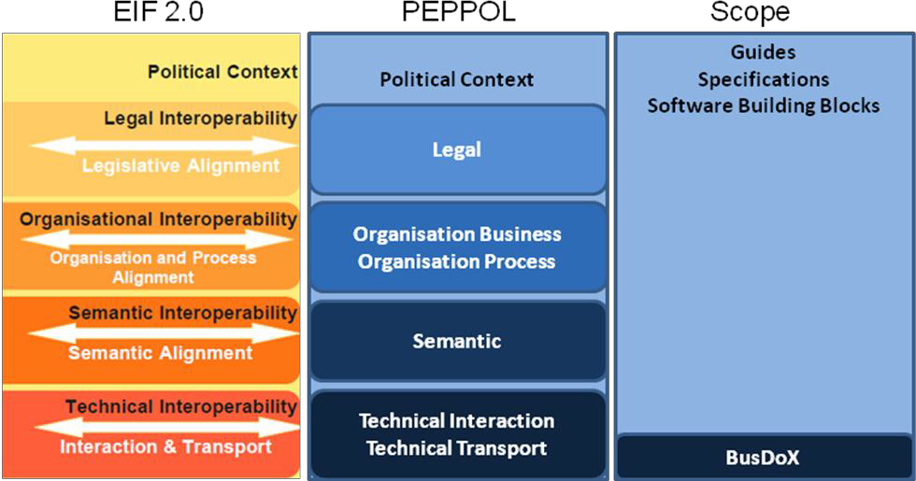

Fig. 1: Peppol Interoperability

## Goals and non-goals

The goal of this document is to describe the interface and transport bindings of the Service Metadata Locator (SML) service. It does not consider its implementation or internal data formats, user management and other procedures related to the operation of this service.

## Terminology

The keywords "MUST", "MUST NOT", "REQUIRED", "SHALL", "SHALL NOT", "SHOULD", "SHOULD NOT", "RECOMMENDED", "MAY", and "OPTIONAL" in this document are to be interpreted as described in RFC 2119 [RFC2119].

### Notational conventions

Pseudo-schemas are provided for each component, before the description of the component. They use BNF-style conventions for attributes and elements: "?" denotes optionality (i.e. zero or one occurrences), "*" denotes zero or more occurrences, "+" one or more occurrences, "[" and "]" are used to form groups, and "|" represents choice. Attributes are conventionally assigned a value which corresponds to their type, as defined in the normative schema. Elements with simple content are conventionally assigned a value which corresponds to the type of their content, as defined in the normative schema. Pseudo schemas do not include extension points for brevity.

<!-- sample pseudo-schema -->

<defined_element

required_attribute_of_type_string="xs:string"

optional_attribute_of_type_int="xs:int"? >

<required_element />

<optional_element />?

<one_or_more_of_these_elements />+

[ <choice_1 /> | <choice_2 /> ]*

</defined_element>

### Normative references

[BDEN-SMP] “Peppol Service Metadata Publishing (SMP) 1.2.0”,  
<https://docs.peppol.eu/edelivery/smp/PEPPOL-EDN-Service-Metadata-Publishing-1.2.0-2021-02-24.pdf>

[XML-DSIG] “XML Signature Syntax and Processing (Second Edition)”,  
<http://www.w3.org/TR/xmldsig-core/>

[RFC-2119] “Key words for use in RFCs to Indicate Requirement Levels”,  
<http://www.ietf.org/rfc/rfc2119.txt>

[RFC3986] “Uniform Resource Identifier (URI): Generic Syntax”,  
<http://tools.ietf.org/html/rfc3986>

[PFUOI4] “Peppol Policy for use of Identifiers 4.1.0”,  
<https://docs.peppol.eu/edelivery/policies/PEPPOL-EDN-Policy-for-use-of-identifiers-4.1.0-2020-03-11.pdf>

### Non-normative references

[WSDL-2.0] “Web Services Description Language (WSDL) Version 2.0 Part 1: Core Language”,  
<http://www.w3.org/TR/wsdl20/>

[WS-I BP] “WS-I Basic Profile Version 1.1”,  
<http://www.ws-i.org/Profiles/BasicProfile-1.1.html>

[WS-I BSP] “WS-I Basic Security Profile Version 1.0”,  
<http://www.ws-i.org/Profiles/BasicSecurityProfile-1.0.html>

[DNS-1034] “Domain Names - Concepts and Facilities”,  
<http://tools.ietf.org/html/rfc1034>

[DNS-1035] “Domain Names - Implementation and Specification”,  
<http://tools.ietf.org/html/rfc1035>

[MD5] “The MD5 Message-Digest Algorithm”,  
<http://tools.ietf.org/html/rfc1321>

## Namespaces

The following table lists XML namespaces that are used in this document. The choice of any namespace prefix is arbitrary and not semantically significant.

|  |  |
| --- | --- |
| Prefix | Namespace URI |
| ids | http://busdox.org/transport/identifiers/1.0/ |
| lrs | http://busdox.org/serviceMetadata/locator/1.0/ |
| soap | http://schemas.xmlsoap.org/wsdl/soap/ |
| wsdl | http://schemas.xmlsoap.org/wsdl/ |
| xs | http://www.w3.org/2001/XMLSchema |

# The Service Discovery Process

The interfaces of the Service Metadata Locator (SML) service and the Service Metadata Publisher (SMP) service cover both sender-side lookup and metadata management performed by SMPs. BUSDOX mandates the following interfaces for these services:

* Service Metadata Locator:
  + Discovery interface for senders
  + Management interface for SMPs
* Service Metadata Publishers:
  + Discovery interface for senders

This specification only covers the interfaces for the Service Metadata Locator.

The Service Metadata Locator service specification is based on the use of DNS (Domain Name System) lookups to find the address of the Service Metadata for a given participant ID [DNS-1034] [DNS-1035]. This approach has the advantage that it does not need a single central server to run the Discovery interface, with its associated single point of failure. Instead, the already distributed and highly redundant infrastructure which supports DNS is used. The SML service itself thus plays the role of providing controlled access to the creation and update of entries in the DNS.

## Discovery flow

For a sender, the first step in the Discovery process is to establish the location of the Service Metadata relating to the particular Participant Identifier to which the sender wants to transmit a message. Each participant identifier is registered with one and only one Service Metadata Publisher. The sender constructs the address for the service metadata for a given recipient participant identifier using a standard format, as follows:

http://<hash over recipientID>.<schemeID>.<SML domain>/<recipientID>/services/<documentType>

The sender uses this URL in an HTTP GET operation which returns the metadata relating to that recipient and the specific document type (for details, see the Service Metadata Publishing specification [BDEN-SMP]). The sender can obtain the information necessary to transmit a message containing that document type to that recipient from the returned metadata. This sequence is shown in Fig. 2.

Note that the sender is required to know 2 pieces of information about the recipient - the recipient's participant ID and the ID of the Scheme of the participant ID (i.e. the format or type of the participant ID). This provides for flexibility in the types of participant identifier that can be used in the system. Since in general a participant ID may not have a format that is acceptable in an HTTP URL, the ID is hashed into a string as described in section 3.1.1 Format of Participant Identifiers.

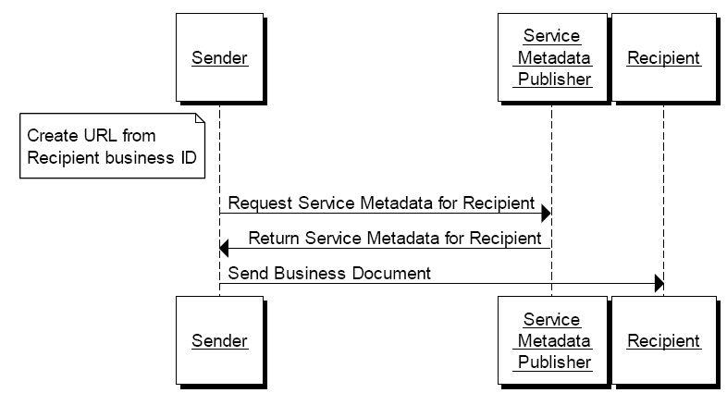

Fig. 2: Sequence Diagram for Sender transmitting Document to Recipient

The underlying design of the Discovery process is based on the use of Domain Name System (DNS) CNAME records which correspond to the Domain Name in the format given above, namely that there is a CNAME record for the domain name <hash over recipientID>.<schemeID>.<SML domain>. Furthermore, that CNAME record points at the Service Metadata Publisher which holds the metadata about that recipient. This means that an address lookup for the domain name by the sender naturally resolves to the Service Metadata Publisher holding the metadata. The resolution of Web URLs in this way is a fundamental part of the World Wide Web and so it is based on standard technology that it available to all users.

## Flows Relating to Service Metadata Publishers

The management of the DNS CNAME records for a given participant identifier is performed through the Management interface of the Service Metadata Locator. The management interface is primarily for use by the Service Metadata Publisher which controls the service metadata for a given participant identifier. Note that the DNS CNAME records are **not** manipulated directly by the Service Metadata Publisher, but are manipulated by the Service Metadata Locator service following requests made to its Management interface. The basic process steps for the SMP to manipulate the metadata relating to a given participant are shown in Fig. 3.

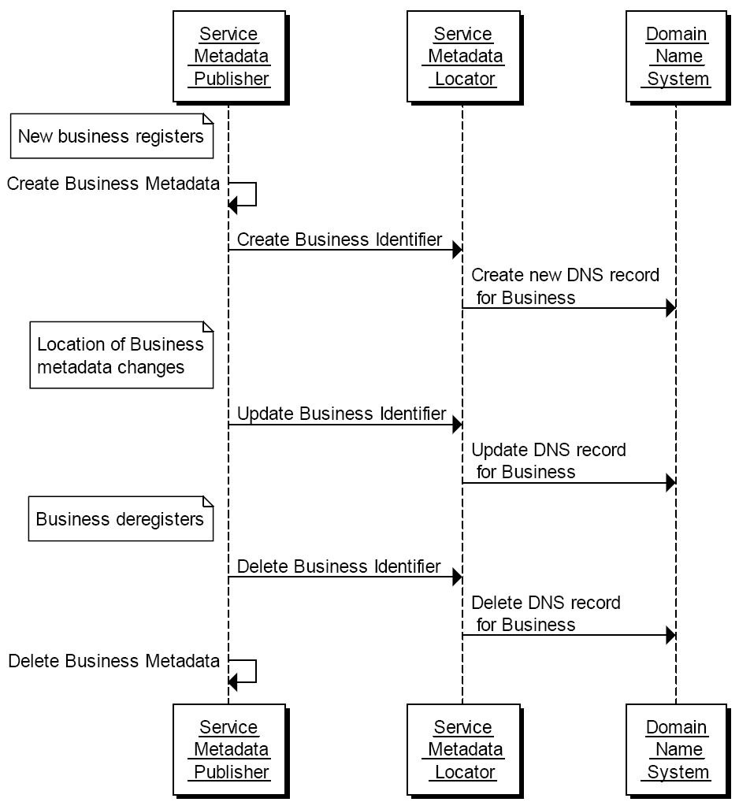

Fig. 3: Sequence Diagram for Service Metadata Publisher Adding, Updating and Removing Metadata for a Participant

Each Service Metadata Publisher is required to register the address of its server with the Service Metadata Locator. Only once this has been done can information relating to specific Participant Identifiers be presented to the SML. The address for the metadata for a given participant is tied to the address of the SMP with which the participant is registered. For this purpose, the SMP uses the ManageServiceMetadata interface with flows as shown in Fig. 4.

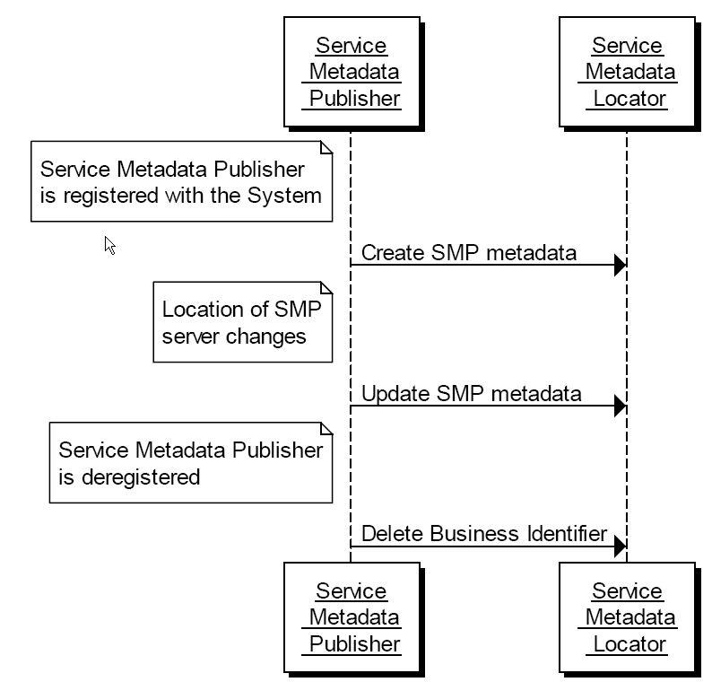

Fig. 4: Service Metadata Publisher use of the ManageServiceMetadata

Another set of steps relating to SMPs and the SML relates to the migration of the metadata about a participant from one SMP to another SMP (for example, the participant decides to change suppliers for this function). There are interfaces to the SML to support migrations of this kind, which imply following a sequence of steps along the lines shown in Fig. 5.

In this sequence, the original SMP receives a request from a participant to migrate its metadata to a new SMP (a step that is done out-of-band: there are no interfaces defined in these specifications for this). The original SMP generates a “Migration Key” and invokes the PrepareToMigrate operation of the SML and then passes the Migration Key to the new SMP (the key passing is an out-of-band step not defined in these specifications). When the new SMP has created the relevant metadata for the participant, it signals that it is taking over by invoking the Migrate operation of the SML, which then causes the DNS record(s) for that participant ID to be updated to point at the new SMP. Once this switch is complete, the original SMP can remove the metadata which it holds for the participant.

The following rules apply to the Migration Key

* MUST have at least 8 characters and not more than 24 characters
* MUST contain at least 2 lower case characters (a-z)
* MUST contain at least 2 upper case characters (A-Z)
* MUST contain at least 2 digits (0-9)
* MUST contain at least 2 characters from this set: “@” (ASCII code 64), “#” (35), “$” (36), “%” (37), “(“ (40), “)” (41), “[“ (91), “]” (93), “{“ (123), “}” (125), “*” (42), “^” (94), “-“ (45), “!” (33), “~” (126), “|” (124), “+” (43) and “=” (61)
* MUST NOT contain whitespace characters

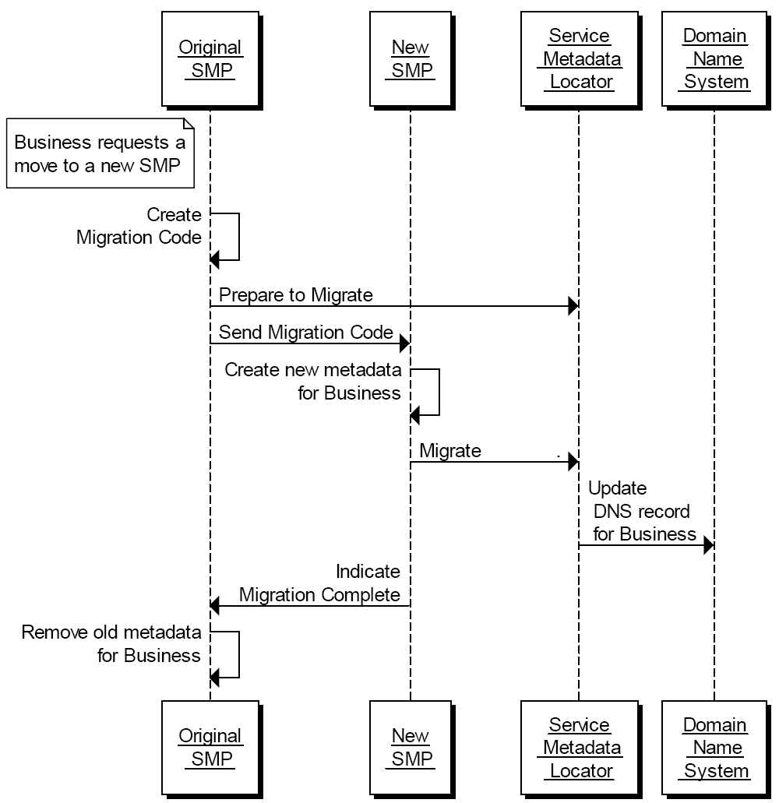

Fig. 5: Steps in Migrating Metadata for a Participant from one SMP to a new SMP

# Interfaces and Data Model

This section outlines the service interfaces and the related data model.

## Service Metadata Locator Service, logical interface

The Service Metadata Locator Service interface is divided into 2 logical parts:

* Manage participant identifiers interface  
  This is the interface for Service Metadata Publishers for managing the registered participant identifiers they expose.
* Manage service metadata interface  
  This is the interface for Service Metadata Publishers for managing the metadata about their metadata publishing service, e.g. binding, interface profile and key information.

### Format of Participant Identifiers

BUSDOX functions by means of logical addresses for the metadata of services offered by a participant, of the form:

http://<hash over recipientID>.<schemeID>.<SML domain>/<recipientID>/services/<documentType>

BUSDOX is flexible with regard to the use of any one of a wide range of schemes for the format of participant identifiers, represented by the schemeID. However, when using this form of HTTP Web address, which is resolved through the DNS system, the format of the recipientID and the schemeID is constrained by the requirements of the DNS system. This means that both the recipientID and the schemeID must be strings which use the ASCII alphanumeric characters only and which have to start with an alphabetic character.

BUSDOX allocates schemeIDs to conform to this requirement. However, there is no guarantee that the participant IDs will conform to this requirement for any given scheme (remembering that in many cases the participant ID scheme will be a pre-existing scheme with its own format rules that might violate the requirements of a DNS name). Therefore a hash of the participant ID is always used, using the MD5 hash algorithm [MD5], and prefixed by "B-".

An example participant ID is 0010:5798000000001, for which the MD5 hash is e49b223851f6e97cbfce4f72c3402aac. See POLICY 7 of the [PFUOI4] for details.

### ManageParticipantIdentifier interface

The ManageParticipantIdentifier interface allows Service Metadata Publishers to manage the information in the Service Metadata Locator Service relating to individual participant identifiers for which they hold metadata.

This interface requires authentication of the Service Metadata Publisher. The identity of the Service Metadata Publisher derived from the authentication process identifies the Service Metadata Publisher associated with the Participant Identifier(s) which are managed via this interface.

It is possible for a given Service Metadata Publisher to provide the metadata for all participant identifiers belonging to a particular participant identifier scheme. If this is the case, then it corresponds to the concept of a "wildcard" CNAME record in the DNS, along the lines:

*.<schemeID>.<SML domain> CNAME <SMP domain>

<SMP domain> may either be the domain name associated with the SMP, or an alias for it.

This implies that all participant identifiers for that schemeID will have addresses that resolve to the single address of that one SMP - and that as result only one SMP can handle the metadata for all participant identifiers of that scheme. Wildcard records are indicated through the use of "*" as the participant identifier in the operations of the ManageParticipantIdentifier interface.

The ManageParticipantIdentifier interface has the following operations:

* Create
* CreateList
* Delete
* DeleteList
* PrepareToMigrate
* Migrate
* List

**Create()**

Creates an entry in the Service Metadata Locator Service for information relating to a specific participant identifier. Regardless of the number of services a recipient exposes, only one record corresponding to the participant identifier is created in the Service Metadata Locator Service by the Service Metadata Publisher which exposes the services for that participant.

* Input CreateParticipantIdentifier: ServiceMetadataPublisherServiceForParticipantType  
  contains the Participant Identifier for a given participant and the identifier of the SMP which holds its data
* Fault: notFoundFault  
  returned if the identifier of the SMP could not be found
* Fault: unauthorizedFault  
  returned if the caller is not authorized to invoke the Create operation
* Fault: badRequestFault  
  returned if the supplied CreateParticipantIdentifier does not contain consistent data
* Fault: internalErrorFault  
  returned if the SML service is unable to process the request for any reason

**CreateList()**

Creates a set of entries in the Service Metadata Locator Service for information relating to a list of participant identifiers. Regardless of the number of services a recipient exposes, only one record corresponding to each participant identifier is created in the Service Metadata Locator Service by the Service Metadata Publisher which exposes the services for that participant.

* Input CreateList: ParticipantIdentifierPage  
  contains the list of Participant Identifiers for the participants which are added to the Service Metadata Locator Service. The NextPageIdentifier element is absent.
* Fault: notFoundFault  
  returned if the identifier of the SMP could not be found
* Fault: unauthorizedFault  
  returned if the caller is not authorized to invoke the CreateList operation
* Fault: badRequestFault  
  returned if the supplied CreateList does not contain consistent data
* Fault: internalErrorFault  
  returned if the SML service is unable to process the request for any reason

**Delete()**

Deletes the information that the SML Service holds for a specific Participant Identifier.

* Input DeleteParticipantIdentifier: ServiceMetadataPublisherServiceForParticipantType  
  contains the Participant Identifier for a given participant and the identifier of the SMP that publishes its metadata
* Fault: notFoundFault  
  returned if the participant identifier or the identifier of the SMP could not be found
* Fault: unauthorizedFault  
  returned if the caller is not authorized to invoke the Delete operation
* Fault: badRequestFault  
  returned if the supplied DeleteParticipantIdentifier does not contain consistent data
* Fault: internalErrorFault  
  returned if the SML service is unable to process the request for any reason

**DeleteList()**

Deletes the information that the SML Service holds for a list of Participant Identifiers.

* Input DeleteList: ParticipantIdentifier  
  contains the list of Participant Identifiers for the participants which are removed from the Service Metadata Locator Service. The NextPageIdentifier element is absent.
* Fault: notFoundFault  
  returned if one or more participant identifiers or the identifier of the SMP could not be found
* Fault: unauthorizedFault  
  returned if the caller is not authorized to invoke the DeleteList operation
* Fault: badRequestFault  
  returned if the supplied DeleteList does not contain consistent data
* Fault: internalErrorFault  
  returned if the SML service is unable to process the request for any reason

**PrepareToMigrate()**

Prepares a Participant Identifier for migration to a new Service Metadata Publisher. This operation is called by the Service Metadata Publisher which currently publishes the metadata for the Participant Identifier. The Service Metadata Publisher supplies a Migration Code which is used to control the migration process. The Migration Code must be passed (out of band) to the Service Metadata Publisher which is taking over the publishing of the metadata for the Participant Identifier and which MUST be used on the invocation of the Migrate() operation.

This operation can only be invoked by the Service Metadata Publisher which currently publishes the metadata for the specified Participant Identifier.

* Input PrepareMigrationRecord: MigrationRecordType  
  contains the Migration Key and the Participant Identifier which is about to be migrated from one Service Metadata Publisher to another.
* Fault: notFoundFault  
  returned if the participant identifier or the identifier of the SMP could not be found
* Fault: unauthorizedFault  
  returned if the caller is not authorized to invoke the PrepareToMigrate operation
* Fault: badRequestFault  
  returned if the supplied PrepateMigrationRecord does not contain consistent data
* Fault: internalErrorFault  
  returned if the SML service is unable to process the request for any reason

**Migrate()**

Migrates a Participant Identifier already held by the Service Metadata Locator Service to target a new Service Metadata Publisher. This operation is called by the Service Metadata Publisher which is taking over the publishing for the Participant Identifier. The operation requires the new Service Metadata Publisher to provide a migration code which was originally obtained from the old Service Metadata Publisher.

The PrepareToMigrate() operation MUST have been previously invoked for the supplied Participant Identifier, using the same MigrationCode, otherwise the Migrate() operation fails.

Following the successful invocation of this operation, the lookup of the metadata for the service endpoints relating to a particular Participant Identifier will resolve (via DNS) to the new Service Metadata Publisher.

* Input CompleteMigrationRecord: MigrationRecordType  
  contains the Migration Key and the Participant Identifier which is to be migrated from one Service Metadata Publisher to another.
* Fault: notFoundFault  
  returned if the migration key or the identifier of the SMP could not be found
* Fault: unauthorizedFault  
  returned if the caller is not authorized to invoke the Migrate operation
* Fault: badRequestFault  
  returned if the supplied CompleteMigrationRecord does not contain consistent data
* Fault: internalErrorFault  
  returned if the SML service is unable to process the request for any reason

**List()**

List() is used to retrieve a list of all participant identifiers associated with a single Service Metadata Publisher, for synchronization purposes. Since this list may be large, it is returned as pages of data, with each page being linked from the previous page.

* Input Page: PageRequest  
  contains a PageRequest containing the ServiceMetadataPublisherID of the SMP and (if required) an identifier representing the next page of data to retrieve. If the NextPageIdentifier is absent, the first page is returned.
* Output: ParticipantIdentifierPage  
  a page of Participant Identifier entries associated with the Service Metadata Publisher, also containing a <Page/> element containing the identifier that represents the next page, if any.
* Fault: notFoundFault  
  returned if the next page or the identifier of the SMP could not be found
* Fault: unauthorizedFault  
  returned if the caller is not authorized to invoke the List operation
* Fault: badRequestFault  
  returned if the supplied NextPage does not contain consistent data
* Fault: internalErrorFault  
  returned if the SML service is unable to process the request for any reason

Note that the underlying data may be updated between one invocation of List() and a subsequent invocation of List(), so that a set of retrieved pages of participant identifiers may not represent a consistent set of data.

### ManageServiceMetadata interface

The ManageServiceMetadata interface allows Service Metadata Publishers to manage the metadata held in the Service Metadata Locator Service about their service metadata publisher services, e.g. binding, interface profile and key information.

This interface requires authentication of the user. The identity of the user derived from the authentication process identifies the Service Metadata Publisher associated with the service metadata which is managed via this interface.

The ManageServiceMetadata interface has the following operations:

* Create
* Read
* Update
* Delete

**Create()**

Establishes a Service Metadata Publisher metadata record, containing the metadata about the Service Metadata Publisher, as outlined in the ServiceMetadataPublisherService data type.

* Input CreateServiceMetadataPublisherService: ServiceMetadataPublisherService  
  contains the service metadata publisher information, which includes the logical and physical addresses for the SMP (Domain name and IP address). It is assumed that the ServiceMetadataPublisherID has been assigned to the calling user out-of-bands.
* Fault: unauthorizedFault  
  returned if the caller is not authorized to invoke the Create operation
* Fault: badRequestFault  
  returned if the supplied CreateServiceMetadataPublisherService does not contain consistent data
* Fault: internalErrorFault  
  returned if the SML service is unable to process the request for any reason

**Read()**

Retrieves the Service Metadata Publisher record for the Service Metadata Publisher.

* Input ReadServiceMetadataPublisherService: ServiceMetadataPublisherID  
  the unique ID of the Service Metadata Publisher for which the record is required
* Output: ServiceMetadataPublisherService  
  the service metadata publisher record, in the form of a ServiceMetadataPublisherService data type
* Fault: notFoundFault  
  returned if the identifier of the SMP could not be found
* Fault: unauthorizedFault  
  returned if the caller is not authorized to invoke the Read operation
* Fault: badRequestFault  
  returned if the supplied parameter does not contain consistent data
* Fault: internalErrorFault  
  returned if the SML service is unable to process the request for any reason

**Update()**

Updates the Service Metadata Publisher record for the Service Metadata Publisher

* Input UpdateServiceMetadataPublisheServicer: ServiceMetadataPublisherService  
  contains the service metadata for the service metadata publisher, which includes the logical and physical addresses for the SMP (Domain name and IP address)
* Fault: notFoundFault  
  returned if the identifier of the SMP could not be found
* Fault: unauthorizedFault  
  returned if the caller is not authorized to invoke the Update operation
* Fault: badRequestFault  
  returned if the supplied UpdateServiceMetadataPublisheServicer does not contain consistent data
* Fault: internalErrorFault  
  returned if the SML service is unable to process the request for any reason

**Delete()**

Deletes the Service Metadata Publisher record for the Service Metadata Publisher

* Input DeleteServiceMetadataPublisherService: ServiceMetadataPublisherID  
  the unique ID of the Service Metadata Publisher to delete
* Fault: notFoundFault  
  returned if the identifier of the SMP could not be found
* Fault: unauthorizedFault  
  returned if the caller is not authorized to invoke the Delete operation
* Fault: badRequestFault  
  returned if the supplied DeleteServiceMetadataPublisherService does not contain consistent data
* Fault: internalErrorFault  
  returned if the SML service is unable to process the request for any reason

### Fault Descriptions

**SMP Not Found Fault**

|  |  |
| --- | --- |
| [action] | http://busdox.org/2010/02/locator/fault |
| Code | Sender |
| Subcode | notFoundFault |
| Reason | The identifier of the SMP supplied could not be found by the SML |
| Detail | As detailed by the SML |

**Unauthorized Fault**

|  |  |
| --- | --- |
| [action] | http://busdox.org/2010/02/locator/fault |
| Code | Sender |
| Subcode | unauthorizedFault |
| Reason | The caller is not authorized to perform the operation requested |
| Detail | As detailed by the SML |

**Bad Request Fault**

|  |  |
| --- | --- |
| [action] | http://busdox.org/2010/02/locator/fault |
| Code | Sender |
| Subcode | badRequestFault |
| Reason | The operation request was incorrect in some way |
| Detail | As detailed by the SML |

**Internal Error Fault**

|  |  |
| --- | --- |
| [action] | http://busdox.org/2010/02/locator/fault |
| Code | Sender |
| Subcode | internalErrorFault |
| Reason | The SML encountered an error while processing the request |
| Detail | As detailed by the SML |

## Service Metadata Locator - data model

The data model for the Service Metadata Locator involves the following data types:

* ServiceMetadataPublisher
* RecipientParticipantIdentifier
* ParticipantIdentifierPage
* MigrationRecord

Each of these data types is described in detail in the following subsections.

### ServiceMetadataPublisherService datatype

Represents a Metadata Publisher Service.

<ServiceMetadataPublisherService>

<PublisherEndpoint>

<EndpointAddress/>

</PublisherEndpoint>

<ServiceMetadataPublisherID/>

</ServiceMetadataPublisherService>

ServiceMetadataPublisherService has the following sub-elements:

* PublisherEndpoint (1..1) : PublisherEndpointType  
  the technical endpoint address of the Service Metadata Publisher, which can be used to query information about particular participant identifiers. ServiceEndpointList is a type defined in the ServiceMetadataPublishingTypes Schema. The PublisherEndpoint element may be a domain name or an IP address of the SMP, or a wildcard expression based on the domain name.
* ServiceMetadataPublisherID (1..1) : xs:string  
  holds the Unique Identifier of the SMP. When creating a ServiceMetadataPublisherService record, it is assumed that the publisher ID has been obtained out of band.

### ServiceMetadataPublisherServiceForParticipant datatype

Represents a Metadata Publisher Service containing information about a particular Participant Identifier.

<ServiceMetadataPublisherServiceForParticipant>

<ServiceMetadataPublisherID/>

<ids:ParticipantIdentifier/>

</ServiceMetadataPublisherServiceForParticipant>

ServiceMetadataPublisherService has the following subelements:

* ServiceMetadataPublisherID (1..1) : xs:string  
  holds the Unique Identifier of the SMP.
* ParticipantIdentifier (1..1) : ids:ParticipantIdentifierType  
  the Participant Identifier which has its services registered in the Service Metadata Publisher. See the “ParticipantIdentifier” section on the format.

### ParticipantIdentifier datatype

Represents a Participant Identifier which has its service metadata held by a specific Service Metadata Publisher.

<ids:ParticipantIdentifier scheme=”xs:string”>

xs:string

</ids:ParticipantIdentifier>

ParticipantIdentifier has the following sub elements:

* ParticipantIdentifier (1..1): xs:string  
  the participant identifier
* @scheme (1..1): xs:string  
  the format scheme of the participant identifier

### ParticipantIdentifier format

For a description of the ParticipantIdentifier format, see the “Peppol Policy for use of Identifier” document [PFUOI4].

### ParticipantIdentifierPage datatype

Represents a page of ParticipantIdentifiers for which data is held by the Service Metadata Locator service.

<ParticipantIdentifierPage>

<ServiceMetadataPublisherID/>

<ParticipantIdentifier/>*

<NextPageIdentifier/>?

</ParticipantIdentifierPage>

* ServiceMetadataPublisherID (1..1) : xs:string  
  holds the Unique Identifier of the SMP
* ids:ParticipantIdentifier (1..1): xs:string  
  the participant identifier
* NextPageIdentifier (0..1): xs:string  
  an element containing a string identifying the next page of ParticipantIdentifiers:

<NextPageIdentifier>

[ Identifier for_Next_Page ]

</NextPageIdentifier>

If no <NextPageIdentifier/> element is present, it implies that there are no further pages.

### MigrationRecord

The MigrationRecord represents the data required to control the process of migrating a ParticipantIdentifier from the control of one Service Metadata Publisher to a different Service Metadata Publisher.

<MigrationRecord>

<ServiceMetadataPublisherID/>

<ParticipantIdentifier/>*

<MigrationKey/>?

</MigrationRecord>

MigrationRecord has the following sub elements:

* ServiceMetadataPublisherID (1..1) : xs:string  
  holds the Unique Identifier of the SMP.
* ParticipantIdentifier (1..1) : ids:ParticipantIdentifierType  
  the participant identifier
* MigrationKey (1..1) : xs:string  
  a string which is a unique key controlling the migration of the metadata for a given ParticipantIdentifier from one Service Metadata Publisher to another. The MigrationKey string is a string of characters and numbers only, with a maximum length of 24 characters.

# Service Bindings

This section describes the Bindings of the services provided by the Service Metadata Locator to specific transports.

## Services Provided as Web services - characteristics

Some of the services described by this specification are provided through Web service bindings.

Where services are provided through Web services bindings, those bindings MUST conform to the relevant WS-I Profiles, in particular WS-I Basic Profile 1.1 and WS-I Basic Security Profile 1.0.

## ManageParticipantIdentifier service - binding

The ManageParticipantIdentifier service is provided in the form of a SOAP-based Web service.

### Transport binding

The ManageParticipantIdentifier interface is bound to an HTTP SOAP 1.1 transport.

See a WSDL for this in “Appendix B: WSDLs”.

### Security

The service is secured at the transport level with a two-way SSL/TLS connection. The requestor must authenticate using a client certificate issued for use in the infrastructure by a trusted third-party. For example, in the Peppol infrastructure, a Peppol certificate will be issued to the participants when they have signed peering agreements and live up to the stated requirements. The server must reject SSL/TLS clients that do not authenticate with a certificate issued under the Peppol root.

## ManageServiceMetadata service - binding

Service Metadata Publishers use this interface to create or update metadata such as the endpoint address for retrieval of metadata about specific participant services.

The ManageServiceMetadata service is provided in the form of a SOAP-based Web service.

### Transport binding

The ManageServiceMetadata interface is bound to an HTTP SOAP 1.1 transport.

See a WSDL for this in “Appendix B: WSDLs”.

### Security

The service is secured at the transport level with a two-way SSL connection. The requestor must authenticate using a client certificate issued for use in the infrastructure by a trusted third-party.

# DNS Spoof Mitigation

The regular lookup of the address of the SMP for a given participant ID is performed using a standard DNS lookup. There is a potential vulnerability of this process if there exists at least one "rogue" certificate (e.g. stolen or otherwise illegally obtained).

In this vulnerability, someone possessing such a rogue certificate could perform a DNS poisoning or a man-in-the-middle attack to fool senders of documents into making a lookup for a specific identifier in a malicious SMP (that uses the rogue certificate), effectively routing all messages intended for one or more recipients to a malicious access point. This attack could be used for disrupting message flow for those recipients, or for gaining access to confidential information in these messages (if the messages were not separately encrypted).

One mitigation for this kind of attack on the DNS lookup process is to use DNSSEC rather than plain DNS. DNSSEC allow the authenticity of the DNS resolutions to be checked by means of a trust anchor in the domain chain. Therefore, it is recommended that an SML instance uses the DNSSEC infrastructure.

# Appendix A: XML Schema (non-normative)

This section defines the XML Schema types used in the interfaces. The normative version of the file is published together with this specification.

## peppol-sml-types-v1.xsd

<?xml version=*"1.0"* encoding=*"utf-8"*?>

<xs:schema id=*"ServiceMetadataPublisherService"*

targetNamespace=*"http://busdox.org/serviceMetadata/locator/1.0/"*

elementFormDefault=*"qualified"*

xmlns=*"http://busdox.org/serviceMetadata/locator/1.0/"*

xmlns:ids=*"http://busdox.org/transport/identifiers/1.0/"*

xmlns:xs=*"http://www.w3.org/2001/XMLSchema"*>

<xs:import schemaLocation=*"http://docs.oasis-open.org/wss/2004/01/oasis-200401-wss-wssecurity-utility-1.0.xsd"*

namespace=*"http://docs.oasis-open.org/wss/2004/01/oasis-200401-wsswssecurity-utility-1.0.xsd"*/>

<xs:import schemaLocation=*"ws-addr.xsd"* namespace=*"http://www.w3.org/2005/08/addressing"*/>

<xs:import schemaLocation=*"peppol-identifiers-v1.xsd"* namespace=*"http://busdox.org/transport/identifiers/1.0/"*/>

<xs:element name=*"ServiceMetadataPublisherID"* type=*"xs:string"*/>

<xs:element name=*"CreateServiceMetadataPublisherService"* type=*"ServiceMetadataPublisherServiceType"*/>

<xs:element name=*"ReadServiceMetadataPublisherService"* type=*"ServiceMetadataPublisherIdentifierType"*/>

<xs:element name=*"UpdateServiceMetadataPublisherService"* type=*"ServiceMetadataPublisherServiceType"*/>

<xs:element name=*"DeleteServiceMetadataPublisherService"* ref=*"ServiceMetadataPublisherID"*/>

<xs:complexType name=*"ServiceMetadataPublisherServiceType"*>

<xs:sequence>

<xs:element name=*"PublisherEndpoint"* type=*"PublisherEndpointType"*/>

<xs:element ref=*"ServiceMetadataPublisherID"*/>

</xs:sequence>

</xs:complexType>

<xs:complexType name=*"PublisherEndpointType"*>

<xs:sequence>

<xs:element name=*"EndpointAddress"* type=*"xs:anyURI"*/>

</xs:sequence>

</xs:complexType>

<xs:complexType name=*"ServiceMetadataPublisherServiceForParticipantType"*>

<xs:sequence>

<xs:element ref=*"ServiceMetadataPublisherID"*/>

<xs:element ref=*"ids:ParticipantIdentifier"*/>

</xs:sequence>

</xs:complexType>

<xs:complexType name=*"ServiceMetadataPublisherIdentifierType"*>

<xs:sequence>

<xs:element ref=*"ServiceMetadataPublisherID"*/>

</xs:sequence>

</xs:complexType>

<xs:element name=*"CreateParticipantIdentifier"* type=*"ServiceMetadataPublisherServiceForParticipantType"*/>

<xs:element name=*"DeleteParticipantIdentifier"* type=*"ServiceMetadataPublisherServiceForParticipantType"*/>

<xs:element name=*"ServiceMetadataPublisherService"* type=*"ServiceMetadataPublisherServiceType"* />

<xs:element name=*"ParticipantIdentifierPage"* type=*"ParticipantIdentifierPageType"*/>

<xs:element name=*"CreateList"* type=*"ParticipantIdentifierPageType"*/>

<xs:element name=*"DeleteList"* type=*"ParticipantIdentifierPageType"*/>

<xs:complexType name=*"ParticipantIdentifierPageType"*>

<xs:sequence>

<xs:element ref=*"ServiceMetadataPublisherID"*/>

<xs:element ref=*"ids:ParticipantIdentifier"* minOccurs=*"0"* maxOccurs=*"unbounded"*/>

<xs:element ref=*"PageID"* minOccurs=*"0"*/>

</xs:sequence>

</xs:complexType>

<xs:element name=*"PageRequest"* type=*"PageRequestType"*/>

<xs:complexType name=*"PageRequestType"*>

<xs:sequence>

<xs:element ref=*"ServiceMetadataPublisherID"*/>

<xs:element name=*"NextPageIdentifier"* type=*"xs:string"* minOccurs=*"0"*/>

</xs:sequence>

</xs:complexType>

<xs:element name=*"PrepareMigrationRecord"* type=*"MigrationRecordType"*/>

<xs:element name=*"CompleteMigrationRecord"* type=*"MigrationRecordType"*/>

<xs:complexType name=*"MigrationRecordType"*>

<xs:sequence>

<xs:element ref=*"ServiceMetadataPublisherID"*/>

<xs:element ref=*"ids:ParticipantIdentifier"*/>

<xs:element name=*"MigrationKey"* type=*"xs:string"*/>

</xs:sequence>

</xs:complexType>

<xs:element name=*"BadRequestFault"* type=*"FaultType"*/>

<xs:element name=*"InternalErrorFault"* type=*"FaultType"*/>

<xs:element name=*"NotFoundFault"* type=*"FaultType"*/>

<xs:element name=*"UnauthorizedFault"* type=*"FaultType"*/>

<xs:complexType name=*"FaultType"*>

<xs:sequence>

<xs:element name=*"FaultMessage"* type=*"xs:string"* minOccurs=*"0"*/>

</xs:sequence>

</xs:complexType>

</xs:schema>

# Appendix B: WSDLs (non-normative)

This section defines the WSDLs for the services offered as Web services. The normative versions of the files are published together with this specification.

## peppol-sml-manage-participant-identifier-service-v1.wsdl

<?xml version=*"1.0"* encoding=*"utf-8"*?>

<wsdl:definitions xmlns:tns=*"http://busdox.org/serviceMetadata/ManageParticipantIdentifierService/1.0/"*

xmlns:soap11=*"http://schemas.xmlsoap.org/wsdl/soap/"*

xmlns:soap=*"http://schemas.xmlsoap.org/wsdl/soap/"*

xmlns:xsd=*"http://www.w3.org/2001/XMLSchema"*

xmlns:lrs=*"http://busdox.org/serviceMetadata/locator/1.0/"*

xmlns:soapenc=*"http://schemas.xmlsoap.org/soap/encoding/"*

xmlns:s=*"http://www.w3.org/2001/XMLSchema"*

xmlns:http=*"http://schemas.xmlsoap.org/wsdl/http/"*

name=*"ManageParticipantIdentifierService"*

targetNamespace=*"http://busdox.org/serviceMetadata/ManageParticipantIdentifierService/1.0/"*

xmlns:wsdl=*"http://schemas.xmlsoap.org/wsdl/"*>

<wsdl:documentation xmlns:wsdl=*"http://schemas.xmlsoap.org/wsdl/"*/>

<wsdl:types>

<s:schema elementFormDefault=*"qualified"* targetNamespace=*"http://busdox.org/serviceMetadata/ManageParticipantIdentifierService/1.0/Schema/"*>

<s:import namespace=*"http://busdox.org/serviceMetadata/locator/1.0/"* schemaLocation=*"peppol-sml-types-v1.xsd"*/>

</s:schema>

</wsdl:types>

<wsdl:message name=*"createIn"*>

<wsdl:documentation xmlns:wsdl=*"http://schemas.xmlsoap.org/wsdl/"*/>

<wsdl:part name=*"messagePart"* element=*"lrs:CreateParticipantIdentifier"*/>

</wsdl:message>

<wsdl:message name=*"createOut"*>

<wsdl:documentation xmlns:wsdl=*"http://schemas.xmlsoap.org/wsdl/"*/>

</wsdl:message>

<wsdl:message name=*"deleteIn"*>

<wsdl:documentation xmlns:wsdl=*"http://schemas.xmlsoap.org/wsdl/"*/>

<wsdl:part name=*"messagePart"* element=*"lrs:DeleteParticipantIdentifier"*/>

</wsdl:message>

<wsdl:message name=*"deleteOut"*>

<wsdl:documentation xmlns:wsdl=*"http://schemas.xmlsoap.org/wsdl/"*/>

</wsdl:message>

<wsdl:message name=*"listIn"*>

<wsdl:documentation xmlns:wsdl=*"http://schemas.xmlsoap.org/wsdl/"*/>

<wsdl:part name=*"messagePart"* element=*"lrs:PageRequest"*/>

</wsdl:message>

<wsdl:message name=*"listOut"*>

<wsdl:documentation xmlns:wsdl=*"http://schemas.xmlsoap.org/wsdl/"*/>

<wsdl:part name=*"messagePart"* element=*"lrs:ParticipantIdentifierPage"*/>

</wsdl:message>

<wsdl:message name=*"prepareMigrateIn"*>

<wsdl:part name=*"prepareMigrateIn"* element=*"lrs:PrepareMigrationRecord"*/>

</wsdl:message>

<wsdl:message name=*"prepareMigrateOut"*>

<wsdl:documentation xmlns:wsdl=*"http://schemas.xmlsoap.org/wsdl/"*/>

</wsdl:message>

<wsdl:message name=*"migrateIn"*>

<wsdl:part name=*"migrateIn"* element=*"lrs:CompleteMigrationRecord"*/>

</wsdl:message>

<wsdl:message name=*"migrateOut"*>

<wsdl:documentation xmlns:wsdl=*"http://schemas.xmlsoap.org/wsdl/"*/>

</wsdl:message>

<wsdl:message name=*"createListIn"*>

<wsdl:part name=*"createListIn"* element=*"lrs:CreateList"*/>

</wsdl:message>

<wsdl:message name=*"createListOut"*>

<wsdl:documentation xmlns:wsdl=*"http://schemas.xmlsoap.org/wsdl/"*/>

</wsdl:message>

<wsdl:message name=*"deleteListIn"*>

<wsdl:part name=*"deleteListIn"* element=*"lrs:DeleteList"*/>

</wsdl:message>

<wsdl:message name=*"deleteListOut"*>

<wsdl:documentation xmlns:wsdl=*"http://schemas.xmlsoap.org/wsdl/"*/>

</wsdl:message>

<wsdl:message name=*"badRequestFault"*>

<wsdl:part name=*"fault"* element=*"lrs:BadRequestFault"*/>

</wsdl:message>

<wsdl:message name=*"internalErrorFault"*>

<wsdl:part name=*"fault"* element=*"lrs:InternalErrorFault"*/>

</wsdl:message>

<wsdl:message name=*"notFoundFault"*>

<wsdl:part name=*"fault"* element=*"lrs:NotFoundFault"*/>

</wsdl:message>

<wsdl:message name=*"unauthorizedFault"*>

<wsdl:part name=*"fault"* element=*"lrs:UnauthorizedFault"*/>

</wsdl:message>

<wsdl:portType name=*"ManageParticipantIdentifierServiceSoap"*>

<wsdl:documentation xmlns:wsdl=*"http://schemas.xmlsoap.org/wsdl/"*/>

<wsdl:operation name=*"Create"*>

<wsdl:documentation xmlns:wsdl=*"http://schemas.xmlsoap.org/wsdl/"*/>

<wsdl:input message=*"tns:createIn"*/>

<wsdl:output message=*"tns:createOut"*/>

<wsdl:fault message=*"tns:notFoundFault"* name=*"NotFoundFault"*/>

<wsdl:fault message=*"tns:unauthorizedFault"* name=*"UnauthorizedFault"*/>

<wsdl:fault message=*"tns:internalErrorFault"* name=*"InternalErrorFault"*/>

<wsdl:fault message=*"tns:badRequestFault"* name=*"BadRequestFault"*/>

</wsdl:operation>

<wsdl:operation name=*"Delete"*>

<wsdl:documentation xmlns:wsdl=*"http://schemas.xmlsoap.org/wsdl/"*/>

<wsdl:input message=*"tns:deleteIn"*/>

<wsdl:output message=*"tns:deleteOut"*/>

<wsdl:fault message=*"tns:notFoundFault"* name=*"NotFoundFault"*/>

<wsdl:fault message=*"tns:unauthorizedFault"* name=*"UnauthorizedFault"*/>

<wsdl:fault message=*"tns:internalErrorFault"* name=*"InternalErrorFault"*/>

<wsdl:fault message=*"tns:badRequestFault"* name=*"BadRequestFault"*/>

</wsdl:operation>

<wsdl:operation name=*"List"*>

<wsdl:documentation xmlns:wsdl=*"http://schemas.xmlsoap.org/wsdl/"*/>

<wsdl:input message=*"tns:listIn"*/>

<wsdl:output message=*"tns:listOut"*/>

<wsdl:fault message=*"tns:notFoundFault"* name=*"NotFoundFault"*/>

<wsdl:fault message=*"tns:unauthorizedFault"* name=*"UnauthorizedFault"*/>

<wsdl:fault message=*"tns:internalErrorFault"* name=*"InternalErrorFault"*/>

<wsdl:fault message=*"tns:badRequestFault"* name=*"BadRequestFault"*/>

</wsdl:operation>

<wsdl:operation name=*"PrepareToMigrate"*>

<wsdl:input message=*"tns:prepareMigrateIn"*/>

<wsdl:output message=*"tns:prepareMigrateOut"*/>

<wsdl:fault message=*"tns:notFoundFault"* name=*"NotFoundFault"*/>

<wsdl:fault message=*"tns:unauthorizedFault"* name=*"UnauthorizedFault"*/>

<wsdl:fault message=*"tns:internalErrorFault"* name=*"InternalErrorFault"*/>

<wsdl:fault message=*"tns:badRequestFault"* name=*"BadRequestFault"*/>

</wsdl:operation>

<wsdl:operation name=*"Migrate"*>

<wsdl:input message=*"tns:migrateIn"*/>

<wsdl:output message=*"tns:migrateOut"*/>

<wsdl:fault message=*"tns:notFoundFault"* name=*"NotFoundFault"*/>

<wsdl:fault message=*"tns:unauthorizedFault"* name=*"UnauthorizedFault"*/>

<wsdl:fault message=*"tns:internalErrorFault"* name=*"InternalErrorFault"*/>

<wsdl:fault message=*"tns:badRequestFault"* name=*"BadRequestFault"*/>

</wsdl:operation>

<wsdl:operation name=*"CreateList"*>

<wsdl:input message=*"tns:createListIn"*/>

<wsdl:output message=*"tns:createListOut"*/>

<wsdl:fault message=*"tns:notFoundFault"* name=*"NotFoundFault"*/>

<wsdl:fault message=*"tns:unauthorizedFault"* name=*"UnauthorizedFault"*/>

<wsdl:fault message=*"tns:internalErrorFault"* name=*"InternalErrorFault"*/>

<wsdl:fault message=*"tns:badRequestFault"* name=*"BadRequestFault"*/>

</wsdl:operation>

<wsdl:operation name=*"DeleteList"*>

<wsdl:input message=*"tns:deleteListIn"*/>

<wsdl:output message=*"tns:deleteListOut"*/>

<wsdl:fault message=*"tns:notFoundFault"* name=*"NotFoundFault"*/>

<wsdl:fault message=*"tns:unauthorizedFault"* name=*"UnauthorizedFault"*/>

<wsdl:fault message=*"tns:internalErrorFault"* name=*"InternalErrorFault"*/>

<wsdl:fault message=*"tns:badRequestFault"* name=*"BadRequestFault"*/>

</wsdl:operation>

</wsdl:portType>

<wsdl:binding name=*"ManageParticipantIdentifierServiceSoap"* type=*"tns:ManageParticipantIdentifierServiceSoap"*>

<soap11:binding transport=*"http://schemas.xmlsoap.org/soap/http"*/>

<wsdl:operation name=*"Create"*>

<!--

The 8 blanks in @soapAction are unfortunate but implemented like this in CEF SML!

-->

<soap11:operation soapAction=*"http://busdox.org/serviceMetadata/ManageParticipantIdentifierService/1.0/ :createIn"* style=*"document"*/>

<wsdl:input>

<soap11:body use=*"literal"*/>

</wsdl:input>

<wsdl:output>

<soap11:body use=*"literal"*/>

</wsdl:output>

<wsdl:fault name=*"UnauthorizedFault"*>

<soap:fault name=*"UnauthorizedFault"* use=*"literal"*/>

</wsdl:fault>

<wsdl:fault name=*"InternalErrorFault"*>

<soap:fault name=*"InternalErrorFault"* use=*"literal"*/>

</wsdl:fault>

<wsdl:fault name=*"BadRequestFault"*>

<soap:fault name=*"BadRequestFault"* use=*"literal"*/>

</wsdl:fault>

</wsdl:operation>

<wsdl:operation name=*"CreateList"*>

<!--

The 8 blanks in @soapAction are unfortunate but implemented like this in CEF SML!

-->

<soap11:operation soapAction=*"http://busdox.org/serviceMetadata/ManageParticipantIdentifierService/1.0/ :createListIn"* style=*"document"*/>

<wsdl:input>

<soap11:body use=*"literal"*/>

</wsdl:input>

<wsdl:output>

<soap11:body use=*"literal"*/>

</wsdl:output>

<wsdl:fault name=*"NotFoundFault"*>

<soap:fault name=*"NotFoundFault"* use=*"literal"*/>

</wsdl:fault>

<wsdl:fault name=*"UnauthorizedFault"*>

<soap:fault name=*"UnauthorizedFault"* use=*"literal"*/>

</wsdl:fault>

<wsdl:fault name=*"InternalErrorFault"*>

<soap:fault name=*"InternalErrorFault"* use=*"literal"*/>

</wsdl:fault>

<wsdl:fault name=*"BadRequestFault"*>

<soap:fault name=*"BadRequestFault"* use=*"literal"*/>

</wsdl:fault>

</wsdl:operation>

<wsdl:operation name=*"Delete"*>

<!--

The 8 blanks in @soapAction are unfortunate but implemented like this in CEF SML!

-->

<soap11:operation soapAction=*"http://busdox.org/serviceMetadata/ManageParticipantIdentifierService/1.0/ :deleteIn"* style=*"document"*/>

<wsdl:input>

<soap11:body use=*"literal"*/>

</wsdl:input>

<wsdl:output>

<soap11:body use=*"literal"*/>

</wsdl:output>

<wsdl:fault name=*"NotFoundFault"*>

<soap:fault name=*"NotFoundFault"* use=*"literal"*/>

</wsdl:fault>

<wsdl:fault name=*"UnauthorizedFault"*>

<soap:fault name=*"UnauthorizedFault"* use=*"literal"*/>

</wsdl:fault>

<wsdl:fault name=*"InternalErrorFault"*>

<soap:fault name=*"InternalErrorFault"* use=*"literal"*/>

</wsdl:fault>

<wsdl:fault name=*"BadRequestFault"*>

<soap:fault name=*"BadRequestFault"* use=*"literal"*/>

</wsdl:fault>

</wsdl:operation>

<wsdl:operation name=*"DeleteList"*>

<!--

The 8 blanks in @soapAction are unfortunate but implemented like this in CEF SML!

-->

<soap11:operation soapAction=*"http://busdox.org/serviceMetadata/ManageParticipantIdentifierService/1.0/ :deleteListIn"* style=*"document"*/>

<wsdl:input>

<soap11:body use=*"literal"*/>

</wsdl:input>

<wsdl:output>

<soap11:body use=*"literal"*/>

</wsdl:output>

<wsdl:fault name=*"NotFoundFault"*>

<soap:fault name=*"NotFoundFault"* use=*"literal"*/>

</wsdl:fault>

<wsdl:fault name=*"UnauthorizedFault"*>

<soap:fault name=*"UnauthorizedFault"* use=*"literal"*/>

</wsdl:fault>

<wsdl:fault name=*"InternalErrorFault"*>

<soap:fault name=*"InternalErrorFault"* use=*"literal"*/>

</wsdl:fault>

<wsdl:fault name=*"BadRequestFault"*>

<soap:fault name=*"BadRequestFault"* use=*"literal"*/>

</wsdl:fault>

</wsdl:operation>

<wsdl:operation name=*"List"*>

<!--

The 8 blanks in @soapAction are unfortunate but implemented like this in CEF SML!

-->

<soap11:operation soapAction=*"http://busdox.org/serviceMetadata/ManageParticipantIdentifierService/1.0/ :listIn"* style=*"document"*/>

<wsdl:input>

<soap11:body use=*"literal"*/>

</wsdl:input>

<wsdl:output>

<soap11:body use=*"literal"*/>

</wsdl:output>

<wsdl:fault name=*"NotFoundFault"*>

<soap:fault name=*"NotFoundFault"* use=*"literal"*/>

</wsdl:fault>

<wsdl:fault name=*"UnauthorizedFault"*>

<soap:fault name=*"UnauthorizedFault"* use=*"literal"*/>

</wsdl:fault>

<wsdl:fault name=*"InternalErrorFault"*>

<soap:fault name=*"InternalErrorFault"* use=*"literal"*/>

</wsdl:fault>

<wsdl:fault name=*"BadRequestFault"*>

<soap:fault name=*"BadRequestFault"* use=*"literal"*/>

</wsdl:fault>

</wsdl:operation>

<wsdl:operation name=*"PrepareToMigrate"*>

<!--

The 8 blanks in @soapAction are unfortunate but implemented like this in CEF SML!

-->

<soap11:operation soapAction=*"http://busdox.org/serviceMetadata/ManageParticipantIdentifierService/1.0/ :prepareMigrateIn"* style=*"document"*/>

<wsdl:input>

<soap11:body use=*"literal"*/>

</wsdl:input>

<wsdl:output>

<soap11:body use=*"literal"*/>

</wsdl:output>

<wsdl:fault name=*"NotFoundFault"*>

<soap:fault name=*"NotFoundFault"* use=*"literal"*/>

</wsdl:fault>

<wsdl:fault name=*"UnauthorizedFault"*>

<soap:fault name=*"UnauthorizedFault"* use=*"literal"*/>

</wsdl:fault>

<wsdl:fault name=*"InternalErrorFault"*>

<soap:fault name=*"InternalErrorFault"* use=*"literal"*/>

</wsdl:fault>

<wsdl:fault name=*"BadRequestFault"*>

<soap:fault name=*"BadRequestFault"* use=*"literal"*/>

</wsdl:fault>

</wsdl:operation>

<wsdl:operation name=*"Migrate"*>

<!--

The 8 blanks in @soapAction are unfortunate but implemented like this in CEF SML!

-->

<soap11:operation soapAction=*"http://busdox.org/serviceMetadata/ManageParticipantIdentifierService/1.0/ :migrateIn"* style=*"document"*/>

<wsdl:input>

<soap11:body use=*"literal"*/>

</wsdl:input>

<wsdl:output>

<soap11:body use=*"literal"*/>

</wsdl:output>

<wsdl:fault name=*"NotFoundFault"*>

<soap:fault name=*"NotFoundFault"* use=*"literal"*/>

</wsdl:fault>

<wsdl:fault name=*"UnauthorizedFault"*>

<soap:fault name=*"UnauthorizedFault"* use=*"literal"*/>

</wsdl:fault>

<wsdl:fault name=*"InternalErrorFault"*>

<soap:fault name=*"InternalErrorFault"* use=*"literal"*/>

</wsdl:fault>

<wsdl:fault name=*"BadRequestFault"*>

<soap:fault name=*"BadRequestFault"* use=*"literal"*/>

</wsdl:fault>

</wsdl:operation>

</wsdl:binding>

</wsdl:definitions>

## peppol-sml-manage-service-metadata-service-v1.wsdl

<?xml version=*"1.0"* encoding=*"utf-8"*?>

<wsdl:definitions xmlns:tns=*"http://busdox.org/serviceMetadata/ManageServiceMetadataService/1.0/"*

xmlns:soap11=*"http://schemas.xmlsoap.org/wsdl/soap/"*

xmlns:soap=*"http://schemas.xmlsoap.org/wsdl/soap/"*

xmlns:xsd=*"http://www.w3.org/2001/XMLSchema"*

xmlns:lrs=*"http://busdox.org/serviceMetadata/locator/1.0/"*

xmlns:soapenc=*"http://schemas.xmlsoap.org/soap/encoding/"*

xmlns:s=*"http://www.w3.org/2001/XMLSchema"*

xmlns:http=*"http://schemas.xmlsoap.org/wsdl/http/"*

name=*"ManageServiceMetadataService"*

targetNamespace=*"http://busdox.org/serviceMetadata/ManageServiceMetadataService/1.0/"*

xmlns:wsdl=*"http://schemas.xmlsoap.org/wsdl/"*>

<wsdl:documentation xmlns:wsdl=*"http://schemas.xmlsoap.org/wsdl/"*/>

<wsdl:types>

<s:schema elementFormDefault=*"qualified"* targetNamespace=*"http://busdox.org/serviceMetadata/ManageServiceMetadataService/1.0/Schema/"*>

<s:import namespace=*"http://busdox.org/serviceMetadata/locator/1.0/"* schemaLocation=*"* *peppol-sml-types-v1.xsd"*/>

</s:schema>

</wsdl:types>

<wsdl:message name=*"createIn"*>

<wsdl:documentation xmlns:wsdl=*"http://schemas.xmlsoap.org/wsdl/"*/>

<wsdl:part name=*"messagePart"* wsdl=*"http://schemas.xmlsoap.org/wsdl/"*/>

<wsdl:part name=*"messagePart"* element=*"lrs:UpdateServiceMetadataPublisherService"*/>

</wsdl:message>

<wsdl:message name=*"updateOut"*>

<wsdl:documentation xmlns:wsdl=*"http://schemas.xmlsoap.org/wsdl/"*/>

</wsdl:message>

<wsdl:message name=*"deleteIn"*>

<wsdl:documentation xmlns:wsdl=*"http://schemas.xmlsoap.org/wsdl/"*/>

<wsdl:part name=*"messagePart"* element=*"lrs:DeleteServiceMetadataPublisherService"*/>

</wsdl:message>

<wsdl:message name=*"deleteOut"*>

<wsdl:documentation xmlns:wsdl=*"http://schemas.xmlsoap.org/wsdl/"*/>

</wsdl:message>

<wsdl:message name=*"badRequestFault"*>

<wsdl:part name=*"fault"* element=*"lrs:BadRequestFault"*/>

</wsdl:message>

<wsdl:message name=*"internalErrorFault"*>

<wsdl:part name=*"fault"* element=*"lrs:InternalErrorFault"*/>

</wsdl:message>

<wsdl:message name=*"notFoundFault"*>

<wsdl:part name=*"fault"* element=*"lrs:NotFoundFault"*/>

</wsdl:message>

<wsdl:message name=*"unauthorizedFault"*>

<wsdl:part name=*"fault"* element=*"lrs:UnauthorizedFault"*/>

</wsdl:message>

<wsdl:portType name=*"ManageServiceMetadataServiceSoap"*>

<wsdl:documentation xmlns:wsdl=*"http://schemas.xmlsoap.org/wsdl/"*/>

<wsdl:operation name=*"Create"*>

<wsdl:documentation xmlns:wsdl=*"http://schemas.xmlsoap.org/wsdl/"*/>

<wsdl:input message=*"tns:createIn"*/>

<wsdl:output message=*"tns:createOut"*/>

<wsdl:fault message=*"tns:unauthorizedFault"* name=*"UnauthorizedFault"*/>

<wsdl:fault message=*"tns:internalErrorFault"* name=*"InternalErrorFault"*/>

<wsdl:fault message=*"tns:badRequestFault"* name=*"BadRequestFault"*/>

</wsdl:operation>

<wsdl:operation name=*"Read"*>

<wsdl:documentation xmlns:wsdl=*"http://schemas.xmlsoap.org/wsdl/"*/>

<wsdl:input message=*"tns:readIn"*/>

<wsdl:output message=*"tns:readOut"*/>

<wsdl:fault message=*"tns:notFoundFault"* name=*"NotFoundFault"*/>

<wsdl:fault message=*"tns:unauthorizedFault"* name=*"UnauthorizedFault"*/>

<wsdl:fault message=*"tns:internalErrorFault"* name=*"InternalErrorFault"*/>

<wsdl:fault message=*"tns:badRequestFault"* name=*"BadRequestFault"*/>

</wsdl:operation>

<wsdl:operation name=*"Update"*>

<wsdl:documentation xmlns:wsdl=*"http://schemas.xmlsoap.org/wsdl/"*/>

<wsdl:input message=*"tns:updateIn"*/>

<wsdl:output message=*"tns:updateOut"*/>

<wsdl:fault message=*"tns:notFoundFault"* name=*"NotFoundFault"*/>

<wsdl:fault message=*"tns:unauthorizedFault"* name=*"UnauthorizedFault"*/>

<wsdl:fault message=*"tns:internalErrorFault"* name=*"InternalErrorFault"*/>

<wsdl:fault message=*"tns:badRequestFault"* name=*"BadRequestFault"*/>

</wsdl:operation>

<wsdl:operation name=*"Delete"*>

<wsdl:documentation xmlns:wsdl=*"http://schemas.xmlsoap.org/wsdl/"*/>

<wsdl:input message=*"tns:deleteIn"*/>

<wsdl:output message=*"tns:deleteOut"*/>

<wsdl:fault message=*"tns:notFoundFault"* name=*"NotFoundFault"*/>

<wsdl:fault message=*"tns:unauthorizedFault"* name=*"UnauthorizedFault"*/>

<wsdl:fault message=*"tns:internalErrorFault"* name=*"InternalErrorFault"*/>

<wsdl:fault message=*"tns:badRequestFault"* name=*"BadRequestFault"*/>

</wsdl:operation>

</wsdl:portType>

<wsdl:binding name=*"ManageServiceMetadataServiceSoap"* type=*"tns:ManageServiceMetadataServiceSoap"*>

<soap11:binding transport=*"http://schemas.xmlsoap.org/soap/http"*/>

<wsdl:operation name=*"Create"*>

<soap11:operation soapAction=*"http://busdox.org/serviceMetadata/ManageServiceMetadataService/1.0/:createIn"* style=*"document"*/>

<wsdl:input>

<soap11:body use=*"literal"*/>

</wsdl:input>

<wsdl:output>

<soap11:body use=*"literal"*/>

</wsdl:output>

<wsdl:fault name=*"UnauthorizedFault"*>

<soap:fault name=*"UnauthorizedFault"* use=*"literal"*/>

</wsdl:fault>

<wsdl:fault name=*"InternalErrorFault"*>

<soap:fault name=*"InternalErrorFault"* use=*"literal"*/>

</wsdl:fault>

<wsdl:fault name=*"BadRequestFault"*>

<soap:fault name=*"BadRequestFault"* use=*"literal"*/>

</wsdl:fault>

</wsdl:operation>

<wsdl:operation name=*"Read"*>

<soap11:operation soapAction=*"http://busdox.org/serviceMetadata/ManageServiceMetadataService/1.0/:readIn"* style=*"document"*/>

<wsdl:input>

<soap11:body use=*"literal"*/>

</wsdl:input>

<wsdl:output>

<soap11:body use=*"literal"*/>

</wsdl:output>

<wsdl:fault name=*"NotFoundFault"*>

<soap:fault name=*"NotFoundFault"* use=*"literal"*/>

</wsdl:fault>

<wsdl:fault name=*"UnauthorizedFault"*>

<soap:fault name=*"UnauthorizedFault"* use=*"literal"*/>

</wsdl:fault>

<wsdl:fault name=*"InternalErrorFault"*>

<soap:fault name=*"InternalErrorFault"* use=*"literal"*/>

</wsdl:fault>

<wsdl:fault name=*"BadRequestFault"*>

<soap:fault name=*"BadRequestFault"* use=*"literal"*/>

</wsdl:fault>

</wsdl:operation>

<wsdl:operation name=*"Update"*>

<soap11:operation soapAction=*"http://busdox.org/serviceMetadata/ManageServiceMetadataService/1.0/:updateIn"* style=*"document"*/>

<wsdl:input>

<soap11:body use=*"literal"*/>

</wsdl:input>

<wsdl:output>

<soap11:body use=*"literal"*/>

</wsdl:output>

<wsdl:fault name=*"NotFoundFault"*>

<soap:fault name=*"NotFoundFault"* use=*"literal"*/>

</wsdl:fault>

<wsdl:fault name=*"UnauthorizedFault"*>

<soap:fault name=*"UnauthorizedFault"* use=*"literal"*/>

</wsdl:fault>

<wsdl:fault name=*"InternalErrorFault"*>

<soap:fault name=*"InternalErrorFault"* use=*"literal"*/>

</wsdl:fault>

<wsdl:fault name=*"BadRequestFault"*>

<soap:fault name=*"BadRequestFault"* use=*"literal"*/>

</wsdl:fault>

</wsdl:operation>

<wsdl:operation name=*"Delete"*>

<soap11:operation soapAction=*"http://busdox.org/serviceMetadata/ManageServiceMetadataService/1.0/:deleteIn"* style=*"document"*/>

<wsdl:input>

<soap11:body use=*"literal"*/>

</wsdl:input>

<wsdl:output>

<soap11:body use=*"literal"*/>

</wsdl:output>

<wsdl:fault name=*"NotFoundFault"*>

<soap:fault name=*"NotFoundFault"* use=*"literal"*/>

</wsdl:fault>

<wsdl:fault name=*"UnauthorizedFault"*>

<soap:fault name=*"UnauthorizedFault"* use=*"literal"*/>

</wsdl:fault>

<wsdl:fault name=*"InternalErrorFault"*>

<soap:fault name=*"InternalErrorFault"* use=*"literal"*/>

</wsdl:fault>

<wsdl:fault name=*"BadRequestFault"*>

<soap:fault name=*"BadRequestFault"* use=*"literal"*/>

</wsdl:fault>

</wsdl:operation>

</wsdl:binding>

</wsdl:definitions>

1. English: Agency for Public Management and eGovernment
2. English: National IT- and Telecom Agency
3. English: Austrian Federal Computing Centre