

Business Interoperability Specification


OpenPEPPOL AISBL

Pre Award Coordinating Community

ICT - Models

BIS eDocuments guide for pre-award

Version: 1.3
Status: Final

Statement of copyright

This PEPPOL Business Interoperability Specification (BIS) document is based on the CEN CWA prepared by the BII workshop specified in the Introduction below.
The original CEN CWA document contains the following copyright notice which still applies:
© 2012 CEN All rights of exploitation in any form and by any means reserved worldwide for CEN national Members.

The CEN CWA documents and profiles prepared by the BII workshop are not specific to a business area. Subject to agreement with CEN, customizations have been made by PEPPOL to establish the PEPPOL BIS, detailing and adding further guidance on the use of BII profiles.
OpenPEPPOL AISBL holds the copyright in the customizations made to the original document. The customizations appear from the corresponding conformance statement which is attached to this document. For the purpose of national implementations, customizations covered by the conformance statement may be further refined and detailed by PEPPOL Authorities and/or other entities authorized by OpenPEPPOL AISBL, provided that interoperability with PEPPOL BIS is ensured.
This PEPPOL BIS document may not be modified, re-distributed, sold or repackaged in any other way without the prior consent of CEN and/or OpenPEPPOL AISBL.

Table of Contents

1 Introduction 4
1.1 Audience 4
2 References 5
3 Document history 6
3.1 Revision history 6
3.2 Contributors 6
4 ENISA SOG-IS standards 7
5 ASiC-E container with CAdES signature 7
5.1 Introduction 7
5.2 Description 7
5.2.1 mimetype 8
5.2.2 sbdh.xml (SBDH) 8
5.2.3 Business documents 8
5.2.4 Additional documents 8
5.2.5 META-INF/asicmanifest*.xml 8
5.2.6 META-INF/signature*.p7s 8
5.2.7 Additional rules 8
5.3 ASiC-E example 9
5.4 ASiC signing 9
6 Encryption of Tender and Qualification documents 11

Introduction
This document describes the cryptographic specifications you need to implement to execute pre-award processes. The cryptographic specifications apply both for the outer corners (corner 1 and 4, e.g. the tendering systems) as for the inner corners (corner 2 and 3, the access points).
All requirements in this document have been designed, tested and approved in the European Large Scale Pilot e-SENS. The document is based on “Signing-and-encrypting-CEN-BII-transactions” by Jon Ølnes (Difi). It explains the usage of the CMS encryption schemes, compliant with IETF RFC 5652 and ENISA SOG-IS standards for recommended crypto schemes and strengths.

Audience
The audience for this document is organizations wishing to be PEPPOL enabled for exchanging pre-award business documents, and/or their ICT-suppliers. These organizations may be:

Service providers
Contracting Authorities
Economic Operators
Software Developers

More specifically, it is addressed towards the following roles:
ICT Architects
ICT Developers
Business Experts

For further information on PEPPOL/OpenPEPPOL please see [COMMON BIS].

References

[PEPPOL] | http://www.peppol.org/
[ASIC-E ETSI] | https://www.etsi.org/deliver/etsi_ts/102900_102999/102918/01.03.01_60/ts_102918v010301p.pdf
[ASIC-E GitHub] | https://github.com/difi/asic
[CEN_BII3] | https://standards.cencenelec.eu/dyn/www/f?p=205:32:0::::FSP_ORG_ID,FSP_LANG_ID:2073699,25&cs=1764296F93587711762A3AB227353671A
[ENISA SOG-IS] | https://www.enisa.europa.eu/events/sog-is
[eSENS] | http://wiki.ds.unipi.gr/display/ESENSPILOTS/D5.6-1+-+5.1.1+-+eTendering
[ETSI REM] | https://www.etsi.org/deliver/etsi_ts/102600_102699/10264002/02.01.01_60/ts_10264002v020101p.pdf
[ETSI] | https://portal.etsi.org/webapp/WorkProgram/SimpleSearch/QueryForm.asp
[IETF] | https://trustee.ietf.org/trust-legal-provisions.html
[PEPPOL Pre-Award Specs] | https://docs.peppol.eu/pracc/
[PEPPOL_CodeList] | https://docs.peppol.eu/edelivery/codelists/
[PEPPOL_eDelivery] | https://peppol.org/library/
[UBL] | http://docs.oasis-open.org/ubl/UBL-2.2.html

Document history

Revision history

Version | Date | Author | Organisation | Description
0.1 | 01-02-2018 | Chander Khoenkhoen | PIANOo | First version
0.2 | 08-03-2018 | Kornelis Drijfhout | PIANOo | Addressed review comments difi
1.1 | 25-06-2018 | Kornelis Drijfhout | PIANOo | Addressed review comments from CMB, adding Specifications for ASiC, deleting cryptographic specifications for REM-evidence.
1.2
1.3 | 2023-02-02 | Jörg Schömer | adesso SE | - Pointing to common-asic of difi  - Provide Example of an ASiC-E file
1.3 | 2023-02-24 | Ansgar Mondorf | Mondorf IT | - Correction of Links,  - Rework of section 6 – Encryption of Tender and Qualification documents  - Final editing of release 1.3

Contributors
Country | Name | Organization (= Beneficiary – Organization in national consortium – Subcontractor)
NL | Kornelis Drijfhout | PIANOo – WG leader
GR | Jerry Dimitriou | University of Piraeus Research Center (UPRC)
GR | Lefteris Leontaridis | NetSmart – senior OpenPEPPOL advisor
GR | Andriana Prentza | University of Piraeus Research Center (UPRC)
ES | Manuel Cano Gomez | NEXUS IT
NO | Jan Mærøe | Difi
NO | Siw Midtgård Meckelborg | Difi
NO | Bergheim, Erlend Klakegg | Difi
IT | Elisa Bertocchi | Intercent-ER Agency
IT | Gandolfi Gabriele | Intercent-ER Agency
IT | Isabella Rapisarda | Consip – Pre-Award CC leader
DE | Ansgar Mondorf | University of Koblenz, Mondorf IT
SE | Daniel Simonsson | Visma
BE | Stefan Van Der Meulen | BOSA
DK | Anna-Lis | Difi – OpenPEPPOL office
DE | Rolf Kewitz | Beschaffungsamt des BMI
PT | Daniel Lobo | Vortal
NL | Sander Fieten | Chasquis
ES | Alberto Chacon | Pixelware
PT | Helder Aranha | EsPAP
PT | Isabel Martins | EsPAP
DE | Jörg Schömer | adesso SE

ENISA SOG-IS standards

ENISA specifies cryptographic protocols, underlying algorithms and strengths. Different cryptographic mechanisms, although incomparable at first, are recalculated to so called comparable bit strength values. ENISA mandates a 128 bit comparable bit strength from 2020 on, accepting 112 bits as legacy until then. This 2-pager document works on the 128 bit strength for symmetric and 112 bits for asymmetric keys.

ASiC-E container with CAdES signature

Introduction
There is a need to pack all separate parts of a message together in order to achieve a single payload document for the transport network. This note specifies use of an ASiC-E container (Associated Signature Container Extended) for this purpose. ASiC is based on the zip format.
ASiC-E includes an ASiC manifest that holds metadata, identification of all parts inside the container, and hash values of these parts. Parts in this case are the SBDH, the CEN BII document, and all attachments that are included as separate parts. ASiC requires the manifest to be signed by a detached signature. Since the manifest holds hash values of all other parts, these are implicitly also signed. The signature is placed in the ASiC container as a separate part. This packaging allows security to be applied at message level, preserving security properties across asynchronous message passing with temporal storage at intermediate nodes. Authenticity and integrity are ensured by the ASiC signature, and confidentiality can be achieved by encrypting relevant parts.

The container described in this chapter is based on ETSI TS 102 918 V1.2.1.

Description
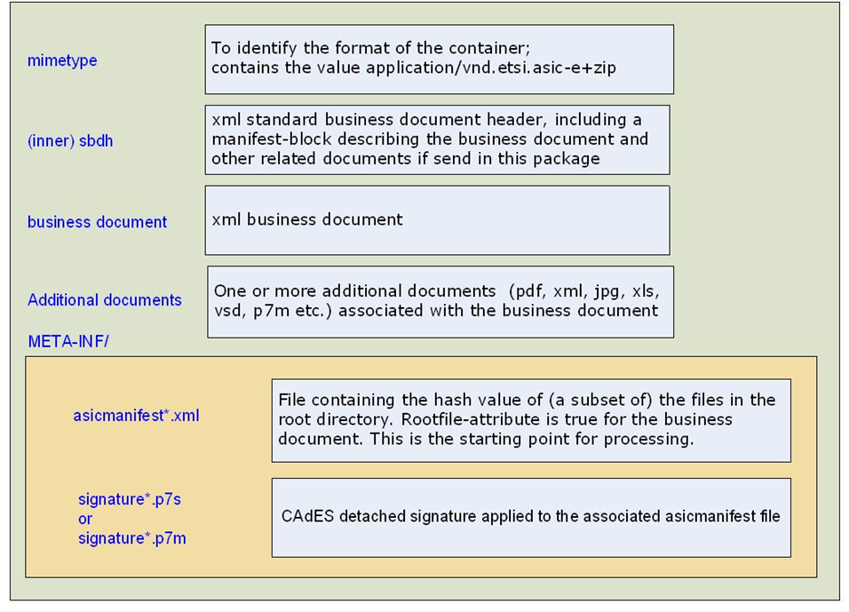
Picture 1: Directory structure of an ASiC-E container with CAdES signature

The container includes the following files:

mimetype
- The purpose of this file is to identify the format of the container.
- Fixed name with the value “application/vnd.etsi.asic-e+zip”.

sbdh.xml (SBDH)
- Xml file containing the standard business document header.
- It includes manifest-block for describing the business document and other related documents.
- All files except mimetype (having fixed name and value) and sbdh will be described in the manifest block.

Business documents
- Xml file containing the business document.₊

Additional documents
- One or more documents of different types e.g. xml, pdf, jpg, xls, p7m and vsd associated with the business document and that needs to be signed.
- Files which are signed and encrypted has extension p7m.

META-INF/asicmanifest*.xml
- One or more files containing the hash values of all the documents (except mimetype) or the hash values of a subset of the data objects.
- If Rootfile attribute present and set to "true" it specify how to begin processing the container. The rootfile is the business document to be processed e.g. biitrdm082.xml.
- If one or more documents needs to be signed separately than the name should be suffixed by a number starting with 1.

Example: asicmanifest1.xml, asicmanifest2.xml etc.

META-INF/signature*.p7s
- One or more files containing the signature of the asicmanifest*.xml.
- If one or more documents needs to be signed separately than the name should be suffixed by a number starting with 1 e.g. signature1.xml, signature2.xml etc.
- For each asicmanifest*.xml file exactly one associated signature file must be present.

The sub directory META-INF includes an optional file manifest.xml, containing an overview of the files in the main directory of the container (except the mimetype).

Additional rules
For the implementation of the transactions the following additional rules are implied:
- Exactly one asicmanifest.xml and consequently one signature.xml file will be used.
- In asicmanifest.xml the hash value of all the files, except mimetype will be calculated and stored.
- For calculating the hash value sha256 hash algorithm will be used.
- The mimetype, sbdh, business document, asicmanifest and the signature are not encrypted.
- Additional documents can be encrypted depending on the content of the document
- When encryption is required, each document is encrypted separately.

ASiC-E example
The picture below shows an example content of an ASiC-E container
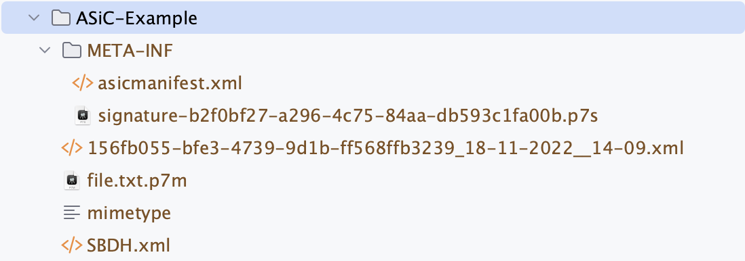
Where signature-b2f0bf27-a296-4c75-84aa-db593c1fa00b.p7s is the detached signature of the asicmanifest.xml.
The content of the asicmanifest.xml file is as follows:
<?xml version="1.0" encoding="utf-8"?>
<ASiCManifest xmlns="http://uri.etsi.org/02918/v1.2.1" xmlns:xmldsig="http://www.w3.org/2000/09/xmldsig" >
<SigReference
URI="META-INF/signature-b2f0bf27-a296-4c75-84aa-db593c1fa00b.p7s"
MimeType="application/x-pkcs7-signature"
/>
<DataObjectReference
URI="SBDH.xml"
MimeType="application/xml"
>
<xmldsig:DigestMethod Algorithm="http://www.w3.org/2001/04/xmlenc#sha256""/>
<xmldsig:DigestValue>s+T1hLcDaaXBLNdV0/lACe7CdlhNh2BMVvQDuQc9gQo=</xmldsig:DigestValue>
</DataObjectReference>
<DataObjectReference
URI="file.txt.p7m"
MimeType="application/pkcs7-mime"
>
<xmldsig:DigestMethod Algorithm="http://www.w3.org/2001/04/xmlenc#sha256"/>
<xmldsig:DigestValue>bMX3M6FUnBbUI9MXeDfgf3w54WahnqdcreYRFrw/s9s=</xmldsig:DigestValue>
</DataObjectReference>
<DataObjectReference
URI="156fb055-bfe3-4739-9d1b-ff568ffb3239_18-11-2022__14-09.xml"
MimeType="application/xml"
Rootfile="true"
>
<xmldsig:DigestMethod Algorithm="http://www.w3.org/2001/04/xmlenc#sha256"/>
<xmldsig:DigestValue>Z+Yk+5AKVpnt+D/st6bkc0C5l1rFPUbDBJc5ebzTlJc=</xmldsig:DigestValue>
</DataObjectReference>
</ASiCManifest>

The SigReference tag points to the detached signature of this asicmanifest.xml.
The DataObjectRefernece tags are pointing to the documents within the container. The DataObjectRefernece with an attribute Rootfile=”true” identifies the business document.
To generate an ASiC-E easily the library no.difi.commons:commons-asic of DigDir can be used.

ASiC signing
Signing values
Protocol | Algorithm | KeySize | HASH | Reference
CADES B-B detached | DS-RSA; PSS (PKCS#1v2.1) | 2048 | SHA-256 | RFC3447, PKCS1, ISO9796-2]

Certificate for signing
type | X.509 V3
CN / Identity holding private key | C1, Tendering Service Provider  Legal Person
Sign / Seal | Sealing, authenticity and integrity  from signature creation time
DATA / Payload | ASiC container; signing encrypted data
Key specs | RSA-2048
Key usage | Signature
extensions | Subject Key Identifier (CMS type 2)
HASH algorithm | SHA-256
PKI | PEPPOL PKI (Pre-award)
Qualified | No
Verifiable / can be validated | YES (PTN PKI)

Encryption of Tender and Qualification documents
The Call For Tenders (CfT) business document is used by the contracting authority to provide an economic operator with the latest updated procurement documents. Besides transporting procurement documents it MUST be used to transport the encryption certificate needed by the economic operator to encrypt his tender or qualification for submission. The method how to include the Encryption Certificates is desribed in T004 - section 5.5. Transport of encryption certificate via the Call For Tenders.

If the CfT business document provided an encryption certificate, the tender documents MUST be encrypted by the economic operator using that certificate.

The examples provided in

- T005 - section 5.2.3 Attached documents and tender encryption
- T019 – section 5.3. Document References and Qualification Encryption

illustrate attached and encrypted tender/qualification documents, its hashs and algorithms. Encrypted tender/qualificaiton documents must use the file extension .p7m in <cbc:Filename></cbc:Filename>.

The attached tender document in the provided example below illustrates how an encrypted and unstructured .pdf file can be referenced in the XML structure.

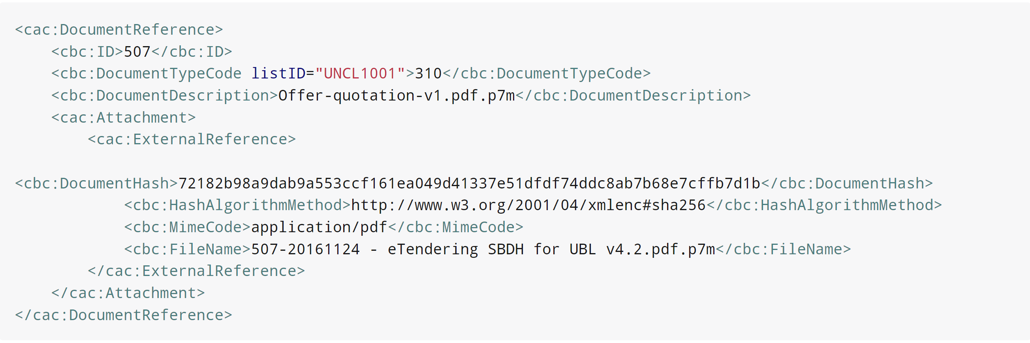

https://spec.cenbii.eu/Tools/documents/BII3-G-TenderSubmission_d10.doc
https://portal.etsi.org/webapp/workprogram/Report_WorkItem.asp?WKI_ID=42455
For more information on encrypting documents see section 6 – Encryption of Tender and Qualification documents
https://github.com/difi/asic
https://www.digdir.no
ENISA allows RSA 2048 (112 bits comparable bit strength) as legacy until 2020
https://docs.peppol.eu/pracc/transactions/T004/index.html
https://docs.peppol.eu/pracc/transactions/T005/index.html
https://docs.peppol.eu/pracc/transactions/T019/index.html

