


Specification



Project Acronym: | PEPPOL
Grant Agreement number: | 224974
Project Title: | Pan-European Public Procurement Online
Pre Award - eCAT
ICT - Models

PEPPOL PPS Implementation
Software Requirements Specification

Version: 1.0.1
Status: In use

Editors:
Giancarlo De Stefano (Consip)
Leonardo Bertini (Consip)
Andrea Leutgeb ( BBG)
Mathias Richter (Paradine)

Project co-funded by the European Commission within the ICT Policy Support Programme
Dissemination Level
P | Public | X
C | Confidential, only for members of the consortium and the Commission Services
Revision History

Revision | Date | Author | Organisation | Description
0.1 | 03/08/2010 | Mathias Richter | Paradine | Initial Version
0.2 | 06/08/2010 | Mathias Richter | Paradine | Reworked during meeting at BBG on 5th Aug 2010 [1] / incorporated requested changes
0.3 | 02/09/2010 | Mathias Richter | Paradine | Rework according to comments sent from BBG on 2nd Sep 2010
0.4 | 06/09/2010 | Mathias Richter | Paradine | Edited during Web Meeting on 3rd Sep 2010 [4]/worked in requested changes
1.0.0 | 10/09/2010 | Andreas Leutgeb | BBG | Signed of on behalf of BBG on 8th Sep 2010 /no veto against implementation start from Coinsip, Difi and ADETEF received on 9th Sep 2010
1.0.1 | 30/06/2012 | Giancarlo De Stefano | Consip | Edited to fit front page with Release 4 of PEPPOL EIA

Statement of originality

This deliverable contains original unpublished work except where clearly indicated otherwise. Acknowledgement of previously published material and of the work of others has been made through appropriate citation, quotation or both.
Statement of copyright
This deliverable is released under the terms of the Creative Commons Licence accessed through the following link: http://creativecommons.org/licenses/by/3.0/.

In short, it is free to
Share — to copy, distribute and transmit the work
Remix — to adapt the work
Under the following conditions
Attribution — You must attribute the work in the manner specified by the author or licensor (but not in any way that suggests that they endorse you or your use of the work).
Contributors

Organisations
Consip, Italy, http://www.eng.consip.it/on-line/en/Home.html
BBG, Bundesbeschaffung GmbH Austria, www.bbg.gv.at
ANCP, Agencia Nacional de Compras Publicas, http://www.ancp.gov.pt/EN/ANCP/PAGES/HOME.ASPX
Paradine www.paradine.eu

Persons
Giancarlo De Stefano (Consip)
Leonardo Bertini (Consip)
Andrea Leutgeb (BBG)
Matthias Richter (Paradine)

Table of Contents

1 Introduction 6
1.1 Purpose 6
1.2 Scope 6
1.3 Definitions 6
1.4 Abbreviations 8
1.5 References 8
2 Overall Description 9
2.1 Background Information 9
2.2 Business Objects 10
2.3 Assumptions and Dependencies 12
3 Use-Case Specifications 13
3.1 Use-Case Model Survey 13
3.2 Roles 23
3.3 Role Based Permissions 24
3.4 Business Use Cases 24
3.5 Workflows 25
4 Functional Requirements 26
4.1 FR01 – User and groups 26
4.2 FR02 – Basic Browsing 27
4.3 FR03 – Search 27
4.4 FR04 – Structure Elements 27
4.5 FR05 – View Templates 28
4.6 FR06 – Structure Templates 29
4.7 FR07 – Out of scope setting 29
4.8 FR08 – Web Services 29
4.9 FR09 – Languages 30
4.10 FR10 – Indication of additional information in tree 31
4.11 FR11 – Token for Copy & Paste 31
4.12 FR12 – Obtaining content of identifiers 31
4.13 FR13 – Versioning 31
4.14 FR14 – Maintenance of multiple supplier codes 32
4.15 FR15 – Special group type “CA group” 32
5 Architectural Requirements 33
5.1 AR01 – WebPortal 33
6 Data Load Requirements 34
6.1 DR01 – Data Load of eCl@ss Version 6.2.1 34
7 Usability Requirements 35
7.1 UR01 – Customization of languages 35
7.2 UR02 – Reference Browser 35
7.3 UR03 – Customization of user interface 35
7.4 UR04 – Menu interface 36
7.5 UR05 – customization of CAs 36
7.6 UR06 – customization of CA groups 36
8 Reliability Requirements 37
8.1 RR01 – Standard Service for production system 37
8.2 RR02 – Backup of production system 37
8.3 RR03 – Maintenance Windows for Deployments 37
9 Performance Requirements 39
10 Supportability Requirements 40
10.1 SR01 – System instances 40
10.2 SR02 – Monitoring 40
10.3 SR03 – Maintenance Book 40
10.4 SR04 – Data Load Book 40
11 Design Constraints 41
11.1 DC01 – Support for multiple portal languages 41
11.2 DC02 – Support for multiple content languages 41
11.3 DC03 – Security 41
12 Quality Requirements 42
13 Documentation Requirements 43
13.1 Online User Documentation 43
13.2 Help System Requirements 43
14 Installation Requirements 44
15 Purchased Components 45
16 Interfaces 46
16.1 User Interfaces 46
16.2 Hardware Interfaces 48
16.3 Software Interfaces 49
16.4 Communications Interfaces 49
17 Licensing Requirements 50
17.1 eCl@ss licensing requirements 50
17.2 eptosTM licensing requirements 50
17.3 Other PEPPOL releated licenses / patents 50
18 Legal, Copyright and Other Notices 51
19 Applicable Standards 52

Introduction

Purpose
This Software Requirements Specification provides a complete description of all the functions and specifications of the PEPPOL Property Server (PPS). The PPS is an on line data base that allows the eCatalogue users to access, search, design and “copy and paste” products and services classification codes and standardized properties into an eCatalogue Template or an eCatalogue Tender. During the PEPPOL project timespan, this service has been delivered by PEPPOL Project in cooperation with eCl@ss (www.eclass-serviceportal.com ) a non-profit organization partner of the Federal Ministry of Economics and Technology within the context of the "eCl@ss for small and medium-sized enterprises".
The expected audience of this document is members of PEPPOL project team and the developers of the system.
This Software Requirements Specification is a requirements agreement between Paradine and PEPPOL.

Scope
It is in scope of this document to describe:
- A web bases eptos4TM portal to view, use and manage structure elements from eCl@ss as well as own PEPPOL structure elements
- Web Services to access the product property server’s content
- Customization of content in a multilingual environment
Out of scope are:
- Defining file export of structure elements and naming templates
- Defining transaction updates
- Defining valuations (explicit values for properties, either requested or contained in catalogue) or
Ranges are stored in eCatalogue Management Tool and are thus out of scope of the PPS server
application

Definitions

1.3.1 Assembly
A set of items that have a relationship to each other apart from being members of the same set [ISO 10303-227:2005]

COMMENT
assemblies consist of components and relationships between them

Note
In PPS assemblies are modeled via so called structure templates.

1.3.2 Component

an item that may be part of another item [ISO 10303-227:2005]

NOTE1
components can be removed and replaced (cf. ISO6527:1982)

NOTE2
for specific applications, components do get treated as separate items

NOTE3
components provide functionality to their assembly (cf. ISO 18435-1:2009)

EXAMPLE
A laptop, composed of several components, e.g.: CPU, memory, display, storage, … that can be replaced, e.g. hard disk vs. another hard disk vs. SSD that provide functions, e.g. storage capacity 128 GiB to the laptop
1.3.3 Contracting Authority (CA)
State, regional or local authorities, bodies governed by public law, associations formed by one or several of such authorities or one or several of such bodies governed by public law.
Source of definition: Procurement Directive 2004/18/EC
Note: under http://ec.europa.eu/internal_market/publicprocurement/authorities_en.htm a current list of CAs is available:

1.3.4 International registration data identifier (IRDI)
machine tractable code defined in ISO/IEC 11179-5, consisting of parts to hierarchically describe the source of a concept definition (see AS01), a part to identify the type of concept, a unique code and a version number.
Note: There also exists a more human readable representation of parts of the IRDI that is also unique for
each type of concept any may be used for display. For examples see subsection on “versioning” below.

1.3.5 Versioning

a process of systematically assigning labels to their description variants (so called “Versioning”). The versioning scheme applied for elements (that are identified by a certaion code) consists of
- a numeric label used to distinguish description variants of the same code (so called “version number”) and
- a numeric label used to distinguish description variants of the same version number (so called “revision number”).

Example:
A description variant of a property namend “Length” defined by PEPPOL may be fully identified by e.g:
PEPPOL-AAA123-001.002:
PEPPOL – human readable designation of the originator of the element (“supplier”)
AAA123 – unique code assigned to a certain property
001 – version number
002 – revision number (usually not shown)

Assuming that 1234-1 be the machine tractable code that is assigned by a registration authority identified as 1234 (following ISO 6523) to PEPPOL, the IRDI would look like:
1234-1#02-AAA123#2:
1234-1 – denoting PEPPOL
02 – denoting the element is a property
AAA123 – unique code assigned to a certain property
2 – being a version identifier (that might for example denote “version number 1, revision number 2”)

Dictionary Change Management rules (based on ISO 13584-42) are applied to express in terms of versioning the impact of a change to an element through assignment of:
- a new code: when there is no compatibility retained between the old and the two elements described
- an increased version number: when the new description variants is upward compatible with the
previous description variant
- an increased revision number: when the new description variant is downward compatible with the
previous description variant

Abbreviations
AC – Application Class
CC – Classification Class
PR – Property
SE – Structure Element
VA – Value
VL – Value List
UN – Unit of measure
KW – Keyword
SY – Synonym
VT – View Template

References
[1] MIN of Meeting on 5th Aug 2010 at BBG: https://sp.paradine.at/sites/PEPPOL/PEPPOL-PPSConsulting/
N-Docs/PEPPOL-PPS-Consulting-0005-MIN-SRS-review-2010-08-05.pdf
[2] PEPPOL LOGO: https://sp.paradine.at/sites/PEPPOL/PEPPOL-PPS-Consulting/N-Docs/PEPPOL-PPSConsulting-
0006-PRJ-PEPPOL_Logo_2010.jpg
[3] PEPPOL CD Manual: https://sp.paradine.at/sites/PEPPOL/PEPPOL-PPS-Consulting/N-Docs/PEPPOLPPS-
Consulting-0007-PRJ-PEPPOL_CD_Manual_100802.pdf
[4] MIN of Web Meeting on 3rd Sep 2010: https://sp.paradine.at/sites/PEPPOL/PEPPOL-PPSConsulting/
Shared-Documents/PEPPOL-PPS-Consulting-0009-MIN-Minutes-WebEx-100903_DRAFT.pdf

Overall Description

Background Information

2.1.1 Big Picture

The objective of the PEPPOL (Pan-European Public eProcurement On-Line) project is to set up a pan European pilot solution that, conjointly with existing national solutions, facilitates EU-wide interoperable public eProcurement. The vision of the PEPPOL project is that any company and in particular SMEs in the EU can communicate electronically with any European governmental institution for the entire procurement process.
The final outcome of PEPPOL will be an inter operational environment build upon national systems and infrastructures supporting the full cycle of eProcurement activities.
The pilots that will be developed in PEPPOL will support any economic operator in the EU and the European Economic Area (EEA) to respond to any published public tender notice electronically and to govern the entire procurement process from their own national infrastructure to any another national infrastructure. Thereby PEPPOL will focus on the engagement and participation of SME companies to public eProcurement.

IMMAGINE COI FRECCIONI

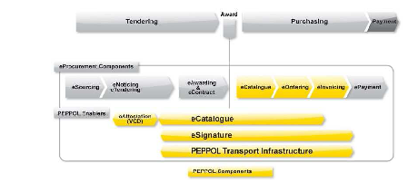

Figure 1:Overview PEPPOL

The broader vision is that any company (incl. SMEs) in the EU can communicate electronically with any EU governmental institution for all procurement processes.

2.1.2 PEPPOL – Workpackage 3 - eCatalogue

(WP3) will define and test solutions to manage eCatalogues to overcome the lack of a standard definition of eCatalogues used in European public procurement procedures that will be used as part of a bid and as a basis for issuing orders.
WP 3 of PEPPOL project shall define standards for electronic catalogues in public procurement. Currently no standards are available. Any national procurement body has an own way of defining product descriptions for a tender or a catalogue.
European public procurement has two major phases for procurement.
1. Pre Awarding phase
During this phase the procurement organization receives a request from a customer to procure some product or service. The procurement body issues a tender for this product or service. Each tender has to include the Common Procurement Vocabulary (CPV) code. The CPV code is the classification system issued by the EU. After the suppliers have sent their offers the award of the tender is given to the best offer. One (or more) supplier(s) get the award.

2. Post Awarding phase
After the supplier won the award the supplier has to deliver an electronic catalogue of the products to the procurement organization. E.g. in Austria this electronic catalogue will be imported in the Eshop of the national procurement organization BBG.
The analysis in the PEPPOL project showed that so far there are no standards to describe products systematically in public procurement throughout Europe.

PEPPOL WP3 took a decision to use eCl@ss classification and product descriptions as a basis for several tenders in the pilot phase. Therefore eCl@ss discussed the possibilities to use eCl@ss content within the PEPPOL pilot phase with eCl@ss e.V. Paradine supported those activities and finally PEPPOL signed a Memorandum Of Understanding with eCl@ss in the beginning of March 2010.
This MOU includes the right for PEPPOL to use eCl@ss content within the PEPPOL pilot phase free of
charge.

In the pilot phase several real tenders shall be processed in the PEPPOL system environment. For selected
tenders product descriptions shall be created according to the ISO 13584 data format based on the existing
eCl@ss properties and classes.

Business Objects

2.2.1 Structure Element

2.2.1.1 Classification Class
class to which no property is assigned
Instead classification classes are used to model a hierarchical (based on subsumption) classification schema. For the viewer they appear like folders.

Note: In case of eCl@ss the classification schema has always four levels.

2.2.1.2 Application Class
class to which properties can be assigned to describe the class.
In eCl@ss an application class is associated to exactly one classification class at the fourth level of the classification hierarchy and has the same name as this CC.

2.2.1.3 Property
an information that may be represented by a data element type [ISO13584-42]
Note: properties are common to all members of a class, while the value assigned to the individual members of the class may be different and a distinction criterion.

2.2.1.4 Domain
Set of permissible values

2.2.1.5 Unit of Measure
reference quantity chosen from a unit equivalence group [adapted from ISO 31-0, 2.1]

2.2.1.6 Value
Data that can be assigned to an attribute to denote some meaning

2.2.1.7 Synonym
String denoting the same meaning as another string
Note: synonyms can be assigned to classification classes, application classes and properties

2.2.1.8 Keyword
String used as an alternative access path to a certain piece of information
Note: keywords can be assigned to classification classes and application classes.

2.2.2 Templates
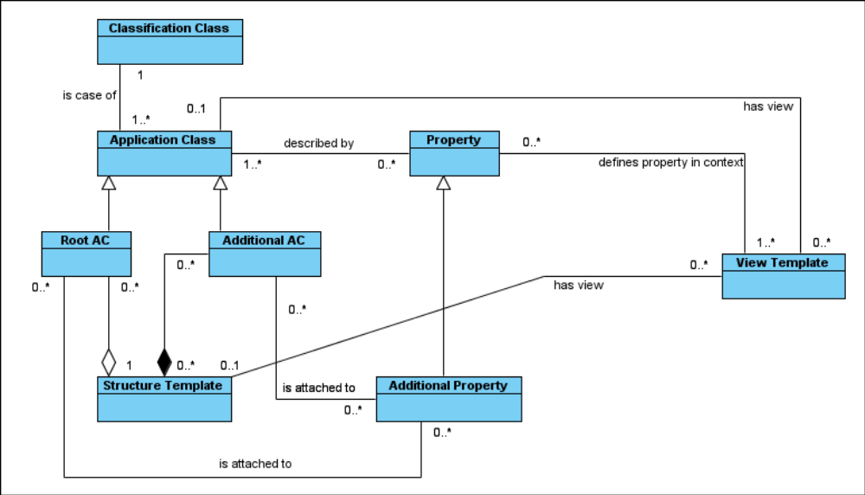
Figure 1: View and Structure Template

Structure templates serve for building a knowledge model out of ACs and properties. Structure template can be found:
- Under a classification class in tree (defined by the root AC of the the structure template)
- Under search
- As a list

View templates serve for restricting, ordering and amending the elements of an application class or structure template. View templates can be found:
- Under an application class in tree
- Under a structure template in tree
- Under search
- As a list

2.2.3 C&P-Token
To support BU01 a globally unique token is used as a temporary pointer to the template the user modified and selected for copying.
Note: (add explaination on create persistant ID on paste)

Assumptions and Dependencies

2.3.1 AS01 – Supplier Code for PEPPOL elements
All Identifiers generated in the PEPPOL PPS Server, will be generated with the supplier set according to the CA group the editing user is in. This means that four suppliers will be generated, each of them needing a human readable representation (like “PEPPOL”) and a machine tractable code (like “1234-1”), the registration authority identifier

2.3.2 AS02 – Treatment of Aspects

Certain properties of application classes within eCl@ss are not assigned directly to the application class, but instead via a so called aspect; this will become especially relevant in eCl@ss 7. In eCl@ss 6 CSV export aspects are ignored and the properties from the aspect therefore are treated as if they were directly connected to the application class. For the purpose of PEPPOL PPS an analogous procedure is chosen.

2.3.3 AS03 – No management workflow for elements

It is assumed that no management workflow is implemented for elements. This means that upon saving of an element a structure element of template is generated by the system without further human interaction.

2.3.4 AS04 – No single sign-on between eCatalogue Management Tool and PPS portal

There is no single sign-on between the eCatalogue Management Tool and the PPS portal. Yet, each user of the eCatalogue Management Tool is supposed to have a unique endpoint identifier and a PPS portal user account.

2.3.5 AS05 – Assignment of users to a group per CA

For each CA there is defined a group in which all users from this CA are member in.

Use-Case Specifications

Use-Case Model Survey

3.1.1 UC01 – User and groups

Under “user and groups” all user account and group management relevant use cases are handled.

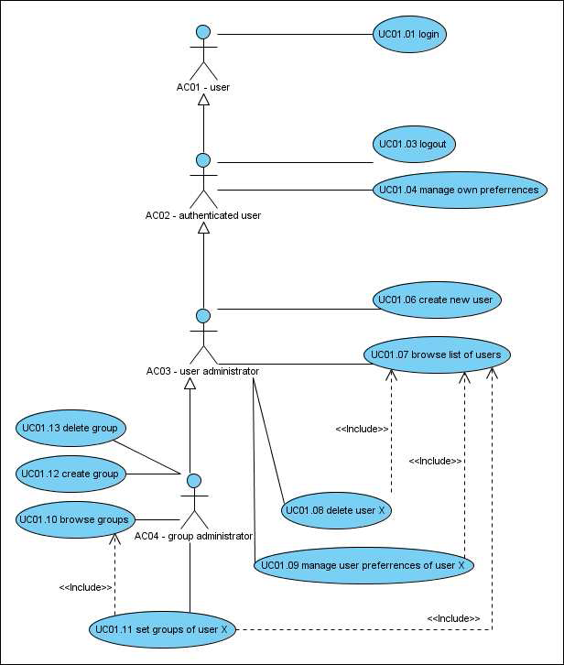FiguFigure 2:UC01 - User and groups

3.1.1.1 Use cases

3.1.1.1.1 UC01.01 – Login
User supplies user name and password to login.

3.1.1.1.2 UC01.03 – Logout
Authenticated user ends current session by logout.

3.1.1.1.3 UC01.04 – manage own preferences
Authenticated user changes details and settings of own account.

3.1.1.1.4 UC01.06 – create user
User administrator creates user account for someone else by supplying required details to the system.

3.1.1.1.5 UC01.07 – browse list of users
User administrator browses the list of users.

3.1.1.1.6 UC01.08 – delete user X
User administrator browses the list of users and selects a certain user for deletion.

3.1.1.1.7 UC01.09 – manage user preferences of user X
User administrator chooses a user from list of users and changes their settings.

3.1.1.1.8 UC01.10 – browse groups
Group administrator browses the list of groups.

3.1.1.1.9 UC01.11 – set groups of user X
Group administrator chooses a user from list of groups or users and changes their group memberships.

3.1.1.1.10 UC01.12 – create group
Group administrator creates a new group

3.1.1.1.11 UC01.13 – delete group
Group administrator deletes an existing group.
Note: “guest” group cannot be chosen for deletion.

3.1.1.2 Actors

3.1.1.2.1 AC01 – User
Somebody accessing the system on before login and after logout.

3.1.1.2.2 AC02 – authenticated user
By logging in a user can become authenticated user.

3.1.1.2.3 AC03 – user administrator
User administrator is an authenticated user who can manage details of other people’s accounts.
Note: one user administrator per PEPPOL participant (eg. BBG, Consip, …) will be specified.

3.1.1.2.4 AC04 – group administrator
Group administrator is a user administrator who can manage groups and user-groups relationship.

3.1.2 UC02 – Browsing and Search
Under “browse and search” all use cases related to searching elements and viewing elements or collections
of elements are handled
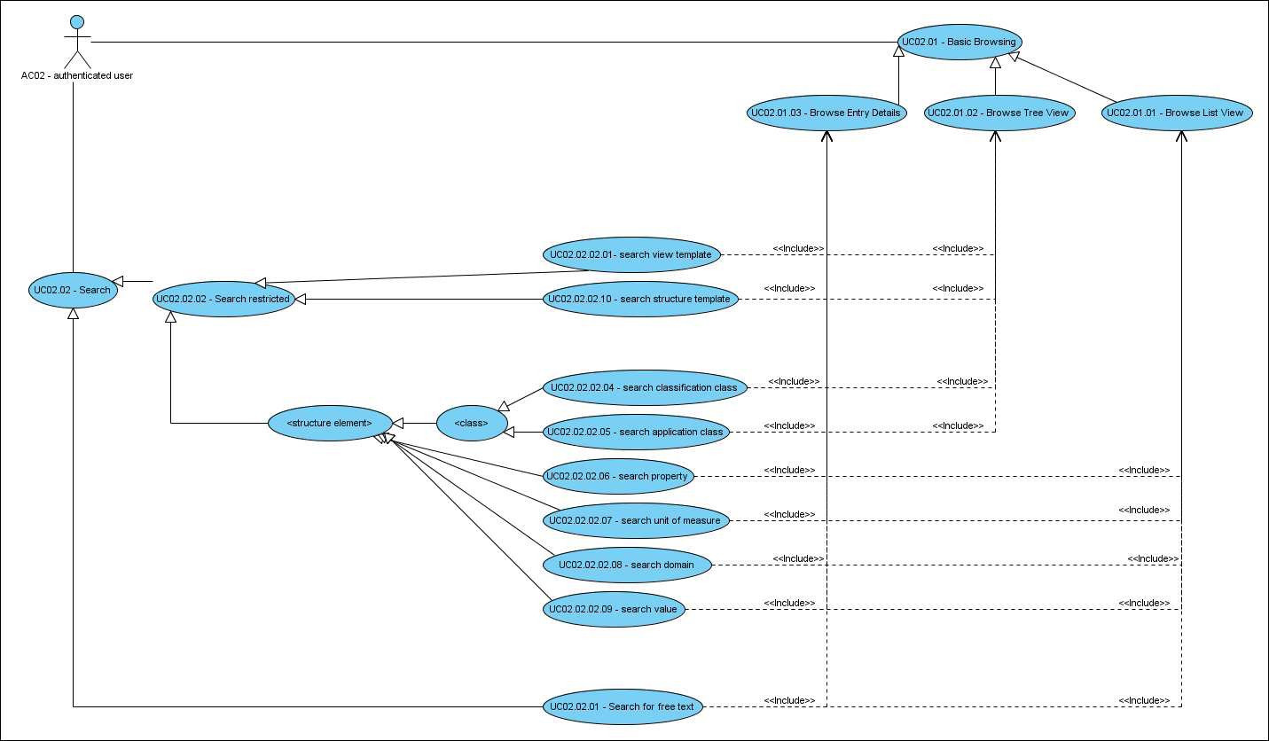

Figure 3 - UC02 Browsing and Searching

3.1.2.1 Use cases

3.1.2.1.1 UC02.01 – Basic Browsing

3.1.2.1.1.1 UC02.01.01 – Browse List View
Authenticated user sees a paginated list of elements.

3.1.2.1.1.2 UC02.01.02 – Browse Tree View
Authenticated user sees the expandable classification tree with attached other elements.

3.1.2.1.1.3 UC02.01.03 – Browse Entry Details
Authenticated user sees the elements details (attributes, values).

3.1.2.1.2 UC02.02 – Search

3.1.2.1.2.1 UC02.02.01 – Search for free text
Authenticated user enters a string to be searched in any attribute of any element.

3.1.2.1.2.2 UC02.02.02 – Search restricted

3.1.2.1.2.3 UC02.02.02.01 – Search view template
Authenticated user enters a string to be searched in textual fields of view template.

3.1.2.1.2.4 UC02.02.02.10 – Search structure template
Authenticated user enters a string to be searched in textual fields of structure template.

3.1.2.1.2.5 UC02.02.02.04 – Search classification class
Authenticated user enters a string to be searched in textual fields of classification class.

3.1.2.1.2.6 UC02.02.02.05 – Search application class
Authenticated user enters a string to be searched in textual fields of view application class.

3.1.2.1.2.7 UC02.02.02.06 – Search property
Authenticated user enters a string to be searched in textual fields of view property.

3.1.2.1.2.8 UC02.02.02.07 – Search unit of measure
Authenticated user enters a string to be searched in textual fields of view unit of measure.

3.1.2.1.2.9 UC02.02.02.08 – Search domain
Authenticated user enters a string to be searched in textual fields of view domain.

3.1.2.1.2.10 UC02.02.02.09 – Search value
Authenticated user enters a string to be searched in textual fields of view value.

3.1.2.2 Actors

Browsing and searching is available to all authenticated users (AC02).

3.1.3 UC03 – Manage Structure Elements
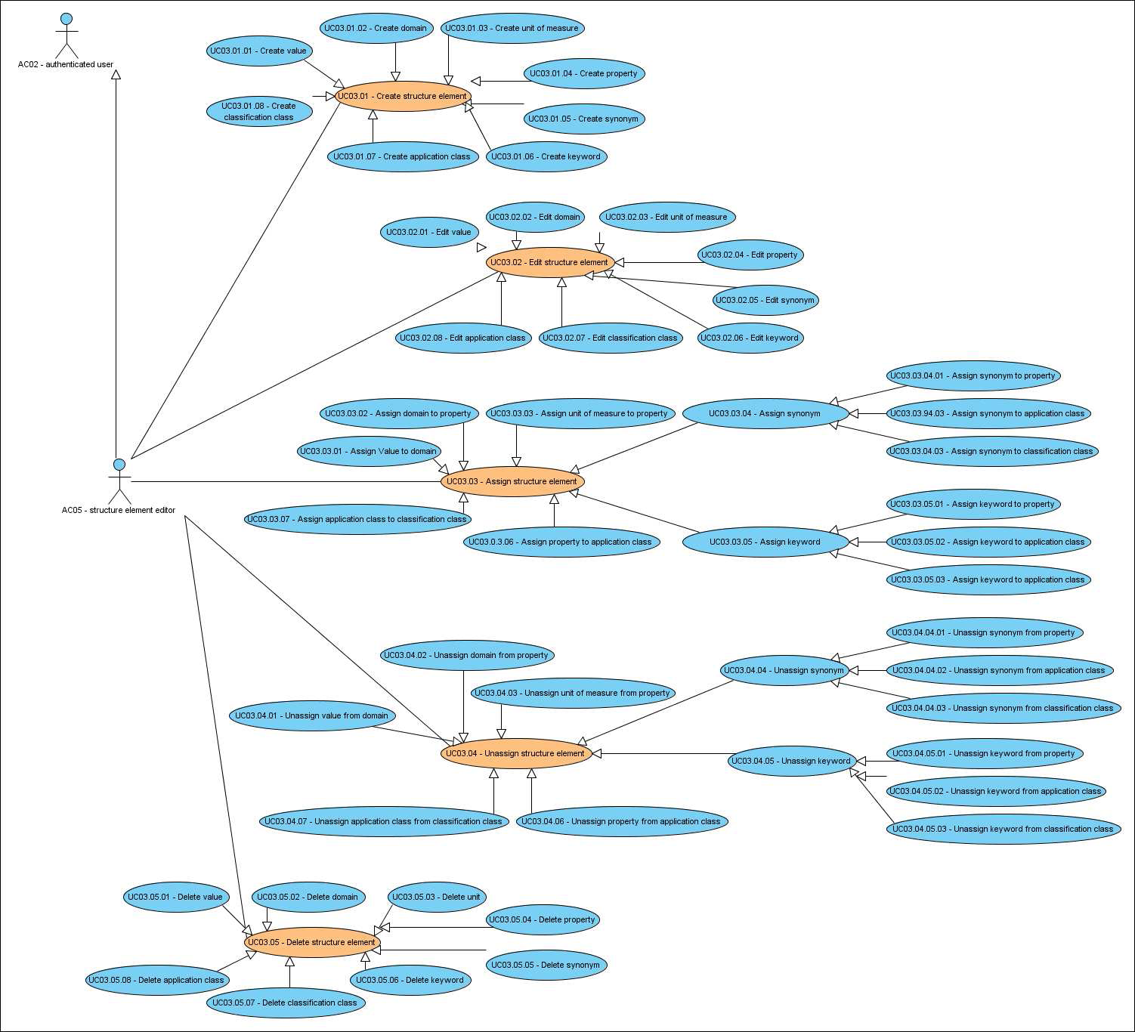
Figure 4: Manage Structure Elements (main use cases highlighted)

3.1.3.1 Use cases

3.1.3.1.1 UC03.01 – Create structure element

3.1.3.1.1.1 UC03.01.01 – Create value
Structure element editor selects create value, enters the mandatory attributes of the value and saves.

3.1.3.1.1.2 UC03.01.02 – Create domain
Structure element editor selects create domain, enters the mandatory attributes of the domain and saves.

3.1.3.1.1.3 UC03.01.03 – Create unit of measure
Structure element editor selects create unit of measure, enters the mandatory attributes of the unit of measure and saves.

3.1.3.1.1.4 UC03.01.04 – Create property
Structure element editor selects create property, enters the mandatory attributes of the property and saves.

3.1.3.1.1.5 UC03.01.05 – Create synonym
Structure element editor selects create synonym, enters the mandatory attributes of the synonym and saves.

3.1.3.1.1.6 UC03.01.06 – Create keyword
Structure element editor selects create keyword, enters the mandatory attributes of the Keyword and saves.

3.1.3.1.1.7 UC03.01.07 – Create classification class
Structure element editor chooses a parent for the to be created classification class from tree, enters the mandatory attributes of the value and saves.

3.1.3.1.1.8 UC03.01.08 – Create application class
Structure element editor chooses a parent for the to be created application class from tree, enters the mandatory attributes of the value and saves.

3.1.3.1.2 UC03.02 – Edit structure element
Note: Performing assignments / unassignments is described in another use case.

3.1.3.1.2.1 UC03.02.01 – Edit value
Structure element editor selects a value from list, modifies the attributes of the value and saves.

3.1.3.1.2.2 UC03.02.02 – Edit domain
Structure element editor selects a domain from list, modifies the attributes of the domain and saves.

3.1.3.1.2.3 UC03.02.03 – Edit unit of measure
Structure element editor selects a unit of measure from list, modifies the attributes of the unit of measure and saves.

3.1.3.1.2.4 UC03.02.04 – Edit property
Structure element editor selects a property from list, modifies the attributes of the property and saves.

3.1.3.1.2.5 UC03.02.05 – Edit synonym
Structure element editor selects a synonym from list, modifies the attributes of the synonym and saves.

3.1.3.1.2.6 UC03.02.06 – Edit keyword
Structure element editor selects a keyword from list, modifies the attributes of the keyword and saves.

3.1.3.1.2.7 UC03.01.07 – Edit classification class
Structure element editor selects a classification class from tree, modifies the attributes of the classification class and saves.

3.1.3.1.2.8 UC03.01.08 – Edit application class
Structure element editor selects an application class from tree, modifies the attributes of the application class
and saves.

3.1.3.1.3 UC03.03 – Assign structure element

3.1.3.1.3.1 UC03.03.01 – Assign value to domain
Structure element editor selects domain from list, assigns value(s) and saves.

3.1.3.1.3.2 UC03.03.02 – Assign domain to property
Structure element editor selects property from list, assigns domain and saves.

3.1.3.1.3.3 UC03.03.03 – Assign unit of measure to property
Structure element editor selects property from list, assigns a unit of measure and saves.

3.1.3.1.3.4 UC03.03.04 – Assign synonym

3.1.3.1.3.4.1 UC03.03.04.01 – Assign synonym to property
Structure element editor selects property from list, assigns synonym(s) and saves.

3.1.3.1.3.4.2 UC03.03.04.02 – Assign synonym to application class
Structure element editor selects application class from tree, assigns synonym(s) and saves.

3.1.3.1.3.4.3 UC03.03.04.03 – Assign synonym to classification class
Structure element editor selects classification class from tree, assigns synonym(s) and saves.

3.1.3.1.3.5 UC03.03.05 – Assign keyword

3.1.3.1.3.5.1 UC03.03.05.01 – Assign keyword to property
Structure element editor selects property from list, assigns keyword(s) and saves.

3.1.3.1.3.5.2 UC03.03.05.02 – Assign keyword to application class
Structure element editor selects application class from tree, assigns keyword(s) and saves.

3.1.3.1.3.5.3 UC03.03.05.03 – Assign keyword to classification class
Structure element editor selects classification class from tree, assigns keyword(s) and saves.

3.1.3.1.3.6 UC03.03.06 – Assign property to application class
Structure element editor selects application class from tree, assigns property(s) and saves.

3.1.3.1.3.7 UC03.03.07 – Assign application class to classification class
Structure element editor selects classification class from tree, assigns application class(es) and saves.

3.1.3.1.4 UC03.04 – Unassign structure element
Note: Performing unassignments leads to setting of elements to deprecated, except for synonyms and keywords this may have undesired side effects on new valuations via assignments.

3.1.3.1.4.1 UC03.04.01 – Unassign value from domain
Structure element editor selects domain from list and chooses which value(s) shall be unassigned.

3.1.3.1.4.2 UC03.04.02 – Unassign domain from property
Structure element editor selects property from list and chooses whether domain shall be unassigned.

3.1.3.1.4.3 UC03.04.03 – Unassign unit of measure from property
Structure element editor selects property from list and chooses whether unit shall be unassigned.

3.1.3.1.4.4 UC03.04.04 – Unassign synonym

3.1.3.1.4.4.1 UC03.04.04.01 – Unassign synonym from property
Structure element editor selects property from list and chooses which synonym(s) shall be unassigned.

3.1.3.1.4.4.2 UC03.04.04.02 – Unassign synonym from application class
Structure element editor selects application class from tree and chooses which synonym(s) shall be unassigned. 3.1.3.1.4.4.3 UC03.04.04.03 – Unassign synonym from classification class Structure element editor selects classification class from tree and chooses which synonym(s) shall be unassigned.

3.1.3.1.4.5 UC03.04.05 – Unassign keyword

3.1.3.1.4.5.1 UC03.04.05.01 – Unassign keyword from property
Structure element editor selects property from list and chooses which keyword(s) shall be unassigned.

3.1.3.1.4.5.2 UC03.04.05.02 – Unassign keyword from application class
Structure element editor selects application class from tree and chooses which keyword(s) shall be unassigned.

3.1.3.1.4.5.3 UC03.04.05.03 – Unassign keyword from classification class
Structure element editor selects classification class from tree and chooses which keyword(s) shall be unassigned.

3.1.3.1.4.6 UC03.04.06 – Unassign property from application class
Structure element editor selects application class from tree and chooses which propertiy(s) shall be unassigned.

3.1.3.1.4.7 UC03.04.09 – Unassign application class from classification class
Structure element editor selects classification class from tree and chooses which application class(es) shall be unassigned.

3.1.3.1.5 UC03.05 – Delete structure element
Note: Setting elements (except for synonyms and keywords) to deprecated may have undesired side effects on new valuations via assignments.

3.1.3.1.5.1 UC03.05.01 – Delete value
Structure element editor selects value(s) from list and confirms that these shall be deleted. The system sets the value(s) to deprecated.

3.1.3.1.5.2 UC03.05.02 – Delete domain
Structure element editor selects domain(s) from list and confirms that these shall be deleted. The system sets the domain(s) to deprecated.

3.1.3.1.5.3 UC03.05.03 – Delete unit of measure
Structure element editor selects unit(s) of measure from list and confirms that these shall be deleted. The system sets the unit(s) of measure to deprecated.

3.1.3.1.5.4 UC03.05.04 – Delete property
Structure element editor selects property(s) from list and confirms that these shall be deleted. The system sets the property(s) to deprecated.

3.1.3.1.5.5 UC03.05.05 – Delete synonym
Structure element editor selects synonym(s) from list and confirms that these shall be deleted. The system sets the synonym(s) to deprecated.

3.1.3.1.5.6 UC03.05.06 – Delete keyword
Structure element editor selects keyword(s) from list and confirms that these shall be deleted. The system sets the keyword(s) to deprecated.

3.1.3.1.5.7 UC03.05.07 – Delete classification class
Structure element editor selects classification class from tree and confirms that these shall be deleted. The system sets the classification class to deprecated.

3.1.3.1.5.8 UC03.05.08 – Delete application class
Structure element editor selects application class from tree and confirms that these shall be deleted. The system sets the application class to deprecated.

3.1.3.2 Actors

3.1.3.2.1 AC05 – Structure element editor
Content editor is an authenticated user that may create new structure elements and edit existing structure elements.

3.1.4 UC04 – Manage View Templates
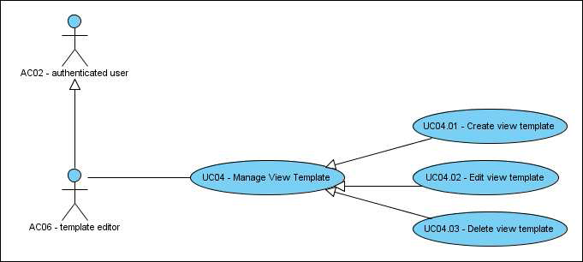
Figure 5: UC05 - Manage View Templates

3.1.4.1 Use Cases

3.1.4.1.1 UC04.01 – Create view template
Template editor selects an application class or structure template, sets visibility and an order of properties and finally saves her selection as a view template.

3.1.4.1.2 UC04.02 – Edit view template
Template editor selects an existing view template and saves modifications as a replacement of existing or a new template.
Note: In case an existing template is replaced, the original is set to deprecated by the system (so only the modified version remains visible to the user). View templates may only be replaced by users who are in the same CA group as the originating user.

3.1.4.1.3 UC04.03 – Delete view template
Template editor selects existing view template and selects it for deletion. Upon confirmation the system sets the view template as deprecated.

3.1.4.2 Actors

3.1.4.2.1 AC06 – Template editor
Content editor is an authenticated user that may create new templates and edit existing templates.

3.1.5 UC05 – Manage Structure Template
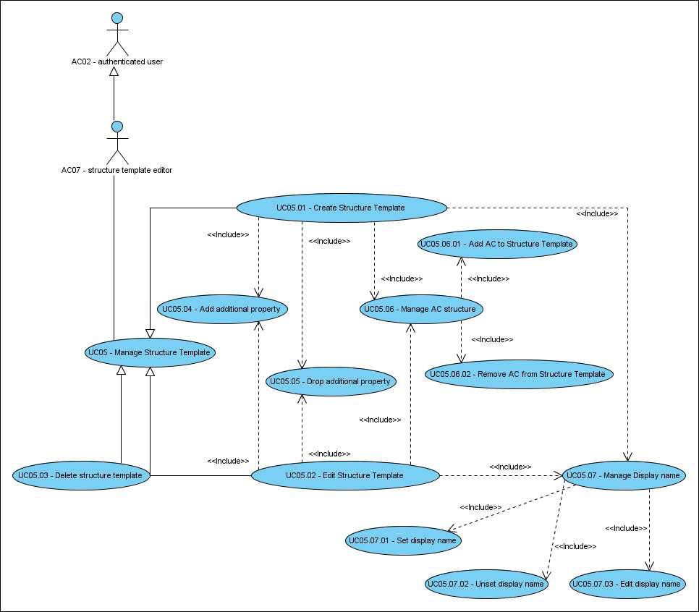
Figure 6: UC05 - Manage Structure Templates

3.1.5.1 Use cases
3.1.5.1.1 UC05.01 – Create Structure Template
Structure Template editor chooses an application class that shall be the main (root) AC for the knowledge model expressed in the structure template. The structure template is placed under the root AC’s classification class. A preferred name for the structure template can be specified. If no preferred name is specified the system creates one based on the name of the AC (adding “template” and an index number).

3.1.5.1.2 UC05.02 – Edit Structure Template
Structure template editor chooses a structure template that he would like to edit.
In case structure template editor and original author are in the same CA group (See FR15) the edited structure template may be saved as a successor of the original one, else a new code has to be generated.

3.1.5.1.3 UC05.03 – Delete Structure Template
Structure template editor may chose to delete an existing structure template. The system sets the structure template and also attached view templates to deprecated (i.e. they can be further interpreted but no longer used).

3.1.5.1.4 UC05.04 – Add additional property
Structure template editor may chose to enrich any AC contained in the knowledge model that is expressed by in the structure template by additional properties. The property is added to the structure template, not to the original AC.

3.1.5.1.5 UC05.05 – Drop additional property
Structure template editor may chose to remove an additional property from the structure template.
Note 1: this works only with additional properties and creates a new code for the structure template.
Note 2: any undesired property can be hidden without a side effect on the structure template via the view template.

3.1.5.1.6 UC05.06 – Manage AC structure
3.1.5.1.6.1 UC05.06.01 – Add AC to structure template
Structure template editor may chose any number of additional ACs and build up a hierarchical structure under the root AC.

Note: Building up the AC structure is equivalent to building up an assembly from it’s components in a topdown manner.

3.1.5.1.6.2 UC05.06.01 – Remove AC from structure template
Structure template editor may chose to remove any number of additional ACs from the hierarchical structure under the root. Removing an AC with children also removes the children.

Note 1: This creates a new code for the structure template.
Note 2: removing the root AC from the structure template is equivalent with UC05.03.

3.1.5.1.7 UC05.07 – Manage Display Name

3.1.5.1.7.1 UC05.07.01 – Set display name
Structure template editor can set for each property in the structure template a name that supersedes the generated preferred name of the property.
Membership in the same CA group as the creator of the structure template means a revision of the structure template is created. Else a new structure template is created.

3.1.5.1.7.2 UC05.07.02 – Edit display name
Structure template editor can edit for each property in the structure template the name that supersedes the generated preferred name of the property.
Membership in the same CA group as the creator of the structure template means a revision of the structure template is created. Else a new structure template is created.

3.1.5.1.7.3 UC05.07.03 – Unset display name
Structure template editor can set back for each property in the structure template the name to the generated preferred name of the property.
Membership in the same CA group as the creator of the structure template means a revision of the structure template is created. Else a new structure template is created.

3.1.5.2 Actors

3.1.5.2.1 AC07 – Structure Template Editor
Structure template editor is an authenticated user that may create new structure templates and edit existing ones.

3.1.6 UC06 – Out of scope setting

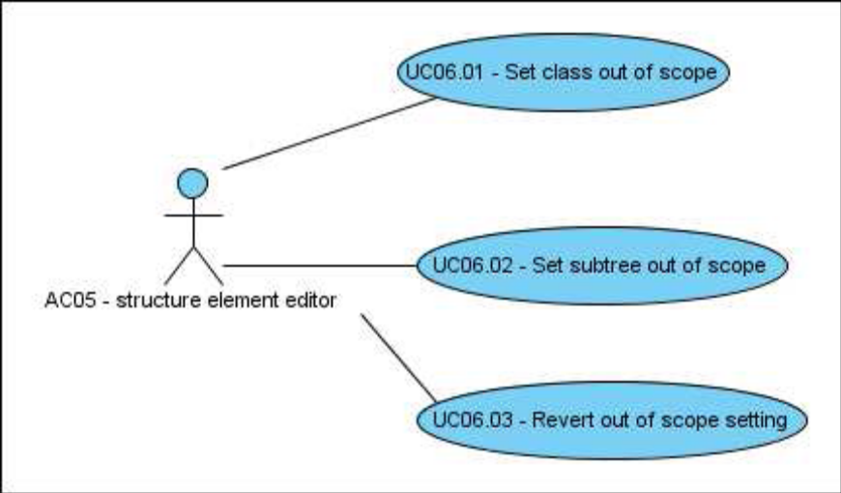
Figure 7: UC06 - Out of scope setting

3.1.6.1 Use cases

3.1.6.1.1 UC06.01 – Set class out of scope
Structure element editor can chose to set a classification class as out of scope for the CA group he is member in. ACs / structure templates under a classification class that is set out of scope can not be accessed by users of that CA group.

3.1.6.1.2 UC06.02 – Set sub-tree out of scope
Structure element editor can chose to set a sub-tree of the classification hierarchy as out of scope for the CA group he is in. CCs / ACs / structure templates under a classification class that is set out of scope can not be accessed by users of that CA group.

3.1.6.1.3 UC06.03 – Revert out of scope setting
Structure element editor can chose to revert an out of scope setting that was done for the CA group he is member in.

Roles
A role is a designation of a business function that will directly allow specific functional permissions within the PEPPOL PPS application. Users may be added to or removed from roles. If user A has role X and is removed and replaced by user B then user B will receive all the permissions associated with role X. Different users having the same role can do the same thing at the same moment.
The following roles will be implemented:
- Administrator
- User Administrator (one per PEPPOL participant: eg. BBG, Consip, …) subsumes AC03 and AC04, so can manage users and their relationship to groups
- Structure Data Editor (AC05)
- Template Editor subsumes AC06 and AC07
- “normal user” – browsing and searching (AC02)
- “Web-Service Access” – (read only) for obtaining templates and information on identified elements
Additionally:
- One gro up per participant into which all users from that participant and only these are member (FR15).

Note: One user must and can not be member in more than one CA group.

Role Based Permissions
Permission to perform certain tasks required membership of a user in a certain user group.

Business Use Cases

3.4.1 BU01 - Copy paste metaphor for interaction with eeCatalogue Management Tool

In the portal user shall be able to select a template and retrieve it with the ECatalogue Management Tool. The token used as a pointer to the user customized template remains valid for the duration of the user’s PPS session.
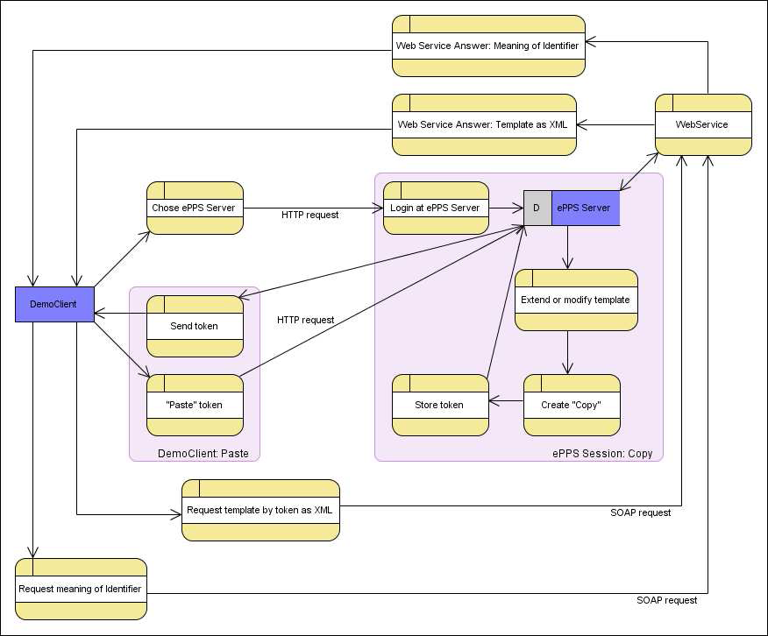
Figure 8: Flow of information for "copy & paste" of view(modified) template

Verbal description of steps:
1. Within the eCatalogue Management Tool a user selects: PPS server
2. User logs into PPS server and navigates to the template
3. User extends / modifies the template
4. User presses <Copy>
5. In the eCatalogue Management Tool user selects <Paste>1
6. eCatalogue Management Tool requests the template (identifiers) as XML file and stores it in the cataloge
7. eCatalogue Management Tool can request the “meaning”2 of the identifiers from the PPS service.

Workflows
Status based workflows for management of database content are out of scope.

Functional Requirements

FR01 – User and groups

4.1.1 FR01.01 – Login
By performing login user becomes an authenticated user and session is started.

4.1.2 FR01.02 – Logout
By performing logout authenticated user has the possibility to end the current session.

4.1.3 FR01.03 – Account

4.1.3.1 FR01.03.01 – account creation
By chosing new user, entering the account details of that user and pressing a save button a new user account can be created. The user is notified automatically by the system via email (given a valid email address is provided by the account creator).

4.1.3.2 FR01.03.02 – account deletion
A sufficiently privileged user can chose to delete a user account. After being prompted for confirmation the personal details of the account are cleared (except for user name) and the account is set to inactive and cannot be reactivated (account is kept just for data consistency reasons).

4.1.4 FR01.04 – preferrence management
Personal details of a user account can be changed (by the user, by a sufficiently privileged person).

4.1.5 FR01.05 – User session
Between Login (see FR01.01) and Logout (see FR01.02) the authorized user has a session in the portal. Within the session certain information may have to be pertained. If an authorized user is inactive for 30 min the session times out automatically and the user has to login again.

4.1.6 FR01.06 – list of users
A paginated list of all active users can be displayed to a sufficiently privileges user from which the details of the accounts can be edited.

4.1.7 FR01.06 – Groups

4.1.7.1 FR01.06.01 – Group creation
A sufficiently privileged user can create new groups.
Note: this will not assign any privileges to the group.

4.1.7.2 FR01.06.02 – Group deletion
On group deletion all connections of users to the deleted group are destroyed.
Note: The “guest” group cannot be deleted, but it may be configured to be hidden.

4.1.7.3 FR01.06.03 – Group browsing
A sufficiently privileged user can browser the list of groups and see which users are members of the individual groups

4.1.8 FR01.07 – Groups and users relationship

4.1.8.1 FR01.07.01 – System group “guest”

Each authenticated user is member of the “guest” group. This group is maintained by the system.

4.1.8.2 FR01.07.02 – user-group-relationship management
A sufficiently privileged user may edit the members of groups and the groups a user is member in.

FR02 – Basic Browsing

4.2.1 FR02.01 – Entry details
Entry details lists all the attributes and values of an element in a tabbed display. The tab and attribute configuration is the same as in the eCl@ss Serviceportal.

4.2.2 FR02.02 – List view
List view shows a table of elements of a certain kind with selected attributes of these elements. The table headers of the list view can be used to sort the list view by the respective attribute. Online customization is out of scope.

4.2.3 FR02.02 – Tree view
Tree view shows an expandable tree structure beginning at a hierarchy node below which the four levels of eCl@ss classification classes unfold. Application classes are connected to the fourth level of the classification classes only. For the applications classes also the properties and their domains can be unfolded in the tree view.

FR03 – Search

4.3.1 FR03.01 – Search for structure elements

4.3.1.1 FR03.01.01 – Search for specific structure elements
A certain type of structure element can be selected and search is restricted to results of that type.

4.3.1.2 FR03.01.02 – Free text search
Free text search shall find all occurrences of the search string

4.3.2 FR03.02 – Search for Templates
Templates can be searched for by name, id and the classification code of the AC they are subsumed by.

4.3.3 FR03.03 – Autocompletion
The restricted search types (for structure element of a certain type, for template) have autocompletion enabled, i.e. when the user starts typing up to 10 available suggestions are presented in a pull-down menu under the input field.

FR04 – Structure Elements

4.4.1 FR04.01 – Creation of PEPPOL structure elements
All new elements created in PEPPOL PPS are PEPPOL structure elements.

4.4.2 FR04.02 – Customization of eCl@ss structure elements
As management of eCl@ss structure elements must only be performed by eCl@ss any extension of an eCl@ss structure element must lead to the creation of a PEPPOL structure element which starts as the clone of the original element and is subject to the modifications and extensions.
The identifier of the original element is recorded with the clone, but keeping detailed track of differences between PEPPOL structure element and original eCl@ss structure element is out of scope.
4.4.3 FR04.03 – Addition of extended attributes to structure elements
PEPPOL may define additional attributes for structure elements which can be added to a certain type of structure element as a so called “extended attribute”. An extended attribute can be used to convey additional data or metadata about a structure element that is not essential to the dictionary (but might be interesting or important for certain users to have). Extended attributes added to a structure element type is not done via a GUI but defined as a supplement to this document. Defining extended attributes is optional.

Note: Adding an extended attribute to a structure element type does not further affect structure elements of
this type, therefore no PEPPOL structure element copies are generated.

4.4.4 FR04.04 –Unassignment and deletion (as deprecation)
In order to keep transactions valid, structure elements, view templates and assignments must never be physically deleted. Instead in case a deletion of a PEPPOL element is intended the system will mark the respective element as deprecated and not show it in the default GUI anymore. Non-visibility of deprecated PEPPOL elements may be overwritten by additional customizations. eCl@ss structure elements cannot be the target of a deletion request as management of eCl@ss structure elements must only be performed by eCl@ss.

4.4.5 FR04.05 – Customized Requirements for Classes
Classes (CC, AC) should function as they do in eCl@ss basic3.

4.4.6 FR04.06 – Customized Requirements for Properties
Properties should function as they do in eCl@ss 6 with the following explicit requirement:
For strings and numeric properties being able to define the length / number of digits is important

FR05 – View Templates

4.5.1 FR05.01 – Search for View Templates
View templates can be searched for just like application classes can.

4.5.2 FR05.02 – Template Requirements

4.5.2.1 FR05.02.01 – mandatory properties per class
A view template defines in the context of an application class or structure template if a given property is mandatory.
Example 1
Class 23110101 has AC with properties:

Property | Property name | Mandatory
BAB341 | threadsize | yes
BAA917 | headshape | yes
BAA997 | threadlength | yes
BAA907 | inner thread | diameter no

4.5.2.2 FR05.02.02 – order of properties per class
A view template defines in the context of an application class or structure template the order of properties. Example 2
Property | Property name | order
BAB341 | threadsize | 1
BAA917 | headshape | 2
BAA997 | threadlength | 3
BAA907 | inner thread diameter | 4

4.5.2.3 FR05.02.03 – Restriction of properties
A view templates defines in the context of an application class or structure template what properties are available.

FR06 – Structure Templates

4.6.1 FR06.01 – Flattening out of structure for presentation
To the view template the structure template shall look like a flat AC.
For the presentation without a defined view template the properties are displayed:
Alphabetically within an AC
ACs are traversed in depth-first-search.

4.6.2 FR06.02 – Automatic generation of display name for properties
Due to the flat nature AC the structure template simulates a clash of property names must be avoided. To cope with this a display name is automatically generated for each property according to the following rules:
If the property is unique for the structure template, the preferred name of the property is taken
If the property is not unique for the structure template a combination of the preferred name of it’s containing AC and the properties’s preferred name is taken

4.6.3 FR06.03 – Identification of elements in the structure template
An element in the structure template can be uniquely located by giving the path of IRDIs traversing the hierarchical AC structure and the IRDI of the property.

FR07 – Out of scope setting

4.7.1 FR07.01 – Out of scope setting of classes
It shall be possible to indicate that a certain class is out of scope for a certain CA (indicated by group membership, see FR15).

4.7.2 FR07.02 – Out of scope setting of class trees
It shall be possible to indicate that a certain part of the class tree as a whole is out of scope for a certain CA (indicated by group membership, see FR15).

FR08 – Web Services
In contrast to the eCatalogue Management Tool which is stateless and uses REST, the Content resolution webservices are stateful and use SOAP.

4.8.1 FR08.01 – ISO 29002-20 WebService
A SOAP webservice accessing the content of the PEPPOL PPS, providing terminology and ontology service as defined in ISO-29002-20:
Terminology Service: search for concepts, languages, and other elements of the dictionary based on
a rich set of keywords, search criteria, and expressions; given an international registration data
identifier (IRDI) in the format defined in ISO/TS 29002-5, retrieve terminological information;
Ontology Service: retrieve ontological information about a concept based on the concept's IRDI.

4.8.2 FR08.02 – ISO 22745-30 WebService
A SOAP webservice accessing the content of the PEPPOL PPS, providing view and structure templates as XML, following the exchange format for identification guides defined in ISO 22745-30.

FR09 – Languages
The user shall have the possibility to set a preferred language separately for portal and content. Default in both cases is English.

4.9.1 FR09.01 – Changeability of portal language

4.9.2 FR09.01.01 – Permanent change of portal language
In their user preferences each user can set an option for portal language that gets used for showing menu and textual content of the page to that user. This preference setting may be overridden (see FR09.01.02) for the current session.

4.9.3 FR09.01.02 – Temporary change of portal language
On each page a user can set an option for a momentary portal language. This setting overrides the permanent choice of the portal language (see FR09.01.01) and lasts until the user’s current session ends.

4.9.4 FR09.02 – Changeability of content language

4.9.5 FR09.02.01 – Permanent change of content language
In their user preferences each user can set an option for content language that gets used for showing structure data to that user. This preference setting may be overridden (see FR09.02.02) for the current session.

4.9.6 FR09.02.02 – Temporary change of content language
On each page a user can set an option for a momentary content language. This setting overrides the permanent choice of the content language (see FR09.02.01) and lasts until the user’s current session ends.

4.9.7 FR09.03 – Translations

4.9.7.1 FR09.03.01 – Translation during creation of structure elemements
When a user has selected another (default) content language than English the interface lets create the user structure elements in English and this language. Optionally content in other languages may be added.

4.9.7.2 FR09.03.02 – Translation of existing elements’ content
Content of existing elements for which no translation has been created in a certain language may be translated by the user. Adding such a translation does not modify the ID of the element. Changing existing content in a certain language creates a new element generation.

4.9.7.3 FR09.03.02 – Display of available translations
When translations of an element into other languages are available these languages shall be indicated.

FR10 – Indication of additional information in tree

4.10.1 FR10.01 – Indication of supplier
In tree view it shall be immediately visible to understand the supplier of a structure element or template (withut having to look into detailed view or list view). Therefore tree nodes can be colored or flagged with an icon indicating a certain supplier (CA).

4.10.2 FR10.02 – Indication of classes with assigned view templates
Classes (application class and the 4th level classification class) which have templates assigned shall be highlighted:
Classes having assigned a template defined by the CA the current member is from in <color> or <icon>
Classes having assigned a template defined by another CA in <color> or <icon>

4.10.3 FR10.03 – Indication of out of scope classes / portions of class tree
When a class or a part of the class tree (see FR07) has been marked as out of scope for a certain CA that class or part of the tree is shown greyed out to the member group of this CA (see FR15).

FR11 – Token for Copy & Paste

4.11.1 FR11.01 – Token provision
Portal user has the possibility to press a button when viewing / editing templates. This expresses the wish that a unique token be generated (valid until end of portal session) that points to the current state of the selected template. The application shows a modal panel showing a message like “Please copy the following token to the eCatalogue Management Tool in order to obtain the template you created:” followed by the token.

Note: The state of the template needs to be preserved for future reference, but not necessarily be visible as a separate template.

4.11.2 FR11.02 – Token resolution
When the eCatalogue Management Tool user pastes the token into the eCatalogue Management Tool, the eCatalogue Management Tool can send a HTTP Request to PPS server to retrieve the denoted view template as XML.

FR12 – Obtaining content of identifiers
Content of elements can be retrieved by querying the SOAP webservice with an identifier (IRDI).

FR13 – Versioning

4.13.1 FR13.01 – Versioning of Structure Elements
Structure elements being assigned a code in PEPPOL PPS are subject to versioning. Any change to eCl@ss elements lead to the assignment of an PEPPOL identifier.

4.13.2 FR13.02 – Versioning of View Templates
Templates are versioned according to the following rules:
Editing by same CA group:
Changing order -> revision number change
Adding property -> version number change
Removing property -> new code
Setting property to mandatory -> version number change
Removing mandatory setting of property -> revision number change
Editing by different CA group: new code

4.13.3 FR13.03 – Versioning of Structure Template
Structure Templates are versioned according to the following rules:
Editing by same CA group:
Change naming of Element: new revision
Add Element: new version
Remove Element: new code
Editing by different CA group: new code

FR14 – Maintenance of multiple supplier codes
The system maintains multiple supplier codes (according to membership the defined CA groups).

FR15 – Special group type “CA group”
A special group type CA group is needed:
Each user may be member of up to one CA group
The CA group influences which elements / templates a privileged user can modify using change management rules
The CA group influences which classes / subtrees are out of scope for a user

Architectural Requirements

AR01 – WebPortal
eptos™ based standard web user interface, which allows online access to the system via internet (7/24 access).

Data Load Requirements

DR01 – Data Load of eCl@ss Version 6.2.1
The Release 6.2.1 of eCl@ss has to be loaded to the PEPPOL PPS Server. No past releases will be loaded, only eCl@ss 6.2.1.
Content in the following languages (ISO 639-1 code) will be included:
- German (de)
- English (en)
- French (fr)
- Italian (it)
- Portuguese (pt)
- Spanish (es)
- Dutch (nl)
- Czech (cz)
The following PEPPOL languages (ISO 639-1 code) are not covered in eCl@ss 6.2.1, but are included as placeholders for translations:
- Norwegian Bokmål (nb)
- Danish (da)
- Finnish (fi)
- Greek (el)
- Hungarian (hu)
- Swedish (sv)

Usability Requirements

UR01 – Customization of languages
Language support in eptosTM based portals distinguishes between:
- Portal language, the language used for menus, texts etc. in the portal
- Content language, the language used by structure elements
Both languages have to be customizable separately.

7.1.1 UR01.01 – Customization of portal languages
The following portal languages are supported in PEPPOL PPS Server:
- DE – German
- EN – English
- IT – Italian
- NB – Norwegian (Bokmål)
- FR – French
Note: Where no data is available, English is used as fallback language.

7.1.2 UR01.02 – Customization of content languages
The following content languages shall be supported in PEPPOL PPS Server:
- German (de)
- English (en)
- French (fr)
- Italian (it)
- Portuguese (pt)
- Spanish (es)
- Dutch (nl)
- Czech (cz)
The following PEPPOL languages (ISO 639-1 code) are not covered in eCl@ss 6.2.1, but are included as placeholders for translations:
- Norwegian Bokmål (nb)
- Danish (da)
- Finnish (fi)
- Greek (el)
- Hungarian (hu)
- Swedish (sv)

UR02 – Reference Browser
The reference browsers for eptos™ systems is the latest released Microsoft Explorer 8 and Mozilla Firefox 3⁴

UR03 – Customization of user interface
The web portal will be customized to fit to PEPPOL’s corporate design. The following customizations will be
made:
- Icon and Logo [2]
- Color scheme [3]
- Font [3]
- Content of initial webpage

__________________________________________________________________________________
⁴ At the time of writing the latest releases are Mozilla Firefox 3.6.8 and Internet Explorer 8 Build
8.0.6001.18702C

UR04 – Menu interface
The menu will be oriented on the eCl@ss Serviceportal and customized to contain the functionality that goes beyond the eCl@ss Serviceportal’s.
Note: An exact menu definition will be done in a separate document and sent to the participants for translation..

UR05 – customization of CAs
For each participating CA a so called “supplier code” (according to ISO 13584) has to be defined.
The PEPPOL CAs have to be customized and assigned a registration authority identifier

Note: If small icons or colors shall be used to indicate different suppliers (see FR10.01) these have to be
specified also.

UR06 – customization of CA groups
A CA group has to be customized for each participating CA

Reliability Requirements

RR01 – Standard Service for production system
The following standard service level agreement applies to the production system (c.f. SR01.03 – Production system):

 | Standard Service
Operating time | Mon – Sun 00:00 – 24:00 CET
Service Time 1 | Mon – Fri*09:00 – 17:00 CET
Response time | 6 hours
Problem solving time | 12 hours
Service Time 2 | Hours not covered byService Time 1
Response time | 16 hours
Problem solving time | 48 hours
Maximum downtimeper month | 48 hours= 93,3 % system availability

Definitions SLAs:
Operating time: Time where eptos™ systems are up and running and may be used by the customer*)
Service Time 1: Operation time of eptos™ systems including availability of telephone- and email-hotline
Service Time 1 covers official working days in Austria
Service Time 2: Operation time of eptos™ systems including availability of email-hotline
Response time: Maximum duration between reporting of an error until initiation of system recovery
Problem solving time: Maximum duration between reporting of an error until system recovery
Scheduled maintenance work: Downtimes caused by planned and announced maintenance work.
Scheduled downtimes are not considered in calculating system availability.
Maximum downtime per month: Maximum cumulated unavailability of system per month not including scheduled maintenance work
Service reference point: Service reference point is the central router at the Paradine data centre

RR02 – Backup of production system
Daily backup of database, retention time 7 days

RR03 – Maintenance Windows for Deployments
For each scheduled deployment or mass data change on the production system a maintenance window of 1h will be foreseen during which the system may be considered down (without adding this downtime to the maximum downtime per month specified in RR01).
The following procedure applies for a maintenance window:
- The maintenance will last for up to one hour. If the change cannot be applied during this time frame the system is reverted to the original state.
- A page stating the expected end of downtime is presented instead of the application.
- PEPPOL will be notified during office hours in advance about a needed downtime at least one working day before the maintenance window and a time will be mutually agreed.
- After the maintenance window closes PEPPOL will be notified about the actual duration of the downtime.

Note: Usually maintenance windows are planned in the time during 22:00 – 09:00 CEST on weekdays.

Performance Requirements
Assuming broadband internet access of the user, a maximum answer time of 2s shall not be exceeded for user-portal interactions and web service answers.

Supportability Requirements

SR01 – System instances

10.1.1 SR01.01 – Development system (BETA)
- Latest software state
- Used for software acceptance tests and verification of new modules
- Test database, no backup of database
- No committed service levels for system operation

10.1.2 SR01.02 – Test system (TEST)
- Always same software state as PROD
- Test database, no backup of database
- Use for testing and training purposes
- No committed service levels for system operation

10.1.3 SR01.03 – Production system (PROD)
- Live system for content development, maintenance and publication

SR02 – Monitoring
Monitoring checks to be performed:
- HTTP availability: BETA, TEST, PROD
- Login: BETA, TEST, PROD

SR03 – Maintenance Book
A maintenance book has to be created containing all information relevant for operating the portal and web services.

SR04 – Data Load Book
Out of scope

Design Constraints

DC01 – Support for multiple portal languages
There has to be the possibility to have the menu and content of texts in the portal in multiple languages.

DC02 – Support for multiple content languages
There has to be the possibility to have content (structure elements) in multiple languages.

DC03 – Security
For the current system accounts are protected by user / password combination that is transported via HTTP.

Note: As an additional layer of security HTTPS may be chosen as transport layer at a later time.

Quality Requirements
none

Documentation Requirements

Online User Documentation
none

Help System Requirements
none

Installation Requirements
Out of scope

Purchased Components
Out of scope

Interfaces

User Interfaces

16.1.1 PF01 - <Page Flow One>
to be defined

16.1.2 UI01 – Entry details
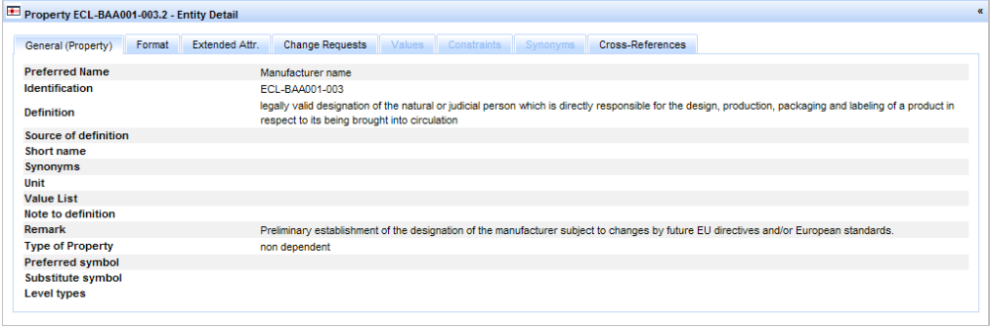

Figure 9: Example of entry details (for a property)

16.1.3 UI02 – Tree view
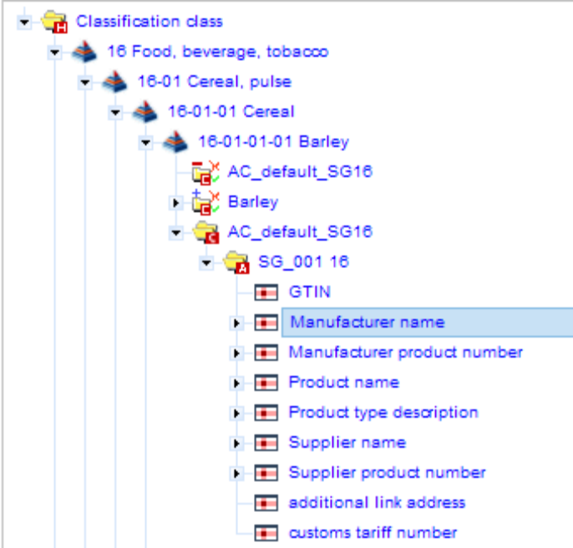
Figure 10: Example of tree view

16.1.4 UI03 – List View
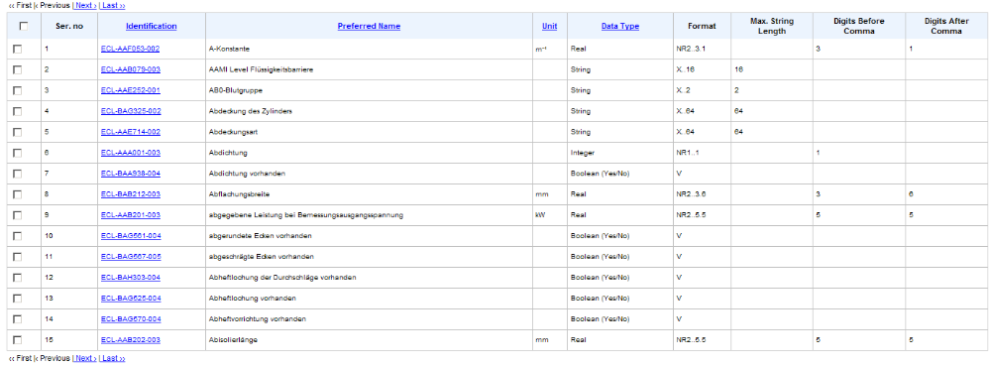
Figure 11: Example of list view

16.1.5 UI04 – View template

16.1.5.1 UI04.01 – Create view template
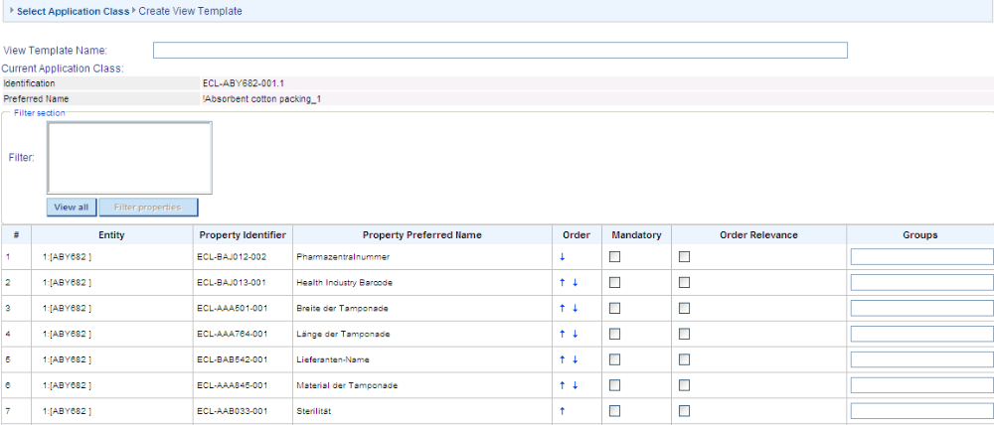
Figure 12: Create view template

16.1.5.2 UI04.02 – Set order of properties
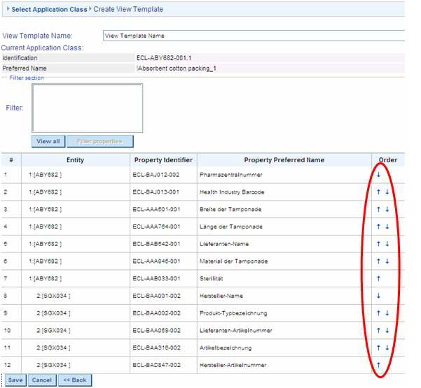
Figure 13: Create order of properties
16.1.5.3 UI04.03 – Set mandatory property

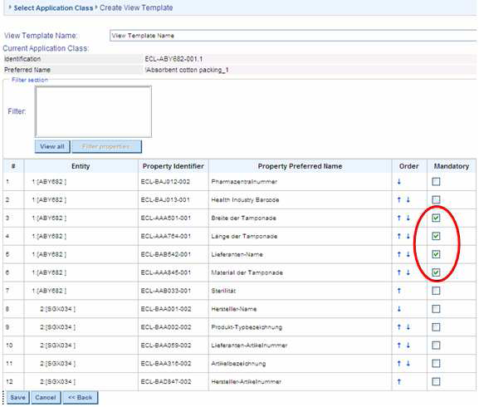
Figure 14: set mandatory properties

Hardware Interfaces
none

Software Interfaces

16.3.1 ISO29002-20 WebService
ISO/TS 29002-20 specifies an interface to retrieve information from a concept dictionary. Three sets of capabilities, called "services", are defined:
- Location Service: given a registration authority identifier, returns location on the Internet of Terminology and Ontology servers for the registration authority;
- Terminology Service: search for concepts, languages, and other elements of the dictionary based on a rich set of keywords, search criteria, and expressions; given an international registration data identifier (IRDI) in the format defined in ISO/TS 29002-5, retrieve terminological information;
- Ontology Service: retrieve ontological information about a concept based on the concept's IRDI.

16.3.2 ISO22475-30 WebService
ISO 22745-30 specifies a conceptual information model for identification guides and the data types necessary to support identification guides. ISO 22745-30 also specifies an Extensible Markup Language (XML) exchange structure for identification guides. The conceptual model is in the Unified Modeling Language (UML). The physical file format is based on the Extensible Markup Language (XML).

The following are within the scope of ISO 22745-30:
• conceptual model for identification guides;
• exchange format for identification guides.

Communications Interfaces
none

Licensing Requirements

eCl@ss licensing requirements
PEPPOL has signed a MOU with eCl@ss that allows PEPPOL to use eCl@ss content within the PEPPOL
pilot phase free of charge.

eptosTM licensing requirements
PEPPOL PPS is provided as a service by Paradine. No software license is acquired.

Other PEPPOL releated licenses / patents
None known.

Legal, Copyright and Other Notices
none

Applicable Standards
none

