


GUIDELINES

 |  | Project Acronym: | PEPPOL
 |  | Grant Agreement number: | 224974
 |  | Project Title: | Pan-European Public Procurement Online
CT-PreAward - eCAT

Test Guidelines

Version: 1.1

Status: In use

Authors:
Giancarlo De Stefano Consip
Klaus Vilstrup Pedersen Difi

Project co-funded by the European Commission within the ICT Policy Support Programme
Dissemination Level
P | Public |  |  | X
C | Confidential, only for members of the consortium and the Commission Services

Revision History

Revision | Date | Editors | Organisation | Description
Version 1.0 | 2009/04/30 | All Authors | All | Created as Deliverable 5.1a
Version 1.01 | 2012/06/30 | Giancarlo De Stefano | All | Adapted as Pre-Award eCat Deliverable

Statement of originality

This deliverable contains original unpublished work except where clearly indicated otherwise. Acknowledgement of previously published material and of the work of others has been made through appropriate citation, quotation or both.
Statement of copyright
This deliverable is released under the terms of the Creative Commons Licence accessed through the following link: http://creativecommons.org/licenses/by/3.0/.

In short, it is free to
Share — to copy, distribute and transmit the work
Remix — to adapt the work
Under the following conditions
Attribution — You must attribute the work in the manner specified by the author or licensor (but not in any way that suggests that they endorse you or your use of the work).
List of Contributors

The following organisations have contributed to Deliverable D3.1:
- Consip, Italy – http://www.consip.it/
- Difi, Norway - http://www.difi.no/

The following persons have contributed to this Deliverable:
- Giancarlo De Stefano Consip
- Klaus Vilstrup Pedersen Difi (formerly National IT- and Telecom Agency, DK)
- Anders Kingstedt ECRU, SWE
- Mogens Christensen Logica, DK

Table of Contents

1 Preamble 5
1.1 Document purpose 5
1.2 Deliverables overview 5
2 Introduction 6
2.1 Motivation 6
2.2 Test Guidelines - overview 7
2.3 Objective 8
2.4 Scope 8
2.4.1 Relation to other CEN ISSS WS/BII PEPPOL deliverables 8
2.4.2 Relation to other CEN ISSS WS/BII test deliverables 10
3 Models 11
3.1 The European Interoperability Framework (EIF) overview 11
3.2 The CEN ISSS WS/BII Profile Architecture 14
3.2.1 The CEN ISSS WS/BII Profile overview 14
3.2.2 Detailed description of the Profile 15
3.3 The V-model - overview 16
4 The Test Framework 17
4.1 Test levels - overview 17
4.2 Test levels - specifics 18
4.3 Test Types 20
4.3.1 Specific Test Types 20
4.3.2 CEN ISSS WS/BII General Test Types 21
5 Test Deliverables 22
5.1 Test objects 22
5.1.1 Specification Deliverables of the Test Guidelines 23
5.1.2 Relationship to WG3 of the CEN ISSS WS/BII 24
5.2 Detail descriptions 24
5.2.1 Test Plan Template 24
5.2.2 Test Case Template 25
5.3 Attachment list 26
6 Test Roles 27

1 Preamble
This Report is developed in cooperation between PEPPOL and CEN ISSS WS/BII WG 4, and is aligned with the draft report CENISSSWS/BIIWG4 Test Guidelines

PEPPOL deliverable 5.1 is divided into three reports:
a) Test Guidelines (this Report)
b) Evaluation Guidelines
c) Pilot Execution Guidelines.

PEPPOL (Pan-European Public eProcurement Online) is a three-year (May 2008 May 2011) large scale pilot under the CIP1 (Competitiveness and Innovation Programme) initiative of the European Commission. The vision of the PEPPOL project is that any company, especially SMEs, in the EUcan communicatewith any European governmental institution for the entire procurement process in an electronic way. To attain this goal, PEPPOL will provide an interoperable environment based on national systems and infrastructures supporting the cycle of eProcurement activities.

The CEN/ISSS Workshop on business interoperability interfaces for public procurement in Europe (CEN/ISSS WS/BII) is established in order to
- Identify and document the required business interoperability interfaces related to pan-European electronic transactions in public procurement expressed as a set of technical specifications,developed by taking due account of current and emerging UN/CEFACT standards in order to ensure global interoperability;
- Co-ordinate and provide support to pilot projects implementing the technical specifications in order to remove technical barriers preventing interoperability.

1.1 Document purpose
Deliverable 5.1a is aimed at supporting test activities in the PEPPOL work packages. The document introduces a structured method towards testing of the conformance of implementations of CEN ISSS WS/BII profiles and their specifications.

1.2 Deliverables overview
1. Deliverable 5.1: Test, Evaluation and Pilot Execution Guidelines Methodologies for testing conformance to CEN ISSS WS/BII profiles, evaluation of pilots based on CEN ISSS WS/BII profiles and execution guidelines for planning the pilots. This deliverable is developed in cooperation with CEN ISSS WS/BII WG 4.

2. Deliverable 5.2: eInvoicing pilot specification
Specifications for creating Process-, semantic- and technical interoperability for eInvoicing. Based on analysis (Design phase in the Pilot stage) and the PoC stage and used as input for the Construction phase in the Pilot stage. This report should be seen as an interim report in relation to deliverable 5.4.

3. Deliverable 5.3: eInvoicing pilot software components
Software components developed based on deliverable 5.2

4. Deliverable 5.4: eInvoicing framework specification
Specifications for creating legal, organizational, semantic and technical interoperability for eInvoicing. Based on analysis (Design phase in the Framework stage), European e-Invoicing Framework and the Pilot stage and used as input for the Construction phase in the Framework stage.

5. Deliverable 5.5: e-Invoicing framework software components
Software components developed on the basis of deliverable 5.4
6. Deliverable 5.6: eInvoicing framework pilot and evaluation report
Report on successes, barriers, best practices and failures in the WP 5 eInvoicing pilot. Based on the deliverable 5.1 methodology.

2 Introduction

2.1 Motivation

“Develop success from failures. Discouragement and failure are two of the surest stepping stones to success .”(Dale Carnegie)

“Failure is success if we learn from it” (Malcom Forbes)

Early and continuous focus on Test and Quality assurance should be a natural and integral part of any IT project and/or IT product / service (including the mechanisms that together form the basis for an SLA governance, maintenance and monitoring). Test and the quality assurance work done in parallel with an IT project will significantly lower the risks when launching the solution (or, in the case of the CEN ISSS WS/BII, the framework and, in the case of the PEPPOL projects, the pilot(s)). The activities described in this document can, if conducted correct, help in securing the expected level of quality for the frameworks and solutions to be developed. Test and quality assurance is also intimately linked to requirements with defined success criterion; a prioritized list of the key criterion (and their respective indicators for success) that is required to be met (preferably grouped according to interest areas) must exist for the test work to be successful.

The Pilot evaluation involves extracting Best Practice, learning from the pilot and measuring the ability to meet the set project objectives. One of the PEPPOL project objectives is to implement a pilot with interoperability between stakeholders. The business processes that are standardized in the CEN ISSS WS/BII are mission critical processes i.e. they represent core processes that is of high importance for the organizations involved in terms of criticality related to core operations. The aim of creating error free interoperability is therefore crucial. Error free meansthat the functional requirementsof all interoperability layersaremet. In this context, testing is the process of securing that the stakeholders providing solutions based on the CEN ISSS BII WS profile specifications meet the functional requirements in their implementation specifications.

In more general terms, the earlier you detect issues (and mitigate these) and the more you know about the risk levels in terms of how an issue will affect the solution, the less money and resources you have to spend correcting mistakes after the final release.
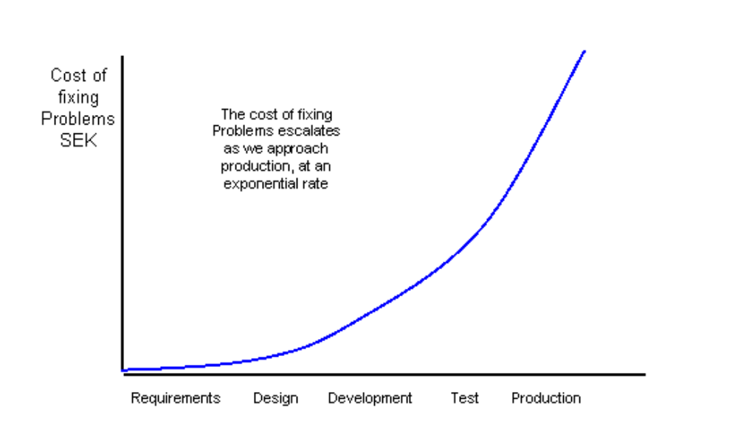
The above picture describes the impact of errors as an IT project progresses. It also illustrates the need to 1 establish the test framework early and 2 the importance of verifying ( testing ) the quality of the requirements as well as the design (architecture) and any deliverables of the solution in terms of code, services and/or other entities that together form the solution (in this case, based on the CEN ISSS BII/WS profile architecture). A crucial success factor is a common understanding of the success criterion, both on organizational (operational), functional and technical level among the stakeholder of the solution. For the launched solution (in this case, the upcoming Pilots) it also important to verify the impact on any change introduced. Ultimately, the chain of events should bemaintained, that is a link between high level requirements, broken down into Use Cases, functional and non-functional requirements and the manifestation of these in terms of implemented design and solution. Finally it is crucial that the adequate resources are allocated in order to fill the need for testing roles, time to execute testing activities, and also hardware and software to support the test and quality assurance efforts.

As this document is intended as a high level document to use be used for any IT projects the actual scope and defined content (roles, activities, deliverables etc.) will vary. Initiating test planning early on will provide better control of the test scope and thereby, as an effect, a correct and reasonable allocation of resources.

Every proof-of-concept or pilot within the CEN ISSS WS/BII and PEPPOL efforts should select the level and amount of testing activities required, using this document as a reference. This document outlines the recommended course of action. Given the scope of the effort, it is in theory possible to avoid testing altogether, allowing the supplier of the effort to provide the test assurance work. This is not, however, recommended and the supplier should at a minimum abide to the test requirements stated.

2.2 Test Guidelines - overview
This document presents a high level Test Guideline for conformance testing of implementations of CEN ISSS WS/BII profiles. The purpose is to outline, define and further elaborate a test process in the form of test guidelines to be used by an interoperability project using CEN ISSS WS/BII profiles, e.g. the PEPPOL project. The document outlines and suggests generic content in the form of those activities, deliverables and roles necessary in order to facilitate test and quality assurance. The generic nature of the document is intentional. To apply the test guidelines on any element of the CEN ISSS WS/BII and pilot projectse.g. PEPPOL should require little effort. The steps necessary to follow should ultimately be the same for any IT effort, independent of whether the scope (subject for testing) is eInvoicing, eOrdering or eCatalogue etc.

The intended reader is test and project management for pilot projects and for approval, the organization management within the CEN ISSS WS/BII WS and the PEPPOL project.
The Test Guidelines is organized and based on three main input models:

- The European Interoperability Framework (EIF) version 2.0
- The V-Model (a best practise model for executing test & quality assurance)
- The CEN ISSS WS/BII Profile architecture

The Test Guidelines is accompanied by templates, providing guidance for the deliverables mentioned in this document. The templates currently available are:

1. Test Guidelines (TG):
The test guidelines provides high level guidance. The TG puts the CEN ISSS WS/BII Test into perspective and explains how the templates and reports are to be used (and in what context).

2. Test Plan Template (TPT):
The test plan template is used to describe how the test should be executed, in terms of goals, resources, dates and activities. The TPT should be aligned with the project plan (in which the test effort is one of many activities). The Test Plan Template actually consists of 1 A Word Document and 2 - a Excel Test Case matrix. The matrix is used to fill out the specifics related to the object subject to test.

3. Test Case Template (TCT):
The test case template is used to set up and describe the test case executed for individual elements of a Profile it concerns what is to be tested. The TCT is composed on the premise that the test is semantic, that is not of a technical nature. In essence, the TCT will provide support for securing conformance validation (high level)

4. Test Case (TC)
An actual test case, based on the TCT, is built for each element of the Profile. If several elements of the same type exist in a Profile, e.g. Collaborations, Transactions etc, these might be grouped and entered in a common Test Case (for that specific Profile).
The test cases are identified by a (suggested) identification system.
Note: even though the Test Case Template has been composed with the CEN ISSS
WS/BII Profile Architecture in mind, the actual Test Case is generic and could easily be used to accommodate for other types of tests and objects other than the Profile constituents.

5. Test Report Template (TRT):
The Test Report Template is used to report findings when executing test.

6. Test Case Exception Report Template (TCERT):
This template is used to document any deviations to the expected prerequisites necessary to exist before executing tests. For example: when testing a collaboration of a profile that consists of one (or more) transactions, the transaction(s) must first have been tested and test should have been passed. If the tests have failed or if they have not been run at all, the test of the collaboration would normally not be executed. If, for any reason, the test is to be run anyway, the reason must be entered into a Test Case Report, using the TCERT.

7. Conformance Test Checklist (CTC):
The Conformance test checklist is used to keep track of the actual execution of the activities necessary in order to do the tests. The CTC could be incorporated into the Test Plan. The value of the CTC is to provide the test manager (most likely) with a rudimentary level of support in terms of checking for that all important aspects of test have been considered before executing test.

2.3 Objective
This document suggests generic Test Guidelines to be used for testing conformance of implementations to the CEN ISSS WS/BII profiles and to be used by Work packages(WPs) in the PEPPOL pilot. It is assumed and required that the Test Guidelines is linked to Systems Use Cases and measurable requirements for all profiles and constituents of profiles subject to test.
The goal is to provide Test Guidelines based on industry class best practices so that the set goals and objectives can be readily verified using proven test mechanisms at all levels and for all entities of the final solution.

2.4 Scope

2.4.1 Relation to other CEN ISSS WS/BII PEPPOL deliverables
The below picture illustrates the relationship and overview level purpose of Guidelines provided by PEPPOL. The Cost , Time and Product are the project-based objective types and Learning , Use and Value are the outcome-based objective types.

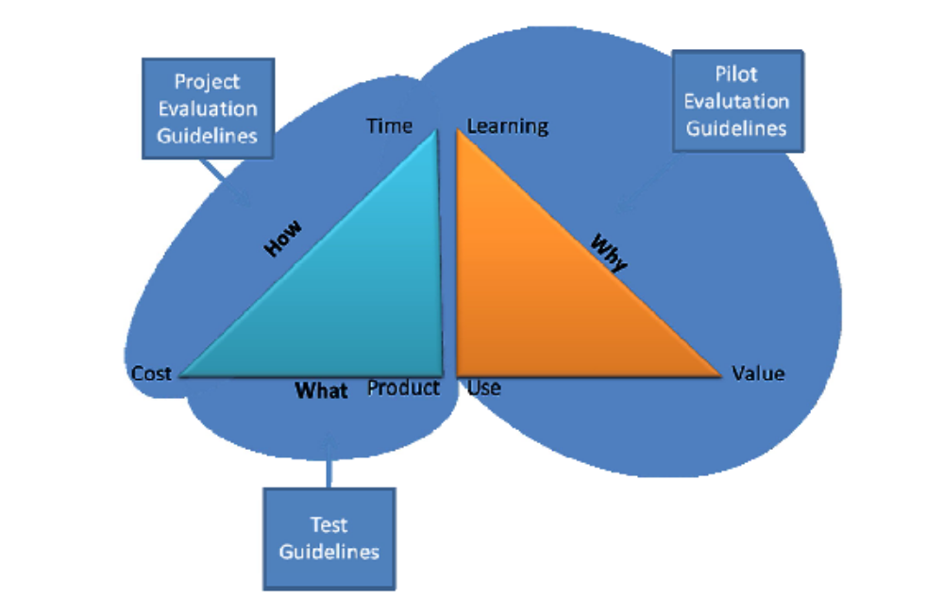

- Project Evaluation Guidelines:
Focus on how the Pilots project will be evaluated, supporting the execution of activitiesin the best possibleway. The guidelinesaddressesthe evaluation of the How issue. Guiding objectivesare cost - whether it came in on budget, and time - whether it came in on schedule. (NOT a PEPPOL Deliverable)

- Test Guidelines:
Provides a way to evaluate the degree of conformance of an eProcurement interoperability model in relation to the CEN ISSS WS/BII profile structure . The Test guidelinesaddressthe What issue. The guiding objective are product - whether the interoperability implementation is conformant with the CEN ISSS WS/BII profiles. (PEPPOL Deliverable 5.1a)

- Pilot Evaluation Guidelines:
Focus on securing that the Pilots based on the CEN ISSS WS/BII profiles are executed in accordance with the pilot objectives. The Pilot Evaluation Guidelines address the Why issue. The guiding objectivesare learning - whether the project helped prepare the stakeholders for the future, value - whether the pilot improved efficiency or effectiveness of the organizations, use whether the interoperability implementation and interoperability model and services was usable. The objective is to assure that the expected pilot objectives is met in the pilots. (PEPPOL Deliverable 5.1b)

2.4.2 Relation to other CEN ISSS WS/BII test deliverables
Not included in the Test Guidelines are suggestions on tools for conducting test, handling requirements and tracking bugs and change requests. It is recommended that the CEN ISSS WS/BII WG3 report BII04 Conformance Testing (work in progress) is also read in conjunction with this report. The following picture illustrates how the Test Guidelines presented by WG4 (Pilot Support) are related to the test efforts of WG3 (Tool Support) and the scope in terms of level in relation to the EIF framework:

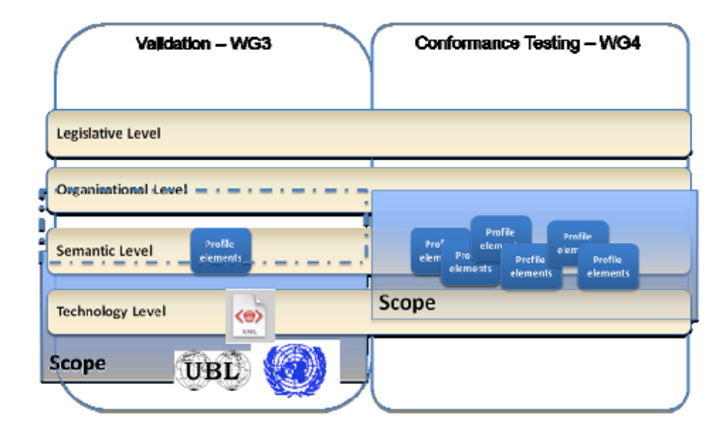

Explanation:
- Conformance testing: the objective is to ensure that
- 1 All elements of the profile are in place; that the solution based on a given profile meets the expected structure in terms of content,
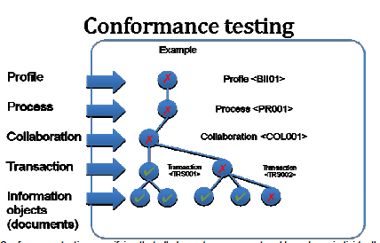

Conformance testing verifying that all elements are present and have been individually tested and that they exist
- 2 that all individual entities of a profile have been tested for conformance in terms of satisfying the expected requirements of the profile elements and

- 3 that any deviations to the expected requirements of a profile or its constituents are reported. The conformance testing is in a way context testing. The conformance testing relies on checklists and test templates.

- In the example above, the profile is not conformant because of an individual element failing to pass (in the example, one of the information objects). Besides failing because of an element (one or more) failing to pass the individual test, a profile might be classified as non-conformant due to an element missing.

- Validation: validation involves testing individual elements of a profile for structure and content, on a semantic level for structure and on technology level for content. Validation is in a way content testing. The validation testing makes use of tools for automated testing.

Please note that other testing types exist within the scope of the Test Guidelines, foremost
Collaboration tests. The objective of Collaboration tests is to ensure expected behavior of collaboration between two parties. To verify that the collaboration and its transaction (one or more) execute correctly, a Test Case is constructed with the purpose to check that the required input and output (e.g. result set) is provided.

It should be pointed out that the tests are conducted at a Semantic level. No technical tests are executed within the context of and with the aid of the Test Guidelines.

3 Models
As mentioned above, the Test Guidelines is based on three cornerstones; the EIF model, the V-model and the CEN ISSS WS/BII architecture. These are described on an overview level below, with references included to further reading and more information.

3.1 The European Interoperability Framework (EIF) overview
An important cornerstone for the Test Guidelines is the European Interoperability Framework (EIF), an initiative run by IDABC (Interoperable Delivery of European eGovernment Services to public Administrations, Business and Citizens). Using state-of-the-art information and communication technologies, developing common solutions and services and by finally, providing a platform for the exchange of good practice between public administrations, IDABC contributes to the i2010 initiative of modernizing the European public sector. IDABC is a Community program managed by the European Commission's Directorate-General for Informatics.

The main objectives of the EIF are:
- To serve as the basis for European seamless interoperability in public services delivery,
- thereby providing better public services at EU level;
- To support the delivery of PEGS by furthering cross-border and cross-sector interoperability;
- To supplement the various National Interoperability Frameworks in the pan- European dimension.

The EIF is related to the Pan-European eGovernment Services (PEGS) initiative, where the EIF provides the framework for interoperability.

The EIF is intended to be part of the set of interoperability guidelines documents and initiatives conducted under the auspices of the IDABC Program which aims at providing guidance and infrastructure services to PEGS stakeholders and developers.

The figure below shows the relationships between the various IDABC documents/initiatives and related processes: the European Interoperability Strategy (EIS), the European Interoperability Framework (EIF), the European Interoperability Architecture Guidelines (EIAG) and the European Interoperability Infrastructure Services (EIIS), and their relation to the PEGS process development. These artifacts collectively provide the basic technical requirements of consumers of eGovernmentservices, cover the lifecycle from strategy through to operations, and provide IT vendors and suppliers with reliable information on their costumers'
needs in this area.

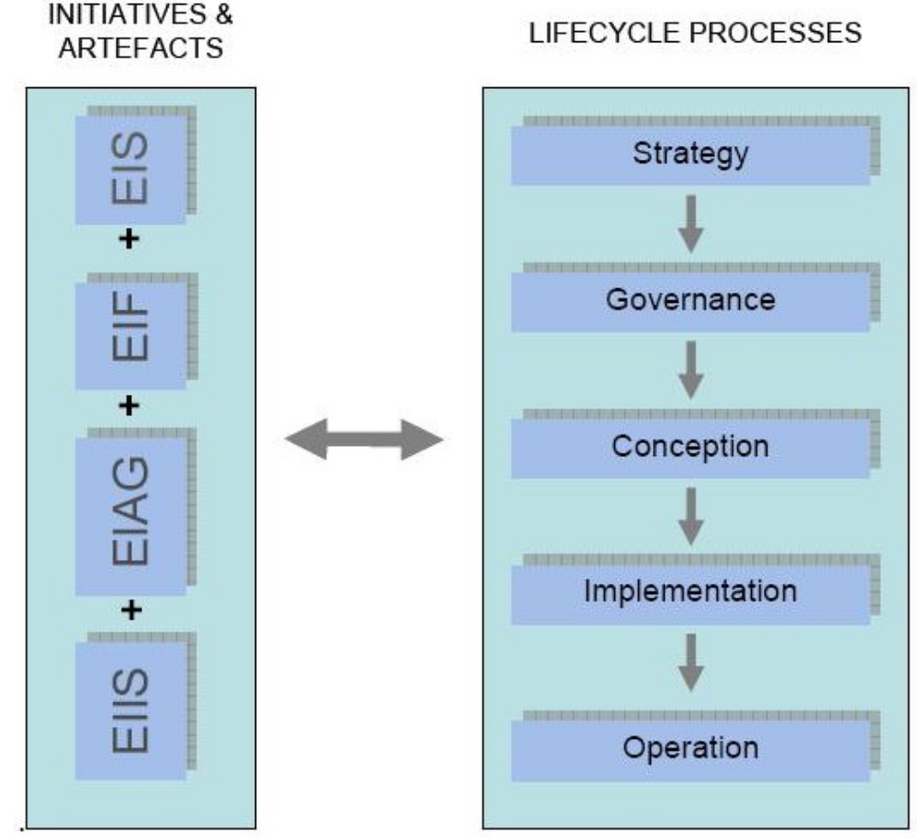

A systematic approach to the governance of Interoperability at EU-level must be taken in the future and concrete goals specified and reached. To this end, a "European Interoperability Strategy" (EIS) will be established in order to provide the basis for defining the organizational, financial and operational framework necessary to support cross-border and crosssector interoperability as well as the exchange of information between European public administrations.

This should ultimately enable the more efficient delivery of improved public services (PEGS). The EIS is currently under development, and is expected to be completed by the end of 2009.

The goal is to define and agree on a focused set of actions at EU level on what are the most effective and efficient means to rapidly deliver more and better PEGS to Citizens and Businesses, and also to improve collaboration between administrations in order to implement community legislation. The EIS will include long term planning information for prioritized and coordinated actions as well as the associated funding requirements. The EIS must contribute to meeting the new challenges, in particular government transformation. The EIS is intended to facilitate the achievement of such transformation at the European level. It must have the strong support of policy makers who are active in efforts aimed at transforming governments at national level in order to ensure that the necessary EU level transformations are also possible. The EIS will in effect make explicit several items which were implicit before. Some minor revisions to the EIF may be necessary once the EIS has been established.

Looking at cross-border interoperability as a layered model, the EIS will be at the highest level. The EIF defines the general rules and principles for governance and conception and will be complemented by a National Interoperability Framework Observatory (under development) and the definition of a Common Assessment Method for Standards and Specifications (under construction). The Architecture Guidelines (to be revised by the end of 2009) provides structured guidance for implementation. The lowest level concerns the operational infrastructure services (s-TESTA, PKI, SEMIC, etc.) provided at EU level to all Member States across all sectors. The EIS serves to steer the entire layered model and associated efforts by
setting strategic priorities and principles.

Note: The above text has been excerpted from the EIF 20.PDF document, dated 15/07/2008.
In terms of providing input to the Test Guidelines for the CEN ISSS WS/BII WS, the EIF provides guiding principles as well as directives in areas relevant to the CEN ISSS WS/BII WS (explicitly or implicitly).

Examples of such areas are:
- Description of Interoperability levels.
Even though the Test Guidelinesprimarily focuson the Semantic level, it svaluable to understand how other levels (organizational and technical levels) are related and what is expected to be covered in these levels as well as on the focus level, the semantic level.

- Description of the Generic Public Services Conceptual Model (GPSCM)
- Description of cross-border issues
- Open Standards and technical specifications

Overall, the EIF is used as a reference framework and as a source of information. For further reading and information, see http://ec.europa.eu/idabc/servlets/Doc?id=31597.

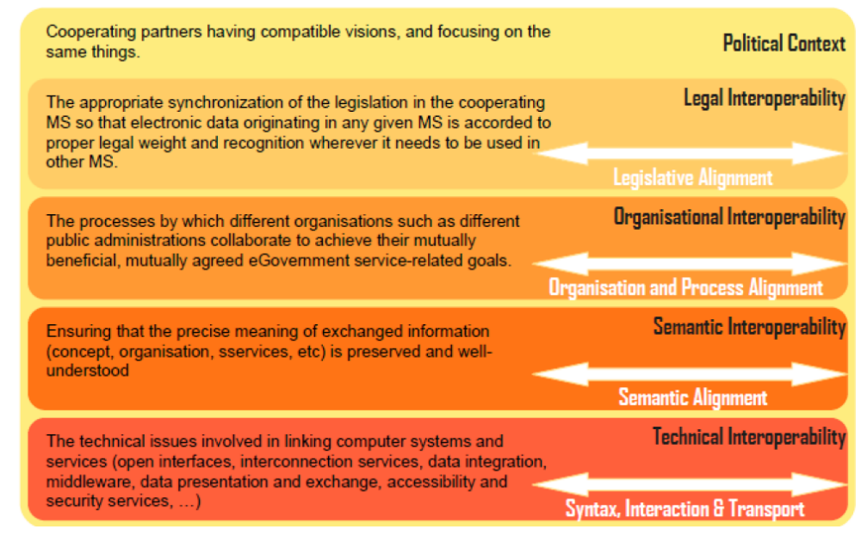

In thiscontext we will use the EIF2.0 interoperability model for structuring the testsby separating the tests into the levels according to the above depicted model. Again, the tests will focuson SemanticAlignment . This, in turn,meansthat objective of the test efforts will be to secure that
1 - The elements of the E-Procurement scenarios, manifested in Profiles, are in place
2 - Individual elements conform to the defined specifications
3 - All prerequisites for running semantic level tests are in place and, if not, that any exceptions are documented as well the actual results of the tests conducted.

3.2 The CEN ISSS WS/BII Profile Architecture

3.2.1 The CEN ISSS WS/BII Profile overview
The CNE BII Profile Architecture is the input that has the most critical importance to the Test Guidelines in terms of providing support for test objects. It is the constituents of the Profile that are themain objectssubject to test. Therefore it simportant to understand the profile architecture to fully understand the composition of the Test Guidelines.

A simplified description of the Profile architecture is depicted below:
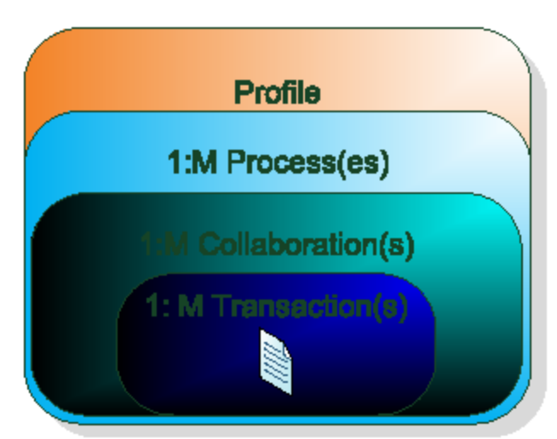

A profile consists of one or more process that in turn consists of one or more collaboration. The collaboration includes at least one transaction and at the core there is at least one information entity manifested as a business document processed and conveyed.

The model is, again, simplified other important entities exist, but the above picture provides an overview and serves as the starting point for further elaboration.
For each entity of the profile, there sobviously a need to define the requirementsneeded in order to verify that the final solution manifested as a application, system, group of applications and/or service or set of services is compliant.

To avoid an overly complex set of requirements, the requirements also need to be categorized and organized according to criticality and prioritization.

A requirement can be defined as follows:
It isa statement that identifies a necessary attribute, capability, characteristic, or quality of a systemin order for it to have value and utility to a user (Source:Wikipedia).

3.2.2 Detailed description of the Profile
A profile description is a technical specification describing
- business processes, i.e. a detailed description of the way trading partners intend to play their respective roles, establish business relations and share responsibilities to interact efficiently with the support of their respective information systems,
- the business rules governing the execution of that business process,
- possible run-time scenarios and the business commitments achieved,
- the electronic messages exchanged as part of the business process and the sequence in
- which these documents are exchanged,
- information content of the electronic messages exchanged.

As well as determining what documents are used, the profile restricts document content in terms of elements and the cardinality of elements. The key standardization aspect of the profile description is thus in the semantics rather than the syntax. Consequently the messages within a profile can be structured based on different message standards/syntax as long as the chosen standard contains all the necessary data elements (an unbound information model is with other words used).

Although the Profile Descriptions provided by the CEN/ISSS Workshop will be neutral of syntax, the workshop has agreed to develop its business document (information) deliverables based on the UBL messages standard. This is done in order provide the market with implementable specifications. The implication of this decision is that the description of especially message content is aligned to the UBL 2.0 message standard.

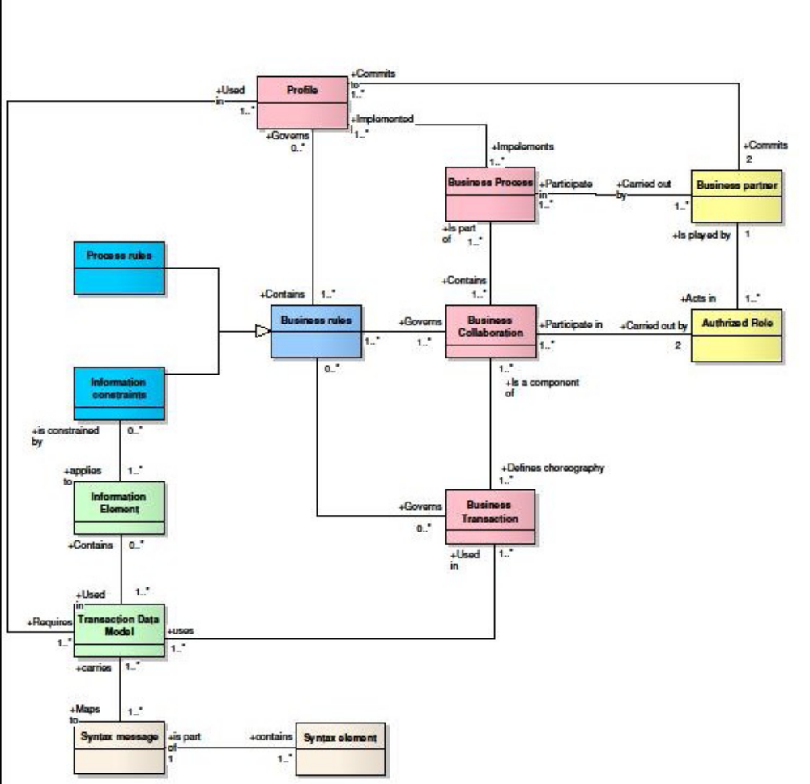

- A profile commits two business partners in an agreement on how to conduct electronic business.
- A profile implements one or more business processes.

- A profile is contains one or more business rule that governs it.
- A profile requires an information set.

Note: A more detailed description of the profile is provided in the CEN ISSS WS/BII WG1 document BII profile document description v1 (work in progress). For more information, please review the referenced document.

3.3 The V-model - overview
The proposed test guidelines are based on the V-model. A V-model generally provides a test and quality assurance framework for the development of an IT solution. The V-model also describes the tests to be conducted, and in what order these should be executed.

A given success factor to test is to provide a clear understanding on who does what and why. One necessary element in achieving this is to clarify how various test stages are related and how dependencies between steps in the test process and different activities and roles affect the outcome of test. The confusion and sometimes friction incurred is many times unnecessary.

Hopefully this picture and the below picture might illustrate the relationship between different test types, roles, value and responsibilities:

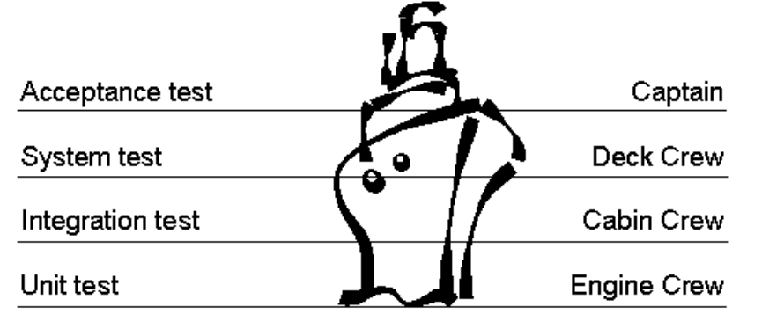

The Unit test is like the engine department of a ship and are performed by developers. They can work in conjunction with a tester if they want to (Pair vise testing and development).
Development and unit tests move us forward.

Integration test ensures that the power created by the actions of the engine crew reaches the rest of the ship. Integration testing in its first phase is also performed by developers (supplier). The second phase of integration testing is the responsibility of the test role ( Cabin crew ).

The System test is the final test that ensures that the ship works and can take us to the intended destination. Power is created and reaches all parts of the ship including the steering mechanism. Deck crew in conjunction with Cabin crew runs all over the ship checking that all is ok. We might take a first tour in the harbor. This is a tester domain.

The Acceptance test takes the ship out for its maiden voyage. Does the ship reach its intended destination (If wewanted to go to the north pool but the ship can t travel cold waters we have a problem.)?Are the passengers( end users ) happy?Doesthe captain approve off maneuverability? This is the stakeholders, operations and end users responsibility.

Again good communication between all involved and a clear understanding of relationships are crucial.

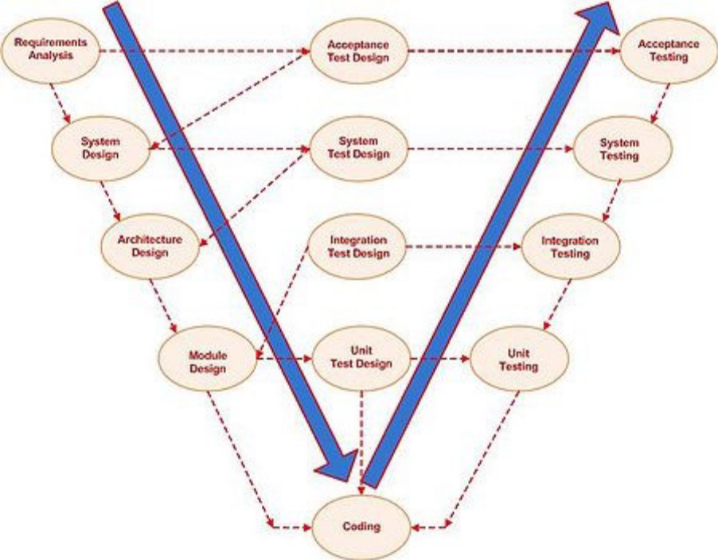
Picture the V-model (general model).

For each test level in the model, there is in principle a related activityythat corresponds to the test activity. As an example, Systems design requires a design of the systems testing and results in a systems test. The picture illustrates how the various parts of the model are related and which steps are required to have been executed before moving on to the next level / next activity. Please note, that even though the model implies a sequential execution, in reality the all steps are subject to review and iteration if necessary (usually defined in the project and test plan).

The V-model provides generic, best practise based guidance on test types, expected input and output, test deliverables and other building blocks of structured test and quality assurance. Not all elements of the V-model are however applicable in the context of the CEN ISSS WS/BII WS. Even though a fairly comprehensive description of the V-model framework is included in the Test Guidelines, some elementsare listed as recommended or optional and should be treated as such.

4 The Test Framework

4.1 Test levels - overview
The scope and structuring of test efforts as outlined in the Test Guidelines is done by mapping the V-model for testing system development solution to the interoperability development and the structure that is provided by the EIF v. 2.0 model. The result is presented in the below picture.
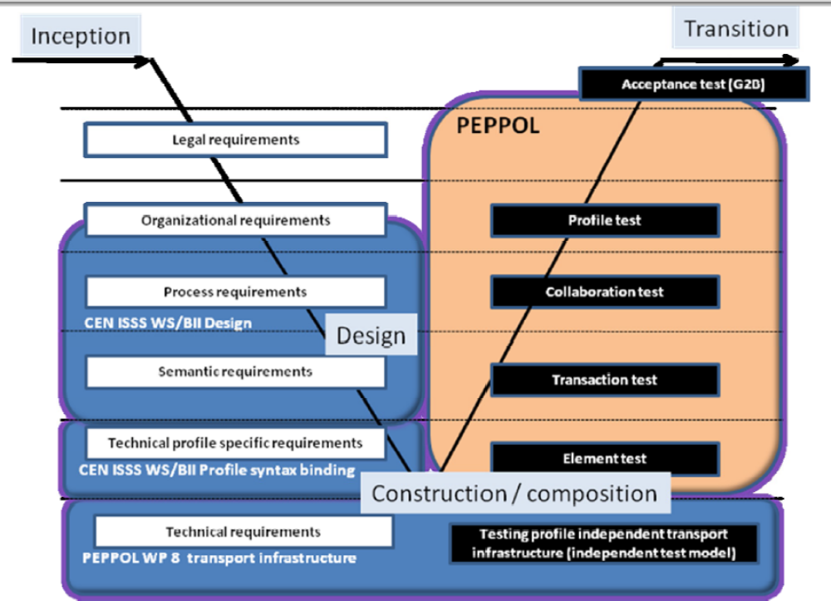
Picture the applied V-model

The inception phase is out of scope for the Test Guidelines. Legal and organizational issues were the focus of the efforts during the Inception phase.

Important note: Out of scope in thiscontext meansthat no practical support for conducting testsof elementsat the level in question existsin the Test Guidelines. Out of scope however does not imply that the the elements classified as being Out of Scope are less imoportant that those in scope . Typically, Out of Scope levels(and elementsof those levels) provide important input to in scope levels, test typesand objects subject to test.

Remark: The Test Guidelines focuses on providing support for conformance testing and semantic level tests . This is essence done by providing checklists and guidance in the form of verification directions for seuring that the elements of the Profile are verified against the expected behaviour. The purpose of the test guidelines is furthermore to secure that constraints, alternate flows, unexpected flaws and missing entities are handled in a correct fashion.

4.2 Test levels - specifics
The test levels correspondsto the design leg of the V-model, linked to the EIF-model’s different levels. Below follows a description of the levels that are in and out of scope for the Test Guidelines.

Legal level (out of scope)
Some requirements at the legal requirements level need to be handled and tested at the legal layer, others are pushed to lower levels.
- Example of requirements handled at this level: alignment of country specific VAT issues.
- Examples of requirements pushed to lower levels:
Common storage requirements of eInvoices for audit.

Organizational level (out of scope)
Some requirements at the organizational level need to be handled and tested at the organizational layer, others are pushed to lower levels.

- Examples of requirements handled at this level:
The internal handling and use of the business documents and the integration with the external processes.
- Examples of requirements pushed to lower levels:
External interaction of information to and from business partners

Process level (in scope)
The requirements at the process level are described by CEN ISSS WS/BII as profiles. Some interoperability requirements are handled and tested at this level.

- Examples of requirements handled at this level:
The collaboration protocol i.e. sequences of the exchange of business documents, governed by the business rules.
- Examples of requirements pushed to lower levels:
Business document information

Semantic level (in scope)
The Semantic level defines the requirements for joint documents and is described by CEN ISSS WS/BII in the profiles. Some interoperability requirements are handled and tested at this level.

- Examples of requirements handled at this level:
The content of the documents in terms of information structure / design (unbound to a specific document standard such as UBL or EDIFACT).
- Examples of requirements pushed to lower levels:
  - The syntax of the Business document information
  - The interchange of the business documents

Technical level (out of scope)
The requirements at the technical level are the design and implementation of the interoperability. The technical level is divided into two sub levels; a profile independent layer and a profile dependent layer.

Technical level profile dependent
The profile dependent level is the technical design of the profiles i.e. involves mapping the requirements into languages.
- Examples of requirements handled at this level: mapping the requirements to UBL and instantiating UBL based business documents
- Examples of requirements pushed to lower levels: n/a (this is the lowest level)
Note: Even though the Technical level profile dependent testing is out of scope for the Test Guidelines, testin g at this level is covered by Validation tests mechanisms provided by CEN ISSS BII / WS -WG3 ( Tool Support ).

Technical level profile independent
The profile independent layer covers the requirements that are pushed directly from the legal and business level.
- Examples of requirements handled at this level: business requirements defined to cater for a reliable and secure cross border infrastructure, e.g.
  - Authenticity
  - Integrity
  - Non repudiation
- Examples of requirements pushed to lower levels: n/a (this is the lowest level)

General remarks
The test methodology is based on the principle that the implementation is tested in a bottom-up manner, by testing the functional requirements of the profile elements and then moving upwards in the applied V-model, corresponding to adding more and more building blocks of the profile together.

The test at a lower level must pass before moving on to the next level (this rule can however be bypassed by exception reporting).

The goal of the test guidelines is primarily to provide methodology support for verifying requirements defined on a semantic level, thus verifying that the core capabilities are included and supported in the object subject to test and quality assurance.

The applied V-model picture (above) illustrates that the CEN ISSS WS/BII WS mainly focuses on design of a framework that will support public E-Procurement. As a consequence, most of the test efforts will be conducted within pilot projects.

4.3 Test Types
The test typescorrespond to the testing activitiesin the right leg of the V-model. As pointed out in the previous section, the actual test activities will be carried out in the context of the PEPPOL project.

4.3.1 Specific Test Types

Element test
Definition
The Element Test is a unit test on of all the elements that are required to exist as part of the profile to which the elements belong in order to run a process from start to finish.
Precondition
The technical profile independent requirements have been designed, implemented and tested
Overall purpose
To create the foundation for transaction and collaboration testing
Test objectives are to verify that:
- the sender system can deliver a document that conforms to the document specifications
- the sender system can send the document to a dummy receiver
- the receiver system can receive generic test documents from a dummy sender
- the receiver system can validate the generic test documents

Transaction test
Definition
The Transaction test is an integration test conducted at a transaction level
Overall purpose
To test document interoperability
Test objectives are to verify that:
- the sender system can deliver a document that conforms to the document specifications
- the sender system can send the document to the receiver
- the receiver system can receive the document from the sender
- the receiver system can validate the document

Collaboration test
Definition
The collaboration test is an integration test at a collaboration level
Overall purpose
To test process interoperability
Test objectives are to verify that:
- the sender system can deliver all the documents that conforms to the document specifications
- the receiver system can validate all the documents

Profile test
Definition
The profile test is a systems test of the profile
Overall purpose
To test process and document interoperability in the specified scenarios valid for the profile
Test objectives are to verify that:
- the scenarios involving sender and receiver are supported and run as expected.
- PEPPOL Deliverable 5.1a, Test Guidelines Page 25

Acceptance test (out of scope)
Definition
Is an acceptance test involving system to system test between the sender and receivers target systems
Overall purpose
To join the external testing (this testing) with internal testing (the alignment between the external processes (profiles) and information content (documents) with the internal business processes and information requirements (this test type is out of scope in this testing model)
Test objectives:
This test has the ultimate goal to verify that all elements of the object subject to test meet the defined business requirements and/or capabilitities. Acceptance tests may in the scope of the CEN ISSS WS/BII WS be executed for individual profiles or for a complete scenario (for example Post Award , which consistsof several profiles.

4.3.2 CEN ISSS WS/BII General Test Types
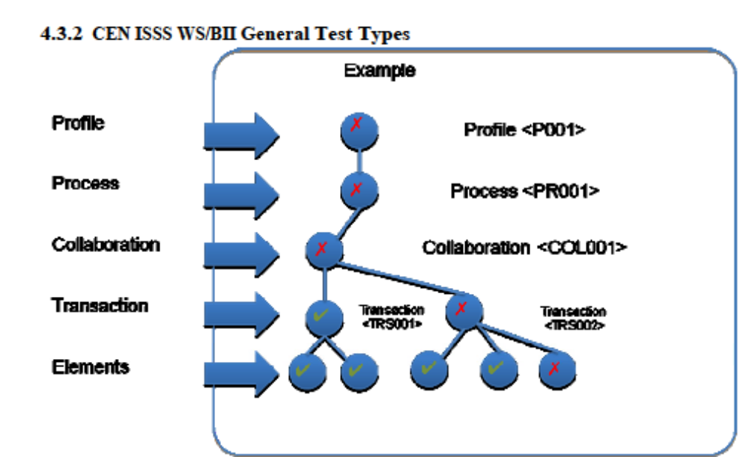

Conformance testing involves providing checklists and supporting documents that will guide the implementers of CEN BII profiles in securing that the expected output at a given level is provided. The Test Guidelines contains templates for setting up and executing conformance testing at each level, primarily by entering pre and post conditions, expected results and a description of the expected flow of events (when applicable).
In the above picture, the transaction 001 isOKcan only beOK1 - given that the underlying elements (constituents of the transaction) are valid and 2 the transaction is executed according to the specification (requirements) of the transaction 001.
Since one element of Transaction 002 isnot valid (the test hasrendered fail ), the transaction and the collaboration and the levels above fail as well until the fail condition for the element is corrected and rendered a pass condition.
Outside passing the conformance tests, all elements of the profile according to the profile specification must also be in place in order for the profile to be conformant.
Note: The conformance test is not executed as a separate activity, but rather as an integral and important part of the above described test types. Any test object is therefore tested for conformance as part of the test at hand, e.g. collaboration test.

5 Test Deliverables

5.1 Test objects
The list of test objects is determined by the number of CEN ISSS WS/BII profiles and their respective constitutients.

Profile elements subject to test
- Profiles for eProcurement

- Entities of profiles,
  - Schemas (unbound information structures)
  - Instantiated business documents (syntax bound)
  - Collaborations (definition of)
  - Transactions (definition of)
  - Business rules
  - Information constraints
  - Misc requirements

- Business rules:
  - Business rules define the information flow.
  - Independent on the final infrastructure and/or composition of ready-built products (applications) and services used for the solution, the business rules must be verified as a part of the test process. The business rules should be tested according to success criterion established, typically:
    - Correctness
    - Legal compliance
    - Availability and restriction
  - If a business rules engine is used as a part of the solution, the functionality and the expected outcome of a rules execution must be set up and tested separately.

- Information constraints:
Information constraints define how the information is processedin the following way:
  - General and/or contextual requirements on the data values in individual data elements. Examples: minimum or maximum values, code table value checks, in a given context an optional value becomes mandatory etc.
  - General and/or contextual relationships between data elements. Examples: A particular value must be higher or lower than another, different values are exclusive, calculation of one value from others etc.

- Infrastructure Tools (out of scope)
Elements subject to test but not covered by the Test Guidelines include Business Requirements
related to the infrastructure.

Considerations:
  - All entities that together form the infrastructure must be tested individually and when used in conjunction.
  - Any tools used to execute the solution must be tested separately

Further elements might need to be added and elaborated.

5.1.1 Specification Deliverables of the Test Guidelines
The following deliverables are provided within the scope of the CEN ISSS WS/BII:
1. Test Guideline (TG):
The test guidelines provides high level guidance. The TG puts the CEN BII Test into perspective and explains how the templates and reports are to be used (and in what context).
2. Test Plan Template (TPT):
The test plan template is used to describe how the test should be executed, in terms of goals, resources, dates and activities. The TPT should be aligned with the project plan (in which the test effort is one of many activities). The Test Plan Template actually consists of 1 A Word Document and 2 - a Excel Test Case matrix. The matrix is used to fill out the specifics related to the object subject to test.
3. Test Case Template (TCT):
The test case template is used to set up and describe the test case executed for individual elements of a Profile it concerns what is to be tested. The TCT is composed on the premise that the test is semantic, that is not of a technical nature. In essence, the TCT will provide support for securing conformance validation (high level)
4. Test Case (TC):
An actual test case, based on the TCT, is built for each element of the Profile. If several elements of the same type exist in a Profile, e.g. Collaborations, Transactions etc, these might be grouped and entered in a common Test Case (for that specific ProPEPPOL Deliverable file). The test cases are identified by a (suggested) identification system.
Note: even though the Test Case Template has been composed with the CEN BII Profile Architecture in mind, the actual Test Case is generic and could easily be used to accommodate for other types of tests and objects other than the Profile constituents.
5. Test Report Template (TRT):
The Test Report Template is used to report findings when executing test.
6. Test Case Exception Report Template (TCERT):
This template is used to document any deviations to the expected prerequisites necessary to be in place before executing tests. For example: when testing a collaboration of a profile that consists of one (or more) transactions, the transaction(s) must first have been tested and test should have been passed. If the tests have failed or if they have not been run at all, the test of the collaboration would normally not be executed. If, for any reason, the test is to be run anyway, the reason must be entered into a Test Case Report, using the TCERT.
7. Conformance Test Checklist (CTC):
The Conformance test checklist is used to keep track of the actual execution of the activities necessary in order to do the tests. The CTC is incorporated into the Test Case. The value of the CTC is to provide the test manager (most likely) with a rudimentary level of support in terms of checking for that all important aspects of test have been considered before executing test.
Note: the CTC is NOT an individual, separate, test deliverable, but an integral part of the Test Case description.

5.1.2 Relationship to WG3 of the CEN ISSS WS/BII
The test tools provided by WG3 supplements the Test Guidelines provided by WG4. The focus for the test tools provided by WG3 is to verify the content and correctness of the Profile elements on a Technical level.

5.2 Detail descriptions

5.2.1 Test Plan Template
The Test plan template will be used and, if necessary, modified to suit the test scenario at hand. Using a template will facilitate the coordination of established decision points stated in the overall project plans for the CEN ISSS WS/BII WS and PEPPOL project.

Identify processes involved in the test scope. When many processes are subject to test, it is recommended that these are divided and defined into smaller groups of processes that are then tested.

A test matrix with test levels and test environments could be created optionally. The purpose of a test matrix is to describe what is to be tested and at what level. Unit test should be conducted in the developer slocal environment or in some situations must be conducted in a fully integrated environment. The matrix will provide support to define what kind of tests need be conducted . Handling risks is critical (on a general level).

Possible topics in the Test Plan

- Intro
- Background
- Test Management & Procedures
- Fault management
- Configuration management
- Change management
- Document management
- Splitting up test plan into several
- Management reporting
- Scope
- Test Environments
- Test data
- Test levels and types
- Integration Test
- System Test
- Acceptance Test
- Test pass/fail criteria
- Suspension /resumption requirements
- Constraints
- Deadline
- Budget
- Resource Constraints
- Technical Constraints
- Assumptions
- Risks
- Entry & Exit Criteria
- Estimates and schedule
- Roles, organization & responsibilities
- Glossary
- Sign off

The above headings will be extracted and placed in a separate Test Plan template (yet to be created).

5.2.2 Test Case Template

5.2.2.1 Overview
The Test Case Template is used to set up test for the object at hand. Set up means:
- Identifying the test object and describing the test object in relation to related test elements
- Describing the prerequisites for test
- Defining the post and pre conditions for success (i.e. for a positive test result)
- Describing the steps to conduct in order to cover all aspects of the defined requirements that need to be fulfilled in order to achieve a verified condition.

The Test Cases that manifested using the Test Case template should be aligned to the overall test & project plan of the CEN ISSS WS/BII WS and PEPPOL project in terms of execution. The Test Case Templatewill include a limited degree of context sensitivity the Test Case Template is constructed to give a limited amount of logical support in terms of cross reference and type of values to be entered into the Test Case.

The composition of each Test Case is mainly based on the Profile Architeture, exemplified below:

Process | Collaboration Use Cases | Pre Condition | Post Condition | Transactions
Billing | Invoicing | There exists a contract for sale on which the invoice  can be based. | The buyer has provided the seller with a response whether  a) he agrees to pay the invoice when due,  b) he does not agree with the invoice | Invoice
 |  |  |  | Accept Invoice
 |  |  |  | Dispute Invoice

In the above example, tests might be excuted for the following individual elements:

- Transactions (Invoice, Accept Invoice, Dispute Invoice)
- Information constraints (if in existence)
- Business Rules (if in existence)
- Pre Condition (where manifested the element of the profile that provides the pre condition check must be entered in the Test Case description)
- Post Condition (where manifested the element of the profile that provides the pre condition check must be entered in the Test Case description)

Collaboration, Process and Profile tests, however, can only be executed if ALL of the above tests have executed according to the test criteria for success.

As a consequence of the Profile Architecture, all elements at level below the level subject to test will normally need to have been successfully tested in order to conduct the test at the current level. Any deviations to this rule should be documented using the Exception Report Template.

5.2.2.2 Test Case Execution Overview
The workflow diagram below depicts the high level steps necessary to follow in order to set up and execute test based on the Test Case Template.

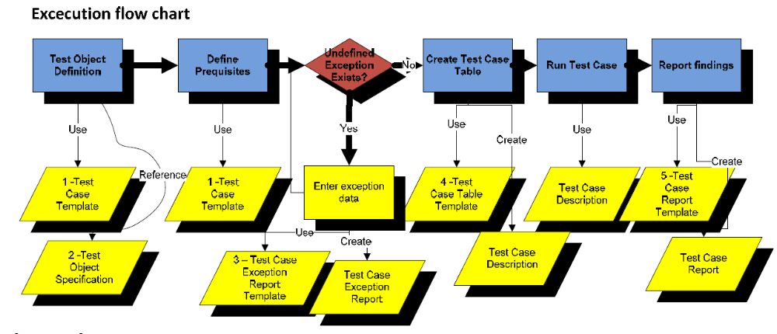

Legend
1 - The Test Case template used to define and set up the Test Case Description.
2 The test object specification provides a reference to the object subject to test or if required, enter a copy of the object description excerpted from the object description for the test object. When referenced, the reference should include at least :
- Business Domain: e.g. Post award procurement
- Business Process: e.g. Payment
- Document Identification: e.g. CEN/ISSS WS/BII Profile 4.doc
3 BII WG4 Test Case Exception Report Template.doc. The template is used to create a Test Case Exception Report reason for the exception, one or more, is entered providing the rationale for not having met the prerequisites prior to test.
4 BII WG4 Test Case Table Template.xls. The Test Case Table Excel Template is used to fill out the core information about the test case, such as input and output prequisites, expected result and more.
5 BII WG4 Test Case Description <Identity>.doc. A Test Case Description document is instantiated using the Test Case Template. The <Identity> placeholder denotes the unique identity for the test.
6 BII WG4 Test Case Report Template.doc. The template is used to create the Test Case Report document, which captures the result of a test.

Note
The Test Case created based on the Test Case Template (this document) and the Test Case Table Template. To resuse headings and previously created content simply create a copy of the template or a previously created Test Case by using Save As fromthe FileMenu in Word and Excel, respectively. Any sections not applicable or redundant might be removed to fit the Test Case at hand.

5.3 Attachment list
Attached are the Test Case deliverables mentioned above.
./1 BII WG4 Test Case Template
./2 BII WG4 Test Case Exception Report Template
./3 BII WG4 Test Case Description Template
./4 BII WG4 Test Case Report Template
PEPPOL Deliverable 5.1a, Test Guidelines Page 33

6 Test Roles

Role | Responsibilities | Manned
Test manager | Govern and lead the tests forward  Conduct test planning Inform and communicate Conduct test report | Rule
Test environment  manager | Establish requirements for the test environment Trouble shooter for the test environment  Responsible that the environment is ready to use when test start | Recommendation
Test data manager | Prepare and set up test data | Recommendation
Test case writer | Write test cases/scripts | Recommendation
Tester | Execute test cases/scripts Order execution of test scripts if tester himself do not have the competence to execute them  Document result of test Report errors Send input when test cases/scripts needs to be improved  Send input when test data needs to be improved | Rule

