

Business Interoperability Specification


OpenPEPPOL AISBL

Pre Award Coordinating Community

ICT - Models

Peppol Business Interoperability Specification

Pre-award guide:
Notification & Two-Stage Procedures

Version: 1.0
Status: Final Version

Statement of copyright

This PEPPOL Business Interoperability Specification (BIS) document is based on the CEN CWA prepared by the BII workshop specified in the Introduction below.
The original CEN CWA document contains the following copyright notice which still applies:
© 2012 CEN All rights of exploitation in any form and by any means reserved worldwide for CEN national Members.

The CEN CWA documents and profiles prepared by the BII workshop are not specific to a business area. Subject to agreement with CEN, customizations have been made by PEPPOL to establish the PEPPOL BIS, detailing and adding further guidance on the use of BII profiles.
OpenPEPPOL AISBL holds the copyright in the customizations made to the original document. The customizations appear from the corresponding conformance statement which is attached to this document. For the purpose of national implementations, customizations covered by the conformance statement may be further refined and detailed by PEPPOL Authorities and/or other entities authorized by OpenPEPPOL AISBL, provided that interoperability with PEPPOL BIS is ensured.
This PEPPOL BIS document may not be modified, re-distributed, sold or repackaged in any other way without the prior consent of CEN and/or OpenPEPPOL AISBL.

Table of Contents

1 Introduction 7
2 Scope 8
2.1 Audience 8
2.2 Peppol specifications in scope of the Notification & Restricted Procedure Guideline 8
2.3 Goals of the Notification & Open Procedure guideline 10
3 Business Environment 10
3.1 Notification procedures in scope of this guideline 11
3.2 Tendering procedures in scope of this guideline 12
3.3 Process control mechanisms in scope of this guideline 14
4 Business Requirements 16
4.1 High level business requirements 16
4.2 Key examples 17
4.2.1 Key example: Notification 17
4.2.2 Key example: Restricted Procedure without use of dynamic purchase system 19
4.2.3 Key example: Restricted Procedure with use of dynamic purchase system 21
Tbd…. 21
5 Business Process 22
5.1 Actors and Roles 22
5.2 Notification & Restricted Procedure Use Cases 23
5.3 Notification & Restricted procedure Business Process 25
5.3.1 Process Map: Notification & Restricted procedure – General process 26
5.3.2 Process Map: Notification & Restricted procedure by using a Dynamic Purchasing System 35
5.4 Notification & Restricted Procedure activity detailed descriptions 36
5.4.1 Activities following the regular process 36
5.4.2 Activities for restricted procedures connected to a dynamic purchasing system (DPS) 40
5.5 Process Control: Tendering Message Response (TMR) 40
6 Implementation of Notification & Restricted Procedure 42
6.1 Peppol BIS - P001 - Procurement procedure subscription 42
6.2 Peppol BIS - P002 - Procurement document access 42
6.3 Peppol BIS - P003 - Tender Submission 42
6.4 Peppol BIS - P004 - Call for Tenders Question and Answers 43
6.5 Peppol BIS - P005 - Tender Clarification 43
6.6 Peppol BIS - P006 - Search Notices 43
6.7 Peppol BIS - P007 - Tender Withdrawal 44
6.8 Peppol BIS - P008 - Publish Notice 44
6.9 Peppol BIS - P009 - Notify Awarding 44
6.10 Peppol BIS - P010 – Tendering Message Response 44
6.11 Peppol BIS - P011 – Tender Qualification 44
6.12 Peppol BIS - P012 –Qualification Response 45
6.13 Peppol BIS - P013 – Invitation to Tender 45
6.14 Peppol Code Lists used in Notification & Open Procedure 45
6.15 Other artifacts used in Notification & Open Procedure 46
External References 47

List of Tables

Table 1: Peppol BISs supporting the Restricted procedure 9
Table 2: Goals of the Notification & restricted Procedure Guideline 10
Table 3: High level business requirements 16
Table 4: Business partners 22
Table 5: Roles & Actors (Standard) 22
Table 5: Special Roles & Actors With use of SPS 22
Table 6:Conditions of the Restricted Procedure 25
Table 7: activity detailed descriptions 38
Table 8: Conditions of the Tendering Message Response 41

List of Figures

Figure 1: Flow of different response messages 14
Figure 2: Flow of Transactions Restricted procedure Key Example 20
Figure 3: Resrtricted procedure use cases 24
Figure 4: Restricted procedure process map (Standard Regime) 26
Figure 6: Notification Process 27
Figure 7: Procurement Document Access process 28
Figure 8: Tender Status Inquiry Process 29
Figure 9: Qualification 30
Figure 10: Invitation to Tender 32
Figure 11: Tender Submission process 33
Figure 12: Awarding Process 34
Figure 5: REStricted Procedure with Dynamic purchasing System 36
Figure 13: Business Process Tendering Message Response 42

Revision history

Version | Date | Author | Organisation | Description
0.1 | 23.10.2023 | Gabriele Dall | Adesso SE | First draft
0.2 | 18.01.2023 | Ansgar Mondorf | Mondorf IT | Final draft
0.3
0.4
0.5
0.6
0.7
0.8
0.9
0.95
0.98
1.0

Contributors
Country | Name | Organization (= Beneficiary – Organization in national consortium – Subcontractor)
DE | Ansgar Mondorf | University of Koblenz-Landau, Mondorf IT
DE | Andreas Schmitz | University of Koblenz-Landau
DE | Gabriele Dall | adesso SE
DE | Rolf Kewitz | Beschaffungsamt des BMI

Abbreviations

Abbreviation | Description
BII | Business Interoperability Interface
BIS | Business Interoperability Specification
br | Business rule
CWA | CEN Workshop Agreement
CEN WS/BII3 | CEN Workshop on Business Interoperability Interfaces for Public Procurement in Europe
CAN | Contract Award Notice
CN | Contract Notice
CA | Contracting Authority
EO | Economic operator
CEN | European Committee for Standardisation
ESPD | European Single Procurement Document
Peppol | Pan-European Public Procurement Online
PIN | Prior Information Notice
P | Profile
PB | Publication Body
SME | Small and Medium Sized Enterprise
eForms | Standard forms for the publication of notices
TED | Tenders Electronic Daily
Trdm | Transaction Data Model

Introduction
Peppol has developed a set of Business Interoperability Specifications (BIS) [Peppol BIS] to support interoperability in the pre- and post-award areas. The scope of Peppol is public procurement but the BISs apply as well to private trade since many private customers use tendering as good business practice. In those cases, official notification of calls and contracts and other transactions are often not applicable [Peppol].
The scope of the Peppol BIS in the domain of Pre-Award is to support the main flows of open as well as two-stage procedures. This includes processes such as publication of notices, search of notices, calls for tenders, tenderer qualification, tenders and awarding notifications. During these processes additional support processes may be executed between contracting bodies and economic operators, such as procurement procedure subscription, call for tenders’ questions and answers, tender withdrawal or tender clarifications. The benefit for users of this guideline in relation to the published Peppol BIS is that it provides a choreography that explains the sequence of two-stage procedures.
All Peppol specifications and guidelines are based upon the directives 2014/24/EU on public procurement and 2014/25/EU on procurement by entities operating in the water, energy, transport and postal services sectors and 2014/23/EU on the award of concession contracts. Supplementary regulations such as Regulation (EU) 2019/1780 establishing standard forms for the publication of notices [eForms] and Regulation (EU) 2016/7 establishing the standard form for the European Single Procurement Document [ESPD] have been considered for the collection of the underlying legal requirements.

This document therefore describes the choreography to execute two-stage procedures using Peppol. Thus, the notification and two-stage procedure guideline is a procedural specification. The guideline does not define individual transactions, but it refers to the already established Peppol BISs and standards, in which the transactions and the transaction information requirements are listed and defined. Even though the guideline is based on a set of PEPPOL BISs, its contents are derived from the agreement of the CEN Workshop on Business Interoperability Interfaces for Public Procurement in Europe [CEN_BII3]. Particularly the CEN Workshop Agreement - E-Tendering - Part 108: Profile BII39 Restricted Procedure (CWA 17027-108:2016) is referenced.
The Peppol guideline for notification and two-stage procedures extends the CWA 17027-108:2016 in the following way. It first introduces the restricted procedure process analogous to CWA 17027-108:2016. This process is used as a reference choreography for a two-stage procedure. However, further choreographies are then illustrated, which can be regarded as variants or derivations of the reference process. The Procurement Directives consider restricted procedures, competitive procedures with negotiation, competitive dialogues, innovation partnerships and dynamic purchasing systems as concrete manifestations of two-stage procedures. Common to these is that contracting authorities make use of the possibility to limit the number of candidates invited to submit a tender [2014/24/EU].
Even though this guideline describes the entire choreography of two-stage procedures, Peppol eTendering service providers may also implement only certain parts or aspects of the procedure guideline. For example, it is possible to implement only the processes up to the provision of the call for tender documents or to exclusively realize processes and transactions that support the publication and search of notices (eNotification). However, it should be noted that individual process steps should be implemented in sequential order, starting from the beginning of the process, as the process steps depend on each other. It is therefore not possible to implement just a single BIS, such as Tender Withdrawal, without having implemented the BIS Tender. It is also recommended to implement the simple form of an open procedure first before going further and implement a more complex two-stage procedure variant. This would be good practices since the two-stage procedure reuses all transactions that have to be implemented for the open procedure. Conversely, this does not apply. The guideline for open award procedures can be found at [Pre-Award Open Procedure]
The two-stage procedure guideline is structured as follows. It illustrates the scope (section 2), the business environment (section 3), the business requirements (section 4), the business process choreography (section 5) and the Peppol artifacts (section 6) to implement an open procedure based on Peppol.

Scope

Audience
The audience for this document is organizations wishing to be Peppol enabled for exchanging pre-award business documents, and/or their ICT-suppliers. These organizations may be:

- Service providers
- Contracting Authorities
- Economic Operators
- Publication Bodies
- Software Developers

More specifically, it is addressed towards the following roles:
- ICT Architects
- ICT Developers
- Business Experts

For further information on Peppol/OpenPeppol please see [Peppol About].

Peppol specifications in scope of the Notification & Two-Stage Procedure Guideline
Peppol pre-award enables trading partners to exchange standards-based electronic eTendering documents over the Peppol network (based on a 4-corner model) [Peppol eDelivery]. These documents are described as profiles, the PEPPOL Business Interoperability Specifications (BIS) [Peppol BIS], and depict business process like the search of notices, the publication of call for tenders, the submission of tenders, etc.
The Peppol BISs in the pre-award domain have been developed by the OpenPEPPOL AISBL Pre-Award Domain Community (PrAC) and are published as part of the Peppol specifications [Peppol Pre Award]. The Peppol BIS in the pre-award constitute the specifications that frame the execution of eTendering procedures [Peppol eTendering].
The Peppol pre-award BISs and transactions referenced in this guideline are intended to be exchanged between the tendering systems of economic operators and contracting bodies. This means that it is expected that the parties have connected their systems to the internet, and that they have middleware in place to enable them to send and receive the Peppol transactions in a secure way, using an agreed syntax and the Peppol network.
In order to implement the Peppol profiles and transactions, however, further guidelines must be considered, in particular:
- Use of transport specifications are described in the BIS eDelivery guide for pre-award [Pre Award eDelivery]
- Use of cryptographic specifications are described in the BIS eDocuments guide for pre-award [Pre Award eDocuments]
The content model of the Peppol transactions can be used in procurement platforms or portals, so that these platforms as well as procurement systems of economic operators and contracting bodies are based on the same information and process models, which makes them interoperable. Even if platforms are not technically interoperable (e.g. not yet connected to the Peppol network), the processes and content models facilitate a common understanding.
The two-stage procedure guideline references and arranges various Peppol BISs in the pre-award domain to describe coherent behavior regarding the execution of two-stage procedures using Peppol. It thereby points to variants such as restricted procedures, competitive procedures with negotiation, competitive dialogues, innovation partnerships and dynamic purchasing systems. The use of Peppol pre-award BISs for Open Procedures is described in the Peppol BIS pre-award guide - Notification and Open Procedure [Pre-Award Open Procedure].
The set of Peppol BISs for supporting two-stage procedures in the pre-award area are collected at [Peppol Pre-Award]:
Table 1: Peppol BIS supporting the Two-Stage procedure
PEPPOL Profile  ID | Profile name | CEN Profile ID | PEPPOL  Transaction ID | PEPPOL Transaction name | CEN Transaction ID
P001 | Procurement procedure subscription | BII46 | T001 | Subscribe to Procedure | Trdm81
 |  |  | T002 | Subscribe to Procedure Confirmation | Trdm82
 |  |  | T022 | Unsubscribe from Procedure Confirmation | Trdm107
P002 | Procurement document access | BII60  BII47 | T003 | Tender Status Inquiry | Trdm97
 |  |  | T004 | Call for Tenders | Trdm83
P003 | Tender Submission | BII54 | T005 | Tender | Trdm90
 |  |  | T006 | Tender Reception Notification | Trdm45
P004 | Call for Tenders Questions and Answers | BII48 | T007 | Tender Questions | Trdm84
 |  |  | T008 | Tender Answers | Trdm85
P005 | Tender Clarification | BII50 | T009 | Tender Clarification Request | Trdm84
 |  |  | T010 | Tender Clarification | Trdm85
P006 | Search Notice | BII45 | T011 | Search Notice Request | Trdm99,
 |  |  | T012 | Search Notice Response | Trdm100, Trdm78, Trdm79, Trdm80
P007 | Tender Withdrawal | BII53 | T013 | Tender Withdrawal | Trdm89
 |  |  | T014 | Tender Withdrawal Notification | Trdm45
P008 | Publish Notice | BII10, BII14, BII43 | T015 | Publish Notice (Contract Notice) | Trdm78, Trdm79, Trdm80
 |  |  | T016 | Notice Publication Response | Trdm065
P009 | Notify Awarding | BII58 | T017 | Awarding Notification | Trdm94
P010 | Tendering Message Response | BII Architecture 107 | T018 | Tendering Message Response | BII Architecture 107
P011 | Qualification | BII49 | T019 | Qualification | Trdm86
 |  |  | T020 | Qualification Reception confirmation | Trdm042
P012 | Qualification Response | BII51 | T023 | Qualification Response | Trdm87
P013 | Invitation to Tender | BII52 | T024 | Invitation to tender | Trdm88
 |  |  | T003 | Tender Status Inquiry | Trdm97

Goals of the Notification & Two-Stage Procedure Guideline
The main business benefits to be gained by implementing this guideline is the execution of two staged procedures. The goals are described below.

Table 2: Goals of the Notification & Two-Stage Procedure Guideline
ID | Description
G39-001 | Reduce human errors and resources - Automated matching of the Tender with the Call for Tender document should eliminate human keying errors and facilitates redeployment of resources.
G39-002 | No previous bi-lateral setup or agreements. Required - Parties (economic operators and contracting bodies) should communicate without a previous bi-lateral setup or agreements.
G39-003 | Facilitate Automated Tender Preparation - e-Tendering/e-Submission solutions should allow Economic Operators (semi)automatically to generate a tender based on the information defined in call for tenders documents
G39-004 | Transparency - The contracting body wants to obtain the best value-for-money by maximising the transparency of its tender procedures in order for economic operators to easily find this business opportunity.
G39-005 | Equal treatment - The contracting body has the obligation to treat all economic operators equally during the whole tender procedure.
G39-006 | Competition - The contracting body wants to obtain the best value-for-money by maximising the competition among bidders.
G39-007 | Insurance bid - The economic operator wants insurance that his bid is valid and has been received by the contracting body within the time limit set out in the tender documents.
G39-008 | Efficiency - The contracting body wants to increase efficiency in the business process, e.g. when evaluating the received bids, in order to save time and costs.
G39-009 | Interoperability - The Member state policymakers want interoperability between all tendering solutions in order to facilitate one single European Market because the better interoperability the more bids.
G39-010 | Equal access - economic operators want equal access to all public procurement business opportunities.
G39-011 | Integrity of the bid - The contracting body and the economic operator want insurance that the integrity of the bid is secured, i.e. insurance of accuracy and consistency when storing and retrieving data.
G39-012 | Authentication - The contracting body wants insurance that it is dealing with real economic operators during the tender procedure.
G39-013 | Legal valid bid - The contracting body wants insurance that the bid is signed by persons mandated by the economic operators therefore being a legally valid bid.
G39-014 | Administrative burdens - The Member state policymakers want to lower the administrative burden in public procurement for economic operators and contracting bodies.
G39-015 | Re-use of information - The economic operator re-uses as much information and documents as possible when preparing a bid in order to save time and costs.
G39-016 | Standards - The economic operator wants to receive as much as possible standardized tender documents, in order to easily understand the content and to easily respond by creating a tender and to respond with standardized evidence and product information that are requested.
G39-017 | Accountability - The contracting body - being accountable for the procedure - doesn't want to make mistakes during the whole tender procedure.

Business Environment
This guideline is intended to support transmission of electronic documents for processing (semi-)automated open procurement procedures. The legal requirements that were taken into account are requirements from European legislation, in particular the EU Directives on public procurement 2014/24/EU, 2014/25/EU, 2014/23/EU and 2009/81/EG.

Additionally, supplementary regulations such as Commission Implementing Regulation (EU) 2019/1780 establishing standard forms for the publication of notices [eForms] and Commission Implementing Regulation (EU) 2016/7 establishing the standard form for the European Single Procurement Document [ESPD] have been considered relevant for the collection of legal requirements.

The descriptions in this section describe the business environment of a restricted procedure. As described before, the reference choreography for two-stage procedures is based on the restricted procedure. Thus, also the business environment and subsequent descriptions are firstly directed to the restricted procedure. Later on, further procedures are introduced, which can be seen as variations of two-staged procedures.

The illustration of the business environment points to the relevant Peppol BISs that depict a particular business process. Additionally, the guideline references the underlying CEN BII3 Workshop Agreement. The CEN BII3 workshop is a standardisation initiative within CEN (European Committee for Standardisation). It provides a framework for interoperability in pan-European electronic transactions expressed as a set of technical specifications ("Profiles") [CEN_BII3].

The profiles provided by CEN BII3 and Peppol are designed to facilitate effective public e-procurement based on a modular approach for implementation, with a focus on global interoperability. Thereby, BII profiles can be seen as “agreements” on message contents and business processes and are the baseline for many Peppol BISs which add specific technical implementation perspectives that are further illustrated in section 6. Thus, the CEN profile descriptions rather focus on the core choreographies, transactions and information elements that typically cater to the majority of user requirements applicable across Europe and lower the need for detailed bilateral agreements between the trading partners whereas Peppol provides a framework for their implementation and adaption.

Notification procedures in scope of this guideline
Official notification through publishing bodies is part of many procurement procedures. Many pre-award opportunities first become visible to the economic operators in the form of notices describing upcoming or current procurement procedures (prior information notices or contract notices). At the end of a procedure, a contract award notice about the result of the procedure is published.
eNotification covers the transfer of electronic procurement notices for publication and dissemination with the ultimate aim of opening business opportunities. eNotification profiles are addressed to all those who exchange procurement notices for publication and further information processing. eNotification is therefore generally addressed to eTendering Plattform Providers, Contracting Bodies, publishers, print shops, information brokers or monitoring and statistical services. eNotification can be carried out at various levels and between different levels (regional, state, European etc). The legal obligation of publishing notices at the correct level is the responsibility of the contracting bodies.
The content model of procurement notices in Europe is based on Commission Implementing Regulation (EU) 2019/1780. It links to Directive 2014/23/EU, Directive 2014/24/EU, Directive 2014/25/EU and Directive 2009/81/EG and their annexes, particularly the annex describing the standard forms to be used for the publication of procurement notices. eForms are at the core of the digital transformation of public procurement in the EU. Through the use of a common standard and terminology, they can significantly improve the quality and analysis of data. Well-implemented eForms increase the ability of businesses and other organisations to find opportunities. They will also reduce the administrative burden for buyers, increase the ability of governments to make data-driven decisions about public spending, and make public procurement more transparent.
eNotification covers the electronic transfer of electronic notices for publication and dissemination services. The publication of notices is executed between a contracting body or his representative and a publisher. CEN WS/BII 3 profiles BII14 Prior Information Notice (CWA 17026-102), BII10 Contract Notice (CWA 17026-101) and BII43 Contract Award Notice (CWA 17026-103) describe the exchange of notices between a contracting body or his representative and a publisher. In Peppol, these profiles are covered by the Peppol BIS P008 Publish Notice which provides electronic messaging support to publish a prior information notice, a contract notice or a contract award notice. Thus, Peppol BIS P008 Publish Notice helps contracting bodies to announce business opportunities and contract awards in public procurement procedures.
In the EU, eForms are used to publish notices above threshold on Tenders Electronic Daily (TED)—an online portal for public procurement notices from across the EU. On the national level public procurement decision makers can benefit from eForms through tailoring and defining a national approach to the various aspects of eForms, e.g. using them for contracts below thresholds, considering different policies and requirements.
The Peppol BIS P006 Search Notice supports a process by which a notification platform can be queried along a set of parameters to find relevant notices and related metadata required by other PEPPOL BISs. The profile is based on CEN WS/BII 3 Profile BII45 Search Notice (CWA 17026-104:2016). The transactions, specified in BIS P006 Search Notice are intended to be exchanged between eTendering systems and Publication Bodies but they can be adopted by many other actors. Since the P006 Search Notice provides access to Open Data, it also provides possibilities for the establishment of new business models that allow monitoring, the provision of statistical information or easy access for economic operators to business opportunities in different countries across eTendering and eNotification platforms.
In order to execute the Peppol BIS P008 Publish Notice and Peppol BIS P006 Search Notice, it is necessary that the parties have Peppol eDelivery in place to enable them to send and receive the transactions in a secure way. Implementers must also support eForms content model because the transactions are based on the EU-wide eForms standard.

Tendering procedures in scope of this guideline
For the purpose of initiating electronic tendering via Peppol, the Peppol BIS P006 Search Notice plays a significant role. When the contracting body has published a notice, the interested economic operators who finds it may want to subscribe to this procedure by using PEPPOL P001 Procurement procedure subscription based on BII46 Subscribe to Procedure. Thereby, the Profile P006 Search Notice delivers necessary organisational and technical information to identify the procedure and contracting authority. This information is required by Peppol implementers because the request for procurement procedure subscription must be directed to the entity responsible for the procurement procedure.
eTendering can be put in place using different procedures, depending on the value and the type of the contract to be awarded, on the legal nature of the contracting body and on specific member state national legislation (Directive 2014/24/EU art. 26). Article 26 to 32 from Directive 2014/24/EU and article 43 to 50 from Directive 2014/25/EU describe the different tendering procedures that can be used by contracting bodies. For the purpose of electronic tendering, some of these procedures have been described in CEN WS/BII 3 BII37 Open Procedure (CWA 17027-106) and CEN WS/BII 3 BII39 Restricted Procedure (CWA 17027-108).
In open procedures, any economic operator can access the call for tenders documents and submit a tender before the time expires, without any previous assessment of their capabilities. In restricted procedures, competitive dialogue procedures, innovation partnerships and negotiated procedures with prior call for competition, contracting entities shall simultaneously and in writing invite the selected candidates to submit their tenders, to take part in the dialogue or to negotiate. Before the Invitation to Tender, there is usually a qualification phase for the candidates
The sequence and orchestration of the process steps specified in the Peppol BIS can be put into the following principal logical context. When the contracting body has published a notice, the interested economic operators may subscribe (and later if necessary unscubsribe) to obtain (or not obtain) tendering information using profile CEN WS/BII 3 BII46 Subscribe to Procedure (CWA 17027-111) covered by Peppol BIS P001 Procurement procedure subscription.
Once the interested economic operator has subscribed to an open procedure, the contracting authority provides the procurement documents by using Peppol BIS P002 Procurement document access. The BIS P002 is based on CEN WS/BII 3 BII60 Tender Status Inquiry (CWA 17027-123) and CEN WS/BII 3 BII47 Call for Tenders (CWA 17027-112) and provides the call for tender documents. It can be repeated at any time until the tender submission deadline to receive the latest version of the procurement documents. Additionally, contracting authorities must push updates to the economic operators that subscribed to a procedure.
Within the call for tenders, contracting authorities must inform economic operators how to qualify for the procedure. This may be done by an European Single Procurement Document (ESPD) defined by the Commission Implementing Regulation (EU) 2016/7 for which Peppol develops the BIS ESPD 3.0 based on the ESPD Exchange Data Model version 3.0. Additionally, call for tenders may include pre-award catalogue information to describe products and services in a common format allowing economic operators to send offers in a structured way and contracting authorities to evaluate products and services automatically through their tendering tools. The Peppol BIS P035 Pre-Award Catalogue can be used for this purpose and was defined according to the CEN WS/BII 3 Profile BII35 Advanced Tendering with Pre-award Catalogue.
In two-stage procedures like, restricted procedures, competitive dialogue procedures, innovation partnerships and negotiated procedures with prior call for competition, the selection and exclusion criteria for the qualification phase are communicated in a first step to the economic operator by using BIS P002 based on CEN WS/BII 3 BII60 Tender Status Inquiry (CWA 17027-123) and CEN WS/BII 3 BII47 Call for Tenders (CWA 17027-112). Up to this point, the sequence of Peppol BIS is analogous to the open procedure. However, the content is restricted to qualification selection information and the following steps are different too.
The submission of qualification information in the subsequent step is executed using profile CEN WS/BII 3 BII 49 Qualification (CWA 17027-114) covered by PEPPOL BIS P011 Qualification. The contracting body notifies the economic operator of having received the qualification documents. After the qualification selection, all economic operators are informed about the results by the contracting authority using profile CEN WS/BII 3 BII 51 Qualification Rejection (CWA 17027-116) reflected by PEPPOL BIS P012 Qualification Response. In two-stage procedures the contracting authority will send an invitation to tender (second step) only to the identified candidates which have been selected after the qualification phase using profile CEN WS/BII 3 BII52 Invitation to Tender (CWA 17027-117). The invitation to tender provides the procurement document and possibility to submit a tender. It is captured by the PEPPOL BIS P013 Invitation to Tender.
Once the economic operator has received the call for tenders or invitation to tender, it can use the Peppol BIS P004 Call for Tenders Questions and Answers for the business process of answering questions about the procurement document or qualitative selection. The BIS P004 is based upon CEN WS/BII3 profile BII48 Call for Tenders Questions and Answers (CWA 17027-113) and supports economic operators to clarify open questions until the submission deadline. Answers of the contracting authority then have to be sent to all economic operators that subscribed to the procedure and additionally the call for tenders (or invitation to tender) should be updated and pushed to the (qualified) subscribers of the procedure.
In case the economic operator decides to submit a tender, he can use the Peppol BIS P003 Tender Submission. After the submission of a tender, the contracting body notifies the economic operator of having received the tender. The BIS P003 is based upon CEN WS/BII3 profile BII54 Tendering (CWA 17027-119). On the contrary, economic operators can decide to withdraw a tender (or qualification) that was previously submitted by using the Peppol BIS P007 Tender Withdrawal. The BIS P007 was derived from CEN WS/BII3 profile BII53 Tender Withdrawal (CWA 17027-118) and provides electronic messaging support for the economic operator to withdraw a tender or the submitted qualification documents. The contracting body notifies the economic operator of having received the tender withdrawal message. After the tender withdrawal, an economic operator may submit a new offer (or new qualification documents) at any time before the tender submission deadline.
On the opening date, the contracting authority gathers and opens all received tenders (or qualifications). The opening board members can now evaluate the received tenders (or qualifications). If questions about specific offers (or qualifications) arise during the course of the evaluation, they can be answered through the Peppol BIS P005 Tender Clarification. The BIS P005 supports the contracting authority to clarify questions on a tender (or qualifications) which has been submitted. The BIS P005 was defined according to the requirements gathered by the CEN WS/BII3 profile BII50 Tender Clarification (CWA 17027-115).
At the end of the evaluation process, the contracting authority needs to inform the participating economic operators upon the results of the tender evaluation. For this purpose, contracting authorities can use the Peppol BIS P009 Notify Awarding which provides electronic messaging support to inform the bidders that a contract has been awarded. The BIS P009 is based upon the CEN WS/BII3 profile BII58 Notify Awarding (CWA 17027-121). The contracting authority can use BIS P009 Notify Awarding to inform the winner(s) at the same time as they inform the unsuccessful tenderers and they must individually declare the reasons why they failed. The notification of the awarding decision initiated by BIS P009 Notify Awarding shall also start the standstill period clock. After the stand still period, the contracting authority can finalize the contract with the winning supplier and also send a contract award notice using BIS Peppol BIS P008 Publish Notice.

Process control mechanisms in scope of this guideline
The purpose of the "PEPPOL BIS Profile P010 - Tendering Message Response" is to describe a common format for a response message that can be used in eTendering procedures. The Tendering Message Response (TMR) shall facilitate an efficient implementation and increased use of electronic collaboration between eTendering platforms. It improves reliability by allowing a receiver of a business document to inform the sender about the results of receivers’ validations and processing success, and in case of negative results, to inform the sender about the nature of the errors as well as their details. The TMR than may allow the sender of the document to take appropriate action.

In a nutshell, the "PEPPOL BIS Profile P010 - Tendering Message Response" is a transaction that adds processing exceptions that may occur on the business level of eTendering in any PEPPOL eTendering BIS.

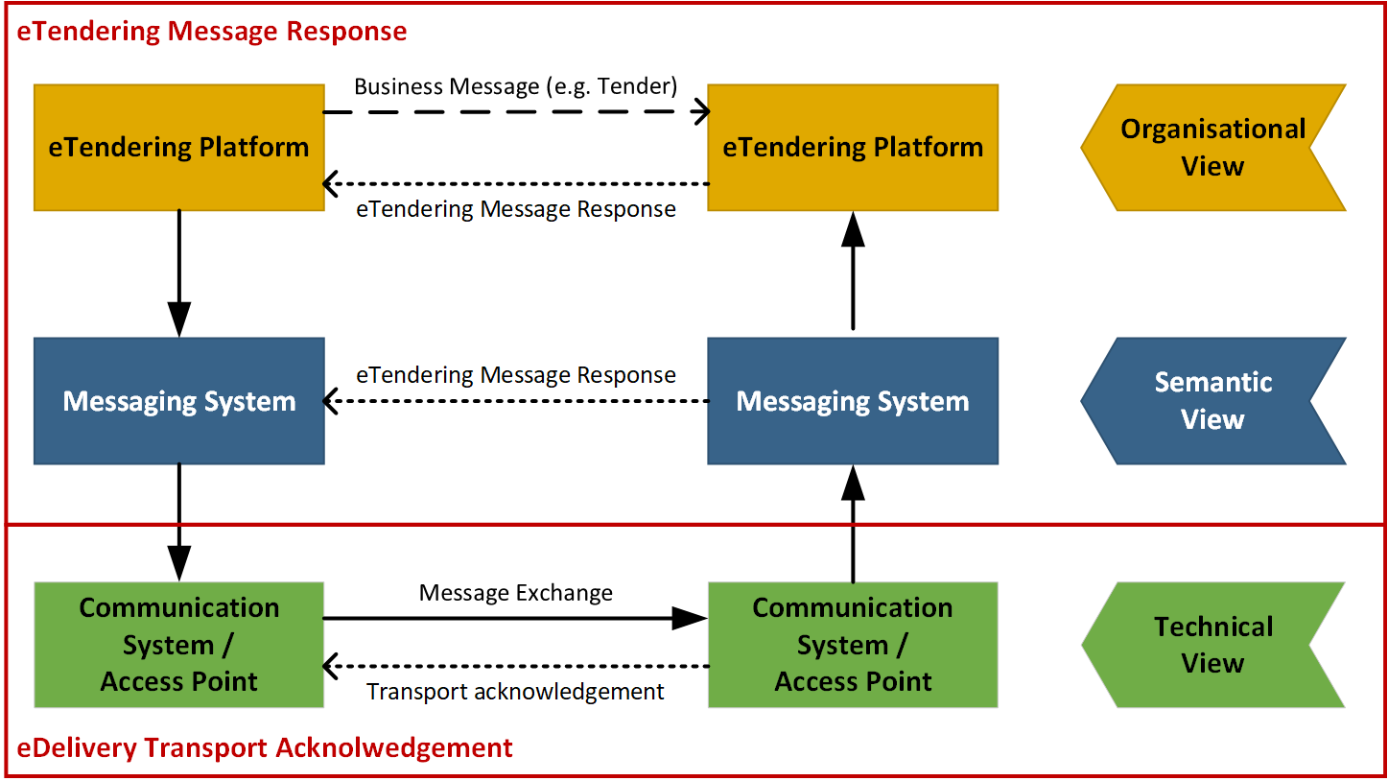
Figure 1: Flow of different response messages

The figure above illustrates the different views where TMR are used. Whereas the technical view is addressed by transport acknowledgements, the TMR is applied to the semantic view (including syntactical aspects) as well as the organizational view of the eTendering process.

Technical View

These are messages that are exchanged within the transport network(s) to inform about the process of carrying a message down the transport line. These responses may inform someone up-line that the delivery to a given point was successful or not and may contain details about issues that are relevant such as why a delivery was not successful. The key nature of these responses is that they do not in any way act on result of validation or processing of the content of the payload that is being transported. These response messages are commonly called “acks” or transport acknowledgements.

Semantic View

When a message has reached a given point in the transport line its content may be validated according to agreed specifications that may be both syntactical and semantic. The outcome of these validations may be reported to a relevant party up-line, informing him whether the validation was successful or not as well as giving some details. An example could be that a tender message that is received is rejected because it is missing a closing tag (syntax error) or because the Economic Operator is not identified by its party and endpoint identifiers. A key nature of these messages is that they report on the message content on the basis of the technical specifications that apply.

Organisational View

A message that has been received and accepted for processing may call for an action on the receiver’s behalf. That receiver’s action may need to be reported back up-line to a relevant party. An example is that a technically correct tender may be received but the receiver decides to reject the tender for any business reason such as expired tender submission deadline, a missing authorization to submit a tender etc. The key nature of these responses is that they report a business decision that is made on the message instance received.

Business Requirements

High level business requirements
Table 3: High level business requirements
Req. ID | Requirement statement | Ref. to goal
BR-001 | All transactions in the procurement procedure, such as subscribe to procedure or status inquiry, and documents, such as call for tenders or catalogues, should be based on common standards. | G39-002
BR-002 | Being interoperable means business partners shall implement the basic level. To fully exploit e-procurement possibilities business partners should implement the advance level.  Presently some individual transactions (or small groups of transactions) have been published as profiles. Some contracting bodies and economic operators may wish to state conformance to just that level of granularity (e.g., Tendering Simple), instead of to the entire process. | G39-003
BR-003 | The value of digitization lies in the implementation of all transactions in a procedure. A contracting body shall therefore be able to enforce a business process (tendering procedure), consisting of multiple transactions, on economic operators. Both contracting bodies and economic operators shall be able to state conformance of their system to the entire process. | G39-002
BR-004 | Code lists shall be consistent for all transactions in a complete procedure. | G39-016
BR-005 | When the contracting body publishes structured information, it requires a structured response; when the contracting body publishes unstructured information it requires an unstructured response. So the entire procedure is either on the basic level or on the advanced level. | G39-019
BR-006 | For contracting bodies and economic operators to be able to process individual transactions, they (or their systems) need to know to what business process the transaction belongs to. The process type and the process instance need to be identified at two levels: the level of the procedure and the level of the profile. | G39-020
BR-007 | All economic operators should be able to query publication portals (where the contract notices are being published) to find interesting business opportunities. | G39-005
BR-008 | All economic operators shall be able to access public tender documents. | G37-005
BR-009 | The economic operator shall optionally be able to subscribe to an interesting business opportunity in order to receive the latest information about the call for tender. | G39-004
BR-010 | All subscribed economic operators should be informed when new versions of the tender documents are published. | G39-004
BR-011 | All economic operators should be able to send questions regarding the tender documents to the contracting body. | G39-010
BR-012 | The contracting body shall answer the questions from economic operators equal and transparent. | G39-010
BR-013 | The contracting body shall be able to send messages to all subscribed economic operators, to a selection of economic operators or to one economic operator. | G39-010
BR-014 | The economic operator shall be able to withdraw his bid as long as the time limit to submit bids has not passed. | G39-007
BR-015 | The contracting body should be able to send the results of the bid evaluation to all economic operator who submitted a bid. | G39-005
BR-016 | The contracting body should be able to award the winning economic operator. | G39-006
BR-017 | The Contracting Body SHALL invite to tender only selected candidates. | G39-008
BR-018 | The economic operator MAY NOT submit a tender if he has not been invited to. | G39-008
BR-019 | Economic operators that do not respect the exclusion or selection criteria MUST be informed that they have not been selected at the same time as the selected are informed and receive the invitation to tender | G39-008

Key examples
This section illustrates key examples for the notification and execution of a restricted procedure using Peppol. Thereby, the first examples focus on the particularities of the notification process, being a particular part of any procurement procedure. The second example then concentrates on the actual business process of the restricted procedure itself and thereby generalizes the part of the publication.

Key example: Notification
This section illustrates a key example for the execution of a notification procedure using Peppol. The initial diagram is accompanied by a textual description. Both, illustrate the flow of transactions that are send between the actors and components. The actors and components involved in this scenario are:

- The contracting body PublicHealthBerlin from Germany
- The eTendering platform PublicPurchase used by PublicHealthBerlin
- A national notification system used by PublicHealthBerlin
- The European notification platfrom Tenders Electronic Daily (TED) operated by the publication office
- The economic operator LisbonMedical from Portugal
- The eTendering platform PowerSeller used by LisbonMedical

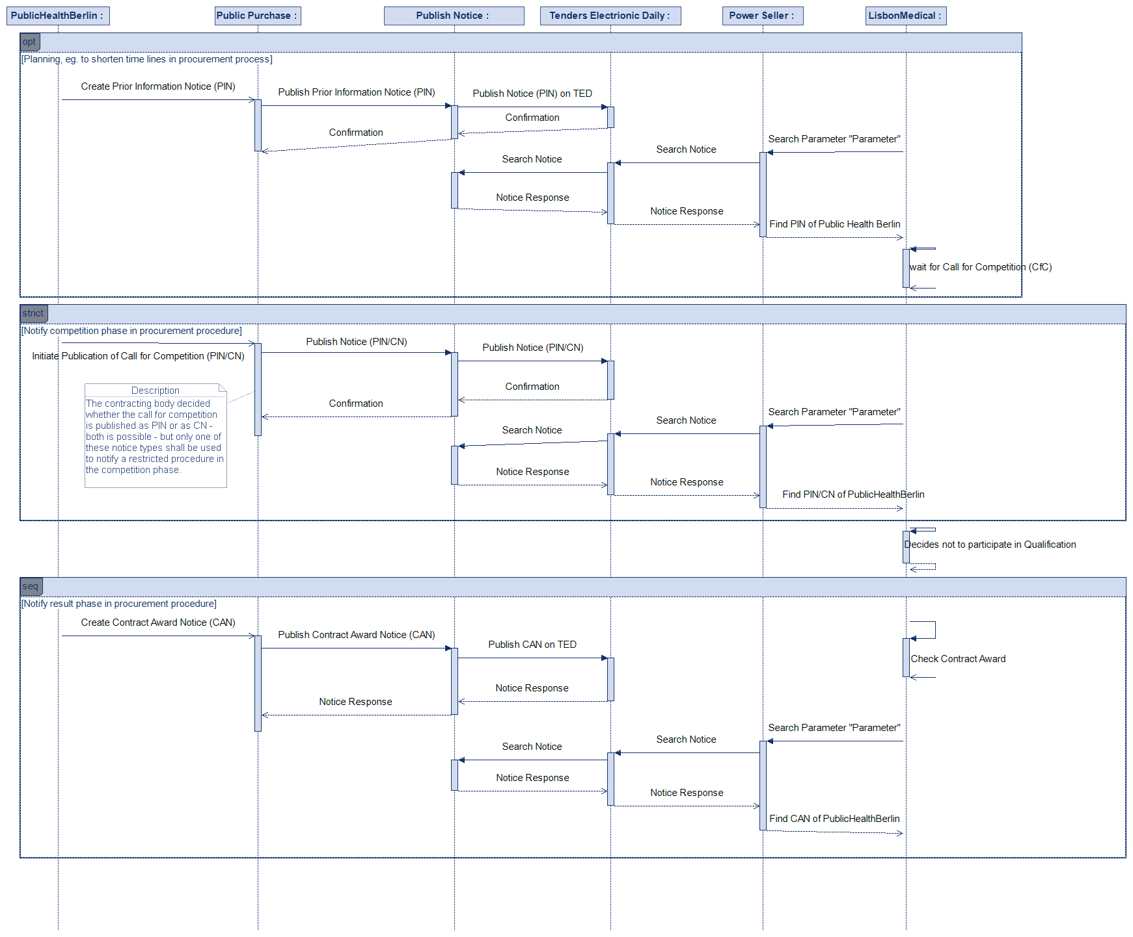
Figure 2: Flow of Notifications Restricted procedure Key Example

Prior Information Notice (PIN) to be used als planning information
The contracting body PublicHealthBerlin from Germany starts a tendering procedure because it wants to buy Covid‑19 Test Kits from any European supplier. To shorten the competition phase, it starts to prepare a prior information notice (PIN) in its eTendering platform PublicPurchase. The PIN is defined along the eForms format and contains details about the project such as the place of performance, the duration and the estimated value of the procurement. All information about the contracting body are included in the notice. Once the PIN has been created on the eTendering platform PublicPurchase, the platform uses its Peppol interface to publish the notice on the National Notification System. The National Notification System confirms the reception of the PIN to the system PublicPurchase used by PublicHealthBerlin. In Germany, the National Notification System is responsible for publishing all announcements of PublicHealthBerlin to the European publication platform Tenders Electronic Daily (TED) operated by the Publication Office. In this scenario, TED also offers a Peppol interface, so that it can receive the PIN via Peppol from the National Notification System. TED confirms the reception of the PIN to the National Notification System which in turn forwards the result of publication to the contracting body PublicHealthBerlin.

The different Notification Platforms TED and National Notification System can be queried by economic operators and/or their eTendering Platforms across Europe to find business opportunities through Peppol. The economic operator LisbonMedical from Portugal uses the Peppol enabled eTendering platform PowerSeller. Through the platform PowerSeller, the supplier LisbonMedical queries TED and the National Notification System along the parameter “Covid-19”. Due to the pandemic, the search on the platforms results in several notices. The platforms answer the search request by sending the matching notices to the tendering system PowerSeller. LisbonMedical finds the business opportunity and PIN from PublicHealthBerlin described above. The notice presents details about the project (ID of the procurement procedure, text description, NUTS codes for location, CPV code for procurement items). LisbonMedical is interested in the tender, notes the “ID of the procurement procedure” and is waiting for the publication of the contract notice.

Contract Notice (CN) or PIN as Call for Competition

After the publication of the PIN, the contracting body PublicHealthBerlin starts to prepare the relevant documents required to publish with a Call for Tender, in this case used as Call for Competition (which is possible to be pulished as Pin or as CN). Both Document are published in its eTendering platform PublicPurchase.
Together with the call for competition notice, the contracting body also prepares the qualification documents. The qualification documents – which can be regarded as procurement documents in this step – contain a detailed description of the procedure and list all qualification criteria which need to be proven by economic operators who apply for the tendering procedure. Once the PIN or CN has been published on the eTendering platform PublicPurchase, the platform uses its Peppol interface to publish the PIN or CN on the National Notification System. The National Notification System confirms the reception of the PIN or CN to the system PublicPurchase used by PublicHealthBerlin. Simultaneously, the National Notification System uses its Peppol interface in order to send a request for publication of the PIN or CN to the European publication platform TED. TED confirms the reception of the PIN or CN to the National Notification System which in turn forwards the result of publication to the contracting body PublicHealthBerlin.

After a while, the supplier LisbonMedical queries all Peppol enabled notification systems along any publication with reference to the formerly published PIN that informed about the planned restricted procurement procedure. The National Notification System and TED answers the search request by sending the searched notice when found to the tendering system PowerSeller. LisbonMedical reads through details of the project and decides not to participate because some requirements of the tenderer’s qualifications list are not met by LisbonMedical.

Having received tenderer’s qualification documents and evaluating them, the contracting body creates a shortlist of qualified tenderers and invites them directly to the main tendering process by sending out the procurement documents directly to those chosen tenderers. During this step, not more notifications will be sent through any notification system.

Contract Award Notice (CAN)

After the contract award, the contracting body PublicHealthBerlin creates the Contract Award Notice (CAN) in the format of eForms. Once the stand-still period has ended, the eTendering platform PublicPurchase uses its Peppol interface to publish the CAN on the National Notification System which in turn forwards the CAN to TED. Both notification systems confirm the reception of the CAN whereas the National Notification System forwards both results of publication to the contracting body PublicHealthBerlin.

The supplier LisbonMedical is interested in the results of the contract award because it wants to learn about the products features and success of its competitors. Thus, the supplier LisbonMedical queries all Peppol enabled notification systems along the “ID of the procurement procedure” that was announced by the PIN and the CN. The platforms answer the search request by sending the notice matching the ID to the tendering system PowerSeller. The received CAN contains details about the procurement procedures (delay, award criterion, number of candidates) and the awarded contract. LisbonMedical finds out that its biggest competitor has won the contract.

Key example: Restricted Procedure
This section illustrates a key example for the execution of a restricted procedure using Peppol. The initial diagram is accompanied by a textual description. Both, illustrate the flow of transactions that are send between the actors and components. The actors and components involved in this scenario are:

- The contracting body PublicHealthBerlin from Germany
- The eTendering platform PublicPurchase used by PublicHealthBerlin
- An undefined set of European (e.g. Tenders Electronic Daily) and national Notification Platforms (they remain in this sequence diagramm although it seems as if they were not participating any more – but their communication part is only hidden by the combined fragments referencing to the notification diagram)
- The economic operator LisbonMedical from Portugal
- The eTendering platform PowerSeller used by LisbonMedical

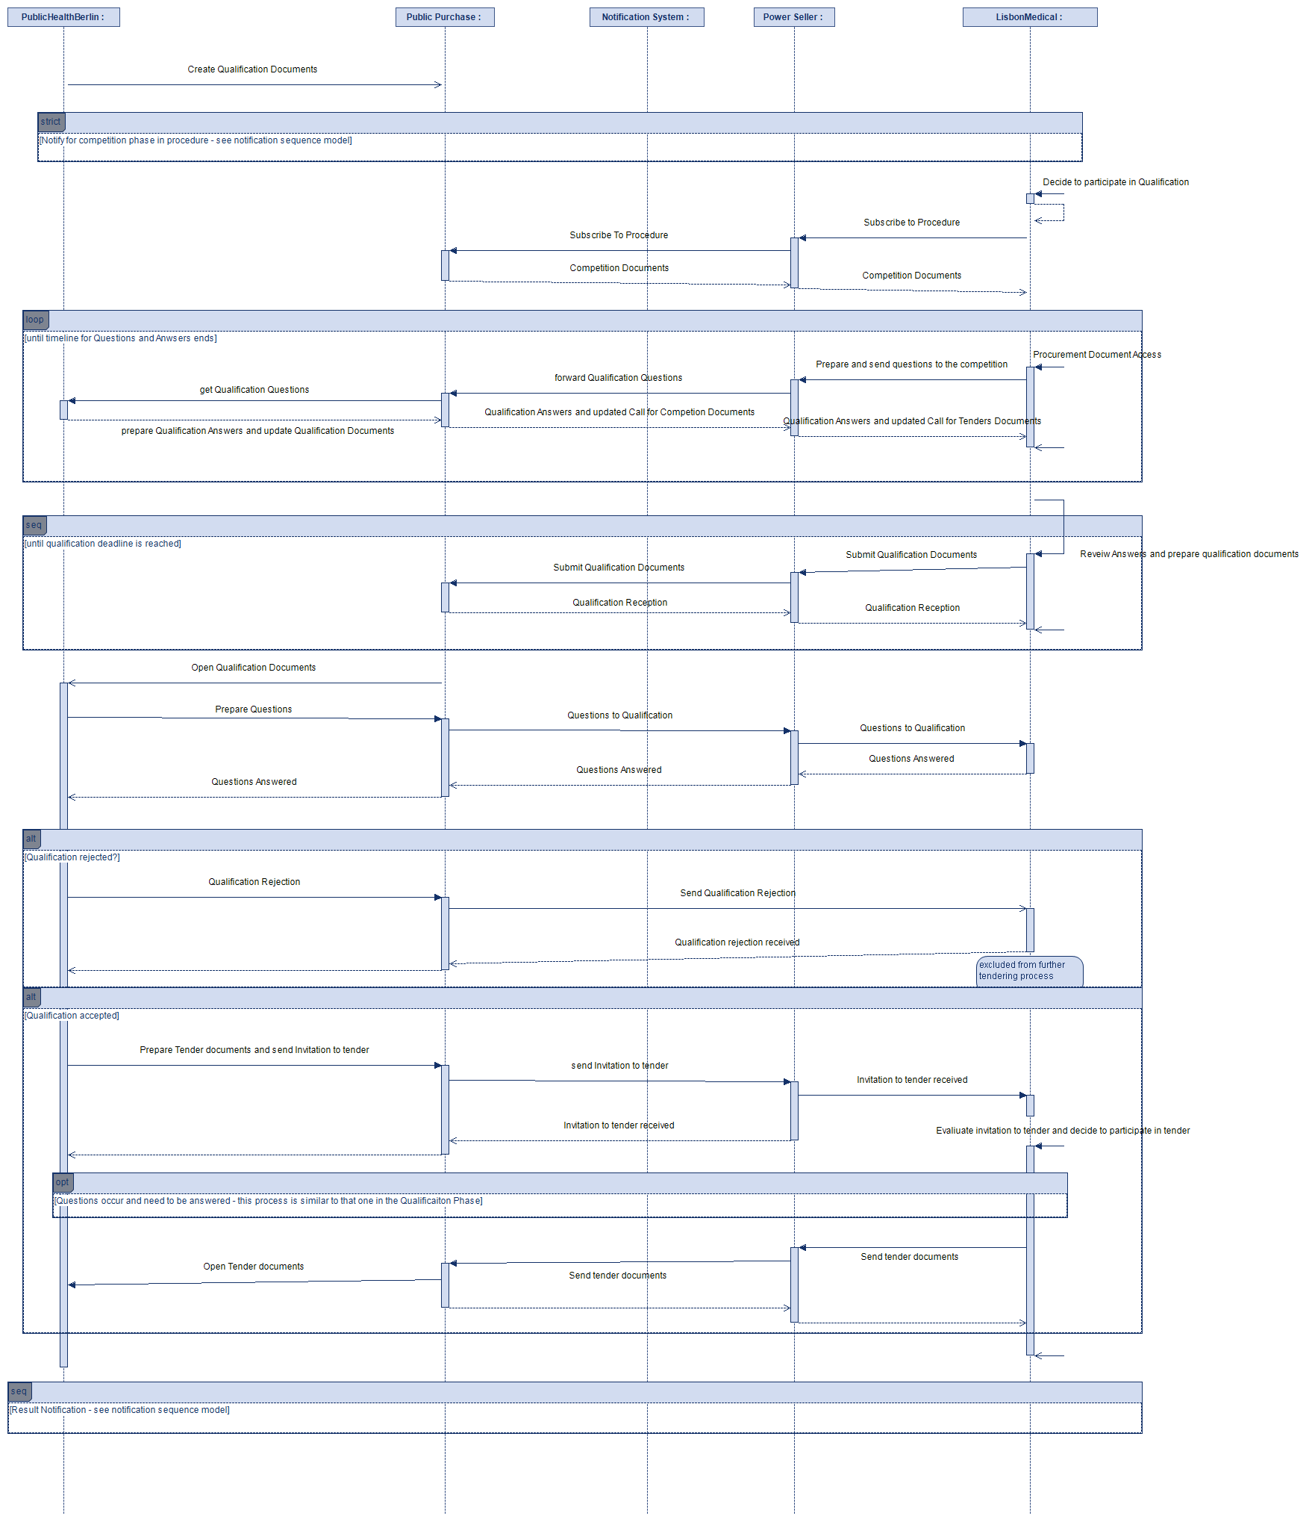
Figure 3: Flow of Transactions Restricted procedure Key Example

Preparation Phase
The contracting body PublicHealthBerlin from Germany starts a tendering procedure because it wants to buy Products or Services from any European supplier and choses a restricted procurement procedure. At first, it starts to prepare the relevant procurement documents in its eTendering platform PublicPurchase, the prior information notices, the contract notice and the call for competition, in any proprietary format.

As part of this process, the contracting body specifies the products to be bought (catalogue request) and defines qualification criteria along the Single European Procurement Document (ESPD) which need to be proven by economic operators which apply for the tendering procedure. The contracting body adds the standardized qualification criteria (ESPD) and product specification (catalogue request) to the call for tenders. All documents are defined in a standardized XML format according to the requirements and rules described by Peppol.
The preparation phase is not explicitly drawn in the sequence model in Figure 2.

Notification
The eTendering platform PublicPurchase used by PublicHealthBerlin has a Peppol interface for exchanging notices with national and European Notification Platforms. The Notification Platforms are required by PublicHealthBerlin to publish the tendering procedure prepared for this entire procedure.

The different Notification Platforms can be queried by economic operators and/or their eTendering Platforms to find business opportunities. The economic operator LisbonMedical from Portugal uses the Peppol enabled eTendering platform PowerSeller. Through the platform PowerSeller, the supplier LisbonMedical queries the Notification Platforms along the parameter Covid-19 and finds the business opportunity and contract notice from PublicHealthBerlin described above.

Procurement Document Access
Through the information established in the relevant notice, the the supplier LisbonMedical can subscribe to the public tendering procedures established by PublicHealthBerlin using the Peppol eTendering interface. The platform PublicPurchase registers subscription of LisbonMedical in its database so that the economic operator will be kept up to date.

Based on the subscription, the contracting authority PublicHealthBerlin uses its Peppol eTendering interface to provide information related to the call for competition to the supplier LisbonMedical. LisbonMedical receives the call for competition including qualification criteria (ESPD) and product specification (catalogue request) and they are sent in a standardized XML format defined by Peppol.

Throughout the procedure, the economic operators LisbonMedical decides to use Peppol to send questions about the qualification procedure from its platform PowerSeller to PublicHealthBerlin. The contracting body PublicHealthBerlin receives the questions via the platform PublicPurchase and answers the questions and stores the answers on the platform PublicPurchase. The platform PublicPurchase forwards the given answers via Peppol to all economic operators that subscribed to the procedure. All economic operator can now review the given answers on their eTendering platforms.

Qualification Submission
The economic operator LisbonMedical decides to participate in the procedure published by PublicHealthBerlin and prepares all required qualification documents to participate in this procedure. The qualification documents include standardized catalogue response and ESPD response which were drafted upon the templates provided by PublicHealthBerlin.

The economic operator sends his qualification participation from his eTendering platform PowerSeller to the eTendering platform PublicPurchase used by PublicHealthBerlin. Afterwards LisbonMedical receives a qualification receipt from the eTendering platform PublicPurchase. Simultaniously, the platform PublicPurchase stores the qualification and the qualification receipt on its platform.

After the initial submission, the economic operator LisbonMedical discovers an error in the qualification documents, corrects it, submits new qualification documents to the platform PublicPurchase and withdraws the old ones.

Qualification selection and tendering only with the qualified tenderers
On the opening date, the contracting authority PublicHealthBerlin examines the submitted qualifications in the ESPD response and evaluates the given qualification aprovals including the specified products in the catalogue response. Throughout the evalution process, PublicHealthBerlin raises a question related to the qualification received from LisbonMedical and receives an answer through the Peppol eTendering interface.

The contracting body PublicHealthBerlin choses a list of qualified partners to whom it will send the invitations to tenders directly. All qualificants who have not been chosen to be qualified partners in the following tendering process will be rejected from the actal tendering process. Qualification rejections as well as invitation to tenders will also be sent through the PublicPurchase platform to the platforms on which the qualificants are registered. In our example LisbonMedical will receive its invitation to tender through its Plattform PowerSeller.
The tendering process follows the same rules and procedures that have been described in the “Qualification Submission” Section already and therefore can be left out hiere.

Awarding
Having finished the actual tendering process and chosen LisbonMedical to be winner of the tendering process, the awarding notification for LisbonMedical additionally includes a draft contract. After that, the platform PublicPurchase simultaneously sends the awarding notifications to each economic operator that submitted a tender.

After the stand-still period, the contracting body PublicHealthBerlin publishes the contract award notification on relevant Notification Platforms.

Key example: Restricted Procedure with use of dynamic purchase system
This section illustrates a key example for the execution of a restricted procedure with the use of a Dynamic Purchasing System including Peppol. This example shows two different diagrams – the first one showing the notifications required to implement, maintain and close the Dynamic Purchasing System and the second one describing the procurement part by using the Dynamic Purchasing System.
Both diagrams are accompanied by a textual description.

Notifications considering the implemetation and qualification terms of a DPS

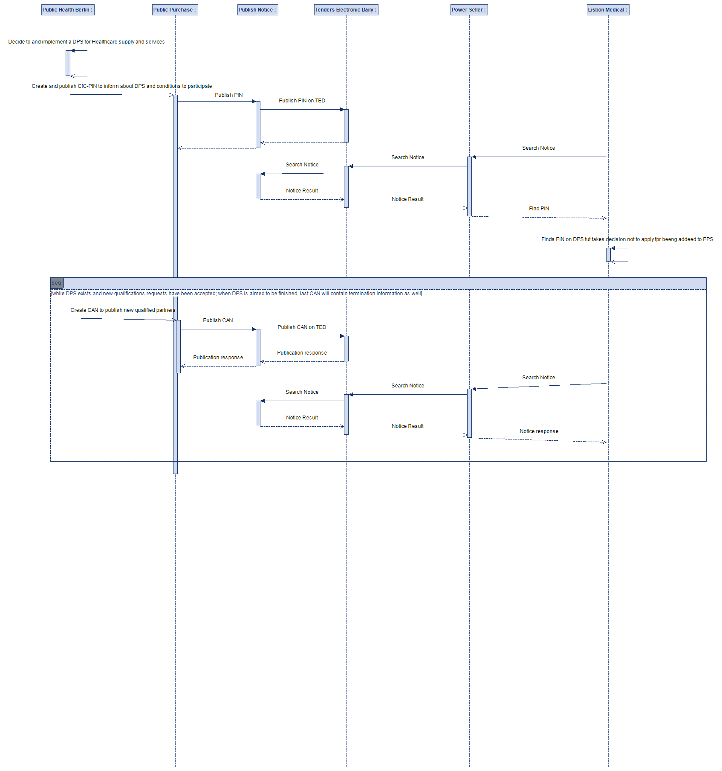
Figure 4 Notifications to inform about DPS and call for Qualifiation

Restricted procedures with use of DPS

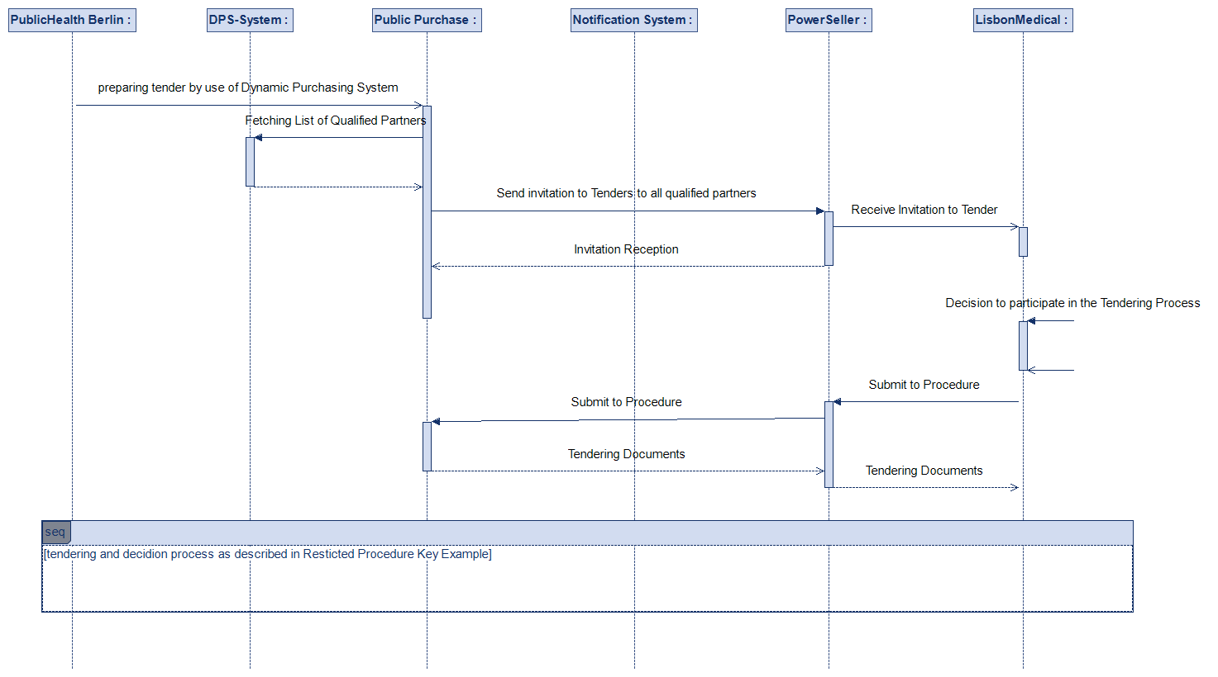
Figure 5 Starting a restricted tendering procedure from a DPS

Business Process

Actors and Roles
The following business partners participate in this profile, acting in the roles as defined below.

Table 4: Business partners
Business partners | Description
Customer | The Customer is the legal person or organization who is in demand of a product, service or work. Examples of customer roles are Buyer, Consignee, Debtor and contracting body.
Supplier | The Supplier is the legal person or organization who provides a product, service or works. Examples of Supplier roles are Seller, Consignor, Creditor and economic operator.
Governmental or private organization | Any organisation.

Table 5: Roles & Actors (Standard)
Roles & Actors | Description
Contracting Authority (CA) | The contracting authority or contracting entity who is buying supplies, services or tendering works.
Economic operator (EO) | Party participating with a bid in a procurement process to sell goods, services or works.
Publication Body (PB) | A Pan-European, national or regional organisation that publishes procurement notices of a contracting body. While the basic role of the publisher may apply to any newspaper, other roles and functions are often restricted to official gazettes. These gazettes are also often responsible to ensure a formal verification of the notices in respect of legislative or other requirements in vigour. Official gazettes may also have the role to receive information exempted from publication (e.g. due to confidential content) used for notification to a supervising authority

Table 6: Special Roles & Actors With use of DPS
Roles & Actors | Description
DPS-Manager (DPm) | In case a Contracting Authority is using a dynamic purchasing system, the role “Contrating Authority” may be subdivided into one who establishes and maintains (manages) the DPS, named DPS-Manager….
Buyer (By) | … and another subrole, buyer, describing those Actors who use the DPS in case a demand for certain goods or services arises.
Qualifying operator (Qo) | When dynamic purchasing systems are involved the Economic operator also splits into two subroles: during the qualification process the subrole should be named as qualifying operator…
Qualified partner  (Qp) | … after the qualification process has been passed, those economic operators that have been qualified successfully will be named “qualified partner”.

Notification & Restricted Procedure Use Cases
Figure 3 shows the Restricted procedure use cases expressed as Peppol BIS that have to be implemented to support the open procedures using Peppol.

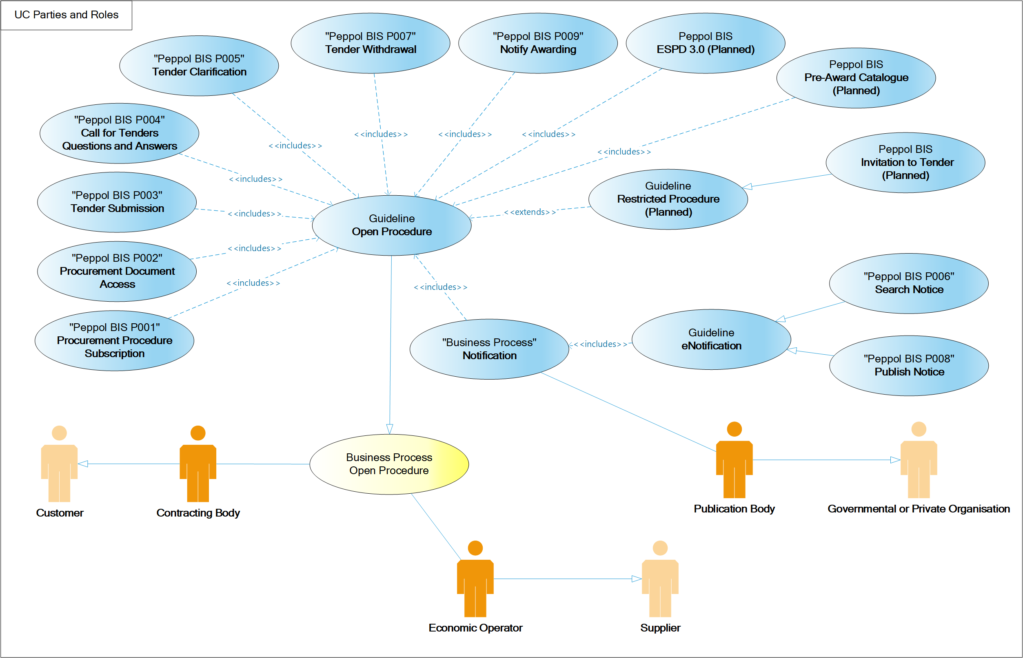
Figure 6: Resrtricted procedure use cases

Notification & Restricted procedure Business Process
The following diagrams illustrate the choreography of the business process targeted by the Notification & Restricted Procedure guideline.

Table 7:Conditions of the Restricted Procedure
Category | Description
Description | A contracting body invites economic operators to qualify in a restricted procedure, in order to participate in the actual tendering process open only to those economic operators who have been qualified successfully.
Pre-conditions | The contracting body decided to tender a contract following a restricted procedure.
Post-conditions | Tendering process has been finished – tender being contracted successfully.

Process Map: Notification & Restricted procedure

Overview
The choreography of business collaborations defines the sequence of interactions when a restricted procedure is executed using Peppol. The following process overview describes the process that will follow any kind of restricted procedure executed in – at least two steps – one (ore more) qualification step(s) directly followed by a tendering process.
The tendering process itself will follow all steps that have already been described with the open procedure.
For better readability the business process has been divided into the following subprocesses: Notification, Procurement Document Access, Qualification, Invitation to Tender, Tender Submission and Awarding illustrated by the process overview below.

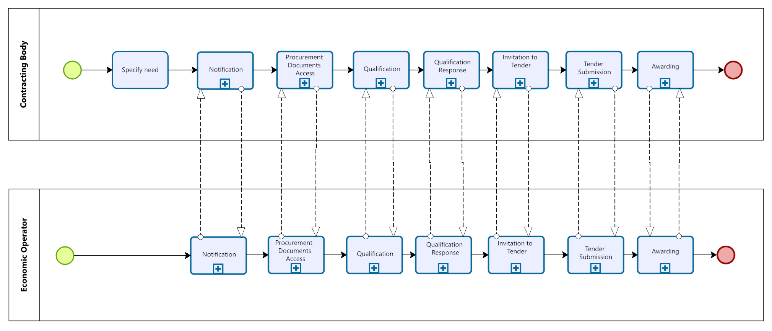
Figure 7: Restricted procedure process map

Process: Notification
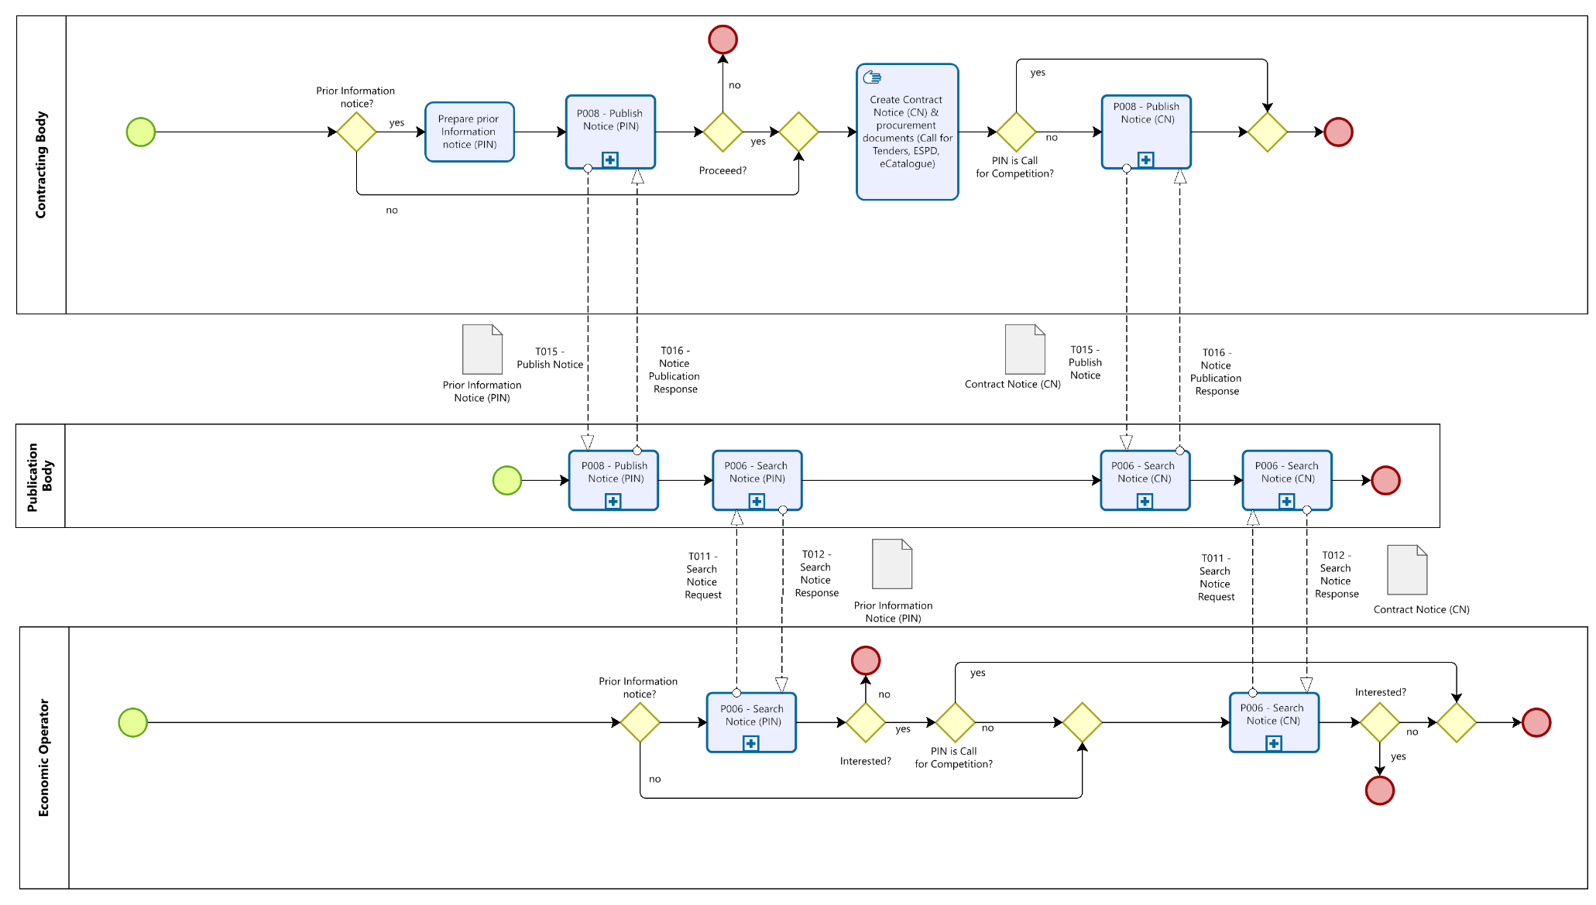
Figure 8: Notification Process

Process: Procurement Document Access
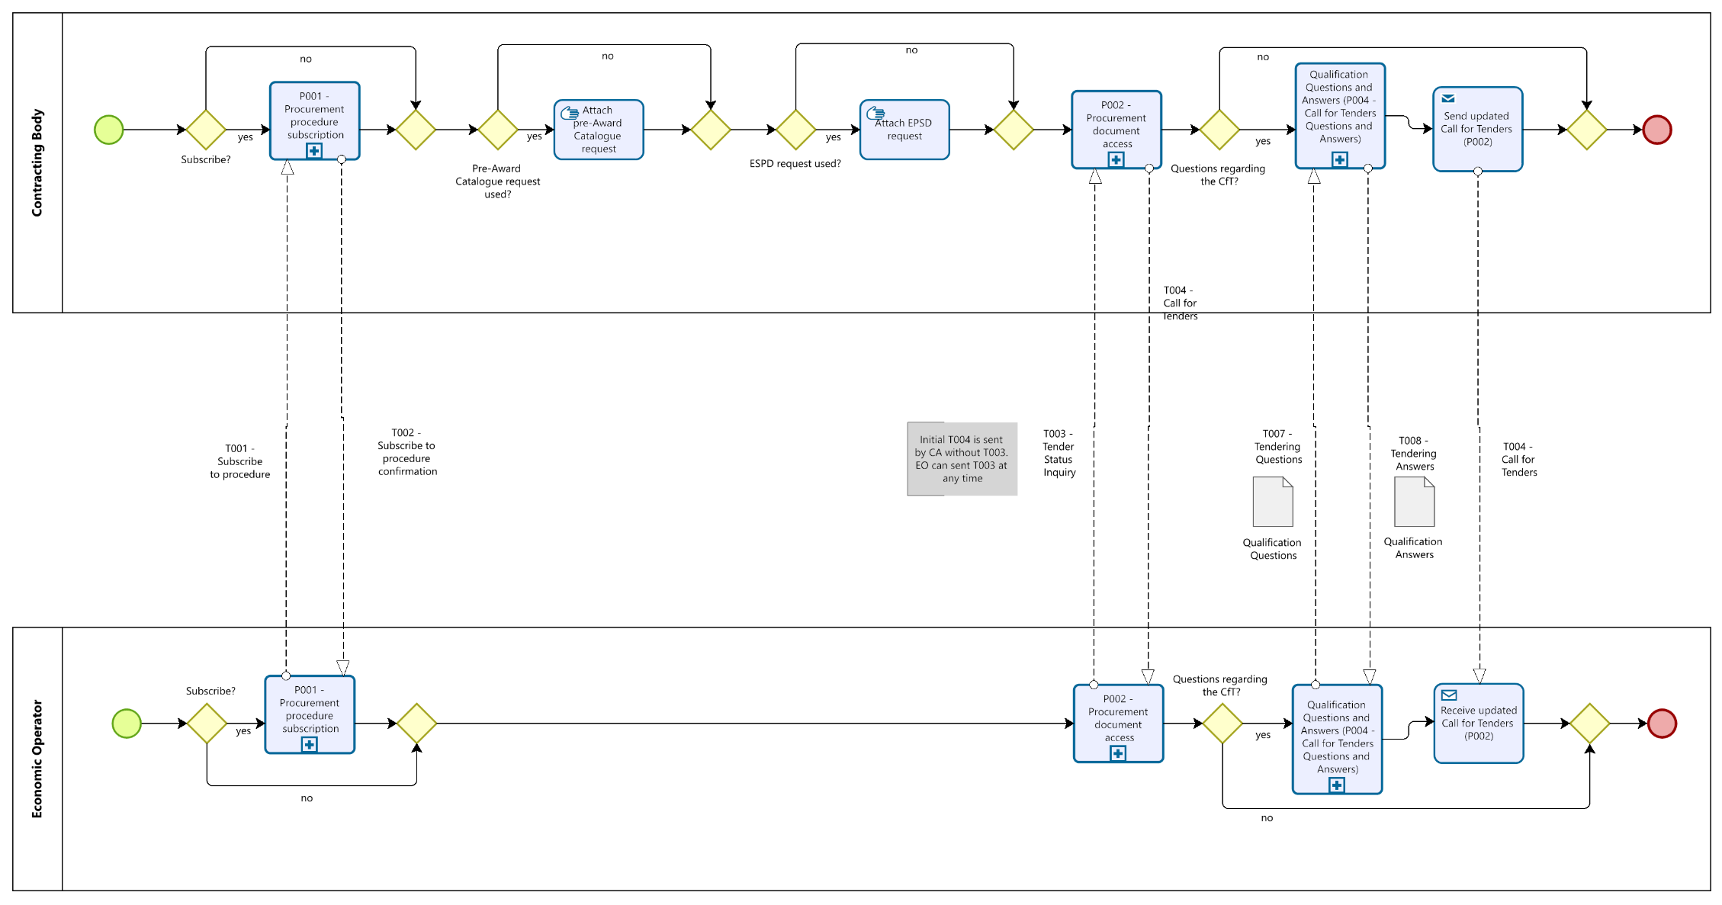
Figure 9: Procurement Document Access process

Process: Tender Status Inquiry
At any moment in the procedure before the submission deadline, the economic operator may start an inquiry about the status of the procedure. After the sending of a Tender status inquiry, the economic operator will receive the latest version of the Call for Tenders.

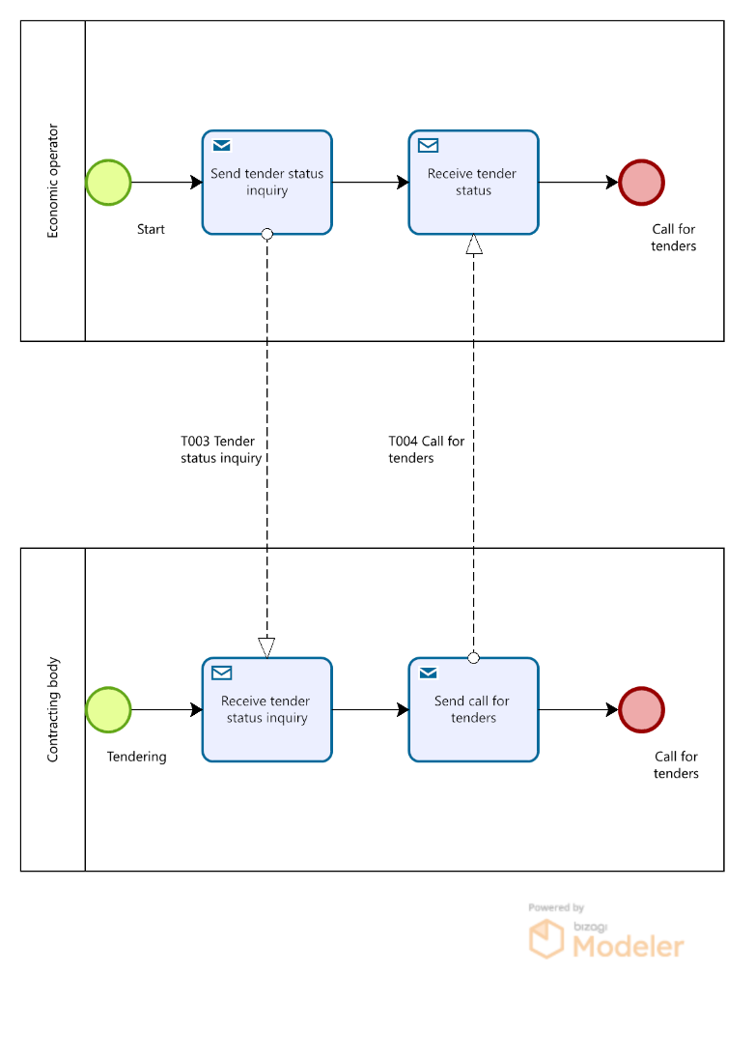
Figure 10: Tender Status Inquiry Process

Qualification
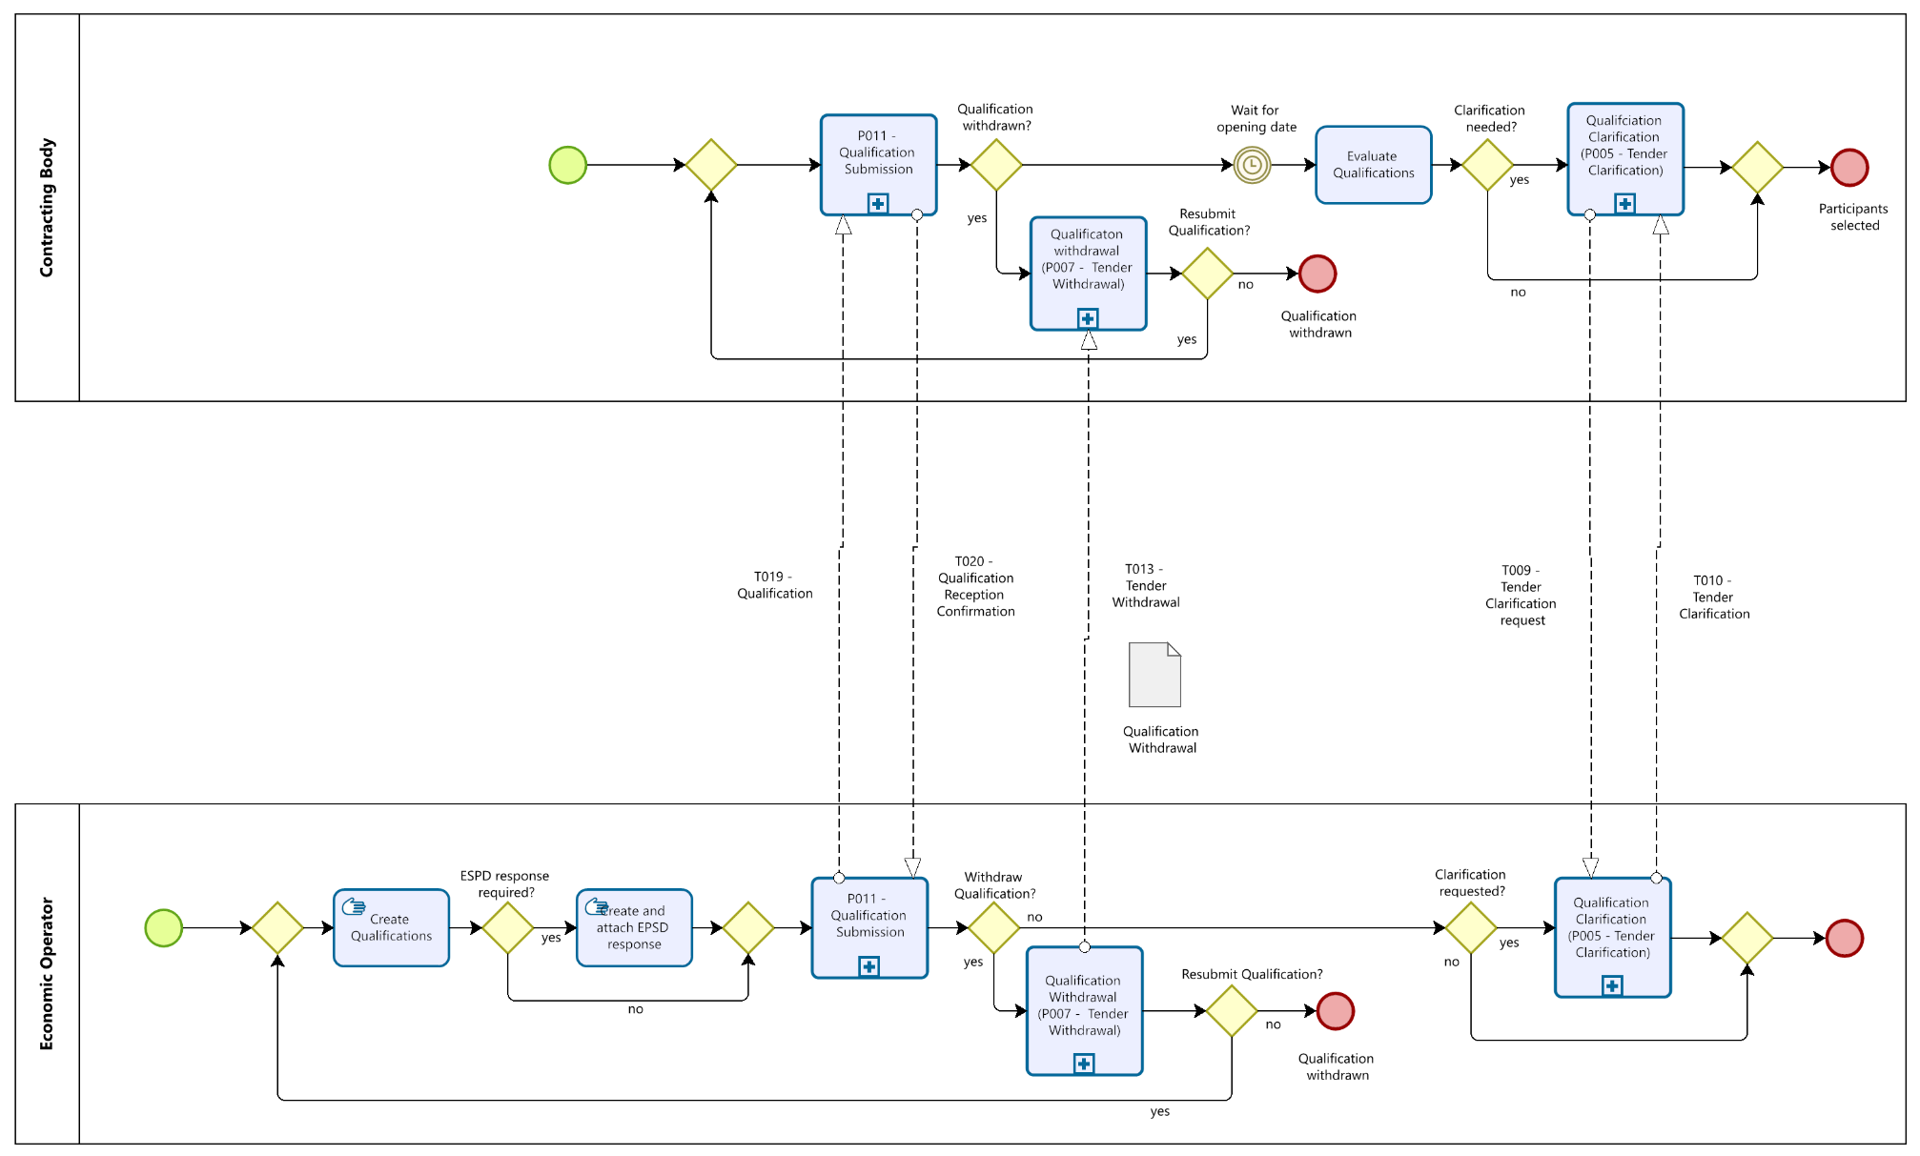
Figure 11: Qualification

Qualification Response
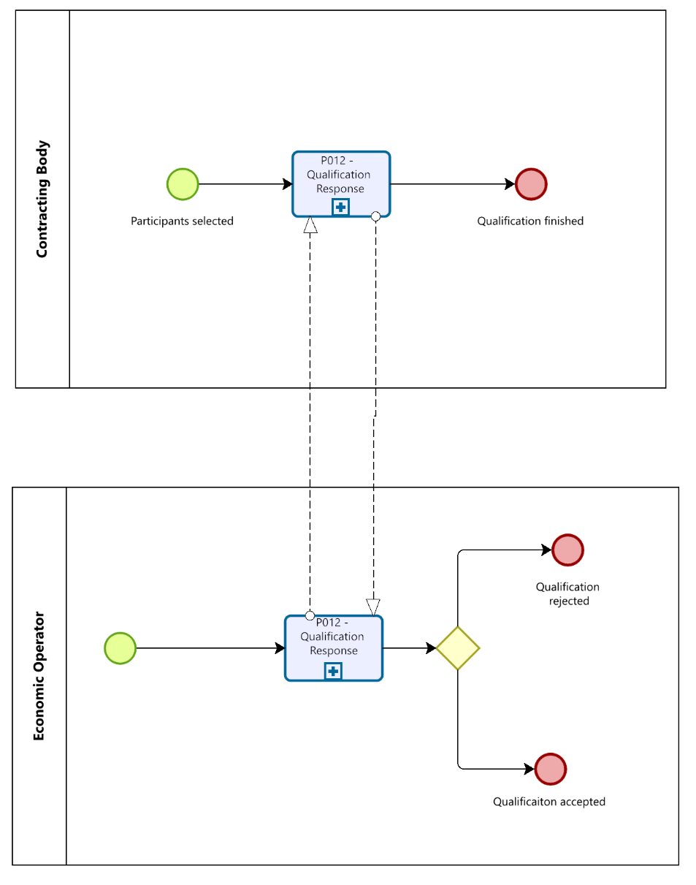
Figure 12: Qualification Response

Invitation to Tender
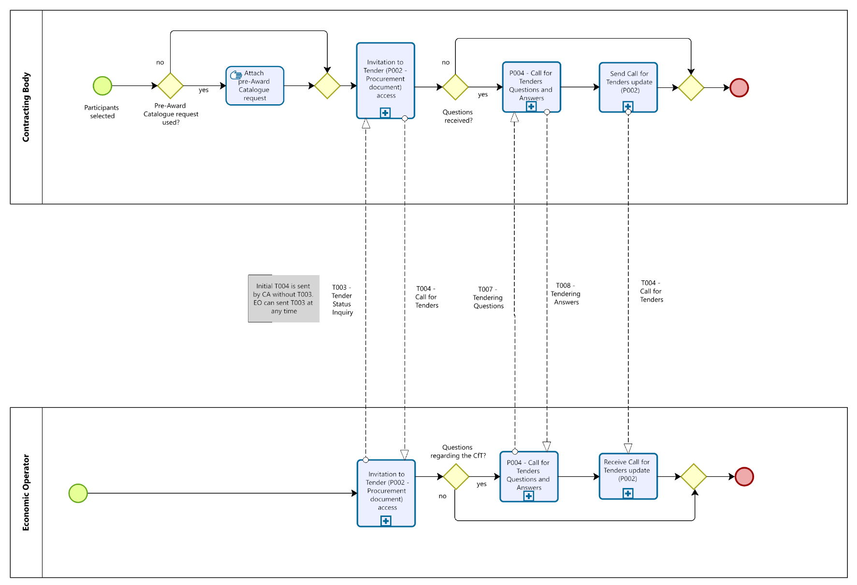
Figure 13: Invitation to Tender

Process: Tender Submission
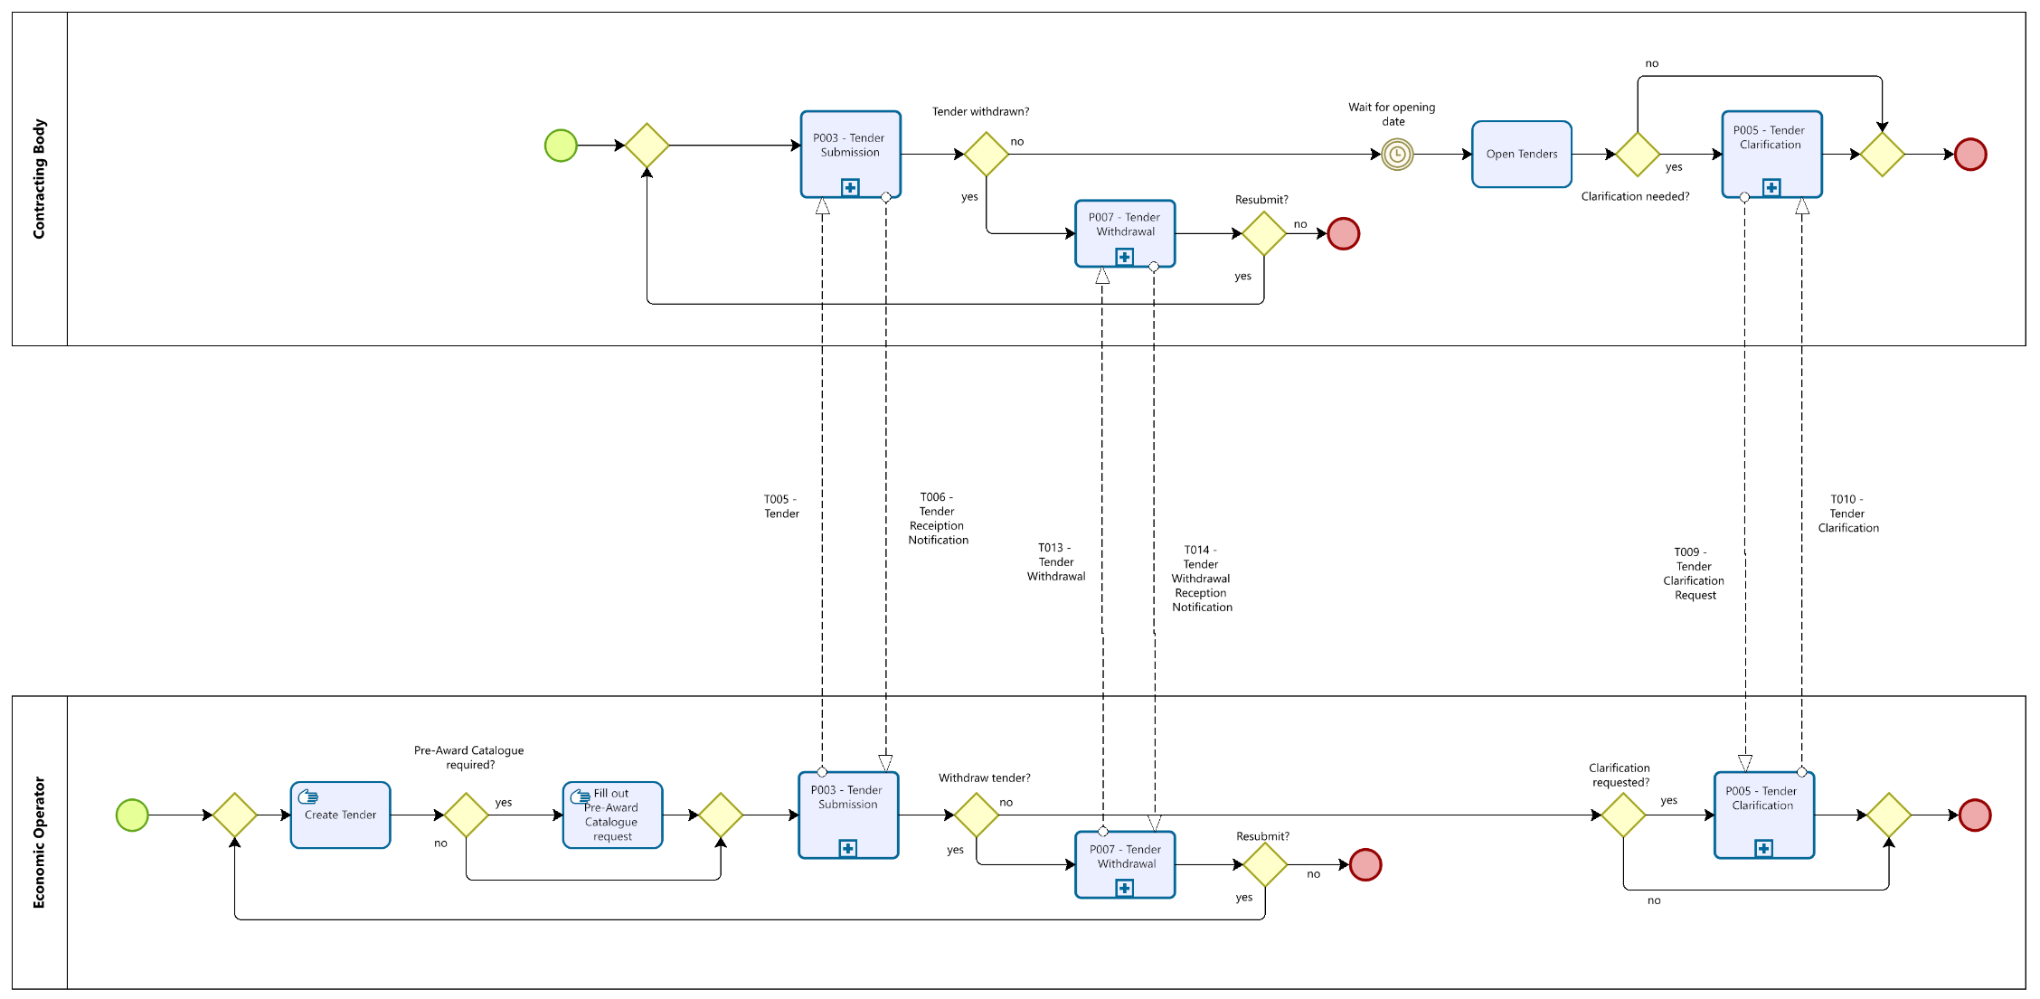
Figure 14: Tender Submission process

Process: Awarding
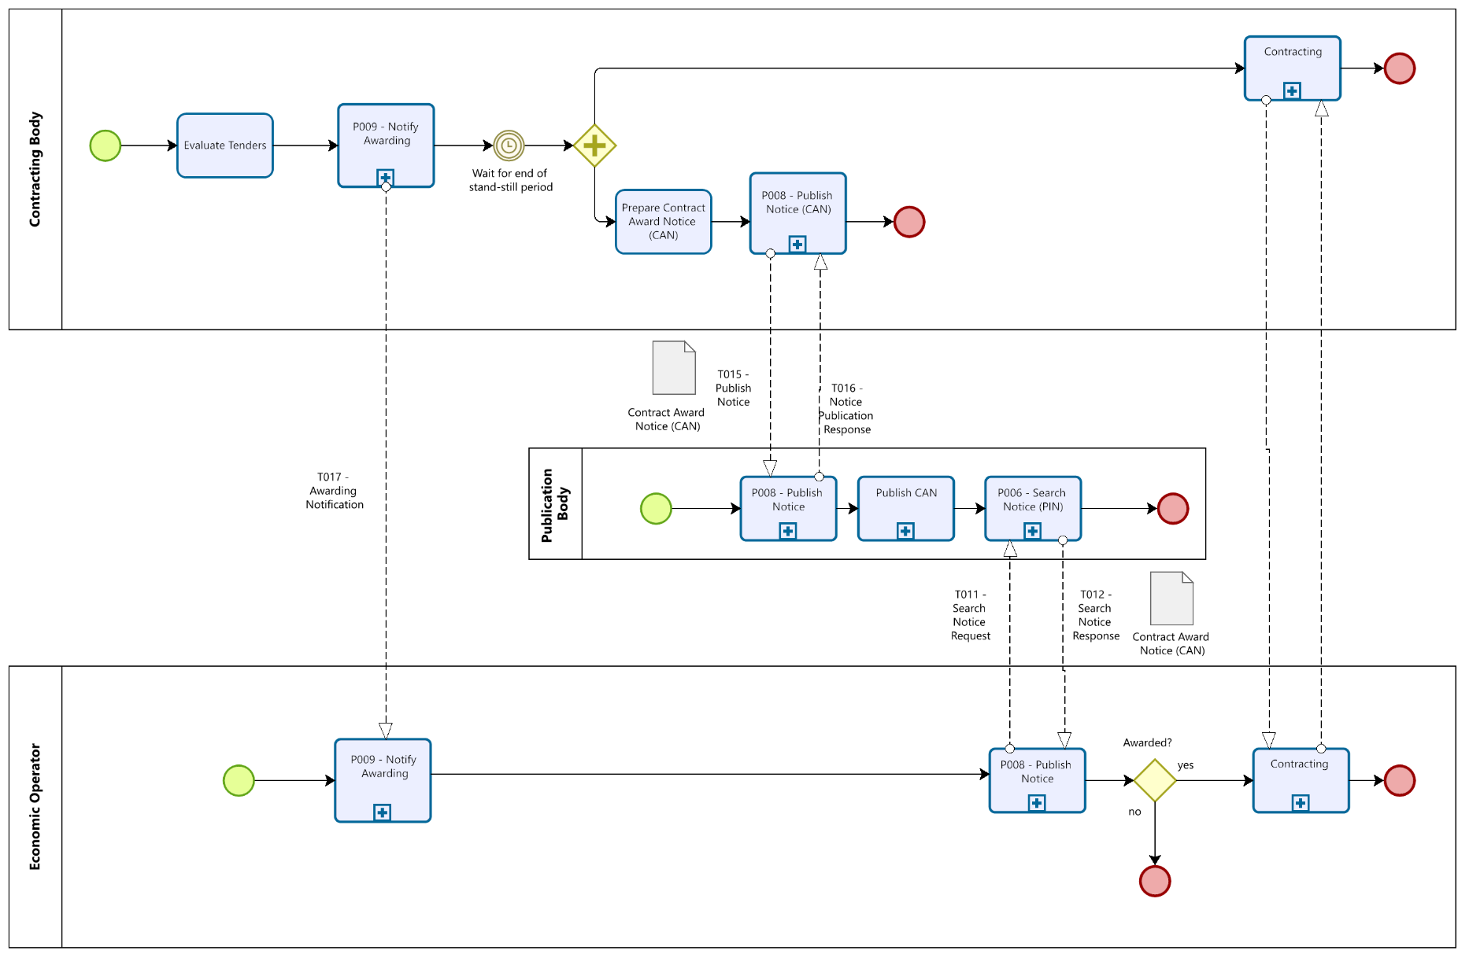
Figure 15: Awarding Process

Process Map: Notification & Restricted procedure by using a Dynamic Purchasing System

Setup and Qualify Economic Operators with the Dynamic Purchasing System

When a dynamic purchasing systems is used for Qualification and Tendering with qualified partners, the qualification process will be made independent form the tendering process. While the qualification process may be open as long as the dynamic purchasing system is maintained, more than one tendering process will be executed between one or many Contracting Bodies and those qualified partners who are listed in with the dynamic purchasing system at that time, the tender is executed. Therefore the overview processes for qualification and tendering will be separated. The First process description will describe the Qualification interactions.
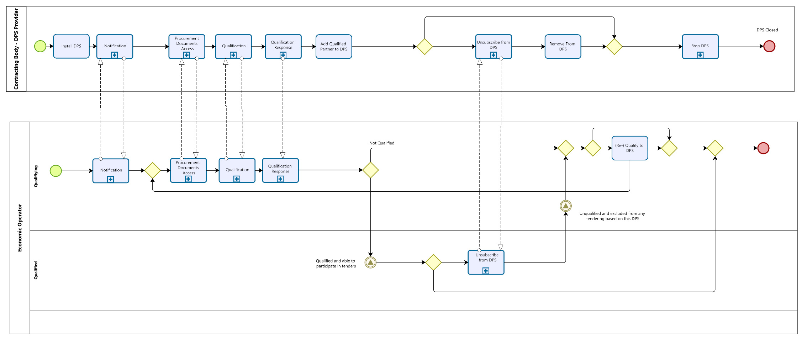

Figure 16: Setting up and mangaing Qualified partners with a DPS System

Tendering with the Dynamic Purchasing System
The following image describes a tendering process with using a DPS. the single processes im themselves do not differ from those already described with the formerly described “regular” restricted procedure. Because of this, the new overview process description will be added here.
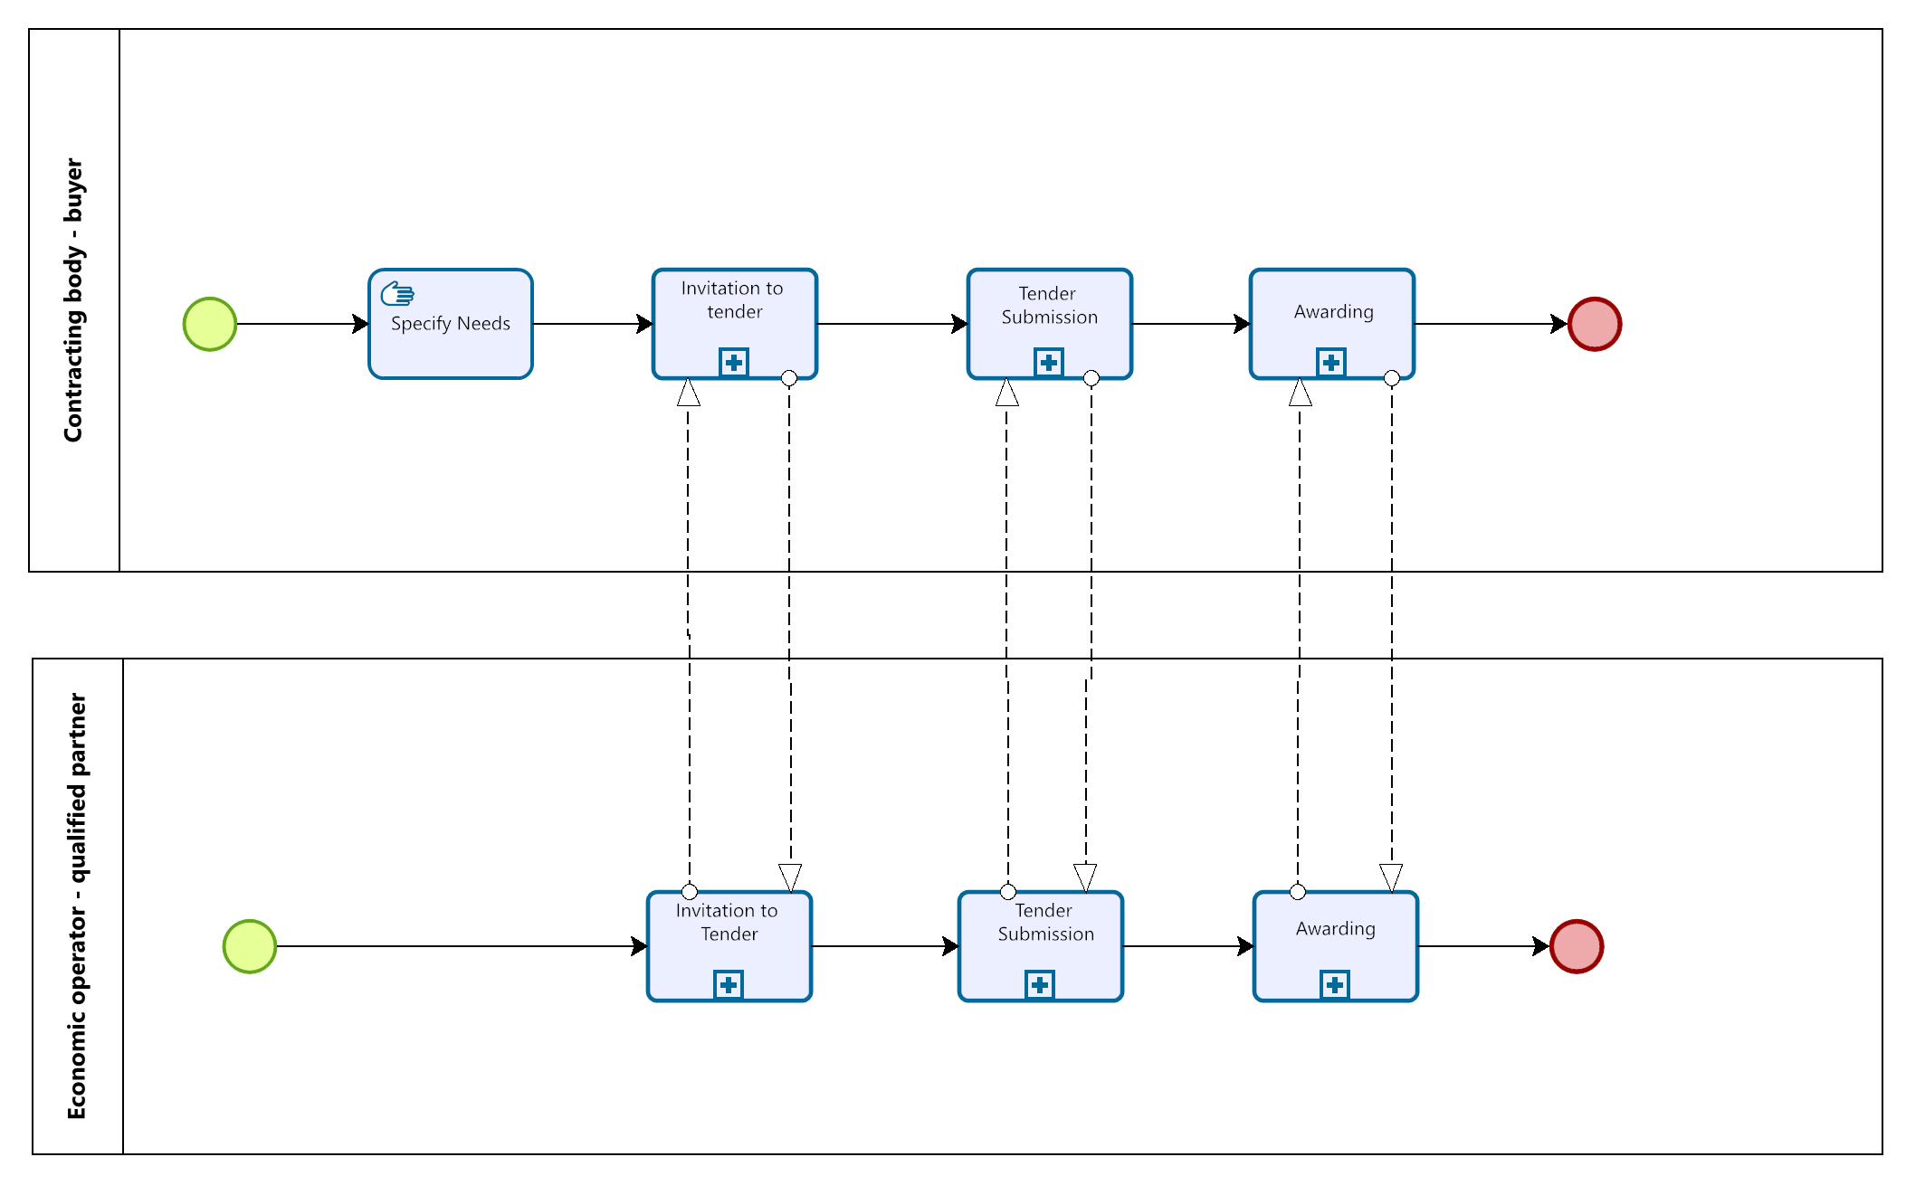
Figure 17: Intive qualified Economic operators to participate in tender

Stopping the Dynamic Procurement System
When the lifecycle of a Dynamic purchasing System has come to its end, this will be announced with the last contract award notice that will be published to inform about contracts being concluded to tenders awarded with the use of that dps before. Closing the dps will be published within BT-119.

The termination date could also be given in this CAN. Some BTs (eg. BT-537 – End Date or BT-36 - Duration) are possible to inform either about a final end date or about a planned duration and these BTs are able to occur in every Contract notices that publishes information about the dps (PIN, CN, Contract Modification, etc.).

Notification & Restricted Procedure activity detailed descriptions

Activities following the regular process
The following table describes the activities of the BPMN business process diagrams described in section 5.3 to support the general workflow to follow restricted procedures. Therefore, the table first points to the corresponding BPMN diagram (5.3.2 – Process: Notification, 5.3.3 – Process: Procurement Document Access, 5.3.4 – Process: Qualification, 5.3.5 – Process: Invitation to Tender, 5.3.6 Process: Tender Submission, 5.3.7 Process: Awarding). Then, the table lists the roles involved in each activity of the BPMN diagram. Additionally, each activity is defined and a reference to the corresponding Peppol BIS is given in case the activity requires bi-lateral communication based on Peppol.

Table 8: activity detailed descriptions
Step | Process Map | Activity | Roles involved | Description | Peppol BIS
1 | Notification | Specify need | CA | The CA needs to specify their need they want to fulfil. Afterwards CA decides whether a prior information notice is needed or not.
2 | Notification | Prepare Prior Information Notice (PIN) | CA | The CA prepares a Prior Information Notice (PIN) if needed.
3 | Notification | Publish Notice (PIN) | CA, PB | If created, the CA sends the PIN to the PB, who confirms the entry with the Notice Publication Response. | P008
4a | Notification | Search Notice (PIN) | PB, EO | The EO searches for interesting PINs. The PB provides all matching results for the query and provides the PINs matching the search parameter. The EO investigates the PINs for interesting opportunities. | P006
4b | Notification | Stop Procedure | CA | The CA may decide to stop the procedure at this moment.
5 | Notification | Search Notice (PIN) | PB, EO | The EO searches for interesting PIN. The PB provides all matching results for the query and provides the PIN matching the search parameter. The EO investigates the PIN for interesting opportunities. | P006
6a | Notification | Create Call For Competition (PIN or CA) | CA | CA prepares the needed procurement documents. It defines the Call for Competition and optionally  - specifies the products to be bought as a Pre-Award Catalogue Request.  - defines qualification criteria along the Single European Procurement Document (ESPD). | (P002)
6b | Notification | Publish Notice (PIN or CN) | CA, PB | The CA will prepare and publish the Call for Competition (as PIN or CN). The PB confirms the publication with a Notice Publication Response. | P008
7 | Notification | Search Notice (PIN or CN of competition phase) | PB, EO | If the EO has been interested in the PIN and now is looking for the following Call for Competition (published as PIN or CN) together with other also interesting Contract notices (CN).  The PB will provide all PINs and CNs corresponding to the matching search criteria of the EO. | P006
8 | Procurement Document Access | Procurement qualification subscription | CA, EO | If the EO is interested in participating in the competition, it subscribes to the Qualification procedure. The CA subscribes the EO to the procedure and provides a confirmation. | P001
9 | Qualification Submission | Prepare and submit Qualification documents | EO | The EO prepares all required qualification certificates and hands in the requested qualification documents or links to authorized qualification bodies that would prove the qualification evidence. | P011
10 | Qualification Reception | Receive and Confirm reception of Qualification Documents | CA | The contracting authority receives the qualification documents and returns a reception answer. | P011
11 | Qualification evaluation | Evaluate qualifications | CA | The EO evaluates all incoming qualifications and decides about which EO will be invited to follow the next steps and who will excluded form the next steps. | (P012)
12 | Qualification rejection | Send out qualification rejection | CA, EO | The CA sends out qualification rejection statements to those EOs that will not be allowed taking part in the next step. The Tendering process is stopped for all Eos having received a qualification rejection. | P012
13 | Prepare Invitation to Tender | Prepare and submit tendering documents | CA | The CA has prepared the tendering documents so far wind will hand them out to those EOs that have been chosen to take part in the actual tendering process. Those EO will be invited to the tendering process with sending out the proper tendering documents. | P013
14a | Procurement Document Access | Attach pre-award catalogue request | CA | The CA prepares the dispatch of the Call for Tenders and attaches the Pre-Award Catalogue Request if a structured product descriptions process is applied.
14b | Procurement Document Access | Attach ESPD request | CA | The CA prepares the dispatch of the call for tenders and attaches the European Single Procurement Document (ESPD) if a structured qualification process is applied.
 | Procurement Document Access | Procurement document access | CA, EO | After their expression of interest, the CA automatically sends the Call for Tenders to the EO subscribed to the procedure. Moreover, the EO can request a Tender Status Inquiry at any time before the submission deadline. | P002
15a | Procurement Document Access | Invitation for Tenders questions and answers | CA, EO | The EO may ask questions on the Invitation to Tender. The answers given by the CA are distributed to all invited EOs. | P013
15b | Procurement Document Access | Send updated procurement documents | CA, EO | When tendering documents need being updated, they will directly be provided from the CA to the EO. | P002
16a | Tender Submission | Create Tender | EO | If the EO decides to participate, it prepares his Tender documents.
16b | Tender Submission | Fill out pre-Award Catalogue | EO | The EO will create a Pre-Award Catalogue Response according to the requirements of the Call for Tender and attach it to the Tender.
16c | Tender Submission | Create ESPD | EO | The EO will create an ESPD Response according to the requirements of the Call for Tender and attach it to the Tender.
16d | Tender Submission | Tender Submission | CA, EO | The EO submits its Tender documents and receives a Tender Reception Notification from the CA. | P003
16e | Tender Submission | Tender Withdrawal | CA, EO | The EO may withdraw his submitted Tender and later resubmit a new one (or not). After the Tender Withdrawal the EO receives a Tender Withdrawal Reception Notification from the CA | P007
17a | Tender Submission | Open Tenders | CA | The CA opens the received Tenders at a previously set opening date.
17b | Tender Submission | Tender Clarification | CA, EO | The CA may require the EO to clarify his Tender or the ESPD Response or the Pre-Award Catalogue Response and sends a Tender Clarification Request to the EO. The EO answers the pending questions and provides a Tender Clarification. | P005
18 | Awarding | Evaluate Tenders | CA | The CA evaluates all received tenders and selects the winning EO.
19 | Awarding | Notify Awarding | CA, EO | All EOs that submitted Tenders are informed about the individual evaluation result and the winning EO. The winner may receive a draft contract as attachment of the Awarding Notification. | P009
20 | Awarding | Prepare Contract Award Notice | CA | The CA prepares the Contract Award Notice.
21 | Awarding | Publish Notice (CAN) | CA, PB | After the stand-still period, the CA sends the Contract Award Notice (CAN) to the PB. The PB confirms the receipt and sends a Notice Publication Response. | P008
22 | Awarding | Publish CAN | PB | The PB publishes the CAN.
23 | Awarding | Search Notice (CAN) | PB, EO | EOs may send a Search Notice Request to the PB looking for the published CAN. The PB provides all matching results for the query and provides the CANs matching the search parameter. | P006
24 | Awarding | Contracting | CA, EO | The CA and EO finalize the contract for the procedure.

Activities for restricted procedures connected to a dynamic purchasing system (DPS)

The steps described in table X in the previous chapter differ slightly when a dynamic purchasing system is involved in the qualification process. Instead of being executed one after the other, the qualification process remains open for the time the dynamic purchasing system is up and running.
It will terminate when the dps is declared to be shut down.
During the qualification phase every interesting EO is allowed to hand in their qualification requests. The list of qualified contributors will change over time and invitations to tenders will be sent out to some or all of the qualified EOs listed.

Process Control: Tendering Message Response (TMR)

The PEPPOL BIS “P010 - Tendering Message Response” (TMR) is a generic support profile that may occur as a response to any business transaction of the Notification & Restricted Procedure Business Process. The following table illustrates the principal conditions under which a TMR is executed.

Table 9: Conditions of the Tendering Message Response
Category | Description
Description | A receiver of a business document sends a TMR if the sender of the business document supports the TMR.
Pre-conditions | (1) A faulty business document was received by the Receiver  (2) A correct business document was received by the Receiver
Post-conditions | (1) A negative TMR was sent to the sender of the business document and the sender takes appropriate actions  (2) A positive TMR was sent to the sender of the business document and the business process continues

The TMR can be sent after receipt of any business document in the transactions of the PEPPOL Pre-Award shown here. It serves both to confirm the successful processing of a business document and to report errors that occurred during the processing of a received document. Without the TMR, it is not possible to report errors that occur during processing back to the sender of a business document.

The BPMN diagram below shows the choreography of the business process implemented by the TMR.

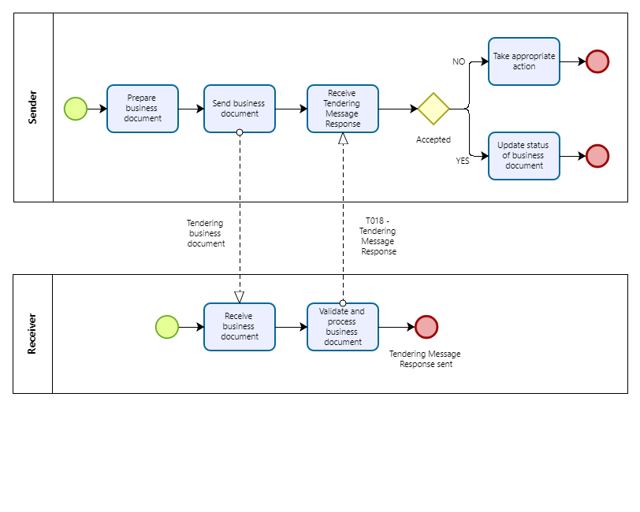
Figure 18: Business Process Tendering Message Response

The process starts when a Business Document Sender is preparing an electronic business document and then sends it. The Business Document Receiver receives the business document, potentially validates syntax and business rules and starts to process the business document.

In case the Business Document Sender has the capability to receive a TMR, the Business Document Receiver either:

- Validates the business document and based on the result returns either an accept (no fatal errors and no processing exceptions found), a conditional accept (warnings found) or a reject (fatal errors or processing exception found)

- Doesn’t validate the business document and does not find any processing exceptions and just sends an accept to the sender of the business document.

If a TMR is returned to the Business Document Sender, it may take appropriate action.

- If the response is positive the BusinessDocumentSender may update the status of the business document or simply ignore the TMR.

- If the response is negative the BusinessDocumentSender may be able to fix the issue and sent an updated version of electronic business document.

- If the response is accepted conditionally the BusinessDocumentSender may be able to analyse and fix the issue for future applications.

Implementation of Notification & Restricted Procedure
The tables in section 6 list the Peppol BIS artifacts that have to be considered when implementing the Open Procedure. For each Peppol BIS, the corresponding documentation of the profile and transaction(s) are provided. Additionally, the tables point to the syntax mapping and rules to implement the transactions. Sections 6.10 and 6.11 provide an overview of other relevant artifacts like codelists, schematrons and guidelines which must be considered during the implementation of Peppol pre-award BISs.

Peppol BIS - P001 - Procurement procedure subscription
Peppol BIS | P001 - Procurement procedure subscription
Documentation | https://docs.peppol.eu/pracc/profiles/p001/index.html
Transaction | T001 – Subscribe to procedure
Documentation | https://docs.peppol.eu/pracc/transactions/T001/index.html
Syntax Mapping | https://docs.peppol.eu/pracc/syntax/ExpressionOfInterestRequest/tree/
Peppol Rules | https://docs.peppol.eu/pracc/rules/T001/
Transaction | T002 - Subscribe to Procedure Confirmation
Documentation | https://docs.peppol.eu/pracc/rules/T002/
Syntax Mapping | https://docs.peppol.eu/pracc/syntax/ExpressionOfInterestResponse/tree/
Peppol Rules | https://docs.peppol.eu/pracc/rules/T002/

Peppol BIS - P002 - Procurement document access
Peppol BIS | P002 - Procurement document access
Documentation | https://docs.peppol.eu/pracc/profiles/p002/index.html
Transaction | T003 - Tender Status Inquiry
Documentation | https://docs.peppol.eu/pracc/transactions/T003/index.html
Syntax Mapping | https://docs.peppol.eu/pracc/syntax/TenderStatusRequest/tree/
Peppol Rules | https://docs.peppol.eu/pracc/rules/T003/
Transaction | T004 - Call for Tenders
Documentation | https://docs.peppol.eu/pracc/rules/T004/
Syntax Mapping | https://docs.peppol.eu/pracc/syntax/CallForTenders/tree/
Peppol Rules | https://docs.peppol.eu/pracc/rules/T004/
CEN BII Rules | https://docs.peppol.eu/pracc/rules/BIIT004/

Peppol BIS - P003 - Tender Submission
Peppol BIS | P003 - Tender Submission
Documentation | https://docs.peppol.eu/pracc/profiles/p003/index.html
Transaction | T005 - Tender
Documentation | https://docs.peppol.eu/pracc/transactions/T005/index.html
Syntax Mapping | https://docs.peppol.eu/pracc/syntax/Tender/tree/
Peppol Rules | https://docs.peppol.eu/pracc/rules/T005/
CEN BII Rules | https://docs.peppol.eu/pracc/rules/BIIT005/
Transaction | T006 - Tender Reception Notification
Documentation | https://docs.peppol.eu/pracc/rules/T006/
Syntax Mapping | https://docs.peppol.eu/pracc/syntax/TenderReceipt/tree/
Peppol Rules | https://docs.peppol.eu/pracc/rules/T006/
CEN BII Rules | https://docs.peppol.eu/pracc/rules/BIIT006/

Peppol BIS - P004 - Call for Tenders Question and Answers
Peppol BIS | P004 - Call for Tenders Question and Answers
Documentation | https://docs.peppol.eu/pracc/profiles/p004/index.html
Transaction | T007 - Tendering Questions
Documentation | https://docs.peppol.eu/pracc/transactions/T007/index.html
Syntax Mapping | https://docs.peppol.eu/pracc/syntax/TenderingQuestions/tree/
Peppol Rules | https://docs.peppol.eu/pracc/rules/T007/
Transaction | T008 - Tendering Answers
Documentation | https://docs.peppol.eu/pracc/rules/T008/
Syntax Mapping | https://docs.peppol.eu/pracc/syntax/TenderingAnswers/tree/
Peppol Rules | https://docs.peppol.eu/pracc/rules/T008/

Peppol BIS - P005 - Tender Clarification
Peppol BIS | P005 - Tender Clarification
Documentation | https://docs.peppol.eu/pracc/profiles/p005/index.html
Transaction | T009 - Tender Clarification Request
Documentation | https://docs.peppol.eu/pracc/transactions/T009/index.html
Syntax Mapping | https://docs.peppol.eu/pracc/syntax/TenderClarificationRequest/tree/
Peppol Rules | https://docs.peppol.eu/pracc/rules/T009/
Transaction | T010 - Tender Clarification
Documentation | https://docs.peppol.eu/pracc/rules/T010/
Syntax Mapping | https://docs.peppol.eu/pracc/syntax/TenderClarification/tree/
Peppol Rules | https://docs.peppol.eu/pracc/rules/T010/

Peppol BIS - P006 - Search Notices
Peppol BIS | P006 - Search Notices
Documentation | https://docs.peppol.eu/pracc/profiles/p006/index.html
Transaction | T011 - Search Notice Request
Documentation | https://docs.peppol.eu/pracc/transactions/T011/index.html
Syntax Mapping | https://docs.peppol.eu/pracc/syntax/SearchNoticeRequest/tree/
Peppol Rules | https://docs.peppol.eu/pracc/rules/T011/
Transaction | T012 - Search Notice Response
Documentation | https://docs.peppol.eu/pracc/rules/T012/
Syntax Mapping | https://docs.peppol.eu/pracc/syntax/SearchNoticeResponse/tree/
Peppol Rules | https://docs.peppol.eu/pracc/rules/T012/

Peppol BIS - P007 - Tender Withdrawal
Peppol BIS | P007 - Tender Withdrawal
Documentation | https://docs.peppol.eu/pracc/profiles/p007/index.html
Transaction | T013 - Tender Withdrawal
Documentation | https://docs.peppol.eu/pracc/transactions/T013/index.html
Syntax Mapping | https://docs.peppol.eu/pracc/syntax/TenderWithdrawalRequest/tree/
Peppol Rules | https://docs.peppol.eu/pracc/rules/T013/
Transaction | T014 - Tender Withdrawal Notification
Documentation | https://docs.peppol.eu/pracc/rules/T014/
Syntax Mapping | https://docs.peppol.eu/pracc/syntax/TenderWithdrawalResponse/tree/
Peppol Rules | https://docs.peppol.eu/pracc/rules/T014/

Peppol BIS - P008 - Publish Notice
Peppol BIS | P008 - Publish Notice
Documentation | https://docs.peppol.eu/pracc/profiles/p008/index.html
Transaction | T015 - Publish Notice
Documentation | https://docs.peppol.eu/pracc/transactions/T015/index.html
Syntax Mapping | https://docs.peppol.eu/pracc/syntax/PublishNotice/tree/
Peppol Rules | https://docs.peppol.eu/pracc/rules/T015/
Transaction | T016 - Notice Publication Response
Documentation | https://docs.peppol.eu/pracc/rules/T016/
Syntax Mapping | https://docs.peppol.eu/pracc/syntax/NoticePublicationResponse/tree/
Peppol Rules | https://docs.peppol.eu/pracc/rules/T016/

Peppol BIS - P009 - Notify Awarding
Peppol BIS | P009 - Notify Awarding
Documentation | https://docs.peppol.eu/pracc/profiles/p009/index.html
Transaction | T015 - Publish Notice
Documentation | https://docs.peppol.eu/pracc/transactions/T017/index.html
Syntax Mapping | https://docs.peppol.eu/pracc/syntax/AwardingNotification/tree/
Peppol Rules | https://docs.peppol.eu/pracc/rules/T017/

Peppol BIS - P010 – Tendering Message Response
Peppol BIS | P010 - Tendering Message Response
Documentation | https://docs.peppol.eu/pracc/profiles/p010/index.html
Transaction | T018 - Tendering Message Response
Documentation | https://docs.peppol.eu/pracc/transactions/T018/index.html
Syntax Mapping | https://docs.peppol.eu/pracc/syntax/TenderingMessageResponse/tree/
Peppol Rules | https://docs.peppol.eu/pracc/rules/T018/

Peppol BIS - P011 – Tender Qualification
Peppol BIS | P011 – Tender Qualification
Documentation | https://docs.peppol.eu/pracc/profiles/p011/index.html
Transaction | T019 - Qualification
Documentation | https://docs.peppol.eu/pracc/transactions/T019/index.html
Syntax Mapping | https://docs.peppol.eu/pracc/syntax/TenderingMessageResponse/tree/
Peppol Rules | https://docs.peppol.eu/pracc/rules/T019/
Transaction | T020 – Qualification Reception Confirmation
Documentation | https://docs.peppol.eu/pracc/transactions/T020/index.html
Syntax Mapping | https://docs.peppol.eu/pracc/syntax/TenderingMessageResponse/tree/
Peppol Rules | https://docs.peppol.eu/pracc/rules/T020/

Peppol BIS - P012 –Qualification Response
Peppol BIS | P012 –Qualification Response
Documentation | https://docs.peppol.eu/pracc/profiles/p012/index.html
Transaction | T023 – Qualification Response
Documentation | https://docs.peppol.eu/pracc/transactions/T023/index.html
Syntax Mapping | https://docs.peppol.eu/pracc/syntax/TenderingMessageResponse/tree/
Peppol Rules | https://docs.peppol.eu/pracc/rules/T023/

Peppol BIS - P013 – Invitation to Tender
Peppol BIS | P013 – Invitation to Tender
Documentation | https://docs.peppol.eu/pracc/profiles/p013/index.html
Transaction | T024 – Invitation to Tender
Documentation | https://docs.peppol.eu/pracc/transactions/T023/index.html
Syntax Mapping | https://docs.peppol.eu/pracc/syntax/TenderingMessageResponse/tree/
Peppol Rules | https://docs.peppol.eu/pracc/rules/T024/
Transaction | T003 – Tender Status Inquiry
Documentation | https://docs.peppol.eu/pracc/transactions/T003/index.html
Syntax Mapping | https://docs.peppol.eu/pracc/syntax/TenderingMessageResponse/tree/
Peppol Rules | https://docs.peppol.eu/pracc/rules/T003/

Peppol Code Lists used in Notification & Open Procedure
additionalConditionsCode | https://docs.peppol.eu/pracc/codelist/addCond/
awardCode | https://docs.peppol.eu/pracc/codelist/addCond/
contractTypeCode | https://docs.peppol.eu/pracc/codelist/contractType/
documentStatusCode | https://docs.peppol.eu/pracc/codelist/docStatus/
documentTypeCode | https://docs.peppol.eu/pracc/codelist/docType/
Electronic Address Scheme (EAS) | https://docs.peppol.eu/pracc/codelist/EAS/
ISO 6523 ICD list | https://docs.peppol.eu/pracc/codelist/ICD/
Country codes (ISO 3166-1:Alpha2) | https://docs.peppol.eu/pracc/codelist/ISO3166/
legalBasisCode | https://docs.peppol.eu/pracc/codelist/legalBasis/
MessageResponseCode | https://docs.peppol.eu/pracc/codelist/messageResponse/
NoticeResponseCode | https://docs.peppol.eu/pracc/codelist/noticeResponse/
procedureTypeCode | https://docs.peppol.eu/pracc/codelist/procedureType/
procurementTypeCode | https://docs.peppol.eu/pracc/codelist/procurementType/
publicationConditionCode | https://docs.peppol.eu/pracc/codelist/publicationCondition/
StatusReasonCode | https://docs.peppol.eu/pracc/codelist/statusReason/
StatusReasonCodeSubset | https://docs.peppol.eu/pracc/codelist/statusReasonSubset/
SubmissionMethodCode | https://docs.peppol.eu/pracc/codelist/submissionMethod/
Economic Operator Role Codes | https://docs.peppol.eu/pracc/codelist/tendererRole/
UBLDocumentSchema | https://docs.peppol.eu/pracc/codelist/ublDocumentSchema/
Document name code, full list (UNCL1001) | https://docs.peppol.eu/pracc/codelist/UNCL1001/

Other artifacts used in Notification & Open Procedure
Peppol BIS eDelivery guide for pre-award | https://docs.peppol.eu/pracc/files/BIS-eDelivery-guide-for-pre-award-v1.3.pdf
Peppol BIS eDocuments guide for pre-award | https://docs.peppol.eu/pracc/files/BIS-eDocuments-guide-for-pre-award-v1.3.pdf
PEPPOL BIS pre-award guide – Notification and Open Procedure | https://docs.peppol.eu/pracc/files/Peppol-BIS-pre-award-guide_Notification-and-Open-Procedure-v1.0.pdf
Schematron files (zip) | https://docs.peppol.eu/pracc/files/schematrons.zip
Code lists (zip) | https://docs.peppol.eu/pracc/files/codelists.zip

External References
Reference | Source
[2008/81/EC] | https://eur-lex.europa.eu/legal-content/EN/TXT/?uri=CELEX%3A32009L0081
[2014/23/EU] | https://eur-lex.europa.eu/legal-content/DE/TXT/?uri=CELEX%3A32014L0023
[2014/24/EU] | https://eur-lex.europa.eu/legal-content/DE/TXT/?uri=CELEX%3A32014L0024
[2014/25/EU] | https://eur-lex.europa.eu/legal-content/DE/TXT/?uri=CELEX%3A32014L0025
[BII10] | https://standards.cencenelec.eu/dyn/www/f?p=205:110:0::::FSP_PROJECT:62007&cs=16D9EEBE9B7C024A15F0CCDEE76075355
[BII14] | https://standards.cencenelec.eu/dyn/www/f?p=205:110:0::::FSP_PROJECT:62008&cs=16824EF2775A9CE68B4E33893BA1F2A05
[BII37 Open Procedure] | https://standards.cencenelec.eu/dyn/www/f?p=205:110:0::::FSP_PROJECT:62023&cs=19453F711D73A2988EC334F37EE564AB1
[BII43] | https://standards.cencenelec.eu/dyn/www/f?p=205:110:0::::FSP_PROJECT:62009&cs=1807B03E8AA497A2C66F5BA5A25A5A3AF
[BII45] | https://standards.cencenelec.eu/dyn/www/f?p=205:110:0::::FSP_PROJECT:62010&cs=1628543602EFDE54C11B8136021A5621A
[BII46] | https://standards.cencenelec.eu/dyn/www/f?p=205:110:0::::FSP_PROJECT:62028&cs=16B7CFE594685D73AD82275DFFE3FCC55
[BII47] | https://standards.cencenelec.eu/dyn/www/f?p=205:110:0::::FSP_PROJECT:62029&cs=16BDCBBEBAE1A6A235013E1B31A0B78D6
[BII48] | https://standards.cencenelec.eu/dyn/www/f?p=205:110:0::::FSP_PROJECT:62030&cs=137D249EEF9A0B7DF6DAD668A740CA477
[BII50] | https://standards.cencenelec.eu/dyn/www/f?p=205:110:0::::FSP_PROJECT:62032&cs=112E5165F9BCEE578DFD26A6C238464E2
[BII53] | https://standards.cencenelec.eu/dyn/www/f?p=205:110:0::::FSP_PROJECT:62035&cs=15E8443FF9806B2D1F6675A41EA29930F
[BII54] | https://standards.cencenelec.eu/dyn/www/f?p=205:110:0::::FSP_PROJECT:62036&cs=12EBD786F7FC4B3EEB54EB811F8FCD901
[BII58] | https://standards.cencenelec.eu/dyn/www/f?p=205:110:0::::FSP_PROJECT:62038&cs=1438046879E98863C8263389E46ED47C4
[BII60] | https://standards.cencenelec.eu/dyn/www/f?p=205:110:0::::FSP_PROJECT:62055&cs=1FA2AB7C9A0F601605C549112B7B93DA3
[BIS Pre-Award catalogue] | https://docs.peppol.eu/pracc/catalogue/1.0/bis/
[CEN_BII3] | https://standards.cencenelec.eu/dyn/www/f?p=205:32:0::::FSP_ORG_ID,FSP_LANG_ID:2073699,25&cs=1764296F93587711762A3AB227353671A  https://cenbii.eu/the-bii-approach-to-interoperability/
[eForms] | https://eur-lex.europa.eu/eli/reg_impl/2019/1780/oj
[ESPD EDM] | https://github.com/OP-TED/ESPD-EDM
[ESPD] | https://eur-lex.europa.eu/eli/reg_impl/2016/7/oj
[Peppol About] | https://peppol.org/about/
[Peppol BIS] | https://peppol.org/learn-more/peppol-interoperability-framework/
[Peppol eDelivery] | https://peppol.org/learn-more/peppol-interoperability-framework/
[Peppol eTendering] | https://docs.peppol.eu/pracc/
[Peppol Pre-Award] | https://peppol.org/documentation/technical-documentation/pre-award-documentation/
[Peppol] | https://peppol.org/
[Pre-Award eDelivery] | https://docs.peppol.eu/pracc/files/BIS-eDelivery-guide-for-pre-award-v1.3.pdf
[Pre-Award eDocuments] | https://docs.peppol.eu/pracc/files/BIS-eDocuments-guide-for-pre-award-v1.3.pdf
[Pre-Award Open Procedure] | https://docs.peppol.eu/pracc/files/Peppol-BIS-pre-award-guide_Notification-and-Open-Procedure-v1.0.pdf

Alternatively, the platform PublicPurchase can publish directly to TED using the Peppol interface.

