

Business Interoperability Specification


OpenPEPPOL AISBL

Pre Award Coordinating Community

ICT - Models

Peppol Business Interoperability Specification

Pre-award guide:
Notification & Two-Stage Procedures

Version: 1.0
Status: Final Version

Statement of copyright

This PEPPOL Business Interoperability Specification (BIS) document is based on the CEN CWA prepared by the BII workshop specified in the Introduction below.
The original CEN CWA document contains the following copyright notice which still applies:
© 2012 CEN All rights of exploitation in any form and by any means reserved worldwide for CEN national Members.

The CEN CWA documents and profiles prepared by the BII workshop are not specific to a business area. Subject to agreement with CEN, customizations have been made by PEPPOL to establish the PEPPOL BIS, detailing and adding further guidance on the use of BII profiles.
OpenPEPPOL AISBL holds the copyright in the customizations made to the original document. The customizations appear from the corresponding conformance statement which is attached to this document. For the purpose of national implementations, customizations covered by the conformance statement may be further refined and detailed by PEPPOL Authorities and/or other entities authorized by OpenPEPPOL AISBL, provided that interoperability with PEPPOL BIS is ensured.
This PEPPOL BIS document may not be modified, re-distributed, sold or repackaged in any other way without the prior consent of CEN and/or OpenPEPPOL AISBL.

Table of Contents
1 Introduction 7
2 Scope 8
2.1 Audience 8
2.2 Procedures handled with this guideline 8
2.3 Peppol specifications in scope of the Notification & Two-Stage Procedures Guideline 8
2.4 Goals of the Notification & Two-Stage Procedures Guideline 10
3 Business Environment 11
3.1 Notification procedures in scope of this guideline 11
3.2 Tendering procedures in scope of this guideline 12
3.3 Process control mechanisms in scope of this guideline 14
4 Business Requirements 16
4.1 High level business requirements 16
4.2 Key examples 17
4.2.1 Key example: Notification 17
4.2.2 Key example: Restricted Procedure 19
5 Two-Stage Procedures – Actors, Roles and Use Cases 24
5.1 Actors and Roles 24
5.2 Two-Stage Procedure Use Cases 25
5.2.1 Pre-Award Procurement Phases and Use Cases 25
5.2.2 Mapping of Use Cases to Pre-Award Procedures 26
6 Notification & Restricted Procedure Business Process 27
6.1 Legal Framework 27
6.2 Process description 27
6.3 Process Map: Notification & Restricted Procedure 28
6.4 Process: Notification 31
6.5 Process: Procurement Document Access 32
6.5.1 Additional note: T021 - Unsubscribe from Procedure 33
6.5.2 Additional note: T003 - Tender Status update 33
6.5.3 Additional note: T007 - Tendering Questions 33
6.6 Process: Qualification 34
6.7 Process: Invitation to Tender 35
6.8 Process: Tender Submission 36
6.9 Process: Awarding 37
6.10 Notification & Restricted Procedure activity detailed descriptions 38
6.11 Process Control: Tendering Message Response (TMR) 43
7 Process Variants of Two-Staged Procedures 45
7.1 Dynamic Purchasing System 45
7.1.1 Introduction 45
7.1.2 Legal Framework 46
7.1.3 Use of eCatalogues 48
7.1.4 Process Description 48
7.1.5 Process Map: Dynamic Purchasing System 50
7.2 Competitive Dialogue 51
7.2.1 Introduction 51
7.2.2 Legal Framework 51
7.2.3 Process Description 52
7.2.4 Process Map Competitive Dialogue 54
7.3 Competitive Procedure with Negotiation 55
7.3.1 Introduction 55
7.3.2 Legal Framework 55
7.3.3 Process Description 56
7.3.4 Process Map: Competitive Procedure with Negotiation 58
7.4 Innovation Partnership 59
7.4.1 Introduction 59
7.4.2 Legal Framework 59
7.4.3 Process description 60
7.4.4 Process Map Innovation Partnership 62
8 Implementation of Notification & Two-Stage Procedure 64
8.1 Peppol BIS - P001 - Procurement procedure subscription 64
8.2 Peppol BIS - P002 - Procurement document access 64
8.3 Peppol BIS - P003 - Tender Submission 64
8.4 Peppol BIS - P004 - Call for Tenders Question and Answers 65
8.5 Peppol BIS - P005 - Tender Clarification 65
8.6 Peppol BIS - P006 - Search Notices 65
8.7 Peppol BIS - P007 - Tender Withdrawal 66
8.8 Peppol BIS - P008 - Publish Notice 66
8.9 Peppol BIS - P009 - Notify Awarding 66
8.10 Peppol BIS - P010 – Tendering Message Response 66
8.11 Peppol BIS - P011 – Tender Qualification 66
8.12 Peppol BIS - P012 –Qualification Response 67
8.13 Peppol BIS - P013 – Invitation to Tender 67
8.14 Peppol BIS - P035 – Pre-Award Catalogue 67
8.15 Peppol Code Lists used in Notification & Two-Stage Procedures 68
8.15.1 Generic Code Lists 68
8.15.2 Catalogue specific Code Lists 68
8.16 Other artifacts used in Notification & Two-Stage Procedures 68
External References 69

List of Tables

Table 1: Peppol BIS supporting the Two-Stage procedures 9
Table 2: Goals of the Notification & Two-Stage Procedure Guideline 10
Table 3: High level business requirements 16
Table 4: Business partners 24
Table 5: Roles & Actors (Standard) 24
Table 7:Conditions of the Restricted Procedure 27
Table 8: activity detailed descriptions 38
Table 9: Conditions of the Tendering Message Response 43

List of Figures

Figure 1: Flow of different response messages 15
Figure 2: Flow of Notifications in Restricted procedure Key Example 18
Figure 3: Flow of Transactions in Restricted procedure Key Example (First Stage) 20
Figure 4: Flow of Transactions in Restricted procedure Key Example (Second Stage) 23
Figure 5: Pre-Award Procurement Phases and Use Cases 25
Figure 6: Mapping of Use Cases to Pre-Award Procedures 26
Figure 7: Notification & Restricted procedure process map 30
Figure 8: Notification Process 31
Figure 9: Procurement Document Access process 32
Figure 10: Qualification Process 34
Figure 11: Invitation to Tender Process 35
Figure 12: Tender Submission process 36
Figure 13: Awarding Process 37
Figure 14: Business Process Tendering Message Response 43
Figure 15: Process Map Dynamic Purchasing System 50
Figure 17: Process Map Competitive Dialogue 54
Figure 16: Process Map competitive procedure with negotiation 58
Figure 18: Process Map Innovation Partnership – Qualification and Negotiation Phase 62
Figure 19: Process Map Innovation Partnerships – Innovation Partnership 63

Revision history

Version | Date | Author | Organisation | Description
0.1 | 23.10.2023 | Gabriele Dall | Adesso SE | First draft
0.2 | 18.01.2024 | Ansgar Mondorf | Mondorf IT | Revision of Scope
0.3 | 19.01.2024 | Ansgar Mondorf | Mondorf IT | Revision of Business Environment
0.4 | 23.01.2024 | Ansgar Mondorf | Mondorf IT | Definition of Business Requirements and Key Examples
0.5 | 06.02.2024 | Ansgar Mondorf | Mondorf IT | Definition of Business Process
0.6 | 16.02.2024 | Ansgar Mondorf | Mondorf IT | Definition of Process Variant DPS
0.7 | 17.02.2024 | Ansgar Mondorf | Mondorf IT | Alignment and cross checking of references and links
0.8 | 22.02.2024 | Gabriele Dall | Adesso SE | Further adaptions to process models after groupwise discussion, adding negotiation procedure description and process overview
0.9 | 15.03.2024 | Ansgar Mondorf | Mondorf IT | Refine and approve business process descriptions for variants
0.95 | 22.03.2024 | Ansgar Mondorf | Mondorf IT | Include description of business process and legal framework to variants
0.98
1.0

Contributors
Country | Name | Organization (= Beneficiary – Organization in national consortium – Subcontractor)
DE | Ansgar Mondorf | Mondorf IT
DE | Andreas Schmitz | University of Koblenz-Landau
DE | Gabriele Dall | adesso SE
DE | Rolf Kewitz | Beschaffungsamt des BMI

Abbreviations

Abbreviation | Description
BII | Business Interoperability Interface
BIS | Business Interoperability Specification
br | Business rule
CWA | CEN Workshop Agreement
CEN WS/BII3 | CEN Workshop on Business Interoperability Interfaces for Public Procurement in Europe
CAN | Contract Award Notice
CN | Contract Notice
CA | Contracting Authority
CPN | Competitive Procedure with Negotiations
EO | Economic operator
CEN | European Committee for Standardisation
ESPD | European Single Procurement Document
Peppol | Pan-European Public Procurement Online
PIN | Prior Information Notice
P | Profile
PB | Publication Body
SME | Small and Medium Sized Enterprise
eForms | Standard forms for the publication of notices
TED | Tenders Electronic Daily
Trdm | Transaction Data Model

Introduction
Peppol has developed a set of Business Interoperability Specifications (BIS) [Peppol BIS] to support interoperability in the pre- and post-award areas. The scope of Peppol is public procurement but the BISs apply as well to private trade since many private customers use tendering as good business practice. In those cases, official notification of calls, contracts, and other transactions are often not applicable [Peppol].
The scope of the Peppol BIS in the domain of Pre-Award is to support the main flows of open as well as two-stage procedures. This includes processes such as publication of notices, search of notices, calls for tenders, tenderer qualification, tenders, and awarding notifications. During these processes additional support processes may be executed between contracting bodies and economic operators, such as procurement procedure subscription, call for tenders’ questions and answers, tender withdrawal, or tender clarifications. The benefit for users of this guideline in relation to the published Peppol BIS is that it provides a choreography that explains the sequence of two-stage procedures.
All Peppol specifications and guidelines are based upon the directives 2014/24/EU on public procurement and 2014/25/EU on procurement by entities operating in the water, energy, transport, and postal services sectors and 2014/23/EU on the award of concession contracts and 2009/81/EG on the coordination of procedures for the award of contracts in the fields of defence and security. Supplementary regulations such as Regulation (EU) 2019/1780 establishing standard forms for the publication of notices [eForms] and Regulation (EU) 2016/7 establishing the standard form for the European Single Procurement Document [ESPD] have been considered for the collection of the underlying legal requirements.

This document therefore describes the choreography to execute two-stage procedures using Peppol. Thus, the notification and two-stage procedure guideline is a procedural specification. The guideline does not define individual transactions, but it refers to the already established Peppol BISs and standards, in which the transactions and the transaction information requirements are listed and defined. Even though the guideline is based on a set of PEPPOL BISs, its contents are derived from the agreement of the CEN Workshop on Business Interoperability Interfaces for Public Procurement in Europe [CEN_BII3]. Particularly the CEN Workshop Agreement - E-Tendering - Part 108: Profile BII39 Restricted Procedure (CWA 17027-108:2016) is referenced.
The Peppol guideline for notification and two-stage procedures extends the CWA 17027-108:2016 in the following way. It first introduces the restricted procedure process analogous to CWA 17027-108:2016. This process is used as a reference choreography for a two-stage procedure. However, further choreographies are then illustrated, which can be regarded as variants or derivations of the reference process. The Procurement Directives consider restricted procedures, competitive procedures with negotiations, competitive dialogues, innovation partnerships, and dynamic purchasing systems as concrete manifestations of two-stage procedures. Common to these is that contracting authorities make use of the possibility to limit the number of candidates invited to submit a tender [2014/24/EU].
Even though this guideline describes the entire choreography of two-stage procedures, Peppol eTendering service providers may also implement only certain parts or aspects of the procedure guideline. For example, it is possible to implement only the processes up to the provision of the call for tender documents or to exclusively realize processes and transactions that support the publication and search of notices (eNotification). However, it should be noted that individual process steps should be implemented in sequential order, starting from the beginning of the process, as the process steps depend on each other. It is therefore not possible to implement just a single BIS, such as Tender Withdrawal, without having implemented the BIS Tender. It is also recommended to implement the simple form of an open procedure first before going further and implementing a more complex two-stage procedure variant. This would be good practice since the two-stage procedure reuses all transactions that have to be implemented for the open procedure. Conversely, this does not apply. The guideline for open award procedures can be found at [Pre-Award Open Procedure]
The two-stage procedure guideline is structured as follows. It illustrates the scope (section 2), the business environment (section 3), the business requirements (section 4), the actors and use cases (section 5), a reference process that illustrates the notification and restricted procedure (section 6) and process variants (section 7) as well as the underlying Peppol artifacts (section 8) to implement two-stage procedures based on Peppol.

Scope

Audience
The audience for this document is organizations wishing to be Peppol-enabled for exchanging pre-award business documents, and/or their ICT-suppliers. These organizations may be:

- Service providers
- Contracting Authorities
- Economic Operators
- Publication Bodies
- Software Developers

More specifically, it is addressed towards the following roles:
- ICT Architects
- ICT Developers
- Business Experts

For further information on Peppol/OpenPeppol please see [Peppol About].

Procedures handled with this guideline
The scope of this guideline describes several kinds of procurement procedures that are built upon one or more selection milestones until the final contract will be signed. Selection may either based on approval of qualification or on negotiation results during the whole procurement process.
The scope of this guideline does especially not include procurement procedure types leading to electronic auctions or contracting frameworks.

Peppol specifications in scope of the Notification & Two-Stage Procedures Guideline
Peppol pre-award enables trading partners to exchange standards-based electronic eTendering documents over the Peppol network (based on a 4-corner model) [Peppol eDelivery]. These documents are described as profiles, the PEPPOL Business Interoperability Specifications (BIS) [Peppol BIS], and depict business processes like the search of notices, the publication of call for tenders, the submission of tenders, etc.
The Peppol BISs in the pre-award domain have been developed by the OpenPEPPOL AISBL Pre-Award Domain Community (PrAC) and are published as part of the Peppol specifications [Peppol Pre Award]. The Peppol BIS in the pre-award constitutes the specifications that frame the execution of eTendering procedures [Peppol eTendering].
The Peppol pre-award BISs and transactions referenced in this guideline are intended to be exchanged between the tendering systems of economic operators and contracting bodies. This means that it is expected that the parties have connected their systems to the internet and that they have middleware in place to enable them to send and receive the Peppol transactions in a secure way, using an agreed syntax and the Peppol network.
To implement the Peppol profiles and transactions, however, further guidelines must be considered, in particular:
- The use of transport specifications is described in the BIS eDelivery guide for pre-award [Pre Award eDelivery]
- The use of cryptographic specifications is described in the BIS eDocuments guide for pre-award [Pre Award eDocuments]
The content model of the Peppol transactions can be used in procurement platforms or portals so that these platforms as well as procurement systems of economic operators and contracting bodies are based on the same information and process models, which makes them interoperable. Even if platforms are not technically interoperable (e.g. not yet connected to the Peppol network), the processes and content models facilitate a common understanding.
The two-stage procedure guideline references and arranges various Peppol BISs in the pre-award domain to describe coherent behavior regarding the execution of two-stage procedures using Peppol. It thereby points to variants such as restricted procedures, competitive procedures with negotiations, competitive dialogues, innovation partnerships, and dynamic purchasing systems. The use of Peppol pre-award BISs for Open Procedures is described in the Peppol BIS pre-award guide - Notification and Open Procedure [Pre-Award Open Procedure].
The set of Peppol BISs for supporting Two-Stage Procedures in the pre-award area are collected at [Peppol Pre-Award]:
Table 1: Peppol BIS supporting the Two-Stage procedures
PEPPOL Profile  ID | Profile name | CEN Profile ID | PEPPOL  Transaction ID | PEPPOL Transaction name | CEN Transaction ID
P001 | Procurement procedure subscription | BII46 | T001 | Subscribe to Procedure | Trdm81
 |  |  | T002 | Subscribe to Procedure Confirmation | Trdm82
 |  |  | T022 | Unsubscribe from Procedure Confirmation | Trdm107
P002 | Procurement document access | BII60  BII47 | T003 | Tender Status Inquiry | Trdm97
 |  |  | T004 | Call for Tenders | Trdm83
P003 | Tender Submission | BII54 | T005 | Tender | Trdm90
 |  |  | T006 | Tender Reception Notification | Trdm45
P004 | Call for Tenders Questions and Answers | BII48 | T007 | Tender Questions | Trdm84
 |  |  | T008 | Tender Answers | Trdm85
P005 | Tender Clarification | BII50 | T009 | Tender Clarification Request | Trdm84
 |  |  | T010 | Tender Clarification | Trdm85
P006 | Search Notice | BII45 | T011 | Search Notice Request | Trdm99,
 |  |  | T012 | Search Notice Response | Trdm100, Trdm78, Trdm79, Trdm80
P007 | Tender Withdrawal | BII53 | T013 | Tender Withdrawal | Trdm89
 |  |  | T014 | Tender Withdrawal Notification | Trdm45
P008 | Publish Notice | BII10, BII14, BII43 | T015 | Publish Notice (Contract Notice) | Trdm78, Trdm79, Trdm80
 |  |  | T016 | Notice Publication Response | Trdm065
P009 | Notify Awarding | BII58 | T017 | Awarding Notification | Trdm94
P010 | Tendering Message Response | BII Architecture 107 | T018 | Tendering Message Response | BII Architecture 107
P011 | Qualification | BII49 | T019 | Qualification | Trdm86
 |  |  | T020 | Qualification Reception confirmation | Trdm042
P012 | Qualification Response | BII51 | T023 | Qualification Response | Trdm87
P013 | Invitation to Tender | BII52 | T024 | Invitation to tender | Trdm88
 |  |  | T003 | Tender Status Inquiry | Trdm97
P035 | Pre-Award Catalogue | BII35 | T036 | PreAward Catalogue | Trdm68
 |  |  | T035 | PreAward Catalogue Request

Goals of the Notification & Two-Stage Procedures Guideline
The main business benefit to be gained by implementing this guideline is the execution of two staged procedures. The goals are described below.

Table 2: Goals of the Notification & Two-Stage Procedure Guideline
ID | Description
G39-001 | Reduce human errors and resources - Automated matching of the Tender with the Call for Tender document should eliminate human keying errors and facilitates redeployment of resources.
G39-002 | No previous bi-lateral setup or agreements. Required - Parties (economic operators and contracting bodies) should communicate without a previous bi-lateral setup or agreements.
G39-003 | Facilitate Automated Tender Preparation - e-Tendering/e-Submission solutions should allow Economic Operators (semi)automatically to generate a tender based on the information defined in call for tenders documents
G39-004 | Transparency - The contracting body wants to obtain the best value-for-money by maximising the transparency of its tender procedures in order for economic operators to easily find this business opportunity.
G39-005 | Equal treatment - The contracting body has the obligation to treat all economic operators equally during the whole tender procedure.
G39-006 | Competition - The contracting body wants to obtain the best value-for-money by maximising the competition among bidders.
G39-007 | Insurance bid - The economic operator wants insurance that his bid is valid and has been received by the contracting body within the time limit set out in the tender documents.
G39-008 | Efficiency - The contracting body wants to increase efficiency in the business process, e.g. when evaluating the received bids, in order to save time and costs.
G39-009 | Interoperability - The Member state policymakers want interoperability between all tendering solutions in order to facilitate one single European Market because the better interoperability the more bids.
G39-010 | Equal access - economic operators want equal access to all public procurement business opportunities.
G39-011 | Integrity of the bid - The contracting body and the economic operator want insurance that the integrity of the bid is secured, i.e. insurance of accuracy and consistency when storing and retrieving data.
G39-012 | Authentication - The contracting body wants insurance that it is dealing with real economic operators during the tender procedure.
G39-013 | Legal valid bid - The contracting body wants insurance that the bid is signed by persons mandated by the economic operators therefore being a legally valid bid.
G39-014 | Administrative burdens - The Member state policymakers want to lower the administrative burden in public procurement for economic operators and contracting bodies.
G39-015 | Re-use of information - The economic operator re-uses as much information and documents as possible when preparing a bid in order to save time and costs.
G39-016 | Standards - The economic operator wants to receive as much as possible standardized tender documents, in order to easily understand the content and to easily respond by creating a tender and to respond with standardized evidence and product information that are requested.
G39-017 | Accountability - The contracting body - being accountable for the procedure - doesn't want to make mistakes during the whole tender procedure.

Business Environment
This guideline is intended to support the transmission of electronic documents for processing (semi-)automated open procurement procedures. The legal requirements that were taken into account are requirements from European legislation, in particular the EU Directives on public procurement 2014/24/EU, 2014/25/EU, 2014/23/EU, and 2009/81/EG.

Additionally, supplementary regulations such as Commission Implementing Regulation (EU) 2019/1780 establishing standard forms for the publication of notices [eForms] and Commission Implementing Regulation (EU) 2016/7 establishing the standard form for the European Single Procurement Document [ESPD] have been considered relevant for the collection of legal requirements.

The descriptions in this section describe the business environment of a restricted procedure. As described before, the reference choreography for two-stage procedures is based on the restricted procedure. Thus, also the business environment and subsequent descriptions are firstly directed to the restricted procedure. Later on, further procedures are introduced in section 7, which can be seen as variations of two-staged procedures.

The illustration of the business environment points to the relevant Peppol BISs that depict a particular business process. Additionally, the guideline references the underlying CEN BII3 Workshop Agreement. The CEN BII3 workshop is a standardisation initiative within CEN (European Committee for Standardisation). It provides a framework for interoperability in pan-European electronic transactions expressed as a set of technical specifications ("Profiles") [CEN_BII3].

The profiles provided by CEN BII3 and Peppol are designed to facilitate effective public e-procurement based on a modular approach for implementation, with a focus on global interoperability. Thereby, BII profiles can be seen as “agreements” on message contents and business processes and are the baseline for many Peppol BISs which add specific technical implementation perspectives that are further illustrated in section 8. Thus, the CEN profile descriptions rather focus on the core choreographies, transactions, and information elements that typically cater to the majority of user requirements applicable across Europe and lower the need for detailed bilateral agreements between the trading partners whereas Peppol provides a framework for their implementation and adaption.

Notification procedures in the scope of this guideline
Official notification through publishing bodies is part of many procurement procedures. Many pre-award opportunities first become visible to the economic operators in the form of notices describing upcoming or current procurement procedures (prior information notices or contract notices). At the end of a procedure, a contract award notice about the result of the procedure is published.
eNotification covers the transfer of electronic procurement notices for publication and dissemination with the ultimate aim of opening business opportunities. eNotification profiles are addressed to all those who exchange procurement notices for publication and further information processing. eNotification is therefore generally addressed to eTendering Plattform Providers, Contracting Bodies, publishers, print shops, information brokers or monitoring and statistical services. eNotification can be carried out at various levels and between different levels (regional, state, European etc). The legal obligation of publishing notices at the correct level is the responsibility of the contracting bodies.
The content model of procurement notices in Europe is based on Commission Implementing Regulation (EU) 2019/1780. It links to Directive 2014/23/EU, Directive 2014/24/EU, Directive 2014/25/EU, and Directive 2009/81/EG and their annexes, particularly the annex describing the standard forms to be used for the publication of procurement notices. eForms are at the core of the digital transformation of public procurement in the EU. Through the use of a common standard and terminology, they can significantly improve the quality and analysis of data. Well-implemented eForms increase the ability of businesses and other organisations to find opportunities. They will also reduce the administrative burden for buyers, increase the ability of governments to make data-driven decisions about public spending and make public procurement more transparent.
eNotification covers the electronic transfer of electronic notices for publication and dissemination services. The publication of notices is executed between a contracting body or its representative and a publisher. CEN WS/BII 3 profiles BII14 Prior Information Notice (CWA 17026-102), BII10 Contract Notice (CWA 17026-101), and BII43 Contract Award Notice (CWA 17026-103) describe the exchange of notices between a contracting body or his representative and a publisher. In Peppol, these profiles are covered by the Peppol BIS P008 Publish Notice which provides electronic messaging support to publish a prior information notice, a contract notice, or a contract award notice. Thus, Peppol BIS P008 Publish Notice helps contracting bodies to announce business opportunities and contract awards in public procurement procedures.
In the EU, eForms are used to publish notices above threshold on Tenders Electronic Daily (TED)—an online portal for public procurement notices from across the EU. On the national level public procurement decision makers can benefit from eForms through tailoring and defining a national approach to the various aspects of eForms, e.g. using them for contracts below thresholds, considering different policies and requirements.
The Peppol BIS P006 Search Notice supports a process by which a notification platform can be queried along a set of parameters to find relevant notices and related metadata required by other PEPPOL BISs. The profile is based on CEN WS/BII 3 Profile BII45 Search Notice (CWA 17026-104:2016). The transactions, specified in BIS P006 Search Notice are intended to be exchanged between eTendering systems and Publication Bodies but they can be adopted by many other actors. Since the P006 Search Notice provides access to Open Data, it also provides possibilities for the establishment of new business models that allow monitoring, the provision of statistical information, or easy access for economic operators to business opportunities in different countries across eTendering and eNotification platforms.
In order to execute the Peppol BIS P008 Publish Notice and Peppol BIS P006 Search Notice, it is necessary that the parties have Peppol eDelivery in place to enable them to send and receive the transactions in a secure way. Implementers must also support eForms content model because the transactions are based on the EU-wide eForms standard.

Tendering procedures in scope of this guideline
For the purpose of initiating electronic tendering via Peppol, the Peppol BIS P006 Search Notice plays a significant role. When the contracting body has published a notice, the interested economic operators who finds it may want to subscribe to this procedure by using PEPPOL P001 Procurement procedure subscription based on BII46 Subscribe to Procedure. Thereby, the Profile P006 Search Notice delivers necessary organisational and technical information to identify the procedure and contracting authority. This information is required by Peppol implementers because the request for procurement procedure subscription must be directed to the entity responsible for the procurement procedure.
eTendering can be put in place using different procedures, depending on the value and the type of the contract to be awarded, on the legal nature of the contracting body and on specific member state national legislation (Directive 2014/24/EU art. 26). Article 26 to 32 from Directive 2014/24/EU and article 43 to 50 from Directive 2014/25/EU describe the different tendering procedures that can be used by contracting bodies. For the purpose of electronic tendering, some of these procedures have been described in CEN WS/BII 3 BII37 Open Procedure (CWA 17027-106) and CEN WS/BII 3 BII39 Restricted Procedure (CWA 17027-108).
In open procedures, any economic operator can access the call for tender documents and submit a tender before the time expires, without any previous assessment of their capabilities. In restricted procedures, competitive dialogue procedures, innovation partnerships, and competitive procedures with negotiations with prior call for competition, contracting entities shall simultaneously and in writing invite the selected candidates to submit their tenders, to take part in the dialogue or to negotiate. Before the Invitation to Tender, there is usually a qualification phase for the candidates.
The sequence and orchestration of the process steps specified in the Peppol BIS can be put into the following principal logical context. When the contracting body has published a notice, the interested economic operators may subscribe (and later if necessary unsubscribe) to obtain (or not obtain) tendering information using profile CEN WS/BII 3 BII46 Subscribe to Procedure (CWA 17027-111) covered by Peppol BIS P001 Procurement procedure subscription.
Once the interested economic operator has subscribed to an open procedure, the contracting authority provides the procurement documents by using Peppol BIS P002 Procurement document access. The BIS P002 is based on CEN WS/BII 3 BII60 Tender Status Inquiry (CWA 17027-123) and CEN WS/BII 3 BII47 Call for Tenders (CWA 17027-112) and provides the call for tender documents. It can be repeated at any time until the tender submission deadline to receive the latest version of the procurement documents is reached. Additionally, contracting authorities must push updates to the economic operators that subscribed to a procedure.
Within the call for tenders, contracting authorities must inform economic operators how to qualify for the procedure. This may be done by an European Single Procurement Document (ESPD) defined by the Commission Implementing Regulation (EU) 2016/7 for which Peppol develops the BIS ESPD 3.0 based on the ESPD Exchange Data Model version 3.0. Additionally, call for tenders may include pre-award catalogue information to describe products and services in a common format allowing economic operators to send offers in a structured way and contracting authorities to evaluate products and services automatically through their tendering tools. The Peppol BIS P035 Pre-Award Catalogue can be used for this purpose and was defined according to the CEN WS/BII 3 Profile BII35 Advanced Tendering with Pre-award Catalogue.
In two-stage procedures like, restricted procedures, competitive dialogue procedures, innovation partnerships and competitive procedures with negotiation with prior call for competition, the selection and exclusion criteria for the qualification phase are communicated in a first step to the economic operator by using BIS P002 based on CEN WS/BII 3 BII60 Tender Status Inquiry (CWA 17027-123) and CEN WS/BII 3 BII47 Call for Tenders (CWA 17027-112). Up to this point, the sequence of Peppol BIS is analogous to the open procedure. However, the content is restricted to qualification selection information and the following steps are different too.
The submission of qualification information in the subsequent step is executed using profile CEN WS/BII 3 BII 49 Qualification (CWA 17027-114) covered by PEPPOL BIS P011 Qualification. The contracting body notifies the economic operator of having received the qualification documents. After the qualification selection, all economic operators are informed about the results by the contracting authority using PEPPOL Profile P012 Qualification Response. This profile is expected to reflect CEN WS/BII 3 BII 51 Qualification Rejection (CWA 17027-116). In contrast to the original CEN WS/BII 3 BII 51 Qualification Rejection, the PEPPOL profile will send any response – positive or negative – since sending out rejections did only fit into the restricted procedure but did not fit into all of the other variants that will be introduced later in chapter 7, “Process Variants of Two-Staged Procedures”.
In two-stage procedures the contracting authority will send an invitation to tender (second step) only to the identified candidates, selected after the qualification phase, using profile CEN WS/BII 3 BII52 Invitation to Tender (CWA 17027-117). The invitation to tender provides the procurement document and leads to the possibility to submit a tender. It is captured by the PEPPOL BIS P013 Invitation to Tender.
Once the economic operator has received the call for tenders or invitation to tender, she can use the Peppol BIS P004 Call for Tenders Questions and Answers for the business process of answering questions about the procurement document or qualitative selection. The BIS P004 is based upon CEN WS/BII3 profile BII48 Call for Tenders Questions and Answers (CWA 17027-113) and supports economic operators to clarify open questions until the submission deadline. Answers of the contracting authority have to be sent to all economic operators that are subscribed to the procedure and additionally, the call for tenders (or invitation to tender) should be updated and pushed to the (qualified) subscribers of the procedure.
In case the economic operator decides to submit a tender, she can use the Peppol BIS P003 Tender Submission. After the submission of a tender, the contracting body notifies the economic operator of having received the tender. The BIS P003 is based upon CEN WS/BII3 profile BII54 Tendering (CWA 17027-119). On the contrary, economic operators can decide to withdraw a tender (or qualification) that was previously submitted by using the Peppol BIS P007 Tender Withdrawal. The BIS P007 was derived from CEN WS/BII3 profile BII53 Tender Withdrawal (CWA 17027-118) and provides electronic messaging support for the economic operator to withdraw a tender or the submitted qualification documents. The contracting body notifies the economic operator of having received the tender withdrawal message. After the tender withdrawal, an economic operator may submit a new offer (or new qualification documents) at any time before the tender submission deadline.
On the opening date, the contracting authority gathers and opens all received tenders (or qualifications). The opening board members can now evaluate the received tenders (or qualifications). If questions about specific offers (or qualifications) arise during the course of the evaluation, they can be answered through the Peppol BIS P005 Tender Clarification. The BIS P005 supports the contracting authority to clarify questions on a tender (or qualifications) which has been submitted. The BIS P005 was defined according to the requirements gathered by the CEN WS/BII3 profile BII50 Tender Clarification (CWA 17027-115).
At the end of the evaluation process, the contracting authority needs to inform the participating economic operators upon the results of the tender evaluation. For this purpose, contracting authorities can use the Peppol BIS P009 Notify Awarding which provides electronic messaging support to inform the bidders that a contract has been awarded. The BIS P009 is based upon the CEN WS/BII3 profile BII58 Notify Awarding (CWA 17027-121). The contracting authority can use BIS P009 Notify Awarding to inform the winner(s) at the same time as they inform the unsuccessful tenderers and they must individually declare the reasons why they failed. The notification of the awarding decision initiated by BIS P009 Notify Awarding shall also start the standstill period clock. After the stand still period, the contracting authority can finalize the contract with the winning supplier and also send a contract award notice using BIS Peppol BIS P008 Publish Notice.

Process control mechanisms in scope of this guideline
The purpose of the "PEPPOL BIS Profile P010 - Tendering Message Response" is to describe a common format for a response message that can be used in eTendering procedures. The Tendering Message Response (TMR) shall facilitate an efficient implementation and increased use of electronic collaboration between eTendering platforms. It improves reliability by allowing a receiver of a business document to inform the sender about the results of receivers’ validations and processing success, and in case of negative results, to inform the sender about the nature of the errors as well as their details. The TMR than may allow the sender of the document to take appropriate action. It is further described in section 6.11

In a nutshell, the "PEPPOL BIS Profile P010 - Tendering Message Response" is a transaction that adds processing exceptions that may occur on the business level of eTendering in any PEPPOL eTendering BIS.

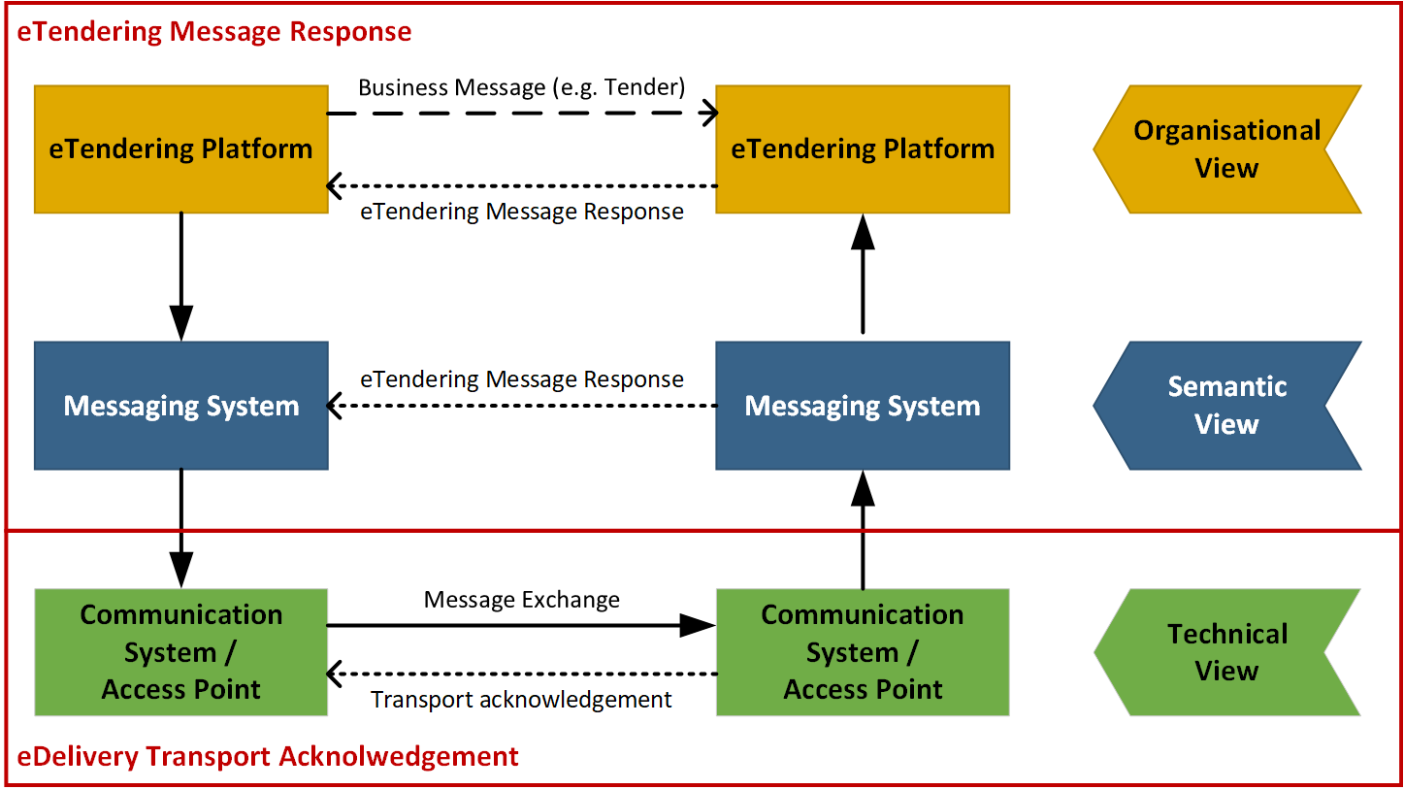
Figure 1: Flow of different response messages

The figure above illustrates the different views where TMRs are used. Whereas the technical view is addressed by transport acknowledgements, the TMR is applied to the semantic view (including syntactical aspects) as well as the organizational view of the eTendering process.

Technical View

These are messages that are exchanged within the transport network(s) to inform about the process of carrying a message down the transport line. These responses may inform someone up-line that the delivery to a given point was successful or not and may contain details about issues that are relevant such as why a delivery was not successful. The key nature of these responses is that they do not in any way act on result of validation or processing of the content of the payload that is being transported. These response messages are commonly called “acks” or transport acknowledgements.

Semantic View

When a message has reached a given point in the transport line its content may be validated according to agreed specifications that may be both syntactical and semantic. The outcome of these validations may be reported to a relevant party up-line, informing him whether the validation was successful or not as well as giving some details. An example could be that a tender message that is received is rejected because it is missing a closing tag (syntax error) or because the Economic Operator is not identified by its party and endpoint identifiers. A key nature of these messages is that they report on the message content based on the technical specifications that apply.

Organisational View

A message that has been received and accepted for processing may call for an action on the receiver’s behalf. That receiver’s action may need to be reported back up-line to a relevant party. An example is that a technically correct tender may be received but the receiver decides to reject the tender for any business reason such as expired tender submission deadline, a missing authorization to submit a tender etc. The key nature of these responses is that they report a business decision that is made on the message instance received.

Business Requirements

High level business requirements
Table 3: High level business requirements
Req. ID | Requirement statement | Ref. to goal
BR-001 | All transactions in the procurement procedure, such as subscribe to procedure or status inquiry, and documents, such as call for tenders or catalogues, should be based on common standards. | G39-002
BR-002 | Being interoperable means business partners shall implement the same profiles and transactions. Ideally, business partners should implement the entire set of transactions. However, contracting bodies and economic operators may wish to state conformance to some individual transactions (or small groups of transactions). | G39-003
BR-003 | The value of digitization lies in the implementation of all transactions in a procedure. A contracting body shall therefore be able to enforce a business process (tendering procedure), consisting of multiple transactions, on economic operators. Both contracting bodies and economic operators shall be able to state conformance of their system to the entire process. | G39-002
BR-004 | Code lists shall be consistent for all transactions in a complete procedure. | G39-016
BR-005 | When the contracting body publishes structured information, it requires a structured response; when the contracting body publishes unstructured information it requires an unstructured response. | G39-019
BR-006 | For contracting bodies and economic operators to be able to process individual transactions, they (or their systems) need to know to what business process the transaction belongs to. The process type and the process instance need to be identified at two levels: the level of the procedure and the level of the profile. | G39-020
BR-007 | All economic operators should be able to query publication portals (where the contract notices are being published) to find interesting business opportunities. | G39-005
BR-008 | All economic operators shall be able to access public procurement documents. | G37-005
BR-009 | The economic operator shall optionally be able to subscribe to an interesting business opportunity in order to receive the latest information about the call for tender. | G39-004
BR-010 | All subscribed economic operators should be informed when new versions of the procurement documents are published. | G39-004
BR-011 | All economic operators should be able to send questions regarding the procurement documents to the contracting body. | G39-010
BR-012 | The contracting body shall answer the questions from economic operators equal and transparent. | G39-010
BR-013 | The contracting body shall be able to send messages to all subscribed economic operators, to a selection of economic operators or to one economic operator. | G39-010
BR-014 | The economic operator shall be able to withdraw his bid as long as the time limit to submit bids has not passed. | G39-007
BR-015 | The contracting body should be able to send the results of the bid evaluation to all economic operator who submitted a bid. | G39-005
BR-016 | The contracting body should be able to award the winning economic operator. | G39-006
BR-017 | The Contracting Body SHALL invite to tender only selected candidates. | G39-008
BR-018 | The economic operator MAY NOT submit a tender if he has not been invited to. | G39-008
BR-019 | Economic operators that do not respect the exclusion or selection criteria MUST be informed that they have not been selected at the same time as the selected are informed and receive the invitation to tender | G39-008

Key examples
This section illustrates key examples for the notification and execution of a restricted procedure using Peppol. Thereby, the first examples focus on the particularities of the notification process, being part of procurement procedure. The second example then concentrates on the actual business process of a particular two phased procedure, the restricted procedure, and thereby generalizes the part of the publication.

Key example: Notification
This section illustrates a key example for the execution of a notification procedure using Peppol. The initial diagram is accompanied by a textual description. Both, illustrate the flow of transactions that are send between the actors and components. The actors and components involved in this scenario are:

- The contracting body PublicHealthBerlin from Germany
- The eTendering platform PublicPurchase used by PublicHealthBerlin
- A national notification system used by PublicHealthBerlin
- The European notification platfrom Tenders Electronic Daily (TED) operated by the publication office
- The economic operator LisbonMedical from Portugal
- The eTendering platform PowerSeller used by LisbonMedical

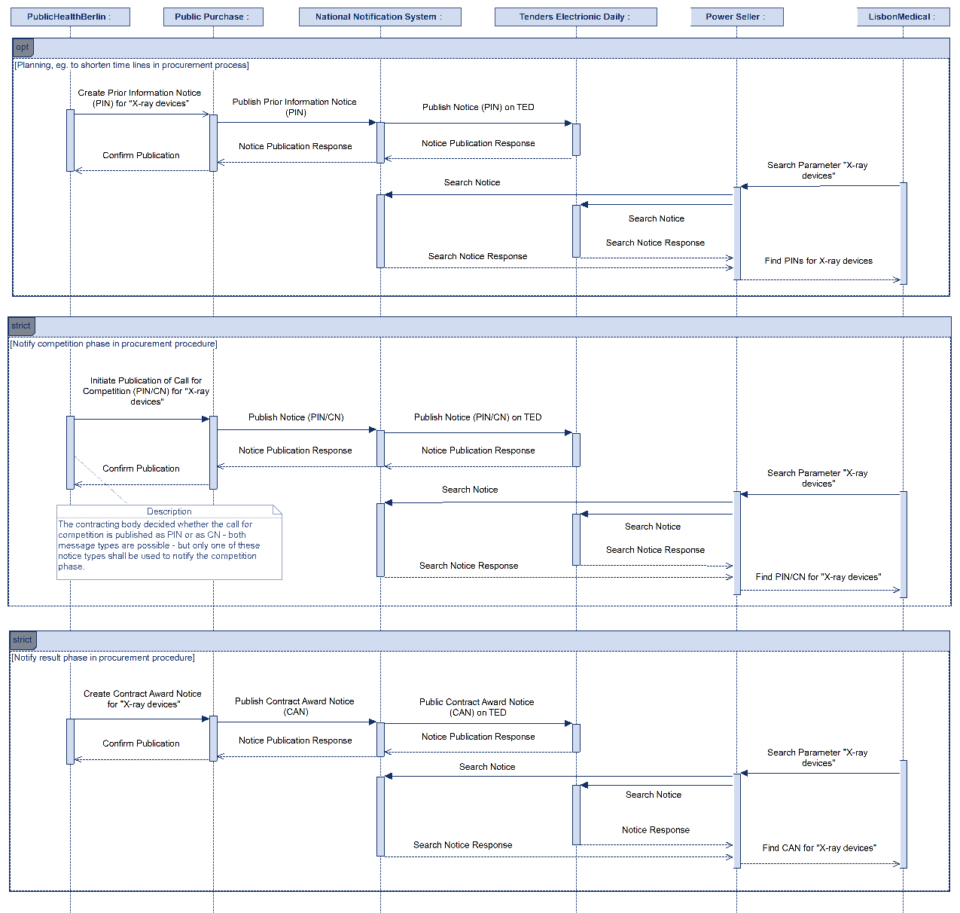
Figure 2: Flow of Notifications in Restricted procedure Key Example

Prior Information Notice (PIN) to be used as planning information
The contracting body PublicHealthBerlin from Germany starts a tendering procedure because it wants to buy X-ray devices from any European supplier. To shorten the competition phase, it starts to prepare a prior information notice (PIN) in its eTendering platform PublicPurchase. The PIN is defined along the eForms format and contains details about the project such as the place of performance, the duration, and the estimated value of the procurement. All information about the contracting body is included in the notice. Once the PIN has been created on the eTendering platform PublicPurchase, the platform uses its Peppol interface to publish the notice on the National Notification System. The National Notification System confirms the reception of the PIN to the system PublicPurchase used by PublicHealthBerlin. In Germany, the National Notification System is responsible for publishing all announcements of PublicHealthBerlin to the European publication platform Tenders Electronic Daily (TED) operated by the Publication Office. In this scenario, TED also offers a Peppol interface, so that it can receive the PIN via Peppol from the National Notification System. TED confirms the reception of the PIN to the National Notification System which in turn forwards the result of publication to the contracting body PublicHealthBerlin.

The different Notification Platforms TED and National Notification System can be queried by economic operators and/or their eTendering Platforms across Europe to find business opportunities through Peppol. The economic operator LisbonMedical from Portugal uses the Peppol enabled eTendering platform PowerSeller. Through the platform PowerSeller, the supplier LisbonMedical queries TED and the National Notification System along the parameter “X-ray devices”. The search on the platforms may result in several notices. The platforms answer the search request by sending the matching notices to the tendering system PowerSeller. LisbonMedical finds the business opportunity and PIN from PublicHealthBerlin described above. The notice presents details about the project (ID of the procurement procedure, text description, NUTS codes for location, CPV code for procurement items). LisbonMedical is interested in the opportunity and is waiting for the publication of the contract notice.

Contract Notice (CN) or Prior Information Notice (PIN) to announce the Call for Competition
After the publication of the PIN, the contracting body PublicHealthBerlin starts to prepare the relevant procurement documents required to publish the Call for Competition for X-ray devices (which is possible to be published as PIN or as CN). The procurement documents are created in the eTendering platform PublicPurchase. Together with the call for competition notice, the contracting body defines the Call for Tender including qualitative selection criteria which need to be proven by economic operators who apply for the tendering procedure. Once the PIN or CN has been created on the eTendering platform PublicPurchase, the platform uses its Peppol interface to publish the PIN or CN on the National Notification System. The National Notification System confirms the reception of the PIN or CN to the system PublicPurchase used by PublicHealthBerlin. Simultaneously, the National Notification System uses its Peppol interface in order to send a request for publication of the PIN or CN to the European publication platform TED. TED confirms the reception of the PIN or CN to the National Notification System which in turn forwards the result of publication to the contracting body PublicHealthBerlin.

After a while, the supplier LisbonMedical queries all Peppol enabled notification systems along any publication with reference to the formerly published PIN that informed about the planned restricted procurement procedure for X-ray devices. The National Notification System and TED answer the search request by sending the searched notice when found to the tendering system PowerSeller. LisbonMedical reads through details of the project and decides whether to participate or not.

Contract Award Notice (CAN) to announce the award results
After the contract award, the contracting body PublicHealthBerlin creates the Contract Award Notice (CAN) in the format of eForms. Once the stand-still period has ended, the eTendering platform PublicPurchase uses its Peppol interface to publish the CAN on the National Notification System which in turn forwards the CAN to TED. Both notification systems confirm the reception of the CAN whereas the National Notification System forwards both results of publication to the contracting body PublicHealthBerlin.

The supplier LisbonMedical is interested in the results of the contract award. The supplier LisbonMedical queries all Peppol enabled notification systems for contract award notices with the parameter “X-ray devices”. The notification platforms answer the search request by sending the notice with matching parameter to the tendering system PowerSeller. The received CAN is analysed by LisbonMedical. It contains details about the contract award results (e.g. delay, award criterion, number of candidates).

Key example: Two Phased Procedure - Restricted Procedure
This section illustrates a key example for the execution of a restricted procedure using Peppol. The diagrams are accompanied by a textual description. Both, illustrate the flow of transactions that are send between the actors and components. The actors and components involved in this scenario are:

- The contracting body PublicHealthBerlin from Germany
- The eTendering platform PublicPurchase used by PublicHealthBerlin
- An undefined set of European (e.g. Tenders Electronic Daily) and national Notification Platforms (they remain in this sequence diagramm although it seems as if they were not participating any more – but their communication part is only hidden by the combined fragments referencing to the notification diagram)
- The economic operator LisbonMedical from Portugal
- The eTendering platform PowerSeller used by LisbonMedical

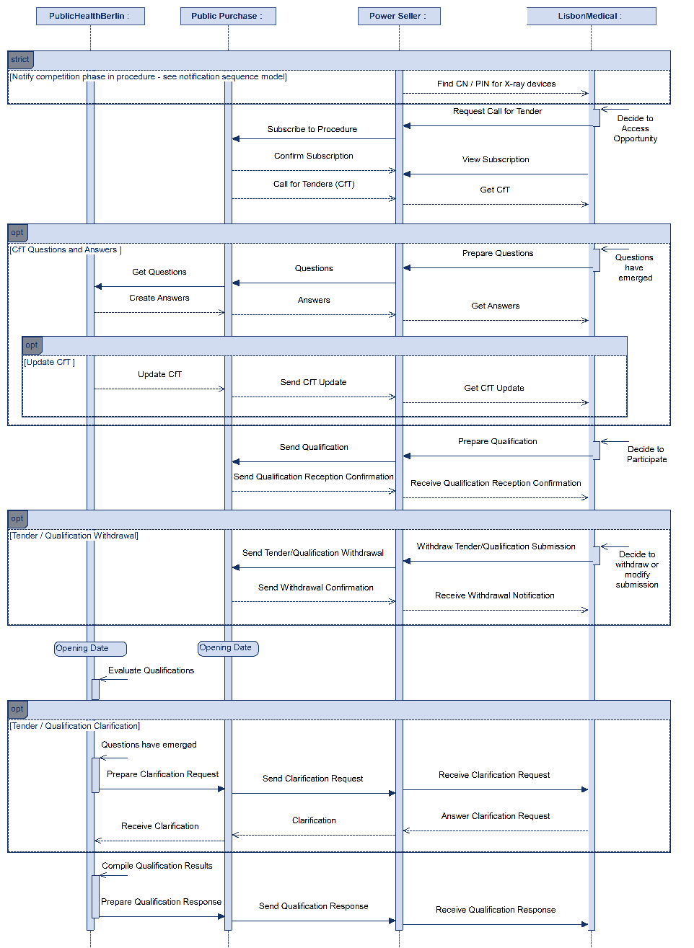
Figure 3: Flow of Transactions in Restricted procedure Key Example (First Stage)

Preparation Phase
The contracting body PublicHealthBerlin from Germany starts a tendering procedure because it wants to buy X-ray devices from any European supplier, and it has chosen to use a restricted procurement procedure. At first, it starts to prepare the relevant procurement documents in its eTendering platform PublicPurchase, the prior information notices, the contract notice, in any proprietary format.

As part of this process, the contracting body specifies the products to be bought (e.g. by using a pre-award catalogue request) and defines qualification criteria (e.g. along the Single European Procurement Document (ESPD)) which need to be proven by economic operators which apply for the tendering procedure. The contracting body adds the standardized qualification criteria (ESPD) and product specification (catalogue request) to the call for tenders (CfT). All documents are defined in a standardized XML format according to the requirements and rules described by Peppol.

Note: The preparation phase is not explicitly captured in the sequence model because it is an internal process.

Notification
The eTendering platform PublicPurchase used by PublicHealthBerlin has a Peppol interface for exchanging notices with national and European Notification Platforms. The Notification Platforms are required by PublicHealthBerlin to publish notices for the tendering procedure.

The different Notification Platforms can be queried by economic operators and/or their eTendering Platforms to find business opportunities. The economic operator LisbonMedical from Portugal uses the Peppol enabled eTendering platform PowerSeller. Through the platform PowerSeller, the supplier LisbonMedical queries the Notification Platforms along the parameter X-ray devices and finds the business opportunity and contract notice from PublicHealthBerlin described above.

The notification phase is referenced but not explicitly drawn in the sequence model in Figure 3 because it was already introduced in Figure 2: Flow of Notifications in Restricted procedure Key Example.

Procurement Document Access
Through the information established in the relevant notice, the the supplier LisbonMedical can subscribe to the public tendering procedures established by PublicHealthBerlin using the Peppol eTendering interface. The platform PublicPurchase registers the subscription of LisbonMedical in its database so that the economic operator will be kept up to date.

Based on the subscription, the contracting authority PublicHealthBerlin uses its Peppol eTendering interface to confirm the subscription and to provide information related to the procurement procedure to the supplier LisbonMedical. LisbonMedical receives the call for tenders including criteria of qualitative selection (e.g. ESPD) and a product specification (e.g. pre-award catalogue request) through the Peppol network.

Throughout the procedure, the economic operators LisbonMedical decides to use Peppol to send questions about the qualification procedure. The message is sent from the platform PowerSeller to PublicHealthBerlin via Peppol. The contracting body PublicHealthBerlin receives the questions via the platform PublicPurchase and answers the questions and stores the answers on the platform PublicPurchase. The platform PublicPurchase forwards the given answers via Peppol to all economic operators that subscribed to the procedure and eventually sends an updated call for tenders to them. All economic operators can now review the given answers.

Qualification Submission
The economic operator LisbonMedical decides to submit a request to participate in the procedure published by PublicHealthBerlin and prepares the required qualification documents for the procedure. The qualification documents are drafted along the qualification criteria and templates provided by PublicHealthBerlin (e.g. by creating an ESPD response).

LisbonMedical sends the qualification document from the eTendering platform PowerSeller to the eTendering platform PublicPurchase used by PublicHealthBerlin. Afterwards LisbonMedical receives a qualification receipt from PublicPurchase. Simultaniously, the platform PublicPurchase stores the qualification and the qualification receipt on its platform.

After the initial submission, the economic operator LisbonMedical discovers an error in the qualification documents, corrects it, submits new qualification documents to the platform PublicPurchase, and withdraws the old submission.

Qualitative selection
On the opening date, the contracting authority PublicHealthBerlin examines the submitted qualifications and evaluates them against the criteria of qualitative selection. Throughout the evalution process, PublicHealthBerlin raises a question related to the qualification approval received from LisbonMedical and receives an answer through the Peppol eTendering interface.

At the end of the qualification process, the contracting body PublicHealthBerlin has chosen a list of qualified economic operators. PublicHealthBerlin compiles the qualification results and sends the qualification responses to the economic operators submitted their qualification documents. A qualification response may be positive or negative. The contracting body PublicHealthBerlin creates a shortlist of qualified tenderers.

All economic operators who have not qualified for the procedure are rejected from the subsequent tendering process. Economic operators which are qualified, receive a positive qualification response and will be invited to tender as shown in the Figure 4: Flow of Transactions in Restricted procedure Key Example (Second Stage).

Invitation to Tender and Tender

LisbonMedical is short-listed and has passed the first stage of the restricted procedure which was directed towards the qualitative selection process. Consequently, PublicHealthBerlin creates and sends an invitation via the PublicPurchase platform using the Peppol network. In our example LisbonMedical will receive its invitation to tender through the Plattform PowerSeller.

The tendering process follows the same rules and procedures that have been described in the first stage for submitting the qualification documents. Therefore, the next process steps are only illustrated in short.

Before the submission deadline LisbonMedical may raise questions using the call for tender questions and answer process. The economic operator LisbonMedical finally decides to submit a tender for the procedure executed by PublicHealthBerlin. It therefore sends the tender to the eTendering platform PublicPurchase used by PublicHealthBerlin. Afterwards LisbonMedical receives a tender receipt from PublicPurchase and may be able to withdraw the tender and to submit a new one.

Awarding
On the opening date, the contracting authority PublicHealthBerlin examines the tenders and evaluates them. Throughout the evaluation process, PublicHealthBerlin raises a question related to the tender received from LisbonMedical and receives an answer through the Peppol eTendering interface of PowerSeller.

The contracting body PublicHealthBerlin awards the contract for X-ray devices to LisbonMedical. It prepares awarding notifications for each bidder with individual reasons for failure or success containing information about the winning economic operator. The awarding notification for LisbonMedical additionally includes a draft contract. After that, the platform PublicPurchase simultaneously sends the awarding notifications to each economic operator that submitted a tender.

After the stand-still period, the contracting body PublicHealthBerlin publishes the contract award notification on relevant Notification Platforms according to the notification examples given in the previous section.
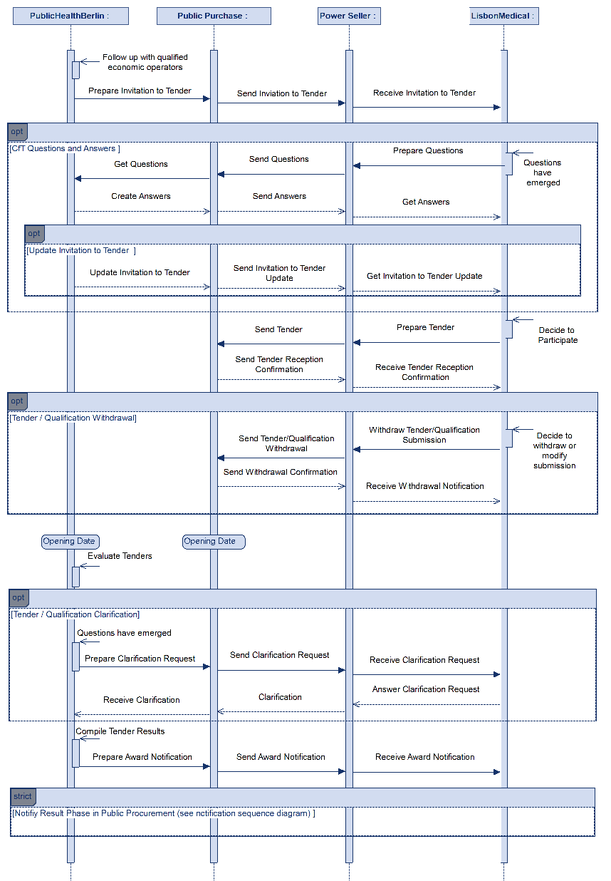
Figure 4: Flow of Transactions in Restricted procedure Key Example (Second Stage)

Two-Stage Procedures – Actors, Roles and Use Cases

Actors and Roles
The following business partners participate in this profile, acting in the roles as defined below.

Table 4: Business partners
Business partners | Description
Customer | The Customer is the legal person or organization who is in demand of a product, service, or work. Examples of customer roles are Buyer, Consignee, Debtor, and contracting body.
Supplier | The Supplier is the legal person or organization who provides a product, service or works. Examples of Supplier roles are Seller, Consignor, Creditor, and economic operator.
Governmental or private organization | Any organisation.

Table 5: Roles & Actors (Standard)
Roles & Actors | Description
Contracting Authority (CA) | The contracting authority or contracting entity who is buying supplies, services, or tendering works.
Economic operator (EO) | Party participating with a bid in a procurement process to sell goods, services or works.
Publication Body (PB) | A Pan-European, national, or regional organisation that publishes procurement notices of a contracting body. While the basic role of the publisher may apply to any newspaper, other roles and functions are often restricted to official gazettes. These gazettes are also often responsible to ensure a formal verification of the notices in respect of legislative or other requirements in vigour. Official gazettes may also have the role to receive information exempted from publication (e.g. due to confidential content) used for notification to a supervising authority

Two-Stage Procedure Use Cases

Pre-Award Procurement Phases and Use Cases
Figure 5 shows the use cases along the phases of public pre-award procurement expressed as Peppol BIS that need to be implemented to support the implementation of notification and two-stage procedures using Peppol.

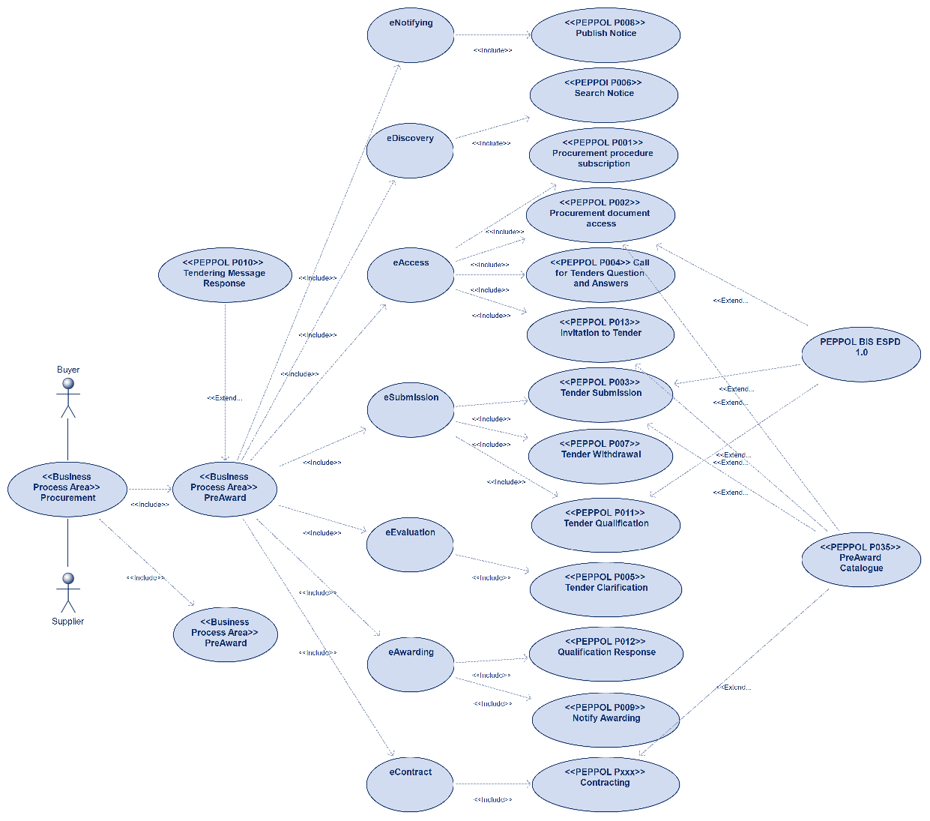
Figure 5: Pre-Award Procurement Phases and Use Cases

Mapping of Use Cases to Pre-Award Procedures
The use case diagram illustrated in Figure 6 maps the different use cases that are expressed as Peppol BIS to the principal procedure types open procedure and two-stage procedure. From the diagram it becomes obvious that the two-stage procedure contains more use cases than the open procedure because the qualification and tendering phases are executed at different times.

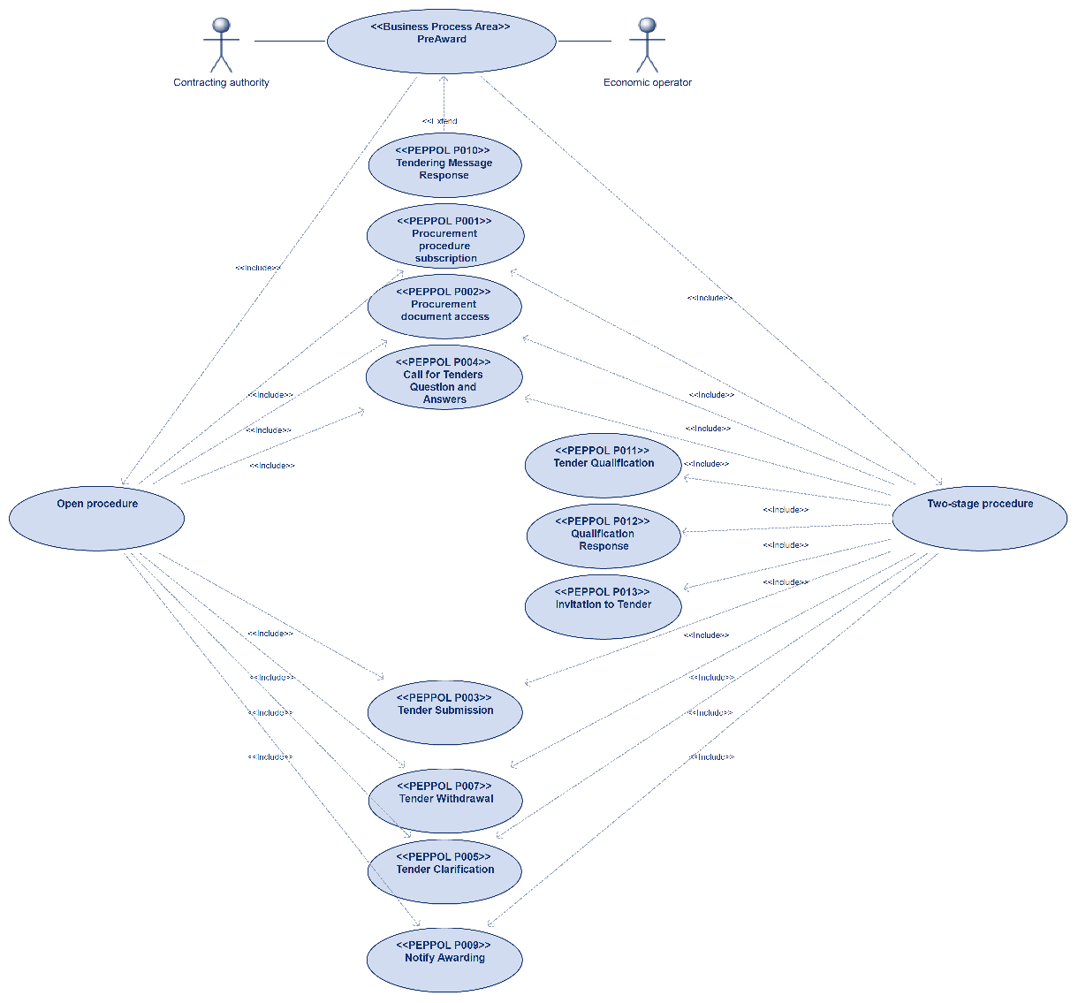
Figure 6: Mapping of Use Cases to Pre-Award Procedures

Notification & Restricted Procedure Business Process
This section illustrates the choreography of the Notification & Restricted Procedure business process. Other two stage procedure business processes such as Dynamic Purchasing System (DPS) are illustrated in section 7 Process Variants from a high-level perspective. The process variants follow a similar sequence of business processes but carry out the various phases repeatedly.

Thus, the conditions and business process for execution a restricted procedure is illustrated first as a major point of reference for other variants. At first a high-level overview (process map) is provided which splits the overall business process into different sub-processes. Each subprocess is modelled within a separate BPMN diagram in the following subsections. A description of all activities is provided at the end in section 6.10.

Table 7:Conditions of the Restricted Procedure
Category | Description
Description | The restricted procedure in European directives for public procurement involves a structured approach to selecting suppliers and awarding contracts. Initially, suppliers express their interest and undergo a pre-qualification phase where they must meet specific criteria. Qualified suppliers are then invited to tender, submitting detailed proposals. These tenders are evaluated based on set criteria, and the contract is awarded to the supplier offering the best value for money and meeting the requirements.
Pre-conditions | The contracting body decided to tender a contract following a restricted procedure.
Post-conditions | The tendering process has been finished. An economic operator who submitted a tender has been contracted successfully.

Legal Framework
The EU Directives 2009/81 EC, 2014/24 EU, 2014/25 EU define the following requirements for the restricted procedure.

Request to Participate and Qualification
In restricted procedures, any economic operator may submit a request to participate in response to a call for competition by providing the information for qualitative selection that is requested by the contracting authority.

The minimum time limit for receipt of requests to participate shall be 30 days from the date on which the contract notice or, where a prior information notice is used as a means of calling for competition, the invitation to confirm interest was sent.

Invitation to Tender
Only those economic operators invited to do so by the contracting authority following the assessment of the information provided may submit a tender. Contracting authorities may limit the number of suitable candidates to be invited to participate in the procedure.

Tender Submission
The minimum time limit for the receipt of tenders shall be 30 days from the date on which the invitation to tender was sent. The time limit for the receipt of tenders may be shortened for several reasons (e.g. use of prior information notice, agreement between contracting authority and economic operators, state of urgency).

Awarding
The final tenders are assessed based on the award criteria and the most economically advantageous tender is identified.

Process description
The Restricted Procedure, which legal basis has been shortly described in chapter 6.1 before, is commonly used for procurement contracts where the contracting authority aims at pre-selecting a limited number of suppliers to participate in the tendering process. The process of the Restricted Procedure can be described as follows:

Initiation of the Procedure: The contracting authority initiates the Restricted Procedure by publishing a contract notice in the Official Journal of the European Union (OJEU) or other designated platforms.
The contract notice invites interested suppliers to submit applications to participate in the procurement process. It includes information about the nature of the contract, the requirements, and the procedure to be followed.

Initial Selection: In the restricted procedure, the procurement process begins with an initial selection phase. During this phase, any interested suppliers are invited to express their interest in tendering for the contract. This expression of interest typically involves providing basic information about their organization and demonstrating that they meet certain qualification criteria set out by the contracting authority.

Qualification: Qualification is the essential step in the initial selection phase: Following the expression of interest, the contracting authority evaluates the suitability of the interested suppliers based on pre-defined selection criteria and selects a shortlist of suppliers who will be invited to submit tenders for the contract. These criteria may include financial stability, technical and professional capability, relevant experience, and compliance with legal requirements. Only suppliers who meet these criteria best, proceed to the next stage.

Invitation to Tender: After the pre-qualification stage, the contracting authority invites the shortlisted suppliers to participate in the tendering process. This invitation includes providing the suppliers with detailed information about the contract requirements, specifications, terms, and conditions. The invitation to tender may also include instructions on how to submit their tender proposals and provide a specified deadline to submit tenders, along with any supporting documentation required by the contracting authority.

Tender Submission: The selected suppliers then prepare and submit their tender proposals in response to the invitation. Tender submissions typically include detailed pricing, technical specifications, proposed methodologies, delivery schedules, and any other relevant information requested by the contracting authority.

Evaluation: Once the tender submission deadline has passed, the contracting authority evaluates the received tenders based on specified evaluation criteria. These criteria may include price, quality, compliance with specifications, and other factors relevant to the contract requirements. The evaluation process is conducted in a fair, transparent, and non-discriminatory manner, ensuring equal treatment of all tenderers.

Award Decision: Finally, the contracting authority makes an award decision based on the evaluation of the tenders. The contract is awarded to the winning bidder, and the other tenderers are notified of the outcome.
The decision is typically made in accordance with the principles of transparency, equal treatment, and non-discrimination. The contract is awarded to the supplier whose tender is determined to offer the best value for money and meet the requirements of the contracting authority.

Contract Implementation: Once the contract is awarded, the contracting authority and the winning bidder implement the contract according to the agreed terms and conditions.

Process Map: Notification & Restricted Procedure
The choreography of business collaborations defines the sequence of interactions when a restricted procedure is executed using Peppol. For better readability the business process overview of the restricted procedure illustrated in in Figure 7 has been divided into the following core subprocesses: Notification, Procurement Document Access, Qualification, Qualification Response, Invitation to Tender, Tender Submission and Awarding illustrated by the process overview below.

Note: The process overview below principally describes the process that will follow any kind of two-stage procedure which is executed in – at least two steps – one qualification step which is followed by a tendering process. In restricted procedure the tendering process is only executed once whereas in competitive dialogs or competitive procedure with negotiations the tendering process may be repeated several times.

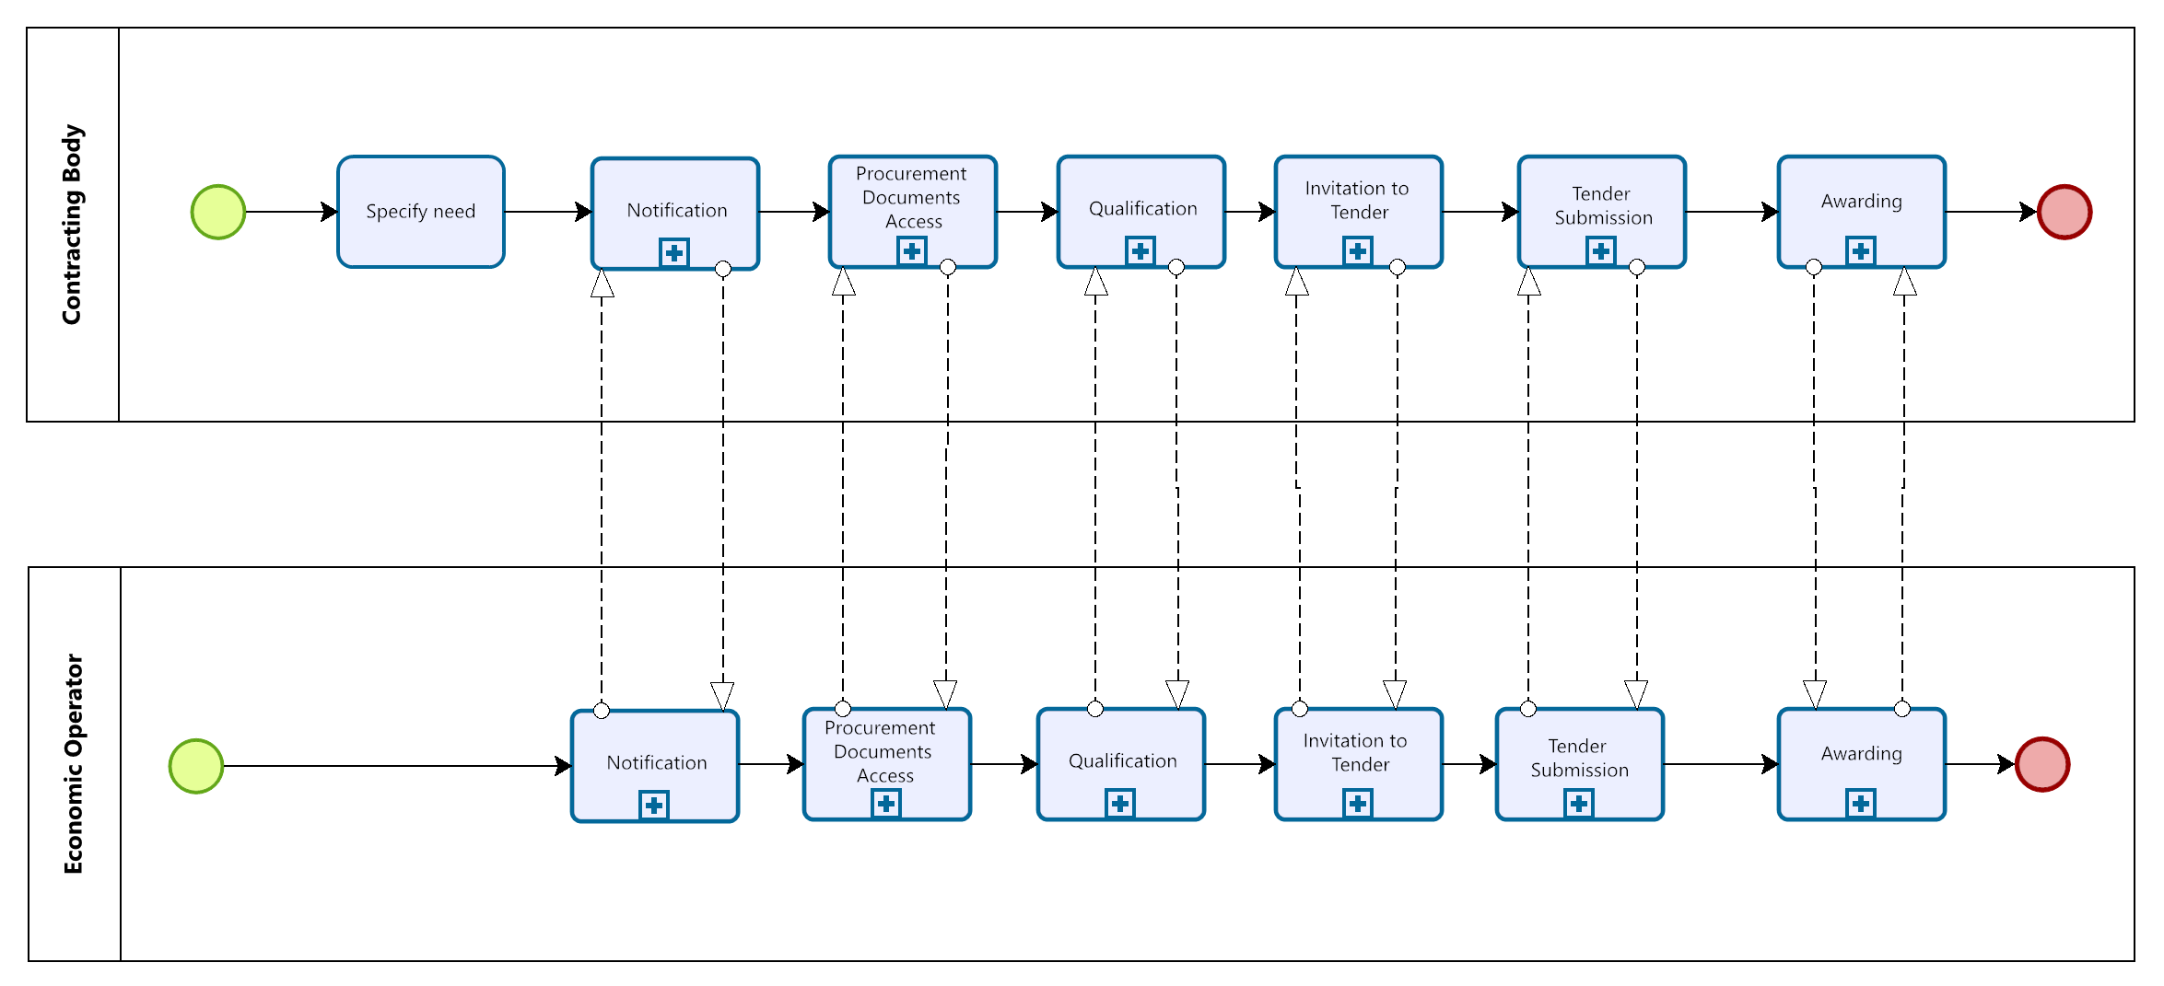
Figure 7: Notification & Restricted procedure process map

Process: Notification
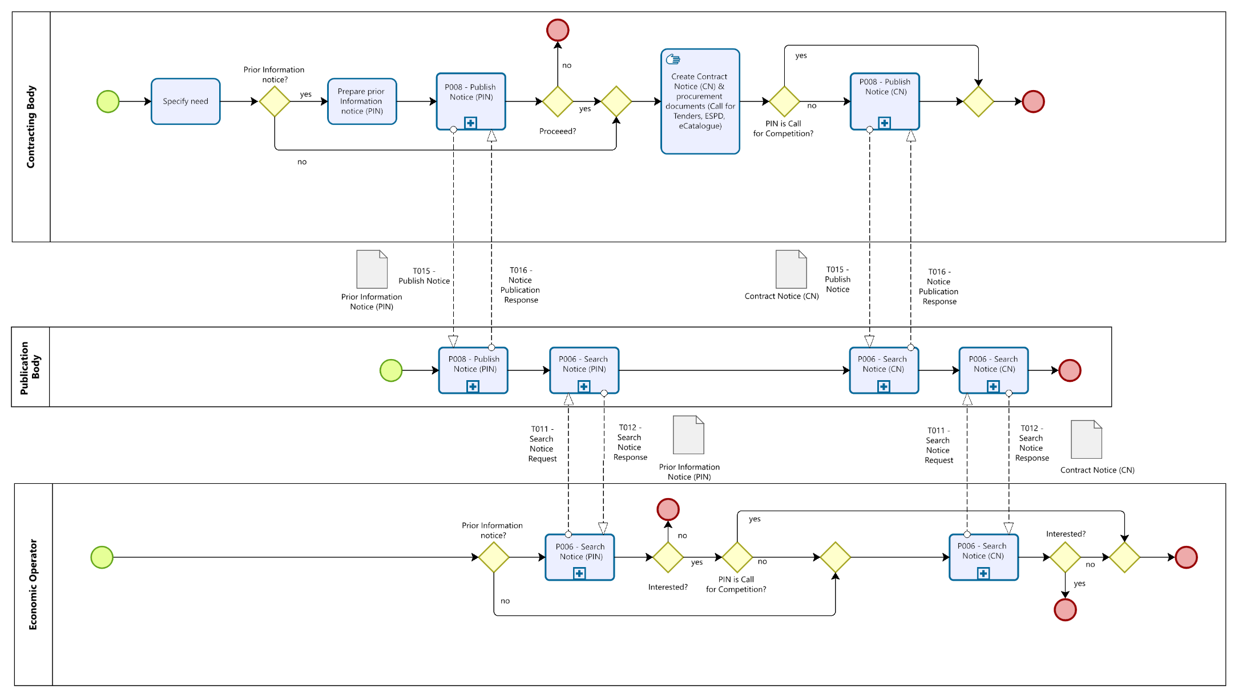
Figure 8: Notification Process

Process: Procurement Document Access
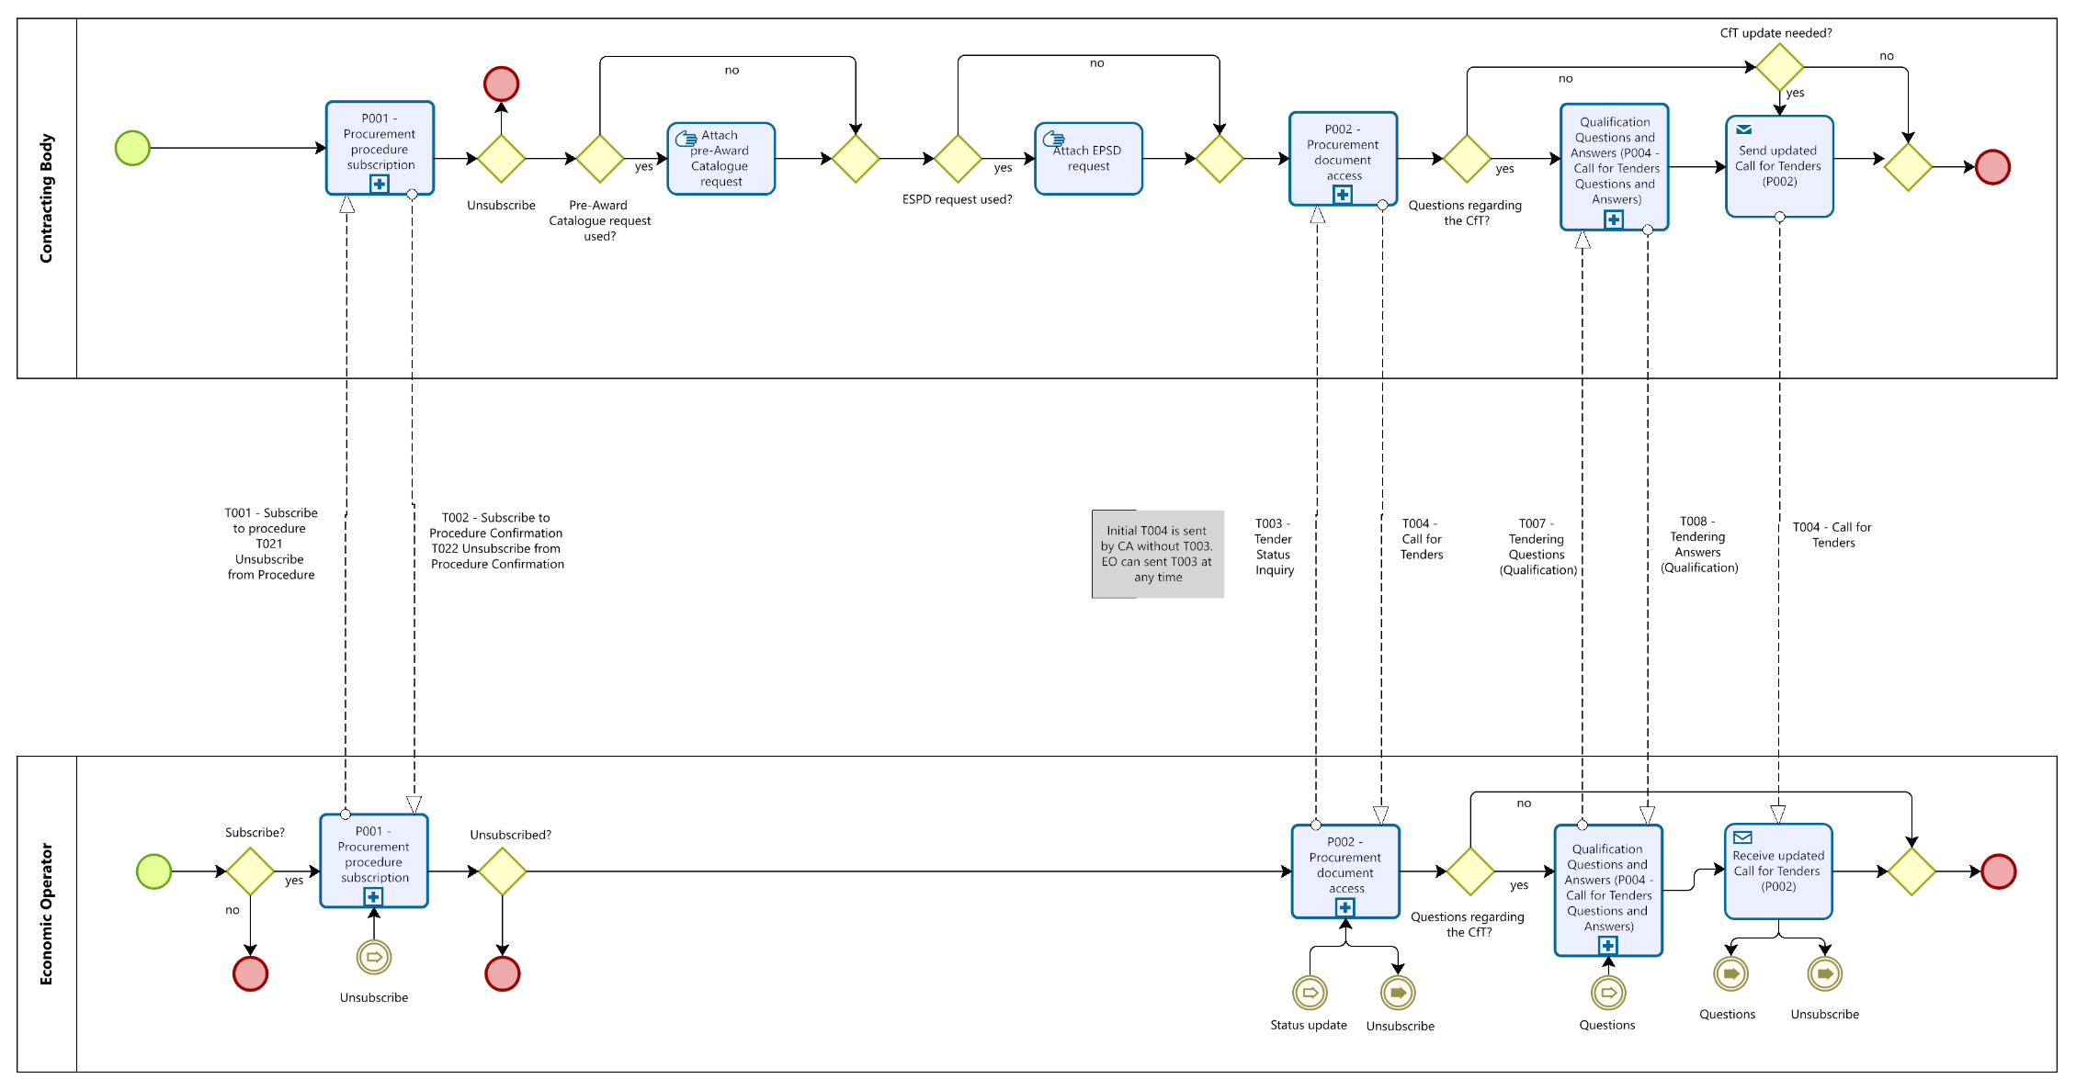
Figure 9: Procurement Document Access process

Some of the transactions illustrated by the process flow do not have to follow a strict sequential order as shown in the process model. This is indicated through the catch-link and throw-link events to avoid iterative representations and process flows. The next subsections add some notes to the chronological peculiarities in the process flows.

Additional note: T021 - Unsubscribe from Procedure
Transaction T021 - Unsubscribe from Procedure and the associated response message T022 - Unsubscribe from Procedure Confirmation can take place at any time after the subscription and before the final tender submission. This is indicated through the catch-link and throw-link events (Unsubscribe). The economic operator's expression of interest in the procedure is withdrawn and confirmed by the contracting authority. Effectively the Unsubscribe from Procedure means that the economic operator will not receive updates of the Call for Tenders or Invitation to Tender anymore and cannot submit his Qualification or Tender, raise questions etc. As Tenders and/or Qualifications that have been submitted are legally binding documents, they remain valid until a Tender Withdrawal has been submitted for the corresponding document. In this case, Economic Operators shall be informed about the results of the evaluation through the Qualification Response and/or Awarding Notification. It shall be also noted that the Unsubscribe from Procedure actions is an unlogic and exceptional case which should be prevented by a tendering platform implementing pre-award processes where a tender has been submitted already.

Additional note: T003 - Tender Status update
At any moment in the procedure before the submission deadline of a Qualification or Tender, the economic operator may start an inquiry about the status of the procedure. After the sending of transaction T003 - Tender Status Inquiry, the economic operator will receive from the contracting authority the latest version of the procurement documents. If the procedure is in the phase of qualification transaction T004 - Call for Tenders will be sent. After the qualification phase the T013 – Invitation to Tender will be returned by the contracting authority. This is indicated through the catch-link and throw-link events (Status update). As noted in Figure 9: Procurement Document Access process, the first T004 shall be sent automatically by the contracting authority after the retrieval of the expression of interest. Any updates to the Call for Tenders shall be also proactively forwarded to the economic operators that subscribed to the procedure.

Additional note: T007 - Tendering Questions
The transaction T007 – Tendering Questions can be sent at any time after the retrieval of the T004 – Call for Tenders and before the submission deadline. It will be responded to by the Contracting Authority with T008 – Tendering Answers if there is enough time to answer and the deadlines for asking questions have been met. This is indicated through the catch-link and throw-link events (Question). For reasons of equal treatment, the contracting authority typically sends the T008 to all economic operators who have expressed an interest.

Process: Qualification
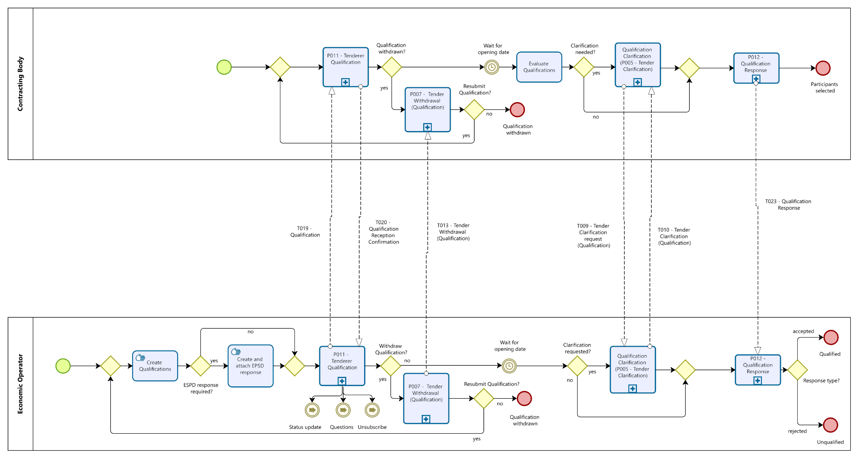
Figure 10: Qualification Process

Process: Invitation to Tender
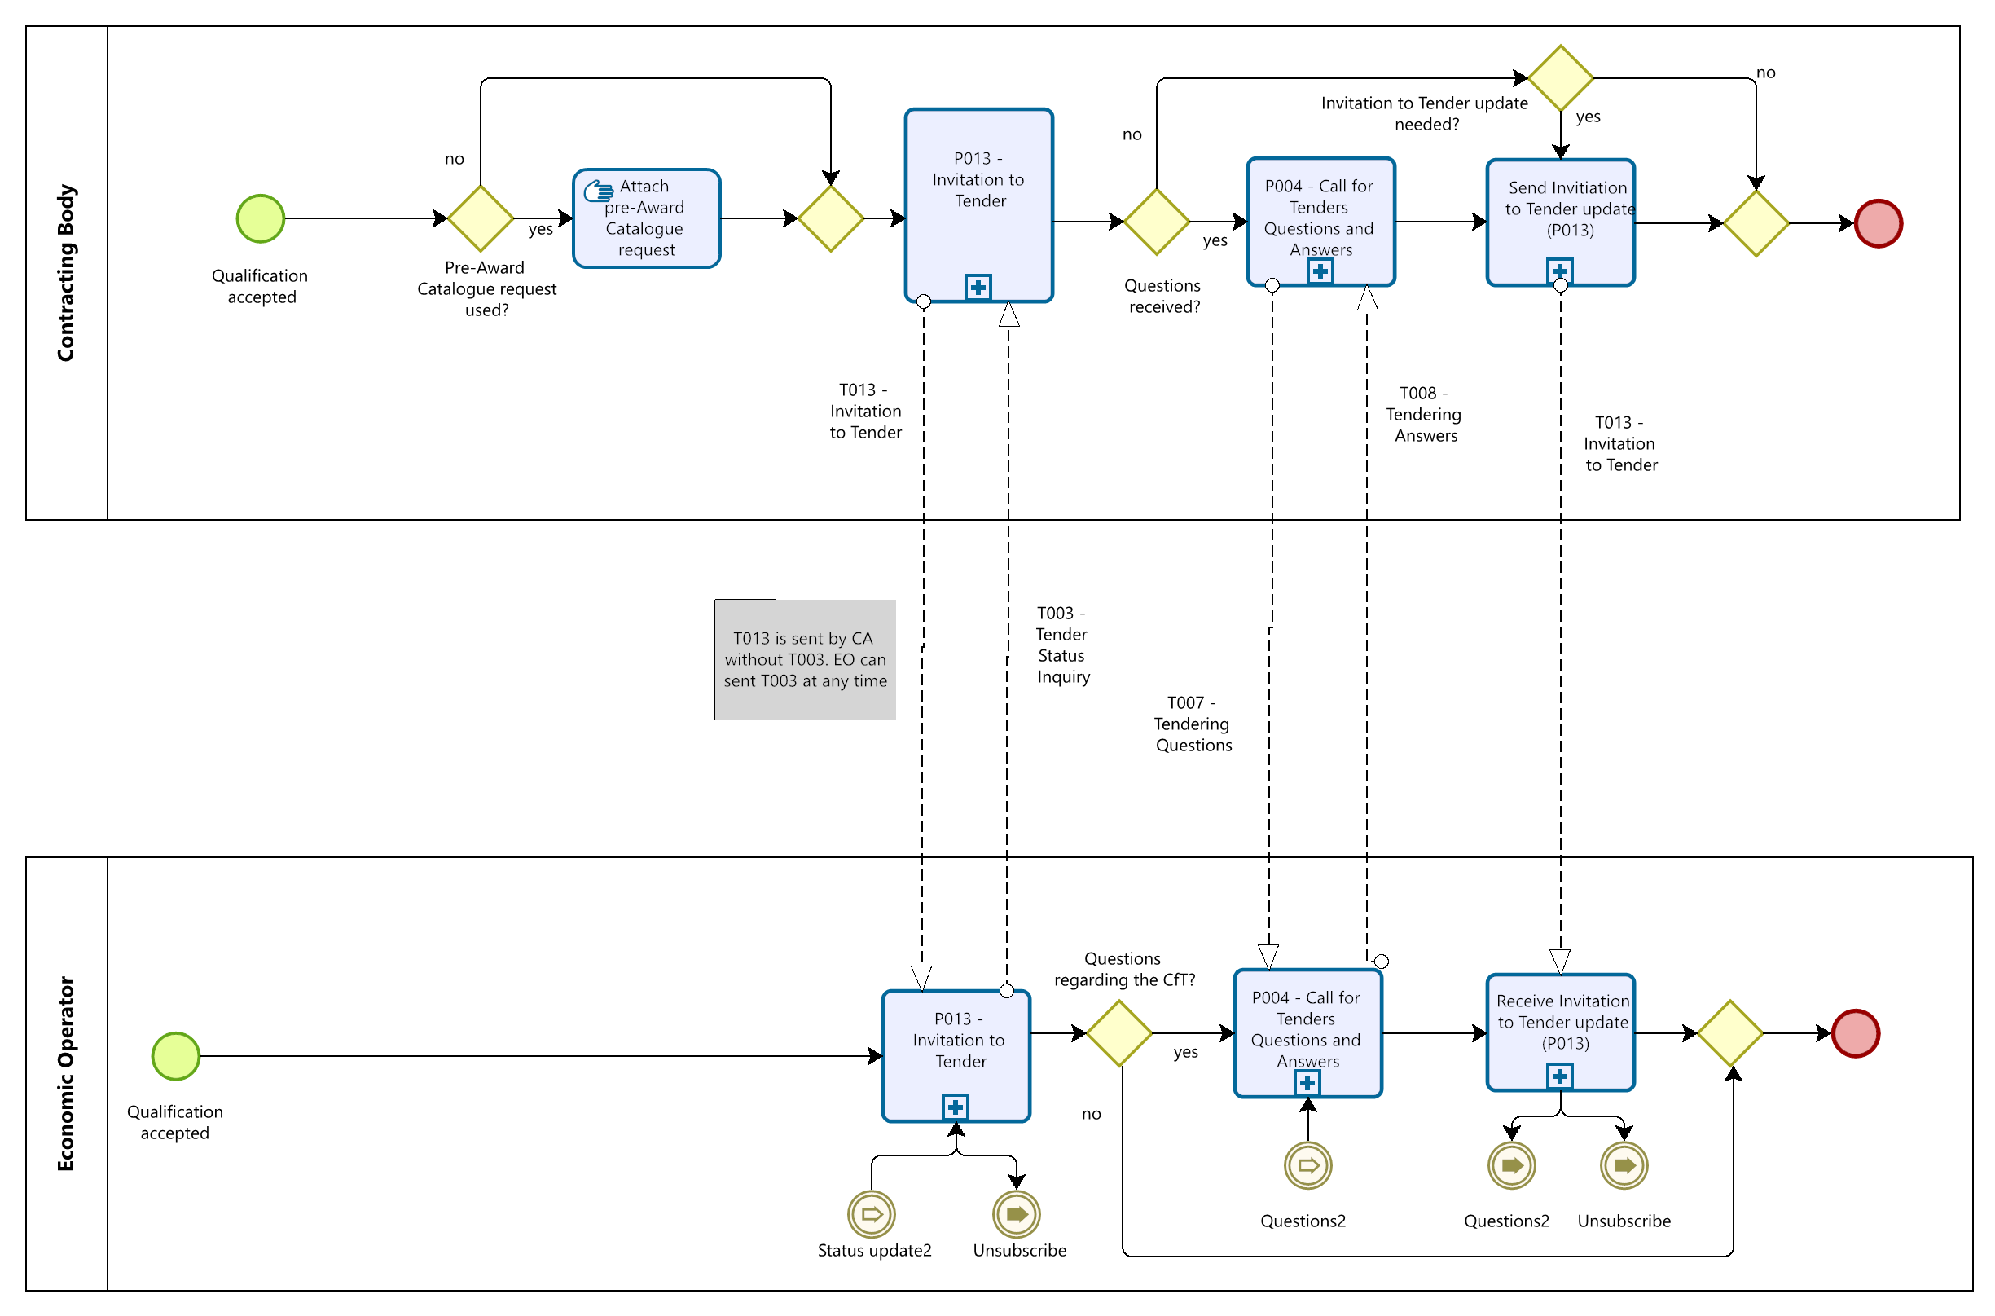
Figure 11: Invitation to Tender Process

Process: Tender Submission
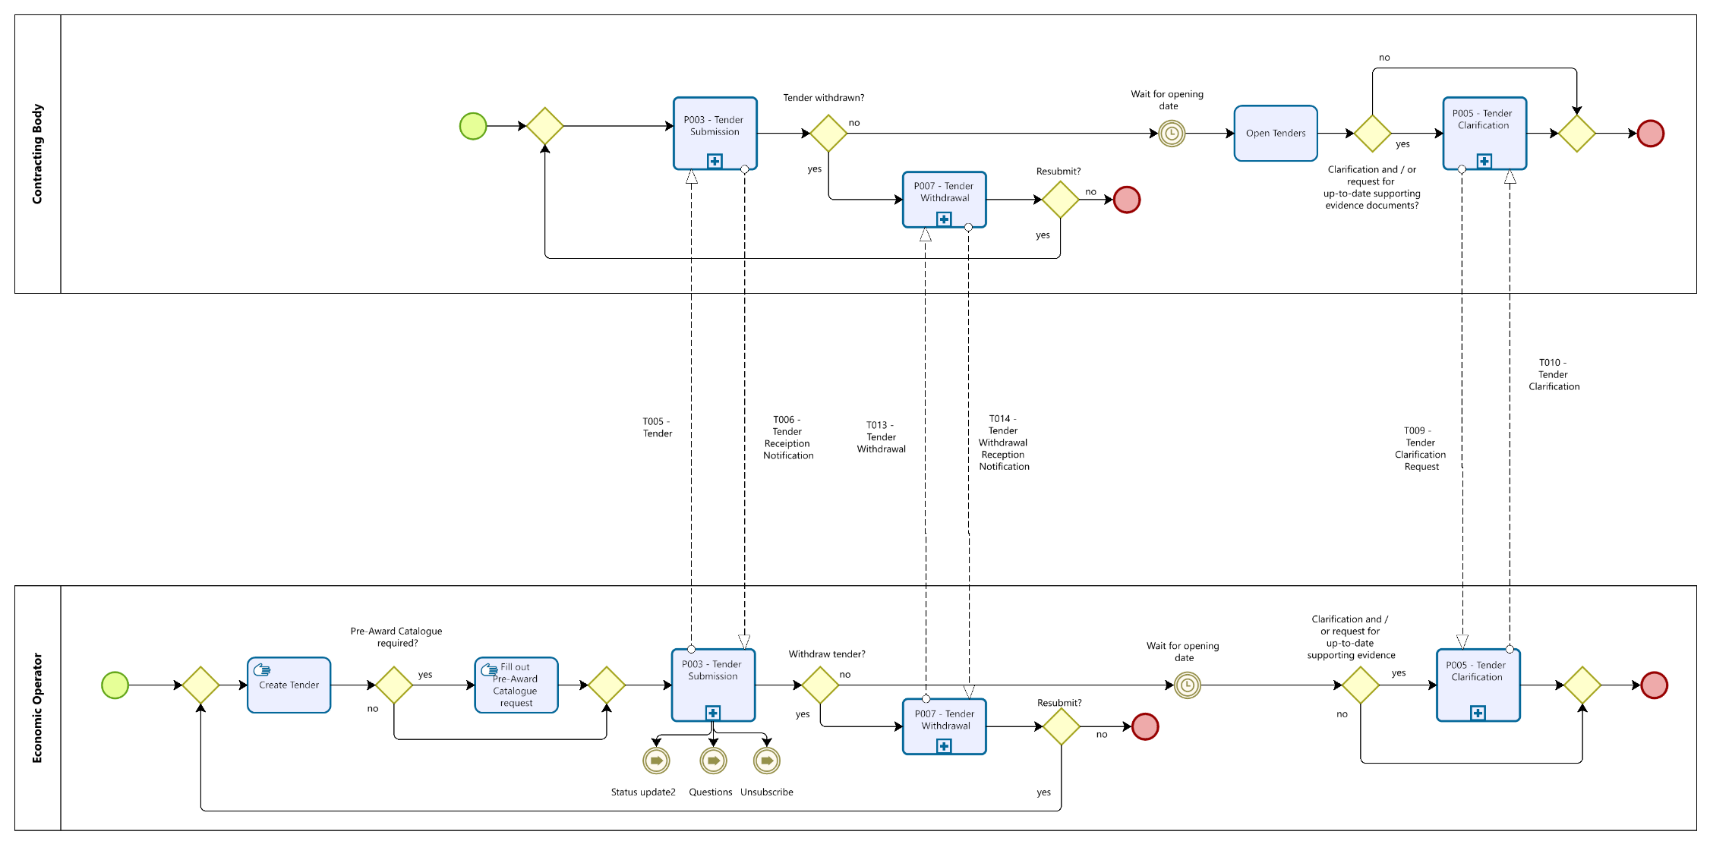
Figure 12: Tender Submission process

Process: Awarding
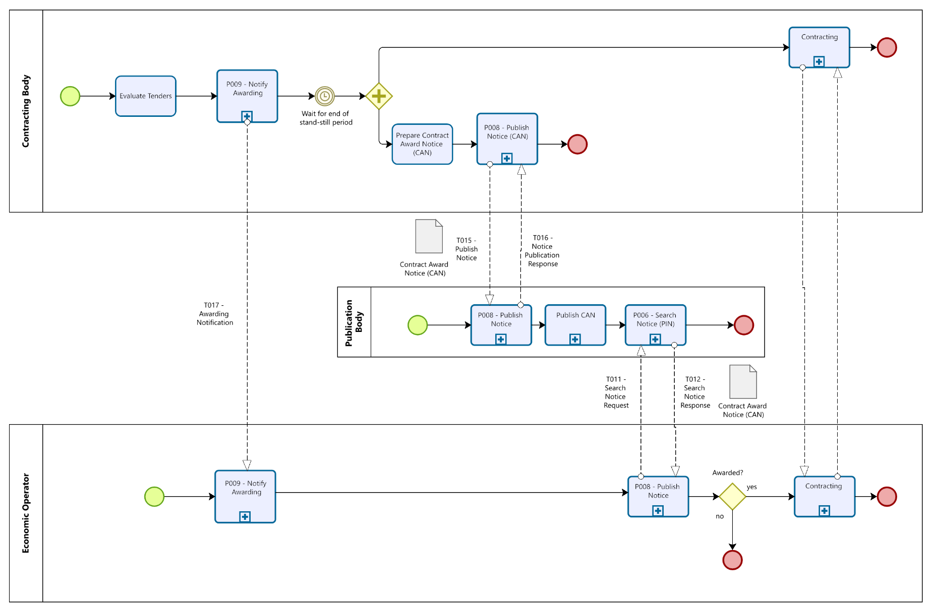
Figure 13: Awarding Process

Notification & Restricted Procedure activity detailed descriptions
The following table describes the activities of the BPMN business process diagrams described in section 6 to support the general workflow to follow restricted procedures. Therefore, the table first points to the corresponding BPMN diagram (Process: Notification, Process: Procurement Document Access, Process: Qualification, Process: Invitation to Tender, Process: Tender Submission, Process: Awarding). Then, the table lists the roles involved in each activity of the BPMN diagram. Additionally, each activity is defined and a reference to the corresponding Peppol BIS is given in case the activity requires bi-lateral communication based on Peppol.

Table 8: activity detailed descriptions
Step | Process Map | Activity | Roles involved | Description | Peppol BIS
1 | Notification | Specify need | CA | The competent authority must specify the needs it intends to cover with the purchase of products or services. | Internal
2 | Notification | Prepare Prior Information Notice (PIN) | CA | If required, the CA prepares a Prior Information Notice (PIN) to make known their intentions of planned procurements. For restricted procedures and competitive procedures with negotiations, sub-central CAs may use a prior information notice as a call for competition. | Internal
3 | Notification | Publish Notice (PIN) | CA, PB | If created, the CA sends the PIN to the PB, who confirms the entry with the Notice Publication Response. | P008
4 | Notification | Search Notice (PIN) | PB, EO | The EO searches for interesting PINs. The PB provides all matching results for the query and provides the PINs matching the search parameter. The EO investigates the PINs for interesting opportunities. | P006
5 | Notification | Search Notice (PIN) | PB, EO | The EO searches for interesting PIN. The PB provides all matching results for the query and provides the PIN matching the search parameter. The EO investigates the PIN for interesting opportunities. | P006
6 | Notification | Create Contract Notice (CN) or Prior information Notice as Call for Competition (PIN) & procurement documents (Call for Tenders, ESPD, eCatalogue) | CA | CA prepares the needed procurement documents. It defines the Call for Competition (Contract Notice) if not yet covered by the PIN and optionally:  - specifies the products to be bought as a Pre-Award Catalogue Request.  - defines qualification criteria along the Single European Procurement Document (ESPD). | Internal
7 | Notification | Publish Notice (CN or PIN of competition phase) | CA, PB | If the PIN is not a Call for Competition the CA will prepare and publish the Contract Notice (CN). The PB confirms the publication with a Notice Publication Response. | P008
8 | Notification | Search Notice (CN or PIN of competition phase) | PB, EO | The EO is searching for business opportunities. In case a PIN has been published he may find the corresponding Call for Competition together with other interesting Contract notices (CN).  The PB will provide all PINs and CNs corresponding to the matching search criteria of the EO. | P006
9 | Procurement Document Access | Procurement procedure subscription | CA, EO | If the EO is interested in participating in the call for competition, it subscribes to the procedure. The CA registers the EO to the procedure and provides a confirmation.  Once subscribed to the procedure, the EO can unsubscribe from the procedure at any time before the final tender submission indicated through the catch-link (Unsubscribe) (see section 6.5.1). | P001
10 | Procurement Document Access | Attach Pre-Award Catalogue Request | CA | The CA prepares the dispatch of the Call for Tenders and attaches the Pre-Award Catalogue Request if a structured product descriptions process is applied. | Internal
11 | Procurement Document Access | Attach ESPD Request | CA | The CA prepares the dispatch of the call for tenders and attaches the European Single Procurement Document (ESPD) if a structured qualification process is applied. | Internal
12 | Procurement Document Access | Procurement document access | CA, EO | After the expression of interest, the CA automatically sends the Call for Tenders to the EO that subscribed to the procedure. The Call for Tenders may contain the Pre-Award Catalogue Request and ESPD Request relevant to carry out the qualification.  After the first retrieval, the EO can send a Tender Status Inquiry at any time before the submission deadline to receive the latest status of the Call for Tenders. This is indicated through the catch-link and throw-link events (Status update) (see 6.5.2). | P002
13 | Procurement Document Access | Qualification Questions and Answers | CA, EO | The EO may ask questions on the Call for Tenders. The answers given by the CA in the response shall be distributed to all EOs that subscribed to the procedure.  The EO can send a Questions at any time before the submission deadline. This is indicated through the catch-link and throw-link events (Status update) (see 6.5.3). | P004
14 | Procurement Document Access | Send updated Call for Tenders | CA, EO | When the Call for Tenders is or must be updated, it will be sent automatically from the CA to the EO. | P002
15 | Qualification | Create Qualifications | EO | If the EO decides to participate, it prepares his Qualification documents. | Internal
16 | Qualification | Create ESPD | EO | If needed, the EO will create an ESPD Response according to the requirements of the Call for Tender and attach it to the Qualification documents. | Internal
17 | Qualification | Qualification Submission | EO, CA | The EO submits all required qualification documents and links to authorized qualification bodies to the CA. The CA confirms the reception of the qualification documents. | P011
18 | Qualification | Tender Withdrawal (Qualification) | CA, EO | The EO may withdraw his submitted Qualification documents and later resubmit a new one (or not). After the Tender Withdrawal the EO receives a Tender Withdrawal Reception Notification from the CA | P007
19 | Qualification | Evaluate qualifications | CA | The EO evaluates all incoming qualification documents. | Internal
20 | Qualification | Qualification Clarification | CA, EO | The CA may require the EO to clarify his Qualification documents or the ESPD Response and sends a Clarification Request to the EO. The EO answers the pending questions and provides a clarification.  The CA sends out qualification rejection statements to those EOs that will not be allowed taking part in the next step. The Tendering process is stopped for all Eos having received a qualification rejection. | P012
21 | Invitation to Tender | Qualification Response | CA, EO | The CA decides about which EO will be invited to follow the next steps and who will excluded form the next steps. It therefore provides a positive or negative Qualification Response to all EOs that submitted qualification documents. | P012
22 | Invitation to Tender | Attach Pre-Award Catalogue Request | CA | The CA prepares the dispatch of the Invitation to Tender and attaches the Pre-Award Catalogue Request if a structured product descriptions process is applied. | Internal
23 | Invitation to Tender | Prepare and submit tendering documents | CA | The CA sends the Invitation to Tender to the EOs that have passed the qualification phase. The Invitation to Tender contains the relevant procurement documents and product description. If applicable, a Pre-Award Catalogue Request can be attached to the Invitation to Tender. | P013
24 | Invitation to Tender | Call for Tenders Questions and Answers | CA, EO | The EO may ask questions on the Invitation to Tender. The answers given by the CA are distributed to all invited EOs.  The EO can send a Questions at any time before the submission deadline. This is indicated through the catch-link and throw-link events (Status update) (see 6.5.3). | P013
25 | Invitation to Tender | Send Invitation to Tender Update | CA, EO | When the Invitation to Tender is or must be updated, it will be sent automatically from the CA to the EO. | P002
26 | Tender Submission | Create Tender | EO | If the EO decides to participate, it prepares his Tender documents. | Internal
27 | Tender Submission | Fill out Pre-Award Catalogue Request | EO | If requested by the Invitation to Tender, the EO will create a Pre-Award Catalogue Response according to the requirements of the Invitation to Tender and attach it to the Tender. | Internal
28 | Tender Submission | Tender Submission | CA, EO | The EO submits its Tender documents and receives a Tender Reception Notification from the CA. | P003
29 | Tender Submission | Tender Withdrawal | CA, EO | The EO may withdraw his submitted Tender and later resubmit a new one (or not). After the Tender Withdrawal the EO receives a Tender Withdrawal Reception Notification from the CA | P007
30 | Tender Submission | Open Tenders | CA | The CA opens the received Tenders at a previously set opening date. | Internal
31 | Tender Submission | Tender Clarification | CA, EO | The CA may require the EO to clarify his Tender or the attached Pre-Award Catalogue Response and sends a Tender Clarification Request to the EO. The EO answers the pending questions and provides a Tender Clarification. | P005
32 | Awarding | Evaluate Tenders | CA | The CA evaluates all received tenders and selects the winning EO. | Internal
33 | Awarding | Notify Awarding | CA, EO | All EOs that submitted Tenders are informed about the individual evaluation result and the winning EO. The winner may receive a draft contract as attachment of the Awarding Notification. | P009
34 | Awarding | Prepare Contract Award Notice | CA | The CA prepares the Contract Award Notice. | Internal
35 | Awarding | Publish Notice (CAN) | CA, PB | After the stand-still period, the CA sends the Contract Award Notice (CAN) to the PB. The PB confirms the receipt and sends a Notice Publication Response. | P008
36 | Awarding | Publish CAN | PB | The PB publishes the CAN. | Internal
37 | Awarding | Search Notice (CAN) | PB, EO | EOs may send a Search Notice Request to the PB looking for the published CAN. The PB provides all matching results for the query and provides the CANs matching the search parameter. | P006
38 | Awarding | Contracting | CA, EO | The CA and EO finalize the contract for the procedure. | No Peppol BIS available yet

Process Control: Tendering Message Response (TMR)
The PEPPOL BIS “P010 - Tendering Message Response” (TMR) is a generic support profile that may occur as a response to any business transaction of the Notification & Two-Stage Procedure Business Process. It is inspired by the Peppol BIS Message Level Response [PEPPOL MLR] and the corresponding CEN BII 3 guideline [BII107] but adds further business processing features beyond the messaging level- The following table illustrates the principal conditions under which a TMR is executed.

Table 9: Conditions of the Tendering Message Response
Category | Description
Description | A receiver of a business document sends a TMR if the sender of the business document supports the TMR.
Pre-conditions | (1) A faulty business document was received by the Receiver  (2) A correct business document was received by the Receiver
Post-conditions | (1) A negative TMR was sent to the sender of the business document and the sender takes appropriate actions  (2) A positive TMR was sent to the sender of the business document and the business process continues

The TMR can be sent after receipt of any business document in the transactions of the PEPPOL Pre-Award shown here. It serves both to confirm the successful processing of a business document and to report errors that occurred during the processing of a received document. Without the TMR, it is not possible to report errors that occur during processing back to the sender of a business document.

The BPMN diagram below shows the choreography of the business process implemented by the TMR.

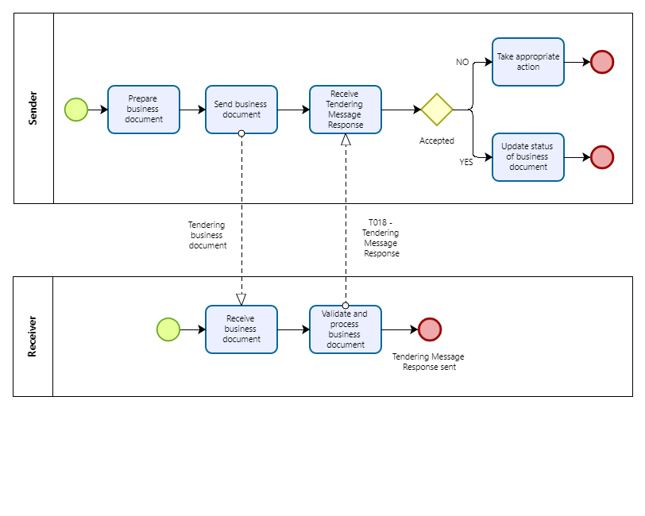
Figure 14: Business Process Tendering Message Response

The process starts when a Business Document Sender is preparing an electronic business document and then sends it. The Business Document Receiver receives the business document, potentially validates syntax and business rules, and starts to process the business document.

In case the Business Document Sender has the capability to receive a TMR, the Business Document Receiver either:

- Validates the business document and based on the result returns either an accept (no fatal errors and no processing exceptions found), a conditional accept (warnings found) or a reject (fatal errors or processing exception found)

- Doesn’t validate the business document and does not find any processing exceptions and just sends an accept to the sender of the business document.

If a TMR is returned to the Business Document Sender, it may take appropriate action.

- If the response is positive the BusinessDocumentSender may update the status of the business document or simply ignore the TMR.

- If the response is negative the BusinessDocumentSender may be able to fix the issue and send an updated version of electronic business document.

- If the response is accepted conditionally the BusinessDocumentSender may be able to analyse and fix the issue for future applications.

Process Variants of Two-Staged Procedures
This section illustrates the choreography of process variants of two-staged procedures. The reference process for two-stage procedures is illustrated in section 6 and illustrates the Notification & Restricted Procedure business process. Variants are illustrated from a high-level perspective. The process variants follow a similar sequence of business processes but carry out the various phases repeatedly or in slightly different business logic.

The variants Dynamic Purchasing System (DPS), Competitive Dialogue, Innovation Partnership, and Competitive Procedure with Negotiation (CPN) are illustrated in this section. In summary, while all four procurement procedures aim to facilitate complex procurement projects and encourage innovation, they differ in their specific features, purposes, and legal frameworks. Each procedure offers unique advantages and may be suitable for different types of projects and procurement needs. A quick comparison in terms of their key features and purposes is provided in the following.

Dynamic Purchasing System (DPS)
Key Features: A DPS is an electronic system used for procurement of commonly used goods, services, or works that are frequently needed by contracting authorities. Suppliers can join the system at any time during its operation, and new suppliers can be added at regular intervals.
Purpose: The purpose of a DPS is to create a pool of pre-qualified suppliers for specific goods, services, or works, allowing contracting authorities to streamline their procurement processes and obtain competitive prices.

Competitive Dialogue
Key Features: Competitive Dialogue is a procurement procedure used for complex projects where the contracting authority needs to discuss and develop solutions with potential suppliers before finalizing tender specifications. It involves a dialogue stage where discussions are held with shortlisted bidders.
Purpose: The purpose of Competitive Dialogue is to enable contracting authorities to explore innovative solutions and tailor the procurement process to the specific needs of the project while maintaining competition and transparency.

Competitive Procedure with Negotiation (CPN)
Key Features: CPN is a procurement procedure used for complex projects where negotiations are required with selected bidders before awarding the contract. It involves a negotiation stage where terms and conditions are discussed and refined with shortlisted bidders.
Purpose: The purpose of CPN is to allow contracting authorities to negotiate complex contracts and solutions with potential suppliers while ensuring competition and transparency throughout the process.

Innovation Partnership
Key Features: Innovation Partnership is a procurement procedure used for the development and subsequent purchase of innovative products, services, or works. It involves a partnership between public authorities and suppliers to jointly develop innovative solutions to specific challenges.
Purpose: The purpose of Innovation Partnership is to foster collaboration between public and private sectors to address societal challenges and develop innovative solutions that may not be available in the market.

Dynamic Purchasing System

Introduction
The DPS has two stages like the restricted procedure. The first one to qualify economic operators (EOs) and the second one for the specific procurements. The difference to all other types of procedures in the Directives is that it gives a possibility for contracting authorities (CAs) to continuously procure goods and services and for EOs to become qualified and then participate at any time in specific procurements. These specific procurements will occur on a regular basis. Therefore, it is a good procedure type to attract Economic Operators (EOs) and especially Small and Medium Size Enterprises (SMEs).

The DPS is meant to be used in a full electronic process. A reason is that a DPS is to be used for standardized goods, services, or works. As specific procedures are recurring, it makes a lot of sense to digitize the process completely. From EOs request to become qualified and participate to the evaluation of the tenders and until payment to reap all benefits. In this section we describe how a complete electronic process of a DPS could be done with both eDelivery and standardized information using Peppol.

Using both, eDelivery and standardized and digital tender documents in a DPS, will contribute to execute a completely digital evaluation of the received tenders. The process approach requires a high degree of interoperability between tendering systems to achieve a completely electronic process.

The use of various Peppol building-blocks such as eDelivery and Peppol BIS for pre-award result in effectiveness in processing the DPS-procedure. For the SMEs their workload in reading complex documents will be reduced significantly. Digital tender documents will be more like a questionnaire to be filled in. In this way the DPS will be a tool for increasing the competition, attracting SMEs to compete, and boost the use of digital tools.

The following descriptions illustrating the DPS are adapted from the “Dynamic Purchasing Systems - Use guidelines” published by the Directorate-General for Internal Market, Industry, Entrepreneurship and SMEs [DPS Guideline].

Legal Framework
A DPS is a two-stage procedure. First, the DPS must be set up and the suppliers to be qualified and then there is an invitation to tender for those suppliers that have been qualified. The DPS system shall be operated as a completely electronic process and shall be open to any economic operator that satisfies the selection criteria throughout the period of validity of the purchasing system. CAs may use DPS for purchases that are generally available on the market and meet the requirements set by the contracting authorities.

Establishment of the DPS
The procurement directives describe a DPS to be operated in the form of a restricted procedure. All the candidates satisfying the selection criteria shall be admitted to the system, but the number of candidates to be admitted to the system shall not be limited, which is different from a restricted procedure.
For the purposes of awarding contracts under a DPS, contracting authorities shall:
- publish a call for competition making clear that a DPS is used;
- indicate in the procurement documents at least the nature and estimated quantity of the purchases envisaged, as well as all the necessary information concerning the DPS, including how the DPS operates, the electronic equipment used, and the technical connection arrangements and specifications;
- indicate any division into categories of products, works, or services and the characteristics defining them;
- offer unrestricted and full direct access to the procurement, as long as the system is valid.

Request to Participate
The minimum time limit for the receipt of requests to participate shall be 30 days from the date on which the contract notice or, where a prior information notice is used as a means of calling for competition, the invitation to confirm interest is sent. No further time limits for receipt of requests to participate shall apply once the invitation to tender for the first specific procurement under the DPS has been sent.

The examination of those requests to participate should normally be performed within a maximum of 10 working days, given that the evaluation of the selection criteria will take place on the basis of the simplified requirements for documentation that are set out in the procurement directives, for example, an ESPD. However, when a DPS is first set up, CAs might, in response to the first publication of the contract notice or the invitation to confirm interest, be faced with such a large number of requests for participation that they would need more time to examine the requests. That should be admissible, provided that no specific procurement is launched before all the requests have been examined, as well as in the contract notice, this must be indicated by the CA.

CAs shall give any EO, throughout the entire period of validity of the DPS, the possibility of requesting to participate in the system under the given conditions. CAs shall finalize their assessment of such requests in accordance with the selection criteria within 10 working days following their receipt. That deadline may be prolonged to 15 working days in individual cases where justified, in particular, because of the need to examine additional documentation or to otherwise verify whether the selection criteria are met.

CAs should be free to organize the way in which they intend to examine the requests for participation, for instance by deciding to conduct such examinations only once a week, provided the deadlines for the examination of each request of admission are observed.

As long as the invitation to tender for the first specific procurement under the DPS has not been sent, CAs may extend the evaluation period provided that no invitation to a specific tender is issued during the extended evaluation period. CAs shall indicate in the procurement documents the length of the extended period that they intend to apply.

CAs shall inform the EO concerned at the earliest possible opportunity of whether or not it has been admitted to the DPS.

Qualification and Role of ESPD
At the time of submission of interests to request participation or of tenders the CAs shall accept the ESPD as preliminary evidence in replacement of certificates etc. The rules of the ESPD also apply for DPS.

This also means that CAs may, at any time during the period of validity of the DPS, can require admitted participants to submit a renewed and updated self-declaration, within five working days from the date on which that request is transmitted.

Before awarding contracts, CAs shall require the tenderer, to which it has decided to award the contract, to submit up-to-date supporting documents like certificates, statements, and other means of proof. If CAs have direct access to national databases for free, they cannot request EOs to submit these documents. The same rule applies if the EOs provide links in the ESPD to national databases, that can be accessed as well by the CAs for free.

The rules regarding self-declarations in the Procurement Directives shall apply throughout the entire period of validity of the DPS.

Tender Submission
CAs shall invite all admitted participants to submit a tender for each specific procurement under the DPS. Where the DPS has been divided into categories of works, products, or services, CAs shall invite all participants having been admitted to the category corresponding to the specific procurement concerned to submit a tender.
The minimum time limit for receipt of tenders shall be at least 10 days from the date on which the invitation to tender is sent.

Awarding
Contracting authorities shall award the contract to the tenderer that submitted the best tender based on the award criteria set out in the contract notice for the dynamic purchasing system or, where a prior information notice is used as a means of calling for competition, in the invitation to confirm interest. Those criteria may, where appropriate, be formulated more precisely in the invitation to tender.

Period of validity of the DPS
CAs shall indicate the period of validity of the DPS in the call for competition. They shall notify the Commission of any change in the period of validity, using the standard forms stated in the directives.

Use of eCatalogues
In the context of DPS, where each acquisition is the result of a “digital” call for competition, electronic catalogues (eCatalogues) can be a powerful tool to enable a simplified and standardized tendering process.
Requesting tenders in highly structured and standardized format facilitates the evaluation process and automatic evaluation speeds-up the time required for managing the tenders. Even if structured formats do not suit all procurement procedures, DPS by definition is a procedure where products and services that are easy to describe and specify are involved and electronic catalogues are specifically suitable.

Moreover, the use of electronic catalogues is particularly suited in DPS where the number of buyers and suppliers involved and of similar procedures is large and the users may not have detailed knowledge of the characteristics of the full range of products and services.

In these conditions, the eCatalogue formats and management rules can be a means to “provide” to the users (CAs and EOs) the know-how of the entity that establishes DPS.

In general terms, depending on the aims and the role of the CA that establishes the DPS (CPB or specific CA), electronic catalogues could be adopted following two main operative models:
- eCatalogues are established and provided by suppliers to respond at each call for competition. The eCatalogue is the template that the CA has provided and the supplier fills it in.
- eCatalogues are established by suppliers in order to participate in the DPS and are updated to respond at each call for competition.

Process Description
The Dynamic Purchasing System (DPS) is a procurement tool used by public authorities in the European Union (EU) to streamline the process of acquiring commonly used goods, services, or works from a pool of pre-qualified suppliers. The process of the Competitive Dialogue according to European directives on public procurement can be described as follows:

Establishment of the DPS: The contracting authority initiates the establishment of the DPS by publishing a contract notice in the Official Journal of the European Union (OJEU) or other designated platforms. The contract notice invites interested suppliers to apply for inclusion in the DPS and provides information about the goods, services, or works to be procured, as well as the criteria for selection.

Supplier Qualification: Interested suppliers submit applications to the contracting authority expressing their interest in participating in the DPS. The contracting authority evaluates the applications and pre-qualifies suppliers based on predefined criteria such as technical and professional capability, financial stability, and compliance with legal and regulatory requirements. Suppliers who meet the qualification criteria are admitted to the DPS and included in the pool of pre-qualified suppliers.

Operation of the DPS: Once established, the DPS operates as an electronic system where contracting authorities can conduct procurement exercises for specific goods, services, or works. Contracting authorities issue specific notices (call-off notices) within the DPS to invite pre-qualified suppliers to submit bids for individual procurement contracts. Suppliers within the DPS have access to these call-off notices and can choose to participate in the procurement exercises by submitting bids in response to the notices.

Call-Off Procedures: Contracting authorities conduct call-off procedures within the DPS in accordance with the applicable procurement rules and procedures. The call-off procedures may include various procurement methods such as open or restricted procedures, depending on the nature and value of the procurement contract. Contracting authorities evaluate the bids submitted by suppliers and award contracts to the successful bidders in accordance with the evaluation criteria specified in the call-off notice.

Duration and Review: The DPS operates for a predetermined duration specified in the initial contract notice, typically several years. During the operation of the DPS, contracting authorities may periodically review and update the list of pre-qualified suppliers based on changes in market conditions, technological advancements, or other relevant factors.

Process Map: Dynamic Purchasing System
A digital and complete electronic process, using both eDelivery and standardized documents, is a new way of building tender documents. The prerequisite will be a standardized transport infrastructure for the distribution of standardized tender documents in structured formats. The process map in Figure 15 illustrates the digital DPS process with the phases that are needed between the CA and EO during a DPS. It is important to underline that the process map references to the Peppol BIS introduced in section 6 for the restricted procedure, as the DPS operates on the similar phases. To understand the details of each phase the reader should therefore consult section 6.

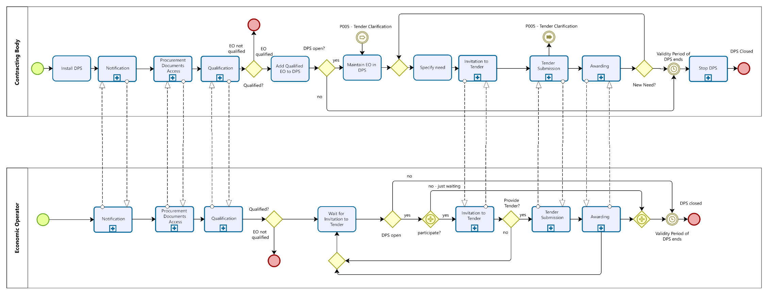
Figure 15: Process Map Dynamic Purchasing System

Competitive Dialogue

Introduction
The possibility to introduce a competitive dialogue is ruled by the following EU Directives: 2009/81 EC, 2014/24 EU, 2014/25 EU. The EU Public tendering rules website defines the use of competitive dialogues as follows [Procedures]:

“This procedure can be used by a contracting authority with the aim of proposing a method of addressing a need defined by the contracting authority.”

The competitive dialogue is used to clarify the need by starting a dialogue with chosen economic operators and after some dialog phases the contracting authorities is inviting them to deliver their final tender. In contrast to the Competitive Procedure with Negotiations (see 7.3) the Competitive Dialogue uses the dialogue phases to sort out solutions rather than contracting partners.

The competitive dialogue mainly distinguishes itself from the restricted procedure by the fact that negotiations concerning every aspect of the contract are authorized and from the negotiated procedure by the fact that, essentially, negotiations are concentrated within a particular phase in the procedure.

Overall, the Competitive Dialogue procedure allows contracting authorities to engage in discussions with potential suppliers to develop innovative and tailored solutions for complex procurement projects. This procedure offers flexibility and encourages collaboration between the contracting authority and suppliers while ensuring transparency, competition, and equal treatment of bidders, as required by European directives on public procurement.

Legal Framework
The EU Directives 2009/81 EC, 2014/24 EU, 2014/25 EU define the following requirements for the Competitive Dialogue which are further detailed in an Explanatory Note [Competitive Dialogue].

Contract Notice and Procurement Documents
In the procurement documents, contracting authorities shall identify the subject-matter of the procurement by providing a description of their needs and the characteristics required of the supplies, works or services to be procured and specify the contract award criteria.

Award criteria and their weighting should remain stable throughout the entire procedure and should not be subject to the dialogue, to guarantee equal treatment of all economic operators. Where the contracting authorities intend to make use of the opportunity to gradually reduce the number of solutions to be discussed during the dialogue phase, they must indicate this in the contract notice or the descriptive
document.

Request to Participate, Qualification and Invitation to Tender
According to Directive 2014/24/EU, in competitive dialogues, any economic operator may submit a request to participate in response to a call for competition containing the information for qualitative selection that is requested by the contracting authority. Where the competitive dialogue is justified by technical complexity, the contracting authorities can establish their requirements concerning the technical capacity of the economic operators on the basis of the definition of needs and requirements.

Only those economic operators invited by the contracting authority following the assessment of the information provided may participate in the dialogue. Contracting authorities may limit the number of suitable candidates to be invited to participate in the procedure. After having made their selection, the contracting authorities send an invitation to participate in the dialogue to the candidates selected.

The Dialogue Stage
The dialogue with selected candidates aims to identify and define the means best suited to satisfying the needs of the contracting authority. The dialogue aims to discuss all aspects of the contract with the chosen candidates. The dialogue may therefore relate not only to "technical" aspects, but also to economic aspects (prices, costs, revenues, etc.) or legal aspects (distribution and limitation of risks, guarantees, etc.).

The Directive does not regulate the conduct of the dialogue in detail. However, the dialogue should be carried out individually with each of the participants based on the ideas and solutions of the economic operator concerned. During the dialogue, contracting authorities may ask the participants to specify their proposals in writing, possibly in the form of progressively completed/refined tenders.

Reduction of Tenders
The competitive dialogue procedure takes place in successive stages in order to reduce the number of solutions to be discussed during the dialogue stage by applying the award criteria. The necessity for the contracting authorities of comparing several solutions and being able to take decisions which can subsequently be justified requires that the application of the award criterion be based on written documents.

However, even if considered to be “tenders”, they may not be expected to contain all the elements (information) required and necessary for the performance of the project. This requirement only applies to tenders that are submitted in the final stage of the competitive dialogue.

End of the Dialogue and Final Tenders
At the appropriate time, the awarding authority declares the dialogue concluded and informs the participants of this. It asks them to submit their final tenders on the basis of that solution/those solutions that have been evolved and specified during the dialogue.

The final tenders shall contain all the elements required and necessary for the performance of the project. Once they have been received, the contracting authority may ask for them to be clarified, specified, and fine-tuned.

Awarding
The final tenders are assessed on the basis of the award criteria and the most economically advantageous tender is identified.

Process Description
The Competitive Dialogue procedure allows contracting authorities to engage in discussions with potential suppliers to develop innovative and tailored solutions for complex procurement projects. The process of the Competitive Dialogue according to European directives on public procurement can be described as follows:

Initiation of the Procedure: The contracting authority initiates the Competitive Dialogue procedure by publishing a contract notice in the Official Journal of the European Union (OJEU) to announce the procurement opportunity. The contract notice includes information about the nature of the contract, the requirements, and the procedure to be followed. It also invites interested bidders to submit applications to participate in the Competitive Dialogue.

Submission of Applications: Interested bidders submit applications expressing their interest in participating in the Competitive Dialogue. These applications typically include information about the bidder's qualifications, experience, and proposed solutions. The contracting authority evaluates the applications and selects a shortlist of bidders who will be invited to participate in the dialogue stage of the procedure.

Dialogue Stage: The contracting authority enters into a dialogue with the shortlisted bidders to discuss the requirements of the contract, potential solutions, and technical specifications. The dialogue may cover various aspects of the contract, including technical feasibility, risk management, pricing, quality standards, and contractual terms. The contracting authority must conduct the dialogue in a fair, transparent, and non-discriminatory manner, ensuring equal treatment of all bidders.

Request for Final Tenders: After the dialogue stage is complete, the contracting authority issues a request for final tenders to the shortlisted bidders. The request for final tenders includes the finalized tender specifications based on the discussions held during the dialogue stage. The shortlisted bidders submit their final tenders, which reflect the solutions developed and discussed during the dialogue stage.

Evaluation of Final Tenders: The contracting authority evaluates the final tenders submitted by the shortlisted bidders based on predefined award criteria.
The evaluation criteria may include technical quality, price, sustainability, and other relevant factors.
The contracting authority selects the winning bidder based on the evaluation of the final tenders.

Award of Contract: The contract is awarded to the winning bidder, and the other bidders are notified of the outcome.

Contract Implementation: Once the contract is awarded, the contracting authority may enter into a contract with the winning bidder, formalizing the terms and conditions discussed during the Competitive Dialogue process.

Process Map Competitive Dialogue

The process map to describe the Competitive Dialogue depends on Peppol BIS sub-processes from introduced in section 6 for the restricted procedure, as the Competitive Dialogue operates on the similar phases. To understand the details of each phase the reader should therefore consult section 6.

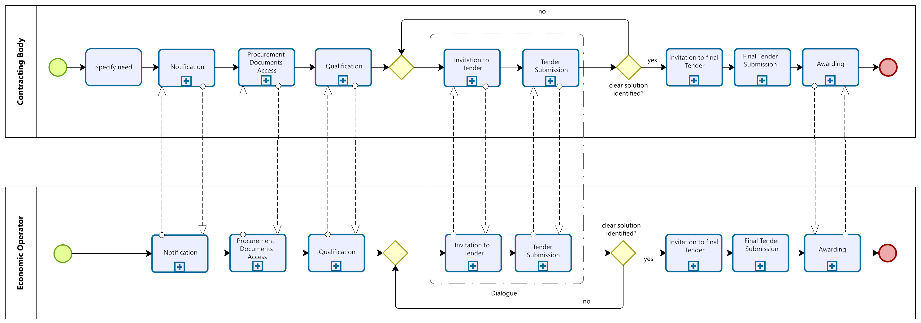
Figure 17: Process Map Competitive Dialogue

Competitive Procedure with Negotiation

Introduction
The possibility to perform competitive procedure with negotiations (or negotiated procedure) is ruled by the following EU Directives: 2009/81 EC, 2014/24 EU, 2014/25 EU. The EU Public tendering rules website defines competitive procedure with negotiations as follows [Procedures]:
“In competitive procedure with negotiations anyone may ask to participate, but only those who are pre-selected will be invited to submit initial tenders and to negotiate.
Contracting authorities can only use this procedure when negotiations are necessary due to the specific or complicated nature of the purchase, however, the contracting bodies in defense and security, water, energy, transport, and postal services sectors may use it as a standard procedure. Competitive Procedure with Negotiation has shown itself to be of use in cases where contracting authorities are unable to define the means of satisfying their needs or of assessing what the market can offer in terms of technical, financial, or legal solutions.
Overall, the Competitive Procedure with Negotiation allows contracting authorities to engage in negotiations with selected bidders to refine and finalize the terms of a contract before awarding it. This procedure offers flexibility and allows for the negotiation of complex contracts while ensuring transparency, competition, and equal treatment of bidders, as required by European directives on public procurement.
Competitive procedures with negotiations are used in various situations where open or restricted procedures without negotiations are not likely to lead to satisfactory procurement outcomes or where an open or restricted procedure results only in irregular or unacceptable tenders. In such cases, contracting authorities should be allowed to conduct negotiations with the aim of obtaining regular and acceptable tenders”.

Legal Framework
The EU Directives 2009/81 EC, 2014/24 EU, 2014/25 EU define the following requirements for the CPN.

Procurement Documents and Minimum Requirements
In the procurement documents, contracting authorities shall identify the subject-matter of the procurement by providing a description of their needs and the characteristics required of the supplies, works, or services to be procured and specify the contract award criteria. They shall also indicate which elements of the description define the minimum requirements to be met by all tenders.

Contracting authorities should indicate beforehand the minimum requirements which characterie the nature of the procurement and which should not be changed in the negotiations. Award criteria and their weighting should remain stable throughout the entire procedure and should not be subject to negotiations, in order to guarantee equal treatment of all economic operators.

Request to Participate, Qualification and Invitation to Tender
According to Directive 2014/24/EU, in competitive procedures with negotiation, any economic operator may submit a request to participate in response to a call for competition containing the information for qualitative selection that is requested by the contracting authority.

Only those economic operators invited by the contracting authority following its assessment of the information provided may submit an initial tender which shall be the basis for the subsequent negotiations. Contracting authorities may limit the number of suitable candidates to be invited to participate in the procedure.

Tender Submission and Negotiations
After submission of the initial tender, contracting authorities shall inform all tenderers, whose tenders have not been eliminated, in writing of any changes to the technical specifications or other procurement documents, other than those setting out the minimum requirements. Following these changes, contracting authorities shall provide sufficient time for tenderers to modify and re-submit amended tenders, as appropriate.

Negotiations should aim at improving the tenders to allow contracting authorities to buy works, supplies, and services perfectly adapted to their specific needs. Negotiations may concern all characteristics of the purchased works, supplies, and services including, for instance, quality, quantities, commercial clauses as well as social, environmental, and innovative aspects in so far as they do not constitute minimum requirements.

Reduction of Tenders
Competitive procedures with negotiation may take place in successive stages in order to reduce the number of tenders to be negotiated by applying the award criteria specified in the contract notice, in the invitation to confirm interest, or in another procurement document.

Conclusion of Negotiations and Awarding
Contracting authorities may award contracts on the basis of the initial tenders without negotiation where they have indicated, in the contract notice or in the invitation to confirm interest, that they reserve the possibility of doing so. Where the contracting authority intends to conclude the negotiations, it shall inform the remaining tenderers and set a common deadline to submit any new or revised tenders. Then final tenders are assessed on the basis of the award criteria and the most economically advantageous tender is identified.

Process Description

The Competitive Procedure with Negotiation (CPN) allows contracting authorities to negotiate the terms of a contract with selected bidders before awarding the contract. The process of the Competitive Procedure with Negotiation according to European directives on public procurement can be described as follows:

Initiation of the Procedure: The contracting authority initiates the CPN by publishing a contract notice in the Official Journal of the European Union (OJEU) to announce the procurement opportunity. The contract notice includes information about the nature of the contract, the requirements, and the procedure to be followed. It also invites interested bidders to submit applications to participate in the CPN.

Submission of Applications: Interested bidders submit applications expressing their interest in participating in the CPN. These applications typically include information about the bidder's qualifications, experience, and proposed solutions. The contracting authority evaluates the applications and selects a shortlist of bidders who will be invited to participate in the negotiation stage of the procedure.

Negotiation Stage: The contracting authority enters into negotiations with the shortlisted bidders to refine and clarify their proposals, terms, and conditions. The negotiations may cover various aspects of the contract, including technical specifications, pricing, delivery schedules, quality standards, and contractual terms. The contracting authority must conduct the negotiations in a fair, transparent, and non-discriminatory manner, ensuring equal treatment of all bidders.

Submission of Final Offers: After the negotiations are complete, the shortlisted bidders submit their final offers, which reflect the negotiated terms and conditions. The final offers are evaluated by the contracting authority based on predefined award criteria, which may include criteria related to technical quality, price, sustainability, and other relevant factors.

Award of Contract: The contracting authority evaluates the final offers and selects the winning bidder based on the predefined award criteria. The contract is awarded to the winning bidder, and the other bidders are notified of the outcome. The contracting authority may enter into a contract with the winning bidder, formalizing the terms and conditions negotiated during the CPN process.

Contract Implementation: Once the contract is awarded, the contracting authority and the winning bidder implement the contract according to the agreed terms and conditions.

Process Map: Competitive Procedure with Negotiation
In contrast to the restricted procedure introduced in section 6, the competitive procedure with negotiations is usually divided into a qualification phase with choosing the most qualified tenderers and after that, multiple re-occurring negotiation phases starting with the initial invitation to tenders that will be followed by further tendering and selection steps until finally the procedure will be awarded / contracted. Each negotiation round will be used to sort out tenderers / improve tenders to the contracting authorities’ specific needs. The number of negotiation rounds is not limited. The tender submitted in each negotiation is not allowed to be clarified since clarification could be part of another negotiation phase. Contracting and the contract award notification is done after the last negotiation.
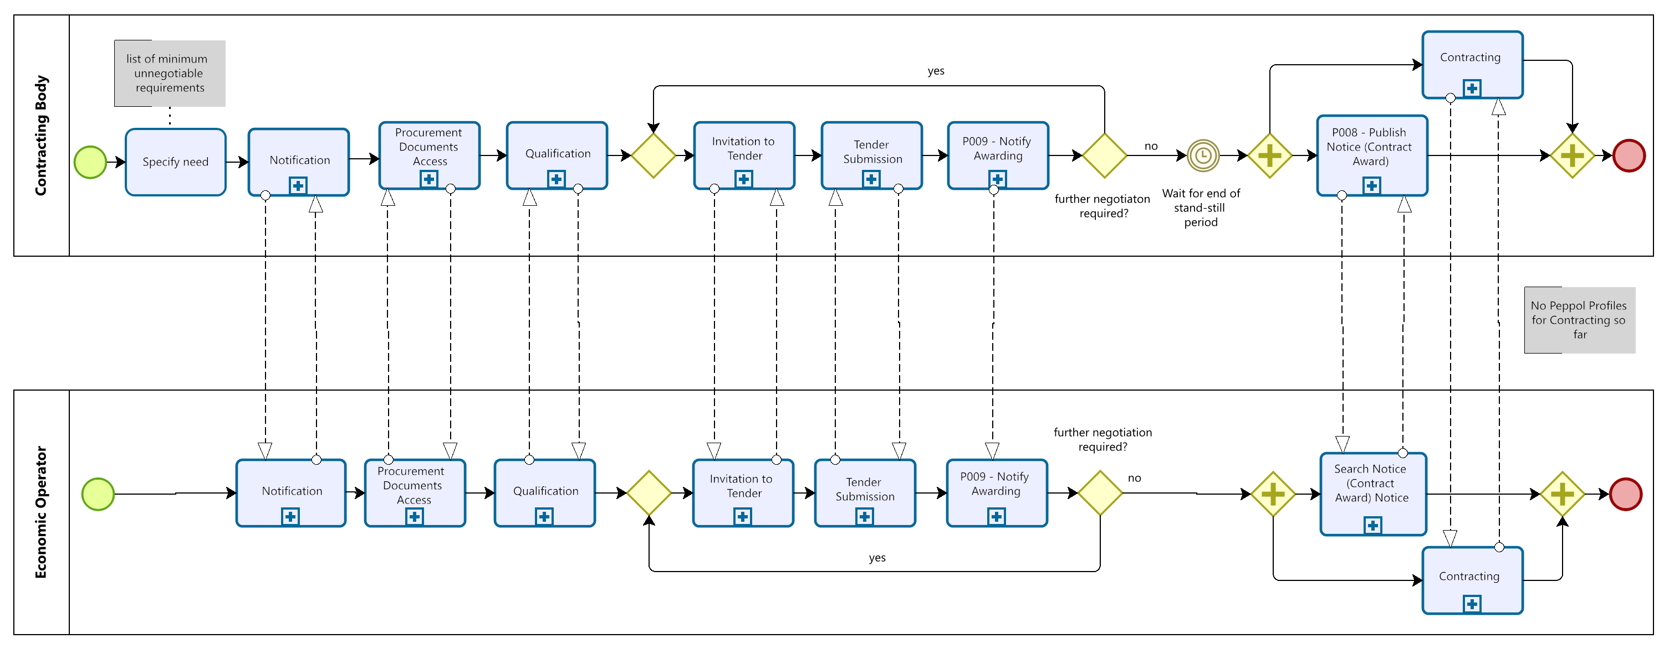
Figure 16: Process Map competitive procedure with negotiation

Innovation Partnership

Introduction
The possibility to introduce an innovation partnership is ruled by the following EU Directives: 2009/81 EC, 2014/24 EU, 2014/25 EU. The EU Public tendering rules website defines the use of innovation partnership as follows [Procedures]:

“This procedure may be used when there is a need to purchase a good or service that is still unavailable on the market. A number of companies may participate throughout the process.”

Where a need for the development of an innovative product or service or innovative works and the subsequent purchase of the resulting supplies, services, or works cannot be met by solutions already available on the market, contracting authorities should have access to innovation partnerships. This specific procedure should allow contracting authorities to establish a long-term innovation partnership for the development and subsequent purchase of a new, innovative product, service, or works provided that such innovative product or service or innovative works can be delivered to agreed performance levels and costs, without the need for a separate procurement procedure for the purchase.

The innovation partnership should be based on the procedural rules that apply to the competitive procedure with negotiation (see section 7.3). Contracts should be awarded on the sole basis of the best price-quality ratio, which is most suitable for comparing tenders for innovative solutions.

Legal Framework
The EU Directives 2009/81 EC, 2014/24 EU, 2014/25 EU define the following requirements for the innovation partnership.

Procurement Documents and Minimum Requirements
In the procurement documents, the contracting authority shall identify the need for an innovative product, service, or works that cannot be met by purchasing products, services, or works already available on the market. It shall indicate which elements of this description define the minimum unnegotiable requirements to be met by all tenders.

Contracting authorities should indicate beforehand the minimum requirements which characterize the nature of the procurement and which should not be changed throughout the entire procedure and which should not be subject to negotiations, in order to guarantee equal treatment of all economic operators.

Request to Participate, Qualification, and Invitation to Tender
According to Directive 2014/24/EU, in innovation partnerships, any economic operator may submit a request to participate in response to a contract notice by providing the information for qualitative selection that is requested by the contracting authority. In selecting candidates, contracting authorities shall in particular apply criteria concerning the candidates’ capacity in the field of research and development and of developing and implementing innovative solutions.

Only those economic operators invited by the contracting authority following its assessment of the requested information may submit research and innovation projects aimed at meeting the needs identified by the contracting authority that cannot be met by existing solutions.

Tender Submission and Negotiations
Contracting authorities may negotiate with tenderers the initial and all subsequent tenders submitted by them, except for the final tender, to improve the content thereof. The minimum requirements and the award criteria shall not be subject to negotiations.

During the negotiations, contracting authorities shall ensure the equal treatment of all tenderers. To that end, they shall not provide information in a discriminatory manner which may give some tenderers an advantage over others. They shall inform all tenderers whose tenders have not been eliminated, in writing of any changes to the technical specifications or other procurement documents other than those setting out the minimum requirements. Following those changes, contracting authorities shall provide sufficient time for tenderers to modify and re-submit amended tenders, as appropriate.

Negotiations during innovation partnership procedures may take place in successive stages in order to reduce the number of tenders to be negotiated by applying the award criteria specified in the contract notice, in the invitation to confirm interest, or in the procurement documents.

Phased Approach in Innovation Partnership
After the negotiation phase, the innovation partnership shall be structured in successive phases following the research and innovation process, which may include the manufacturing of the products, the provision of the services, or the completion of the works. The innovation partnership shall set intermediate targets to be attained by the partners and provide for payment of the remuneration in appropriate instalments.

The contracting authority may decide to set up the innovation partnership with one partner or with several partners conducting separate research and development activities. Setting up innovation partnerships with several partners could contribute to prevent, restrict, or distort competition.

The innovation partnership shall aim at the development of an innovative product, service, or works and the subsequent purchase of the resulting supplies, services, or works, provided that they correspond to the performance levels and maximum costs agreed between the contracting authorities and the participants.

Termination of Partnerships and Selection of Supplier
Based on the defined targets, the contracting authority may decide after negotiation or after each phase of the innovation partnership to terminate the innovation partnership or, in the case of an innovation partnership with several partners, to reduce the number of partners by terminating individual contracts, provided that the contracting authority has indicated in the procurement documents those possibilities and the conditions for their use.

The contracting authority should also determine in advance a mechanism for regulating the issues related to the final selection of supplier(s).

Process description
Overall, the process of innovation partnerships according to European directives on public procurement involves a collaborative approach between public authorities and suppliers to develop and procure innovative solutions that address specific needs and challenges. The process is designed to promote innovation, competition, and transparency while ensuring compliance with EU procurement rules and principles. The process of innovation partnerships according to EU directives can be described as follows:

Identification of Need: The process begins with a public authority identifying a need for goods, services, or works that require innovation to fulfill. This need could arise from societal challenges, technological advancements, or inefficiencies in current solutions.

Market Consultation: Before initiating the procurement procedure, the public authority may conduct market consultations to gauge interest from potential suppliers and gather information about available innovative solutions. This helps in shaping the specifications of the procurement and ensures that the process is market-driven.

Publication of Contract Notice: The public authority publishes a contract notice in the Official Journal of the European Union (OJEU) to inform potential suppliers about the procurement opportunity. The notice includes information about the nature of the contract, the requirements, and the procedure to be followed.

Submission of Applications: Interested suppliers submit applications expressing their interest in participating in the innovation partnership. These applications typically include information about the supplier's qualifications, experience, and after qualification and shortlisting of bidders, an invitation to tender will be sent so that economic operators can submit an initial tender and start to propose innovative solutions. Contracting authorities may conduct negotiations upon the tenders with the aim of obtaining regular and acceptable tenders.

Selection of Participants: The public authority evaluates the submitted applications and selects the participants who will be invited to participate in the innovation partnership. The selection criteria may include technical and financial capacity, relevant experience, and the innovative nature of proposed solutions.

Initiation of Partnership: The selected participants enter into an innovation partnership with the public authority. This partnership is often based on a framework agreement that sets out the phases, terms, and conditions governing the collaboration, including the objectives, roles and responsibilities, allocation of risks and rewards, and intellectual property rights.

Development Phase: During the development phase of the innovation partnership, the participants work collaboratively to develop innovative solutions that meet the needs identified by the public authority. This may involve research, design, prototyping, testing, and validation of the proposed solutions.

Procurement of Resulting Solutions: Once the innovative solutions have been developed and validated, the public authority may procure them through a separate procurement procedure, such as competitive dialogue or negotiated procedure with prior publication. The procurement procedure follows the relevant rules and procedures set out in the European Directive on public procurement.

Process Map Innovation Partnership
The process of an Innovation Partnership follows the steps of the Competitive Procedure with Negotiations as shown in Figure 18. It is important to underline that that the process map references to the Peppol BIS introduced in section 6 for the restricted procedure, as the Innovation Partnership operates on the similar phases. To understand the details of each phase the reader should therefore consult section 6.

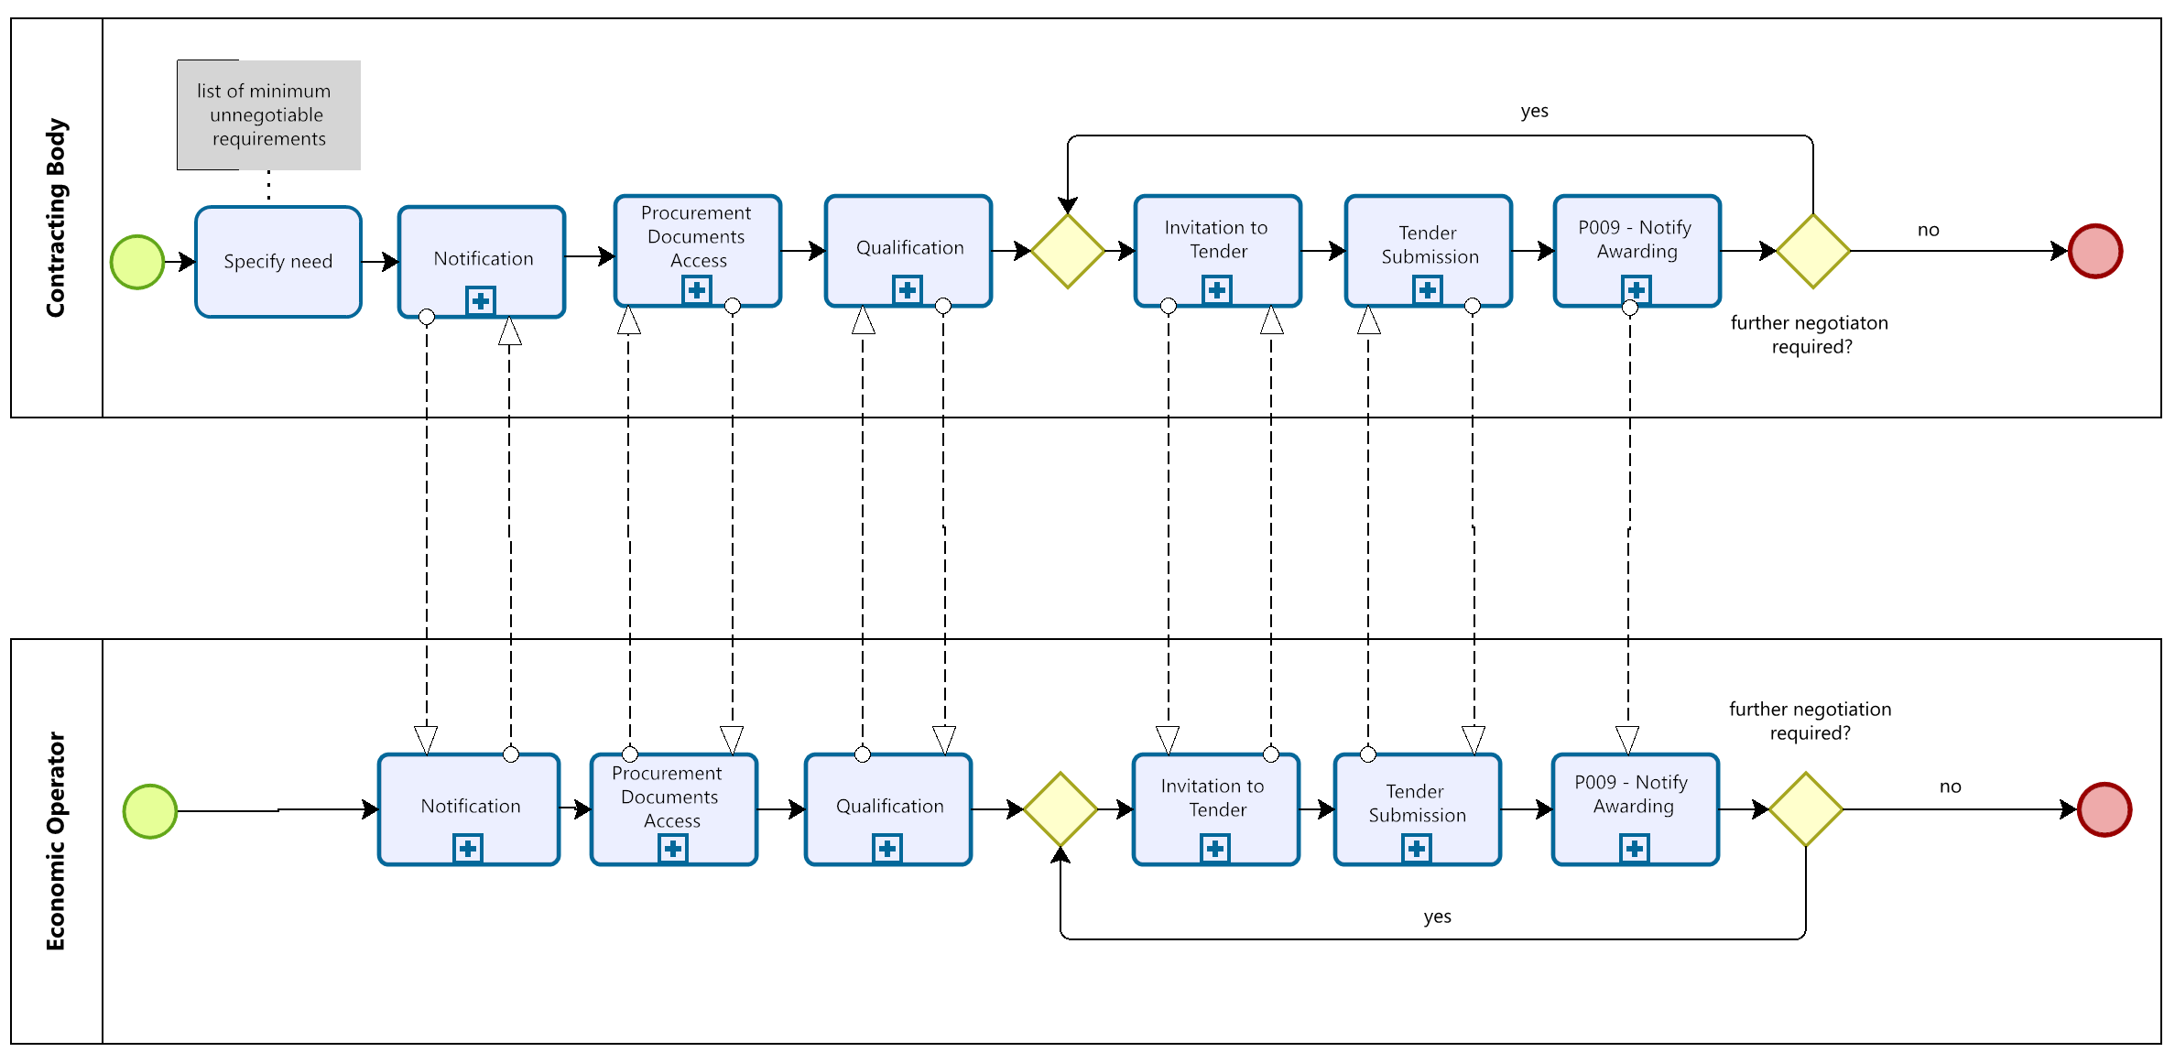
Figure 18: Process Map Innovation Partnership – Qualification and Negotiation Phase

However, after the negotiation phase, an innovation partnership is established. The phase illustrated in Figure 19 is the start of the effective implementation of the Innovation Partnership through partnership contract. During this stage of the innovation partnership, it is also possible to use a multi-phase approach that incorporates development, prototyping and testing phases. The contracting authority may reduce the number of partners by terminating the partnership contracts in compliance with pre-determined conditions. Thus, the contracting authority should also determine a mechanism for regulating the issues related to the selection of a supplier(s) beforehand.
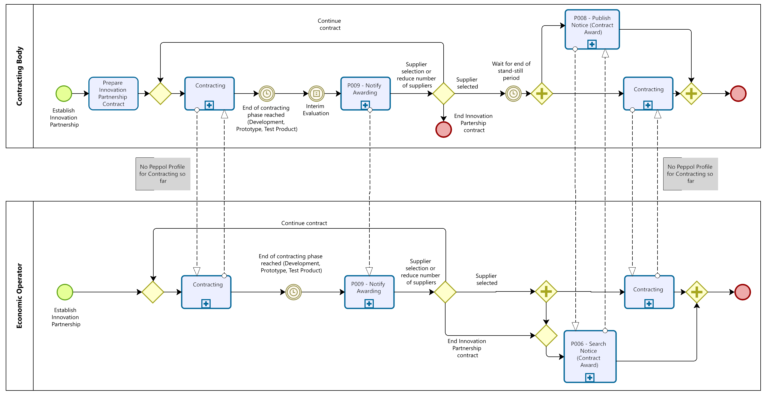
Figure 19: Process Map Innovation Partnerships – Innovation Partnership

Implementation of Notification & Two-Stage Procedure
The tables in this section list the Peppol BIS artifacts that have to be considered when implementing two-stage procedures. For each Peppol BIS, the corresponding documentation of the profile and transaction(s) are provided. Additionally, the tables point to the syntax mapping and rules to implement the transactions. Sections 8.15 and 8.16 provide an overview of other relevant artifacts like codelists, schematrons, and guidelines which must be considered during the implementation of Peppol pre-award BISs.

Peppol BIS - P001 - Procurement procedure subscription
Peppol BIS | P001 - Procurement procedure subscription
Documentation | https://docs.peppol.eu/pracc/profiles/p001/index.html
Transaction | T001 – Subscribe to procedure
Documentation | https://docs.peppol.eu/pracc/transactions/T001/index.html
Syntax Mapping | https://docs.peppol.eu/pracc/syntax/ExpressionOfInterestRequest/tree/
Peppol Rules | https://docs.peppol.eu/pracc/rules/T001/
Transaction | T002 - Subscribe to Procedure Confirmation
Documentation | https://docs.peppol.eu/pracc/rules/T002/
Syntax Mapping | https://docs.peppol.eu/pracc/syntax/ExpressionOfInterestResponse/tree/
Peppol Rules | https://docs.peppol.eu/pracc/rules/T002/

Peppol BIS - P002 - Procurement document access
Peppol BIS | P002 - Procurement document access
Documentation | https://docs.peppol.eu/pracc/profiles/p002/index.html
Transaction | T003 - Tender Status Inquiry
Documentation | https://docs.peppol.eu/pracc/transactions/T003/index.html
Syntax Mapping | https://docs.peppol.eu/pracc/syntax/TenderStatusRequest/tree/
Peppol Rules | https://docs.peppol.eu/pracc/rules/T003/
Transaction | T004 - Call for Tenders
Documentation | https://docs.peppol.eu/pracc/rules/T004/
Syntax Mapping | https://docs.peppol.eu/pracc/syntax/CallForTenders/tree/
Peppol Rules | https://docs.peppol.eu/pracc/rules/T004/
CEN BII Rules | https://docs.peppol.eu/pracc/rules/BIIT004/

Peppol BIS - P003 - Tender Submission
Peppol BIS | P003 - Tender Submission
Documentation | https://docs.peppol.eu/pracc/profiles/p003/index.html
Transaction | T005 - Tender
Documentation | https://docs.peppol.eu/pracc/transactions/T005/index.html
Syntax Mapping | https://docs.peppol.eu/pracc/syntax/Tender/tree/
Peppol Rules | https://docs.peppol.eu/pracc/rules/T005/
CEN BII Rules | https://docs.peppol.eu/pracc/rules/BIIT005/
Transaction | T006 - Tender Reception Notification
Documentation | https://docs.peppol.eu/pracc/rules/T006/
Syntax Mapping | https://docs.peppol.eu/pracc/syntax/TenderReceipt/tree/
Peppol Rules | https://docs.peppol.eu/pracc/rules/T006/
CEN BII Rules | https://docs.peppol.eu/pracc/rules/BIIT006/

Peppol BIS - P004 - Call for Tenders Question and Answers
Peppol BIS | P004 - Call for Tenders Question and Answers
Documentation | https://docs.peppol.eu/pracc/profiles/p004/index.html
Transaction | T007 - Tendering Questions
Documentation | https://docs.peppol.eu/pracc/transactions/T007/index.html
Syntax Mapping | https://docs.peppol.eu/pracc/syntax/TenderingQuestions/tree/
Peppol Rules | https://docs.peppol.eu/pracc/rules/T007/
Transaction | T008 - Tendering Answers
Documentation | https://docs.peppol.eu/pracc/rules/T008/
Syntax Mapping | https://docs.peppol.eu/pracc/syntax/TenderingAnswers/tree/
Peppol Rules | https://docs.peppol.eu/pracc/rules/T008/

Peppol BIS - P005 - Tender Clarification
Peppol BIS | P005 - Tender Clarification
Documentation | https://docs.peppol.eu/pracc/profiles/p005/index.html
Transaction | T009 - Tender Clarification Request
Documentation | https://docs.peppol.eu/pracc/transactions/T009/index.html
Syntax Mapping | https://docs.peppol.eu/pracc/syntax/TenderClarificationRequest/tree/
Peppol Rules | https://docs.peppol.eu/pracc/rules/T009/
Transaction | T010 - Tender Clarification
Documentation | https://docs.peppol.eu/pracc/rules/T010/
Syntax Mapping | https://docs.peppol.eu/pracc/syntax/TenderClarification/tree/
Peppol Rules | https://docs.peppol.eu/pracc/rules/T010/

Peppol BIS - P006 - Search Notices
Peppol BIS | P006 - Search Notices
Documentation | https://docs.peppol.eu/pracc/profiles/p006/index.html
Transaction | T011 - Search Notice Request
Documentation | https://docs.peppol.eu/pracc/transactions/T011/index.html
Syntax Mapping | https://docs.peppol.eu/pracc/syntax/SearchNoticeRequest/tree/
Peppol Rules | https://docs.peppol.eu/pracc/rules/T011/
Transaction | T012 - Search Notice Response
Documentation | https://docs.peppol.eu/pracc/rules/T012/
Syntax Mapping | https://docs.peppol.eu/pracc/syntax/SearchNoticeResponse/tree/
Peppol Rules | https://docs.peppol.eu/pracc/rules/T012/

Peppol BIS - P007 - Tender Withdrawal
Peppol BIS | P007 - Tender Withdrawal
Documentation | https://docs.peppol.eu/pracc/profiles/p007/index.html
Transaction | T013 - Tender Withdrawal
Documentation | https://docs.peppol.eu/pracc/transactions/T013/index.html
Syntax Mapping | https://docs.peppol.eu/pracc/syntax/TenderWithdrawalRequest/tree/
Peppol Rules | https://docs.peppol.eu/pracc/rules/T013/
Transaction | T014 - Tender Withdrawal Notification
Documentation | https://docs.peppol.eu/pracc/rules/T014/
Syntax Mapping | https://docs.peppol.eu/pracc/syntax/TenderWithdrawalResponse/tree/
Peppol Rules | https://docs.peppol.eu/pracc/rules/T014/

Peppol BIS - P008 - Publish Notice
Peppol BIS | P008 - Publish Notice
Documentation | https://docs.peppol.eu/pracc/profiles/p008/index.html
Transaction | T015 - Publish Notice
Documentation | https://docs.peppol.eu/pracc/transactions/T015/index.html
Syntax Mapping | https://docs.peppol.eu/pracc/syntax/PublishNotice/tree/
Peppol Rules | https://docs.peppol.eu/pracc/rules/T015/
Transaction | T016 - Notice Publication Response
Documentation | https://docs.peppol.eu/pracc/rules/T016/
Syntax Mapping | https://docs.peppol.eu/pracc/syntax/NoticePublicationResponse/tree/
Peppol Rules | https://docs.peppol.eu/pracc/rules/T016/

Peppol BIS - P009 - Notify Awarding
Peppol BIS | P009 - Notify Awarding
Documentation | https://docs.peppol.eu/pracc/profiles/p009/index.html
Transaction | T015 - Publish Notice
Documentation | https://docs.peppol.eu/pracc/transactions/T017/index.html
Syntax Mapping | https://docs.peppol.eu/pracc/syntax/AwardingNotification/tree/
Peppol Rules | https://docs.peppol.eu/pracc/rules/T017/

Peppol BIS - P010 – Tendering Message Response
Peppol BIS | P010 - Tendering Message Response
Documentation | https://docs.peppol.eu/pracc/profiles/p010/index.html
Transaction | T018 - Tendering Message Response
Documentation | https://docs.peppol.eu/pracc/transactions/T018/index.html
Syntax Mapping | https://docs.peppol.eu/pracc/syntax/TenderingMessageResponse/tree/
Peppol Rules | https://docs.peppol.eu/pracc/rules/T018/

Peppol BIS - P011 – Tender Qualification
Peppol BIS | P011 – Tender Qualification
Documentation | https://docs.peppol.eu/pracc/profiles/p011/index.html
Transaction | T019 - Qualification
Documentation | https://docs.peppol.eu/pracc/transactions/T019/index.html
Syntax Mapping | https://docs.peppol.eu/pracc/syntax/Qualification/tree/
Peppol Rules | https://docs.peppol.eu/pracc/rules/T019/
Transaction | T020 – Qualification Reception Confirmation
Documentation | https://docs.peppol.eu/pracc/transactions/T020/index.html
Syntax Mapping | https://docs.peppol.eu/pracc/syntax/QualificationReceipt/tree/
Peppol Rules | https://docs.peppol.eu/pracc/rules/T020/

Peppol BIS - P012 –Qualification Response
Peppol BIS | P012 –Qualification Response
Documentation | https://docs.peppol.eu/pracc/profiles/p012/index.html
Transaction | T023 – Qualification Response
Documentation | https://docs.peppol.eu/pracc/transactions/T023/index.html
Syntax Mapping | https://docs.peppol.eu/pracc/syntax/QualificationResponse/tree/
Peppol Rules | https://docs.peppol.eu/pracc/rules/T023/

Peppol BIS - P013 – Invitation to Tender
Peppol BIS | P013 – Invitation to Tender
Documentation | https://docs.peppol.eu/pracc/profiles/p013/index.html
Transaction | T024 – Invitation to Tender
Documentation | https://docs.peppol.eu/pracc/transactions/T024/index.html
Syntax Mapping | https://docs.peppol.eu/pracc/syntax/InvitationToTender/tree/
Peppol Rules | https://docs.peppol.eu/pracc/rules/T024/
Transaction | T003 – Tender Status Inquiry
Documentation | https://docs.peppol.eu/pracc/transactions/T003/index.html
Syntax Mapping | https://docs.peppol.eu/pracc/syntax/TenderStatusRequest/tree/
Peppol Rules | https://docs.peppol.eu/pracc/rules/T003/

Peppol BIS - P035 – Pre-Award Catalogue
Peppol BIS | P035 – Pre-Award Catalogue
Documentation | https://docs.peppol.eu/pracc/profiles/p035/index.html
Transaction | T035 Pre-Award Catalogue Request
Documentation | https://docs.peppol.eu/pracc/transactions/T035/index.html
Syntax Mapping | https://docs.peppol.eu/pracc/syntax/catalogueRequest/tree/
Peppol Rules | https://docs.peppol.eu/pracc/rules/T035/
Transaction | T036 - Pre-Award Catalogue
Documentation | https://docs.peppol.eu/pracc/transactions/T036/index.html
Syntax Mapping | https://docs.peppol.eu/pracc/syntax/catalogue/tree/
Peppol Rules | https://docs.peppol.eu/pracc/rules/T036/

Peppol Code Lists used in Notification & Two-Stage Procedures

Generic Code Lists
additionalConditionsCode | https://docs.peppol.eu/pracc/codelist/addCond/
awardCode | https://docs.peppol.eu/pracc/codelist/addCond/
contractTypeCode | https://docs.peppol.eu/pracc/codelist/contractType/
documentStatusCode | https://docs.peppol.eu/pracc/codelist/docStatus/
documentTypeCode | https://docs.peppol.eu/pracc/codelist/docType/
Electronic Address Scheme (EAS) | https://docs.peppol.eu/pracc/codelist/EAS/
ISO 6523 ICD list | https://docs.peppol.eu/pracc/codelist/ICD/
Country codes (ISO 3166-1:Alpha2) | https://docs.peppol.eu/pracc/codelist/ISO3166/
legalBasisCode | https://docs.peppol.eu/pracc/codelist/legalBasis/
MessageResponseCode | https://docs.peppol.eu/pracc/codelist/messageResponse/
NoticeResponseCode | https://docs.peppol.eu/pracc/codelist/noticeResponse/
procedureTypeCode | https://docs.peppol.eu/pracc/codelist/procedureType/
procurementTypeCode | https://docs.peppol.eu/pracc/codelist/procurementType/
publicationConditionCode | https://docs.peppol.eu/pracc/codelist/publicationCondition/
StatusReasonCode | https://docs.peppol.eu/pracc/codelist/statusReason/
StatusReasonCodeSubset | https://docs.peppol.eu/pracc/codelist/statusReasonSubset/
SubmissionMethodCode | https://docs.peppol.eu/pracc/codelist/submissionMethod/
Economic Operator Role Codes | https://docs.peppol.eu/pracc/codelist/tendererRole/
UBLDocumentSchema | https://docs.peppol.eu/pracc/codelist/ublDocumentSchema/
Document name code, full list (UNCL1001) | https://docs.peppol.eu/pracc/codelist/UNCL1001/

Catalogue specific Code Lists
UNCL5305 Duty or tax or fee category code | https://docs.peppol.eu/pracc/codelist/UNCL5305/
UNCL5387 Price specification code | https://docs.peppol.eu/pracc/codelist/UNCL5387/
UNCL8273 Dangerous goods regulations code | https://docs.peppol.eu/pracc/codelist/UNCL8273/
UN/ECE Recommendation 20 | https://docs.peppol.eu/pracc/codelist/UNECERec20/
Transaction condition code | https://docs.peppol.eu/pracc/codelist/TransactionCondition/
UNCL6313 Measured attribute code | https://docs.peppol.eu/pracc/codelist/UNCL6313/
Item type identification code (UNCL7143) | https://docs.peppol.eu/pracc/codelist/UNCL7143/

Other artifacts used in Notification & Two-Stage Procedures
Peppol BIS eDelivery guide for pre-award | https://docs.peppol.eu/pracc/files/BIS-eDelivery-guide-for-pre-award-v1.3.pdf
Peppol BIS eDocuments guide for pre-award | https://docs.peppol.eu/pracc/files/BIS-eDocuments-guide-for-pre-award-v1.3.pdf
PEPPOL BIS pre-award guide – Notification and Open Procedure | https://docs.peppol.eu/pracc/files/Peppol-BIS-pre-award-guide_Notification-and-Open-Procedure-v1.0.pdf
Schematron files (zip) | https://docs.peppol.eu/pracc/files/schematrons.zip
Code lists (zip) | https://docs.peppol.eu/pracc/files/codelists.zip

External References
Reference | Source
[2008/81/EC] | https://eur-lex.europa.eu/legal-content/EN/TXT/?uri=CELEX%3A32009L0081
[2014/23/EU] | https://eur-lex.europa.eu/legal-content/DE/TXT/?uri=CELEX%3A32014L0023
[2014/24/EU] | https://eur-lex.europa.eu/legal-content/DE/TXT/?uri=CELEX%3A32014L0024
[2014/25/EU] | https://eur-lex.europa.eu/legal-content/DE/TXT/?uri=CELEX%3A32014L0025
[2009/81/EC] | https://eur-lex.europa.eu/legal-content/EN/TXT/?uri=CELEX%3A32009L0081
[BII10] | https://standards.cencenelec.eu/dyn/www/f?p=205:110:0::::FSP_PROJECT:62007&cs=16D9EEBE9B7C024A15F0CCDEE76075355
[BII14] | https://standards.cencenelec.eu/dyn/www/f?p=205:110:0::::FSP_PROJECT:62008&cs=16824EF2775A9CE68B4E33893BA1F2A05
[BII35] | https://standards.cencenelec.eu/dyn/www/f?p=205:110:0::::FSP_PROJECT:62022&cs=1EF6066023AE7AE2A2D9F6E77398C162C
[BII37 Open Procedure] | https://standards.cencenelec.eu/dyn/www/f?p=205:110:0::::FSP_PROJECT:62023&cs=19453F711D73A2988EC334F37EE564AB1
[BII39 Restricted Procedure] | https://standards.cencenelec.eu/dyn/www/f?p=205:110:0::::FSP_PROJECT:62025&cs=16FE060019144359C0A826411A5F67E89
[BII43] | https://standards.cencenelec.eu/dyn/www/f?p=205:110:0::::FSP_PROJECT:62009&cs=1807B03E8AA497A2C66F5BA5A25A5A3AF
[BII45] | https://standards.cencenelec.eu/dyn/www/f?p=205:110:0::::FSP_PROJECT:62010&cs=1628543602EFDE54C11B8136021A5621A
[BII46] | https://standards.cencenelec.eu/dyn/www/f?p=205:110:0::::FSP_PROJECT:62028&cs=16B7CFE594685D73AD82275DFFE3FCC55
[BII47] | https://standards.cencenelec.eu/dyn/www/f?p=205:110:0::::FSP_PROJECT:62029&cs=16BDCBBEBAE1A6A235013E1B31A0B78D6
[BII48] | https://standards.cencenelec.eu/dyn/www/f?p=205:110:0::::FSP_PROJECT:62030&cs=137D249EEF9A0B7DF6DAD668A740CA477
[BII49] | https://standards.cencenelec.eu/dyn/www/f?p=205:110:0::::FSP_PROJECT:62031&cs=1B70B853F56C648B3483016CF296DFC0A
[BII50] | https://standards.cencenelec.eu/dyn/www/f?p=205:110:0::::FSP_PROJECT:62032&cs=112E5165F9BCEE578DFD26A6C238464E2
[BII51] | https://standards.cencenelec.eu/dyn/www/f?p=205:110:0::::FSP_PROJECT:62033&cs=1A7DBDEE6682A0238FED320C05D7FEE35
[BII52] | https://standards.cencenelec.eu/dyn/www/f?p=205:110:0::::FSP_PROJECT:62034&cs=14EBEB82D050E426BA2F37CC537677DFB
[BII53] | https://standards.cencenelec.eu/dyn/www/f?p=205:110:0::::FSP_PROJECT:62035&cs=15E8443FF9806B2D1F6675A41EA29930F
[BII54] | https://standards.cencenelec.eu/dyn/www/f?p=205:110:0::::FSP_PROJECT:62036&cs=12EBD786F7FC4B3EEB54EB811F8FCD901
[BII58] | https://standards.cencenelec.eu/dyn/www/f?p=205:110:0::::FSP_PROJECT:62038&cs=1438046879E98863C8263389E46ED47C4
[BII60] | https://standards.cencenelec.eu/dyn/www/f?p=205:110:0::::FSP_PROJECT:62055&cs=1FA2AB7C9A0F601605C549112B7B93DA3
[BII107] | https://standards.cencenelec.eu/dyn/www/f?p=205:110:0::::FSP_PROJECT:61996&cs=1F1CAB7AB3DA79B9397033D8EC7A317CE
[BIS Pre-Award catalogue] | https://docs.peppol.eu/pracc/catalogue/1.0/bis/
[CEN_BII3] | https://standards.cencenelec.eu/dyn/www/f?p=205:32:0::::FSP_ORG_ID,FSP_LANG_ID:2073699,25&cs=1764296F93587711762A3AB227353671A  https://cenbii.eu/the-bii-approach-to-interoperability/
[Competitive Dialogue] | https://ec.europa.eu/docsroom/documents/15473
[DPS Guideline] | https://op.europa.eu/en/publication-detail/-/publication/9b5394f7-3219-11ec-bd8e-01aa75ed71a1
[eForms] | https://eur-lex.europa.eu/eli/reg_impl/2019/1780/oj
[ESPD EDM] | https://github.com/OP-TED/ESPD-EDM
[ESPD] | https://eur-lex.europa.eu/eli/reg_impl/2016/7/oj
[Peppol About] | https://peppol.org/about/
[Peppol BIS] | https://peppol.org/learn-more/peppol-interoperability-framework/
[Peppol eDelivery] | https://peppol.org/learn-more/peppol-interoperability-framework/
[Peppol eTendering] | https://docs.peppol.eu/pracc/
[PEPPOL MLR] | https://docs.peppol.eu/poacc/upgrade-3/profiles/36-mlr/
[Peppol Pre-Award] | https://peppol.org/documentation/technical-documentation/pre-award-documentation/
[Peppol] | https://peppol.org/
[Procedures] | https://europa.eu/youreurope/business/selling-in-eu/public-contracts/public-tendering-rules/index_en.htm
[Pre-Award eDelivery] | https://docs.peppol.eu/pracc/files/BIS-eDelivery-guide-for-pre-award-v1.3.pdf
[Pre-Award eDocuments] | https://docs.peppol.eu/pracc/files/BIS-eDocuments-guide-for-pre-award-v1.3.pdf
[Pre-Award Open Procedure] | https://docs.peppol.eu/pracc/files/Peppol-BIS-pre-award-guide_Notification-and-Open-Procedure-v1.0.pdf

Legal frameworks identify "contracting authorities” as well as “contracting entities”. Assuming that Peppol is predominantly used in the context of public authorities, we will only use the term "contracting authority" here. However, the term "contracting entity" is not explicitly excluded in those contexts where applicable.
Alternatively, the platform PublicPurchase can publish directly to TED using the Peppol interface.
For the time being, a PEPPOL-Specification for a Contracting-Profile is not available, but a placeholder for potential future profile for contracting is included to the guideline (e.g. in Figure 5 ) to illustrate a bridge to post-award. A contract thereby could be established based on products and services established in the PreAward Catalogue.
Organizing the business process into phases to be illustrated in the process maps differs from the phases previously described in the use cases in Figure 5: Pre-Award Procurement Phases and Use Cases. Use cases rather illustrate a static perspective, while the process map disassembles the process into phases following the business logic. However, the differences should be comprehensible.
EU Directives allow to perform competitive procedure with negotiations without prior call for competition. However, absence of prior call for competition can be only executed if an open or restricted procedure with call-for-competition that was executed before did not lead to any appropriate result.

