Hi to all,

I conducted experiments to validate the use of PIV on ultrasound images of cohesive sediments (a.k.a. fluid mud). For this I towed an ultrasonic transducer through the fluid mud at various known velocities (0.5 m/s to 1.5 m/s) while generating ultrasound images at a frame rate of about 350 Hz. See gif image in attachment.



This all worked well and the velocities coming out of the PIV match well with the speed at which the transducer was towed.

However, I noticed there is a velocity limit in the output. Hereunder you find a graph clearly indicating this. The orange line is the velocity profile of the towed probe in function of time. Each blue marker is the average velocity at the specified depth (in this case 24 mm) of a produced vector field:

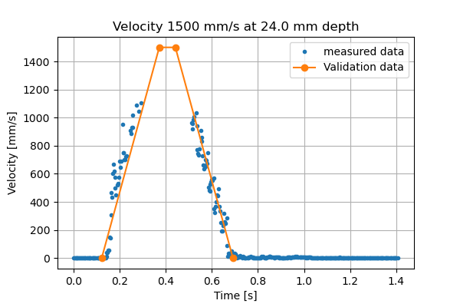

As you can see, the recordings follow the acceleration nicely till a velocity of approximately 1100 mm/s is reached.

I maximised the window size (10 mm (1st iteration) and 5 mm (2nd iteration)) and overlap (8.8 mm (1st iteration) and 4.4 mm (2nd iteration)) to optimise the maximum recordable velocity. I am however at the limit because of the limited width of my images (13.9 mm).

The frame rate was 350 Hz. This means that the maximum recordable displacement was 1100/350 = 3.143 mm.

In theory, I would expect that the maximum displacement would be the window size + (window size – overlap). In my case 11.2 mm for the 1st iteration and 5.6 mm for the 2nd iteration. Both are however far more greater than the actual max recordable displacement of 3.143 mm.

The reason for maximising the window size and overlap because of a similar observation. Initially the window sizes were 4.8 mm (1st iteration) and 2.4 mm (2nd iteration). The corresponding overlap was 2.4 mm (1st iteration) and 1.2 mm (2nd iteration).

In this case the maximum recordable velocity was 600 mm/s. The frame rate was similar, thus the maximum recordable displacement was 1.7 mm. While the maximum recordable displacement during the second iteration is still window size + (window size – overlap) =  3.6 mm.

Considering both cases I noticed that the actual maximum recordable displacement is about 56 % of the window size + (window size – overlap) for the 2nd iteration:

* 2 /(2.4 + (2.4 – 1.2)) = 0.55555
* 3.143 / (5 + (5 – 4.4)) = 0.56125

Enclosed I attach a zip file with my images, scripts and results :

* Folder “Img_pairs_3.5_D115_U60_V1500” contains the image pairs during the acceleration of my experiment with uniform velocity of 1500 mm/s. As there is an upload limit I can only provide the images till the velocity of 600 mm/s is reached. The results discussed below consider more images reaching higher velocities.
* Folder “OpenPIV_code” contains o.a. two OpenPIV scripts:
  + 2_OpenPiv_windef_client_(48-24).py
  + 2_OpenPiv_windef_client_(100-88).py

Both are the same, apart from the size of the windows and overlap. The numbers refer to the value of both for the first iteration. Both scripts allow for 2 iterations. Both window size and overlap are halved for the second iteration.

So for the first file the window sizes are 48 pixels  (1st iteration) and 24 pixels (2nd iteration) with an overlap of 24 pixels (1st iteration) and 12 pixels (2nd iteration).

For the second file the window sizes are 100 pixels  (1st iteration) and 50 pixels (2nd iteration) with an overlap of 88 pixels (1st iteration) and 44 pixels (2nd iteration).

In these images 1 mm  = 10 pixels.

* Folders “Results_PIV_48-24_S2N1.25” and “Results_PIV_100-88_S2N1.25” contain the results of the OpenPIV scripts
* The scripts “Velocity_profiles_rev1(48-24)” and “Velocity_profiles_rev1(100-88)” are used to evaluate the results. I simplified them for your comfort. For each vector field they take the average velocity at 24 mm depth.
* Folder “Velocity_profiles” contains the plots of the scripts mentioned just above.

As you can see for the 48-24 combination the acceleration is visible till a velocity just above 600 mm/s. While for the combination 100-88 it is limited to 1100 mm/s while it should go up to 1500 mm/s.

**What I would like to know is why the velocity recordings stop at respectively 600 mm/s and 1100 mm/s when changing only the window size and overlap while these parameters should not be the limiting factor as mentioned above.**

Ps. The value for maximum displacement as a validation criteria was set to an unrealistic value of 1000 pixels (= 100 mm). See the two OpenPIV scripts.

Thanks in advance!