Stream2DB
========================================
By: Aux (s_aukema@ not-so-coldmail . com

Streaming plug-in that invokes your VLC server

Version 0.4 <Release candidate>
- Uses XML file for tv-stations
- Some code optimalisation
- Removed the stop button.. I didn't use it anyway

Version 0.3 <BETA>
- Reads IP number from movieplayer.xml config-file instead of hard-coded
- Sends the dreambox ip number to the VLC server, so the php script needs no configuration
- Adjusted php script to accept ip-numbers
- Adjusted php script to be platform independent (windows/linux)
- Added button to stop the server to stream (to save bandwith)

Version 0.2
- listbox with multiple streams
- php script including code to handle variable in stream names

Version 0.1
- Proof of concept version
- 1 button to start the streaming
- simple php script
========================================

Requirements:

Movieplayer should be configured correctly on your dreambox. If it is not possible to stream a movie to your dreambox, this won’t work either!!!

Extract the phpdev package to c:\phpdev
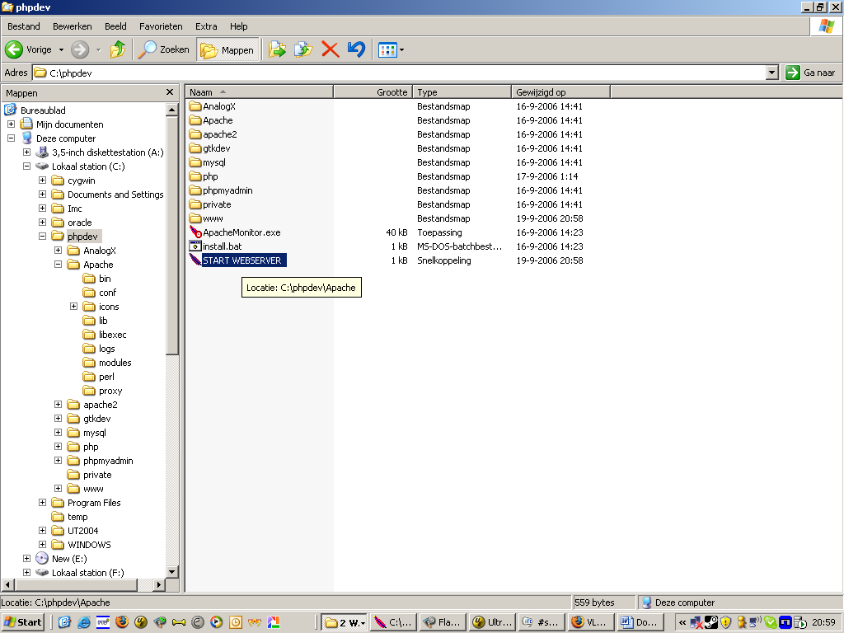
Attention, when extracted anywhere else, it won’t work!

Double click on the START WEBSERVER icon
ftp the plug-in to your dreambox
Put the .cfg and .so files in /var/tuxbox/plugins/
Put the .xml file in /var/tuxbox/config/webstream2db/

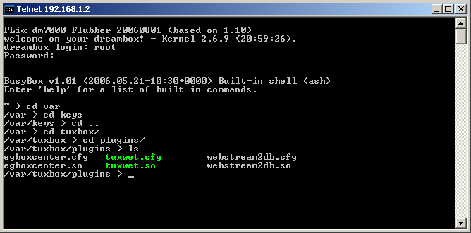
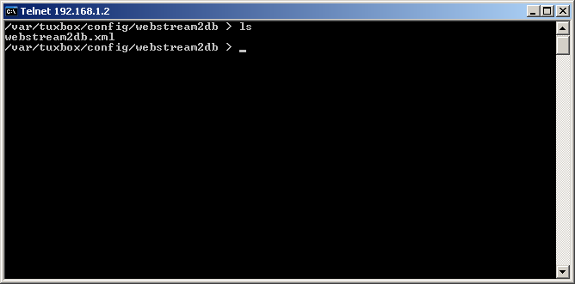

---------------
TROUBLESHOOTING
---------------

It doesn't Work

1. Shut down all firewalls

2. Test the movieplayer using the webinterface of the dreambox.

3. Try http://localhost in your browser.. It should look like:
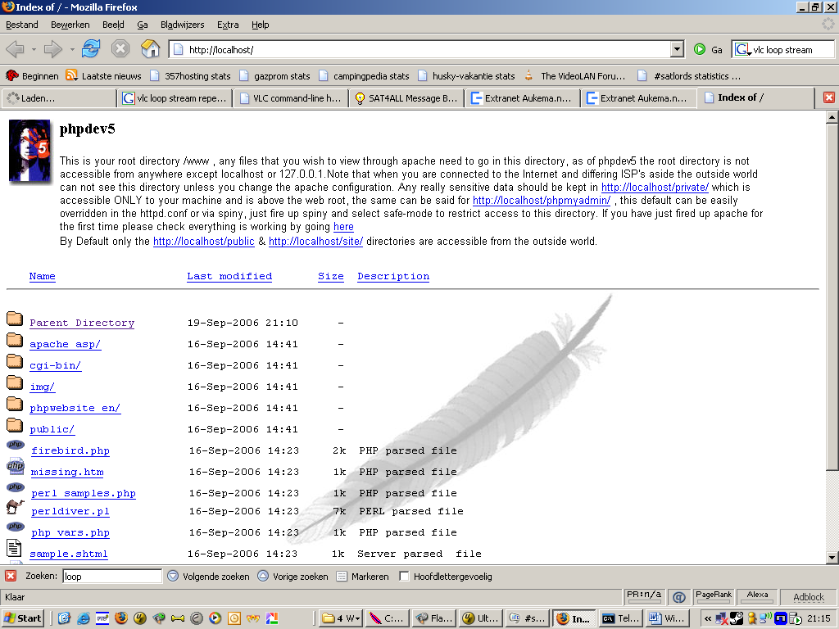

4. Enter the following URL in your browser and check if VLC starts. You can see this with the taskmanager under Windows.
VLC should eat cpu power now. (don't mention the IP address and port here)
http://localhost/startvlc.php?url=http://cgi.omroep.nl/cgi-bin/streams?/tv/bnn/delamas/bb.laatste.asf&ip=192.168.1.2&port=9090
--> If it doesn't work, VLC is not properly installed on you PC

Thanks go to:
Mechatron, Digi_Casi, Mordillo, bacicciosat,

