JETSON HOW-TO

This guide is a superset of https://github.com/xlz/libfreenect2/wiki/Jetson-TK1-HOWTO

FLASH THE DEVICE:
Use JetPack downloadable here: https://github.com/OpenPTrack/open_ptrack/tree/jetson-dev/jetpack
Follow the figures at the end of the document (In particular, take care to the figure in which you should put the device in FORCE RECOVERY mode. The instructions showed in ther terminal window are bugged, follow the ones in this guide!).

After the flashing phase you should be able to ssh-ing the device if it is powered on and attached to your Local Area Network. Try to connect to it with this command:

ssh -X ubuntu@tegra-ubuntu.local

The default password is:
ubuntu

If the above command does not work check your network with IP scanning tools and see whether you see the device.
If you change the default username & password the following commands should be changed accordingly.

PRELIMINARY STEPS:

- Enabling USB 3.0 Full performance
USB 3.0 must be enabled for full performance. (With 30 FPS, JPEG stream consumes 20MB/s, and depth stream consumes 85MB/s). Edit /boot/extlinux/extlinux.conf to change usb_port_owner_info=0 to usb_port_owner_info=2 to enable USB 3.0.
Add also usbcore.autosuspend=-1 at the end of the last command to disable the USB autosuspending.

- Add udev rule for Kinect v2: create /etc/udev/rules.d/90-kinect2.rules with the following content:
# ATTR{product}=="Kinect2"
SUBSYSTEM=="usb", ATTR{idVendor}=="045e", ATTR{idProduct}=="02c4", MODE="0666"
SUBSYSTEM=="usb", ATTR{idVendor}=="045e", ATTR{idProduct}=="02d8", MODE="0666"
SUBSYSTEM=="usb", ATTR{idVendor}=="045e", ATTR{idProduct}=="02d9", MODE="0666"

INSTALL UTILITIES & PERMITS UNIVERSE+MULTIVERSE
sudo apt-add-repository universe
sudo apt-add-repository multiverse
sudo apt-get update
sudo apt-get install -y bash-completion command-not-found locate git gitg vim

INSTALL&CONFIGURE ROS BASE SYSTEM

sudo sh -c 'echo "deb http://packages.ros.org/ros/ubuntu $(lsb_release -sc) main" > /etc/apt/sources.list.d/ros-latest.list'
sudo apt-key adv --keyserver hkp://pool.sks-keyservers.net --recv-key 0xB01FA116
sudo apt-get update
sudo apt-get install -y ros-indigo-desktop
sudo apt-get install -y python-rosinstall
sudo apt-get install -y ros-indigo-compressed-depth-image-transport ros-indigo-compressed-image-transport
sudo rosdep init
rosdep update
echo "source /opt/ros/indigo/setup.bash" >> ~/.bashrc
source ~/.bashrc
mkdir -p ~/workspace/ros/catkin/src
cd ~/workspace/ros/catkin
catkin_make --force-cmake
echo "export KINECT_DRIVER=openni" >> ~/.bashrc
echo "export LC_ALL=C" >> ~/.bashrc
echo "source /home/$USER/workspace/ros/catkin/devel/setup.bash" >> ~/.bashrc

INSTALL POINT CLOUD LIBRARY

sudo add-apt-repository -y ppa:v-launchpad-jochen-sprickerhof-de/pcl
sudo apt-get update
sudo apt-get install -y libpcl-1.7-all

INSTALL & CONFIGURE NTP

Follow https://github.com/OpenPTrack/open_ptrack/wiki/Time%20Synchronization

INSTALL CUDA

wget http://developer.download.nvidia.com/compute/cuda/6_5/rel/installers/cuda-repo-l4t-r21.2-6-5-prod_6.5-34_armhf.deb
sudo dpkg -i cuda-repo-l4t-r21.2-6-5-prod_6.5-34_armhf.deb
sudo apt-get update
sudo apt-get install -y cuda-toolkit-6-5
sudo usermod -a -G video $USER
echo "# Add CUDA bin & library paths:" >> ~/.bashrc
echo "export PATH=/usr/local/cuda/bin:$PATH" >> ~/.bashrc
echo "export LD_LIBRARY_PATH=/usr/local/cuda/lib:$LD_LIBRARY_PATH" >> ~/.bashrc
source ~/.bashrc

INSTALL LIBFREENECT2 & ADD THE SCRIPTS FOR THE MAX PERFORMANCE

By default, only one core of the jetson is active and it works at the minimum frequency. Furthermore, even the memory bus, the GPU frequency and the GPU memory frequency should be set for the max performance.
You can done this using the scripts in the libfreenect2 repository. There are several scripts for enabling the max performance, check the Status of the card and for the disabling of the autosuspending mode of the USB (to be used after having connected the Kinect v2).

cd ~
sudo apt-get install -y build-essential libturbojpeg libtool autoconf libudev-dev cmake mesa-common-dev freeglut3-dev libxrandr-dev doxygen libxi-dev libjpeg-turbo8-dev
git clone https://github.com/openptrack/libfreenect2.git
cd libfreenect2
git checkout jetson-dev
cd depends
./install_deps.sh
sudo ln -s /usr/lib/arm-linux-gnueabihf/libturbojpeg.so.0.0.0 /usr/lib/arm-linux-gnueabihf/libturbojpeg.so
cd ..
cd jetson_scripts
chmod +x *
sudo cp * /usr/bin
echo "MaxPerformance &> /dev/null" >> ~/.bashrc

Reboot the jetson
sudo reboot

*check Protonect*
Kinect v2 connect instructions:
- Before connecting the Kinect, open a terminal and launch the following command:
sudo Status
If everything is good, you should see something like this:
CPUs active (it should be 0-3):
0-3

CPUs freq (it should be 2320500):
2320500
2320500
2320500
2320500
CPU governor (it should be userspace):
userspace
userspace
userspace
userspace

GPU clock (it should be 852000000):
852000000

GPU memory clock (it should be 924000000):
924000000

If something is wrong give the command
sudo MaxPerformance
and re-try to check the Status.
- Connect the already powered-on Kinect v2 cable to the USB port of the Jetson.
- Wait 3 seconds
- Invoke
sudo Status
At the end of the Status you should see the Autosuspending state with all -1 (no 2). If this is not the case something went wrong. Probably the Kinect v2 is powered off and it is not listed there or you have not done well the PRELIMINARY STEPS. Try to redo the steps and/or reboot the device. Take care of the order of the instructions!!
- The Kinect v2 is correctly connected, now we will check if Protonect works correctly.
cd ../examples/protonect/
mkdir build && cd build
cmake ..
make -j4
../bin/Protonect
You should see [with some delay (we are trying to ssh-ing a lot of information)] three windows opening, one with the depth information, one with the color information and one with the ir information. To close the program just type “ESC” with the focus on any image. Don’t worry about the low framerate, we are seeing a stream of information through an encrypted channel. If you don’t see anything, and on the terminal there are a lot of
[DepthPacketStreamParser::handleNewData] subpacket incomplete (needed X received Y)]
probably the jetson is not in max performance mode or the Kinect has not been attached correctly (take care of the order specified previously!).
If you see some USB errors, probably Protonect has been linked with the uncorrect version of libusb or the USB is in Autosuspending mode. Try to reboot and/or check ldd Protonect.

If Protonect works, you can install the libraries in the system (always inside the build dir).
sudo make install

INSTALL IAI_KINECT2 (currently not available)

roscd
cd ../src
git clone https://github.com/OpenPTrack/iai_kinect2
git checkout jetson-dev
Catkin
(only if you see internal compiler error)
CatkinJ1

INSTALL OPEN_PTRACK

roscd
cd ../src
git clone https://github.com/OpenPTrack/open_ptrack
git checkout jetson-dev
cd ~/workspace/ros/catkin/src/open_ptrack/scripts
chmod +x *.sh
./calibration_toolkit_install.sh
cd ~/workspace/ros/catkin
catkin_make --pkg calibration_msgs
catkin_make --pkg opt_msgs
catkin_make --force-cmake

FLASH THE DEVICE WITH JETPACK
Once downloaded the Jetpack run file type:
chmod +x JetPack*
./JetPack...run
Go through the phases, select CUSTOM installation option and take care to have the correct selections like in the following figures.

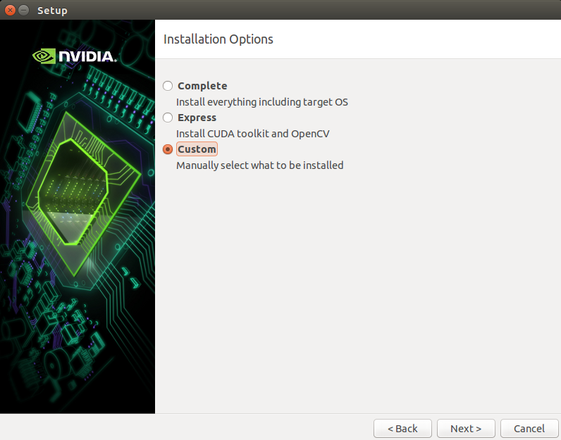

Select the following components to be installed:
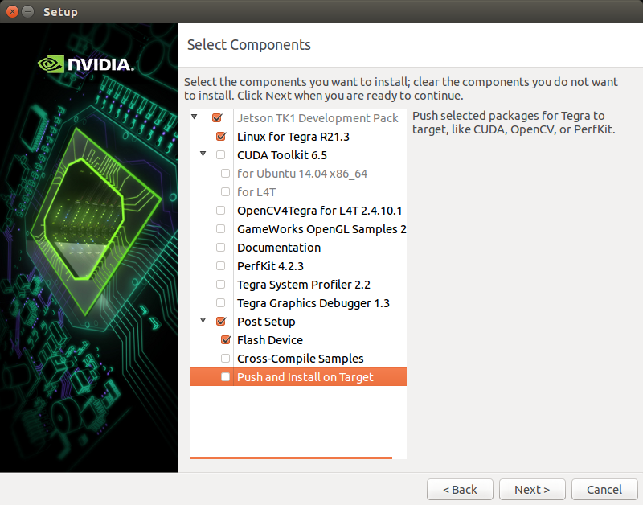

And follow the installation until you arrive where you have to put the device in FULL RECOVERY mode (see the picture):
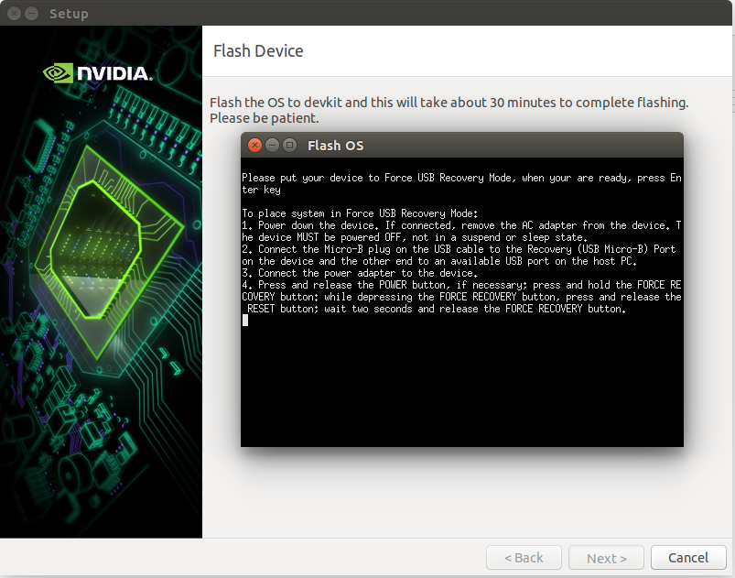

The instruction are not correct. In particular you have to substitute “depressing” with “pressing” and you have to give Enter once the force recovery is active. The correct instructions are:
- Power off the device if it is powered on
- Connect it with Micro USB cable to te computer
- Power on the device (connect AC adapter + press POWER button if the fan does not start automatically).
- Press and hold the FORCE RECOVERY BUTTON. While pressing it, press and release the RESET button, after two seconds release the FORCE RECOVERY BUTTON.
- Press Enter

Follow the flashing until the end.

