Multi-Camera Calibration and Tracking in a Distributed Network

This guide explains how to calibrate a camera network composed of Microsoft Kinect sensors (XBOX version) and how to perform people tracking in a distributed configuration.

There exist two models of the Kinect for XBOX (the model number can be read under the Kinect):
- 1414: old firmware, open source drivers can read its serial number
- 1473: new firmware, open source drivers cannot read its serial number and return a list of zeros instead.
This guide is thought for camera networks where at least one Kinect of type 1473 is present, thus the serial information is not used and different Kinects are identified by names written in a configuration file, as explained later.
Using these sensors, the disadvantages are that you cannot provide a custom intrinsic calibration and you can have just one Kinect attached to every computer.
If you have only Kinects of type 1414, then you can follow the 'multicamera_calibration_guide_with_serials.doc', which uses Kinect serial numbers to identify cameras in the network, thus more than one Kinect can be used per computer.

Let's start!
The whole procedure can be summed up into the following steps:
1) connect every PC to the network and set the Master IP
2) create files for multicamera calibration
3) perform multicamera calibration
4) perform multicamera people tracking

1) Connect every PC to the network an set the Master IP
Every sensor should be connected to a PC connected to a Gigabit Ethernet network.
One PC will be the master, where the calibration code and the tracking code will run, while the other PCs will run the sensor drivers (during calibration) and the people detection code (during distributed detection and tracking).
For allowing communication between software nodes in different computers, the environment variable ROS_MASTER_URI must be set on every client PC to the IP address of the master PC.
Moreover, the ROS_IP environment variable must be set on every PC to the its IP.
This can be temporarily done on a terminal by typing this command:

export ROS_MASTER_URI=http://<MASTER_IP>:11311/
export ROS_IP=<MACHINE_IP>
(e.g.: export ROS_MASTER_URI=http://192.168.202.226:11311/
export ROS_IP=192.168.202.2)
For setting them once for all, these lines can be directly added to the end of the '.bashrc' file in the home folder by typing:

echo "export ROS_MASTER_URI=http://<MASTER_IP>:11311/" >> ~/.bashrc
echo "export ROS_IP=<MACHINE_IP>" >> ~/.bashrc

2) Create files for multicamera calibration
Multicamera calibration is performed running a calibration node in the master PC and a sensor driver in every PC attached to a sensor (one driver node for every sensor).
Network parameters have to be written in the ‘opt_calibration/conf/camera_network.yaml’ file. Then, by running:

roslaunch opt_calibration calibration_initializer.launch

the launch files needed for calibration are created.
In the 'camera_network.yaml' file, the number of cameras and a name for every Kinect have to be written, as shown here below for a network composed of two cameras:

# Camera network parameters
num_sensors: 2
sensor0_id: "Kinect1"
sensor1_id: "Kinect2"
calibration_with_serials: false

Be sure that the 'calibration_with_serials' flag is set to false.
Also the parameteres of the checkerboard used for calibration have to be added, as shown below:

# Checkerboard parameters
rows: 6
cols: 5
cell_width: 0.12
cell_height: 0.12

These parameters define the number of chess intersections in rows and cols and the width and height of every square.

3) Perform multicamera calibration
The calibration initialization described at point (3) creates a main launch file for calibration (opt_calibration_master.launch) to be run on the master PC and a launch file for every sensor (sensor_<sensorN_id>.launch) which launches the OpenNI driver for the camera named “sensorN_id”.

To perform multicamera calibration, this should be run on the master PC:
roslaunch opt_calibration opt_calibration_master.launch

while this should be run for every sensor (in the PC attached to that sensor):
roslaunch opt_calibration sensor_<sensorN_id>.launch
where <sensorN_id> is the name given to the N-th sensor.

When two cameras see the checkerboard, the transformation between the two is estimated. Every camera is then extrinsically calibrated with respect to another camera, composing a tree of transformations which describe the whole network.
Every time a camera is calibrated with respect to another camera, a link appears between the two in Rviz and this kind of output is provided in the console:

/<sensorN_id> added to the tree.

When all cameras are calibrated, the following output appears:

All cameras added to the tree. Now calibrate the global reference frame and save!

At this point, the user is requested to put the checkerboard on the ground in the position and orientation which define the global reference frame to be used for people tracking and so that one of the sensors can see the checkerboard. Then, all calibration data can be saved by running:
rostopic pub /opt_calibration/action std_msgs/String "saveExtrinsicCalibration" -1

The origin of the global (/world) reference frame is set at the top-left square intersection as illustrated in the figure below. The /world reference frame saved for tracking will have the X axis pointing towards up and the Y axis pointing towards left. Note that the top of the checkerboard can be univocally determined only if the checkerboard has an odd number of intersections in one direction (e.g. rows) and even in the other direction (e.g. cols).
You can check where the origin is placed in Rviz when calibrating the network.
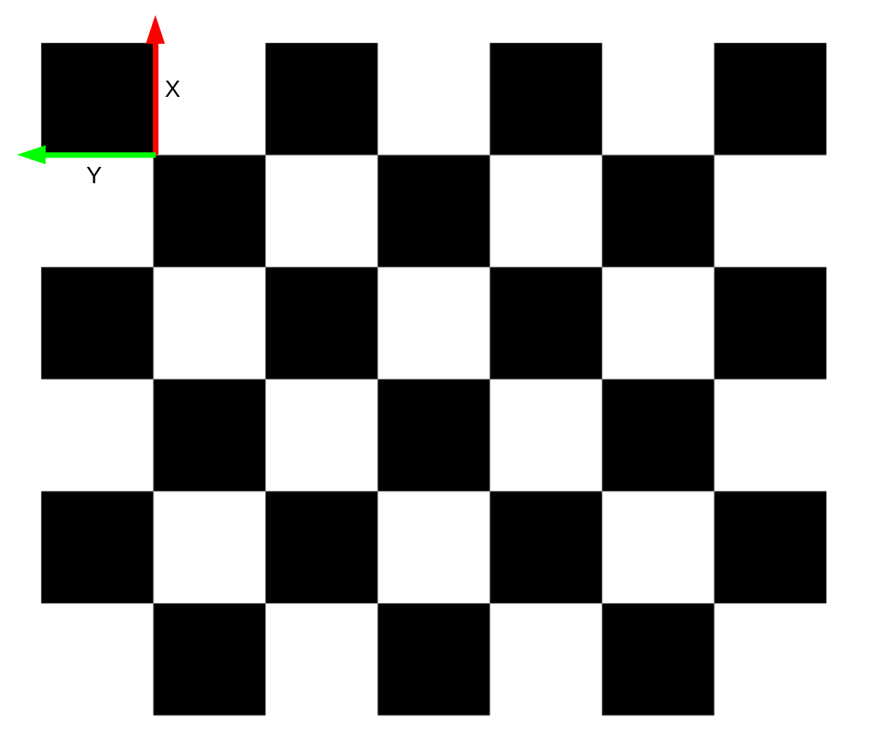

All extrinsic calibration data are saved to the 'multicamera_calibration_results.launch' file in the 'opt_calibration/launch' folder.
Moreover, a text file with all camera poses 'camera_poses.txt' and a launch file with name 'detection_node_<sensorN_id>.launch' is created for every sensor in the 'detection/launch' folder of the Master PC. These detection_node files can be directly used to perform distributed people detection after they have been moved to the 'detection/launch' folder of the computer attached to the sensor with <sensorN_id> name.
NB: Do remember to also copy the 'detection/launch/camera_poses.txt' file to the 'detection/launch' folder of every computer.

4) Perform multicamera people tracking
Once multicamera calibration has been performed, multicamera people tracking can be launched by simply running a detection node for every sensor and a tracking node in the Master PC.

In particular, in the Master PC, this should be run:
roslaunch tracking tracking_node.launch
which publishes calibration data, performs tracking and opens Rviz to see tracking results.

While, in every PC attached to a sensor, the launch file 'detection_node_<sensorN_id>.launch' saved during multicamera calibration should be run as follows:
roslaunch detection detection_node_<sensorN_id>.launch

After running the tracking node, Rviz is opened, people positions are plotted in the global reference frame (/world) and camera reference frames are shown. No people detection output is shown in order to avoid to transmit images over the network.

NB: when running multicamera tracking based on multicamera extrinsic calibration, the 'extrinsic_calibration' flag in 'tracking/conf/tracker_multicamera.yaml' must be set to true.
If set to false, the camera reference frame is used as global reference frame and no extrinsic calibration information is used.
All parameters used for multicamera tracking are written in 'tracking/conf/tracker_multicamera.yaml'.

NB2: be sure that all PCs are synchronized in time. You can make them use internet to update clock information. An alternative option for synchronization will be implemented as a future work.
If your PCs are not synchronized in time, you will see an error like this in the tracking command line: [ERROR] [1396947072.332131826]: transform exception: Lookup would require extrapolation into the past.

Multi-Camera Calibration and Tracking in a Network with SwissRangers

If the network contains also Mesa SwissRangers 4500, the procedure for multicamera extrinsic calibration and tracking is the same as for networks composed of only Kinects.
The only difference is in the configuration file 'open_ptrack/opt_calibration/conf/camera_network.yaml', where, for SwissRanger cameras, the IP address should be used as sensorN_id.
Example:
sensor1_id: "192.168.1.33"

