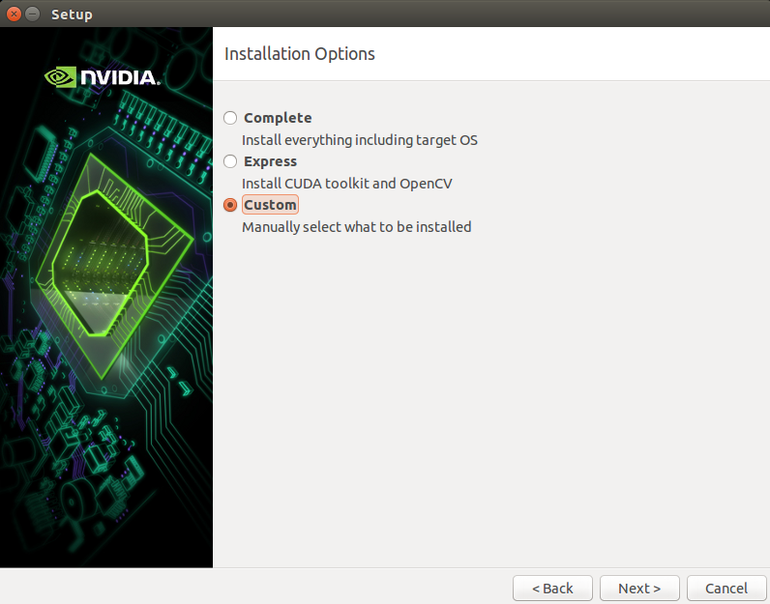
FLASH THE DEVICE WITH JETPACK
Once downloaded the Jetpack run file (you can find it in open_ptrack's docs folder) type:
chmod +x JetPack*
./JetPack...run
Begin the flashing, select CUSTOM installation option and take care to have the correct selections like in the following figures.

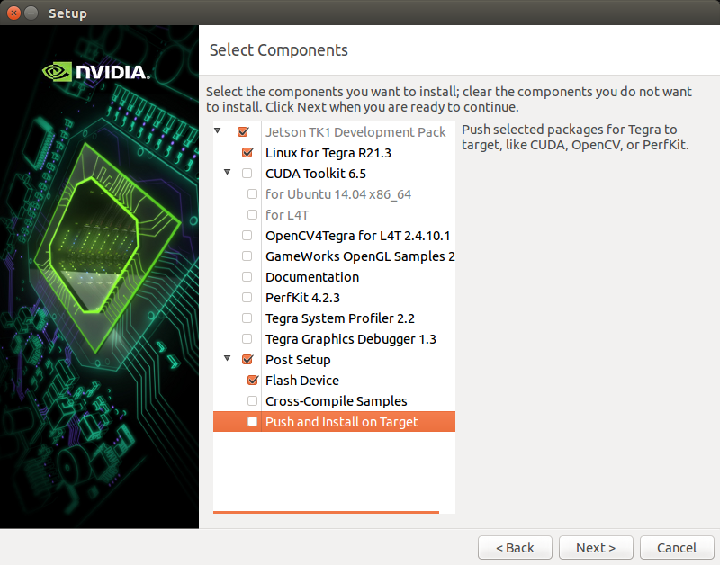

Follow the installation until you arrive where you have to put the device in FULL RECOVERY mode (see next picture):

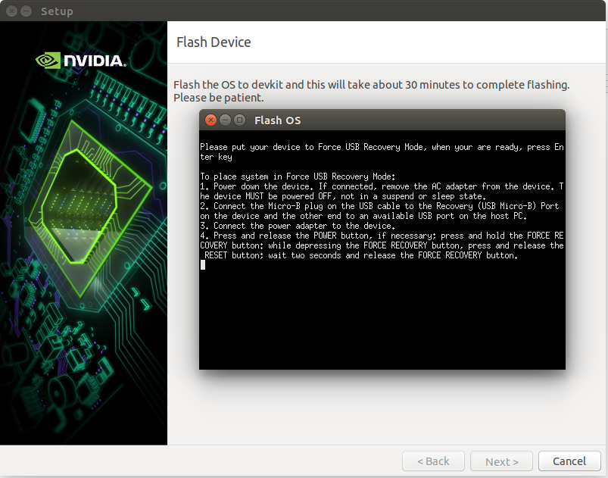
The instruction are not correct. In particular you have to substitute “depressing” with “pressing” and you have to give Enter once the force recovery is active. The correct instructions are:
- Power off the device if it is powered on
- Connect it with Micro USB cable to te computer
- Power on the device (connect AC adapter + press POWER button if the fan does not start automatically).
- Press and hold the FORCE RECOVERY BUTTON. While pressing it, press and release the RESET button, after two seconds release the FORCE RECOVERY BUTTON.
- Press Enter

Follow the procedure until the end.

