Buddhist Creators Convention 2026

Award Winners

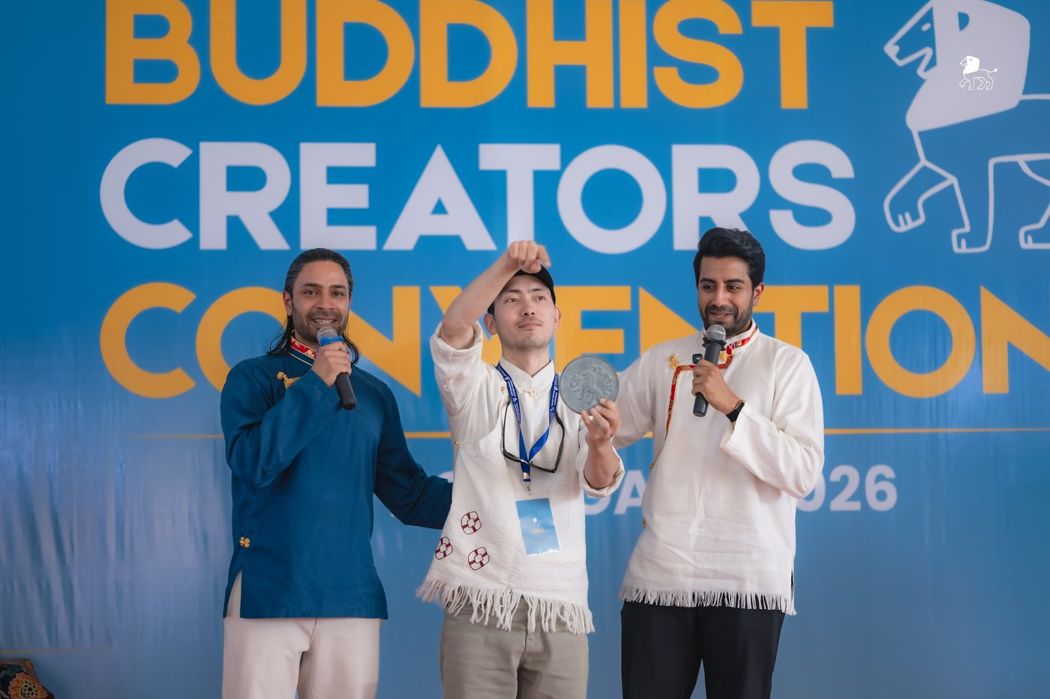
Audience Choice
Tashi Chosgon
@undercover._.monk
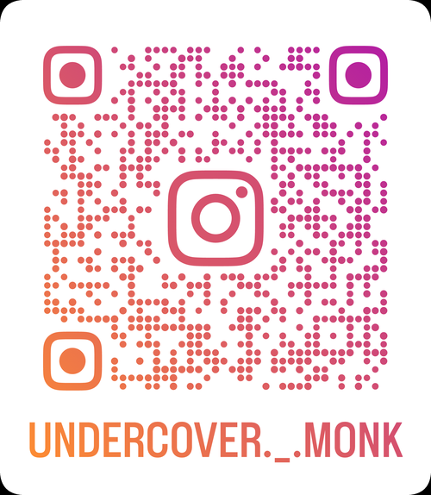
Photo 1 · TC

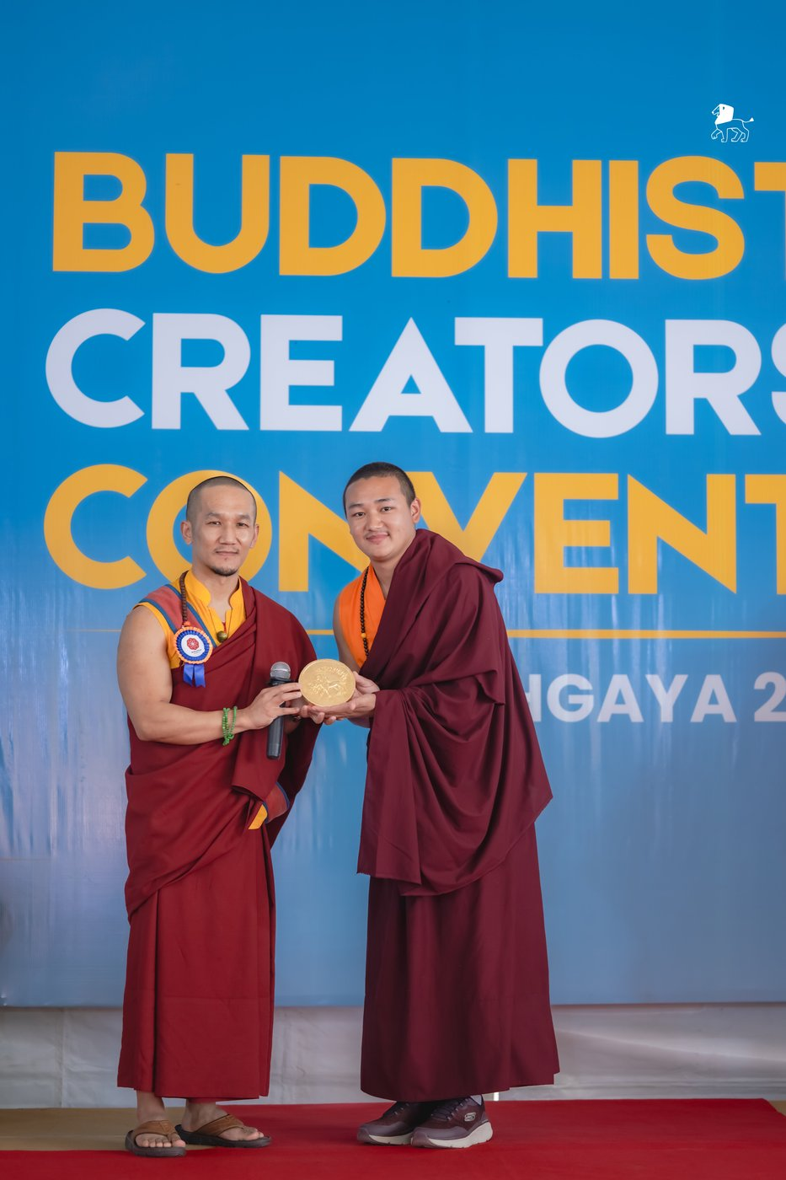
Influencer of the Year
Quinthup Pema Bhutia
@qp_buddhist.monk.official
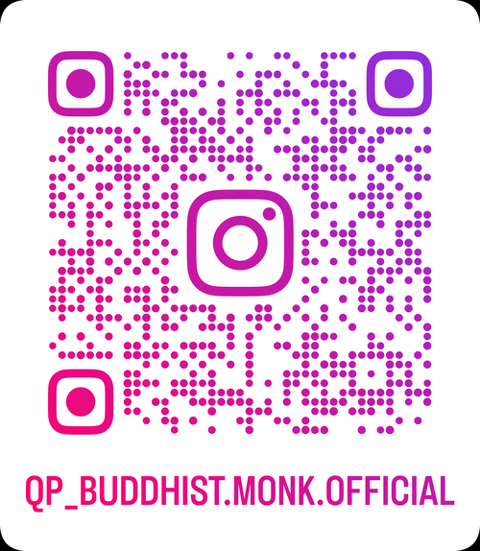
Photo 2 · QP

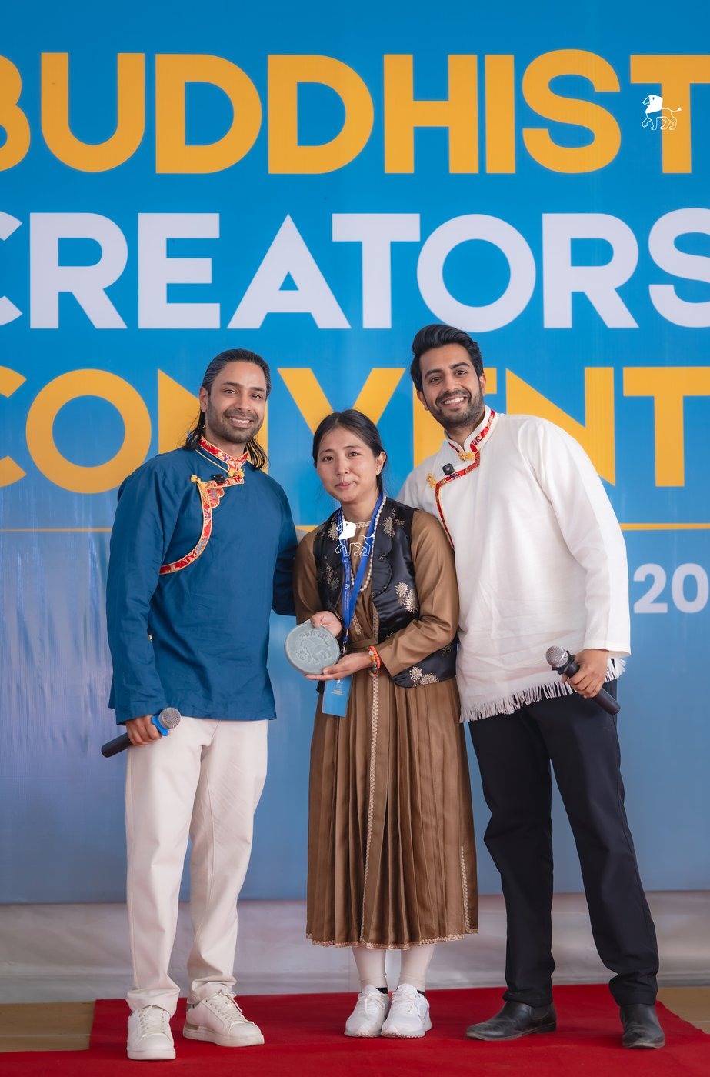
Most Followers Gained
Sonam Dolma
@_sonam.dolma_
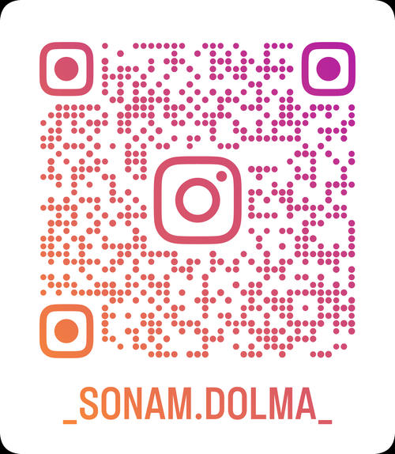
Photo 3 · SD

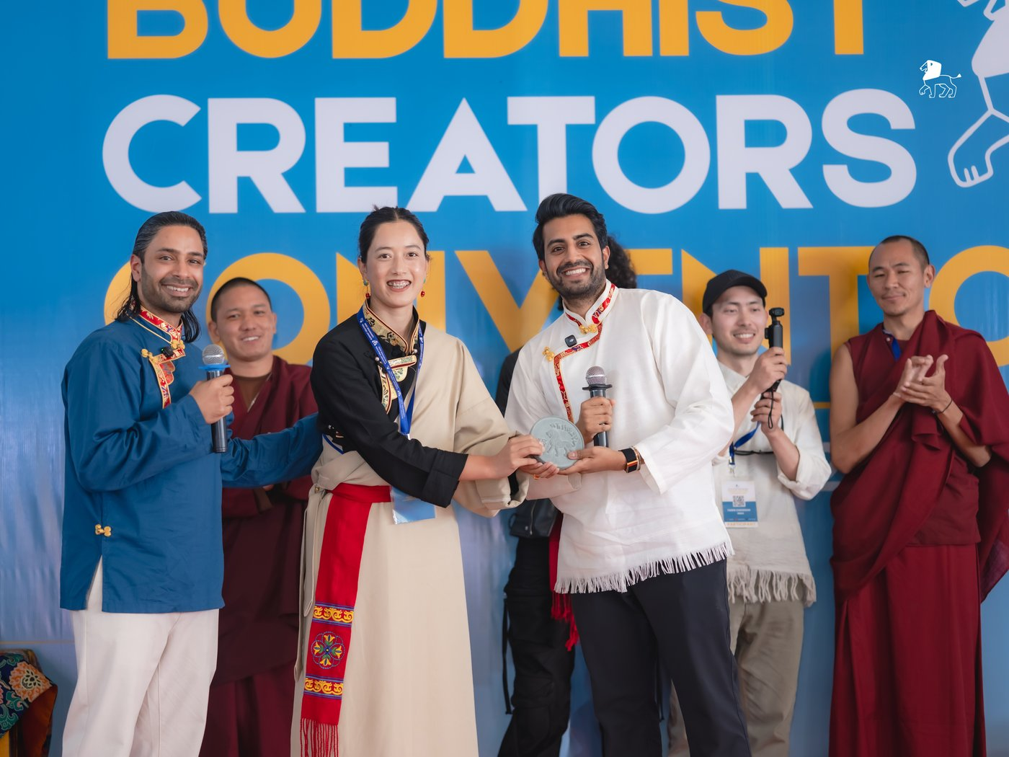
Most Creative Video
Tenzin Chime
@tenzinc_vlog
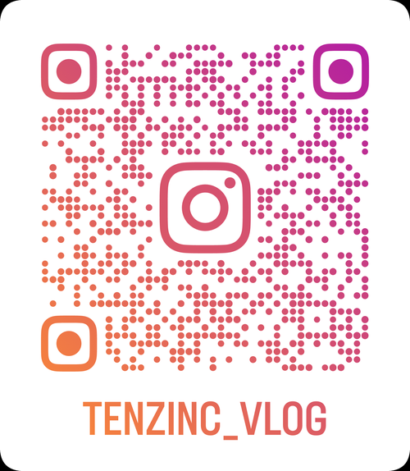
Photo 4 · TC

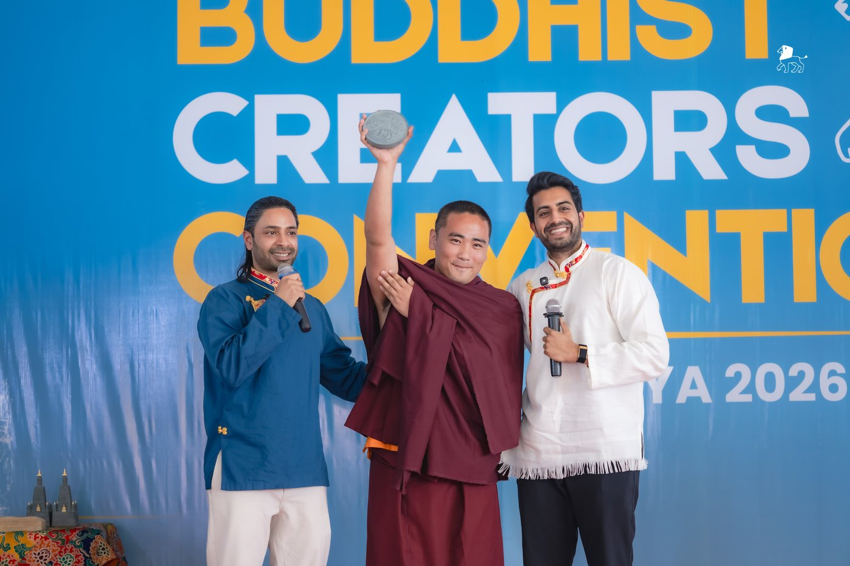
Rising Star
Chhewang Dorjee
@m.g.m_tsewang
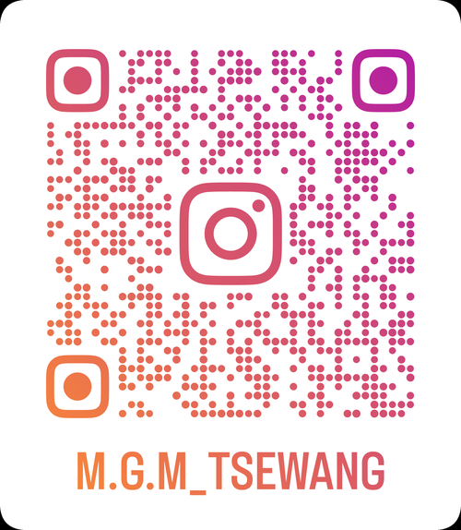
Photo 5 · CD

