Retention Band Material Testing Plan
Comparative validation protocol for TPU, Spandex, EPDM, and hybrid band constructions
Prepared for portfolio and concept-development use
Objective | Compare retention-band materials under cyclic fatigue, creep, tensile, and environmental-aging conditions to support downselect for a robotic storage application.
Primary outputs | Cycles to failure, permanent set, force retention, tensile strength, visible damage ranking, and final material recommendation.

1. Test Scope
This document outlines a practical engineering test plan for comparing candidate retention-band materials. The study is intended for early design validation, not formal qualification. The emphasis is on durability, elastic recovery, and visible wear under realistic stretch conditions.

2. Candidate Materials and Sample Plan
Prepare at least 10 samples per material per major test condition. Record supplier, lot number, nominal width, thickness, free length, and mass per unit length before testing.
Material | Construction | Qty / condition | Key reason to test | Notes
TPU-core elastic | Multi-core woven elastic | 10 | Good durability and recovery candidate | Use baseline option
Spandex elastic | 3- or 4-core textile elastic | 10 | High stretch, easy sourcing | Track creep carefully
EPDM band | Rubber strip or coated elastic | 10 | Strong environmental resistance | Confirm flexibility
Hybrid laminate | Textile + elastomer stack | 10 | Potential balance of grip and life | May need custom fixture

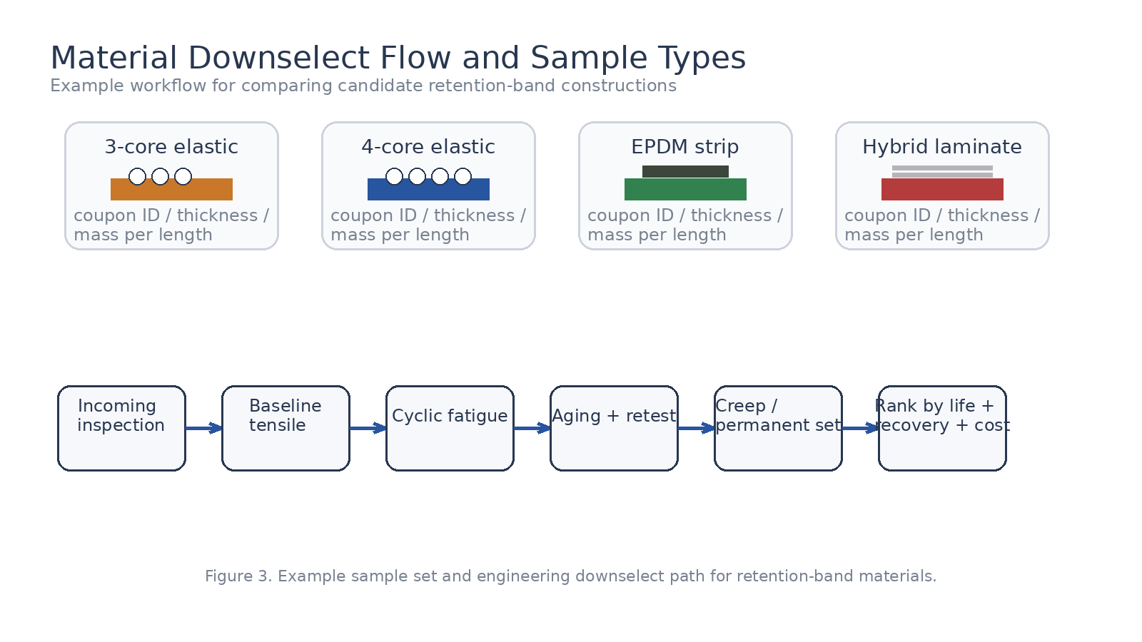
Figure 1. Example sample set and engineering downselect path for retention-band materials.

3. Test Methods
Run the following tests in the order shown unless there is a reason to isolate one variable. Use separate samples for destructive testing.

3.1 Incoming inspection
Measure free length, width, thickness, and mass per unit length. Photograph each sample. Reject coupons with visible nicks, loose stitching, surface cracking, or edge defects.

3.2 Baseline tensile test
Use a universal testing machine to pull each band at a constant crosshead speed until failure or target extension. Capture force-displacement data, elongation at break, and any local tearing near grips.

3.3 Cyclic fatigue test
Cycle the band between the selected minimum and maximum extension to represent repeated pod use. Record cycle count, peak load, valley load, and permanent set at regular intervals.

3.4 Environmental aging
Condition samples in a temperature-humidity chamber before fatigue retest. Optional exposures include synthetic oil, light dust contamination, or UV depending on expected field conditions.

3.5 Constant-load creep
Apply a fixed load for an extended dwell period, then unload and measure permanent set after recovery.
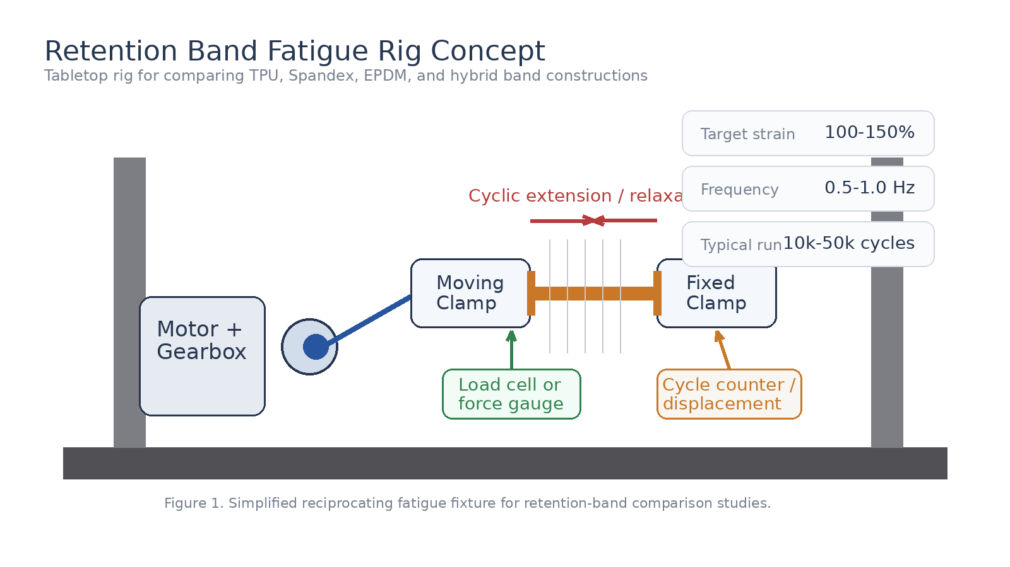
Figure 2. Simplified reciprocating fatigue fixture for retention-band comparison studies.
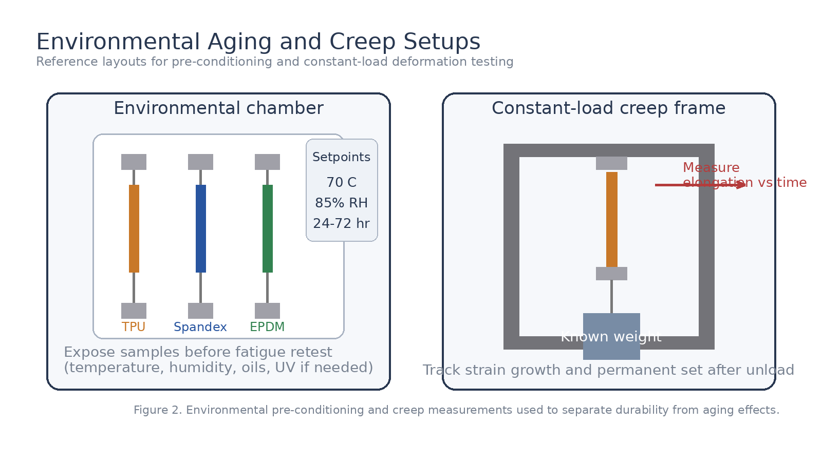
Figure 3. Environmental pre-conditioning and creep measurements used to separate durability from aging effects.

4. Recommended Initial Test Matrix
Test | Condition | Setpoint | Samples | Output | Pass / review trigger
Tensile | Ambient | 50-100 mm/min | 5 | UTS, break strain | Large grip slippage or early tearing
Fatigue | Ambient | 100-150% strain, 0.5-1.0 Hz, 10k+ cycles | 10 | Life, load retention, visible wear | Rapid force drop, stitching failure, crack growth
Aging | Temp + RH | 70 C / 85% RH, 24-72 hr | 5 | Property change after conditioning | Embrittlement, tackiness, delamination
Creep | Constant load | 8-15 N for 24-48 hr | 5 | Strain vs time, permanent set | Recovery too low after unload

5. Data to Record
For each sample, capture the following minimum dataset:
- Material, supplier, lot number, and coupon ID
- Initial dimensions: free length, width, thickness, and mass
- Fixture settings: gauge length, strain range, cycling frequency, and dwell time
- Peak load, valley load, extension, permanent set, and cycles completed
- Visible observations: fraying, cracking, stitching pullout, coating wear, odor, tackiness, or oil swelling

6. Example Ranking Criteria
Criterion | Weight | Preferred direction | Comment
Cycles to failure | 35% | Higher | Primary durability metric
Permanent set after test | 25% | Lower | Measures recovery after repeated use
Force retention after conditioning | 20% | Higher | Captures aging sensitivity
Unit cost / manufacturability | 20% | Lower | Use only after performance screen

7. Notes for a Tabletop Portfolio Rig
A simple portfolio rig can be built using a low-speed gearmotor, eccentric crank, linear guide, two clamping blocks, and either a small inline load cell or a digital force gauge. Keep guard panels around moving parts, add an emergency stop, and start with a lower cycle rate while checking for alignment and grip damage.

8. Revision Notes
This document is intentionally written as a practical first-pass engineering plan. Final qualification limits, sample sizes, and environmental conditions should be updated once the actual use case and supplier capabilities are known.

