# Abstract Metadata in Public Broadcasting

# Part 3: Time-based Descriptive Metadata

Version 2.1

May 2017

## Table of Contents

1 Introduction

Conceptual Overview

Figure 1: Segmentation Overview

2 Segmentation Metadata Values

Source Media

Description

Media ID

Source Media Type

Source Media Duration

Title

Events

Location

Start Time

End Time

Event Details

Event Type

Title

Timelines

Figure 2: Single Timeline

Figure 3: Multiple Timelines

Timeline Type

Contiguous

relatedContent

Frame Rate

Events

# 

# 

# 1 Introduction

This document explains the metadata that provides detailed time-based information about media content. Time-based descriptive metadata is important in a number of ways. It can provide:

* A list of primary elements to traffic personnel to ensure confidence in content placement and programming continuity
* A list of secondary graphical elements to brand/marketing personnel to allow additional placement of graphics or other treatments
* A list of content or chapter breaks to allow logical placement of underwriting or pledge breaks
* Information that can be passed to station playout automation for automated workflows (e.g. ‘Channel in a box’ and many more workflows)

This is the third part of a series of documents concerning the Interconnection System’s metadata system. The other documents in this series are as follows:

* **Part 1: Introduction to Abstract Metadata in Public Broadcasting**  
  This part introduces the Interconnection System and the need for an abstract hierarchical metadata system.
* **Part 2: Core Values**  
  This part describes the core abstract metadata models that compose the content library.

## Timecode Format

Timecode notation is specified using the following form: HHpMMpSSqFF

Where:

* **HH** is the two digit hour representation
* **MM** is the two digit minute representation
* **SS** is the two digit second representation
* **FF** is the two digit frame representation
* **p** is the punctuation delimiter. Generally, this is the colon (:) character but sometimes is represented as a semi-colon (;) to indicate drop-frame timecodes
* **q** is the punctuation delimiter for Frames. For drop-frame timecodes, this shall be the semi-colon character (;). At present, virtually all media at 29.97 FPS and thus uses the drop-frame timecode. In the extremely rare case for non drop-frame timecodes, the colon (:) character should be used.

Example of time codes:

“01:00:00;00” - Represents one hour

“12:38:59;28” - Represents twelve hours, 38 minutes, 59 seconds and 28 frames

## Conceptual Overview

Figure 1 shows the relationships between segmentation concepts (Source Media and Timelines) and abstract content concepts (Episode and Release).

During the Production phase of a content’s lifecycle, **Source Media** are placed in sequence to create Releases. **Timelines** can be created to better categorize similar elements in sequential order.

All Releases contain Source Medias with individual Timelines, and individual Source Medias can have its own Sub-Timelines. In Figure 1, the Release has a Primary Events Timeline and a Secondary Events Timeline layered on top of each other.

Multiple Timelines is discussed more in the Timelines section.

##### 

##### 

##### **Figure 1**: Release Timeline and Sub-Timelines

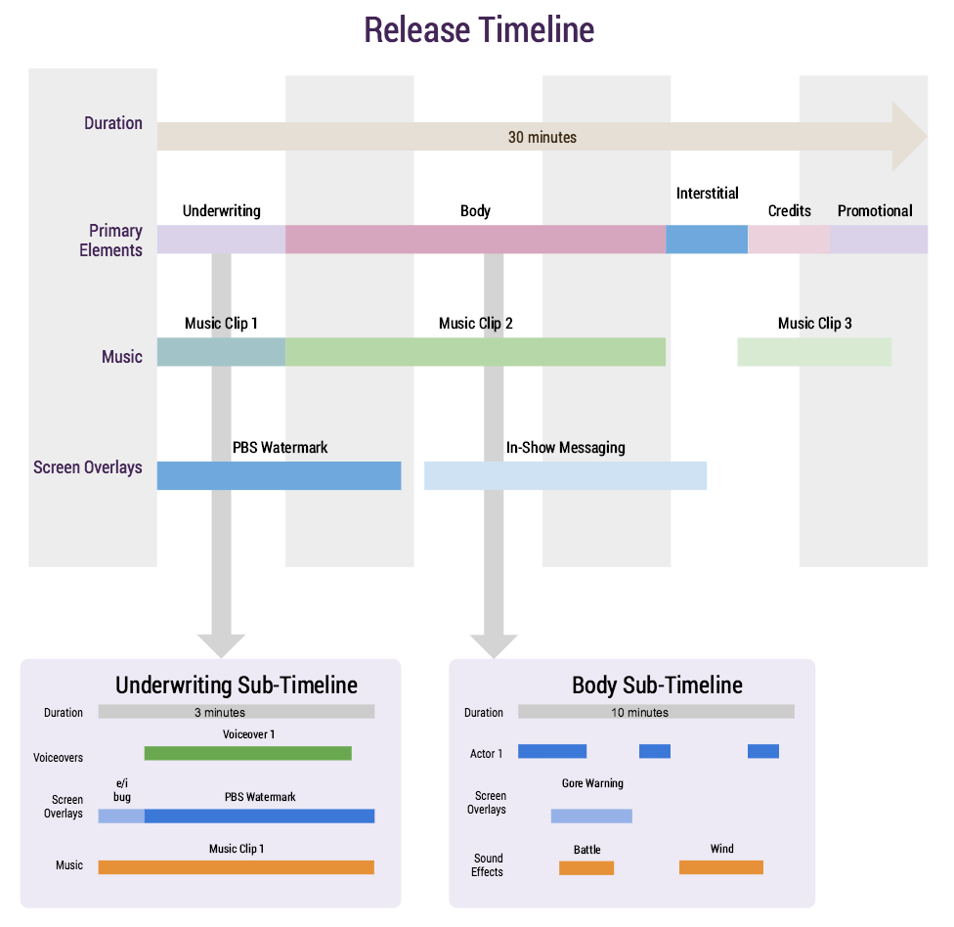

This is an example of a Release’s master timeline, which is composed of different Source Media: Primary Elements, Music, Screen Overlays, etc.. Each Source Media can have its own Sub-Timelines, as demonstrated by the Underwriting and Body Sub-Timelines.

Simply put, each piece of media has the possibility to contain one or more discrete timelines. When combined with other media, Timelines can be combined to form a single master Timeline of all the newly combined media.

# 

# 

# 2 Segmentation Metadata Values

## Source Media

Source Media includes all the raw audio, video, and flag components that can be edited together into Episodes.

Source Media is created during Production, and the metadata around it should be documented before Distribution.

* Description
* Media ID
* Source Media Duration
* Source Media Type
* Start of Message
* End of Message
* Title
* UID

### Description

The identifying characteristics of the media’s content.

**Format:** String (4000)

### Media ID

The House ID of the respective asset manager, which is a unique value generated by the metadata store for each content provider. Additional identification numbers can be associated to the source media using the ‘Alias’ relationships.

**Format:** String (50)

### Source Media Type

The physical/logical format of the Source Material. If the Source Media Type=Video, the Source Media will have associated Source Media Durations and Timelines.

**Format:** video, graphic, audio

### Source Media Duration

If Source Media Type=Video, the total expected duration of a Source Media is calculated from the Timeline’s Start Time and End Time.

**Format:** Timecode

### Title

A descriptive title for a piece of content, such as *A Chef’s Life.* More information could be included to help identify the Source Media, such as: “A Chef’s Life; webtags; credits over content”

**Format:** String limited to 400 characters.

### Start of Message

The media timecode for the start of the content. The timecode of the media is not required to be 00:00:00;00—more commonly the Source Media content will begin at 01:00:00;00 to accommodate the preamble. The preamble usually includes a slate, bars, or a countdown.

**Format:** Timecode

### End of Message

The media timecode for the end of the media.

**Format:** Timecode

### UID

Unique ID for internal tracking purposes during the Acquisition phase.

**Format:** urn:pbs:content:<uuid>

**Example**: urn:pbs:content:899310eb-b7cd-4364-acf0-8da105f46966

## Events

Events are time-based elements that make up a Source Media Video’s content. Multiple Events that have the same Type can be temporally sequenced together to form a Timeline.

Events are defined by the following metadata:

* Visual Location (optional)
* Start Time
* End Time
* Event Details
* Event Type
* Relationship Element (optional)
* Title (optional)

### Visual Location

This field captures the physical location of where a digital onscreen graphic (a graphic overlay, ticker, watermark, or bug) will appear on the screen. For example, the value for this field could be “lower right.”

**Format**: String

### Start Time

The timecode at the beginning of an Event. This value is used with an [End Time](https://docs.google.com/document/d/1wJmK5hHRXiqliOVGkQlXIfUf_3FkNso_E8eUIt9L9SE/edit#heading=h.506pcixzrpf8) to calculate the Source Media Duration. Alternatively, the Source Media Duration could be specified to calculate the End Time.

**Format:** Timecode

### End Time

The timecode at the end of an Event. This value is used with a Start Time to calculate the Source Media Duration.

**Format:** Timecode

### Event Details

Specific information relevant to an Event.

**Format:** String limited to 1000 characters.

### Event Type

Describes the category of an Event. Possible values are as follows:

* Primary Element: Essence
* Primary Element: Supplemental Media
* Secondary Element: Supplemental Media
* Other, based on Timeline

This list should remain flexible for Timeline needs, as each Timeline will dictate the types of Events that occur during the Timeline. For example, a ‘Rundown’ Timeline will consist solely of contiguous Primary Elements. But a Timeline that is capturing a series of events for playback on a digital tablet device could trigger interactive features and games, and thus may have an Event Type of ‘Trigger: Interactive Game.’

### Relationship Element

A reference to the Source Media or the Supplemental Media.

**Format:** Reference to Source ID or Supplemental Media EIDR ID.

### Title

A human-friendly identifier for the Event*.*

**Format:** String limited to 100 characters.

## Timelines

Timelines are time-based constructs that describe the content of video media. Each Timeline represents a specific type of Events that occur within the video media.

Since Timelines are generic constructs, they may be associated with any abstract metadata model that represents video. In the current model, the following models[1] may have associated Timelines:

* Source Media (when Source Media Type is video)
* Release
* Manifestation
* Supplemental Media

Timelines can be created as a general catch-all for similar events. For example, the Episode in Figure 2 has one Timeline known as the ‘Rundown’ that represents all the Source Medias that appear in the Episode, in order.

##### **Figure 2**: Single Timeline

##### 

This figure shows a single Timeline containing all the Primary Elements of an Episode. Each piece of Source Media (teal) contains a Duration. Its place on the Timeline is indicated by the timestamp above the Source Media box. The long blue arrow above the timestamp line indicates the Episode’s total duration.

Timelines of different types can be created in a single video, as shown in Figure 3. Timelines of different types in the same video media exist in parallel and do not interact in any way. For example, an Episode or OTO can contain a Timeline for Graphic Events only, a separate Timeline for Audio Events, and even a separate Timeline for when actors appear and disappear on-screen.

The duration of the Timeline, while expressed as a timecode, is always relative to the Start of Message (SOM) of the associated model. Thus while the timecode of the SOM for Source Media is often 01:00:00;00, the associated Timelines will always start at 00:00:00;00. This means that consumers of the Timeline who wish to know absolute timecodes of Timeline events must add the SOM timecode to the Timeline timecodes.

##### **Figure 3**: Multiple Timelines

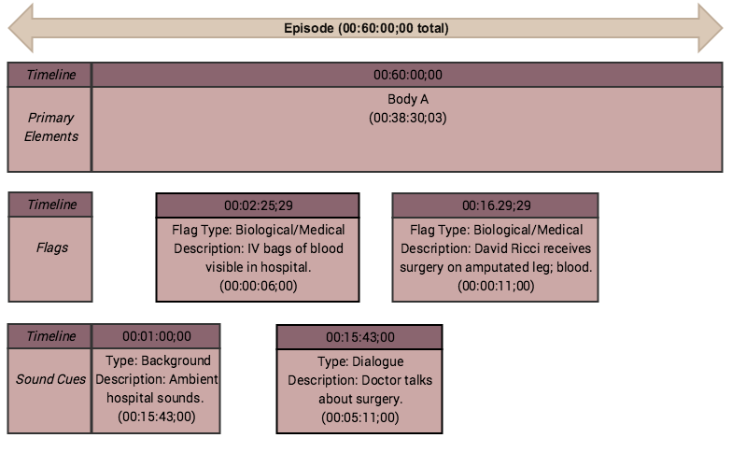

This figure shows three different Timelines running concurrently in the same Episode. The first Timeline contains the Timestamps, Name, and Duration for Source Media categorized as Primary Elements. The second Timeline contains the Timestamps, Name, and Duration for Source Media categorized as Flags. The third Timeline contains the Timestamps, Name, and Duration for Source Media categorized as Sound Cues.

Events do not need to form a contiguous block of events to be a complete Timeline, as illustrated in Figure 3.

During the production and distribution phases of content, many pieces of media (Source Media, Supplemental Media, etc.) will be combined to form the final distributed content. During this process, the Timelines of these pieces of media will be combined, ultimately producing a finished piece of media that not only combines the visual and audio but also is associated with a combined set of Timelines that represent all the Timelines of the component pieces of media.

During the combination of component Timelines, Timelines of the same type can simply be added together, assuming they have compatible frame rates. The finished piece will have a distinct number of Timelines that represents the total number of distinct Timeline types. Each combined Timeline will be the union of all Timelines from the source components.

Here is an example:

* Source Media A represents a 12-minute kids’ show with an associated Timeline that records educational curriculum opportunities at periodic points in the show. The events in this Timeline are calculated from the start of Source Media A, starting with a Start Time of 00:00:00;00.
* Source Media B represents an 11-minute kids’ show with a different associated Timeline that also records educational curriculum opportunities. This Timeline also uses a Start Time of 00:00:00;00.
* When both Source Medias A and B are combined into an Episode, the Episode now has a single Timeline for educational curriculum opportunities with all events from both Source Media Timelines. However, the Events from Timeline B have been temporally shifted to start after A’s Timeline.

This process is repeated for all Timelines in each Source Media. Consequently, when a Release is created from Episodes, One-Time-Onlys, or traffic/promotional Source Media, the Timelines of all components are combined by Timeline type.

Timelines are defined by the following metadata:

* Timeline Type
* Contiguous
* Related Content
* Frame Rate
* Events

### Timeline Type

The Events contained by the Timelines can have specific meaning to systems that interpret the data. Common Timeline Types include the following:

* **Rundown**: This type of Timeline is a contiguous set of events that defines the primary elements included in the media.
* **Visual Overlays**: This type of Timeline identifies various graphics and overlays applied on top of the video essence.
* **Content Flags**: This type of Timeline identifies various events in the video media that must be identified and communicated to consumers for viewing discretion and or broadcast decisions.
* **Chapters**: This type of Timeline identifies logical breaks in a story according to the content creator.
* **In-Show Messaging**: This type of Timeline identifies the temporal location, duration, placement, and associated content
* **In-Show Messaging Opportunities**: This type of Timeline identifies the temporal location, duration, and placement of opportunities for broadcasters to insert additional overlays or secondary elements.
* **Interactive Events:** This type of Timeline allows markers that may instruct playback devices to trigger an external interactive feature.

Additional types of timelines may be added as needed.

**Format:** String

### Contiguous

This field describes if the Events in the Timeline are contiguous. If True, then the Timeline must have no undefined gaps between events. And the events must cover the entire time period of the Timeline. In the case of the **Rundown** Timeline, all events are contiguous.

**Format:** True/False

### Related Content

This field captures the UID of the abstract metadata model to which this Timeline is associated.

**Format:** urn:pbs:content:<uuid>

### Frame Rate

The expected Frame Rate of all Events in the Timeline. This is used to ensure Timeline compatibility and nomenclature. The frame rate is derived from the Source Media itself and tells us if it is drop/non-drop, interlaced/non-interlaced. SMPTE timecode.

**Format:** String in Frames Per Second (FPS). Example: 29.97

### Events

This field captures the associated Events in the Timeline.

**Format:** Collection of relationships to Events.

1. Only Source Media is discussed in this Part. The other models (Episode, Story, etc.) are discussed and defined in Part 2 of this document series.