**Abstract Metadata in Public Broadcasting**

**Part 5: Supplemental Material**

Version 2.1

May 2017

# 

## 

## 

## Table of Contents

Introduction

Terms and Definitions

Conceptual Overview

Types of Supplemental Media

Supplemental Media Metadata

Figure 1

Relational Metadata

Descriptive Metadata

NOLA Code

Series/Season/Episode/OTO Title

Synopsis

Talent Info

EIDR ID

Asset Type

Branding Type

Allowable Business Use

Structural Metadata Fields

Video Codec

Bit Rate

Audio Mappings

Example of Embedded Supplemental Media

Figure 2

Figure 3

## 

## Introduction

This document is part of the Abstract Metadata in Public Broadcasting Specification series. This part describes the relationships between supplemental media and primary media.

The other parts in this series are as follows:

* **Part 1: Introduction to Abstract Metadata in Public Broadcasting**  
  This part introduces the Interconnection System and the need for an abstract hierarchical metadata system.
* **Part 2: Core Models**  
  This part describes the core abstract metadata models that compose the content library.
* **Part 3: Time-based Descriptive Metadata**  
  This part explains the metadata that provides detailed information about media content.

### Terms and Definitions

The following terms are used throughout and should be interpreted with the definitions below.

Systems:

* The **Interconnection System** (IXS) is responsible for calculating and enforcing the Delivery Window of content from a content provider to a content consumer.
* The **Entertainment Identifier Registry** (EIDR) a global registry that provides a unique ID for media content based on select metadata entries. The IXS abstract metadata system borrows from and relies on EIDR precedents, and the IXS will include EIDR IDs to better sync metadata with external entities.

Metadata:

* The metadata system discussed in the document series so far is an **abstract hierarchy** that borrows from EIDR, MovieLabs, and established broadcasting standards.
* The abstract hierarchy system is composed of **abstract models** and **packaged content/digital files**.
  + Abstract models act as containers for **metadata descriptors**, which are information structured for both humans and machines and abstract models or packaged content/digital files easier to find, retrieve, and use. Examples from the abstract metadata hierarchy system for content, which is detailed in Part 2, include Series, Episodes, Seasons, and One-time-onlys (OTO).
  + Packaged content/digital files include **Releases**, which are final editorial sequences, and **Manifestations**, which are concrete renderings of Releases. They contain the Primary Essence.
  + **Primary Media** includes the main storyline of a Release. The main storyline may be represented as one or more bodies.
* Types of metadata include but are not limited to **Relational, Descriptive,** and **Structural.**
  + **Relational Metadata** describes the relationships between metadata concepts.
  + **Descriptive Metadata** is metadata that describes the content of the show. These fields become the basic identifying features of a show.
  + **Structural Metadata** describes the technical aspects or renderings of a piece of content.

## 

## 

## Conceptual Overview

The abstract metadata hierarchy system presented thus far has been focused on the identification and use of Primary Media: the video and audio material containing the defining plots and characters of a show. Any other media that contributes to or supports the Primary Media is called Supplemental Media. Examples include promotional materials, short clips, and underwriting.

Supplemental Media are not standalone programs and must:

1. Promote or support one or multiple Primary Medias
2. Augment a primary work with additional content
3. Promote or support an organization, abstract model, channel, or other construct relevant to the purpose of the media

Supplemental Media metadata shall be relevant in two ways:

1. **Cataloging all Supplemental Media embedded within a primary work's 'Release' and merely referenced and/or described with metadata.** In this way, the Release is associated with deep-linked metadata, allowing stations to fully understand the included component media elements.
2. **Tracking and linking individual media files that are distributed separately from the Primary Media, such as a promotional tease or sizzle**. This is especially relevant when individual Supplemental Media files are distributed in the IXC system. By making Supplemental Media metadata standardized and searchable, stations and programmers will be able to identify, track, find, and obtain the appropriate files to suit their needs.

## Types of Supplemental Media

The following list of possible Supplemental Media is not complete but is meant to define the scope of what can be classified as Supplemental Media.

The list is divided into types: Promotional, Brand, Program, and Sponsorship. Subtypes of each fall underneath.

Promotional

* Series Sell (SS)
* Long Lead Tease (LLT)
* Episodic
* Next-On
* Next-Time-Teaser
* Previous-Time-Teaser
* Theme
* Sizzle
* Press Tour
* Clip
* Clip Reel
* Interstitials
* Evergreen
* Crossover
* Other

Brand

* Seasonal
* Testimonial(s)
* Donate
* Fundraising
* Awards
* Support
* Brand Package
* Genre
* Channel (linear feeds)
* System Cue

Program

* Preamble
* Clip
* Bumper
* Featurette
* Other

Sponsorship

* Ad
* Underwriting

Other

* External Event
* Organization

## 

## 

## Supplemental Media Metadata

As represented in Figure 1, Supplemental Media can:

1. be included in any Release (package) that is created and distributed
2. have multiple Manifestations to support multiple versions in different video formats
3. relate to any abstract model, organization, or external construct (e.g. promotion of a local event). If the Supplemental Media refers to an external construct, it is beyond the metadata model to capture full metadata information.

##### Figure 1

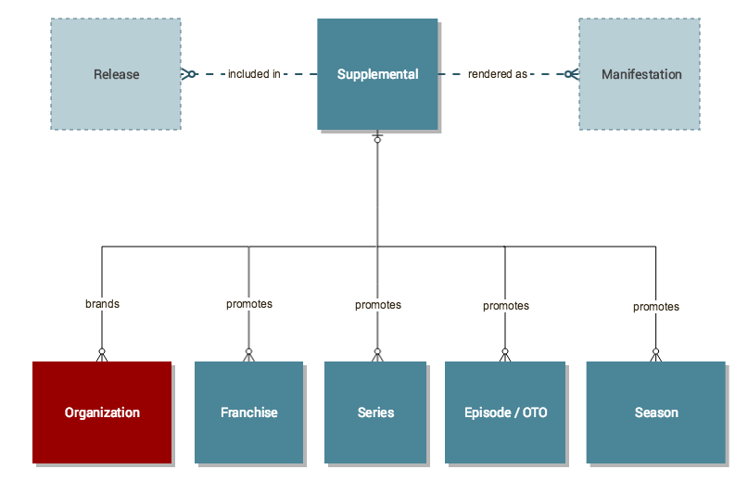

In the current abstract metadata hierarchy system for public media, Supplemental Media can be seen as an abstract model separate from but connected to the primary abstract content hierarchy.

### Relational Metadata

Supplemental Media has the following relationships:

|  |  |
| --- | --- |
| **Relationship** | **Description** |
| promote | Supplemental Media, regardless of the type, must support or promote some sort of Primary Media: Franchise, Series, Episode/OTO, Season, or Organization.   For example, a standalone promo can have any one of the following relationships:   * The media promotes a Series * The media promotes a Franchise * The media promotes a Season of a Series * The media promotes a single Episode * The media promotes two Episodes from different Series |
| brand | Supplemental Media may exhibit or showcase an organization or branding concept. |
| supplement | Supplemental Media may be additional secondary content to primary media. |
| support | Supplemental Media may showcase organizational sponsorship or otherwise show some supporting relationship. |
| included in | Supplemental Media can be included in any Release. |

### Descriptive Metadata

Supplementary Media inherit many metadata field values from associated Primary Media, and the number and types of metadata fields vary depending on the type of Supplementary Media. Metadata fields common to all Supplementary Media include the following:

* Title
* Description
* Keywords
* EIDR ID

Supplemental Media has unique characteristics in descriptive metadata. Descriptive metadata germaine to Supplemental Media include the following:

* Asset Type
* Allowable Business Use
* Allowable Business Use Time Window

#### Asset Type

See the Types of Supplemental Media.

#### Allowable Business Use

Offers guidance to consumers of standalone Supplemental Media as to the allowed usage. For example, the Business Use could be ‘Broadcast’ or ‘Online.’

#### Allowable Business Use Time Window

Indicates the start / stop time window for the aforementioned business use.

### Structural Metadata Fields

Most structural metadata is inherited from the Primary Media’s Manifestation values, which can be seen in Part 2 of this document series. Examples of structural metadata germaine to Supplemental Media include the following:

* Video Codec
* Bit Rate
* Audio Mappings
* And more...

## Example of Embedded Supplemental Media

The example that follows is taken from the show *Arthur*, package number P339442-010.

Figure 2 shows the exact timing of elements in the package. This package contains two pieces of Primary Media: Cue #4 BOD and Cue #11 CWT. All the other cues are Supplemental Media.

##### Figure 2

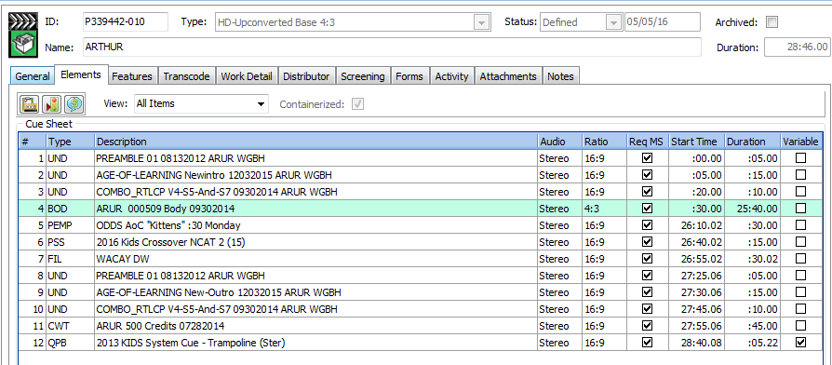

The breakdown of the Supplemental Media in the package shown in Figure 2 is represented in Figure 3:

##### Figure 3

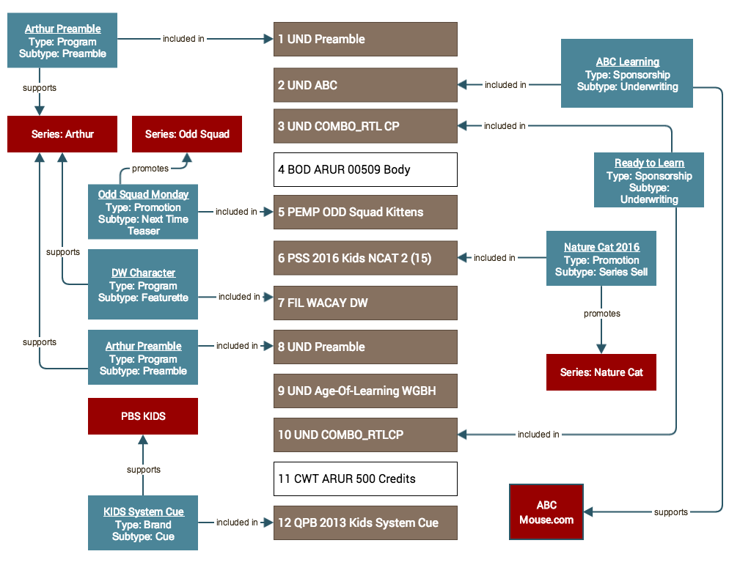

Cues from the package shown in Figure 2 are displayed in the central column as brown and white boxes. The blue boxes represent the Supplemental Medias included in those cues. The rex boxes represent brands or organizations promoted or supported by Supplemental Media.