OpenRcon Documentation

Content:

- Introduction
- Connecting to a server

Introduction

OpenRcon is a cross-platform RCON administration tool. Our goal is to create a full-fledged, universal and cross-platform RCON tool.

These include:

GNU/Linux
MacOS X
Windows

What is good with this?

With OpenRcon, you can access your servers from anywhere. From Mac at home, or your Windows PC at work (or Vice versa). We are even thinking about making it for mobile platforms.

Using OpenRcon is easy. Follow me:

Open up OpenRcon. It will look like this:
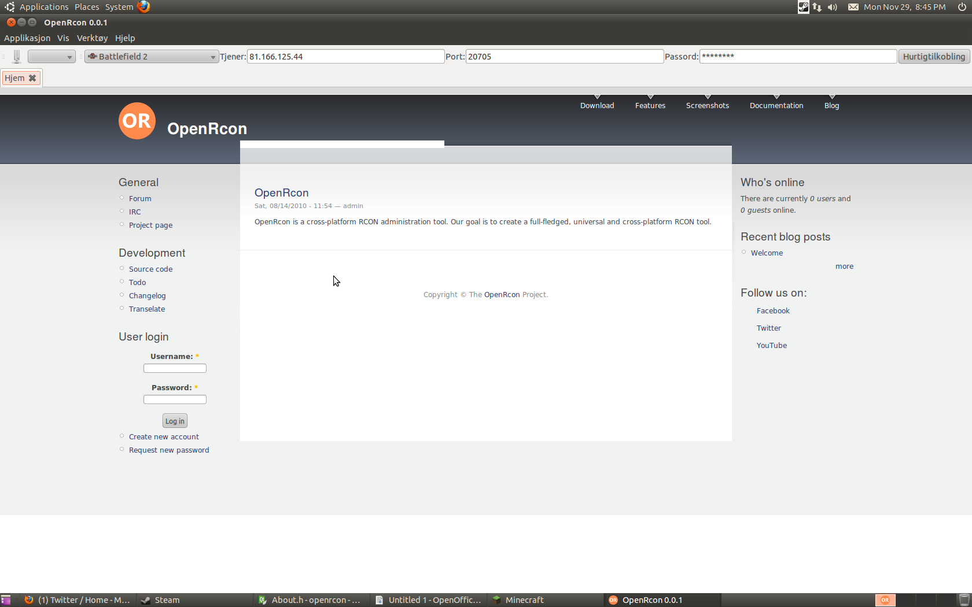

At the Top Left there is a button with a picture of a server on. Press it.
You will now get the Server list menu up:
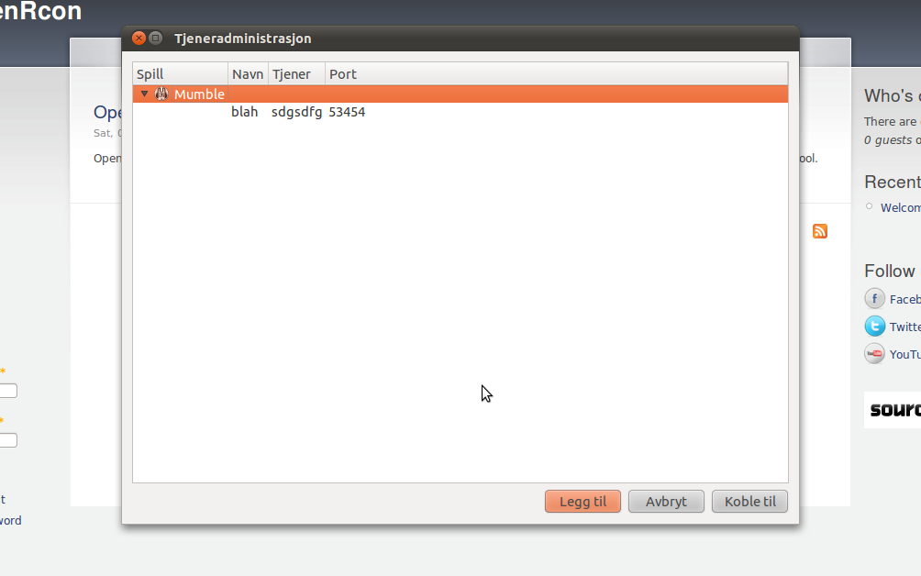

Press Add. This is the first button from the Left. This dialog will now appear:
