<$ScrKeepWithNext><$Scr_H::1><$Scr_Ps::0>System Model
<!$Scr_H::1><!$Scr_Ps::0>
<$ScrKeepWithNext><$Scr_H::2><$Scr_Ps::1>Channel Environment
<!$Scr_H::2><!$Scr_Ps::1>
The Earth-Moon channel for AREx is dominated by tracking requirements and path loss. Tracking requirements are explored in the GMAT AREx document.

Mean size of lunar dust is 19 microns but the size distribution is diverse. Lunar dust is 45% SiO2 and 15% Al2O3. It’s magnetic, with an Fe patina. The particles are jagged and have a high porosity. Simulated dust causes high friction on tools and equipment.

“The unique properties of lunar regolith make for the extreme coupling of the soil to microwave radiation. Space weathering of lunar regolith has produced myriads of nanophase-sized Fe0 grains set within silicate glass, especially on the surfaces of grains, but also within the abundant agglutinitic glass of the soil. It is possible to melt lunar soil (i.e., 1,200–1,500°C) in minutes in a normal kitchen-type 2.45GHz microwave, almost as fast as your tea-water is heated. No lunar simulants exist to study these microwave effects; in fact, previous studies of the effects of microwave radiation on lunar simulants, MLS-1 and JSC-1, have been misleading. Using real Apollo 17 soil has demonstrated the uniqueness of the interaction of microwave radiation with the soil. The applications that can be made of the microwave treatment of lunar soil for in situ resource utilization on the Moon are unlimited.”

Microwave Sintering of Lunar Soil: Properties, Theory, and Practice
Lawrence A. Taylor and Thomas T. Meek

Will traffic to the lunar surface cause enough dust around the moon to negatively affect the radio environment at the frequencies of interest for AREx?

<$ScrKeepWithNext><$Scr_H::2><$Scr_Ps::1>Link Budget
<!$Scr_H::2><!$Scr_Ps::1>
Several link budgets have been drafted. Attitude Determination and Control (ADAC) modes and phases are required to produce accurate link budgets, but with some assumptions about pointing and station-keeping, estimates and bounds can be made.

<$ScrKeepWithNext><$Scr_H::2><$Scr_Ps::1>System Block Diagram
<!$Scr_H::2><!$Scr_Ps::1>
The high level hardware block diagram is below. It has four sections, TT&C transceiver, C-band receiver, X-band transmitter, and FPGA processor board.

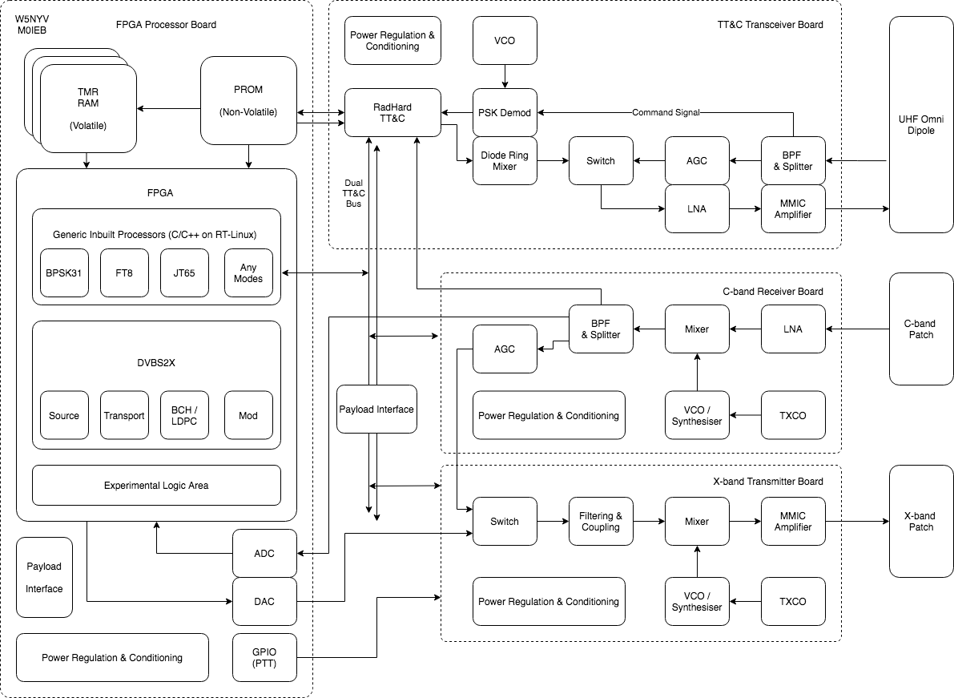

There are four divisions, called “boards”, in the system design.

FPGA Processor Board
TT&C Transceiver Board
C-band Receiver Board
X-band Transmitter Board

Antennas are external to the boards and are also considered part of system architecture.

The interfaces between the boards are chosen to allow multiple options for the boards. This means that early designs could have something like a PLUTO for the FPGA Processor Board. Later designs could have a different SDR or custom hardware. The system architecture accommodates modularity.

<$ScrKeepWithNext><$Scr_H::2><$Scr_Ps::1>Hardware States
<!$Scr_H::2><!$Scr_Ps::1>
The two switches in the system diagram create four possible states of radio frequency hardware operation. Switches highlighted below.

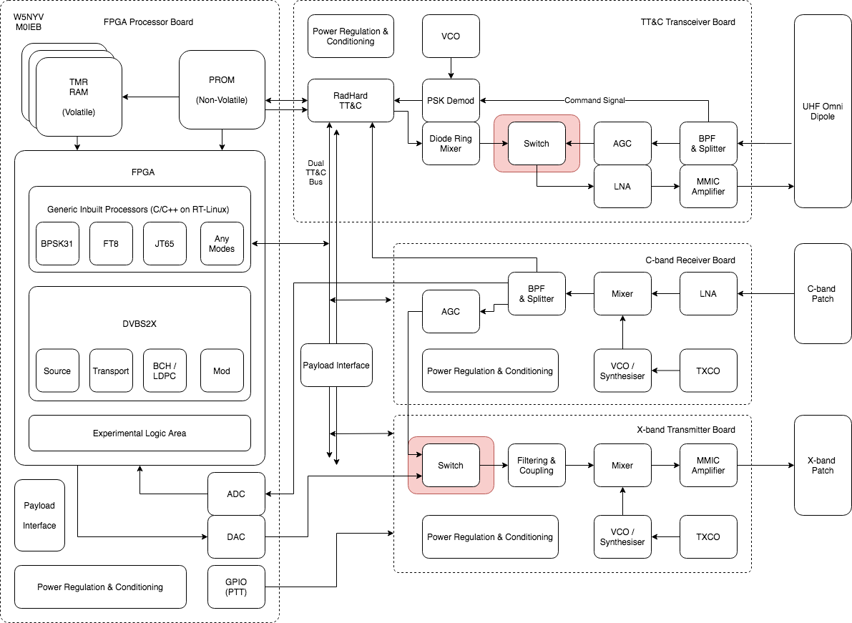

The four RF Hardware States are summarized in the table below. All four states are valid and provide different functionality. Green (darker box background) are default states or define default output.

RF Hardware State | TT&C Switch | Rx C-band | Tx X-band Switch | SDR
Transponder | 0 = UHF Transponder | ON | 0 = X-band Transponder | Not used.
Digital Mode | 0 = UHF Transponder | ON | 1 = SDR input | Active. Default Output of file-based operations.
Transponder + UHF Telemetry | 1 = TT&C Active | ON | 0 = X-band Transponder | Not used.
Digital Mode + UHF Telemetry | 1 = TT&C Active | ON | 1 = SDR input | Active. Default Output of file-based operations.

<$ScrKeepWithNext><$Scr_H::2><$Scr_Ps::1>File-based SDR Operations
<!$Scr_H::2><!$Scr_Ps::1>
SDR has a default directory that is pre-loaded with control.txt and IQ files. The IQ files are test modes. They are selected to provide test coverage for space and ground operations. The file control.txt is an ASCII file edited by TT&C command. Addition, deletion, enable, disable, and loop are the anticipated commands. This provides a very low bandwidth method to control potentially very high bandwidth SDR output in a useful manner. The same file-driven approach is used in the Telemetry View. AI: add link or reference to that section.

The digital interfaces are summarized below.

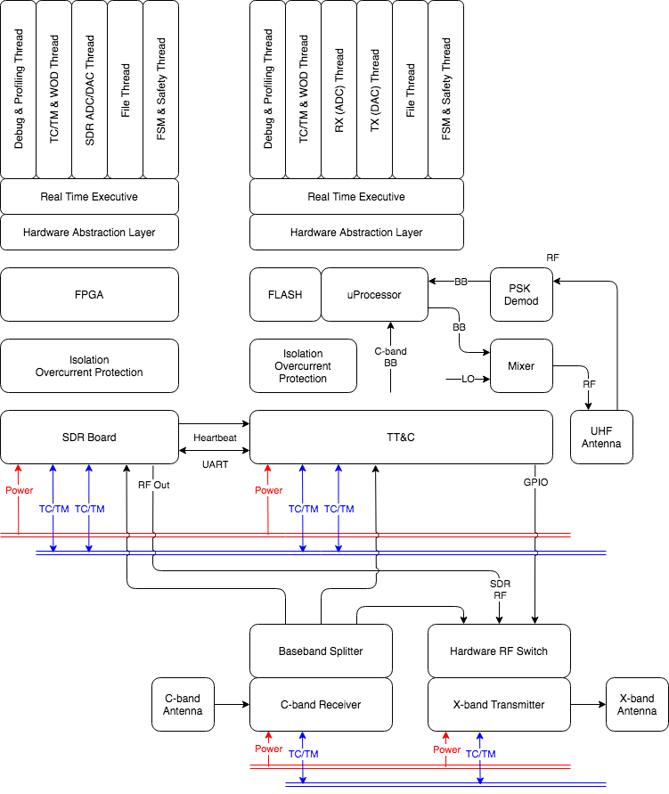

<$ScrKeepWithNext><$Scr_H::2><$Scr_Ps::1>User Operating Modes
<!$Scr_H::2><!$Scr_Ps::1>
The user operating modes, description, and control interfaces required are summarized in the table below.

User Operating Mode | Description | Control Interfaces Required
Analog Transponder | Uplink signals appear in analog downlink. | GPIO controlled.
Digital Transponder | Uplink signals appear in digital downlink. Supports all operating modes. Open loop control. No digital optimization. No Access control. | GPIO controlled
Digital Transponder + Telemetry | Uplink signals appear in digital downlink. Operators must be able to hear themselves in the downlink in order to transmit through the communications resource. | GPIO controlled + Acquisition Control.  Acquisition Control consumes and produces Derived and Acquisition Telemetry.
Digital Transponder + Telemetry +  Access Control | Uplink signals appear in digital downlink. Operators must be able to hear themselves in the downlink in order to use the communications resources. Operators may be authenticated and/or authorized to transmit through the communications resource. | GPIO controlled + Acquisition Control + Access Control.  Acquisition Control consumes and produces Derived and Acquisition Telemetry.  Access Control consumes and produces data related to the authentication and authorization protocols desired by the operator.

