<$ScrKeepWithNext><$Scr_H::1><$Scr_Ps::0>Introduction and Scope
<!$Scr_H::1><!$Scr_Ps::0>
This System Architecture document defines the models, controllers, and views of microwave band communications for Amateur Radio Experiment (AREx).
The model defines system structures. These include hardware, software, firmware, and data.
The controller defines the logical behavior of the structures defined by the model.
The view defines the displays or interfaces. Views connect the user to the controller and allow the user to see updates from the system model.
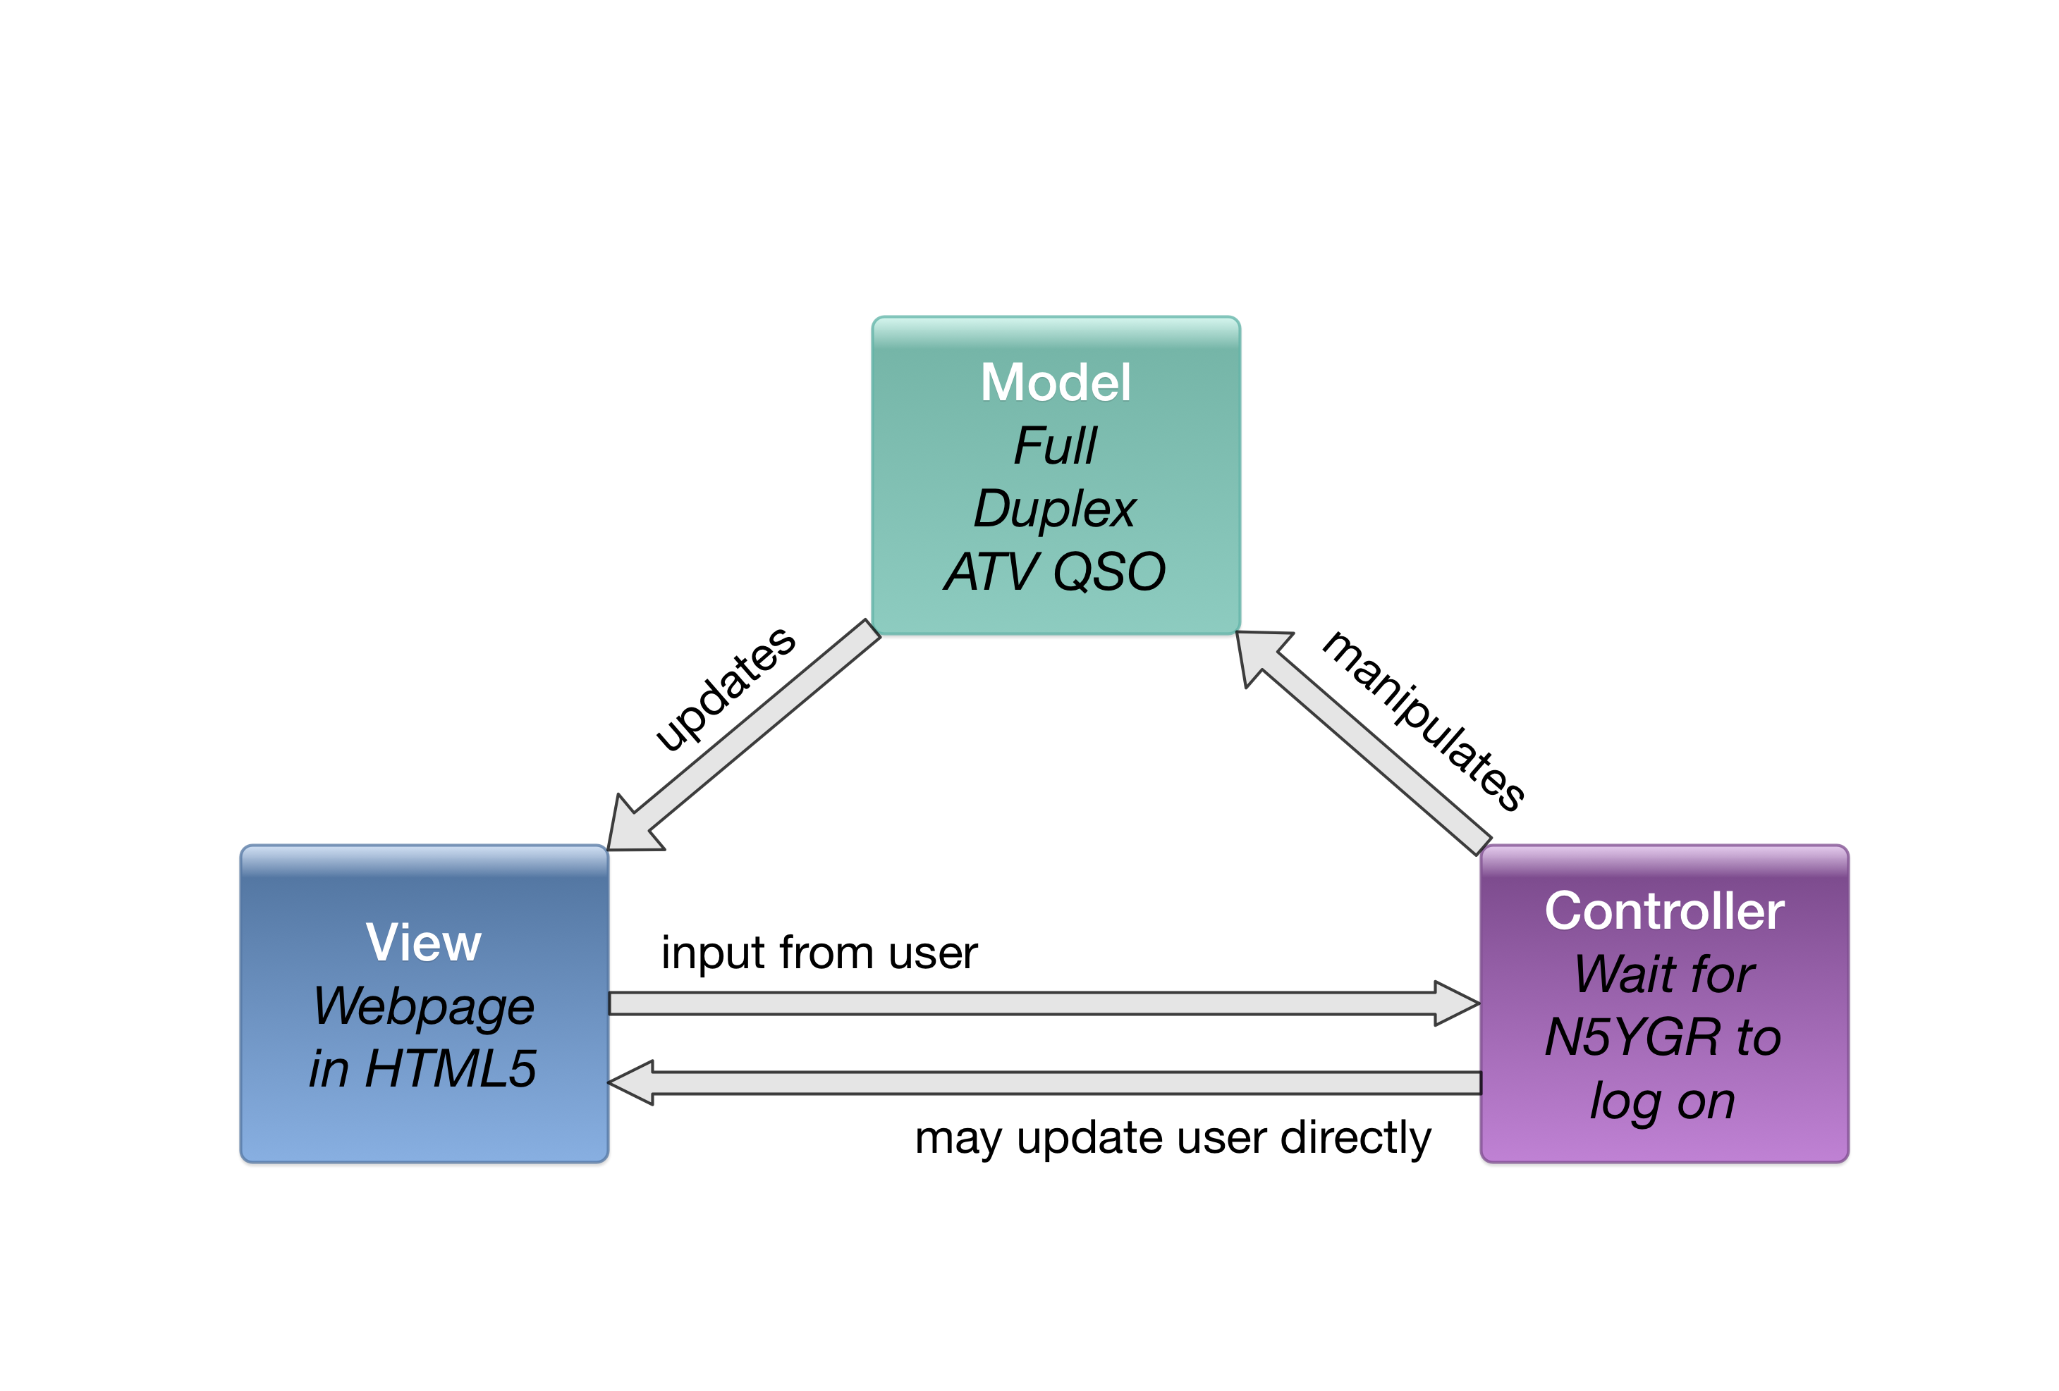
AREx proposes to design, build, test, and deliver amateur radio satellite service equipment for use in space. Communication services include routine amateur contacts and operation, student contacts, classroom and laboratory educational activities, communications experiments, scientific payload support, the ability to provide emergency or backup communications, and more. In order to provide these services, AREx must ensure reliable digital microwave communications across a variety of mission opportunities. These opportunities include high earth orbits (HEO), geostationary earth orbits (GEO), the near rectilinear halo orbit of Lunar Orbiting Platform - Gateway, and other interplanetary opportunities in the future.
Reliable means messages are guaranteed to reach their destination complete, uncorrupted, and in order. For the downlink, quasi-error free (QEF) is the standard. This means less than one uncorrected error-event per transmission hour, before the application layer. This can be approximated as a bit error rate of 10 to the negative tenth.

System architecture must achieve the following high-level goals.
- It must define a model and control system that prioritizes reliable amateur communications.
- It must define a control system that detects and adapts to digital subsystem failures.
- It must define views that are open, accessible, and documented.

The design has a frequency division multiple access (FDMA) uplink at 5 GHz. The received channelized signals are amplified, filtered, and digitized. The digital data streams are processed, multiplexed, and controlled. The data is packed into Digital Video Broadcast for Satellite version 2 and Satellite version 2 eXtension (DVB-S2/X) frames which are transmitted on a single 10 GHz time division multiplexed (TDM) downlink.

