ALL-STATES-REPORT - DIVERSITY-MATRIX for SIMPPLLE 2.5

REPORT OBJECTIVE

The “all-states-report” is designed to provide the capability to track all individual states, or any combination of species / size class – structure / density. The report is designed to identify the “average”, maximum, minimum, and standard deviation of acres for each desired state by time step, from the results of multiple simulations. This report is in contrast to the basic Excel macro that provides a summary of the disturbance processes, each species, each size class, and each density attribute separately. This report requires an output file generated by SIMPPLLE and the use of an Excel template. You must have Excel 2002 to run the macros in the Report Template. You must be using SIMPPLLE version 2.5 If the report is done on all individual states it may take a considerable time to complete. Most likely the report will be done on “groupings” of the states such as grouping used for a “Diversity Matrix”.

CHANGES FROM PREVIOUS VERSIONS

Some changes have been made from earlier versions of this report. We have dropped the use of AGE as a keyword. Age is not identifiable in SIMPPLLE. The time in any state may be identified but age cannot be identified as the starting age of each plant community is not provided the system.

The use of SPECIAL AREA and OWNERSHIP as key words in the file has been removed. Groupings by these, if used in the area file, can be obtained within the Excel macro that is based on a pivot table.

Since we created options in running SIMPPLLE version 2.5 that use less memory, when these are chosen, the use of this report must be specified at the beginning of a set of simulations.

STEPS IN CREATING THE REPORT

1. Create a grouping text file. Create a text file that contains grouping information (examples provided latter).

2. Make SIMPPLLE simulations. The most common combination is that you are making multiple simulations and they are long term. To save on memory and make the simulations possible you may chose to discard unnecessary information. Regardless if the option to discard information is chosen, the grouping file for the “all-states report” must be identified in the simulation parameters.

Your “simulations parameters” screen will look like the following where you specify the grouping file prior to making the simulations.

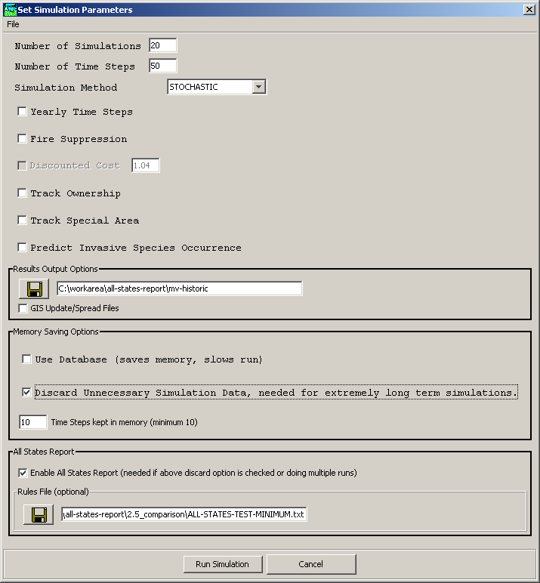

SIMPPLLE will make an “all-states” file for each grouping identified in the grouping txt file. Other combinations that were possible in previous version of SIMPPLLE are no longer available, such as making the simulations and then going to reports and selecting the “all-states-report”. This report is shaded out and can not be selected.

- Execute the “SIMPPLLE MACRO – ALL-STATES-REPORT-26Aug2006.xls

Following the successful simulations, execute the “All States” spreadsheet. Make sure you chose to “enable macros”.

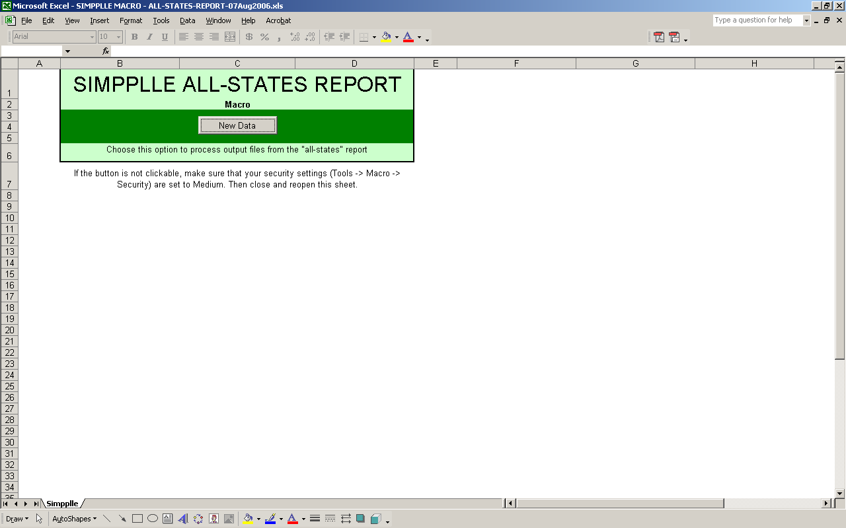

Select “new data” and browse to find the all-states txt files that SIMPPLLE has included in the output directory under the prefix name you specified in the simulation parameters screen.

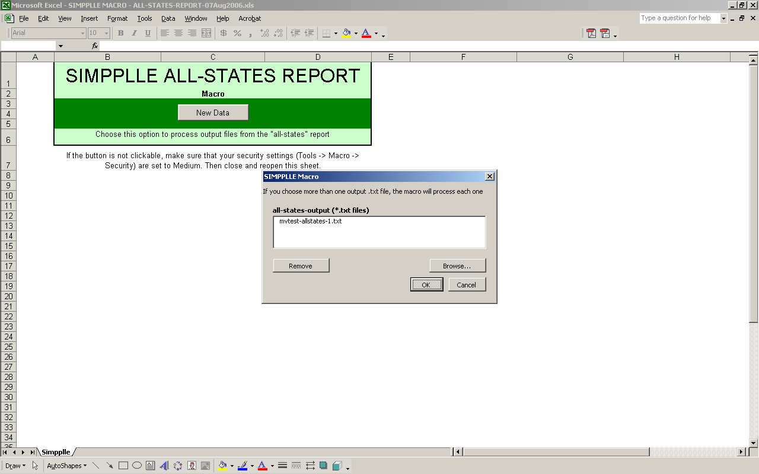

Check what combination of Average, Max, Min, and Standard Deviation you want computed.

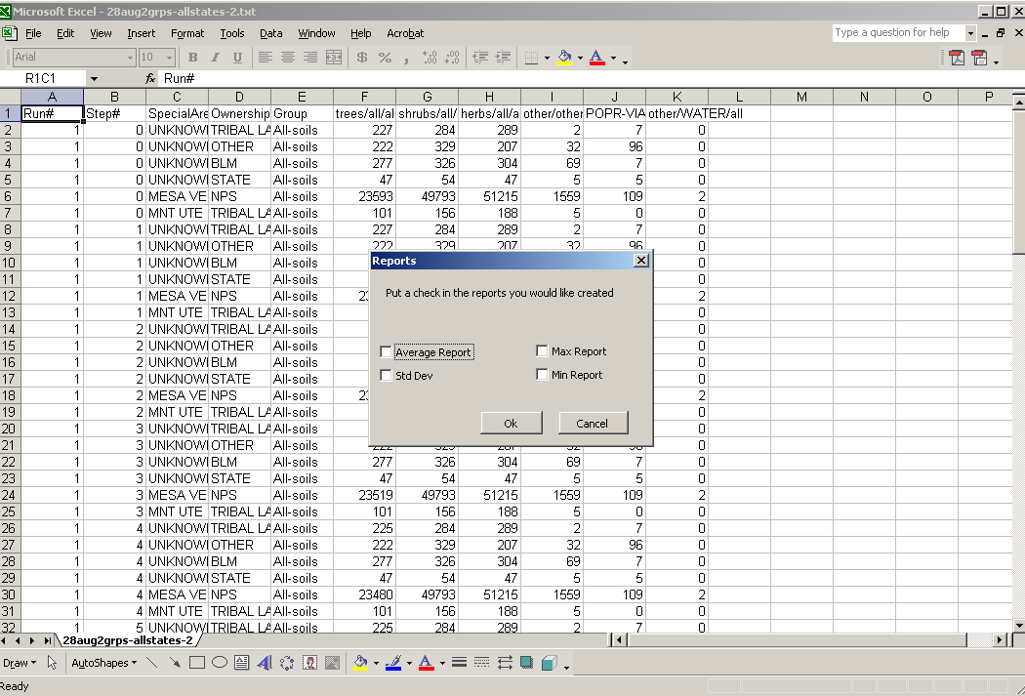

The basic grouping desired was “deep soils” and “shallow soils”. But special area and ownership was identified in the area file and SIMPPLLE also includes it without the user specifiying any keywords. It is very easy to make changes in the display.

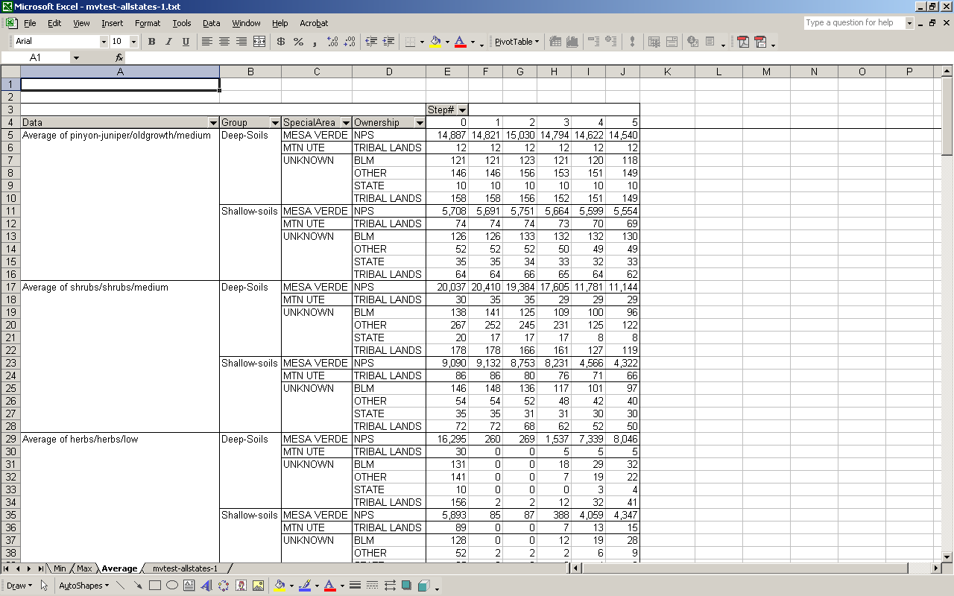

If you place the cursor over the heading until you get a four arrow symbol, you can then hold down on the left mouse button and drag the field upward until you get a row within grey line. This takes the field out of the calculations.

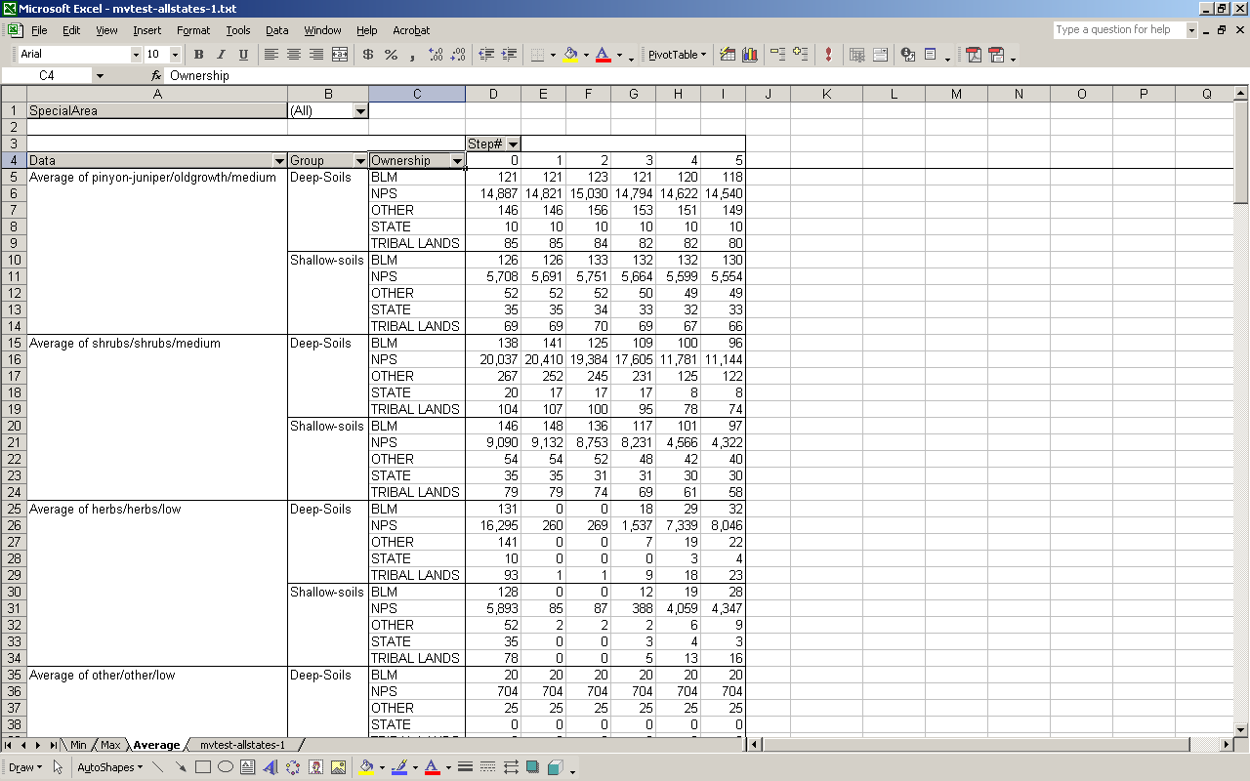

4. Save the computations. Select “Save As” and save the results in an excel spreadsheet format “.xls”.

THE “GROUPING TXT FILE”

All states report customization file format (the *.txt file):

Legal Keywords:
· SPECIES
· SIZE-CLASS
· DENSITY
· HABITAT-TYPE-GROUP (more generically – ecological stratification)

{ and } server to illustrate format and are not part of it.
{< or >}{ITEM} means either < or > followed by ITEM (e.g. <9)
{comma} means insert a Comma.
There can be as many keywords as you like and each can be listed multiple
times.

----------------File format
--------------------------------------------------
{BEGIN}{comma}{OPTIONAL DESCRIPTION}
{KEYWORD}{space}{OPTIONAL-DESCRIPTION}
{ITEM1}{comma}{ITEM2}{comma}{ITEM3}…
{KEYWORD}{space}{OPTIONAL-DESCRIPTION}
{ITEM1}{comma}{ITEM2}{comma}{ITEM3}…
END

Remember the special-area and ownership key words have been taken out. If these designations have been used within the area file, the capabilities in the Excel macro, pivot tables, can be used to create any combination desired.

Example :

BEGIN
HABITAT-TYPE-GROUP For
A1,A2,B1,B2,B3,C1,C2,D1,D2,D3,E1,E2,F1,F2,G1,G2
HABITAT-TYPE-GROUP NonFor
NF1A,NF1B,NF1C,NF2A,NF2B,NF2C,NF2D,NF3A,NF3B,NF3C,NF3D,NF4A,NF4B,NF4C,NF4D,NF4E,NF5A,NF5B
SPECIES TASH
AF,ES,WB,MH,AF-ES-MH,ES-AF
SPECIES TGCH
GF,C,WH,WH-C,WH-C-GF
SPECIES IMXS
L-DF,L-DF-AF,L-DF-ES,L-DF-GF,L-DF-PP,L-DF-WP,L-DF-LP,L-DF-RRWP,L-ES,L-ES-AF,L-GF,L-LP,L-LP-GF,L-PP,L-PP-LP,L-RRWP-GF,L-WP,L-WP-GF,WB-ES-AF,AL,AL-AF,AL-WB-AF
SPECIES DF-PP-MIX
PP-DF,PF
SPECIES LP
LP,LP-AF,LP-GF
SPECIES DF
DF,DF-ES,DF-AF,DF-LP,DF-GF,DF-LP-AF,DF-LP-ES,DF-LP-GF,DF-PP-GF,DF-WP,DF-WP-GF,DF-RRWP,DF-RRWP-GF,DF-PP-GF,DF-PP-LP
SPECIES PP
PP
SPECIES WL
L
SPECIES UMD
QA,QA-MC
SPECIES RIPHD
CW,CW-MC
SPECIES GFS
ALPINE-GRASSES,ALTERED-GRASSES,NATIVE-FORBS
SPECIES MMS
MESIC-SHRUBS
SPECIES MXS
XERIC-SHRUBS
SIZE-CLASS 1-5
ss
SIZE-CLASS 5-9
pole,pts,pmu
SIZE-CLASS 9+
medium,mts,mmu,large,lmu,lts,very-large,vlmu,vlts
SIZE-CLASS
closed-herb,closed-low-shrub,clumped,open-herb,open-low-shrub,open-mid-shrub,open-tall-shrub,scattered,uniform
END

The ouput file created by SIMPPLLE will be placed in the directory created with the prefix you provided in the simulations parameters screen. The file will be named “prefix-allstates-1.txt”

More than one grouping can be put in a *.txt file. SIMPPLLE will create an output file to be processed through the Excel macro for each grouping. For example the following is a grouping txt file that has two groups.

BEGIN
HABITAT-TYPE-GROUP Manchos-soils
msm,msx,mmm,mmx,mgm,mgx
HABITAT-TYPE-GROUP Deep-Soils
dsm,dsx,dmm,dmx,dgm,dgx
HABITAT-TYPE-GROUP Shallow-soils
ssm,ssx,smm,smx,sgm,sgx
SPECIES pinyon-juniper
jusc2-pied,pied-jumo,pied-juos,pied-jusc2
SPECIES pinyon
pied
SPECIES juniper
jumo,jusc2
SPECIES mixed-conifers
pien,pien-abla,pien-abla-potr5,pipo,pipo-potr5,pipo-psme,pipo-psme-potr5,potr5-pien-abla,potr5-psme-pien-abla,psme,psme-pien,psme-pien-abla,psme-pien-abla-potr5,psme-pipo
SPECIES hardwoods
poan3,potr5
SPECIES shrubs
alint,arbi3,arno4,arno4-putr2,artr2,artr2-putr2,atco-arbi3,cemo2,loin5,mesic-shrub,putr2,putr2-artrv,saex,sage2,salix,save4,syoro,tara,vamy2-rimo2
SPECIES oak-shrubs
quga,quga-amal2,quga-amut
SPECIES herbs
achy,bogr2,brte,cage2,canu4,fear2,forbs,geri,heco26,heco26-plja,luca,niat-chfr3,orse,pg-forbs,pofe,pofe-achy,pofe-viam,pose-pasm,spai,thfe,
SPECIES other
agr,ba,nd,nf,ns,urban,water
SIZE-CLASS young
e,ss
SIZE-CLASS medium
medium,mmu
SIZE-CLASS large
large,very-large
SIZE-CLASS oldgrowth
lmu,vlmu
SIZE-CLASS shrubs
small-sh,medium-sh,large-sh
SIZE-CLASS herbs
clumped,uniform
SIZE-CLASS other
nf,ba,urban,agr
DENSITY low
1
DENSITY medium
2,3
DENSITY high
4
END
BEGIN
HABITAT-TYPE-GROUP All-soils
msm,msx,mmm,mmx,mgm,mgx,dsm,dsx,dmm,dmx,dgm,dgx,ssm,ssx,smm,smx,sgm,sgx
SPECIES trees
jusc2-pied,pied-jumo,pied-juos,pied-jusc2,pied,jumo,jusc2,pien,pien-abla,pien-abla-potr5,pipo,pipo-potr5,pipo-psme,pipo-psme-potr5,potr5-pien-abla,potr5-psme-pien-abla,psme,psme-pien,psme-pien-abla,psme-pien-abla-potr5,psme-pipo,poan3,potr5
SPECIES shrubs
alint,arbi3,arno4,arno4-putr2,artr2,artr2-putr2,atco-arbi3,cemo2,loin5,mesic-shrub,putr2,putr2-artrv,saex,sage2,salix,save4,syoro,tara,vamy2-rimo2,quga,quga-amal2,quga-amut
SPECIES herbs
achy,bogr2,brte,cage2,canu4,fear2,forbs,geri,heco26,heco26-plja,luca,niat-chfr3,orse,pg-forbs,pofe,pofe-achy,pofe-viam,pose-pasm,spai,thfe,
SPECIES other
agr,ba,nd,nf,ns,urban,water
SIZE-CLASS all
e,ss,medium,mmu,large,very-large,lmu,vlmu,small-sh,medium-sh,large-sh,clumped,uniform
SIZE-CLASS other
nf,ba,urban,agr
DENSITY all
1,2,3,4
END

Within the folder for the simulation results that is created by SIMPPLLE there will be two files:

prefix-allstates-1.txt
prefix-allstates-2.txt

It’s easy to see if you have missed values in creating the groups because these individuals will show up in the reports in the Template.

