


LANDSAT DATA CONTINUITY MISSION

LANDSAT
WORLDWIDE REFERENCE SYSTEM-2
(WRS-2) DEFINITION

Effective Date: January 4, 2007
Expiration Date: January 4, 2012

Goddard Space Flight Center
Greenbelt, Maryland
National Aeronautics and
Space Administration

CM FOREWORD

This document is a Landsat Data Continuity Mission (LDCM) Project Configuration Management (CM)-controlled document. Changes to this document require prior approval of the applicable Configuration Control Board (CCB) Chairperson or designee. Proposed changes shall be submitted to the LDCM CM Office (CMO), along with supportive material justifying the proposed change. Changes to this document will be made by complete revision.

Questions or comments concerning this document should be addressed to:

LDCM Configuration Management Office
Mail Stop 427
Goddard Space Flight Center
Greenbelt, Maryland 20771

Prepared by:
Original Signed  James C. Storey  USGS LDCM Systems Engineer  USGS/EROS – SAIC | 01/04/07  Date
Reviewed by:
Original Signed  Edward G. Grems, III  LDCM Mission Systems Engineer  NASA/GSFC – a.i. Solutions | 01/04/07  Date | Original Signed  Del T. Jenstrom  LDCM Deputy Project Manager  NASA/GSFC – Code 427 | 01/04/07  Date
Original Signed  Evan H. Webb  LDCM Mission Systems Manager  NASA/GSFC – Code 599 | 01/04/07  Date | Original Signed  Thomas A. Kalvelage  USGS LDCM Chief Engineer  USGS/EROS | 01/04/07  Date
Approved by:
Original Signed  William R. Ochs  LDCM Project Manager  NASA/GSFC – Code 427 | 01/04/07  Date

LDCM PROJECT
DOCUMENT CHANGE RECORD
Sheet: 1 of 1
REV  LEVEL | DESCRIPTION OF CHANGE | DATE  APPROVED
Rev. - | Baseline Release. Approved by CCR 427-06-02-002. | 01/04/07

TABLE OF CONTENTS

1.0 Purpose 1
1.1 WRS-2 Scene Definition 1
1.2 WRS-2 Path Definition 2
1.3 WRS-2 Row Definition 2
2.0 Mathematical Definition of the WRS-2 Grid 3
2.1 WRS-2 Nominal Scene Center Computation Algorithm 3
3.0 References 5

1.0 Purpose
The Landsat Worldwide Reference System-2 (WRS-2) provides an indexing scheme for the repeating pattern of orbital ground tracks traversed by the Landsat 4, 5, and 7 spacecraft over their 16-day orbital repeat cycle. The original WRS (WRS-1) was designed for the Landsat 1, 2, and 3 missions which flew in a higher orbit. The current WRS-2 was designed for the 705-km orbit used by the later missions.

1.1 WRS-2 Scene Definition
Although the Landsat Thematic Mapper (TM) and Enhanced Thematic Mapper Plus (ETM+) imagers collect continuous along-track swaths of data while operating, the data are cataloged and distributed as fixed-size along-track image segments referred to as scenes. Standard Landsat scenes are extracted around nominal scene-center coordinates and are sized so as to provide along-track overlap between adjacent scenes. Figure 1 shows how a continuous Landsat swath is segmented into overlapping scenes, based on the WRS grid, for cataloging and distribution. Although the standard scene size is often cited as 185-km cross-track (based upon the TM/ETM+ field of view) by 170-km along-track, the Landsat 7 scenes distributed by the USGS Center for EROS contain 375 ETM+ scans, each nominally covering 0.48 km, so a full scene actually spans approximately 180 km. Based upon this heritage, a LDCM scene area is defined as 185-km cross-track by 180-km along-track.

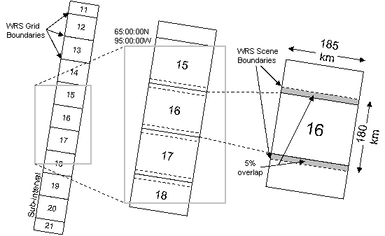
Figure 1: A continuous image swath is logically subdivided into overlapping scenes.

1.2 WRS-2 Path Definition
The WRS indexes orbits (paths) and scene centers (rows) into a global grid system comprising 233 paths by 248 rows. Since adjacent Landsat scenes overlap, indexing the location of an acquisition by latitude/longitude can be ambiguous and, in any event, provides little insight into where the scene falls in the 16-day acquisition cycle. The path/row notation provides a standard designator for every nominal scene center that can be readily related to both the 16-day acquisition cycle and longitude and latitude coordinates. Once established for Landsat-4, the WRS-2 also provided the target data collection pattern for subsequent missions, ensuring that Earth targets were observed using common viewing geometry, independent of the collecting spacecraft.

The Landsat orbital altitude and repeat cycle dictate that the 16-day acquisition cycle is completed in 233 orbits. The repeating ground tracks corresponding to the 233 orbits that make up a complete acquisition cycle are numbered sequentially with the numbers increasing to the west. The number of unique ground tracks means that adjacent ground tracks are approximately 172 km apart at the equator. The Earth’s rotation during each revolution of the spacecraft in its sun-synchronous orbit causes consecutive orbits to be approximately 2752 km apart at the equator. Thus, each orbit advances 16 paths (2752/172), causing each WRS path to be traversed once per 16-day cycle in an interleaved pattern. Figure 2 shows the time sequence of WRS paths over a 16-day acquisition cycle.

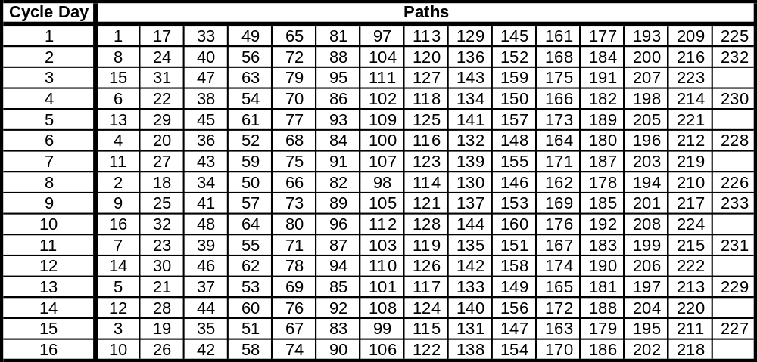
Figure 2: WRS-2 path time sequence.

1.3 WRS-2 Row Definition
Segmenting each Landsat orbit into 248 equally spaced scenes, covering both the day and night sides of the Earth, leads to a set of scene centers separated by just under 162 km. Thus, approximately 10% of the 180 km scene coverage overlaps the adjacent scenes. The WRS row system is indexed so that the scene center at the orbital descending node is row 60, with the row numbers increasing in the along-track direction. Note that unlike the path numbers which, being fixed to the orbital ground tracks, must be integers, fractional row numbers are possible by shifting the scene window along-track relative to the fixed WRS-2 scene centers.

2.0 Mathematical Definition of the WRS-2 Grid
The WRS-2 grid is related to WGS84 geodetic latitude/longitude coordinates using the nominal Landsat orbital parameters. The procedure for computing the WRS scene center is described below. Figure 3 shows the input parameters used in the subsequent WRS scene center computations.

Parameter | Value
Earth Parameters
Semi-Major Axis (WGS84) | 6378137.0 m
Semi-Minor Axis (WGS84) | 6356752.314 m
Orbit Parameters
Inclination | 98.2 degrees
WRS Parameters
Number of Paths | 233
Number of Rows | 248
WRS Repeat Cycle | 16 days
Descending Node Row | 60
Longitude of Path 001, Row 060 | -64.6 degrees (64.6 West)
Scene Parameters
Path | Integer 1-233
Row | Float 0.5 < R < 248.5
Figure 3: WRS-2 input parameters.

The unknown values to be computed are:
WRS Scene Center Latitude (WRS_Lat)
WRS Scene Center Longitude (WRS_Long)

2.1 WRS-2 Nominal Scene Center Computation Algorithm
Convert input angles to radians:
Inclination_Angle = π / 180 * Inclination_Angle
Long_Path1_Row60 = π / 180 * Long_Path1_Row60

Compute the Earth’s angular rotation rate:
earth_spin_rate = 2 π / (24 * 3600)

Note: This computation uses the solar rotation rate, rather than the sidereal rate as called for in the General Electric Landsat D Program Information Release (PIR) that first described the Worldwide Reference System-2, in order to account for the orbital precession which is designed to make the orbit sun synchronous. Thus, the apparent Earth angular velocity is the inertial (sidereal) angular velocity plus the mean precession rate which, by design, is equal to the solar angular rate.

Compute the spacecraft’s angular rotation rate:
SC_Ang_Rate = 2 π * WRS_Cycle_Orbits / (WRS_Cycle_Days * 24 * 3600)

Compute the central travel angle from the descending node:
Central_Angle = (Row - Descending_Node_Row)/Scenes_Per_Orbit * 2 π

Compute the WRS geocentric latitude:
WRS_GCLat = asin( -sin(Central_Angle) * sin(Inclination_Angle) )

Compute the longitude of Row 60 for this Path:
Long_Origin = Long_Path1_Row60 - (Path - 1) * 2 π / WRS_Cycle_Orbits

Compute the WRS longitude:
Delta_Long = atan2( tan(WRS_GCLat)/tan(Inclination_Angle),
cos(Central_Angle)/cos(WRS_GCLat) )
WRS_Long = Long_Origin - Delta_Long - Central_Angle * Earth_Spin_Rate / SC_Ang_Rate

Make sure the longitude is in the range +/-π:
While ( WRS_Long > π )
WRS_Long = WRS_Long - 2 π
While ( WRS_Long < - π )
WRS_Long = WRS_Long + 2 π

Convert the WRS geocentric latitude to geodetic latitude:
WRS_Lat = atan( tan(WRS_GCLat) * (Semi_Major_Axis/Semi_Minor_Axis)
* (Semi_Major_Axis/Semi_Minor_Axis) )

Convert angles to degrees:
WRS_Lat = WRS_Lat * 180 / π
WRS_Long = WRS_Long * 180 / π

Round WRS lat/long off to the nearest whole arc minute:
WRS_Lat = round( WRS_Lat*60 ) / 60
WRS_Long = round( WRS_Long*60 ) / 60

Return the results:
WRS_Lat
WRS_Long

3.0 References
Landsat 7 Science Data Users Handbook, prepared by Landsat Project Science Office, http://ltpwww.gsfc.nasa.gov/IAS/handbook/handbook_toc.html, last updated 10 May 2005.
Landsat 7 Image Assessment System Geometric Algorithm Theoretical Basis Document, Version 3.2, prepared by Landsat Project Office, http://ltpwww.gsfc.nasa.gov/IAS/handbook/pdfs/L7_geometry_ATBD.pdf, last updated 09 July 1998.
Landsat 7 System Program Coordinates System Standard, Revision B, prepared by Martin Marietta Astro Space, document number PS23007610B, dated 2 December 1994.
Landsat 7 ETM+ Level Zero-P Distribution Product Data Format Control Book (DFCB), Version 5, prepared by Landsat Project Office, document number LS-DFCB-03.5, dated August 2004.
DMA TR 8350.2-A, DMA Technical Report, Supplement to Department of Defense World Geodetic System 1984 Technical Report, prepared by the Defense Mapping Agency WGS84 Development Committee, dated December 1, 1987.

