Welcome to OpenSkyImager.

OSI (OpenSkyImager) was written in the hopes of forwarding astronomical image capture for Linux and the CCD (Charged Couple Device) cameras a team of us possessed at the time. The CCD cameras we started with were QHY (Qiu Hung Yu) which serves us very well for our hobby of capturing deep sky objects in the night sky.

At a later stage an optional support for the SBIG camera/cfw lineup, through the “sbig universal driver”, was add. Unlike QHY, this driver is “proprietary code” so we can only distribute the binaries, and we'll keep the package up to date as a new release of the “devToolKit” will pop out.

Since the “sbig universal driver” dropped support for legacy parport models, an optional URVC driver (a custom version, statically linked) can be activated.
Please notice the two SBIG drivers are incompatible and as such can't live in one single binary, while each of them can live together with QHY embedded driver.

Below you will find a description of the program for each of the buttons and tabs which are the heart of the program and how to use it to get the best possible use out of your camera.
The cameras that this program supports as of writing this document are the QHY2, 5, 5II(series), 6, 7, 8, 9 (both OSC and BW), 10, 11 and 12, IC8300. The latter will also be able to run OpenSkyImager on his embedded ARM device.
More cameras will be added once we have our hands on them and the firmware released by QHY.

So far OSI has been tested on Linux Ubuntu 12.04, 12.10, 13.04, 13.10, 14.04, Mint 9, 10, 11, 12, 13, 14, 15 and 16. Other people have reported OSI to work and run stable on ARM devices too.

Please note OpenSkyImager is now part of iAstroHub (http://sourceforge.net/projects/iastrohub/) thanks to the kind collaboration with Ph. D. Anat Ruangrassamee. Therefore all ARM devices listed there are will also run the program smoothly.

This version is classed as stable as it has been tested under ideal conditions out in the field at a star party namely the 2 Kelling Heath, Equinox star parties, Norfolk, England. UK and also from a balcony nearby Rome, Italy. But, it must also be said that this is still a work in progress as you will see once we start looking at the different tabs within OSI.

Starting from version 0.9.0 first install of the program will also carry all necessary firmwares and udev rules in order to get 100% working QHY support out of the box. Updates of previous versions (/etc/qhyccd folder already existing) will NOT update firmware as a default. A special parameter can be used to force firmware / udev rules update. See installation section.

The same goes for SBIG (unidrv): firmwares and udev rules are only installed together with updated library. After first install, library update must be specifically requested during install process.

Index
Welcome to OpenSkyImager. 1
Program description 3
Main window 3
Camera Tab 7
Cooling Tab 9
Filename Tab 10
Scripting Tab 12
Time-lapse Tab 13
Fits Tab 14
CFW Tab 15
FOV Calc Tab 16
Compiling and installing 17
Compiling your binary 18
Collaboration 19

Program description

Main window
Lets begin our tour with a look around OSI. Firstly the open program shows a screen like this.

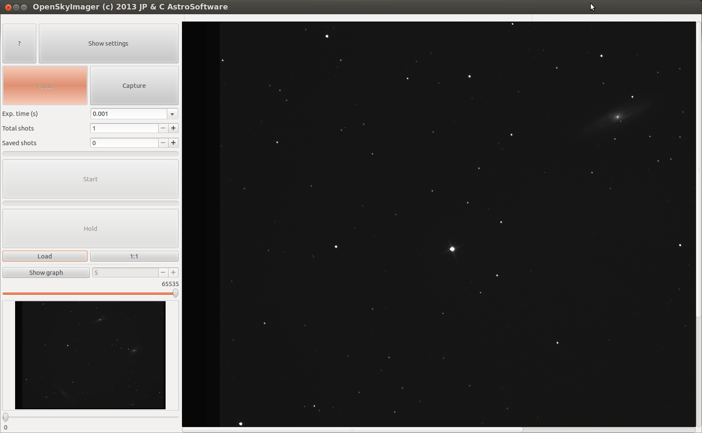
I have added an image to show what the program will look like once in action under the stars. If we start our trip around the program at the top left you can see the button with a question mark. This is just an about page that tells you about the program being open source and the authors. The About page should look like this.
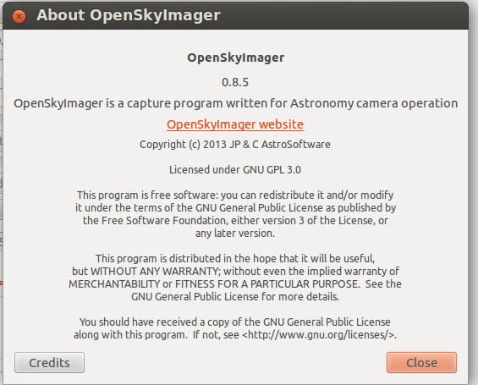

The next button is the Show Settings which opens up the heart of the program that helps the user get the best out of your camera. Below these buttons we have the Focus button which allow you to focus the camera without saving images to your computer. The button to its right is the Capture button, pressing this button after setting all other settings will allow you to capture images and store them in the desired folder on your hard drive.

Below the Focus and Capture buttons we have the Exp.time(s) which is the exposure time calculated in seconds or parts of seconds. The mostly used times are already input into the drop down menu for your convenience. You can of course add your own timings here by simply clicking in the box and typing the amount of time you want in seconds.

Just under the Exp.time you will find the Total shots box. This is the number of frames you want to capture of the deep sky object. Just below this you have the Saved shots box. This is the number of images you have managed to save during this session. You can click into this box and put your own number in here. Especially useful should you wish to add images from the night before or wish to start a fresh count elsewhere on your hard drive.

Next we have the line which moves from left to right showing you how many images in graphic format you have captured to your hard drive. Useful to show how far through a captured set of images the program has run through.

Just below this you have the Start button which does what it says. Once all settings have been set this button will actually start the sequence of capturing the images and storing them on the PC. Once the Start button is pressed it will change to “Stop”.
Should you wish to stop the capture then press this button again. The computer will wait until the amount of exposure time has elapsed as it is waiting for a response from the camera. After the second button press, it will change color and have “KILL” in the middle.
Some times you may want to abandon the capture altogether for one reason or another. Pressing the same button while it shows “KILL” will interrupt the camera capture and return it to a waiting state. The button will then show “Start” again as the camera will be ready for normal use.

Between the Start button and the Hold button you will see the count down graphical counter. This moves from right to left and lets you see how far through the currant exposure you are. This count down is done in seconds so you can see the line move for each second passed.

The Hold button is a nice feature that allow you to pause your imaging session should clouds or an aircraft fly through the area you are imaging. Once the clouds or aircraft have flown through you press Hold again and the program will resume capture till the required amount of images in total shots has been acquired.

Below and left of the Hold button we have the Load button. This will load a saved image in into the program and allow you to inspect the image. To the right of the Load button we have the 1:1 button. Click this button and it will change to say Fit meaning your image on the right in the large area will fill the available space. Click it again and Fit will become 1:1. Now you can browse around the image by using the grab/scroll bars on the right and bottom of the image. Especially useful if the image is from a large format camera and the image is larger than the available space.

Just beneath the Load button we have the Show graph button. Loading or capturing an image this will be also shown in the small window below. Click the Show graph button and it will changed into a Histogram of the image on screen. Use the + and – buttons to the right of the Hide Graph to magnify the histograms output.
Top and bottom of the small image or histogram area you have two sliders. The top slider lowers the white point within the displayed image and the bottom slider raises the black count or raises the black point.

This little area has another very important job: you can use it to help focus your camera. Here's how to use it. First click on a star on the large image in the right hand large window.
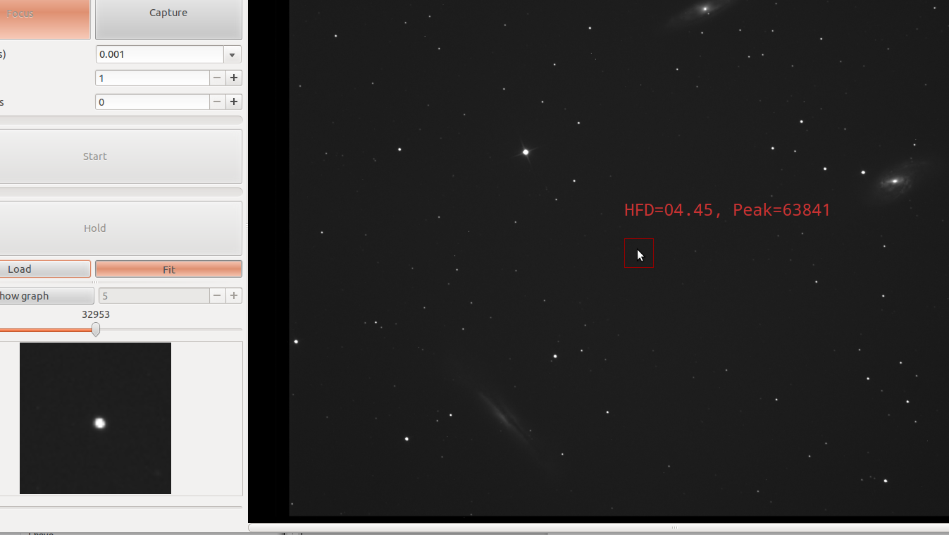
You will notice that it has some red writing and a red box around the star you clicked on.
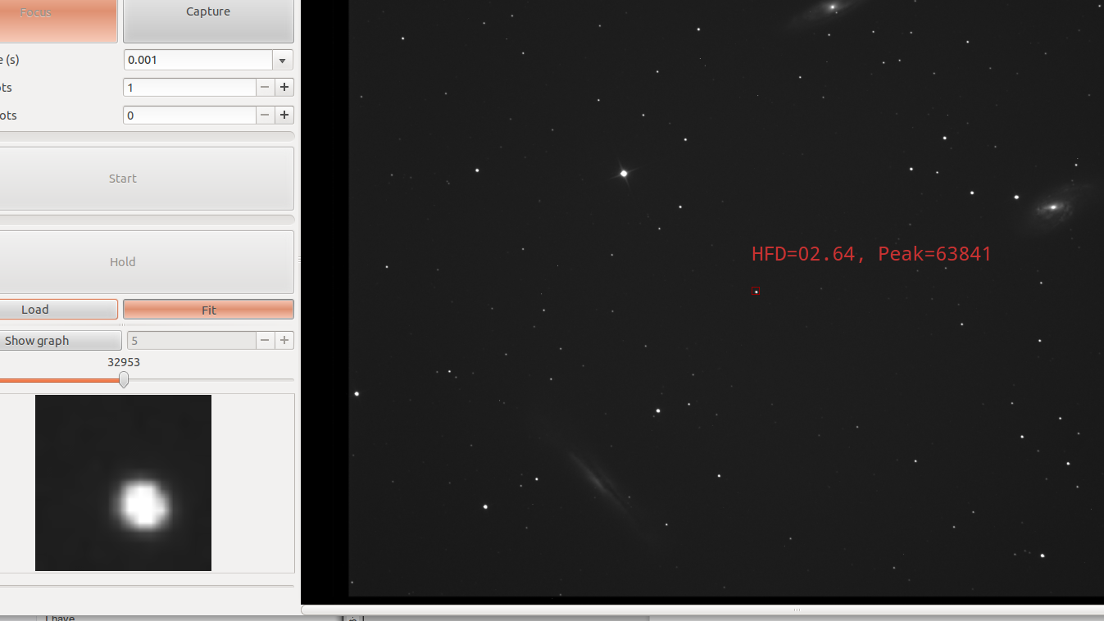
The red writing is the HFD, “Half Flux Diameter” (please see http://www005.upp.so-net.ne.jp/k_miyash/occ02/halffluxdiameter/halffluxdiameter_en.html) which lets you know how far out of focus you are. The lower the number the better the focus. Now turn your attention to the little red box on the right of the screen. Move your mouse pointer into the red box and gently scroll the mouse wheel. Notice the red box on the large screen got smaller and the star in the little window on the left got larger ? The star has been magnified.
Now scroll the mouse wheel again in the opposite direction and the star in the left window will shrink back to normal size but the red box on the large image to the right will grow larger. Use this to help focus your star.
As you change the red square size HFD numbers will change greately. This is normal as the “Flux” is a function of the measurement area.

Now lets turn our attention to the heart of the program and the tabs that perform the magic behind the scenes. Click Show settings at the top left. Now notice the tabs on the right.

Camera Tab
The first tab should be Camera and should be your first call to set up which camera you have. Click the button with None to the right of Model. The program should auto detect which cameras you have plugged in and should appear in this list. If for some reason your camera (this feature is for QHY models only) does not appear in this list you can try and click the Full list and click on your camera and see if it will Connect. If your camera is not in the list or is in the Full list and still it won't connect then there is another problem somewhere. Try using the Reset button to reset the selected model (QHY models only). When all fails, join the QHY Forum at http://qhyccd.com/ccdbbs/ for answers to this and other problems you may have.

After choosing your camera press Connect and your camera should now be connected and the drop down menus below should light up with the choices you can make.

Offset and Gain should be set according to the manufacturers advice. For most cameras Offset is around the 120 mark and the Gain is best when set to between 0 -10. Remember the higher the gain the more noise you input into the image.

Binning Mode is a feature which will allow you to make a super pixel by adding together the amount of pixels chosen by the binning number. Most images are captured with Bin X1 or Bin X2.
Bin X4 is best for focusing.
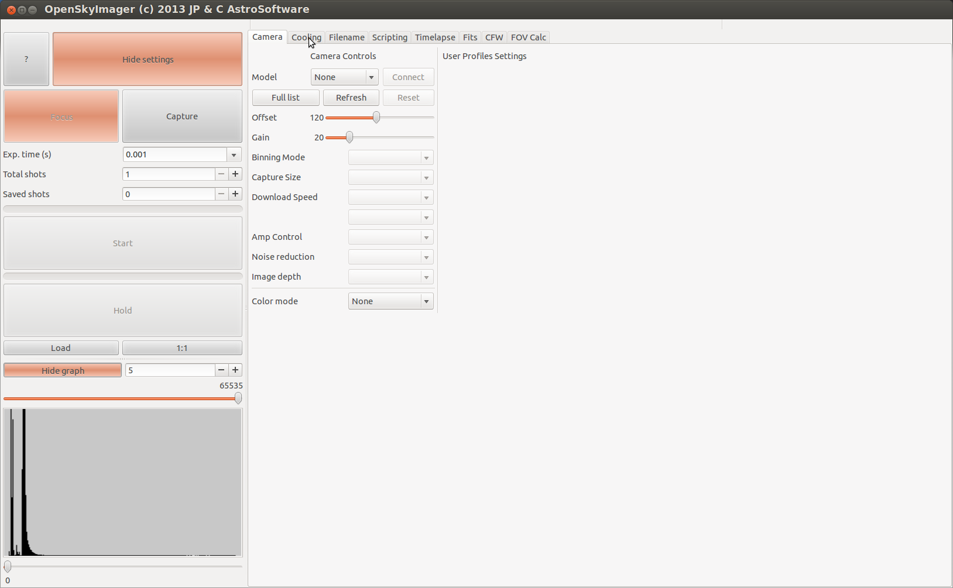
Capture size, if your camera supports it, will allow you to capture different size frames.
Sometimes used for the capture of planets where 2,000 x 2,000 would be a complete waste of space and time so use the Capture size to help. Also useful for focusing as it speeds up the download of the image from the camera.

Download Speed is available to all QHY CCD cameras. Use the 0 or slow download speed for capture of your good images and 1 or fast download for focusing. You will notice that the faster you download your images the brighter your images will be. So for instance if you set X4 binning and fast download speed for focusing your images will be very bright and easy to the deepsky object on screen. Then set the Binning back to 1 and set the download speed back to 0 or slow and notice now the image is very dim even after many minutes capture. This is normal behavior as other programs are used for the post processing your images and will not be discussed here.

Light/Dark, if your camera supports it, are for the different kind of images meaning either a light frame or the images you are going to capture or the dark frame which is captured with the telescope covered helps rid the light frame of unwanted hot and cold pixels. Again this is in post processing stage.

Amp control is for controlling the amplifier inside the camera. Some cameras have to take two images, first field followed by the second field to get an even image of both fields. QHY6 is one such camera. Take only one field and you would get a light line of pixels followed by a dark line of none exposed pixels forming a black line through your image. Again follow the manufactures advice here.

Image depth is 8,16 bit or Hdr, depending on the camera plugged in. Most of the QHY5 series of cameras are only 8 bit, most CCD camera are 16 bit. Choose the bit depth according to your camera and the kind of work you're doing .

Colour mode is only for the one shot color (OSC) cameras like the QHY8 etc. For some models selection is automatic, but for others the “color variant” can't be detected automatically, in that case, set this according to your cameras needs.

Cooling Tab
Moving onto the Cooling tab we should see something like the image below. This is for cameras that can be controlled by the computer or which sensor temperature can be read. These are all QHY models equipped with DC201, IC8300, QHY5L-II (read only), and SBIG models (regardless of pc connection type).

Pressing “Enable” allows the program to read the sensor temperature. Temperature read out will be superimposed on the front screen so that you to see the temperature read out.

Pressing “Auto” turns on Auto mode and setting the temperature on the right it is now “set and forget”. The temperature will be lowered gently to what the user has set it too. Temperature lowering speed can be controlled using the “Speed” value. The higher the speed the more aggressive is the tec reaction.

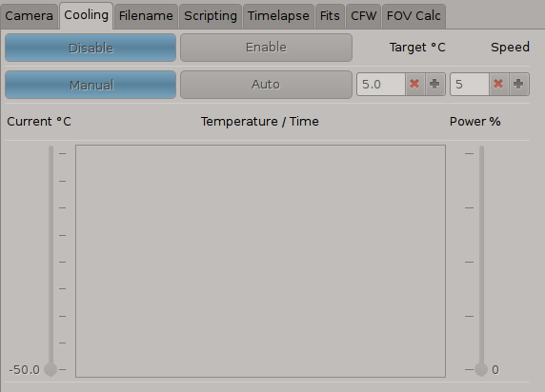
Beware that for some models, when the camera is set in “fast download“ mode, the automatic temperature control and the CCD temperature read are disabled in order to get the highest speed in preview mode and ease the focus process at most. Should this happen this panel will reflect this and controls will stay disabled until the download speed is set to “slow” again.

Program will retain the last value set for cooling power, and the previous choice for cooling mode will be restored once exiting from “fast download” mode.

Filename Tab
Moving onto the Filename tab you should see something like the image below:

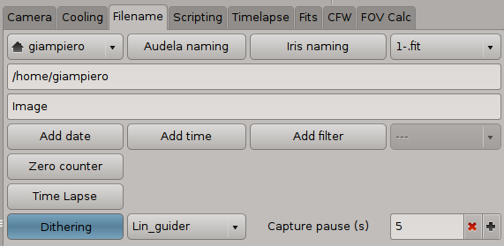
The “Select folder” button allows you to choose which folded will be used to save files, it will also default the “base file name” to “Image”, this you can change any time by writing in the text box below.

If your using either Audela or Iris (Siril under Linux) you can just choose one of the standard naming conventions. These will set folder accordingly, while you will still be able to set a “base file name”. Both Iris (Siril) and Audela naming convention will attach to the file name a few info to make final filename unique.

On the far right of the 3 naming conventions you have the format in which you wish to save: “.fit”, “.avi”, “.fit + .avi”, “preview2avi”.
- The standard is the .fit format for astronomical images.
- The .avi is mostly used for the capture of planetary images, data is saved in raw (undebayered) format, but >8bpp will be linearly scaled to 8bpp.
- The third option is to save in both formats at the same time.
- The “preview2avi” will save an avi with data from the preview. That is, resulting avi will retain color rendering and black/white limits as set for preview.
The latter is not generally recommended for astronomy, although it may be useful for survey and time-lapse. Ultimately it may be used whenever a >8bbp camera data must be used to feed the avi, in order to optimize use of the 8bpp avi data space to store relevant data.

Add date and Add time will append the date and time to the filename and is useful if you want to keep records of the date and time of captured files.
Add filter is a way of adding the filter name to the name of the captured set of the files. Mostly used by mono imagers so that they know what filter was used when taking the image and is useful in the post processing stage. Just select the filter type from the drop down menu.

Zero counter resets the counter on the main page of OSI.

Time Lapse activates the Time Lapse tab.

Dithering will enable the guide program drop down combo and the capture pause spin button. When used, whether in focus or capture mode, the program will attempt communication with the selected guide program. Is the command is successfully sent and performed (i.e. no error reported from guide program), capture pause (s) are waited and a new frame integration will start.
Should the guide program report error, OSI will not wait for the capture pause (s).
Generally speaking the status of the communication with the guide program is reported to the user on the top-center status bar.

Scripting Tab
The next tab is the Scripting page and is a work in progress. When operational it will allow the user to set up a series of exposure times, number of images to capture, binning and filters.

Time-lapse Tab
The Time-lapse tab should look something like below:

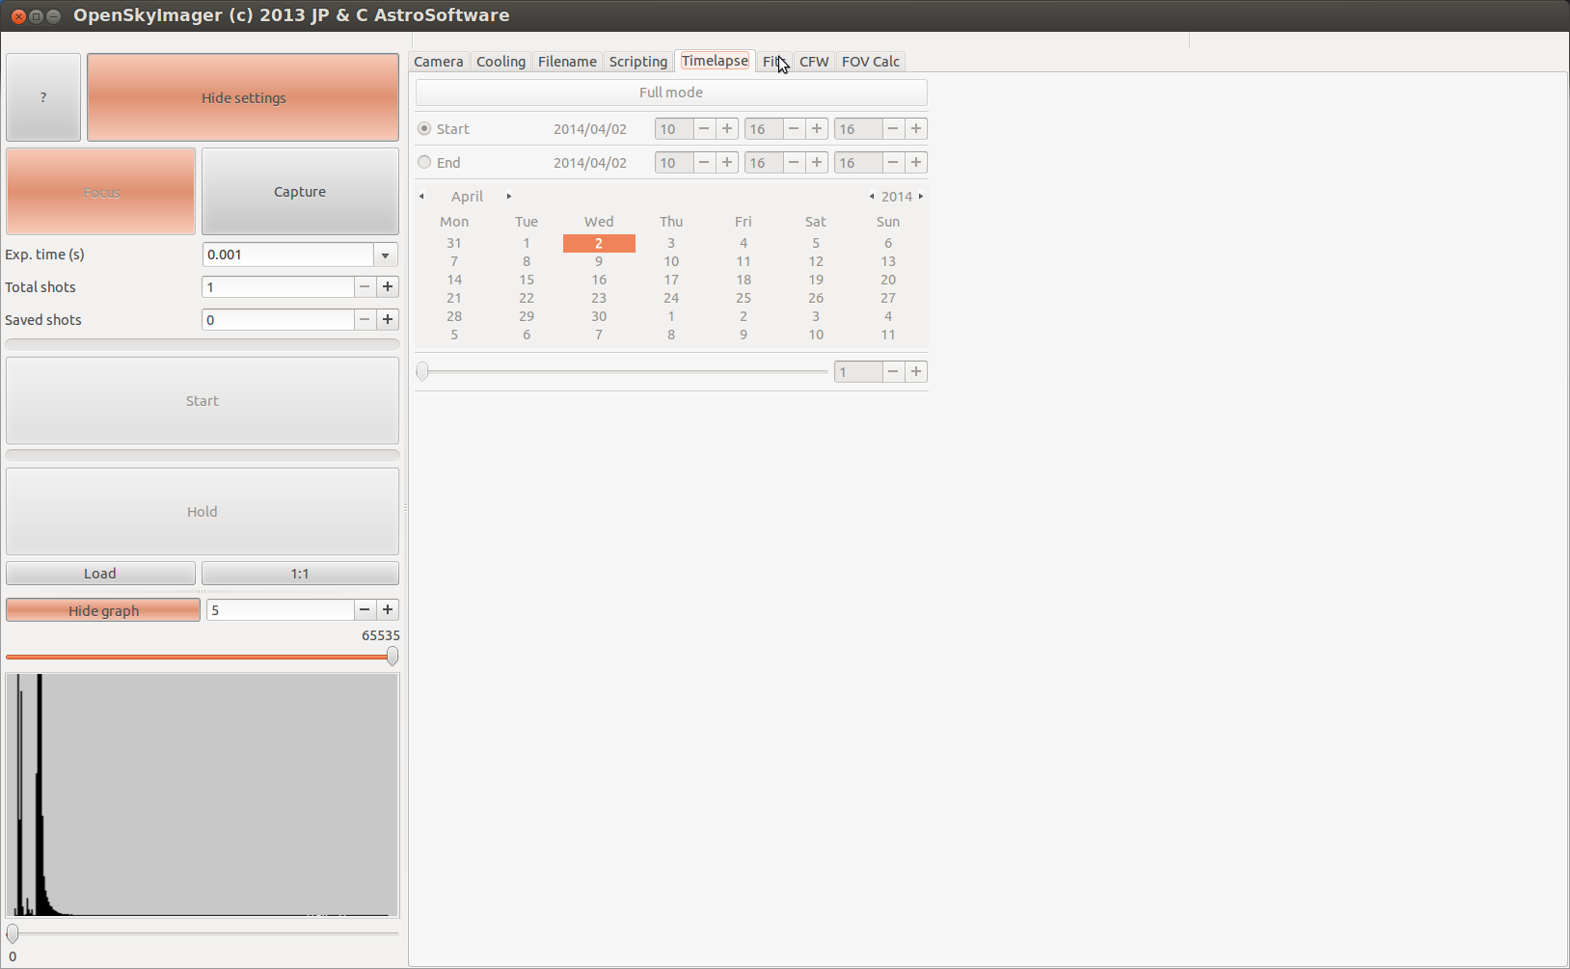
notice if you did not press the “Time Lapse” button on the Filename tab this page will be grayed out and so can not be used.

For the use of a quick time lapse sequence just move the slider to adjust the counter in seconds at the bottom of the page. This will make the program pause/sleep between each image captured. Useful if you want to take a sequence of images of an occultation of a planet disappearing behind another or the Moon or even a star going behind a planet. To use this page to its fullest extent you first have to press the Full mode.

Turning on Full mode now allows you to set all the parameters needed to set up a complete sequence of a time lapse set of images from the year, month, day, date and time to start capture and end the imaging sequence.

To change the month press the little arrow buttons on either side of the displayed Month, use the same kind of arrows either side of the displayed Year to adjust the year. Use the up and down buttons to change the hours, minutes and seconds. The last thing to set should be the amount of time in seconds to actually pause or sleep between each image. The maximum amount of time allowed to sleep is 86400 seconds which is 24 hours.

Fits Tab
The next tab is the Fits tab and is a work in progress and will show and allow adjusting the fits header of the captured images.

CFW Tab
The CFW (color filter wheel) tab should resemble the image below:

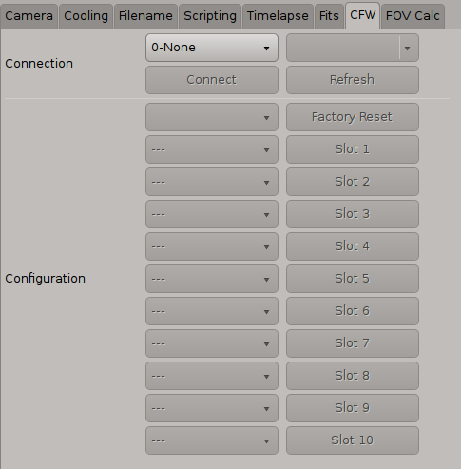
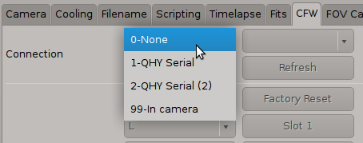

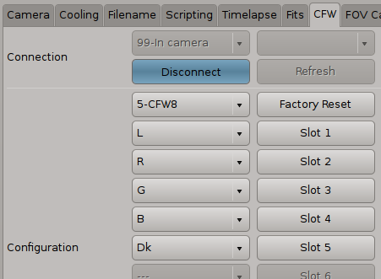

here you can choose which method you wish to use to talk to the filterwheel.

OpenSkyImager supports connection to QHYCFW 2” and QHYCFW2 series through RS232, QHYCFW 2” and QHYCFW2 series through camera connection and SBIG CFWXX models connected to a SBIG camera.

In the “Connection” section one can choose from the drop down combo which connection to establish. RS232 based alternatives are always shown, and once selected will enable the drop down combo on the right to choose the “tty” port. Through-camera alternative is shown once a suitable camera is connected.

Pressing on the “Connect” button will actually attempt connection. Whenever possible the CFW slot count is detected and a suitable choice is picked up for you in the drop down combo below the button (in the Configuration section). If the choice is not correct (or auto-detect is not supported), please pick a better choice from the list, the correct number of buttons will be enabled accordingly.

CFW slots auto detect is currently supported for RS232 connected QHY models and SBIG, for in-camera connected QHY develop is underway.

Optionally details of which filter for which slot can be filled in. When this is done for all enabled slots, the “filters” drop down combo in the Filename Tab will only show elements from the current CFW configuration. Also when changing current slot, the selected element in the “filters” drop down combo of the Filename Tab, will change accordingly, thus driving the naming convention automatically (if the “Add filter” was used).

Use enabled buttons to move to the relevant slot. At present this is the only way to move the filter wheel but in future it will also be moved from the Scripting tab.

Just in case your filter wheel becomes mixed up and does not know which filter is in which slot press the Factory Reset which should zero the filter wheel.

FOV Calc Tab
The FOV (Field Of View) calculator tab should resemble the image below:

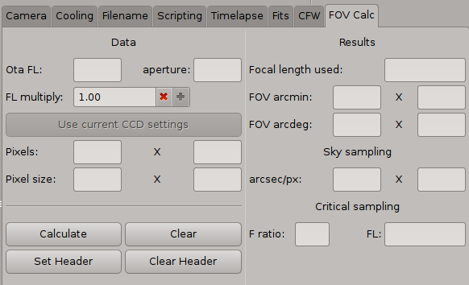
In the “Data” section:
- Ota FL: your optical tube assembly focal length before using any barlow / reducer
- Aperture: your optical tube aperture. This is optional and will be used for the “critical sampling calculation only.
- FL multiply: your barlow / reducer factor, if one is on use, otherwise leave 1.00
- “Use current CCD settings” will be enabled as soon as a camera is connected. When this is the case, selecting it will fill all “Pixel” fields below following current capture setting (i.e. binning, subframe, …)
- Pixels (x,y): each axis pixel count This must take into account binning setting. So if your camera has 2048 x 2048 pixels, and Bin 2x2 is in use, input 1024 x 1024.
- Pixel size (x,y): each axis pixel size in um. This must take into account binning setting. So if your camera has 7.4um pixels, and Bin 2x2 is in use, input 15.0um.
- Calculate: will derive all results based on data available.
  - Focal length used will be actual FL in use considering the FL multiply factor
  - FOV xxx will be the actual field of view expressed both in arcmin and degrees.
  - arcsec/pix will be the actual “sky sampling” factor. That is which is the sky size in each pixel of the resulting image
  - The Critical sampling section will report the minimum focal length required to fully sample a high resolution image with any particular CCD. The assumption is perfect seeing and the Airy disk being the limit of resolution. This is useful for planetary imaging where some “lucky frames” may exploit the full resolution.
- Clear: will clear all result fields
- Set Header: will set “Focal Length used”, “Aperture”, “arcsec/px” values in the fit header skeleton, so that each frame will have them available for further elaboration, plate-solve and so on.
- Clear Header: will clear the fit header skeleton from the above mentioned data.

For references on actual formulas used please see: http://www.wilmslowastro.com/software/formulae.htm

Compiling and installing
As of version 0.9.0 the build mechanism has moved to CMake (many thanks to Marco Gulino for his invaluable help in the process). This greatly ease configuring which drivers one may want in the final binary and which additional tasks is willing to perform during installation (firmware / library updates).

Usual CMake/Make commands can of course be used, but a couple of install scripts have been provided, reworking those originally developed by Clive Rogers:

- install_OSI.bash will install all that is needed to use QHY camera series
- install_OSI_full.bash will add SBIG (unidrv) support to the mix

Both scripts will check for dependencies, (prompt for install if needed), CMake / Make and install the program in a suitable folder (sudo will be needed in order for the lib/program install process to be successful).

Following parameters are available to customize code configuration:

- FORCE_GTK2 (default =off) use of GTK2 toolkit
- FORCE_QHY_HEX (default =off) update of QHY firmwares and udev
- FORCE_QHY_ONLY (default =on) use of QHY embedded driver only
- FORCE_NO_SBIG (default =off) don't use SBIGunidrv when not QHY only
- FORCE_SBIG_UPDATE (default =off) update SBIGunidrv instead of using current.
- FORCE_NO_URVC (default =on) don't use URVC driver when not QHY only

Use of these parameters should be as follows:
~/OpenSkyImager $ sudo ./install_OSI.bash -D FORCE_QHY_HEX=on
the above will compile a binary with QHY embedded driver only, and force update of QHY firmwares / udev during install.

Please note that the install_OSI_full.bash is just the same of:
~/OpenSkyImager $ sudo ./install_OSI.bash -D FORCE_QHY_ONLY=off

A special case is when one wants to compile a binary with support for legacy SBIG parport camera:
~/OpenSkyImager $ sudo ./install_OSI_full.bash -D FORCE_NO_SBIG=on -D FORCE_NO_URVC=off
the above will compile a binary with URVC driver in addition to QHY embedded. Please note that URVC and proprietary SBIG drivers are incompatible for reasons that are yet to be determined. So, until further changes, one needs to to have two different binaries to support both usb/Ethernet SBIG and parport SBIG.

However should anyone prefer to do all by hands here's what's needed and how to:

Compiling your binary
OpenSkyImager was written to compile with both GTK2 and GTK3 toolkit. Unless CMake is forced to, GTK3 will have precedence over GTK2, when both are available on the system.

You will need these libraries, both binaries and dev. Please get them from your repos:
- GTK2 >= 2.20 / GTK3 >= 3.20
- GLIB >= 2.24
- CFITSIO
- LIBUDEV
- FXLOAD
- CMAKE

So far several combinations have been tested:
- GTK2
- Ubuntu 14.04 - unity (GTK2 2.24, Glib 2.40)
- Mint13 (GTK2 2.24, Glib 2.32),
- Ubuntu 11.10 (GTK2 2.24 GLib 2.30)
- Mint 9 (GTK2 2.20 GLib 2.24)

- GTK3
- Ubuntu 14.04 - unity (GTK3 3.10, Glib 2.40)
- Mint LMDE amd64 (GTK3 3.82, Glib 2.36)
- Mint13 (GTK3 3.42, Glib 2.32)
- Ubuntu 11.10 (GTK3 3.2 GLib 2.30)
- Arm device (ASUS transformer TF101) using debian kit over android 4.1.x, running a deb wheezy, xrdp to display the X session

Please note that OpenSkyImager is now a part of iAstroHub automated astro imaging system (http://sourceforge.net/projects/iastrohub/), this means that all ARM devices there listed are also supported and tested for real.

In order to compile your binary, once you got suitable libs as listed above, create a
"build" folder inside the OpenSkyImager tree. Change to that folder and issue:

- cmake .. (cmake -D FORCE_QHY_ONLY=off .. in order to add SBIG unidrv support)
- make
- sudo make install

the install command will alse create a desktop file to have the program show in the system menu.

For a complete list of available CMake options, please see “Compiling and Installing” paragraph.

You can also use make clean to force a full recompile, should this be needed. Make uninstall is also available to cleanup installed files.

You're not expected to see error messages or warnings while compiling. If so, let us know. Submit details for your hardware / software configuration so that we'll be able to track down any issue effectively.

Collaboration
Lastly if you can program in C and GTK and would like to join the team then please do send an email to gspezzano@gmail.com.

Sincerely
The OpenSkyProject team

