



Open Source Cornell
7th Semiannual Linux Installfest
Monday, May 5 11am – 4:30pm Upson Lounge
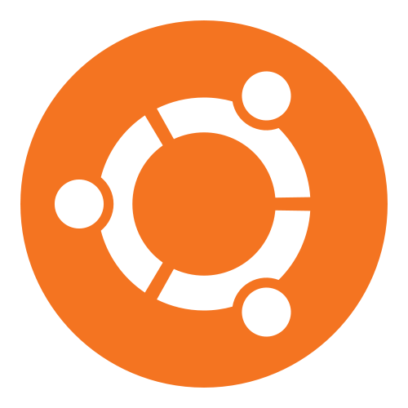

A community-assisted open-source software installation festival on May 5. Experienced users will be on hand to help you discover the cutting edge of open source computing.
We will help you install:
- Popular Linux distros: Ubuntu, Debian, Fedora, Mint
- Communication software: Thunderbird, Pidgin
- Students' favorite: LibreOffice, Notepad++
- Security: TrueCrypt, KeePass, KeeFox
- And more!
All are open-source & free!
If in doubt, just come by and chat!
opensource@cornell.edu | orgsync.rso.cornell.edu/org/opensourcecornell

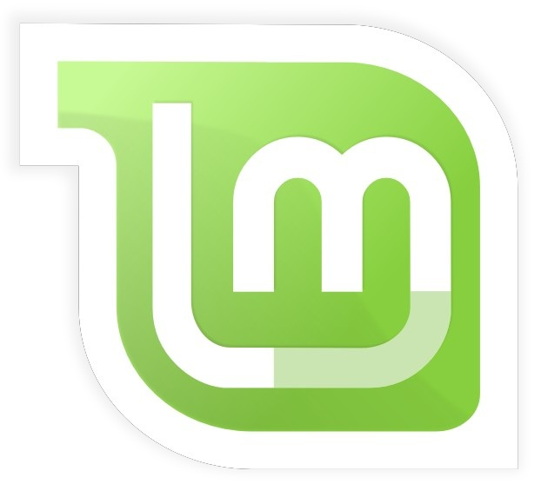





(while the risk is low, you are strongly advised to backup
your data beforehand if you want to install an operating system)
Be part of the future of open source!

