


Cornell Open Source Aficionados
6th Semiannual Linux Installfest
Friday, April 26 12pm – 3pm Upson Lounge
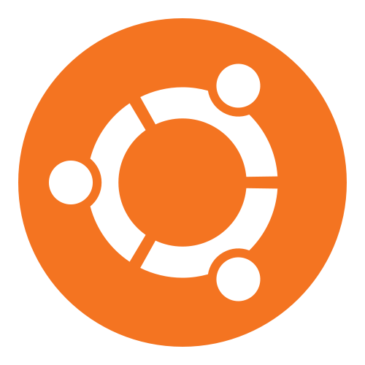

A community-assisted Linux installation festival timed to coincide with the release of Ubuntu 13.04 on April 25. Experienced Linux users will be on hand to help you discover the cutting edge of open source computing.
- Test drive open source operating systems,
- Pick up an installation disk to take home,
- Take advantage of knowledgeable assistance and install a new operating system at the event,
- Discuss open source philosophy ,
- Get to know the Cornell open source community.

opensource@cornell.edu | rso.cornell.edu/open-source




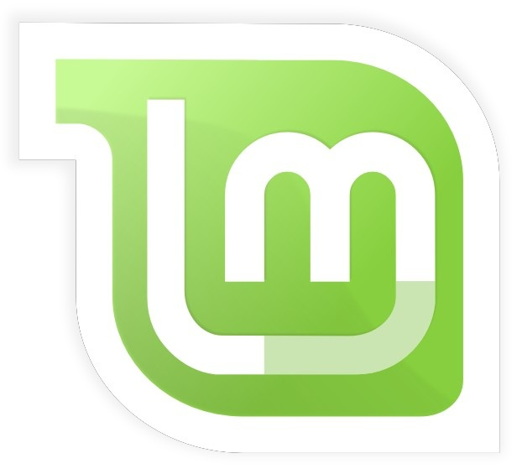

➀ Back Up ➁ Test Drive ➂ Install
Be part of the future of open source!

