Open Source Drug Discovery - Highly Potent Antimalarials Derived from the GlaxoSmithKline Tres Cantos Arylpyrroles
Vicky Avery,ª Jonathan Baell,^{b} Sanjay Batra,^{c} Jeremy Burrows,^{d} Soumya Bhattacharyya,^{c} Felix Calderon,^{e} Sue Charman,^{b} Sergio Wittlin,^{f} Sandra Duffy,ª Javier Gamo,^{e} Zoe Hungerford,^{g} James Pham,^{h} Stuart Ralph,^{h} Matthew H. Todd,^{g} Paul Willis,^{d} Karen White,^{b} Laura White,^{g} Paul Ylioja.^{g}

ª Discovery Biology, Eskitis Institute for Cell and Molecular Therapies, Griffith University, Nathan, QLD 4111, Australia
^{b} Monash Institute of Pharmaceutical Sciences, Monash University, 381 Royal Parade, Parkville, VIC 3052, Australia
^{c} Medicinal Chemistry Division, Central Drug Research Institute, PO Box 173, Lucknow, 226 001, India
^{d} Medicines for Malaria Venture, PO Box 1826, 20 rte de Pré-Bois, 1215 Geneva 15, Switzerland
^{e} Tres Cantos Medicines Development Campus, Diseases of the Developing World (DDW), GlaxoSmithKline, Severo Ochoa 2, 28760 Tres Cantos, Spain
^{f} Swiss Tropical and Public Health Institute, Socinstr. 57, 4051 Basel, Switzerland
^{g} School of Chemistry, The University of Sydney, NSW 2006, Australia
^{h} Department of Biochemistry & Molecular Biology, Bio21 Molecular Science and Biotechnology Institute, The University of Melbourne, Victoria, 3010, Australia

Abstract Test

Graphical Abstract
Introduction
Malaria remains one of the world’s most deadly diseases. There were an estimated 216 million cases of malaria in 2010, including around 655,000 deaths of which 86%, tragically, were children under five years of age.[WHO 2011] Besides the threat to human health, there is significant economic and social impact on the affected communities with malaria costing Africa $12bn p.a. in direct losses and even more when considering lost economic growth.[Snow 2003; RollBackMalaria 2008] The continual threat of drug resistance has led to the World Health Organisation only recommending combination therapies for treatment; artemisinin combination therapies (ACTs) comprising an artemisinin derivative and a 4-aminoquinoline or amino alcohol currently represent the front line. However the inevitable reports of resistance or tolerance, in the form of increased parasite clearance times, have already appeared.[Carrara 2009, Dondorp 2009, Phyo 2012] Loss of the artemisinin class of drugs is a terrifying scenario that requires urgent risk mitigation. Apart from the introduction of the ACTs, no viable drug for malaria has appeared in the last 15 years and whilst a vaccine is currently in Phase III trials, expectations to date suggest at best around 50% efficacy.[Bejon 2008] New series that can replace and complement the ACTs for blood stage falciparum malaria are urgently needed, particularly ones with unusual activity profiles, for example targeting gametocytes (to prevent transmission) or mosquito stage parasites.[Peatey 2012] (reference Winzeler Science paper here for liver stage? 10.1126/science.1211936)
The ability of the pharmaceutical industry to provide new medicines cost-effectively is diminishing.[Scannell 2012] The industry acknowledges that lack of innovation is a problem.[Paul 2010] Pharma is responsible for the creation of most marketed drugs, yet many of these are not innovative; in contrast academia and the biotech industry generate more innovative leads, but many are orphan drugs.[Kneller 2010] Such challenges disproportionately affect research into new medicines for tropical diseases, which would inevitably generate a slim profit margin unlikely to recoup the necessary expenses of research and development.[10/90 Gap, 1999]
The weak status of many drug development pipelines in the pharmaceutical industry is driving the exploration of alternative models. The current model of drug discovery, whether in academia or industry, can be characterised by secrecy and an underlying profit motive. In the area of tropical diseases there are significant philanthropic efforts being made by many companies in providing treatments [unitingtocombatntds] and engaging in drug development [OWH] but also in conducting not-for-profit research.[Novartis][GSK open lab] There have been calls for greater sharing of data in the NTD field,[Hopkins 2007][Ortí 2009] including the development of patent pools[WIPO Re:search] and Product Development Partnerships.[Jakobsen 2011] There has been much recent discussion of the need for “Open Innovation,” a term with a somewhat nebulous definition but typically describing a range of ideas from the sharing of data in a pre-competitive environment through to competitions that allow organisations to bring in the best external ideas to complement in-house research but for which there is no requirement for any collaboration.[Hunter 2010]
A model that has been mooted,[Maurer 2004][Munos 2006][Singh 2008][Munos 2010][Woelfle 2011][Ortí 2009 b)] [include http://pubmedcentralcanada.ca/pmcc/articles/PMC3206459/?lang=en-ca] but never properly evaluated, is drug discovery and development where all data and ideas are freely shared, there are no barriers to participation and there are no patents – so-called “Open Source” Drug Discovery. It was shown recently that the opening up of an experimental chemical research project to unrestricted participation by anyone accelerated the research because experts unknown to the core team could come to the project.[Woelfle 2011] That project involved the discovery of a route to a known compound, specifically the active enantiomer of the drug of choice for the treatment of schistosomiasis, praziquantel. [Woelfle 2011 b)] The project benefitted from the open sharing of chemical data and procedures on the internet, i.e., using the internet as a collaborative, peer-reviewable medium where readers can alter the direction of the research, rather than simply as an information resource; several other initiatives have leveraged the advantage of open discussion of chemical data and results.[orgprepdaily][CS synthetic pages][Reaves 2012]
The present work extends this idea to the identification of novel bioactive compounds. A previous demonstration of an open drug discovery cycle was shown by the Usefulchem project, which found four micromolar hits from a small product library after in silico target prediction and docking.[Usefulchem] The Open Source Drug Discovery project in India has carried out a crowdsourcing project for annotation of the tuberculosis genome[osdd india][Anand 2011][Bhardwaj 2011] and recently launched an open source drug discovery portal for malaria.[osdd malaria] In the field of biotechnology the CAMBIA organization used patents to enforce a code of conduct based on the open sharing of technologies, in that experimental tools could be freely used provided no further patents were taken to restrict the use of those tools by others.[Jefferson 2006]
The “open source” moniker is not merely semantic and distinguishes such projects from other “open” ventures in several important regards: a) anyone may take part at any level, b) there is complete and timely sharing of all data, and c) the research process (i.e., strategic discussions, issues involving doubt) take place in the public domain. Project hierarchy is dictated by activity rather than status. The present project operates on such rules.[TSL post on rules] The on-going project strives to build an online community of collaborators where tasks are modularised and carried out by different research groups or individuals. Raw data are posted in real-time to online electronic notebooks[http://malaria.ourexperiment.org] and the data are discussed on another website, The Synaptic Leap.[http://www.thesynapticleap.org] The project is not “owned” by anyone and any of the work can be used by others outside those actively participating, provided that the work or its derivatives are correctly attributed through the Creative Commons CC-BY-3.0 licence.[CC/licences] Quality control is maintained through deposition of all data in the associated laboratory notebooks which are publicly available to anyone.
In 2010, teams led by Novartis, St. Jude’s Children’s Research Hospital and GSK Tres Cantos released large sets of antimalarial compounds derived from high throughput screening (HTS) campaigns.[Gamo 2010][Guiguemde 2010][CheMBLNTD] The GSK Tres Cantos Dataset contained 13,533 filtered hits which have since been prioritised and grouped to provide numerous starting points for other research groups.[Calderón 2011] GSK has further evaluated two of these priority series. The first, cyclopropyl carboxamides, showed promise as an orally available lead[Rueda 2011] but the series exhibited rapid development of resistance.[Sanz 2011] The second (indoline) series was optimized to increase antimalarial potency while reducing the potency towards a known target for this series, the 5-HT_{2C} receptor.[Calderón 2012] The original GSK data set was used to identify starting points for the present lead development campaign, resulting in the selection of TCMDC-123812 (X) and its 4-aminoantipyrine derivative TCMDC-123794 (X) because of their attractive physicochemical properties, such as low logP and molecular weight, coupled with promising bioactivity. A further targeted search of the database gave an interesting “near neighbour” set also containing the arylpyrrole moiety that could be investigated at the same time (X). These hits were originally identified by a HTS process applied to a compound collection that included commercial compound libraries. It was thus important to re-synthesize the original hit compounds to confirm their activity.
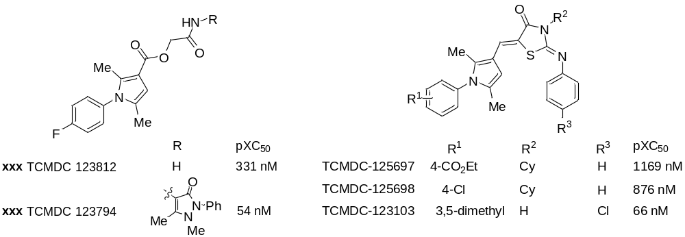
Scheme 1. Starting-point Aryl Pyrrole Hits from the TCAMS Dataset and their Near Neighbours
Results and Discussion
Chemical Synthesis
The target compounds consist of an arylpyrrole core coupled to either an ester or 2-iminothiazolidin-4-one side-chain. The ester side chain of TCMDC-123794 was obtained by condensation of glycolic acid acetonide[Greiner 1990][Daryaee 2009] and 4-aminoantipyrine in toluene. Its amide amine analogue (xxx) was prepared from Boc-glycine by a coupling using propyl phosphonic anhydride,[Dunetz 2011] followed by deprotection using TFA in dichloromethane (Scheme 2).
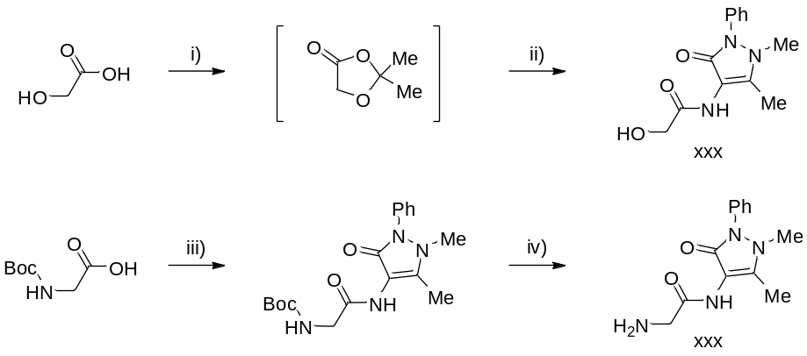
Scheme 2. Synthesis of Antipyrene Side Chains. Conditions: i) p-TSA (few crystals), acetone, 1 hour, rt; ii) 4-aminoantipyrine (1.05 equiv.), toluene, 16 hours, reflux; iii) 4 aminoantipyrine (1.1 equiv.), pyridine (5.7 equiv.), 50% propylphosphonic anhydride (T3P) in EtOAc (1.7 equiv.), DMF, 21 hours, 0 °C to rt; iv) 20% TFA, DCM, 16 hours, rt.
The aryl pyrrole core of these series was obtained via a Paal-Knorr cyclisation of an aniline and ethyl 2-acetyl-4-oxopentanoate (X, Scheme 3).[Ping Gu X 1987][Pak-Kan C 1989] This was hydrolysed to the free acid and converted to the acid chloride[WO2006076202] for coupling with the side chains.

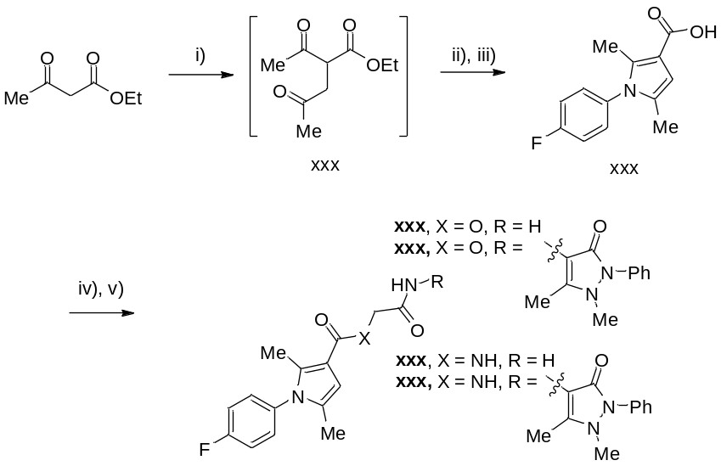
Scheme 3. Synthesis of Ester and Amide Analogues of X. Conditions: i) potassium carbonate (1.3 equiv.), chloroacetone (1.1 equiv.), sodium iodide (1 equiv.), acetonitrile, 2 hours, 80 °C; ii) 4-fluoroaniline (1 equiv.), 2 hours, 80 °C; iii) 20% sodium hydroxide (approx. 8 equiv.), ethanol, 17 hours, reflux; iv) thionyl chloride (2 equiv.), toluene, 4 hours, 0 °C to rt; v) glycolamide, glycinamide, xxx or xxx (1.1 equiv.), DIPEA (2.1 equiv.), 4-DMAP (0.5 equiv.), THF, overnight, rt.
The 2-iminothiazolidin-4-one (“near neighbour”) analogs were obtained from the pyrrole aldehyde X obtained via another Paal-Knorr cyclization using 2,5-hexanedione and the relevant aniline (Scheme X). This gave multi-gram quantities of the pyrrole that could be furnished with an aldehyde in good yield using Vilsmeier-Haack conditions.[Manetti 2006] The formylation step was improved by a suggestion on the project coordination website[TSL CreativeChem] to include an overnight hydrolysis step during the work-up resulting in a significant improvement in yield on a gram scale. The aldehydes were then condensed with 2-iminothiazolidin-4-ones[Bhandari 2009] using conditions developed by Roberts.[Urbano 2011] Unsubstituted phenyl-2-iminothiazolidin-4-ones were then converted to the acyl, cyclohexyl and methylenenitrile derivatives (X-X) by standard substitutions in the presence of base (Scheme X).
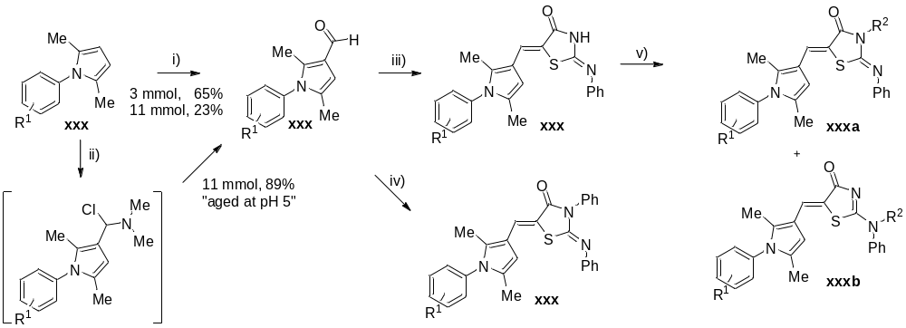
Scheme 4: conditions: i) POCl₃/DMF, 45 min, 0 °C to rt then poured onto ice and filtered; ii) POCl₃/DMF, 45 min, 0 °C to rt, then poured onto ice and “aged” for 16 hours (pH 6); iii) 2-phenyliminothiazolidin-4-one (1 equiv.), piperidine (1.5 equiv.), ethanol, 1.5-4.5 hours, 60 °C; iv) 3-phenyl-2-(phenylimino)-1,3-thiazolidin-4-one (1 equiv.), piperidine (1.5 equiv.), ethanol, 1.5-4.5 hours, 60 °C; v) acetic anhydride (4 equiv.), pyridine (2 equiv.), toluene, 7-21 hours, 80 °C; or cyclopentylbromide (1.2 equiv.), sodium hydride (1.5 equiv.), DMF, 3 days, 60 °C; or bromoacetonitrile (2 equiv.), sodium iodide (2 equiv.), potassium carbonate (2 equiv.), acetonitrile, 2 hours at 80 °C then 16 hours at rt.
The products were crystalline and were, in most cases, isolated by filtration. X-Ray crystallography of xxxa (Scheme X, A) revealed Z- geometry for the alkene of the only product, consistent with a previous assignment based on NMR spectroscopy.[Urbano 2011] Substitution with bromoacetonitrile gave two separable isomers (Scheme X, xxxa and xxxb), one of which gave X-ray quality crystals, revealing that isomer to be xxxa where the methylenenitrile was attached to the iminothiazolidinone nitrogen (Scheme X, B). The other methylenenitrile-functionalised isomer (xxxb) was therefore assigned to be the N-phenyl substituted isomer. On substitution with cyclopentyl bromide or acetyl chloride, however, only one isomer was observed and isolated. Both these samples gave X-ray quality crystals revealing that in the case of cyclopentyl bromide, the substituent had become attached to the iminothiazolidinone nitrogen (xxxa, C), whereas with acetyl chloride the substituent was attached to the exocyclic nitrogen (xxxb, D).
Scheme 5. X-Ray Crystallographic Structural Assignment of X-X

Biological Evaluation
The first round of compounds was evaluated against 3D7 (drug-sensitive) and K1 (chloroquine resistant) strains of P. Falciparum in a whole cell assay and against HEK-293 cells as a cytotoxicity marker. The screen was repeated in three different institutions using different assays (see supporting information).
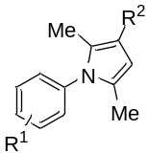
Entry | R¹ | R² | Ralph | GSK | 3D7 (Avery) | K1 | HEK293
 |  |  | IC50  nM | IC50 (48 hr) nM | IC50 nM | IC50 nM | IC50 % inhibition  at 120 µM
1 | 4-F | CHO |  | >5000 | 60% at 120 µM | 50% at 120 µM | 25%
2 | 4-F | CO₂Et |  | >5000 | 11960 | 12400 | 25%
3 | 4-F | CO₂H |  | >5000 | 75% at 120 µM | 50% at 120 µM | 20%
4 | 4-F | Acyl urea |  | >5000 | 7800 | 4550 | 75%
5 | H | CO₂H |  | - | 70% at 120 µm | 50% at 120 µM | 0%
6 | 4-Me | CO₂H |  | - | 70% at 120 µM | 0% | 0%
7 | 4-CF₃ | CO₂H |  | - | 25% at 120 µM | 0% | 0%
8 | H | CHO |  | - | 55% at 120 µM | 80% at 120 µM | 25%
9 | 4-Me | CHO |  | - | Could not determine | - | -
10 | 4-Me | CO₂Et |  | - | 85% at 120 µM | 50% at 120 µM | 0%
11 | 4-H | CO₂Et |  | - | 80% at 120 µM | 0% | 0%
12 | 4-CF₃ | CO₂Et |  | - | 85% at 120 µM | 20% at 120 µM | 75%
13 | 4-F | 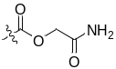 |  | 818 | 404 | 375 | 20%
14 | 4-F | 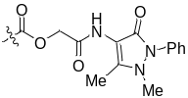 |  | 245 | 345 | 152 | 20%
15 | 4-F | 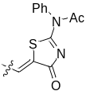 |  | 46.5 | 47.4 | 66.2 | 75%
16 | 4-F | 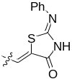 |  | - | 176 | 360.8 | 25%
17 |  | Chloroquine |  | 52.3 | 18.7 | 266 | 100%
18 |  | Artemisinin |  | - | 6 | 0.7 | 25%
19 |  | Artesunate |  | 19.4 | -
Table 1. Initial Round of Biological Evaluation for TCMDC Arylpyrrole Analogs
These tests confirmed that the original GSK Tres Cantos compounds TCMDC-123812 and TCMDC-123794 are active, although less than previously reported (Scheme 1). The stability of the ester linker under biological conditions was expected to be poor. Therefore, the acid, ester and aldehyde compounds were evaluated as potentially active fragments, but were found to be relatively inactive, suggesting the parent compounds do not act as prodrugs. The 2-iminothiazolidin-4-one leads were found to be comparable to chloroquine in potency. [Any comments here from anyone?] With these results in-hand, a second round of compounds were synthesised and evaluated, with a focus on the 2-imino-4-thiazolidinone series.
Entry | R¹ | R² | GSK | 3D7 (Avery) | Ralph
 |  |  | IC50 (48 hr) nM | IC50 nM | IC50 nM
1 | 4-F | 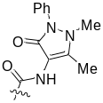 | >5000 | 100% at 8000 | >1000
2 |  | 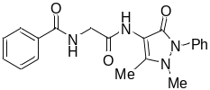 | >5000 | 0% at 8000
3 | 4-F | 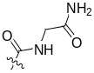 | >5000 | 80% at 8000 | >1000
4 | 4-F | 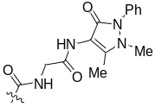 | >5000 | 31000 | >1000
5 | H |  | 36 | 26 | 10.9
6 | 4-Me |  | 28 | 15 | 9.2
7 | 4-CF₃ |  | 29 | 2.15 | 205
8 | 3,5-CF₃ |  | 7 | 0.8 | 4.7
9 | 4-CO₂Et |  | 267 | 169 | 339
10 | 4-CF₃ | 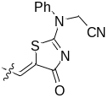 | >5000 | - | >1000
11 |  | 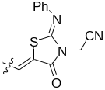 | >5000 | 3120 | >1000
12 | 4-CF₃ |  | 26 | 12 | 7.7
13 | 4-H |  | 85 | 63 | 28
14 | 4-Me |  | 25 | 319 | 156
15 | 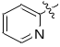 |  | 309 | 186 | 442
16 | 4-CF₃ | 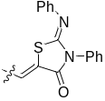 | 372 | 54 | 485
17 | 3-F |  | 3200*
18 |  | 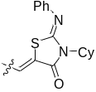 | 276 | 34 | 520
19 |  | 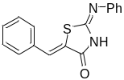 | >5000 | 100% at 4000-8000 | >1000
20 |  | Chloroquine | 23 | 15.45
21 |  | Artemisinin | 23 | 2.95
22 |  | Artesunate
Table 2. Evaluation of a Second Round of TCMDC Arylpyrrole Analogs. *Assay performed at CDRI Lucknow using chloroquine and PMY 10-6 as a controls; IC₅₀ for K1 strain > 5 µM.[Batra 2012]

Replacement of the ester linkage of the original TCMDC compound set with an amide resulted in complete loss of activity. Most of the iminothiazolidinones were highly active compounds. The aryl component of the pyrrole moiety was fairly tolerant to changes (with the exception of the 3-F isomer), while thiazolidinone component was found to be more sensitive. Incorporation of cyclopentyl, phenyl and acetyl components was tolerated but the methylenenitrile group was not. Replacement of the arylpyrrole moiety with a phenyl resulted in loss of activity. (Any more comments here from anyone?)
While high potency was obtained with several of the “near neighbour” set, this was achieved at the cost of logP (Scheme 6) which in many cases approach or exceed desirable values. Nevertheless the potency, achieved through the synthesis of a relatively small number of compounds, was seen as sufficiently promising that some of these novel compounds were examined in more detail, see below.
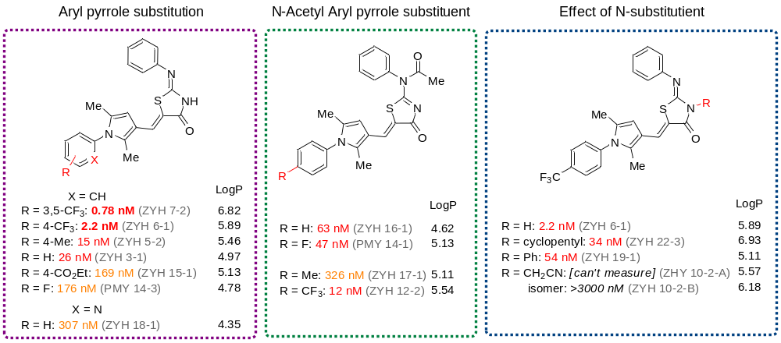
Scheme 6. Relationship Between Potency and logP for the Most Potent Compounds Identified in the Biological Screening (This scheme is optional, but is a nice representation of the data)
An important contribution to the project on the coordination website from outside the core experimental team was discussion of whether the most potent hits were Pan Assay INterference compounds (PAINS).[TSL PAINS discussion][Baell 2010] Both the 2-imino-4-thiazolidinone and arylpyrrole components of these compounds have been identified as potential PAINS, with the proposed cause of the interference of the former being the thiazolidinone exo-double bond acting as a Michael acceptor. This topic has been the subject of recent discussion in papers and in online communities.[In the Pipeline articles] Although most of the concern has centered on rhodanines, any related structure could be problematic due to the potentially reactive conjugated exo-double bond, but it is acknowledged that in the area of chemotherapeutic and antiparasitic agents, such motifs may still be present in viable leads.[Baell 2010 Future Med Chem] The negative view of rhodanine derivatives in the medicinal chemistry community is generally derived from academic reports and patents where positive assay hits have been reported without adequate evaluation of SAR or elucidation of the mode of action. It was not thought that the most potent hits in the present work suffered from pan-assay interference for three reasons: 1) The parent hit compounds (TMDC-123812 and [“near neighbours”]) were shown not to be “promiscuous” frequent hitters in the original GSK data [Javier/Felix – any more comment needed on this?];[Gamo 2010] 2) the assay data described above show that 2-imino-4-thiazolidinone component was inactive on its own (Table 2, Entry X, ZYH 23-1/OSM-S-55) and 3) Explicit experimental controls were performed to assess the reactivity of the exo double bond: treatment of xxx with sodium borohydride, attempted hydrogenation or addition of benzylthiol did not result in reaction at the double bond by ¹H NMR spectroscopic analysis and mass spectrometry (Scheme 7).[Paul Y to follow up on thiol experiment to establish product]
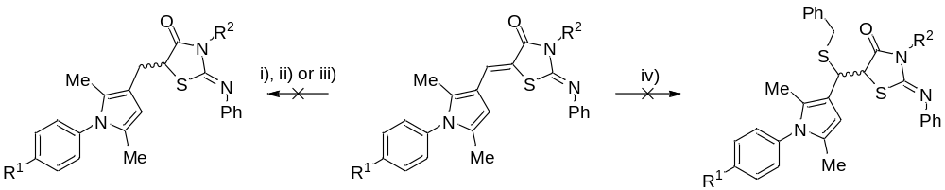
Scheme 7: conditions: i) R¹ = F, R² = H, NaBH₄ (10 equiv.), methanol, 20 h, 60 °C ; ii) R¹ = F, R² = H, 10% Pd/C (20% w/w), hydrogen (1 atm), ethanol, 18 h, rt; iii) R¹ = F, R² = Ac, NaBH₄ (8.6 equiv.), acetonitrile, 18 h, rt gave deacylated product xxx, quant.; iv) R¹ = CF₃, R² = H, benzylthiol (5 equiv.), CH₂Cl₂, 68 h, 40 °C then K₂CO₃ (1.5-2 equiv.), 20 h.
All these compounds fail by ALARM NMR filtering. Do we need to discuss this more? Is this significant? What do we do with this information? [http://pubs.acs.org/doi/pdf/10.1021/ja0455547][ http://pasilla.health.unm.edu/tomcat/biocomp/smartsfilter][http://dx.doi.org/10.1016/j.drudis.2010.08.010][http://dx.doi.org/10.1039/C0MD00129E],
Gametocyte. A selection of compounds showed activity comparable to Artemisinin and Artesunate against malaria gametocytes. The near neighbours OSM-S-38 and 39 had activities of 4 nM and 2.6 nM respectively while TCMDC-123812 showed only moderate activity. Given that there are only limited drugs available that are able to treat malaria in the gametocyte stage,[Peatey 2012] this is a useful result and worthy of further study. Both the arylpyrrole ester and iminothiazolidinone classes of compound are promising hit series for further development given their activities in both the asexual and sexual assays. (Raw data in Supp Info + link to lab book) (Any further comments on these data?)
 | Late stage GAM | Asexual assay
ZYH7-2 | 2.6 nM | 0.78 nM
PMY14-1 | 28 nM | 53 nM
ZYH6-1/6-2 | 4 nM | 2.2 nM
PMY10-2 | 75% at 60 uM | 598 nM
Chloroquine | 86% at 120 uM
Pyrimethamine | 50% at 120 uM
Tafenoquine | 2800 nM
Pyronaridine | 2960 nM
Epoxomicin | 0.3 nM
Artemisinin | 2.4 nM 67% max response
Artesunate | 1.1nM 88% maximum response

HERG. Compounds ZYH 3-1 and TCMDC-123812 were also shown to not suffer from significant hERG activity (IC₅₀ >33 µM). (Raw data to go into supporting information + link to lab book) (Is there any more discussion needed here?)
Metabolism. Both aryl pyrrole ester compounds xxx and xxx showed noticeable non-NADPH metabolism along with moderate microsomal degradation.(Raw data in Supp Info + link to lab books) The iminothiazolidinone compounds showed generally low rates of microsomal metabolism. The rate of metabolism for the acyl substituted compounds OSM-S-9 could not be determined since it was observed to rapidly hydrolyse to the parent compound, OSM-S-10. (Any more discussion needed here?)
Compound | Degradation half life (min) | In vitro CLint (µL/min/mg protein) | Degradation rate classification
OSM-S-5 | 59 | 29 | moderate
OSM-S-6 | 29 | 60 | moderate
OSM-S-9 | c.n.c. (could not calculate due to rapid non-NADPH acetamide hydrolysis of test compound to PMY 39-1)
OSM-S-10 | 113 | 15 | moderate
 | 92 | 19 | moderate
OSM-S-37 | 245 | 7 | Low
OSM-S-38 | >250 | <7 | Low
 | >250 | <7 | low
ZYH 7-2 | >250 | <7 | low
 | >250 | <7 | low
ZYH 22-3 | 121 | 14 | moderate

Oral. The decision was made to trial representative compounds from both sub-series in an oral in vivo mouse trial. The original starting points OSM-S-5 and OSM-S-6 (TCMDC-123812 and -123794) were chosen. The 2-imino-4-thiazolidinone compounds suffer from very poor solubility as expected from their high ClogP values and measured solubilities in pH 2 or pH 6.5 isotonic phosphate buffer of less than 1.6 µg/mL. One of the less lipophilic iminothiazolidinone compounds OSM-S-35 (ZYH-3, ClogP 4.97) were chosen for the trial in the hope of achieving some oral bioactivity. Unfortunately both compound series were found to be inactive in vivo oral P. Berghei mice at 50 mg/kg after 4 days. [PK data pending] [PK data depending: It can be expected that at least some of the arylpyrrole ester compounds would be degraded by general hydrolysis before absorption and this could explain their inactivity in the mouse model despite their more reasonable AlogP values (OSM-S-5 1.91, OSM-S-6 2.79; ChEMBL). Further comments here?
Mode of action discussion. The activity assays have been carried out on whole parasites in human serum giving a more realistic measure of activity than enzyme based assays at the expense of an unknown mode of action. This remains one of the areas for further research in the OSDD community, with preliminary in silico prediction of protein targets for our most active lead zyh 7-2 providing a starting point for experimental confirmation. Iain Wallace to comment on method used and predictions? [http://malaria.ourexperiment.org/uri/bb]
Reference on reliability of data in ChEMBL for in silico prediction: [http://dx.doi.org/10.1021/jm300131x]
This section is to some extent contingent on GSK DHODH assay, and also possibly on the Nislow Yeast screen, which is in progress.
Acknowledgements
Identities of compounds are here
The original lab notebook entries and data can be found here
References
() WHO World Malaria Report 2011: http://www.who.int/malaria/world_malaria_report_2011/en/
() Snow RW, Craig M, Newton C, Steketee R (2003) The Public Health Burden of Plasmodium Falciparum Malaria in Africa: Deriving the Numbers. Fogarty International Centre, National Institute of Health, Bethesda, Maryland. 2010: 1-81.
() The Global Malaria Action Plan; Geneva, 2008: http://www.rollbackmalaria.org/gmap/
() Carrara VI, Zwang J, Ashley EA, Price RN, Stepniewska K, Barends M et al. (2009) Changes in the treatment responses to artesunate-mefloquine on the nortwestern border of Thailand during 13 years of continuous deployment. PloS One 4: e4551. (10.1371/journal.pone.0004551)
() Dondorp AM, Nosten F, Yi P, Das D, Phyo AP, Tarning J et al. (2009) Artemisinin resistance in Plasmodium falciparum Malaria. New Engl J Med 361: 455-467. (10.1056/NEJMoa0808859)
() Phyo AP, Standwell N, Stepniewska K, Ashley EA, Nair S, McGready R et al (2012) Emergence of artemisinin-resistant malaria on the western border of Thailand: a longitudinal study. Lancet 379: 1960-1966 (10.1016/S0140-6736(12)60484-X)
() Bejon P, Lusingu J, Olotu, A, Leach A, Lievens M, Vekemans J et al. (2008) Efficacy of RTS,S/AS01E vaccine against malaria in children 5 to 17 months of age. New Engl J Med 359: 2521-2532.
() Peatey CL, Leroy D, Gardiner DL, Trenholme KR (2012) Anti-malarial drugs: how effective are they against Plasmodium falciparum gametocytes? Malaria J 11: 34 (10.1186/1475-2875-11-34)
() Scannell JW, Blanckley A, Bolden H, Warrington B (2012) Diagnosing the decline in pharmaceutical R&D efficiency. Nat Rev Drug Disc 11:191-200 (10.1038/nrd3681)
() Paul SM, Mytelka DS, Dunwiddie CT, Persinger CC, Munos BH, Lindborg SR et al. (2010) How to improve R&D productivity: the pharmaceutical industry’s grand challenge. Nature Rev Drug Disc 9: 203-14.
() Kneller R (2010) The importance of new companies for drug discovery: origins of a decade of new drugs. Nat Rev Drug Disc 9: 867-882.
() The 10/90 Report on Health Research 1999, Global Forum for Health Research; 1999.
() http://www.unitingtocombatntds.org
() http://www.oneworldhealth.org/
() http://www.nibr.com/research/developing_world/NITD/index.shtml
() http://www.openlabfoundation.org/
() Hopkins AL, Witty MJ, Nwaka S (2007) Neglected Diseases Mission Possible. Nature 449: 166-169 (10.1038/449166a)
() Ortí L, Carbajo RJ, Pieper U, Eswar N, Maurer SM, Rai AK et al. (2009) A kernel for the tropical disease initiative. Nature Biotech 27: 320-1.
() http://www.wipo.int/research/en/
() Jakobsen PH, Wang MW, Nwaka S (2011) Innovative partnerships for drug discovery against neglected diseases. PLoS Negl Trop Dis 5(9): e1221 (10.1371/journal.pntd.0001221)
() Hunter J, Stephens S (2010) Is open innovation the way forward for big pharma? Nat Rev Drug Disc 9: 87-88 (10.1038/nrd3099)
() Maurer SM, Rai A, Sali A (2004) Finding cures for tropical diseases: Is open source an answer? PLoS Med 1(3): e56 (10.1371/journal.pmed.0010056)
() Munos B (2006) Can open-source R&D reinvigorate drug research? Nat Rev Drug Disc 5: 723-729 (10.1038/nrd2131)
() Singh S (2008) India takes an open source approach to drug discovery. Cell 133:201-203 (10.1016/j.cell.2008.04.003)
() Munos B (2010) Can Open-Source Drug R&D Repower Pharmaceutical Innovation? Clin Pharmacol Ther 87: 534-6 (http://dx.doi.org/10.1038/clpt.2010.26)
() Woelfle M, Olliaro P, Todd MH (2011) Open science is a research accelerator. Nature Chem 3: 745-748 (10.1038/nchem.1149)
() Ortí L, Carbajo RJ, Pieper U, Eswar N, Maurer SM, Rai AK et al. (2009) A kernel for open source drug discovery in tropical diseases. PLoS Negl Trop Dis 3(4): e418 (10.1371/journal.pntd.0000418)
() Woelfle M, Seerden JP, de Gooijer J, Pouwer K, Olliaro P, Todd MH (2011) Resolution of Praziquantel. PLoS Negl Trop Dis 5(9): e1260 (10.1371/journal.pntd.0001260)
() https://orgprepdaily.wordpress.com/
() http://cssp.chemspider.com/
() Reaves ML, Sinha S, Rabinowitz JD, Kruglyak J, Redfield RJ (2012) Absence of arsenate in DNA from arsenate-grown GFAJ-1 cells. ArXiv:1201.6643v2 (http://arxiv.org/abs/1201.6643)
() The Usefulchem Project: http://usefulchem.wikispaces.com/
() Indian OSDD Project: http://www.osdd.net/
() Anand P, Sankaran S, Mukherjee S, Yeturu K, Laskowski R, Bhardwaj A et al. (2011) Structural annotation of Mycobacterium tuberculosis proteome. PLoS ONE 6(10): e27044 (10.1371/journal.pone.0027044)
() Bhardwaj A, Scaria V, Raghava GPS, Lynn AM, Chandra N, Banerjee S et al. (2011) Open source drug discovery – a new paradigm of collaborative research in tuberculosis drug development. Tuberculosis 91: 479-486 (10.1016/j.tube.2011.06.004)
() http://malaria.osdd.net/
() Jefferson, R (2006) Science as Social Enterprise: The CAMBIA BiOS Initiative. Innovations: Technology, Governance, Globalization 1: 13-44
() Todd MH (2011) Open Source Drug Discovery for Malaria http://www.thesynapticleap.org/node/343
() http://malaria.ourexperiment.org
() http://www.thesynapticleap.org
() http://creativecommons.org/licenses/
() Gamo FJ, Sanz LM, Vidal J, de Cozar C, Alvarez E, et al (2010) Thousands of chemical starting points for antimalarial lead identification. Nature 465: 305-310 (10.1038/nature09107)
() Guiguemde WA, Shelat AA, Bouck D, Duffy S, Crowther GJ, et al (2010) Chemical genetics of Plasmodium falciparum. Nature 465: 311-315 (10.1038/nature09099)
() http://www.ebi.ac.uk/chemblntd
() Calderón F, Barros D, Bueno JM, Coterón JM, Fernández E, Gamo FJ et al (2011) An invitation to open innovation in malaria drug discovery: 47 quality starting points from the TCAMS. ACS Med Chem Lett 2:741-746 (10.1021/ml200135p)
() Rueda L, Castellote I, Castro-Pichel J, Chaparro MJ, de la Rosa JC, Garcia-Perez A et al (2011) Cyclopropyl carboxamides: a new oral antimalarial series derived from the Tres Cantos anti-malarial set (TCAMS). ACS Med Chem Lett 2: 840-844 (10.1021/ml2001517)
() Sanz LM, Jiménez-Díaz MB, Crespo B, De-Cozar C, Almela MJ, Angulo-Barturen I et al (2011) Cyclopropyl carboxamides, a chemically novel class of antimalarial agents identified in a phenotypic screen. Antimicrob Ag Chemother 55: 5740-5745 (10.1128/AAC.05188-11)
() Calderón F, Vidal-Mas J, Burrows J, de la Rosa JC, Jiménez-Díaz MB, Mulet T et al (2012) A divergent SAR study allows optimization of a potent 5-HT2c inhibitor to a promising antimalarial scaffold. ACS Med Chem Lett 3: 373-377 (10.1021/ml300008j)
() Daryaee F, Kobarfard, F, Khalaj A, Farnia P (2009) Synthesis and evaluation of in vitro anti-tuberculosis activity of N-substituted glycolamides. Eur J Med Chem 44: 289-295 (10.1016/j.ejmech.2008.02.022)
() Dunetz JR, Xian Y, Baldwin A, Ringling J (2011) General and Scalable Amide Bond Formation with Epimerization-Prone Substrates Using T3P and Pyridine, Org. Lett. 13: 5048-5051 (http://dx.doi.org/10.1021/ol201875q)
() Greiner A, Ortholand J-Y (1990) Chirality transfer from lactic acid selective synthesis of 2,2-disubstituted-1,3-dioxolan-4-ones from ketones and acetals. Tet Lett 31(15): 2135-2138
() Ping Gu X, Nishida N, Ikeda I, Okahara M (1987) 2-(Chloromethyl)-3,5-dioxahex-1-ene. An effective acetonylating reagent. J Org Chem 52: 3192-3196 (http://dx.doi.org/10.1021/jo00391a003)
() Chiu P-K, Sannes MP (1990) The synthesis and chemistry of azolenines. Part 18. Preparation of 3-ethoxycarbonyl-3H-pyrroles via the paal-knorr reaction, and sigmatropic rearrangements involving competitive ester migrations to c-2, c-4 and n. Tetrahedron 46: 3439-3456
(http://dx.doi.org/10.1016/S0040-4020(01)81514-3)
() http://www.wipo.int/patentscope/search/en/WO2006076202
() Manetti F, Magnani M, Castagnolo D, Passsalacqua L, Botta M et al (2006) Ligand-Based Virtual Screening, Parallel Solution-Phase and Microwave-Assisted Synthesis as Tools to Identify and Synthesize New Inhibitors of Mycobacterium tuberculosis. Chem Med Chem 1: 973-989 (http://dx.doi.org/10.1002/cmdc.200600026)
() http://www.thesynapticleap.org/node/344
() Bhandari SV, Bothara KG, Patil AA, Chitre TS, Sarkate AP et al (2009) Design, Synthesis and Pharmacological Screening of Novel Antihypertensive Agents Using Hybrid Approach. Bioorgan Med Chem 17:390-400 (http://dx.doi.org/10.1016/j.bmc.2008.10.032)
() Urbano M, Guerrero M, Velaparthi S, Crisp M, Chase P, Hodder P et al (2011) Discovery, synthesis and SAR analysis of novel selective small molecule S1P₄-R agonists based on a (2Z,5Z)-5-((pyrrol-3-yl)methylene)-3-alkyl-2-(alkylimino)thiazolidin-4-one chemotype. Bioorg Med Chem Lett 21: 6739-6745 (10.1016/j.bmcl.2011.09.049)
() Batra 2012: http://malaria.ourexperiment.org/uri/d8
() PAINS discussion: [http://www.thesynapticleap.org/node/367]
() Baell JB, Holloway GA (2010) New substructure filters for removal of pan assay interference compounds (PAINS) from screening libraries and for their exclusion in bioassays. J Med Chem 53: 2719-2740 (10.1021/jm901137j)
() Baell JB (2010) Observations on screening-based research and some concerning trends in the literature. Future Med Chem 2: 1529-1546 (10.4155/fmc.10.237)

Others to include?
() Wells TNC, Alonso PL, Gutteridge WE (2009) Nat Rev Drug Disc 8: 879-891.
() Moran M. et al. The Malaria Product Pipeline: Planning for the Future; PolicyCures, Sydney, 2007.

