

1

2

3

4

5

6

7

8

9

10

11

13

14

12

A

B

C

D

E

F

G

H

I

J

**SAMPLE KSY+RC**

**1H NMR**

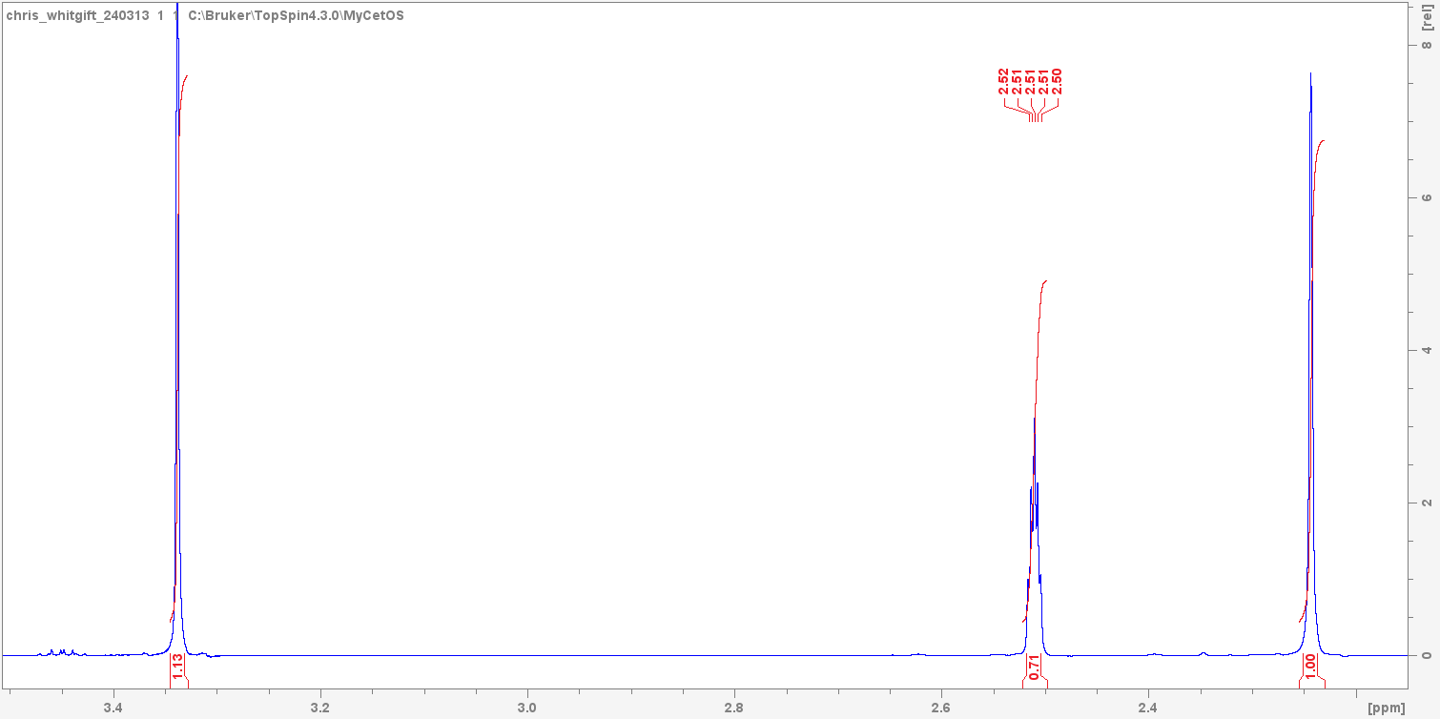

A

DMSO

H2O

E

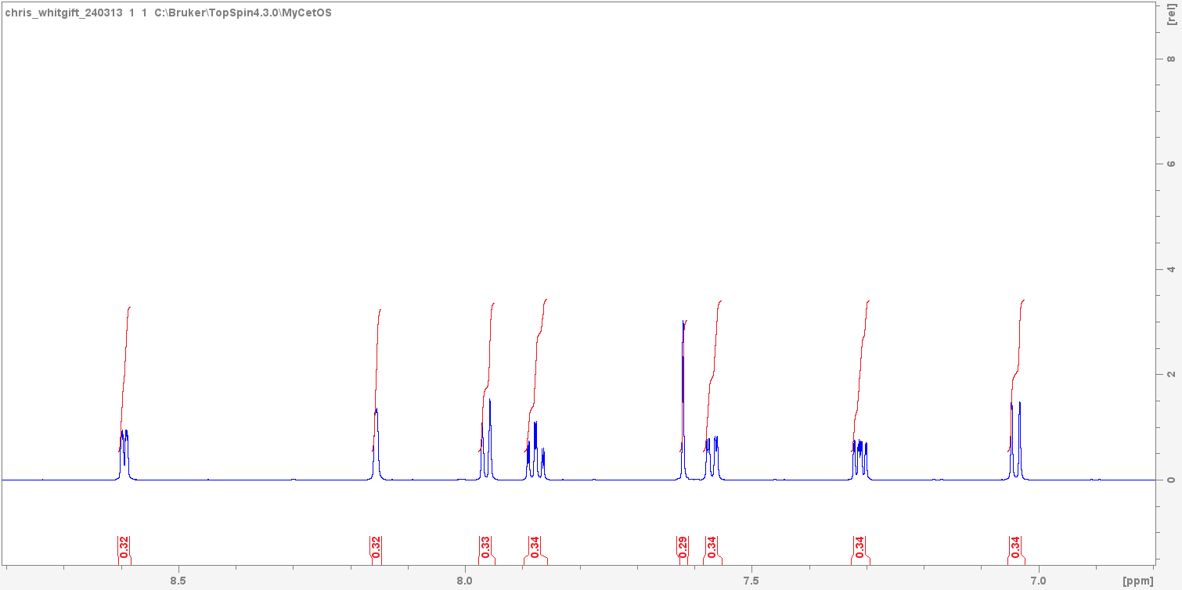

B

F

J

D

G

H

I

C

**13C NMR**

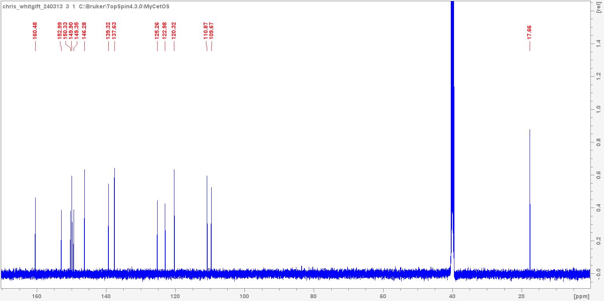

1

DMSO

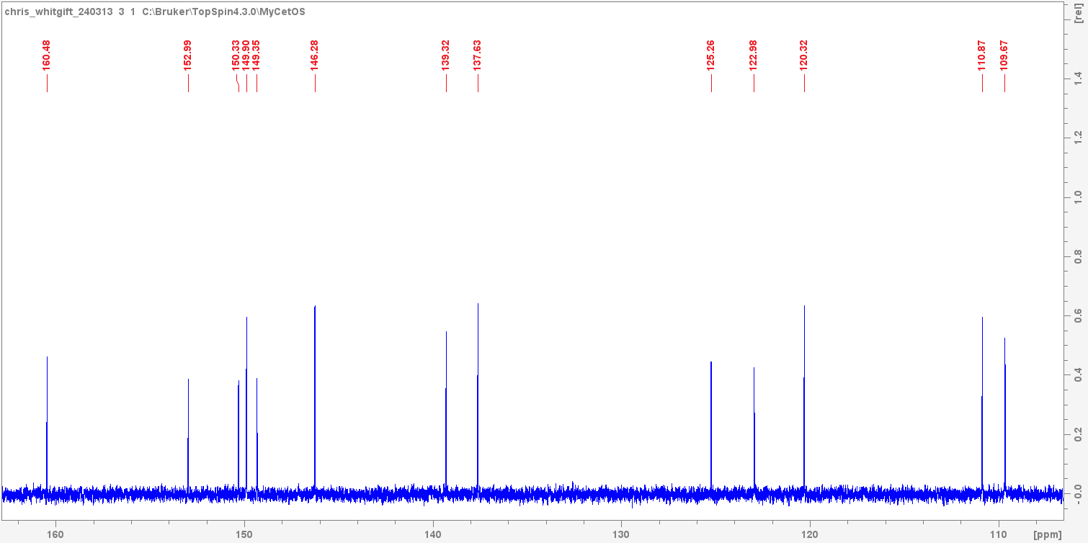

7

10

6

5

14

9

4

13

2

11

3

12

8

**SAMPLE: JH**

**1H NMR**

**SAMPLE: SAM**

**1H NMR**

**SAMPLE: QUENTIN**

**1H NMR**

**SAMPLE: JWSC**

**1H NMR**

