**Projectile Motion: Angry Birds[1]**

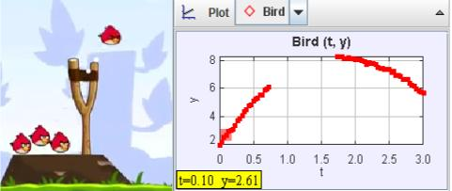

In the game *Angry Birds*, birds are shot from a slingshot. Does their motion follow projectile motion? If so, how big are they? When we do video analysis, we use something in the video to calibrate the video to determine how many pixels=1m. In the case of *Angry Birds*, instead of scaling the video with a known object on the screen, we can scale the video by the acceleration due to gravity, assuming the *Angry Bird* world is the Earth.

Download or find in the zip file the following:

* angry_bird_short.mov
* angry_bird_projectile.trk

The “trk” file is a partially marked Tracker file and if you double click it (and Tracker is installed), it should launch a tab in Tracker (it will likely ask you where the video file is and you will have to point it to where you downloaded the mov file). Play the video and notice that the “camera” moves to follow the bird and that the window changes size.

In order to track the bird, we will need a fixed origin (the sling slot) and since the origin goes off screen, we need an offset point (the distance from the sling shot to a blade of grass that shows up for most of the trajectory of the bird).

We also need a set length since the movie zooms in and out. It turns out that the height to the fork of the slingshot is the same as the height of the pedestal the pig sits on so that is length “1” in “trk” file. So, even as the images zooms and pans, the length of the pig’s pedestal is always “1” and the location of the origin is set. DO NOT adjust the “Coordinate Offset” or the “Calibration Stick” or the data will no longer account for the movement of the “camera” or the “zooming” in and out on the screen.

The“trk” file already has the position of the angry bird marked. The track of the marked points is not a parabola on the video. Why not?

However, the plots of x vs t and y vs t match more closely what you might expect for projectile motion.

Sketch the plot of x vs t below:

Explain why some points are missing:

Explain why the plot is a straight line:

Now, sketch the y-position data as a function of time (click on the vertical axis label “x” and change it to “y”).

Why is it parabolic (or would be if there weren’t missing data)?

We are going to fit the data of the position versus time data. Right-click on a plot (graph) you want to fit (y versus t for one of the masses) and choose Analzye:

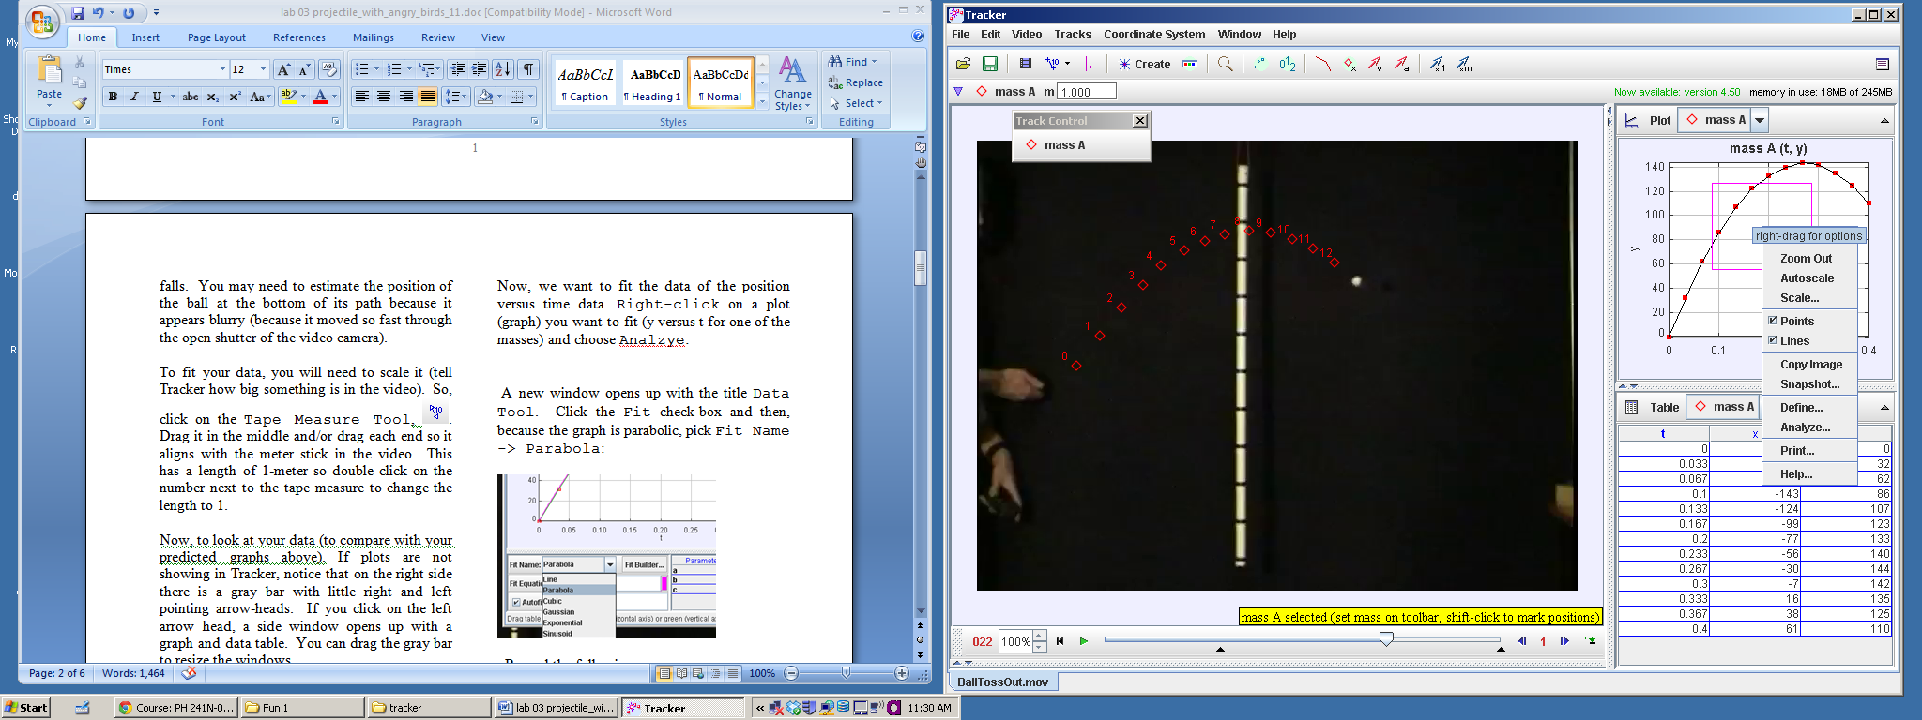

A new window opens up with the title Data Tool. Click the Fit check-box and then, because the graph is parabolic, pick Fit Name -> Parabola:

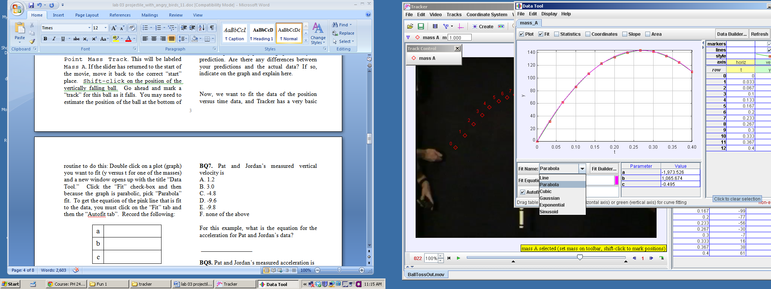

Record the following:

|  |  |
| --- | --- |
| a |  |
| b |  |
| c |  |

The equation of fit is for an equation of the form:

y=at2+bt+c

Now, when two students, Pat and Jordan fit their data they got the following (this is **not** the data you will get, it is simply an example):

|  |  |
| --- | --- |
| a | -4.8 |
| b | 3.0 |
| c | 1.2 |

Taking the above information and transforming it to the book’s notation, their equation of motion would be the following:



**For this example**, (assuming that the ball has just left the hand at t = 0) what is the equation of the velocity in the y-direction (differentiate the equation of displacement):

__________________ (for Pat & Jordan’s data)

What is the vertical velocity right after the ball left the hand of the person throwing in this example?

__________________ (for Pat & Jordan’s data)

**Q1.** Pat and Jordan’s measured initial vertical velocity is

A. 1.2

B. 3.0

C. -4.8

D. -9.6

E. -9.8

F. none of the above

For this example, what is the equation for the acceleration for Pat and Jordan’s data?

_________________

**Q2.** Pat and Jordan’s measured acceleration is

A. 1.2

B. 3.0

C. -4.8

D. -9.6

E. -9.8

F. none of the above

**Now, back to your data.**

What is **your** equation of motion?

y = _____________________

Differentiating this, what is **your** equation for the velocity as a function of time?

vy = ______________________

What is the “initial” velocity in the y-direction (velocity leaving the sling shot)?

v0y = _________________

What is the acceleration (from **your** data)?

ay = ________________

You should not get a value of -9.8 or anything close to that because your acceleration is in units of pig pedestal/second2. Why is that your unit instead of m/s2??

If we assume the acceleration due to gravity is -9.8 m/s2, what is the conversion for pig pedestal units to meters? For example, if Pat and Jordan found (with different data from above):

ay = __-3.5 pig pedestals/s2__________

Then they know that

3.5 pig pedestals= 9.8 m or

1 pig pedestal = 2.8 m

What is your conversion between pig pedestals and meters?

1 pig pedestal = ___________ m

Your “measuring tape” is calibrated to pig pedestal units. Click on your measuring tape (Tape A) to measure the following (click on an end to adjust the length):

How many pig pedestal units tall is the sling shot? _____________

How many meters is that?___________

How many pig pedestal units is the angry bird?

_______________

How many meters tall is the angry bird?

______________

Is that a big or small bird? Explain.

From your tracker data, what is the initial y-velocity of the angry bird in m/s (instead of pig pedestal units/s):

voy = ___________________m/s

Now, go back to the graph of x versus time and fit the x-position data to a line (instead of a parabola):

|  |  |
| --- | --- |
| a |  |
| b |  |

(from y = a*t+b)

x-position equation:

x = _____________________

What is the initial velocity in the x-direction?

v0x = __________________pig pedestals/s

and in meters/s:

v0x = _________________ m/s

What then is the initial speed of the launch from the sling shot (magnitude of the initial velocity vector)?

1. Inspired by Rhett Allain’s DotPhysics blog for Wired Magazine: “The Physics of Angry Birds,” Oct 8, 2010. <http://www.wired.com/wiredscience/2010/10/physics-of-angry-birds/> and by Frank Nochese’s Action-Reaction blog, “Angry Birds in the Classroom,” <http://fnoschese.wordpress.com/2011/06/16/angry-birds-in-the-physics-classroom/> (accessed Nov 21, 2011).