实验（第五章 中断字符设备驱动）
实验一、中断字符设备驱动实验
按键扫描驱动（通过外部中断）
1. 实验目的
采用中断方式实现按键扫描驱动，通过该实验可使学员掌握在Linux驱动中如何实现中断处理。
2．实验内容
编写一个简单的字符设备驱动程序，通过外部中断实现四个按键的扫描。
3. 按键原理图
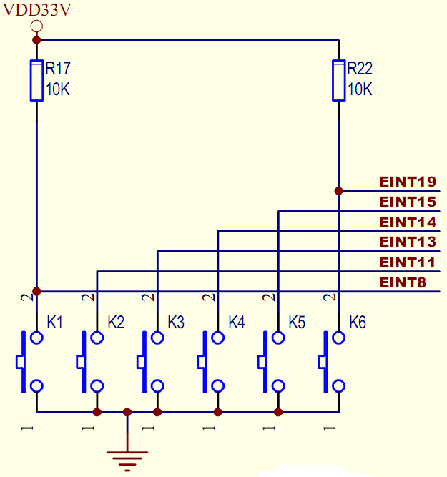
图：按键扫描原理图
3. 实验步骤
3.1 添加驱动程序到内核中：
    - 修改目录~/drivers/char/下的Kconfig文件，在100行处添加如下内容
config PAN_KEY_IRQ
tristate “PAN_BUTTONS Driver”
depends on MACH_MINI2440
default m if MACH_MINI2440
help
this is a myself buttons driver

    - 修改目录~/drivers/char/下的Makefile文件，在115行处添加如下内容
obj-$(CONFIG_PAN_KEY_IRQ) += pan_irq.o
3.1.3 在目录文件~/drivers/char/下添加文件文件pan_irq.c，具体内容如下：
#include <linux/module.h>
#include <linux/kernel.h>
#include <linux/fs.h>
#include <linux/init.h>
#include <linux/delay.h>
#include <linux/poll.h>
#include <linux/irq.h>
#include <asm/irq.h>
#include <linux/interrupt.h>
#include <asm/uaccess.h>
#include <mach/regs-gpio.h>
#include <mach/hardware.h>
#include <linux/platform_device.h>
#include <linux/cdev.h>
#include <linux/miscdevice.h>
#include <linux/sched.h>
#include <linux/gpio.h>
#include <linux/wait.h>

#define PAN_IRQ_MAJOR 236 /*预设的pan_irq的主设备号*/
#define MAX_KEYS 6 /*6个按键*/

static int pan_irq_major = PAN_IRQ_MAJOR;

MODULE_LICENSE("Dual BSD/GPL");

static int ev_press=0;
static DECLARE_WAIT_QUEUE_HEAD(pan_irq_waitq);

static int pan_irq_values[6] = {0};

struct pan_irq_pin
{
int irq;
int pin;
int pin_setting;
unsigned long flags;
char *name;
};

static struct pan_irq_pin pan_button_irq[] =
{
{IRQ_EINT8 , S3C2410_GPG(0) , S3C2410_GPG0_EINT8 , IRQF_TRIGGER_FALLING, "KEY0"},
{IRQ_EINT11, S3C2410_GPG(3) , S3C2410_GPG3_EINT11 , IRQF_TRIGGER_FALLING, "KEY1"},
{IRQ_EINT13, S3C2410_GPG(5) , S3C2410_GPG5_EINT13 , IRQF_TRIGGER_FALLING, "KEY2"},
{IRQ_EINT14, S3C2410_GPG(6) , S3C2410_GPG6_EINT14 , IRQF_TRIGGER_FALLING, "KEY3"},
{IRQ_EINT15, S3C2410_GPG(7) , S3C2410_GPG7_EINT15 , IRQF_TRIGGER_FALLING, "KEY4"},
{IRQ_EINT19, S3C2410_GPG(11) , S3C2410_GPG11_EINT19 , IRQF_TRIGGER_FALLING, "KEY5"},
};

/*pan_irq设备结构体*/
struct cdev *pan_irq_cdev;

/*中断处理函数*/
static irqreturn_t pan_irq_interrupt(int irq, void *dev_id, struct pt_regs *regs)
{
volatile int *pan_irq_values = (volatile int *)dev_id;
*pan_irq_values = *pan_irq_values + 1;
ev_press = 1; /* 表示中断发生了 */
wake_up_interruptible(&pan_irq_waitq); /* 唤醒休眠的进程 */
return IRQ_RETVAL(IRQ_HANDLED);
}

/*文件打开函数*/
int pan_irq_open(struct inode *inode, struct file *filp)
{
int i,err;
for (i = 0; i < sizeof(pan_button_irq)/sizeof(pan_button_irq[0]); i++)
{ // 注册中断处理函数
s3c2410_gpio_cfgpin(pan_button_irq[i].pin, pan_button_irq[i]. pin_setting);
err=request_irq(pan_button_irq[i].irq, pan_irq_interrupt,pan_button_irq[i].flags, pan_button_irq[i].name, (void *)&pan_irq_values[i]);
if (err)
break;
}
if (err)
{
// 释放已经注册的中断
i--;
for (; i >= 0; i--)
{
free_irq(pan_button_irq[i].irq, (void *)&pan_irq_values[i]);
}
return -EBUSY;
}
return 0;
}
/*文件释放函数*/
int pan_irq_release(struct inode *inode, struct file *filp)
{
int i;
for (i = 0; i < sizeof(pan_button_irq)/sizeof(pan_button_irq[0]); i++)
{
// 释放已经注册的中断
free_irq(pan_button_irq[i].irq, (void *)&pan_irq_values[i]);
}
return 0;
}

/* ioctl设备控制函数 */
static int pan_irq_ioctl(struct inode *inode, struct file *filp, unsigned int cmd, unsigned long arg)
{
return 0;
}

/*读函数*/
static ssize_t pan_irq_read(struct file *filp, char __user *buff, size_t count, loff_t *offt)
{
unsigned long err;
ev_press = 0;
/* 将按键状态复制给用户，并清0 */
err = copy_to_user(buff, (const void *)pan_irq_values, min(sizeof(pan_irq_values), count));
memset((void *)pan_irq_values, 0, sizeof(pan_irq_values));
return err ? -EFAULT : 0;
}

static unsigned int pan_irq_poll(struct file *filp, poll_table *wait)
{
unsigned int mask = 0;
poll_wait(filp, &pan_irq_waitq, wait);
if(ev_press)
{
mask |= POLLIN | POLLRDNORM;
}
return mask;
}

/*写函数*/
static ssize_t pan_irq_write(struct file *filp, const char __user *buf, size_t size, loff_t *offt)
{

return 0;
}

/*文件操作结构体*/
static struct file_operations pan_irq_fops =
{
.owner = THIS_MODULE,
.read = pan_irq_read,
.write = pan_irq_write,
.ioctl = pan_irq_ioctl,
.open = pan_irq_open,
.release = pan_irq_release,
.poll = pan_irq_poll,
};

/*初始化并注册cdev*/
static void pan_irq_setup_cdev(struct cdev *dev, int index)
{
int err, devno = MKDEV(pan_irq_major, index);

cdev_init(dev, &pan_irq_fops);
dev->owner = THIS_MODULE;
dev->ops = &pan_irq_fops;
err = cdev_add(dev, devno, 1);
if (err)
printk(KERN_NOTICE "Error %d adding LED%d", err, index);
}

/*设备驱动模块加载函数*/
int pan_irq_init(void)
{
int result, ret;
dev_t devno = MKDEV(pan_irq_major, 0);

/* 申请设备号*/
if (pan_irq_major)
result = register_chrdev_region(devno, 1, "pan_irq");
else /* 动态申请设备号 */
{
result = alloc_chrdev_region(&devno, 0, 1, "pan_irq");
pan_irq_major = MAJOR(devno);
}
if (result < 0)
{
printk(KERN_WARNING"pan_irq: unable to get major %d\n", pan_irq_major);
return result;
}

/*动态申请结构体内存*/
pan_irq_cdev = kmalloc(sizeof(struct cdev), GFP_KERNEL);
if(!pan_irq_cdev)
{
ret = -ENOMEM;
goto fail_malloc;
}
memset(pan_irq_cdev, 0, sizeof(struct cdev));
pan_irq_setup_cdev(pan_irq_cdev, 0);

printk("pan_irq installed, with major %d\n", pan_irq_major);
return 0;

fail_malloc: unregister_chrdev_region(devno, 1);
return result;
}

/*模块卸载函数*/
void pan_irq_exit(void)
{
cdev_del(pan_irq_cdev); /*注销cdev*/
kfree(pan_irq_cdev);
unregister_chrdev_region(MKDEV(pan_irq_major, 0), 1); /*释放设备号*/
printk("pan_irq device uninstalled\n");
}

MODULE_AUTHOR("xxxxxxxxx");

module_init(pan_irq_init);
module_exit(pan_irq_exit);
3.2. 配置内核
执行以下命令
# make menuconfig 注：要将编译pan_irq.c选项选择“M”
# make zImage
# make SUBDIR=drivers/char/ modules
最终在~/divers/char/目录下，生成pan_irq.ko模块
3.3. 编写测试程序
3.3.1 在/root/test目录下新建pan_irq_test.c和Makefile文件
文件pan_irq_test.c的内容为：
/*******************************************************
NAME: pan_irq_test.c

*******************************************************/

#include <stdio.h>
#include <stdlib.h>
#include <unistd.h>
#include <sys/ioctl.h>
#include <sys/types.h>
#include <fcntl.h>
#include <sys/select.h>
#include <sys/time.h>
#include <errno.h>
int main(void)
{
int i;
int fd;
int press_cnt[6]={0,0,0,0,0,0};
int sum[6] = {0,0,0,0,0,0};

//打开键盘设备文件
fd = open("/dev/pan_irq", 0);
if(fd<0)
{
printf("cannot open /dev/pan_irq\n");
return -1;
}
for(;;)
{
int ret;
fd_set rds;
FD_ZERO(&rds);
FD_SET(fd, &rds);

ret = select(fd+1, &rds, NULL, NULL, NULL);
if(ret<0)
{
perror("select error!");
exit(1);
}
if(ret==0)
printf("select timeout!\n");
if(FD_ISSET(fd, &rds))
{
/*开始读键盘驱动发出的数据，注意key_value和键盘驱动中定义为一致的类型*/
ret = read(fd, press_cnt, sizeof(press_cnt));
/*打印键值*/
for(i=0; i<6; i++)
{
sum[i] = sum[i] + press_cnt[i];
if(press_cnt[i])
printf("K%d has been pressed %d times! sum = %d times!\n", i+1, press_cnt[i], sum[i]);
}
}
}
close(fd);
return 0;
}
文件Makefile的内容为：
EXEC=pan_irq_test
OBJS=pan_irq_test.o
SRC=pan_irq_test.c

CC=arm-linux-gcc
CFLAGS+=-O2 -Wall
LDFLAGS+=

all:$(EXEC)

$(EXEC):$(OBJS)
$(CC) $(LDFLAGS) -o $@ $(OBJS)

%.o:%.c
$(CC) $(CFLAGS) -c $< -o $@

clean:
@rm -vf $(EXEC) *.o *~
    - 使用命令make pan_irq_test编译生成可执行程序pan_irq_test；
3.3.3 将pan_irq.ko与pan_irq_test拷贝到rootfs中，重新制作根文件系统镜像文件，并将其移植到开发板上
3.4. 调试
3.4.1 将S2开关拨在NANDFLASH上，打开电源，进入系统
3.4.2 加载模块
# insmod pan_irq.ko
3.4.3 创建设备文件
用mknod命令在目标机的根文件系统的/dev下创建设备节点。mknod的命令如下：
# mknod /dev/pan_irq c 236 0
其中pan_irq是设备节点的名字，“c”代表该设备为字符（char）设备，236是设备的主设备号，0是设备的次设备号。

3.4.4 运行pan_irq_test，方法如下：
#./pan_irq_test
运行该命令后，会打印出对应哪个按键被按下，及按下的次数。
4．实验结果
当按下某个按键时，会在按键按下和释放时分别产生一次中断，并在终端打印出对应哪个按键别按下。
