PRIVILEGED AND CONFIDENTIAL
Attorney-client communication, prepared at the request of counsel. Not for filing or distribution.

Inventor's Responses to Counsel's Questions
WSU 26-1902 | FS 66174-0372 | Provisional application: vertebral level determination from limited-field projection images
Inventor | Gregory J. Schwing, MD, PhD, Department of Surgery (General Surgery), Wayne State University School of Medicine / Detroit Medical Center
Prepared for | Meeting with patent counsel on preparing the provisional application
Date | 20 October 2026
Answers to | "WSU 26-1902 FS 66174-0372 Questions to Inventor" (60 questions)
Based on | The draft provisional (SPECIFICATION.md, CLAIMS.md of 18 September 2026), the WSU disclosure package of 25 September 2026, and the code and result records of the research repositories, read at fixed commits (spine-program 240cabc; spinesurg-ct-nnunet 0ab783f)

Contents
1. What counsel should know first
2. Numbers in the draft to replace before filing
3. Answers to the 60 questions
3.1 Prior Art, Disclosures and Timing (Q1-5)
3.2 System and Naming Module (Q6-10)
3.3 Acquisition Protocol and Landmark (Q11-14)
3.4 Scale Recovery and Detection Repair (Q15-18)
3.5 Linking (Q19-25)
3.6 Chain and Alphabets (Q26-30)
3.7 Confidence and Commanded Displacement (Q31-40)
3.8 Later-Image Registration and Prediction Sets (Q41-44)
3.9 Persistent Digital Marker (Q45-48)
3.10 Performance, Variations and Other Anatomy (Q49-51)
3.11 Claims (Q52-60)
A. Subject matter added after the draft
B. References for the information disclosure statement
C. Open items for the meeting

1. What counsel should know first
Most answers are routine: ranges, alternatives and examples to widen the specification. Ten points change what is filed or when, and they are listed here in order of consequence.
- The draft provisional does not describe Part A, and the WSU disclosure does not describe the draft. The draft (18 September) is a third invention: overlapping C-arm exposures linked into a chain, alternative alphabets, a confidence that commands the next move, and a persistent digital marker. The disclosure form (25 September) covers Part A (preoperative CT) and Part B (single C-arm exposure) and never mentions a chain, overlap or sweep. A supplemental disclosure to WSU should cover the chain (Q1, Figure 1).
- The disclosure timeline given to WSU is incomplete for Parts A and B. It says no public item discloses either part. A later review of the public repositories (SCRUB_PLAN.md, 26 September) found that some did: documents pushed by mistake to the public CTSpinoPelvic1K repository on 4 September disclosed Part B concepts (an anchor at the sacral base, a transitional flag, the evaluation design); scripts public from 7 September implemented Part A elements (a rule-based call per record, the call printed with the scores behind it); a design note public by 27 August stated Part A's name-free premise in part; and a Zenodo build archive of 7 September carries Part A results. These cannot be withdrawn; for the United States they start the one-year grace period on the dates given, and abroad they count at once. The same review found nothing public about the chain. The GitHub Support purge requests drafted that day have no record of being filed. Section 6 of SCRUB_PLAN.md lists the corrections owed to the WSU package (Q1, Q5).
- Part A is design only. Its features are extracted on 3,524 CT and segmenter pairs, but no classifier has been trained. I recommend it go in a later provisional (Q1).
- The measured numbers in the draft must be replaced before filing. On the morning of 18 September, 681 of the 801 render subjects were found to be in the naming network's training set (commit d6f407a); the draft, written that evening, still carries those numbers. On 19 September every earlier render was found to have the wrong field size. Section 2 lists each affected paragraph with its corrected, held-out value. The claims recite no accuracy, so this is a support and candour matter, not a claim matter.
- Three statements of mechanism or result are now known to be overstated. [0048]: widening the search window barely changes counting, so the window is not the mechanism (Q20, Figure 7). [0073]: the reduced-resolution search has not been shown to lose nothing; a real-frame check disagreed (Q42). [0083a]: on a later phantom about one in four asserted marker positions still fell on the neighbouring vertebra (Q47).
- Subject matter invented after the draft should be added while the provisional is still unfiled: a fifth alphabet (four lumbar), the C2 anchor class, the end rule ("the last move is a full move or none"), the global link solve, masked correlation for a round receptor, an end-plate filter, a pixel-spacing guard, needle confirmation and the start-from-target workflow (Appendix A).
- [0071c] refers to the wrong paragraph. The return to the operative field belongs to the start-from-target mode, which the specification never describes. It should get its own section, since claim 4 depends on it (Q37).
- Closest prior art for the IDS: SX-Stitch (arXiv:2409.05681, overlapping intraoperative C-arm images stitched, no naming) and US 8,718,346 (NuVasive; stitched C-arm composite with labels placed by hand), with the LevelCheck family and its patents for registration (Q2, Q3, Appendix B).
- Timing. Nothing public discloses the chain (DISCLOSURE_MEMO.md). Four things must wait for the filing: the Part B manuscript (held), a data request to the SX-Stitch authors (drafted, not sent, and it describes the method), older manuscript drafts and a QI paper that describe the sweep (unsubmitted), and any CNS talk content beyond the cleared public deck (talk on 2 November 2026). The memo also recommends exporting the GitHub audit log before filing.
- No real overlapping intraoperative series has been tested. Part B has real C-arm results (in the manuscript); the chain does not. A phantom or cadaver sweep on a hospital C-arm is the fastest addition before the non-provisional (Q5).
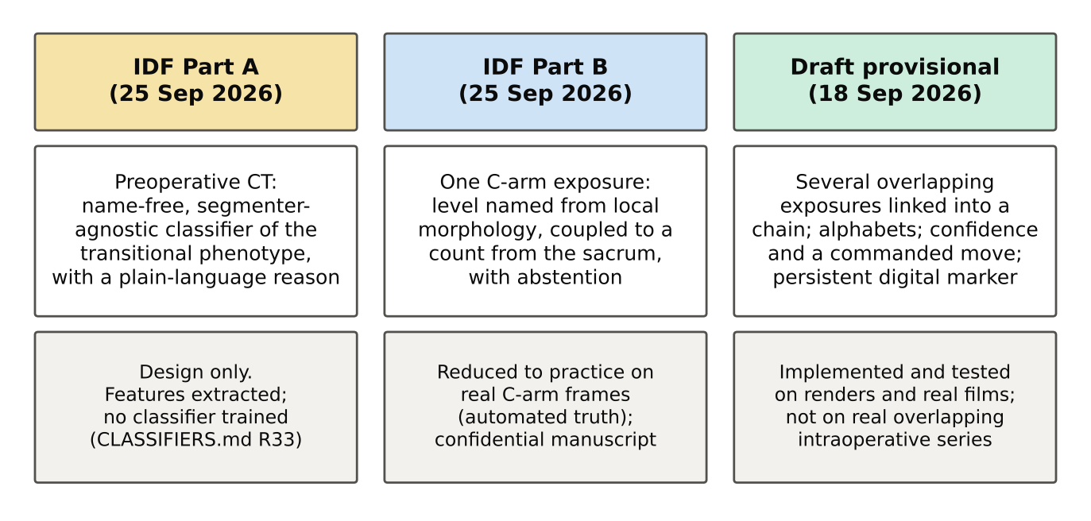
Figure 1. Three framings of one programme. The WSU disclosure has Parts A and B; the draft provisional describes a third invention, the chain, which the disclosure form does not mention. Sources: 00_README_for_TTO.md; CLASSIFIERS.md R33; 01 STATUS.md.

How to read the answers
Each answer carries one status tag, so counsel can see at a glance what the record supports:
Tag | Meaning
Shown in the repository | Implemented in code, or measured with a recorded result file
Shown on renders or synthetic data only | Measured, but on CT renders, a synthetic subject or a phantom; not on real intraoperative images
Inferred: inventor's judgement, not tested | My technical view, offered to widen the specification; no code or measurement behind it
Not recorded | No file records the fact asked for
Design only | Written down as a plan; not built

Links. Source links point to two private GitHub repositories at fixed commits (OpenSpineConsortium/spine-program and the inventor's spinesurg-ct-nnunet), which open only for an account given access. Every linked file is also in this package, in the folder 05_Evidence; Appendix D maps each link to its file. Numbers marked RECORD ONLY are held-out results on renders with the annotation's boxes; they support the description and are not for marketing claims.
Ranges. Where a question asks for a working range, the value actually used is stated first; the range around it is my judgement unless the answer says it was measured.

2. Numbers in the draft to replace before filing
Two corrections reach most measured statements in the draft. (1) Training-set overlap: 681 of the 801 render subjects, 145 of 170 real radiographs and 64 of 76 whole-spine subjects had been seen by the naming network (commit d6f407a, 18 September, 07:50). (2) The row-spacing defect: every render sweep before sweep_v3 (19 September, job 40384843) used the wrong field size. Only sweep_v3 results, on the subjects held out from the network, count.
Para. | Draft says | Problem | Use instead
[0035] | 801 subjects; 86.6 / 93.6 / 95.1 / 95.2 / 93.2 % at O = 0.5 to 4; chains 94.2 to 80.4 % | Training-set overlap; wrong field size | Chains completed on 120 held-out renders: 81.7 (0.5), 95.8 (1), 91.7 (1.5), 97.5 (2), 96.7 (2.5), 90.8 (3), 82.5 % (4). Figure 6
[0036] | 2.5 / 2.6 / 3.0 / 6.9 exposures | Same | 3.4 exposures at O = 2 (120 held out); with the end rule 120 of 120 chains complete
[0053] | Detector missed 2.2 %; 17.9 % entered twice (real radiographs) | Real films, so no field-size defect; result file not named in the record | Keep only if the file is found; otherwise state the effect without numbers
[0063] | 85.8 % per node versus 95.5 % decoded (9.7 points) | 18-September corpus | Re-run on sweep_v3 or state without numbers
[0070] | 4,792 frames; 95.7 versus 95.3 %; 42 versus 82 % | 18-September corpus; result file not named | See Q34: re-run, or keep the reasoning only
[0076] | 69.6 to 95.1 %, 85.9 to 95.0 %, 91.2 to 95.7 %; 31.1 to 99.3 % on 76 subjects; nine transitional subjects all correct | Training-set overlap; wrong field size | 120 held-out renders: 72.1 to 95.2 (2 bodies), 86.8 to 94.7 (3), 90.2 to 94.8 % (4). 12 held-out whole spines from C2: 9.5 to 100, 25 to 100, 30 to 100 %. Figure 8
[0083a] | Every asserted marker position fell on the marked vertebra | One synthetic subject; a later phantom left about 1 in 4 on the neighbour | Report as synthetic, or drop the numbers
[0084], [0007] | 179 placements, 52 minutes, 183 mGy | Correct, uncited | Cite Siminski et al. 2023 (Q4)
[0087] | 2.29 and 22.94 ms (GPU); 18.30 and 330.58 ms (CPU); later stages untimed | Older benchmark of older models; later stages now timed | Model card 6.3 timings with their limits (Q49)

Counting along the chain with correct boxes, which needs no network, gives the strongest current evidence: 834 of 834 walks from C2 on 76 whole spines; 99.66 per cent of 6,255 walks on 801 renders; and 1,204 of 1,209 walks (99.67 per cent) on 262 real cervical films (COUNTING_EVIDENCE.md). With detector boxes on renders it falls to 30.06 per cent: detection, not linking, is the binding constraint, which matters for how the product is described but not for the claims.
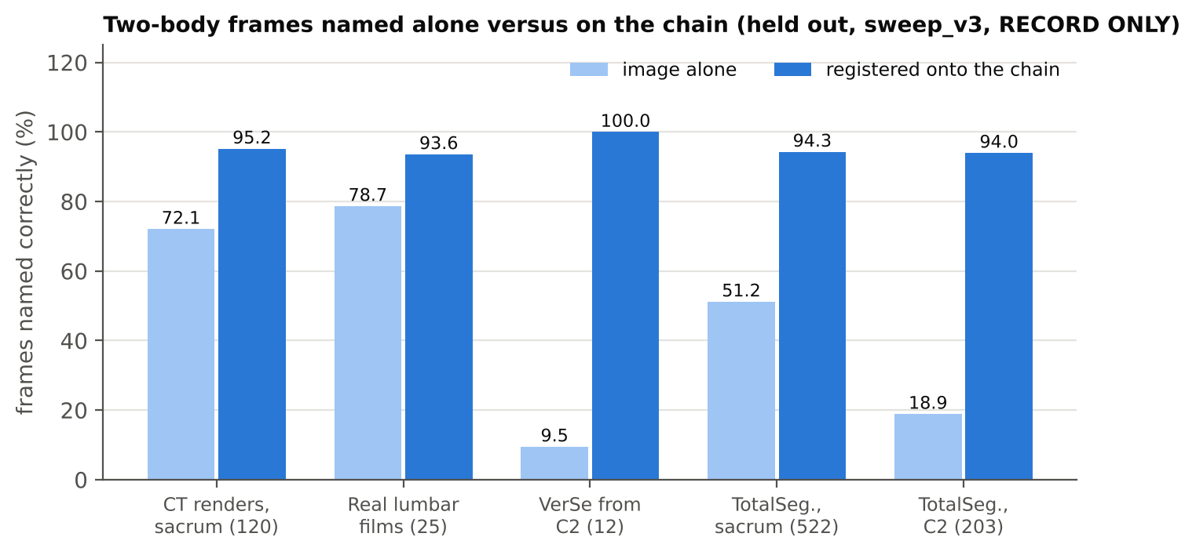
Figure 8. Frames with two bodies named from the image alone and after registration onto the chain, held out, sweep_v3, true boxes. RECORD ONLY. These replace the figures in [0076]. Source: sweep-map-replaces-registration.md; RESULTS_CATALOG.md C3.1-C3.3.

3. Answers to the 60 questions
Grouped as in counsel's list. The question text is counsel's, sometimes shortened.

3.1 Prior Art, Disclosures and Timing

Question 1 00_README
The provisional will only cover Part A (but not "as claimed" per 00_readme). What is meant by "plan-language reasons"? Is all of the subject matter within these documents sufficient to describe Part A for a provisional filing and later non-provisional conversion?
SHOWN IN THE REPOSITORY
The premise needs correcting before anything else: the draft provisional does not describe Part A at all. Three different framings exist (Figure 1). The WSU disclosure of 25 September has Part A (a preoperative CT classifier) and Part B (naming a level from one C-arm exposure). The draft provisional in the provisional/ folder, written on 18 September, describes a third thing: several overlapping C-arm exposures linked into a patient-specific chain, decoded against alternative alphabets, with a confidence that commands the next C-arm move and a persistent digital marker. The disclosure form never mentions a chain, an overlap or a sweep (a text search of the form returns none of the three words). It is closest to Part B's setting, the intraoperative C-arm, but it is a separate invention with its own dated record (first commit 6984446, 17 September 2026, 22:11).
"Plan-language reasons" is a typo for plain-language reasons. Part A outputs, with each call, a short sentence built from the features that drove it. An example from the design: "6 rib-free bodies above a sacral plateau at 240 mm; last rib 41 mm right / 12 mm left; TP-ala contact 0 mm2 both sides". The sentence is generated from the top-ranked feature attributions (SHAP values) of the trained classifier, so a radiologist can check the call against the image.
One correction to the WSU package bears on Part A. The disclosure timeline says nothing public discloses Part A or Part B. The review of 26 September (SCRUB_PLAN.md) found Part A elements public in the CTSpinoPelvic1K repository: a design note stating, in part, that the segmentation classes carry no vertebral identity (by 27 August), scripts making a rule-based call per record and printing the scores behind it (7 September), and Part A results in a Zenodo build archive (7 September). Part B concepts were public from 4 September in documents pushed by mistake and later removed, which remain fetchable by commit. Counsel should weigh these against any Part A or Part B claim; none of them touches the chain.
"Not as claimed" in the README means that what has already been made public (the NeurIPS paper, the dataset, the AACA slides) does not disclose Part A's classifier as it would be claimed. It does not mean that Part A is ready.
Part A is not reduced to practice, and the material is probably not enough to support it in a provisional. The design is written out in detail: the name-free features (rib presence traced in the CT, the rib-free body count above the sacral plateau, the transverse-process to sacral-ala contact area, disc and end-plate geometry, the iliac crest line), the model (gradient-boosted trees plus a small recurrent network over the column), the reason string, an "unusual spine" out-of-distribution flag, and abstention when the junction is outside the field. The features have been extracted on 3,524 CT and segmenter pairs. But no classifier has been trained: the spread gate J2 failed and the training job J3 was never submitted (CLASSIFIERS.md row R33). At current sample sizes only the ordinary and L6 classes are certifiable. A constructive reduction to practice is possible on paper, but there are no results to describe.
Drafting suggestion
- Decide with counsel which invention this first provisional is for. The chain and closed-loop material is the most complete and most commercially distinctive, and it is ready. My recommendation: file the chain provisional now, with a short Part B section (single-exposure naming, the count from the sacrum, abstention, per-device image formation) drawn from the confidential manuscript, since that manuscript is the one enabling disclosure and is being held for this filing. Part A can be a second provisional once its classifier is trained.
- Ask WSU for a supplemental disclosure covering the chain, so the TTO record matches the application.
Sources: 00_README_for_TTO.md; SCRUB_PLAN.md; INVENTION_DISCLOSURE.md; CT_LSTV_CLASSIFIER_PLAN.md; CLASSIFIERS.md (R33); commit 6984446 (first commit of the sweep, 17 Sep 2026)

Question 2 [0004]
Which commercial systems, products or publications do you have in mind for the registration-based systems that import vertebral numbering from a preoperative CT/MR volume?
SHOWN IN THE REPOSITORY
The reference is to LevelCheck and its family from Johns Hopkins (Siewerdsen's group): a preoperative CT, with levels labelled, is registered to the intraoperative radiograph and the labels are projected across. Key citations: Otake et al. 2012 (Phys Med Biol); Lo et al. 2015; De Silva et al., Spine 2016 (PMID 27035579); the multi-scale version msLevelCheck (PMID 28375139); the clinical evaluation (PMID 25646750); and MR-LevelCheck (Phys Med Biol 2017;62(2):684, PMC5321067).
Patents on the same approach: US 11,284,846 (Siemens Healthineers with Johns Hopkins; claim 1 requires a preoperative 3D CT), US 10,368,956 (Johns Hopkins; requires a preoperative 3D MR and display of the registered volume), and US 12,223,118 (stored image based on a 3D representation of the surgical field).
Commercial navigation that relies on a preoperative or intraoperative 3D volume registered to the patient: Medtronic StealthStation with O-arm and Mazor, Globus ExcelsiusGPS, Stryker's spine navigation, Brainlab, and the 3D-capable C-arms of Siemens (Cios Spin), GE (OEC 3D), Ziehm and Philips. None of these names a level from 2D C-arm images alone.
Drafting suggestion
- All of the above belong in the IDS. The freedom-to-operate notes say none of the four patents is infringed, but the INPADOC family sweep for continuations has not been done yet; it should be commissioned.
Sources: PRIOR_ART_LEVEL_ID_XRAY.md; INVENTION_DISCLOSURE.md, freedom-to-operate table

Question 3 [0005]
Do you know of image-stitching or panoramic techniques, such as long-leg or full-spine stitching with radiopaque rulers or grids, that join overlapping radiographs? How does your linking differ from them?
SHOWN IN THE REPOSITORY
Yes. The closest prior art here should be in the IDS:
SX-Stitch (Li Y, Gao H, He M, Liang J, Gu J, Liu W; arXiv:2409.05681, 2024). It stitches 1,032 intraoperative C-arm spine images in consecutive overlapping series with 20 to 90 per cent overlap, using a segmentation network. It is the closest published acquisition to ours. It produces a picture and does not name any vertebra.
US 8,718,346 (NuVasive, originally Saferay Spine) discloses, but does not claim, stitching several C-arm exposures into a composite and showing level labels on it. The labels are placed by hand by the surgeon (pull-down menu, drag and drop). Nothing is determined automatically, and no claim recites naming a vertebra.
Huang et al. 2022, Comput Methods Programs Biomed 227:107222: O-arm long-film stitching with level labels, 88.3 per cent on 13 cadavers. This needs the O-arm gantry.
Conventional long-film stitching for scoliosis and long-leg films (vendor auto-stitch with a radiopaque ruler or grid on DR rooms) aligns images by the ruler or by the table encoder.
How our linking differs. (1) The purpose is identity, not a picture: we find which vertebral bodies two exposures share, and build a chain whose members are the same bones seen in different images. (2) Alignment comes from the anatomy in the overlap, with no ruler, grid, tracker or encoder. (3) The search is confined to a window about the commanded step, so the periodic spine cannot alias the link by one vertebra; a stitcher has no notion of a vertebral period. (4) Each link reports a margin: how much better it is than a link one vertebra away. That margin feeds the confidence and decides the next commanded move. (5) The chain is named as a whole against alternative alphabets with a landmark at one end. No stitching method decodes identity or controls the next acquisition.
Drafting suggestion
- Keep the claim language on the shared-vertebra determination and the closed loop, not on "joining images". A claim that reads on forming a composite alone would meet SX-Stitch and '346.
Sources: SX-Stitch_request.md (draft, not sent); INVENTION_DISCLOSURE.md, freedom-to-operate table; PRIOR_ART_LEVEL_ID_XRAY.md

Question 4 [0007]
Is the gold-fiducial data (179 placements, 52 minutes, 183 mGy) published? If not, can we use it in a public filing, and is the institution identifiable?
SHOWN IN THE REPOSITORY
It is published and can be cited: Siminski et al., American Journal of Neuroradiology 2023;44(5):618-622. PMID 37080723; PMC10171395; DOI 10.3174/ajnr.A7854. The institution is Mayo Clinic, named in the article.
The figures in [0007] are rounded from the paper: 179 patients from 3 January 2019 to 16 March 2022 (about 38 months), 176 thoracic; mean procedure time 51.9 minutes (range 20 to 114); mean dose 183.43 mGy (range 13 to 805); 143 placed under fluoroscopy and 36 under CT.
Drafting suggestion
- Cite the article in [0007] and [0084]. "Quaternary referral centre" can be replaced by the citation. Consider saying "a mean of 51.9 minutes" to match the source exactly.
Sources: WRONG_LEVEL_COST_EVIDENCE.md, lines 69-75

Question 5 Reduction to practice
The note says behaviour on real intraoperative fluoroscopy has not been measured. When do you expect real-fluoroscopy results? Is any data available that could be added before the non-provisional? Or is this data within the Part B manuscript?
SHOWN IN THE REPOSITORY
Two different things need separating. Part B, naming from a single C-arm exposure, has real intraoperative results, and they are in the confidential Part B manuscript. On the C-ArmLSpine set, from a C-arm the model never saw, 595 of 617 lateral vertebrae were named exactly (96.4 per cent, zero-shot). Anteroposterior views were 43.7 per cent zero-shot and 96.4 per cent after fine-tuning; fine-tuned lateral was 97.4 per cent. A count from the detected sacrum gave 97.0 per cent, the coupling of the count with the network gave 98.2 per cent, and the system stopped (abstained) on 9.9 per cent of frames. The level truth in that set comes from two automated CBCT labellers agreeing; no human has read a level on a real intraoperative frame.
The chain has never been run on a real overlapping intraoperative series. Its real-image evidence is limited to real long radiographs cut into overlapping frames (25 held-out lumbar films; 262 cervical films for counting). No such series is in hand. The one published set (SX-Stitch) has been requested only in draft; the request has not been sent, and it describes the method, so it should not go out before filing.
Earlier public items, for completeness. Part B concepts (not results) were public from 4 September 2026 in documents later removed from the CTSpinoPelvic1K repository but still fetchable by commit; see Q1 and SCRUB_PLAN.md. No chain material was found in any public place.
Expected timing: not recorded. The hospital test plan has eleven gated steps (S0 to S10). The IRB protocols are drafted and not submitted, and a phantom or cadaver sweep is step S9. Results before a non-provisional deadline twelve months out are possible but depend on IRB approval. The fastest route to real overlapping data is a phantom or cadaver sweep on a hospital C-arm, which needs no patient data.
Drafting suggestion
- Under the 12-month window, a phantom or cadaver sweep is the realistic addition to the non-provisional. Results are support, never limitations, so the application does not depend on them.
Sources: 01 STATUS.md; 01 TODO.md; SX-Stitch_request.md (draft, not sent); SCRUB_PLAN.md

3.2 System and Naming Module

Question 6 [0026]
Does the method work with cone-beam CT scout views, O-arm style gantries, biplanar systems or digital radiography rooms? Both AP and lateral? Can AP and lateral chains be combined or cross-checked?
INFERRED: INVENTOR'S JUDGEMENT, NOT TESTED
Nothing in the method depends on the device: it needs successive projection images that overlap along the column. A cone-beam CT or O-arm scout, a biplanar system (EOS-style) and a DR room taking overlapping exposures all produce that. Inferred; only C-arm geometry (renders cast under real C-arm poses) and cut real radiographs have been tested.
Lateral is the primary sweep in the written protocol; an AP sweep is added when the surgeon asks or when the lateral cannot show the anatomy (large habitus, upper thoracic spine, severe scoliosis). The naming network works on both views (Part B: AP 96.4 per cent after fine-tuning, lateral 97.4 per cent).
Combining AP and lateral chains is not implemented. It is a natural extension: on a biplanar system the two chains share the same bones, so their namings can be required to agree, and a disagreement lowers the confidence or triggers a move. Inferred.
Drafting suggestion
- Add a paragraph on two chains acquired in two planes and the cross-check between them, and a dependent claim for it. List cone-beam scouts, O-arm, biplanar and DR rooms in [0088](1).
Sources: SWEEP_PROTOCOL.md; 01 STATUS.md

Question 7 [0027], [0029]
Could the computing unit be a cart-side workstation, a tablet, or an edge server elsewhere in the hospital, connected over a closed local network? What is the broadest "local" arrangement you would accept?
INFERRED: INVENTOR'S JUDGEMENT, NOT TESTED
Yes to all three. The computation is light (see Q49) and needs nothing but the images the device just made. The operator console already works by watching a folder that the imaging device writes into (guided_console.py, option --watch), which fits a cart-side workstation or any machine that can see that folder.
The privacy benefit holds as long as no image leaves the institution's own network and no preoperative volume is transported. The broadest arrangement I would accept is an on-premises computer (cart, tablet or edge server) on a closed hospital network. A cloud server outside the institution loses the benefit.
Drafting suggestion
- Claim it in tiers: within the room (the present claim 19), at the device, and within the facility's local network with no image transmitted outside it.
Sources: guided_console.py (operator console)

Question 8 [0030]
Besides the CNN plus sequence model, are there non-learned or alternative naming modules that would work? Could the method work with a naming module that outputs only a distribution and no feature vector?
SHOWN IN THE REPOSITORY
Yes, and it is shown: counting alone needs no learned model. With correct body positions, counting along the chain from the landmark was exact on 834 of 834 walks from C2 (76 whole spines, three bodies of overlap), on 99.66 per cent of 6,255 walks on 801 CT renders, and on 1,204 of 1,209 walks (99.67 per cent) on 262 real cervical films. The network's job is then only to decide which alphabet a variant spine has.
Template matching, shape descriptors and classical classifiers would also work as naming modules; anything that gives a distribution over levels per body plugs into the decoder.
Without a feature vector the method still works: linking uses image similarity in the overlap, and the decoder uses only the distributions. The feature vector is used only for the secondary check of [0055] and the fallback registration of [0075]. Both have image-based routes.
Drafting suggestion
- Make the feature vector optional in the claims (it is already absent from claim 1). Add an embodiment where the naming module is a count from the landmark with no learned component, since this is the result best supported by measurement.
Sources: COUNTING_EVIDENCE.md

Question 9 [0030]
Besides the auxiliary channel, are there other ways to tell the feature extractor which body to name, such as masking, cropping to a single body or positional encoding?
INFERRED: INVENTOR'S JUDGEMENT, NOT TESTED
Yes. The implemented model uses a second input channel that marks the target body in a fixed-scale crop. Masking the other bodies, a tight crop of the one body, a positional encoding of the target's location, or an attention query at the target's centre would each do the same job. A sequence model over all bodies in the field (the recurrent head already used) also identifies each body by its position in the sequence. The alternatives were not built.
Drafting suggestion
- List these alternatives in [0030] so the auxiliary channel is one example, not the only one.
Sources: MODEL_CARD.md

Question 10 [0030], not to be claimed
Without disclosing the weights, can you describe the training data type, labels, augmentation and training procedure at a level a skilled person could reproduce?
SHOWN IN THE REPOSITORY
Yes. A description at this level:
Detector. A single-stage object detector, initialised from general-image pretraining, trained for 40 epochs at 1024 pixels, batch 8, with two classes (vertebral body, sacrum). The training data are CT scans rendered into synthetic radiographs under a real C-arm's poses and passed through that device's fitted image-formation model (nine terms per device), mixed with real frames, with one whole device held out for testing.
Naming encoder. A convolutional network with a two-channel input: a 320 by 320 crop at a fixed physical scale (the target body about 96 pixels tall) and a marker channel for the target. It outputs a 512-number feature vector and a distribution over 27 classes (C1 to C7, T1 to T13, L1 to L6, sacrum; T13 and L6 are real classes). Fine-tuned for 15 epochs at learning rate 1e-4 with intensity and geometric augmentation.
Sequence head. A small two-layer bidirectional recurrent network over the feature vectors of two to nine consecutive bodies, trained on runs of mixed length.
Data. A mix of synthetic radiographs from labelled CT (with labels from CT segmentation) and real radiographs and C-arm frames with level labels, split by patient, never by crop.
Labels. Per-body level from the CT segmentation for renders; for real C-arm frames, two independent automated CBCT labellers that must agree.
Training procedure details to note. The current encoder was initialised from an earlier model whose training bank had a patient-split leak (NHANES II entered twice; CTSpinoPelvic1K under two naming schemes). That does not touch the test cases, but a clean rebuild is planned. The research models were trained on non-commercially licensed data (CTSpine1K derivatives, VinDr-SpineXR, COBRA, DeepFluoro), so a commercial model must be retrained on commercially licensed data. The method, not these weights, is the asset.
Drafting suggestion
- In the specification, describe the networks generically ("a single-stage detector", "a residual convolutional encoder", "a bidirectional recurrent sequence model"). The draft claims note says no off-the-shelf network should be named (Dental Monitoring). The model card names the specific architectures for counsel's own reference only.
Sources: MODEL_CARD.md section 3; MODEL_CARD.md

3.3 Acquisition Protocol and Landmark

Question 11 [0033]
Can the landmark be detected automatically instead of being declared by the operator? Can the landmark be in an image acquired later? Can an implanted device, a previous fusion or a rib-bearing transition serve as the declared landmark?
SHOWN IN THE REPOSITORY
Automatic detection is implemented in two ways. (1) In the guided loop the system checks the declared landmark from the naming network's own distribution and refuses to start a run on a landmark it cannot see (anchor_p_min). (2) After 18 September a detector class for C2 was added, so the cranial landmark is found the same way as the sacrum (commit f956dae), with an "anchor by class or refuse" rule.
A landmark in a later image is implemented too. In the start-from-target mode the surgeon images the operative level first; the system steps toward the landmark until the chain is pinned, then names the operative field retrospectively and commands the return.
An implanted device of known level, a previous fusion or the rib-bearing transition can serve as the landmark; [0088](3) already lists them. Not implemented. One caution from the data: a rib cue was tested as a decoding aid and added nothing (a perfect rib truth gained nothing and cost one spine with an absent 12th rib), so the rib-bearing transition is weaker than the sacrum or C2 as a landmark.
Drafting suggestion
- Add a dependent claim in which the landmark is identified automatically from the naming module's output, and one in which the landmark appears in an image other than the first.
Sources: acquisition.py L649 _decide; commit f956dae (C2 class for the anchor detector); sweep-map-replaces-registration.md

Question 12 [0034]
How is a fractional overlap such as O = 0.5 carried out in practice? Could the overlap be specified as a distance or a percentage of the field?
SHOWN IN THE REPOSITORY
In practice the system converts the overlap into millimetres: step = S - O x p, where p comes from the image itself (Section III). For a lumbar field of 140 mm, O = 0.5 means a step of about 123 mm; O = 2 means about 72 mm. The operator is told "move 72 mm cranial"; a half body is just a distance.
Yes, the overlap can equally be stated as a distance or a fraction of the field. Number of bodies is used because it is the quantity that matters to linking: the link works on the shared anatomy, and the number of shared bodies is what changes the accuracy.
Drafting suggestion
- Add "or an equivalent distance, or a fraction of the field extent" to the definition of the overlap in [0034].
Sources: SWEEP_PROTOCOL.md; sweep_map.py L103-104 (spacing constants, field presets)
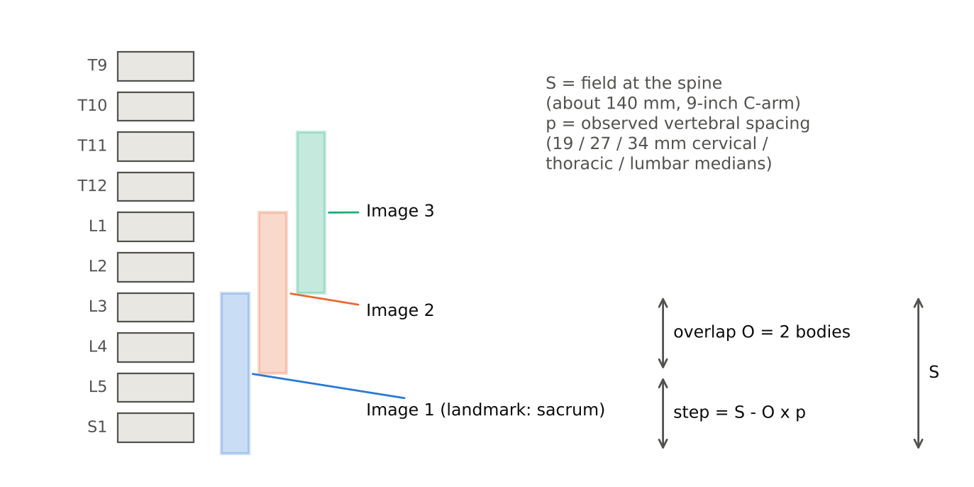
Figure 2. Acquisition geometry, schematic. Each exposure spans S at the spine and overlaps the previous one by O bodies; the commanded step is S - O x p, with p the vertebral spacing measured in the image. After SPECIFICATION.md [0031]-[0036].

Question 13 [0035]-[0036]
Please give practical ranges for O, the field extent S and the number of exposures per sweep.
SHOWN ON RENDERS OR SYNTHETIC DATA ONLY
These ranges are from the corrected held-out renders (sweep_v3), which replace the numbers in [0035]-[0036] (see the table of numbers to replace).
Overlap O. Workable from 0.5 to 4 bodies; good from 1 to 3; best at 2. Chains completed: 81.7 per cent at 0.5, 95.8 at 1, 91.7 at 1.5, 97.5 at 2, 96.7 at 2.5, 90.8 at 3, 82.5 at 4 (Figure 6). The relationship is not monotone, as [0035] says.
Field S. 100 mm (collimated) to 200 mm (30 cm flat panel); 140 mm for a 9-inch and 190 mm for a 12-inch intensifier. At one body of overlap the chain completed on 92.4 per cent with a collimated field, 95.8 with 9 inches and 99.2 with 12 inches.
Exposures per sweep. About 2 to 4 in the lumbar spine from the sacrum (3.4 at two bodies of overlap on 120 held-out spines; 1.98 to 2.96 in the counting arms); up to 8 is the guided loop's default cap. For long runs plan_run picks the nearer landmark, which turns a fifteen-exposure run into one or two for cervical work.
Drafting suggestion
- Fallback dependent claims: O from 0.5 to 4 bodies; from 1 to 3; about 2. S from 100 to 200 mm. Not more than 8 exposures; not more than 4.
Sources: sweep-map-replaces-registration.md; RESULTS_CATALOG.md, rows C3; COUNTING_EVIDENCE.md; acquisition.py L229 plan_run
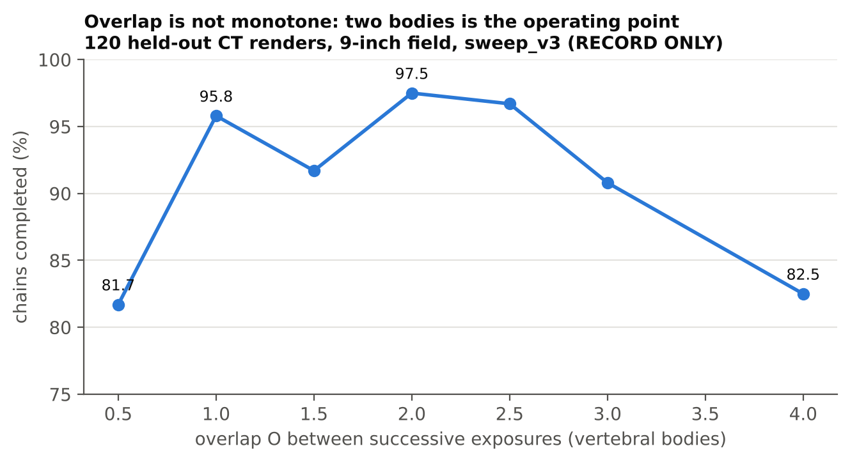
Figure 6. Chains completed against overlap, 120 held-out CT renders, 9-inch field, sweep_v3 (job 40384843), true boxes. RECORD ONLY. Replaces the 801-subject figures in [0035]. Source: sweep-map-replaces-registration.md; RESULTS_CATALOG.md C3.4.

Question 14 [0088](4)
If the sequence is not monotone, how is the chain built when an image overlaps a non-adjacent image, or when two sub-chains must be merged? Can a gap in the chain be bridged later?
SHOWN IN THE REPOSITORY
A global solve is implemented (build_chain_global): links are formed between any pair of images that overlap, not only neighbours, and all link displacements are solved together for one consistent position per image. Bodies are then grouped into nodes by position. This is what handles an image that overlaps a non-adjacent one or two sub-chains that meet. It helped where some links were skipped (at three bodies of overlap 90.8 to 91.7 per cent; at four, 83.3 to 90.0) and cost three spines at the operating point, so it is optional.
A gap is bridged by acquiring one further image that overlaps both sides; the sub-chains are then merged through that image. Until then the guided loop treats the two pieces as unlinked and asserts no name across the gap.
Drafting suggestion
- Describe the global solve and node grouping as an embodiment of [0056]; a dependent claim on merging sub-chains through a bridging image.
Sources: sweep_map.py L1177 build_chain_global; sweep-map-replaces-registration.md; commit 23fb7f3 (node merge and position order)

3.4 Scale Recovery and Detection Repair

Question 15 [0038]
The anatomical spacing constant depends on the region, which may not be known before naming. Is the region estimated first, iterated, or taken from the naming output? Are other statistics or patient-specific constants contemplated?
SHOWN IN THE REPOSITORY
The region is known from the protocol: the sweep starts at a declared landmark (the sacrum for lumbar and lower thoracic work, C2 for cervical and upper thoracic work), and plan_run takes the region from the target level. As the chain grows, the region of each node follows from its name, so the constant can be updated from the naming output. Errors are small because the three constants (19, 27, 34 mm) only set the conversion to millimetres, and the commanded step is then checked against what the link actually measured.
Other statistics would work: the median is used because one wrong box moves it little; a trimmed mean or mode would be fine. Patient-specific constants (paediatric, height-adjusted) are contemplated but not implemented. Inferred.
Drafting suggestion
- Add: the region is taken from the declared landmark, the target level, or the naming output, and may be updated iteratively.
Sources: sweep_map.py L103-104 (spacing constants, field presets); acquisition.py L229 plan_run

Question 16 [0038]
What makes an image's pixel-spacing value "trustworthy," and how does the system decide which scale path to use?
SHOWN IN THE REPOSITORY
This turned out to matter. Many intraoperative headers carry a placeholder (C-ArmLSpine frames say PixelSpacing 1.0 where the real object-plane pixel is 0.1915 mm). A silent default of 0.8 mm was found to make a real film plausible and wrong (commit 7508769).
A value is trusted only if it is present, is an object-plane calibration (not a detector pitch), and agrees with the anatomy: the vertebral spacing it implies must lie within the range expected for the region. Otherwise the anatomical path is used. The rule as stated is my description of what the code guards against; the exact acceptance range is not written in one place.
Drafting suggestion
- Describe the cross-check: header spacing used only where it agrees with the anatomical estimate within a stated tolerance.
Sources: commit 7508769 (silent 0.8 mm pixel pitch guard)

Question 17 [0041]
What range of values would work for the 0.45 and 1.55 thresholds? Do the repair rules hold up with scoliosis, kyphosis or a fracture?
INFERRED: INVENTOR'S JUDGEMENT, NOT TESTED
Workable ranges: the duplicate threshold from about 0.3 to 0.6 of the local spacing, and the gap threshold from about 1.4 to 1.8. They must stay clear of 1.0 on both sides so that a normal neighbour is never merged or split. Only 0.45 and 1.55 were measured.
Scoliosis and kyphosis: the spacing is measured along the fitted axis of the column, and a curved column shortens the projected spacing gradually, which the local median follows. A fracture (a collapsed body) shortens one gap and could trigger a merge. The protection is that a merged box costs one body, and the linker's robust rule tolerates one wrong pair. Not tested on deformity.
Drafting suggestion
- Claim ranges: first fraction 0.3 to 0.6, second 1.4 to 1.8.
Sources: sweep_map.py L682 repair_boxes

Question 18 [0044]
Is "two bodies per gap" a tunable range, for example one to three? What happens when the gap is larger?
SHOWN IN THE REPOSITORY
Yes, it is a parameter (max_insert = 2); one to three is a fair range. When the gap is larger, nothing is invented: the gap stays, the two sides are treated as unlinked, and the guided loop either commands an image over the gap or declines.
Drafting suggestion
- Range one to three; dependent claim that a larger gap leads to a refusal or a commanded image, not an interpolation.
Sources: sweep_map.py L682 repair_boxes

3.5 Linking

Question 19 [0046]
Does the linking search allow for in-plane rotation, scale change or C-arm angulation, or only translation? How does linking handle a curved column?
SHOWN IN THE REPOSITORY
The link search is translation only (dy, dx). The simulation includes rotation of up to 3 degrees and magnification change of up to 5 per cent between exposures, and linking held up under both. An optional refinement allowing rotation and translation (an ECC Euclidean fit, --place ecc) was added and gave identical results on renders. Registration of a later image (Section VIII) searches scale from 0.9 to 1.1.
A curved column is handled because each link is local: the lateral search of plus or minus 0.3 of a body absorbs drift between neighbouring images, and the chain is built link by link. A strongly curved column would need the lateral search widened or the image rotated to the local axis first. Not tested on scoliosis.
Drafting suggestion
- State rotation, scale and angulation as optional degrees of freedom of the search, so a competitor adding them does not escape.
Sources: sweep_map.py L952 ncc_shift; sweep_map.py L1320-1325 (window, jitter); sweep_map.py L1535-1538 map_query_panorama

Question 20 [0047]-[0049]
Please give working ranges for the 0.6 and 0.5 search-window bounds, the +/-0.3 lateral search, the 0.4 minimum band, and "a small number of columns." Can the window adapt?
SHOWN IN THE REPOSITORY
Important correction to [0048]. After the provisional was drafted, the window was measured directly (commit a644897). Widening the far bound from 0.6 to 1.2 or 2.1 bodies left counting at 98.9 to 99.6 per cent exact (Figure 7). So the restricted window is not what makes linking work; correlation over two bodies of overlap does that by itself. What the window buys is the last errors: it is the only setting with zero errors on the 76 whole spines, and it cuts wrong walks on 801 spines from 67 to 21. [0048] should be rewritten to say what the window is worth, not that it is the mechanism.
Working ranges: far bound 0.5 to 1.0 body beyond the step (0.6 used); near bound 0.3 to 0.7 of a body (0.5 used); lateral 0.2 to 0.5 (0.3 used); minimum band 0.3 to 0.6 of a body (0.4 used); minimum columns 8 ("a small number" = 4 to 16). Overlap coverage must be at least 60 per cent of the template (MIN_COVER).
Adaptation: the window is centred on the commanded step, and in the guided loop each later step is computed from measured link positions, so the window already follows where the device went. Adapting its width from the previous link's error is not implemented. Inferred as possible.
Drafting suggestion
- Rewrite [0048] as "reduces wrong links". Keep the asymmetric window as a dependent claim, not an essential feature. Recite "a bounded search window about the commanded step" with the ranges as fallbacks.
Sources: COUNTING_EVIDENCE.md; sweep_map.py L952 ncc_shift; commit a644897 (window ablation)
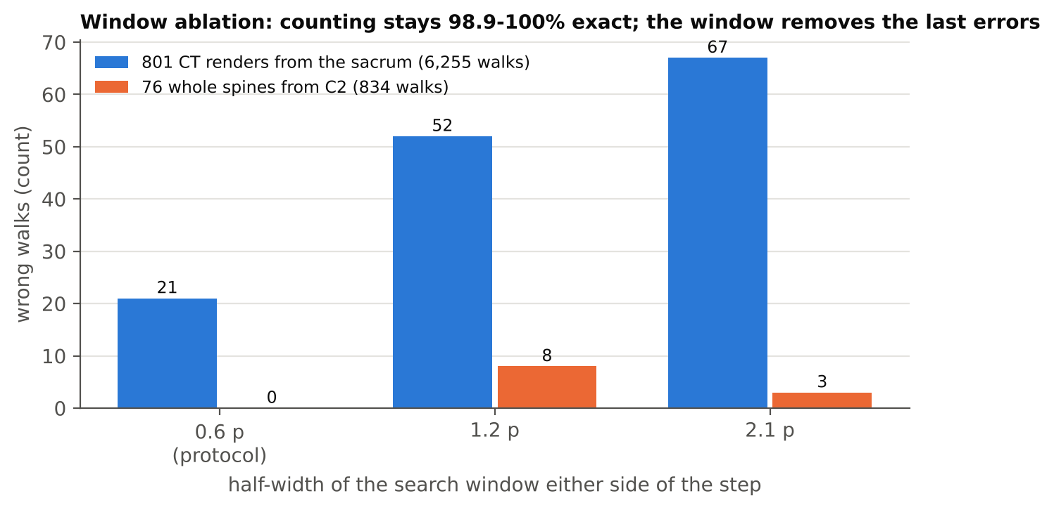
Figure 7. Window ablation (commit a644897). Widening the search window leaves counting 98.9 to 100 per cent exact, so the window is not the mechanism; it removes the last wrong walks. True boxes, renders. Source: COUNTING_EVIDENCE.md.

Question 21 [0051]
What ranges are acceptable for the 0.4 tolerance and the half lateral weighting? Could other distance measures be used, such as Mahalanobis distance or a learned metric?
INFERRED: INVENTOR'S JUDGEMENT, NOT TESTED
Tolerance 0.3 to 0.5 of the spacing (above 0.5 two neighbours could both match); lateral weight 0.25 to 1.0. Any distance that weights axial error more than lateral error works. A Mahalanobis distance with a covariance that is long laterally and short axially is exactly that, and is a natural generalisation; a learned metric would also work. Only 0.4 and 0.5 were measured.
Drafting suggestion
- Recite "an anisotropic distance in which axial displacement is weighted more heavily than lateral displacement", with Mahalanobis and learned metrics as examples.
Sources: sweep_map.py L1065 link_pair

Question 22 [0053]
Is the "strict rule" directly accounted for within the proposed dependent claims?
SHOWN IN THE REPOSITORY
No. The strict rule is described in [0053] as the rule that fails on detector output, and it is the contrast that motivates the robust rule. It is still the implemented default when boxes are exact (link_pair mode="strict"), so it is a real embodiment. Claim 1(b) covers both, since it only says the shared bodies are determined from the displacement. The robust rule appears only in the supporting table.
Drafting suggestion
- Add two dependent claims: (i) the shared block is the largest m whose every implied pair is supported; (ii) the robust scoring of [0054]. That way both are covered, and the robust rule is a fallback position.
Sources: sweep_map.py L1065 link_pair; CLAIMS.md

Question 23 [0054]
Is the term "robust" tied to the scenario immediately following, or is there another definition that would also apply?
SHOWN IN THE REPOSITORY
In [0054] "robust" means the specific rule that follows: score each candidate block by supported pairs less a penalty for unsupported pairs, reject blocks below a majority fraction, accept the whole block at the winning m. The general idea is a selection of the shared block that tolerates a minority of unsupported pairs, so that one wrong or missing box costs one pair instead of the whole link.
Drafting suggestion
- Define "robust" in the specification by that general property, with the scoring rule as one example, so the word is not limited to one formula.
Sources: sweep_map.py L1065 link_pair

Question 24 [0054]
What ranges are acceptable for the half penalty and the 0.6 majority fraction? Are other robust selection methods possible, such as RANSAC or maximum-likelihood?
INFERRED: INVENTOR'S JUDGEMENT, NOT TESTED
Penalty 0.25 to 1.0; majority fraction 0.5 to 0.8. RANSAC over the pairs, a maximum-likelihood choice of m under a detection-error model, or a median-based consensus all fit the same definition. Only 0.5 and 0.6 were measured.
Drafting suggestion
- List RANSAC and maximum-likelihood as alternatives in [0054].
Sources: sweep_map.py L1065 link_pair

Question 25 [0055]
When the image-displacement route and the feature-vector route choose different m, does the system act on the disagreement? Could the feature-vector route be the primary linking method?
SHOWN IN THE REPOSITORY
Today the disagreement is recorded, not acted on. Acting on it is straightforward: lower the link's margin (so the geometry term of the confidence falls and the loop commands more overlap at that seam), or decline the link. Not implemented.
The feature-vector route can be primary. It is already the fallback for registering a later image (map_query_emb, with a margin threshold of 0.05). The image route was preferred because it needs no network and its margin is directly the one-vertebra ambiguity.
Drafting suggestion
- Dependent claim: disagreement between the two routes reduces the confidence or triggers a commanded displacement.
Sources: sweep_map.py L1065 link_pair; sweep_map.py L1636 map_query_emb

3.6 Chain and Alphabets

Question 26 [0057]
Besides the arithmetic mean, are other pooling methods contemplated, such as weighting by position in the field or image quality, or the product of probabilities?
INFERRED: INVENTOR'S JUDGEMENT, NOT TESTED
Yes: a weighted mean (weights from distance to the field centre, since edge bodies are foreshortened and cut by the collimator, or from detection confidence), the product of probabilities (equivalently a sum of logs), the maximum, or a learned pooling. The mean is used because it is stable when one view is bad. Only the mean was measured.
Drafting suggestion
- List these in [0057].
Sources: sweep_map.py L1387 alphabet, L1436 decode_alphabets

Question 27 [0059]
Besides T13 and L6, which variants should have alphabets? How is an alphabet for a previously operated-on subject built?
SHOWN IN THE REPOSITORY
A fifth alphabet was added after the provisional: four lumbar vertebrae, which covers a sacralised L5 (commit 4fb9d64, option --alphabets ext, including four lumbar with T13). This should go into the filing.
Others worth listing: 11 thoracic levels; a cervical rib (C7 rib-bearing); lumbarised S1 (a sixth free segment from the sacral side, which reads as L6); partial assimilation (Castellvi types, which change where the junction is drawn); hemivertebra or block vertebra; a surgically absent vertebra (corpectomy).
Prior surgery: the alphabet does not change (the bones are still there), but instrumented or fused levels are known from the record. They can be used as extra landmarks (a known screw at L4 pins that node), or a fused block can be treated as one node with a known number of members. Not implemented.
Drafting suggestion
- Add the four-lumbar alphabet with its commit date. Make [0059] an open list.
Sources: commit 4fb9d64 (fifth alphabet, four lumbar); sweep_map.py L1387 alphabet, L1436 decode_alphabets
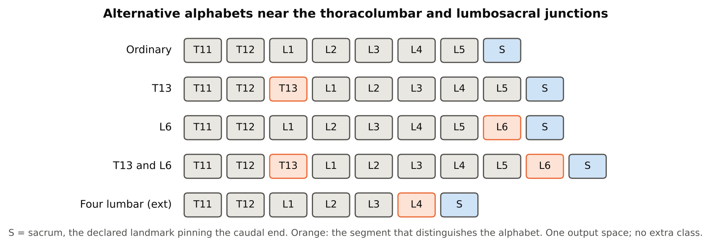
Figure 4. Alternative alphabets. Each is a complete admissible ordering of level names drawn from one output space; a naming must be a contiguous run pinned at the landmark. The four-lumbar alphabet was added after the draft (commit 4fb9d64).

Question 28 [0060]
Could alphabets be weighted by population prevalence (priors)? Could decoding be done with an HMM/Viterbi or another sequence-decoding method?
INFERRED: INVENTOR'S JUDGEMENT, NOT TESTED
Yes to both. A log prior per alphabet (for example about 10 per cent L6 or sacralised L5, a few per cent T13) can be added to the score. Exhaustive offset scoring over a handful of alphabets is cheap (0.2 ms per walk), but an HMM or Viterbi decoder over a state graph whose paths are the alphabets is equivalent and scales to many variants. A soft term from rib evidence was added to the decoder after the provisional (commit 7325682) and is an example of extra evidence entering the score.
One caution: a prior shifts calls toward the ordinary spine, which is the population where errors are rare; on variant spines it would hide true calls. A prior should be optional.
Drafting suggestion
- Recite "scoring" broadly, with exhaustive offset scoring and dynamic-programming (HMM/Viterbi) decoding as examples, and priors as an option.
Sources: sweep_map.py L1387 alphabet, L1436 decode_alphabets; COUNTING_EVIDENCE.md; commit 7325682 (soft rib term)

Question 29 [0061]
What happens downstream when a non-ordinary alphabet wins? Is the surgeon alerted, is a variant-margin threshold applied, or are both namings displayed?
SHOWN IN THE REPOSITORY
The guided loop reports the variant and its margin with every name ("Field contains L4, L5, L6 [L6 variant]"). There is no separate alarm and no variant-margin threshold in code yet. One open case shows why a threshold matters: on one real film the network read every body one level caudal and the L6 alphabet beat a correct count with a margin of 0.74, inside the range of genuine T13 calls.
My recommendation for the product: show the variant call prominently, and when the margin is below a threshold, show both namings and ask the operator to confirm against a second landmark. Inferred.
Drafting suggestion
- Dependent claims: alerting when a non-ordinary alphabet wins; displaying both namings when the variant margin is below a threshold.
Sources: acquisition.py L649 _decide; sweep-map-replaces-registration.md

Question 30 [0065]
Please describe the disc-based convention for delimiting a transitional segment more fully, including how disc presence is detected on a projection.
INFERRED: INVENTOR'S JUDGEMENT, NOT TESTED
[0065] is the only text on this in the repositories; the following is my description. The convention: a segment counts as a separate presacral vertebra if an intervertebral disc separates it from the sacrum (or, at the top, from its neighbour), regardless of how much bone is fused at the transverse processes. On a projection a disc is a radiolucent band between two parallel end plates; it is detected as a gap in the bone along the column axis (an intensity profile along the fitted axis), or as two end-plate edges with a band between them. An end-plate filter was added to the linker after the provisional (commit ab903a4), and the CT feature set for Part A measures the L5-S1 disc directly (joined versus disc, gap in mm, disc-height ratio).
Why the disc: fusion at the transverse process (Castellvi type I and some type II) is invisible on a lateral film, but the disc is visible in both views, so a convention based on the disc can be decided from the image the device produces.
Drafting suggestion
- Expand [0065] with the detection described above, so the claim 18 limitation is enabled. I should confirm the convention in the meeting.
Sources: CT_LSTV_CLASSIFIER_PLAN.md; commit ab903a4 (end-plate filter)

3.7 Confidence and Commanded Displacement

Question 31 [0066]
What ranges are acceptable for tau? Have you tried other combinations of the two terms?
SHOWN IN THE REPOSITORY
tau has been 0.2 (engine default), 0.09 (console default) and 0.033 (calibrated on renders as the median margin of correct links, job 40375066; percentiles 0.015 / 0.033 / 0.131). A workable range is about 0.01 to 0.3, and it depends on image texture, so it must be calibrated per device on real images.
Only the product with clipping was implemented. A minimum of the two normalised terms, a weighted sum, or a learned combination would also work; [0088](9) covers this.
Drafting suggestion
- Range 0.01 to 0.3; "calibrated on images from the imaging device" as a dependent claim.
Sources: acquisition.py L65 (tau); acquisition.py L500 _confidence; GUIDED_ACQUISITION.md

Question 32 [0068]
How is the confidence threshold set (fixed, calibrated, user-selectable)? What values have you used?
SHOWN IN THE REPOSITORY
Fixed per run, set as a parameter: 0.50 in the engine, 0.30 in the console. It is meant to be calibrated on a held-out set per device and offered to the user as a small number of operating points (for example "strict" and "standard"). It has not been calibrated on real images.
Drafting suggestion
- Recite fixed, calibrated and user-selectable as alternatives.
Sources: acquisition.py L649 _decide; guided_console.py (operator console)

Question 33 [0069]
When both a and b are low, which remedy is commanded, and in what order?
SHOWN IN THE REPOSITORY
Geometry first. The code checks the link margin before anything else, because every name beyond a bad link is wrong however confident it looks. So when both are low, the system first commands the move back over the weak seam (more overlap there). Only once the geometry is resolved does it address appearance with a full step toward the landmark. If the geometry cannot be resolved within the bound, it refuses (Figure 5).
Drafting suggestion
- Dependent claim: where both terms fail, the geometric remedy is commanded first.
Sources: acquisition.py L649 _decide
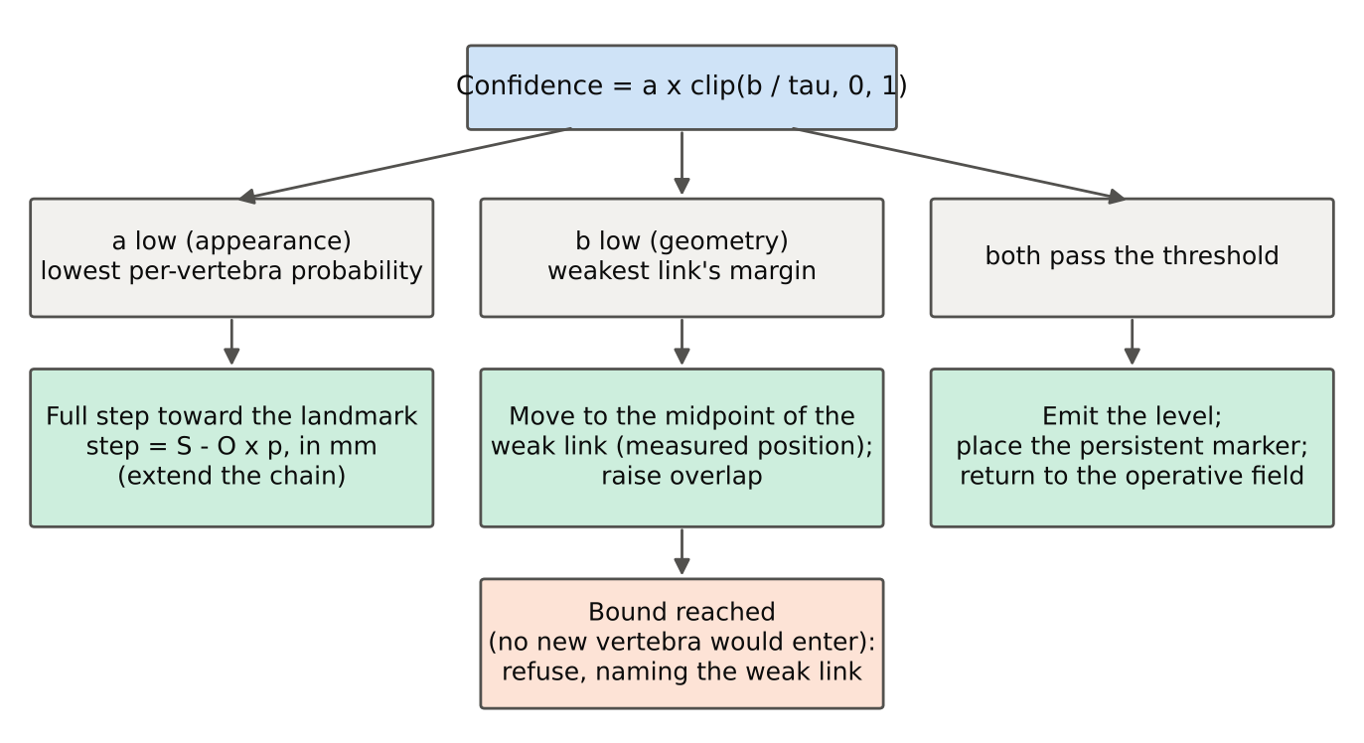
Figure 5. Which remedy is commanded. The geometric term is checked first; a low appearance term gets a full step toward the landmark; a refusal ends an escalation that cannot add new anatomy. Source: acquisition.py _decide.

Question 34 [0070]
Please give the dataset details behind the 4,792-image re-acquisition result.
NOT RECORDED
This result should not be filed as it stands. It comes from the 18-September work, before two corrections: (1) the same day it was found that 681 of the 801 render subjects had been in the naming network's training set (commit d6f407a), and (2) on 19 September every earlier render was found to have the wrong field size (the row-spacing defect). The 4,792 query frames were drawn from that corpus. The measurement was added in commit 8c43e3e ("A decline is not a free retake"); the result file behind 95.7 versus 95.3 per cent, and behind 42 versus 82 per cent, is not named in the documents I have, so I cannot give the dataset details beyond that.
What is solid is the direction of the finding, and the overlap evidence that replaces it: more overlap between linking images raises the share of chains completed (Figure 6), and the selective-prediction work shows that declining a frame changes coverage, not accuracy.
Drafting suggestion
- Either re-run the re-acquisition comparison on the held-out sweep_v3 corpus before filing, or keep [0070] as reasoning ("a re-acquisition of substantially the same view adds no new anatomy to the chain") without the numbers. Claim 1(f) does not depend on the number.
Sources: GUIDED_ACQUISITION.md (code repository); commit 8c43e3e (the re-acquisition measurement); commit d6f407a (trained-on numbers withdrawn); drr-row-spacing-defect.md

Question 35 [0071a]
Is the midpoint the only target position, or would any position between the two images of the weak link work?
SHOWN IN THE REPOSITORY
Any position that overlaps both images of the weak link works; the midpoint maximises overlap with both. The code itself uses another position on the second attempt: it nudges the target a further 0.4 of a body so that the second exposure is not the first one again. So "intermediate" in claim 2 is right and supported.
Drafting suggestion
- Keep "intermediate"; add "such that the further image overlaps both images of the pair".
Sources: acquisition.py L523 offset_to_seam; acquisition.py L649 _decide

Question 36 [0071b]
What information does the refusal contain, and how is it shown? Can the operator override it?
SHOWN IN THE REPOSITORY
The refusal names the weak link (seam number), its margin, how many attempts were made, and the instruction. For example: "The link at seam 3 stayed ambiguous (margin 0.03) after 2 attempts at more overlap. Every level beyond it would rest on a shift that cannot be told from a one-vertebra shift, so no level is asserted. Restart the run from the anchor." It is shown on the console and written to the session log with the confidence, both terms and the frame count. A separate refusal is given when the exposure budget is used up, saying whether geometry or appearance was the cause.
Override: the operator can always restart or count by eye; the system will not assert a name. An explicit override that forces a name is not provided, on purpose. A product might log an operator's own call beside the refusal.
Drafting suggestion
- Dependent claim reciting the content of the refusal (identification of the link and of the term that failed).
Sources: acquisition.py L649 _decide

Question 37 [0071c]
[0071c] refers to the return to the operative field "in the embodiment of [0011]", but [0011] does not mention returning to an operative field. Which embodiment is meant?
SHOWN IN THE REPOSITORY
Counsel is right; the cross-reference is wrong. The embodiment meant is the start-from-target mode described in the guided-acquisition document and implemented in acquisition.py. The surgeon first images the operative level, which has no landmark. The system commands steps toward the landmark until the chain is pinned. It then names the operative field retrospectively and commands the return: "Return 92 mm caudal to the operative field." That return distance is computed from the measured link displacements back to the first image (offset_to_frame(0)), not from the sum of commanded moves, which is what [0071c] is about. On a synthetic subject with 10 per cent execution error on four moves, every position was recovered to within 1.2 mm.
This mode is not described anywhere else in the specification.
Drafting suggestion
- Add a section describing the start-from-target mode and the return, and fix the reference. Claim 4 then has proper support.
Sources: GUIDED_ACQUISITION.md; acquisition.py L649 _decide

Question 38 [0071d]
How is the target level entered? Can the system switch landmarks partway through a sweep?
SHOWN IN THE REPOSITORY
Typed at the console (--target T12), and the marker level likewise (--mark). Taking it from the surgical plan or from the marker record is straightforward but not built. plan_run then chooses the nearer landmark.
Switching landmarks mid-run is not implemented. It is possible in principle: a chain pinned at the sacrum that reaches C2 is pinned at both ends, which is a strong check. Inferred.
Drafting suggestion
- Recite target entry by typing, from a surgical plan, or from a stored marker; a dependent claim on a chain pinned at both termini.
Sources: guided_console.py (operator console); acquisition.py L229 plan_run

Question 39 [0071f]
How is the commanded displacement converted into multi-axis C-arm motion? Does the system check, from the next image, that the device moved as commanded?
SHOWN IN THE REPOSITORY
The displacement is computed along the column axis found in the image, then transformed into the device's own axes using the measured angle of that axis (the Command carries delta_row_mm, delta_col_mm and the axis angle). For a mobile C-arm that is longitudinal travel plus a small lateral correction. Orbital, wig-wag and table moves are not modelled; mapping to them is a kinematic transform specific to each device. Inferred for those axes.
Yes, closed-loop verification is built. The next image's link measures where the device actually went. executed_mm() gives the distance actually moved beside commanded_mm, which is the tracking error, and every later command is computed from the measured positions.
Drafting suggestion
- Dependent claim: measuring the executed displacement from the link and computing the next command from it. Recite the transform into device axes broadly ("one or more axes of the positioner, including a table").
Sources: acquisition.py L649 _decide; acquisition.py L523 offset_to_seam

Question 40 [0088](10)
Please describe the overlay, audible and haptic outputs. Does the system indicate in real time, during fluoroscopy, when the device has reached the target position?
INFERRED: INVENTOR'S JUDGEMENT, NOT TESTED
Implemented: text instructions with distance and direction, and a marker drawn on the image. Overlay, sound and haptics are described, not built: an arrow and a distance on the live display that count down as the device moves, a tone that changes pitch as the target nears, and a vibration on the handle of a motorised arm.
Real-time indication during fluoroscopy is possible because each live frame can be linked to the last stored one (about half a second per link on a shared CPU; see Q49), giving a running position. Not built.
Drafting suggestion
- Describe the live countdown as an embodiment; it is an attractive product feature and a good dependent claim.
Sources: guided_console.py (operator console)

3.8 Later-Image Registration and Prediction Sets

Question 41 [0072]
Can a later image taken at a different C-arm angle or projection be registered onto the chain? Is a scale range wider than 0.9-1.1 workable?
INFERRED: INVENTOR'S JUDGEMENT, NOT TESTED
A small change of angle, yes; the other plane, no, unless a chain was also built in that plane (see Q6). Oblique views of more than a few degrees change the appearance of the vertebrae and would need a chain in that view or a learned similarity. Scale: 0.8 to 1.25 is workable at a modest extra cost; the search is cheap at working resolution. Only 0.9 to 1.1 was measured.
Drafting suggestion
- Scale ranges as fallbacks: 0.8-1.25; 0.9-1.1.
Sources: sweep_map.py L1535-1538 map_query_panorama

Question 42 [0073]
What working resolution (pixels per vertebra) do you use, and what range would work?
SHOWN IN THE REPOSITORY
40 pixels per vertebral spacing (WORK_PITCH); 20 to 80 should work. The reason it matters is speed: on the same (shared) CPU one link took 422.6 s at full resolution and 575 ms at working resolution, 734 times faster.
A caution on [0073]. It says nothing the located position depends on is lost. That has not been shown: a check on a real-frame fixture found the two resolutions disagreed by 14.6 pixels against a 4.4-pixel tolerance, and the model card withdrew its "same answer" statement. The reduction has no measured accuracy result on real frames yet.
Drafting suggestion
- Range 20 to 80 pixels per spacing. Keep the cost argument in [0073]; delete "nothing upon which the located position depends is lost" until it is measured.
Sources: sweep_map.py L1535-1538 map_query_panorama; MODEL_CARD.md section 6.3

Question 43 [0075]
What margin threshold is used for the feature-vector fallback, and how was it chosen?
SHOWN IN THE REPOSITORY
0.05 (min_margin in map_query_emb), on mean cosine agreement; the minimum feature agreement for a link is 0.35. Both were chosen by hand on development renders. Neither has been calibrated on real images.
Drafting suggestion
- Recite "a threshold" with 0.05 as an example.
Sources: sweep_map.py L1636 map_query_emb; sweep_map.py L1065 link_pair

Question 44 [0077]-[0078]
What coverage levels are used for the prediction sets? Are the sets computed on chain-pooled distributions or per image? Is the region-level output used to command a displacement?
SHOWN IN THE REPOSITORY
Coverage levels: 99, 95 and 90 per cent (alpha 0.01, 0.05, 0.10), split conformal with an optional per-class (Mondrian) version, calibration partitioned by subject.
The sets are computed per vertebra, not on chain-pooled distributions. The regions used are cervical, upper thoracic, lower thoracic, upper lumbar, lower lumbar, the lumbosacral junction and sacral.
The region output is not wired into the guided loop; the link from "straddles two regions" to a commanded displacement is described only. The number in the notes (one region on 70.3 per cent at 99.7 per cent) comes from a model trained on a bank later found to leak, so it must not be quoted.
Drafting suggestion
- Keep [0077]-[0079]; add pooled distributions as an alternative. No number.
Sources: level_selective.py; selective-prediction-the-honest-99.md

3.9 Persistent Digital Marker

Question 45 [0080]
Can a marker be placed before confirmation (e.g., a planned target level), or on structures other than a vertebral body?
INFERRED: INVENTOR'S JUDGEMENT, NOT TESTED
Yes to both in principle. A planned target can be placed as a provisional marker shown differently until confirmed. A pedicle, disc space or planned screw entry point is a point in the image that registers with the chain exactly as a body centre does. The implemented marker sits on a body centre. Others not built.
Drafting suggestion
- Broaden the marker to "a location associated with a vertebra"; dependent claims for a planned (unconfirmed) marker and for a pedicle or entry point.
Sources: acquisition.py L855 FiducialBoard

Question 46 [0082]
Can marker records be exported to navigation, robotic or EMR systems? What format does the audit log use?
SHOWN IN THE REPOSITORY
The FiducialBoard keeps a record per event: placement, propagation, loss of registration, with image coordinates, the level, the confidence, the margin and whether it is stale (node lost, no registration, ambiguous registration). The console writes every command, every naming and both confidence terms to a session.json file as they happen. Export to navigation, robots or the EMR is not built; DICOM structured reports, HL7 FHIR or a vendor navigation interface are the obvious formats. Inferred.
Drafting suggestion
- Recite export with the procedure record; formats as examples.
Sources: acquisition.py L855 FiducialBoard

Question 47 [0083a]
What margin threshold value is used for marker assertion, and has it been tested outside the synthetic subject?
SHOWN ON RENDERS OR SYNTHETIC DATA ONLY
The marker's threshold is the same tau as the confidence (min_margin = tau). It has been tested on a phantom subject only. A corpus run was submitted (job 40376577) but its result is not recorded. One more finding counsel should know: on the regional-pitch phantom the margin guard still leaves about one in four asserted positions on the neighbouring vertebra. The statement in [0083a] that every asserted position fell on the marked vertebra was true of the first synthetic subject and is not general.
Drafting suggestion
- Soften [0083a] to report the synthetic result as such, or remove the numbers. Claim 21 does not depend on them.
Sources: acquisition.py L855 FiducialBoard; GUIDED_ACQUISITION.md

Question 48 [0083b]
Can the distance-to-marker output drive the positioner automatically back to the marked level?
SHOWN IN THE REPOSITORY
Yes. The distance and direction to the marked body (off_field_mm) is the same kind of number as any other commanded displacement, and it is emitted in the same Command form that a motorised positioner can take. Driving the positioner is not built because no motorised device has been connected.
Drafting suggestion
- Dependent claim: the distance to the marker is emitted as a control signal to the positioner.
Sources: acquisition.py L855 FiducialBoard

3.10 Performance, Variations and Other Anatomy

Question 49 [0087]
When will the linking, composition and registration stages be timed? What hardware is intended for the in-room computing unit?
SHOWN IN THE REPOSITORY
They have now been timed (model card section 6.3, 22 September 2026), with three limits: a shared workstation CPU with no GPU, synthetic exposures, and the detector not included. Linking: 575 ms per pair at working resolution (422.6 s at full resolution). Confirming a later image: 34.8 ms reduced, 142.5 ms full. Naming four bodies: 3.35 s on that contended CPU. A whole sweep, detector excluded: 12.6 s for 3 exposures and 27.2 s for 7. Decoding the alphabets: 0.2 ms.
A caution on [0087]. The 2.29 ms and 22.94 ms figures there come from an older benchmark of older models; no latency of the reported model stack exists yet, and a GPU job to measure it has not been run. Those figures should be replaced or removed.
Intended hardware: a cart-side workstation with a mid-range GPU, or the C-arm's own embedded computer. Inferred; not recorded in any file.
Drafting suggestion
- Keep the rule "no latency limitation in a claim". Update [0087] with the CPU timings and say the machine was shared.
Sources: MODEL_CARD.md section 6.3; COUNTING_EVIDENCE.md

Question 50 [0088](12)
Are other serially repeating anatomies realistic targets, such as rib counting or dental arches? Could other modalities with limited fields, such as ultrasound, work?
INFERRED: INVENTOR'S JUDGEMENT, NOT TESTED
Rib counting is the most realistic: ribs repeat, are confused one for another, and are often counted from a landmark (the first rib or the 12th) in limited fields, for example for rib fracture fixation or chest-wall surgery. Dental arches repeat but have strong individual features. Long bones do not repeat. Ultrasound of the spine (counting from the sacrum for epidurals) is a good fit: overlapping limited views of a periodic structure with a landmark at one end. Intraoperative endoscopy is another. None tested.
Drafting suggestion
- Name rib counting and spinal ultrasound in [0088](12).
Sources: SPECIFICATION.md

Question 51 [0088](6)
Has the method been tried on veterinary anatomy? If so, which species and which alphabets?
NOT RECORDED
No. The only veterinary item in the record is a request listed for a canine biplanar radiograph dataset (Giessen); it was not pursued. Dogs carry the same problem: 13 thoracic and 7 lumbar is typical, with common transitional lumbosacral and thoracolumbar variants, so the alphabet idea carries over directly with canine alphabets (13T/7L, 13T/6L, 12T/8L, 14T/6L). Inferred.
Drafting suggestion
- Give the canine alphabets as an example in [0088](6).

3.11 Claims

Question 52 Claim 1(a)
Claim 1 recites overlap containing "at least one vertebral body," while [0009] describes a "predetermined number." Is a variable or adaptive overlap within your intended scope?
SHOWN IN THE REPOSITORY
Yes. The guided loop varies the overlap on purpose: two bodies by default, three or more over a weak seam, capped so a new body always enters. The C-arm operator also never moves exactly. So the overlap is adaptive in the preferred embodiment, and claim 1(a) should not require a fixed number.
Drafting suggestion
- Keep "at least one vertebral body" in claim 1; change [0009] to "a number of vertebral bodies, which may be predetermined or adapted during acquisition".
Sources: acquisition.py L649 _decide

Question 53 Claim 1(e)
Would a system using only the margin term, or only the appearance term, still be valuable to protect? Is there support for either alone?
SHOWN IN THE REPOSITORY
Yes. The margin alone is the more valuable: it says, before any name is emitted and without truth, whether a link could be one vertebra off. That is new and directly tied to the remedy (more overlap at the seam). The appearance term alone is close to ordinary classifier confidence and weaker. Support: [0050] and [0083a] describe the margin by itself and use it alone for the marker; the code computes and logs each term separately and picks the remedy from whichever is low.
Drafting suggestion
- Add an independent claim on the margin alone driving a commanded displacement. Keep the product as a dependent form.
Sources: acquisition.py L500 _confidence; acquisition.py L649 _decide

Question 54 Claim 1(f)-(g)
Is there a version in which the positioner executes the displacement and the next image is acquired automatically (a fully closed loop)? Should it be a separate dependent claim?
INFERRED: INVENTOR'S JUDGEMENT, NOT TESTED
Yes. Each Command already carries acquire_after_move, and the control dict is shaped for a motorised positioner. With a motorised C-arm or robot the loop runs without a person: move, acquire, link, decide. Not run on a real device. It should be a separate dependent claim, since it is the robotics market.
Drafting suggestion
- Dependent claim: the positioner executes the displacement and the device acquires the further image automatically.
Sources: acquisition.py L649 _decide

Question 55 Claim 12
If a signal claim is not available, which output interface best describes the commercial product, for an apparatus claim?
INFERRED: INVENTOR'S JUDGEMENT, NOT TESTED
The display. Most C-arms are moved by hand, so the product's output is an instruction on the screen ("move 38 mm cranial") and a marker on the image. Second, a network or serial port to the positioner, for motorised and robotic systems. A speaker is a minor option.
Drafting suggestion
- Apparatus claim reciting "an output interface comprising at least one of a display and a control port to the positioner".
Sources: guided_console.py (operator console)

Question 56 Claim 13
Could the fewer-exposures benefit be stated more concretely, for example as a number of exposures relative to the distance to the landmark?
SHOWN ON RENDERS OR SYNTHETIC DATA ONLY
Yes. The number of exposures is about 1 + (D - S/2) / (S - O x p), where D is the distance from the landmark to the level of interest; plan_run computes exactly this. In the held-out renders that is about 3.4 exposures to cover the lumbar spine at two bodies of overlap. A concrete form: "not more than the number of field extents, less the overlap, needed to span the distance to the landmark, plus one".
Drafting suggestion
- Use the formula in the specification and, if wanted, in a dependent claim; avoid a fixed count.
Sources: acquisition.py L229 plan_run; sweep-map-replaces-registration.md

Question 57 Claim 15
Is the alternative-alphabet decode useful without a chain, for example on a single long-field image or a scout CT?
SHOWN IN THE REPOSITORY
Yes. Any view that contains a landmark and several bodies can be decoded against the alphabets: a long-field radiograph, a full-spine film, a CT or MR scout, or a CT volume. The decoder takes only per-body distributions and a landmark. On a single limited field without a landmark it cannot decide between alphabets ([0062]), which is why the chain matters there.
Drafting suggestion
- Keep claim 15 independent of the chain (it is), and add examples of single-image sources to the specification.
Sources: sweep_map.py L1387 alphabet, L1436 decode_alphabets

Question 58 Claim 19
Should the in-room limitation also apply to the marker method of claim 20 and the alphabet method of claim 15?
INFERRED: INVENTOR'S JUDGEMENT, NOT TESTED
Yes for claim 20 (the marker runs in the room, like everything else). For claim 15 it can be a dependent claim, but the alphabet decode is also useful away from the room (on a scout CT reviewed elsewhere), so it should not be limited by it.
Drafting suggestion
- Add dependent in-room claims to 15 and 20.
Sources: CLAIMS.md

Question 59 Claims 20-23
Is operator confirmation the only trigger for placing a marker, or can a confidence threshold place it automatically? Should both be claimed separately?
SHOWN IN THE REPOSITORY
Both are described in [0080]. The console places a marker on a named level once the confidence passes the threshold (--mark); operator confirmation is the other path. Both should be claimed.
Drafting suggestion
- Claim 20: "responsive to confirmation of an identity, by an operator or by a confidence satisfying a criterion"; dependent claims for each.
Sources: guided_console.py (operator console); acquisition.py L855 FiducialBoard

Question 60 Supporting table
Which items do you see as commercially most important or hardest to design around?
SHOWN IN THE REPOSITORY
In order of importance, with what the evidence now says:
1. The link margin and the remedy it drives (claim 1(e)(ii), 2, 3). Hard to avoid: any system that links overlapping images of a periodic spine must deal with one-vertebra aliasing.
2. Robust block scoring for shared bodies. Detector output always has missed and duplicated boxes; a competitor using a detector needs this or something equivalent. The duplicates this rule fixes were 17.9 per cent of bodies on real films with the strict rule.
3. Detection repair without assuming a count. Essential on transitional spines, which are the clinical target; a fixed-count decoder fails there by construction.
4. The alternative alphabets (now five). The strongest novelty.
5. The fixed working resolution. It makes the method fast enough to use (734 times faster), but it is easy to rediscover; a dependent claim, not a lead.
6. The asymmetric search window. Still worth a dependent claim, but the ablation shows it is not the mechanism, so it should not be promoted as essential.
7. Prediction sets. Least important commercially today: not wired into the loop and not calibrated on real data.
Post-provisional additions worth promoting (Appendix A): the end rule ("the last move is a full move or none", which took chain completion from 97.5 to 120 of 120 held-out spines), the C2 anchor class, needle confirmation, and the masked correlation for a round receptor.
Drafting suggestion
- Promote items 1 to 4 to dependent claims; keep 5 to 7 in the specification with ranges.
Sources: CLAIMS.md; COUNTING_EVIDENCE.md; sweep-map-replaces-registration.md; HANDOFF_PHYSICS.md

Appendix A. Subject matter added after the draft
Each item is dated by a commit in the private code repository (spinesurg-ct-nnunet). All post-date the draft of 18 September and none is in it. Because the provisional has not been filed, these can go into it directly.
Commit | Date | What it adds
4fb9d64 | 19 Sep | Fifth alphabet: four lumbar bodies (sacralised L5), and four lumbar with T13 (--alphabets ext)
f956dae | 19 Sep | C2 detector class: the cranial landmark found as the sacrum is; anchor by class or refuse
8aac5b7 | 19 Sep | End rule (refuse a final move under half a body) and open last link; chains 97.5 to 120 of 120
7325682 | 19 Sep | Soft rib term in the alphabet decoder (measured: adds nothing; a fallback)
23fb7f3 | 19 Sep | Node merge and position ordering (opt-in)
a644897 | 20 Sep | Window ablation: what the bounded search is worth
4f6f25b | 20 Sep | Field width and magnification-mismatch sweep
6a14981, 4176667 | 20 Sep | Masked correlation over the doubly exposed region; fixes for a round receptor
ab903a4 | 20 Sep | Each link measured against the displacement that produced it; end-plate filter
7508769 | 20 Sep | Guard against a silent default pixel pitch
(acquisition.py) | 18 Sep onward | Start-from-target mode and the return to the operative field (not in the specification text)
(needle_confirm.py) | by 20 Sep | Needle confirmation: a later frame with a radiopaque needle assigned to the right vertebra on 99.31 % of 5,385 confirmations (renders), 84.58 % in the cervical spine
(sweep_map.py) | by 20 Sep | Global link solve; Euclidean (ECC) refinement of a link (--place ecc)

From the physics work (HANDOFF_PHYSICS.md), also worth describing: the step size is the main lever under realistic image physics (a half-body step reached 88.43 per cent), storing the exposure added 4.6 points, and the global solve added 5.5 points. Nine other linking fixes were tried and refuted; they should not be described as embodiments.

Appendix B. References for the information disclosure statement
- Siminski et al. Preoperative fiducial marker placement for thoracic spine surgery. AJNR Am J Neuroradiol 2023;44(5):618-622. PMID 37080723; DOI 10.3174/ajnr.A7854. (Background, [0007].)
- Li Y, Gao H, He M, Liang J, Gu J, Liu W. SX-Stitch: an efficient VMS-UNet based framework for intraoperative scoliosis X-ray image stitching. arXiv:2409.05681, 2024.
- US 8,718,346 B2 (NuVasive, originally Saferay Spine): stitched C-arm composite with manually placed level labels.
- US 11,284,846 B2 (Siemens Healthineers, Johns Hopkins); US 10,368,956 B2 (Johns Hopkins); US 12,223,118 B2: registration of a preoperative volume to intraoperative images.
- Otake Y et al. 2012, Phys Med Biol (LevelCheck); Lo SL et al. 2015; De Silva T et al., Spine 2016 (PMID 27035579); msLevelCheck (PMID 28375139); LevelCheck clinical evaluation (PMID 25646750); MR-LevelCheck, Phys Med Biol 2017;62(2):684 (PMC5321067).
- Huang et al. 2022, Comput Methods Programs Biomed 227:107222 (O-arm long-film stitching with labels).
- Automated vertebra labelling on radiographs: Cina et al. 2021, Sci Rep 11:9482; VertXNet 2024; Kim et al. 2024; Konya et al. 2021.
- The inventor's own public items (NeurIPS 2026 paper; CTSpinoPelvic1K dataset on Zenodo and arXiv 2609.22760; AACA Tech Fair slides, 13 June 2026), listed in 06_disclosure_timeline.md, for counsel to judge.
Not yet done: the INPADOC family search for continuations of the four patents above.

Appendix D. Where each linked file is in this package
Every source link in this document is to a file at a fixed commit. The same file is in the package at the path below. Commit links point to the dated commit record, 05_Evidence/CONCEPTION_RECORD.txt.
Linked as | Path in the package
CLAIMS.md | 02_Draft_Provisional/CLAIMS.md
SPECIFICATION.md | 02_Draft_Provisional/SPECIFICATION.md
DISCLOSURE_MEMO.md | 03_Disclosure_Records/DISCLOSURE_MEMO.md
GUIDED_ACQUISITION.md | 03_Disclosure_Records/GUIDED_ACQUISITION.md
INVENTION_DISCLOSURE.md | 03_Disclosure_Records/INVENTION_DISCLOSURE.md
SCRUB_PLAN.md | 03_Disclosure_Records/SCRUB_PLAN.md
00_README_for_TTO.md | 04_WSU_TTO_Package/00_README_for_TTO.md
06_disclosure_timeline.md | 04_WSU_TTO_Package/06_disclosure_timeline.md
drr-row-spacing-defect.md | 05_Evidence/spine-program/01_carm_level_detection/docs/handoff/context/drr-row-spacing-defect.md
selective-prediction-the-honest-99.md | 05_Evidence/spine-program/01_carm_level_detection/docs/handoff/context/selective-prediction-the-honest-99.md
sweep-map-replaces-registration.md | 05_Evidence/spine-program/01_carm_level_detection/docs/handoff/context/sweep-map-replaces-registration.md
RESULTS_CATALOG.md | 05_Evidence/spine-program/01_carm_level_detection/docs/handoff/RESULTS_CATALOG.md
01 STATUS.md | 05_Evidence/spine-program/01_carm_level_detection/STATUS.md
01 TODO.md | 05_Evidence/spine-program/01_carm_level_detection/TODO.md
CT_LSTV_CLASSIFIER_PLAN.md | 05_Evidence/spine-program/06_transitional_ct_census/docs/CT_LSTV_CLASSIFIER_PLAN.md
CLASSIFIERS.md | 05_Evidence/spine-program/06_transitional_ct_census/docs/ruleclass/CLASSIFIERS.md
WRONG_LEVEL_COST_EVIDENCE.md | 05_Evidence/spine-program/09_wrong_level_clinical_qi/docs/WRONG_LEVEL_COST_EVIDENCE.md
COUNTING_EVIDENCE.md | 05_Evidence/spinesurg-ct-nnunet/docs/COUNTING_EVIDENCE.md
SX-Stitch_request.md | 05_Evidence/spinesurg-ct-nnunet/docs/data_requests/SX-Stitch_request.md
GUIDED_ACQUISITION.md | 05_Evidence/spinesurg-ct-nnunet/docs/GUIDED_ACQUISITION.md
HANDOFF_PHYSICS.md | 05_Evidence/spinesurg-ct-nnunet/docs/HANDOFF_PHYSICS.md
INVENTION_DISCLOSURE.md | 05_Evidence/spinesurg-ct-nnunet/docs/INVENTION_DISCLOSURE.md
MODEL_CARD.md | 05_Evidence/spinesurg-ct-nnunet/docs/MODEL_CARD.md
PRIOR_ART_LEVEL_ID_XRAY.md | 05_Evidence/spinesurg-ct-nnunet/docs/PRIOR_ART_LEVEL_ID_XRAY.md
SWEEP_PROTOCOL.md | 05_Evidence/spinesurg-ct-nnunet/docs/SWEEP_PROTOCOL.md
tests/test_acquisition.py | 05_Evidence/spinesurg-ct-nnunet/tests/test_acquisition.py
acquisition.py | 05_Evidence/spinesurg-ct-nnunet/tools/acquisition.py
guided_console.py | 05_Evidence/spinesurg-ct-nnunet/tools/guided_console.py
level_selective.py | 05_Evidence/spinesurg-ct-nnunet/tools/level_selective.py
sweep_map.py | 05_Evidence/spinesurg-ct-nnunet/tools/sweep_map.py

Appendix C. Open items for the meeting
- Which invention the first provisional covers: the chain alone, the chain with Part B, or all three (Q1).
- A supplemental WSU disclosure for the chain.
- Re-running the 18-September measurements on held-out sweep_v3 data, or filing those paragraphs without numbers (Section 2).
- Correcting the WSU disclosure timeline for the public items SCRUB_PLAN.md lists, and whether the GitHub purge requests should be filed.
- Confirming the disc-based convention (Q30) and the intended hardware (Q49).
- The order of filing and the held disclosures: the Part B manuscript, the SX-Stitch data request, the CNS talk of 2 November 2026.

