## Modern Development Process

Starting with [Nexus video](https://www.youtube.com/watch?v=b98_qxkqtpA)

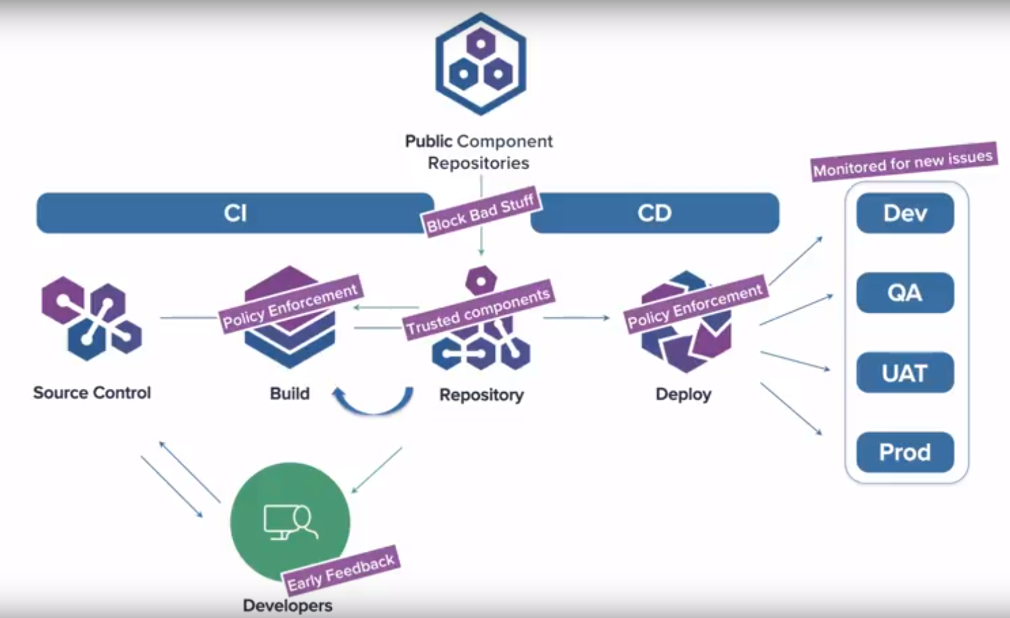

### **Primary Goal**

**The Goal of a Modern development Process (MDP) is:**

* **to get more value into the market quicker,**
* **reduce risk,**
* **Empower developers,**
* **Promote DevOps.**

### **Goal Elements**

* **Early feedback**
  + Developers are at the start of the MDP.
  + Developer’s awareness of continuously managed policies and procedures supports reduction or avoidance of MDP CI/CD cycles.
* **Block Bad Stuff**
  + Delivered components from the MDP are 80% Open Source and 20% Local Code
  + Block components that are never allowed:
    - Incompatible Licenses with your organizations policies and/or business model
    - Known vulnerabilities
    - Not yet Security vetted/approved
* **Trusted Components**
  + The purpose of the **Primary Repository** is to maintain trusted Components
* **Policy Enforcement**
  + Updated and applied continuously in CI and CD
  + Verify Nothing has changed and nothing has gone bad
  + “Components age like milk not like wine”
* **Monitor for new issues**
  + Done continuously in Developer IDEs, Build, Repository, and Deployment systems.
  + Triggers updates to affected elements

### **MDP elements**

* Public Component Repositories
* Primary Repository
* Continuous Integration (CI) Process
  + Developers
  + Source Control
    - Promotes Code Reviews
    - Supports branching/merging
    - Tags code sets
  + Build System
    - CI/CD Unit, Configuration, UAT Testing
* Continuous Delivery (CD) Process
  + Deployment System
  + Deployment Environments
    - Dev
    - QA
    - UAT
    - Prod

### **Procedure**

1. Dev checks out code from source control and builds
2. Build system fetches from Repository manager
   1. Repository manager gets from Public Comp Repositories
3. When Dev done, pushes source and build manifest to source control which triggers automated build in CI system
4. If Unit and Integration test passes, final bits pushed to Repository
   1. May trigger lower level builds (submodel or component)
5. Final applications will be picked up from Repository by automated deployment process that manages deployment to environments

### **Notes:**

1. Processes that try to reduce legal, security, and architecture risk have not evolved as fast.
   1. These processes usually require humans to enforce and implement.
2. Manual processes requiring humans to enable and manage slows the MDP process down.
3. Integrated Developer Environments (IDEs).
4. Waterfall processes are Legacy. Remove or continuously automate to remove them.