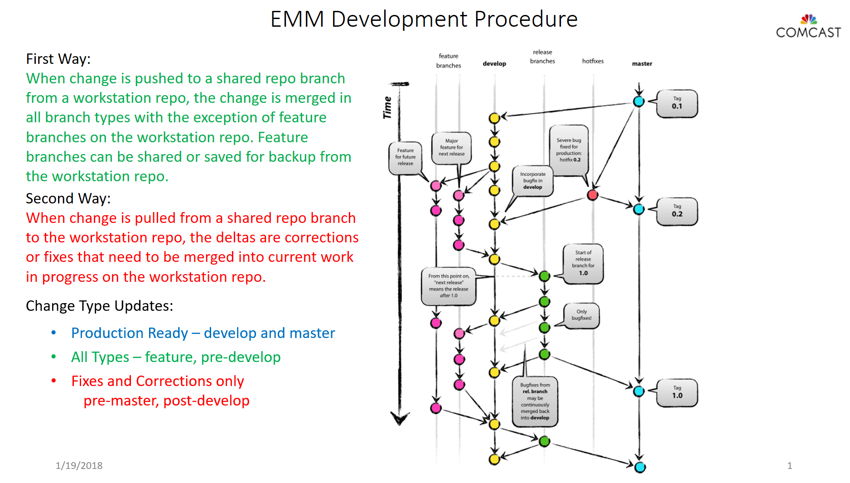

Release Candidates (RC)

Required when many releases are managed prior to production release deliveries.

The number of RCs managed is limited by the available team DevOps resources.

RC branches are constructed of merged feature branch sets that are in the process of being tested and validated.

RC are complete when they have been merged and tagged in the development branch.

* RC1, RC2, RC3, RC4, etc for tags in develop branch. These can be associated with GoCD pipeline groups and production deployment release-M.m branches.
* Reduces dangling branches keeping RC current and in line with current release-M.n and HotFix fixes and corrections.