OpenTM2 for Windows®

A Quick Tour

Version 1.0

First Edition, June 2010-07-26

This edition applies to the OpenTM2 version 1.

All changes since the last edition are marked with a vertical bar ( | ).

Table of content:

First of all 5
What OpenTM2 is 5
Some books you may need 5
Installing OpenTM2 6
Hardware Requirements 6
Software Requirements 6
A new installation step-by-step 6
An upgrade installation step-by-step 7
Lesson 1: Starting OpenTM2 8
Lesson 2: Starting a Translation 9
Opening a OpenTM2 Folder 9
Opening a Document for Translation 10
Lesson 3: Translating a Sample Document 11
Using the Translation Editor 12
Using a Translation Proposal from a Translation Memory 13
Using a Term Proposal from a Dictionary 14
Finishing the Translation 15
Revising the Translation 15
Saving the translation 16
Exporting the translation 17
Leaving OpenTM2 19
Glossary 20

First of all

This book is intended for users who work with open source version of OpenTM2 under Windows®.

If you are not familiar with OpenTM2 for Windows® (called OpenTM2 hereafter) and want to use it for the first time, it is helpful to work through this booklet.

It teaches you the basics of translating with OpenTM2. Besides these basic tasks OpenTM2 offers a lot more. You learn about these other functions in the Translator’s Reference Part 1. For a quick start, however, it is sufficient to work through the samples given here.

The tasks of translating are split up in individual lessons containing practical examples. You will translate a short English sample source text (provided with the program) into a target language of your choice. In the samples given here, German has been selected as target language. The lessons should be worked through in the given sequence. By completing all of them, you learn how to use OpenTM2 when you translate.

What OpenTM2 is

OpenTM2 is a computer-aided translation system that assists you when translating texts from one language to another. Moreover, it presents a working environment which lets you translate and perform all tasks closely related to translating, such as:
- Looking up terms in dictionaries
- Checking the spelling of your translations

A major component of OpenTM2 is the Translation Memory. Whatever you translate in OpenTM2 is saved in a Translation Memory and you can reuse the translation when you have to translate identical or similar texts. For each translation project you can create an individual Translation Memory.

The actual translation is performed with the help of an editor. With OpenTM2 you can translate a great variety of document types, for example, documents created with OpenOffice. All formatting information is retained during translation, so that the translation document has the same layout as the corresponding original document.

Some books you may need

In addition to this booklet, the following OpenTM2 publications are available for learning how to work with the product:

- OpenTM2 for Windows®: Translator’s Reference.

Installing OpenTM2

Before working with OpenTM2, you must install it on your system. If OpenTM2 has already been installed on your computer, you can skip this chapter.

To install OpenTM2, follow the instructions below.

Hardware Requirements

The following minimum hardware configuration is required in order to install OpenTM2:
- Standard PC with 32bit processor.
- Minimum 1GB RAM.
- Minimum 1GB free disk space.

Software Requirements

IMPORTANT: the current version of OpenTM2 only supports MS Windows®.

The following minimum software configuration is required in order to install OpenTM2:
- Windows® NT
- Windows® 2000
- Windows® XP
- Windows® 7

A new installation step-by-step

Assumption: this description assumes that you install OpenTM2 on your c: drive. If you install to a different drive, adjust the drive letter accordingly.

- Download the actual OpenTM2 package (*.ZIP) to a temporary directory on your local hard disk drive.
- Unzip the content of the ZIP-file to the temporary directory on your local hard disk drive (you'll find a root-directory named \OTM\ in your temporary directory).
- From the temporary directory, copy the entire OTM-structure (incl. all sub-directories) to your disk's root-directory (c:\). This automatically creates the directory structure required by OpenTM2 (c:\OTM\).
IMPORTANT: do NOT install OTM into e. g. c:\Program Files\. This does not work in the current version of OpenTM2.
- Navigate to c:\OTM\WIN\ using e. g. the Windows® EXPLORER.
- Run the OpenTM2.exe
- Panel "System Preferences" opens and message "EQF0368: Select the default target language" appears.
- Click "OK".
- From "Default Target Language" select your TARGET language [e.g. GERMAN(REFORM) ].
- Still being in panel "System Preferences":
  - Check "Use Explorer-like tree view" (an improved FOLDER LIST Window starts after re-starting OpenTM2),
  - Set the "Logo display time in ms" to "0" (the start-up panel no longer appears).
- Restart OpenTM2 (indicated by message "EQF0258: You have to restart OpenTM2 in order to activate the new mode for the folder and document list windows").
- After having re-started OpenTM2, you are ready to work with OpenTM2 (the OpenTM2 workbench is displayed).

For more information on how to use OpenTM2, read the documentation:
- Translator’s Reference Guide

An upgrade installation step-by-step

Assumption: this description assumes that you install OpenTM2 on your c: drive. If you install to a different drive, adjust the drive letter accordingly.

- Download the actual OpenTM2 update package (*.ZIP) to a temporary directory on your local hard disk drive.
- Unzip the content of the ZIP-file to the temporary directory on your local hard disk drive (you'll find a root-directory named \OTM\ in your temporary directory).
- COPY the entire structure (incl. all sub-directories) of the already existing OTM-directory to your disk's root-directory (c:\) and OVERRIDE the existing structure.
- The UPDATE is completed.

Lesson 1: Starting OpenTM2

What you learn | This lesson introduces how to start OpenTM2. After OpenTM2 has been installed, you find the OpenTM2 program icon on the desktop.
Step 1 | In order to start OpenTM2, double-click on the OpenTM2 icon on the desktop.
Summary | OpenTM2 is started, and you are located in OpenTM’2 main window – the workbench. From the work bench select the document(s) that need to be translated.
Next steps | Continue with “LESSON 2: Starting a translation” on page 9.

Lesson 2: Starting a Translation

Start with this window (OpenTM’2 workbench) | 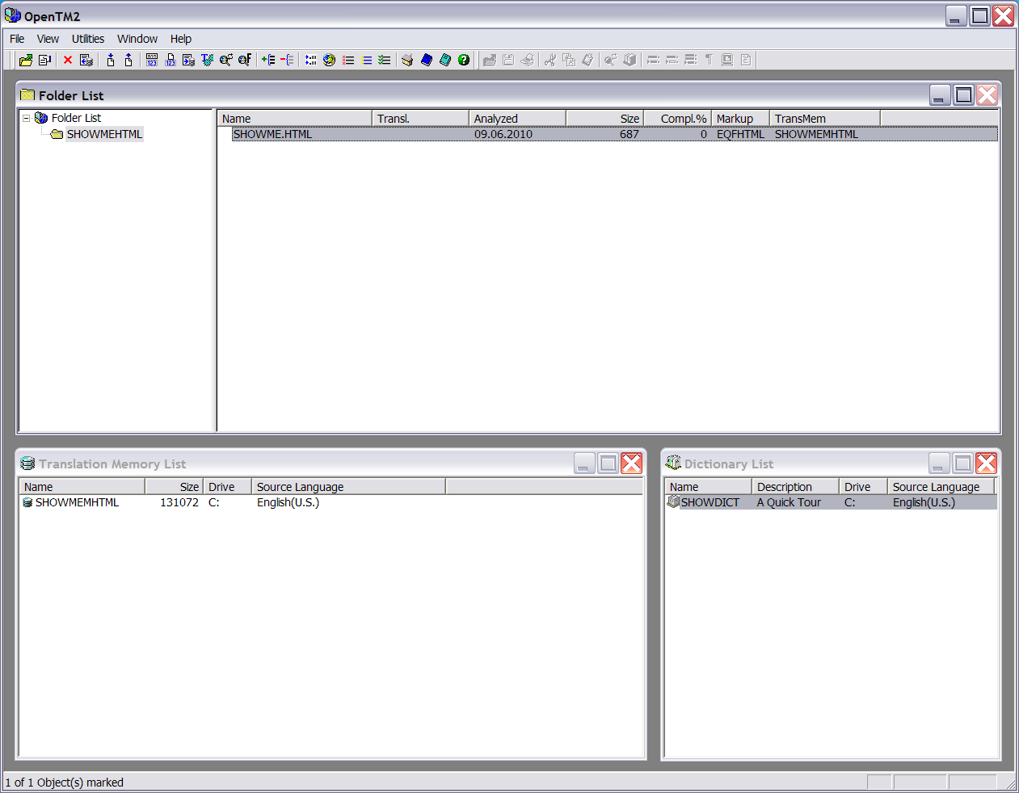

Opening a OpenTM2 Folder

A folder helps organizing the translation material and keeping it in one place. | To start a translation, you must first inform OpenTM2 about the document you want to translate. Here you learn how to select the folder SHOWMEHTML. It contains the document to be translated and all the information necessary to translate it, for example, which dictionary and which Translation Memory to use for this translation.
STEP 1  The Folder List window must be activated in order to work with it. To activate it, click inside of it until the title bar gets highlighted.  Double-clicking on the folder SHOWMEHTML is a quicker way of opening the folder.  STEP 1 and 2 can then be skipped. | Make sure that the folder SHOWMEHTML in the “Folder List” window is selected.  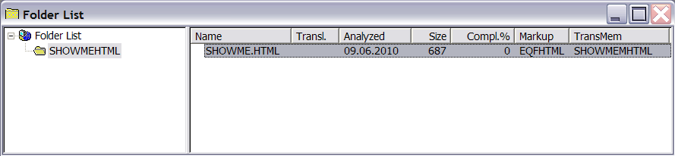  1
STEP 2  Clicking on mouse button 2 immediately opens a context menu containing the Open command.  2 | Make sure that the folder SHOWMEHTML in the “Folder List” window is selected.  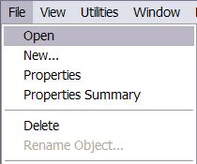
Summary | The sample folder is opened. The “Document List” window is displayed and active immediately. It contains the document that needs to be opened for translation. You are ready to select and open the document SHOWME.HTML for translation.

Opening a Document for Translation

STEP 1  Double-clicking on the document SHOWME.HTML is a quicker way of opening it.  STEP 1 and 2 can then be skipped. | Make sure that the document SHOWME.HTML is selected.  1
STEP 2  Clicking on mouse button 2 immediately opens a context menu containing the Open command. | In the File menu click on Open to open document SHOWME.HTML.  2
Summary | You opened the document SHOWME.HTML for translation and you are in the Translation Environment. The text of the document has been divided into individual units (segments). A segment corresponds roughly to a sentence. The first segment, which is ready for translation, is highlighted with a yellow background.
Next steps | Continue either with LESSON 3 Translating a sample document or read more about the current topic in the section on opening a document of the Translator’s Reference.

Lesson 3: Translating a Sample Document

What you learn | In this lesson you learn how to:  - Translate document SHOWME.HTML with the integrated editor.  - Use a translation proposal from a translation memory.  - Use a translation proposal from a dictionary.
The information displayed in red is markup information, which must not be translated. It is needed to format the document for printing. During  Translation, this markup information is protected. | After having selected and opened a document, you are in the translation environment, and from here you start translating the document SHOWME.HTML. The first segment, which is ready for translation, is highlighted with a yellow background, and the cursor is already located on the first character in the activated segment.  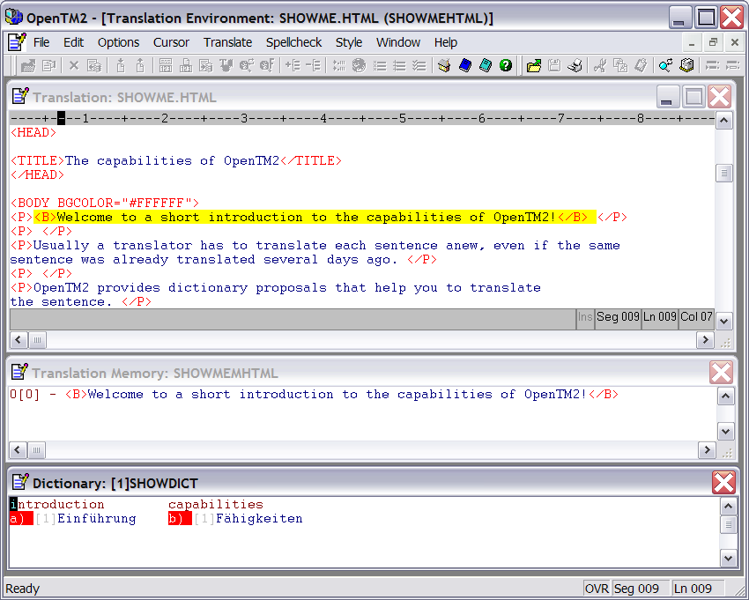

Using the Translation Editor

For this exercise you can type any translation. | You translate with the integrated OpenTM2 editor by overtyping the source text. You can choose between two modes of typing:  - In replace mode the source text is overwritten.  - In insert mode the source text is pushed ahead.  You are automatically in replace mode when you open the document for translation. With the Insert key you can toggle between the two modes.  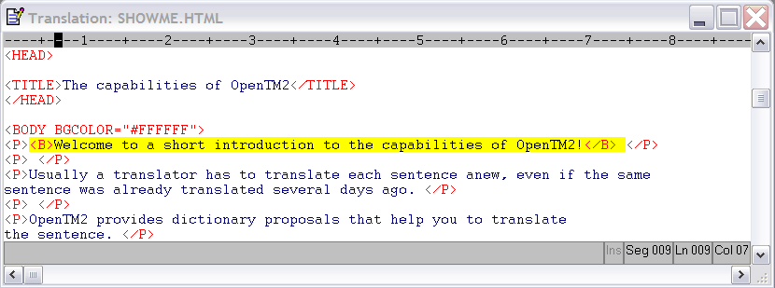
STEP 1  A segment is a text unit for translation. | Type your translation over the segment "Welcome to a short introduction ..."
STEP 2 | Delete any remaining characters by pressing the Alt and Delete keys simultaneously. When you are asked if you also want to delete the protected characters, click on No. This will keep the formatting information.
STEP 3  Each segment you translate is stored in the Translation Memory. | Hold the Ctrl key and press the Enter key to save this segment and to continue with the next segment. You find the cursor located on the next segment to be translated (the segment is highlighted in yellow). Type your translation in this segment and repeat STEP 2, if necessary.
STEP 4 | Repeat STEP 1, STEP 2, and STEP 3 for the next segment ("OpenTM2 provides dictionary proposals ...") in order to get used to the task of translating a segment by typing the translation and storing it into the translation memory.  Alternatively go directly to the segment "OpenTM2 also provides an integrated Translation Memory ..." by placing the cursor on any character inside this segment and pressing Ctrl and Enter simultaneously.
Summary | The first segments of the sample document are translated. The cursor is located in the next untranslated segment, which is shown with a yellow background ("OpenTM2 also provides an integrated Translation Memory ..."). Now learn how to translate using translation proposals that the system has stored.

Using a Translation Proposal from a Translation Memory

The Translation Memory contains previously translated texts. | The next segment ("OpenTM2 also provides an integrated  Translation Memory ...") is active and the cursor is located on the first character. In the “Translation Memory” window you see a translation proposal ("OpenTM2 bietet einen integrierten  Übersetzungsspeicher ..."). This means that a translation of exactly the same segment originating from a previous translation session is available. To save translation time, copy this translation into your text.  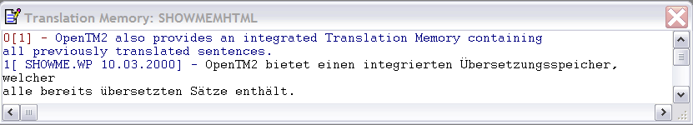
STEP 1  Sometimes several translation possibilities are offered. Each one has a number.  1 | Hold the Ctrl key and then press the “1” key to copy the translation memory proposal (the number “1” can be found in the Translation Memory proposal window right in front of the memory proposal).
STEP 2  Copying from the Translation Memory saves time and brings more consistency to your translations. | Hold the Ctrl key and then press the Enter key to accept the translated segment and to continue with the next one.
Summary | The translation proposal has been copied into your translation, the translated segment has been saved, and the next segment is active ("Using translation proposals offered by OpenTM2 ...").

Using a Term Proposal from a Dictionary

Using online dictionaries frees you from paper-shuffling. | The next segment is activated and the cursor is located on the first character in this segment ("Using translation proposals offered by OpenTM2 ..."). In the “Dictionary” window you see an entry for the term proposal. OpenTM2 found it in the sample dictionary SHOWDICT. You can copy the term proposals into your text.  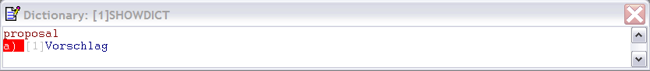
STEP 1  Sometimes several translation possibilities are offered. Each one has a letter for accessing it. | Translate the segment up to the point where you want to insert the term proposal. Hold the Ctrl key and press the key “a” to copy the term that is offered by the dictionary.
STEP 2  If necessary, adapt the copied term. | Translate the rest of the segment and press the Ctrl and Enter keys simultaneously to save this segment. A message window appears indicating that the translation has completed. Press  OK.
Summary | The term that was found in the dictionary has been copied into the text at the cursor position and the translated segment has been saved. This was the last segment of the sample document SHOWME.HTML. You are still in the Translation Environment.
Next steps | You can either continue with “LESSON 4 Finishing your translation” on page 15 or read more about the current topic in the chapter Working with the editor of the Translator’s Reference.

Finishing the Translation

What you learn | This lesson shows you how to:  - Revise what you translated  - Save your translation  - Export the translation  - Exit OpenTM2

Revising the Translation

Use OpenTM2’s post-editing option for this task. | After you finished the draft of your translation, you may want to revise it and redo specific phrases or correct typos.
STEP 1  Another way to get into post-editing mode is to click on post-editing in the Translate menu. | Once you translated and saved the last segment in SHOWME.HTML, you see a message informing you that the translation has completed.  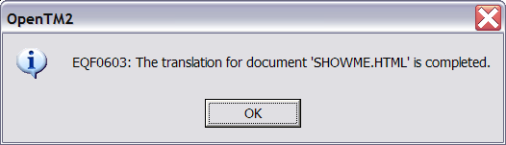  Click here  Click on OK to leave this window and get into post-editing mode. In this mode, the “Translation Memory” window and the “Dictionary” window are no longer displayed.
STEP 2 | Click the maximize icon in the upper right corner in the “Translation” window to see more of the context. Be careful not to click the maximize icon in the OpenTM2 main window.  Click here
STEP 3 | Press the Ctrl and Home keys simultaneously to move the cursor to the beginning of the text. To hide the markup information select Compact from the Style menu.
STEP 4  For the purpose of this exercise you can choose any part of the text. | Move the cursor to the position where you want to change text.
STEP 5  You are in replace mode automatically. With the Insert key you can switch to insert mode. | Type your changes over the previous translation.
Summary | Now you have seen an example of how a translation can be revised. Once you finished a translation you are automatically in OpenTM2’s post-editing mode. While you are in this mode, you can make use of OpenTM2’s spell check option. Any changes you make in the text while you are in post-editing mode are automatically reflected in the Translation Memory. So what you corrected in the translation is corrected in the Translation Memory as well. You or your colleagues can benefit from these updates whenever you translate the same or a similar sentence again.

Saving the translation

 | Once you are satisfied with your translation, you can save it. You can then continue working with the translation outside OpenTM2, for example, print it and pass it on to a customer. However, any changes that are made in the text outside OpenTM2 will not be reflected in the Translation Memory.
STEP 1  You can also press the F4 key to save the translation.  Click here | In File menu click on End-Save.  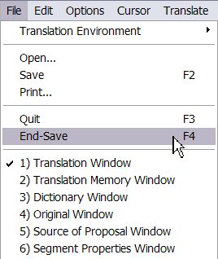
Summary | You saved the translation of SHOWME.HTML and returned to the OpenTM2 main window. You can now continue working with this translation. For example, format it with a word processor or desktop-publishing system to print it. Or send the file to your customer. For these purposes you must make the translation available outside OpenTM2. This task is called exporting. How you export the translation is shown in the next exercise.

Exporting the translation

 | Once the translation was finished and saved, you can pass it on e.g. to a customer. For this purpose, you use the document export feature in OpenTM2.
STEP 1 | Ensure that the document SHOWME.HTML in the “Document List” window is selected.  1
STEP 2  Clicking on mouse button 2 immediately opens a menu containing the Export... command.  2 | In the File menu click on Export...  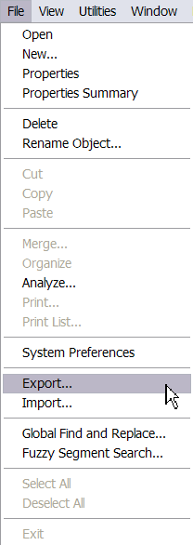

STEP 3  You export translations in external format to make them available to customers.  4  3 | From the “Export As” drop-down menu select External Format.  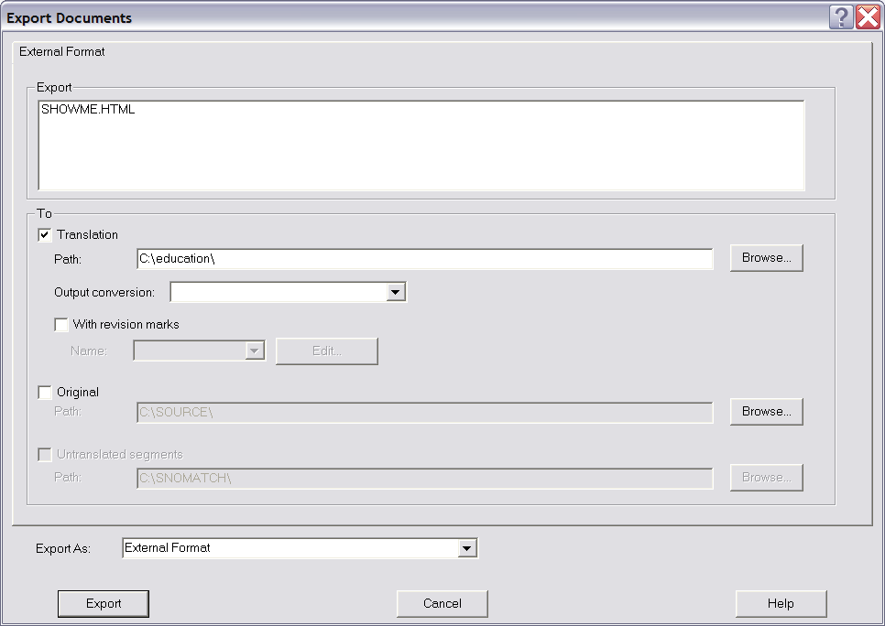  5
STEP 4 | Ensure the Translation check box in the “Export Documents” window is selected, because the translated document needs to be export. Type in (or Browse…) the path where you want to store the file to.
STEP 5 | Click on Export.
STEP 6 | Click OK in the window that tells you that exporting has completed successfully.
Summary | You successfully exported the translated file and you may print it now. To print the SHOWME.HTML with the correct layout you best must use a Browser (e.g. Mozilla Firefox).

Leaving OpenTM2

Leaving OpenTM2 is as easy as starting it. | Now that you have completed the exercises, you are ready to exit OpenTM2.
STEP 1  Pressing the Alt and F4 keys simultaneously is another way of exiting. STEP 1 and STEP 2 can then be skipped. | Click the control-menu box in the upper left corner in the OpenTM2 main window.  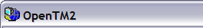  1
STEP 2  The quickest method of quitting is to double-click on the control-menu box. | From the control menu select Close.  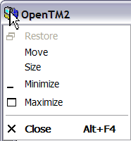  2
STEP 3 | You are asked if you want to save the current workbench. Select Yes to get the same arrangement of windows on the workbench the next time you start OpenTM2.
Summary | You left OpenTM2 and are back on the system desktop.
Next steps | You have worked through the last lesson in an OpenTM2 translation course and did a short sample translation.  Now that you learned about the basic OpenTM2 tasks, you are ready to do your first own translation with OpenTM2 and make yourself familiar with more advanced OpenTM2 topics. Refer to the Translator’s Reference to learn about advanced topics of OpenTM2.  Note: Before you start translating your own documents, you must bring them into OpenTM2 and specify the required translation information. How you do this is shown in the Translator’s Reference Guide.

Glossary

Document. A generic term used to describe all types of files containing information that is to be translated. Documents must be imported and opened before being translated. The source of the document you translate is called the original document. The document that you edit during translation is called the translation document.

Editor. An integrated editor available in the “Translation” window of the Translation Environment. It offers basic word processing features, such as search and replace, and is especially adapted to translation needs.

Export. To copy folders, documents, dictionaries, and Translation Memories from one drive to another to make them available to another user.

Folder. Contains documents belonging to one project, and references to the dictionaries and Translation Memory to be used for this project.

Icon. A small graphical symbol. Icons can represent windows that you want to work with (such as Document List, Dictionary List, Translation Memory List) or tasks that you want to perform.

Import. To copy folders, documents, dictionaries, and Translation Memories from one drive to another to make them available to OpenTM2.

Markup information. Information added to a document to enable a word processor to format it. This information is retained when translating with OpenTM2.

Original document. The source of the document that you translate. You cannot edit this document but you can display it and use it for comparison or checking purposes.

Postediting. Revising an already translated document. Any changes cause an automatic update of the already translated segments stored in the Translation Memory.

Proposal. A translation example for a term or a phrase found in a dictionary or a Translation Memory during translation. Each term in a segment is automatically looked up in the dictionary selected. If an entry is found, the translation possibilities for this term are shown on the screen. Also, each segment in the document to be translated is automatically searched for in the selected Translation Memory. If it is found there along with its translation, it is displayed in the “Translation Memory” window.

Segment. A translation unit, for example, a sentence.

Translation document. The translation document is the document that you edit during translation.

Translation Environment. Environment where the actual translation is performed. It consists of a window where you can edit the document, a window with proposals from the associated Translation Memory, and a dictionary window with translation proposals for terms in the document. All translation proposals can be copied into the document.

Translation material. All the files you need for translating: documents to be translated, dictionaries, and Translation Memories.

Translation Memory. A database that contains previously translated segments added during translation.

Translation workbench. Main window of OpenTM2. From here you either go to the Translation Environment to do the actual translation, or start with another translation-related task, such as managing terminology lists or counting words in documents

