GeoNode 2.0 Technical details
tl:dr; open source community software development works … its requires a lot of concoooerted effrt, but the process is effective. GeoNode is an unstoppable machine.

Wow, where to begin. Sprint nearly one year ago in alexandria. Beta11 -> RC1 Summer 2013
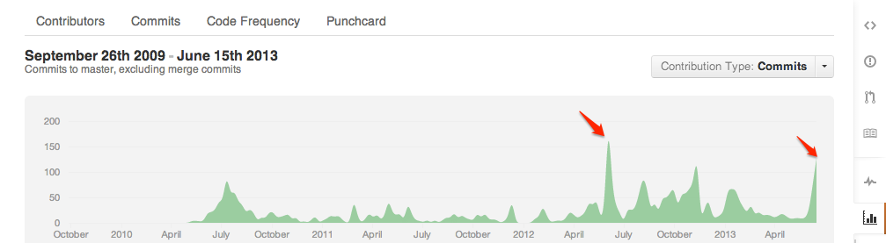

Overview

Pulse

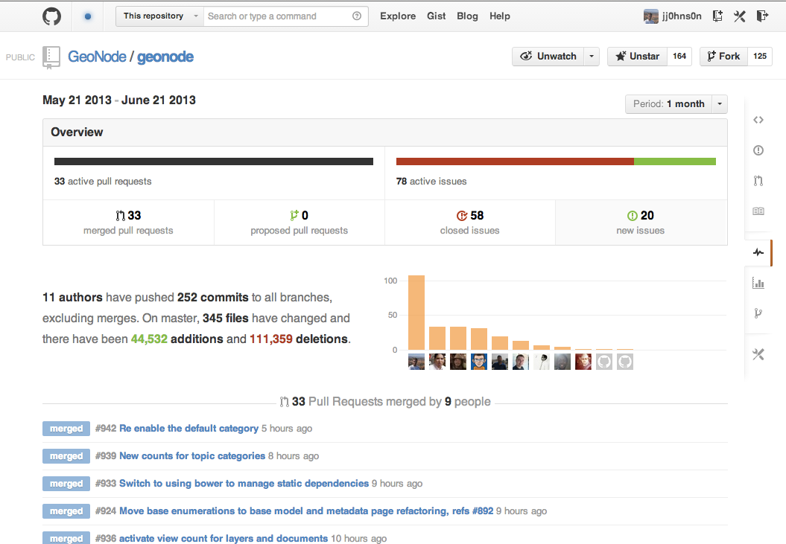

HUGE List of Contributors

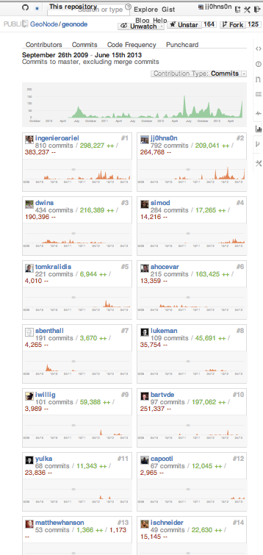 | 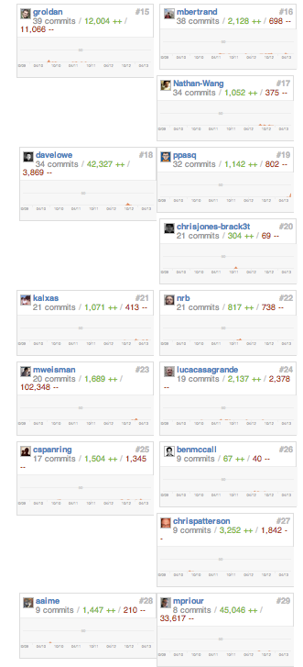 | 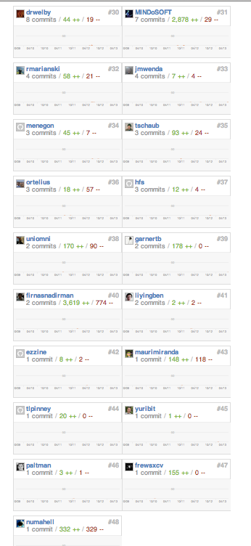

Process Refactoring
- Bylaws
- Committers
- Contributors
- Improvement Proposals https://github.com/GeoNode/geonode/wiki/GeoNode-Improvement-Proposals
- Pull Requests
- Issue Tracker
- Automated Test Plan
- Manual Test Plan
Project Structure Refactoring (Ariel, Jeff, Ian, Ivan, MattP, Bart, Simone et al)
- GNIP-29---Code-Repository-Reorganization
- GNIP-30----Split-out-geonode.maps-into-2-modules
- GNIP 20 - Rename geonode.core to geonode.security and migrate unrelated tests
- GNIP-3---Merge-geonode-integration-and-geonode
- GNIP 31 - Build System Refactor
- GNIP-19---GeoNode-Migrations
- GNIP-2---Template-refactor:-Conventions-and-extensions
- GNIP-7---Django-projects-compatibility
- GNIP 32 - Upgrade to GeoServer 2.2
Catalogue Refactoring (Tom Kralidis, Ariel)
- GNIP-5----Abstract-OGC:CSW-Functionality
- GNIP-4-----Accept-XML-Metadata-with-Uploaded-Layer-Data
- GNIP-6----CSW-Metadata-Format-Transformation
- GNIP-27--CSW-Django-Backend-Support
UI Refactoring (Naomi, Yulka, Luke)
  - Design https://sites.google.com/a/opengeo.org/geonode-ui/
  - Bootstrap & Jquery Implementation
Client Refactoring (Bart, Ariel, Ivan, Luke and Jeff)
- Client Frameworks
  - GNIP-28---Adoption-of-Twitter-Bootstrap-CSS-Framework
  - GNIP 34 - ExtJS->Jquery migration for non-spatial widgets
  - GNIP 38 - JavaScript Requirements Handling refactor
  - GNIP 39 - Javascript Testing Framework Implementation
- GeoExplorer Refactoring
  - GNIP-40---Use-Standard-GeoExplorer-(vs-custom-geonode-client)
  - GNIP-21-–-Create-New-Vector-Layers-and-Add-Edit-Delete-Layer-Features
  - GNIP-23---Add-GeoRSS-Layers-such-as-Picasa-and-Youtube-Feeds
- Python Requirements
  - GNIP-25---LayerAttribute-Model-for-Customizing-Feature-Info-Results
  - Gnip-33---viewer-json-refactor
Import/Upload Refactoring (Ian, Ivan and Jeff)
- GNIP-17----Data-Conversion-on-Upload-Import
- GNIP 44 - Uploader Javascript Refactor

Search Refactoring (Ian, Simone, Luke, and Jeff) ROADMAP - Improved Layer Search
- GNIP-14---New-Search-Backend
- GNIP-15---New-Search-Frontend-(Page-+-Map-Composer)
Social Features (Jeff & Luke)
- GNIP-9---Profile-Migration-to-idios
- GNIP-10---Notifications-Messages-and-Announcements
- GNIP-11---Feedback-and-Social-SharingFeatures
- GNIP-12---Tagging-(with-Migration)
Proposals Still Under Development or Review
- GNIP-8---Groups-and-Group-Permissions (Jeff and Paolo) (ROADMAP - Groups)
- GNIP-13---Collections
- GNIP-16---Remote-Services (Jeff & Tom) (ROADMAP - Add Remote WMS Service to Search)
- GNIP-22---Display-Layers-from-Remote-ArcGIS-REST-servers (MattB & Jeff)
- GNIP-26---Load-Layers-to-a-Map-without-GetCapabilities-Requests (Bart?)
- GNIP-24---Map-Revision-History (MattB)
- GNIP-41---Printing-System-Replacement (Ian, Ivan, MattP & Jeff)
- GNIP-42---GeoNode-Portals (Jeff & Luke)
Proposals Still Under Discussion & Planning
- GNIP-1----Securing-GeoNode-Proxies (Ariel & Kevin)
- GNIP-18---GeoNode-API (Jeff & Ariel) (ROADMAP - Public API's and Interfaces)
- GNIP 35 - Black Box Integration Tests (Jeff, Ariel and MichaelW)
- GNIP 36 - Use Virtual Services to limit GetCapabilities size (Bart?)
- GNIP 37 - HTTP Client code refactor (Ivan?)
- GNIP 43 - Upgrade to GeoServer 2.3 (Ian)
Roadmap Items
- (Under discussion)
- ROADMAP - LDAP Authentication (Under discussion)
- ROADMAP - Time Controls on Map (Development Stage)
- ROADMAP - GeoGit Integration (Development Stage)
Localization (Jeff, Nathan and Angelos)
- Transifex https://www.transifex.com/projects/p/geonode
- Javascript
- GeoServer
Website, Docs and Workshops (Naomi, Jeff, Ian, Ariel)
- Website http://geonode.org on github pages http://github.com/geonode/geonode.github.com
  - Gallery
- Workshops
  - User
  - Admin
  - Developer
- Docs
Dev & Build & Package System (Ariel, MichaelW, Angelos and Jeff)
- GitHub Organization https://github.com/GeoNode
  - Main Project
  - Sub Projects
- Jenkins (http://build.geonode.org/)
- Travis CI https://travis-ci.org/#!/GeoNode/geonode
- Pypi https://github.com/GeoNode
- Launchpad http://www.launchpad.net/~geonode
- Latest Beta Demo http://beta.dev.geonode.org/

