|  |
| --- |
|  |
| Outreach Mobile Website |
| Backend changes needed for 2014 specifications |
|  |
| **Arul Gunalan** |
| **19-Dec-14** |



|  |
| --- |
| The current Pathways production database is setup in accordance with the 2010 HUD specifications. For the Mobile Outreach Site, we are implementing changes to the schema to support new fields required for the 2014 specifications with minimum changes to the current working setup. |

# Current Schema:

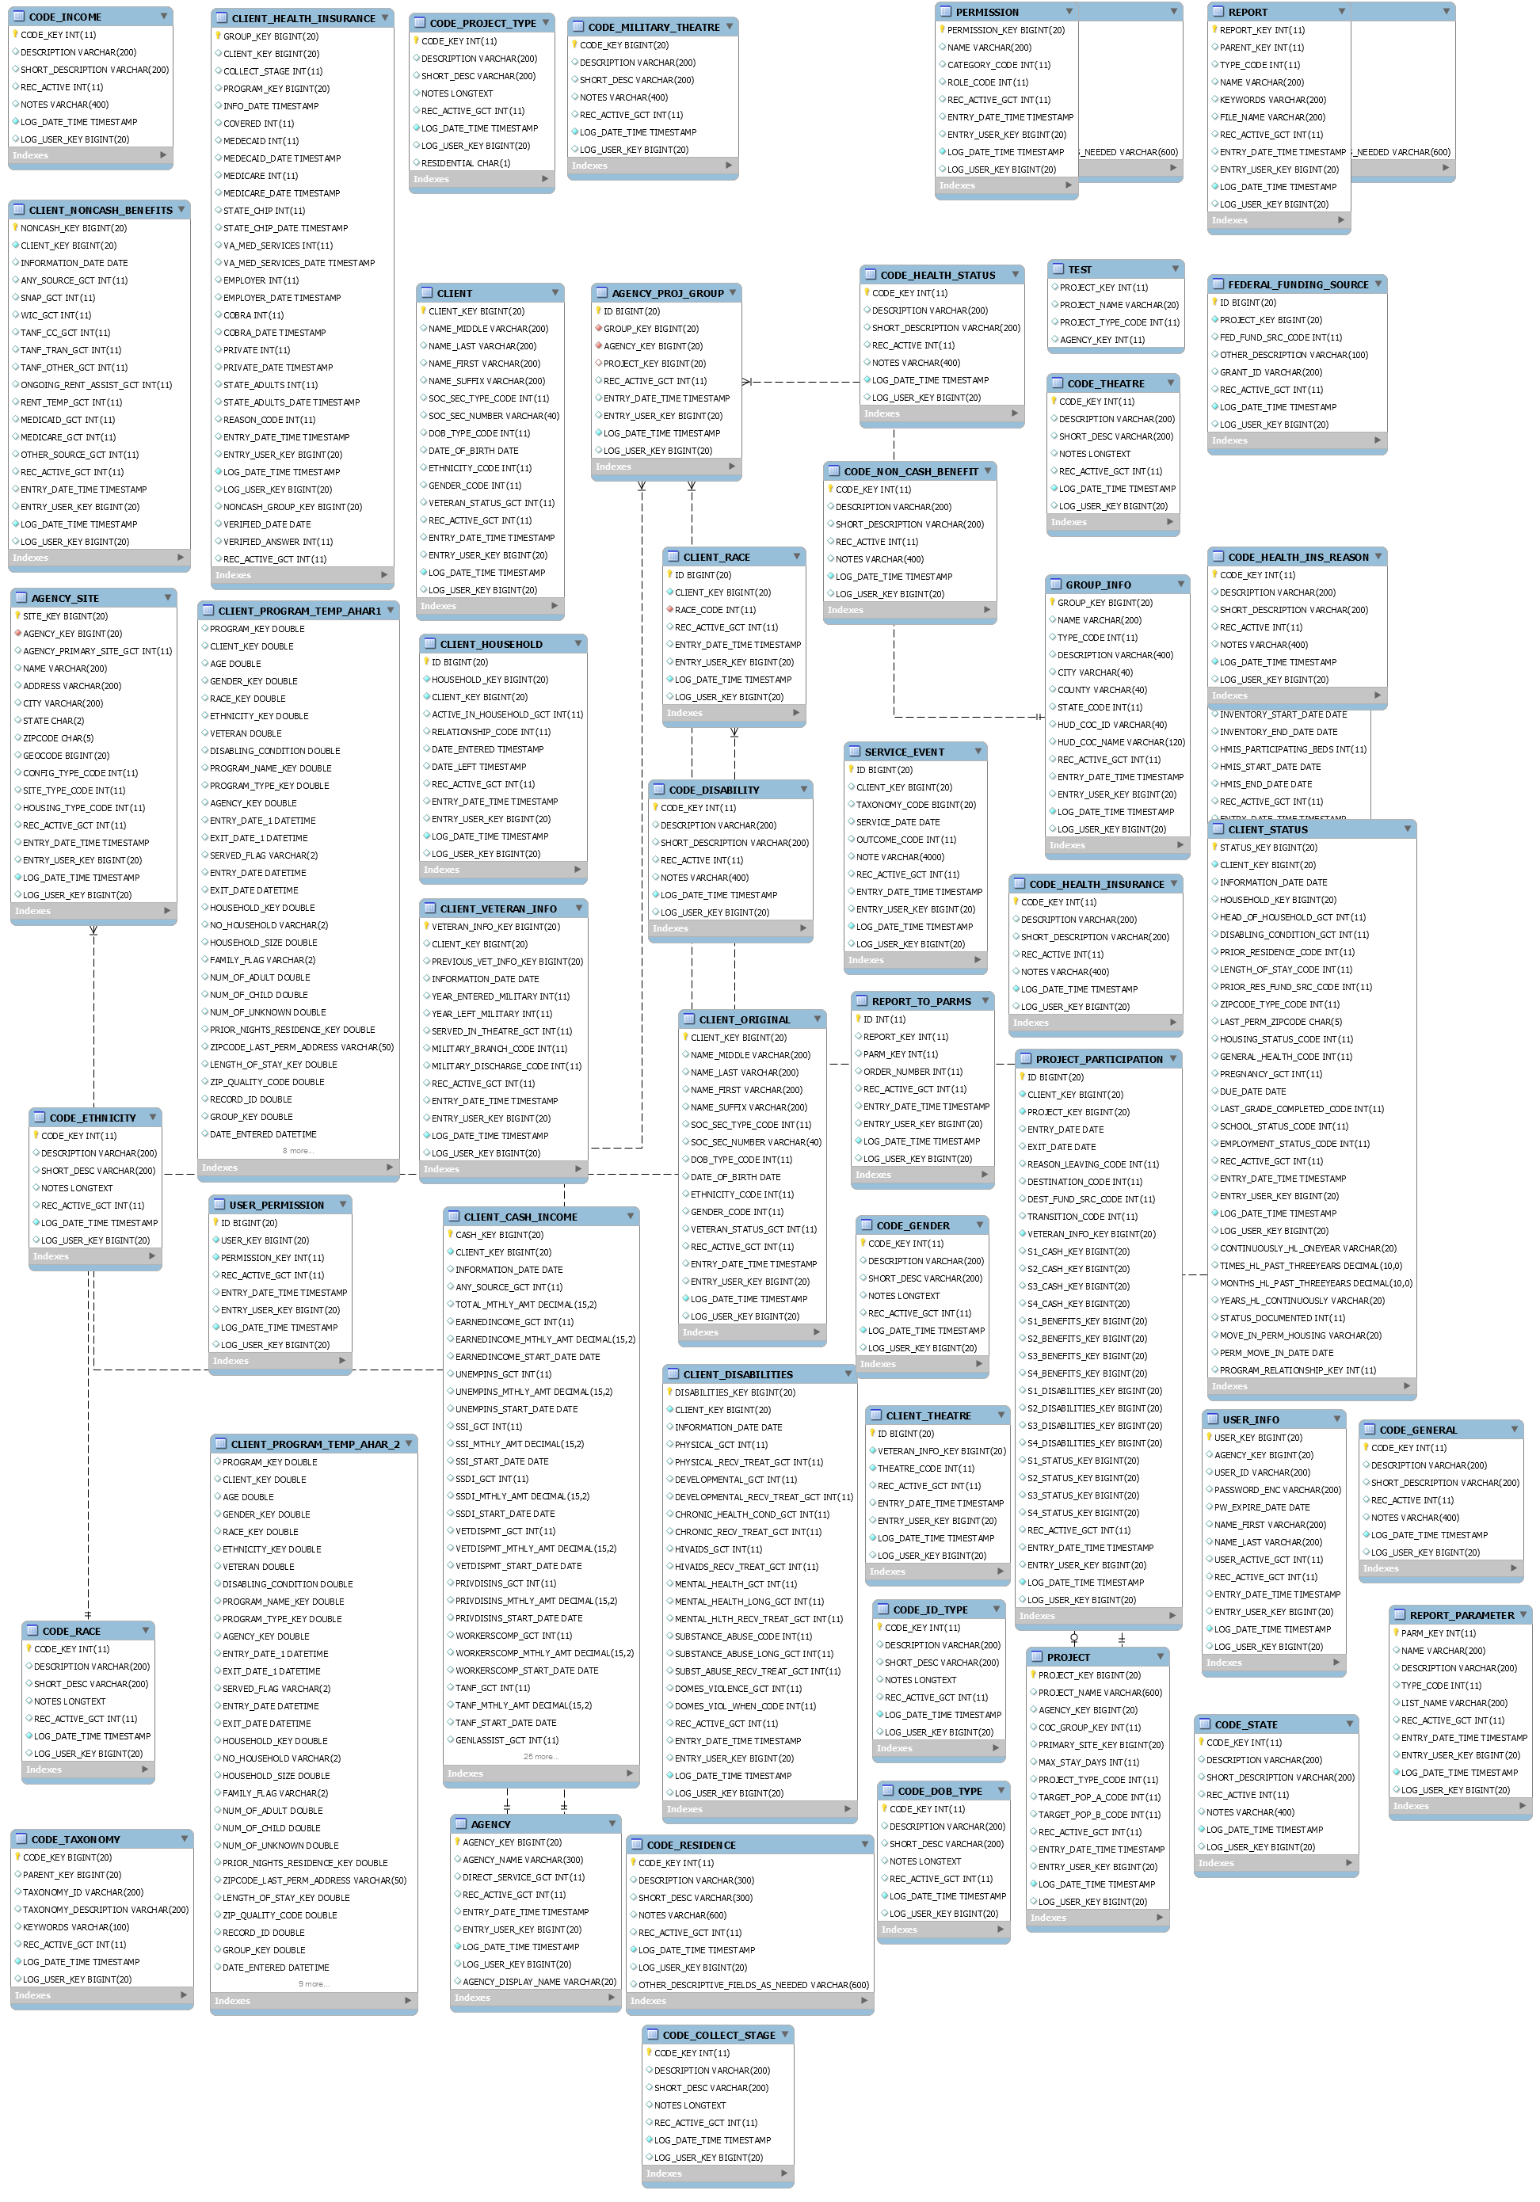

# Schema used for app development:

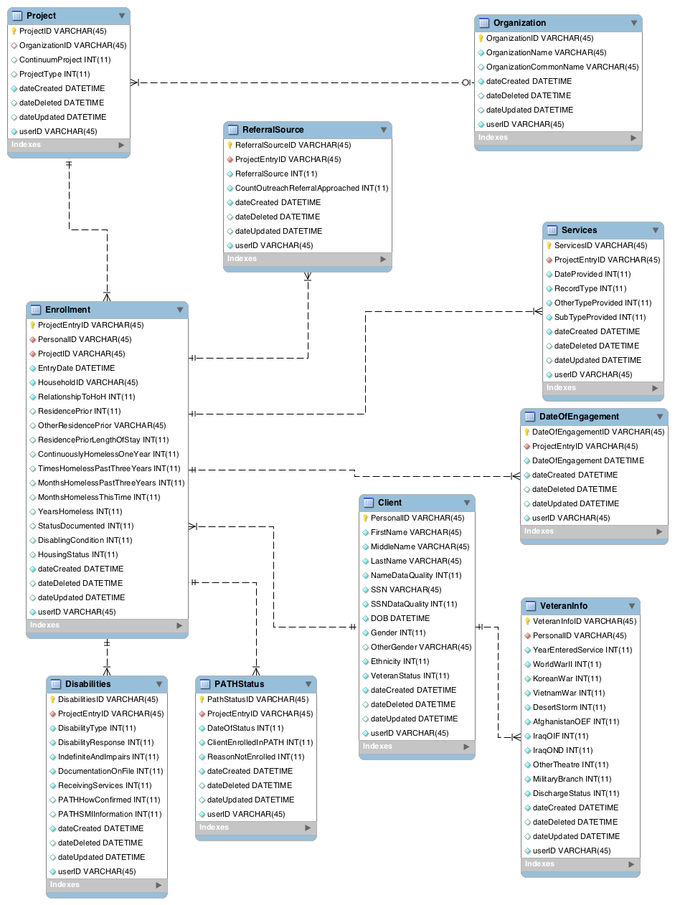

# Notes/ Observations on changes required:

1. The two main tables in the proposed schema are the CLIENT and ENROLLMENT tables. The client table has most of the data in common with the existing CLIENTtable.
2. The Enrolment table has data from both the CLIENT_STATUS and PROJECT_PARTICIPATION tables.
3. Innoppl will need to refer to the CODE_* tables to set the values in the CLIENT_STATUS tables according to the field values entered as answers to the questions in the app.
4. Data Quality Reference:

|  |  |
| --- | --- |
| Code | Value |
| 1 | Full data reported |
| 2 | Partial data reported |
| 8 | Client doesn’t know |
| 9 | Client Refused |
| 99 | Data not collected |

1. HMIS Data Dictionary: <https://www.hudexchange.info/resource/3824/hmis-data-dictionary/>
2. Innoppl will use the field names as present in the DB for matching fields.
3. In the tables below, fields in **GREEN** need to be added and fields in RED need to be deleted.

# Mapping Information:

## Client to CLIENT

|  |  |  |
| --- | --- | --- |
| Proposed (Client) | Existing | Notes |
| PersonalID | CLIENT_KEY | Change from VARCHAR to BIGINT |
| FirstName | NAME_FIRST |  |
| MiddleName | NAME_MIDDLE |  |
| LastName | NAME_LAST |  |
| SSN | SOC_SEC_NUMBER |  |
| SSNDataQuality | SOC_SEC_TYPE_CODE |  |
| DOB | DATE_OF_BIRTH | Change type to DATE |
| DOBDataQuality | DOB_TYPE_CODE |  |
| Gender | GENDER_CODE |  |
| OtherGender |  |  |
| Ethnicity | ETHNICITY_CODE |  |
| VeteranStatus | VETERAN_STATUS_GCT |  |
| DateCreated | ENTRY_DATE_TIME |  |
| DateDeleted | **ACT_DATE_TIME** | Do we need this? The data cannot be deleted from the app anyway. But the DB needs this to conform to standards. |
| DateUpdated | LOG_DATE_TIME | Not used by the App. |
| UserID | ENTRY_USER_KEY | The app only created records for now. If it does updates, we will need those APIs to change LOG_USER_KEY |

## Enrolment to PROJECT_PARTICIPATION, CLIENT_STATUS

|  |  |  |  |
| --- | --- | --- | --- |
| Proposed (Enrolment) | Existing | Table | Notes |
| ProjectEntryID | ID | PROJECT_PARTICIPATION |  |
| PersonalID | CLIENT_KEY | PROJECT_PARTICIPATION |  |
| ProjectID | PROJECT_KEY | PROJECT_PARTICIPATION |  |
| EntryDate | ENTRY_DATE | PROJECT_PARTICIPATION |  |
| ExitDate | EXIT_DATE | PROJECT_PARTICIPATION |  |
| HouseHoldID | HOUSEHOLD_KEY | CLIENT_STATUS |  |
| RelationshipToHoH | HEAD_OF_HOUSEHOLD_GCT | CLIENT_STATUS | Refer dictionary |
| ResidencePrior | PRIOR_RESIDENCE_CODE | CLIENT_STATUS |  |
| OtherResidencePrior | PRIOR_RESIDENCE_CODE | CLIENT_STATUS | Check whether the fields cover all scenarios |
| ResidencePriorLengthOfStay | LENGTH_OF_STAY_CODE | CLIENT_STATUS |  |
| ContinuouslyHomelessOneYear | ??? |  | Check with Tony again. He mentioned another table with the homeless time date |
| TimesHomelessPastThreeYears | ??? |  | Check with Tony again. He mentioned another table with the homeless time date |
| MonthsHomelessPastThreeYears | ??? |  | Check with Tony again. He mentioned another table with the homeless time date |
| MonthsHomelssThisTime | ??? |  | Check with Tony again. He mentioned another table with the homeless time date |
| YearsHomeless | **???** |  | Check with Tony again. He mentioned another table with the homeless time date |
| StatusDocumented | ??? |  | Check with Tony again. He mentioned another table with the homeless time date |
| DisablingCondition | DISABLING_CONDITION_GCT | CLIENT_STATUS |  |
| HousingStatus |  |  |  |
| dateCreated | ENTRY_DATE_TIME | ALL |  |
| dateDeleted |  |  |  |
| dateUpdated |  |  |  |
| userID | ENTRY_USER_KEY | ALL |  |