ENTITY RELATIONSHIP DIAGRAMS

YESE
OpenTek School Enterprise Management System (SEMS-ERP)
Modular Data Model — Domain Map, per-Domain ERDs & Data Dictionary
Version 1.0 — Aligned to the Master Implementation Prompt & SRS
Prepared by KWIDJA Marc & NOKA Gildas — OpenTek
Date: 29 September 2026

Table of Contents

1. Introduction

1.1 Purpose
This document presents the data model for YESE — OpenTek's multi-tenant, modular School Enterprise Management System (SEMS-ERP). Because the platform is genuinely modular, the model is presented as a modular set: a domain map showing how the domains relate, followed by a detailed entity-relationship diagram for each domain, and a consolidated data dictionary. It is derived from the database architecture in the Master Implementation Prompt and the SRS, and targets PostgreSQL.

1.2 Notation & Conventions
- Notation: crow's-foot ERD. Each entity lists its columns with markers — PK (primary key), FK (foreign key), UQ (unique). A leading * marks a required (NOT NULL) column.
- Database: PostgreSQL. This resolves the earlier Postgres-vs-MongoDB ambiguity decisively in favour of PostgreSQL (relational integrity, row-level tenant isolation, financial ledgers).
- Multi-tenancy: every tenant-owned table carries a tenant_id foreign key; isolation is enforced at the data-access layer, never the frontend.
- Data ownership: each domain owns its tables. Cross-domain references use foreign keys to another domain's primary key, but a module never manipulates another module's internal tables directly.
- Identifiers: UUID surrogate keys throughout, for global uniqueness across tenants.

2. Domain Map (Cross-Domain Relationships)
The domain map shows the platform's domains and how they depend on one another. Every domain depends on the Core Platform for tenancy, identity, RBAC and module activation. Arrows indicate dependency and data reference between domains, not table-level foreign keys (those appear in the per-domain diagrams that follow).
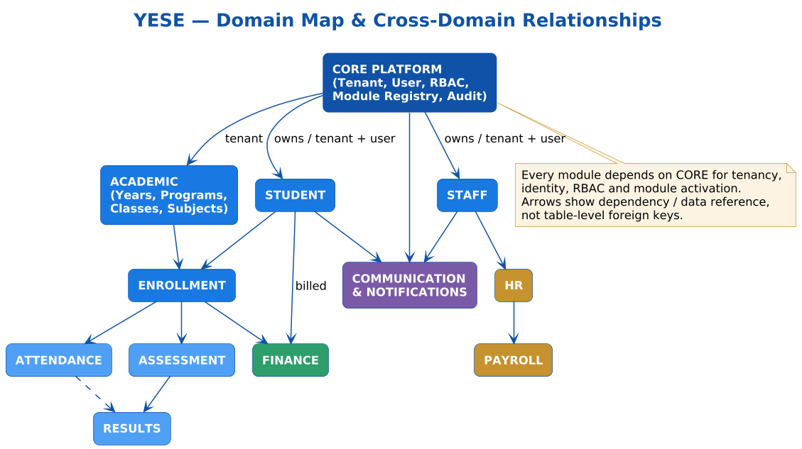
Figure 1 — YESE domain map.

3. Core Platform Domain
The Core Platform underpins every other module: multi-tenancy (Tenant), identity and accounts (User, Identity), the two-layer RBAC model (Role with fixed archetypes plus tenant-defined custom roles, Permission, and the User-Role / Role-Permission junctions), the Module Registry that makes the platform configurable (Module, Module_Version, Module_Dependency, Tenant_Module, Module_Configuration), and Audit_Log for traceability.
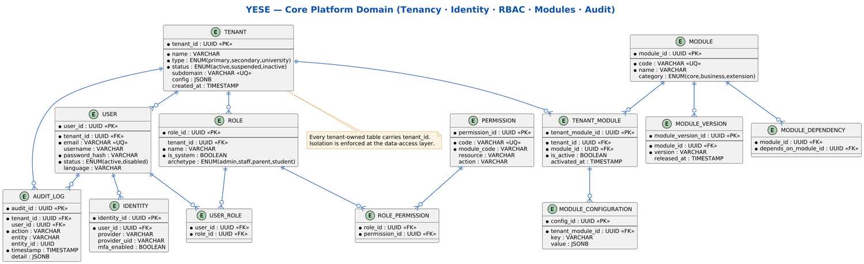
Figure 2 — Core Platform domain ERD.

4. Student & Staff Domains
The Student domain holds student records, profiles, statuses, documents, and the many-to-many Student-Guardian relationship (a student may have several guardians and a guardian several children). Not every student has a user account — primary pupils may have none. The Staff domain mirrors this for teaching and non-teaching staff, with types, statuses, profiles and assignments.
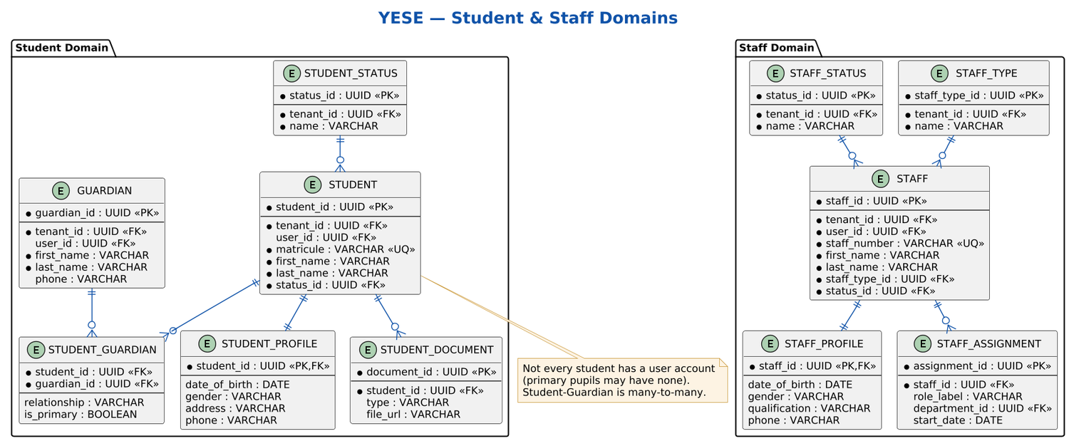
Figure 3 — Student & Staff domains ERD.

5. Academic Structure & Enrollment
The Academic domain defines the institution's academic frame: academic years and terms, departments, programs, classes and sections, subjects and courses (with credit units for universities), curricula, and teacher assignments. The Enrollment domain places a student into a section for an academic year; Teacher_Assignment binds staff to a subject within a section.
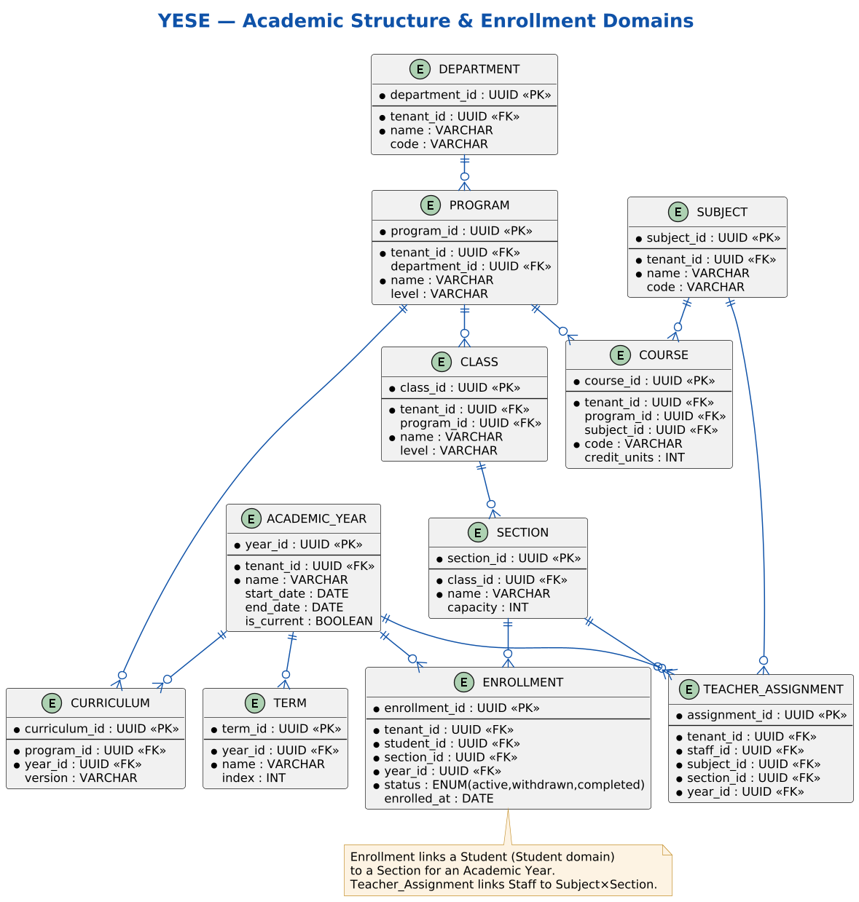
Figure 4 — Academic structure & enrollment ERD.

6. Academic Operations (Attendance · Assessment · Results)
Academic operations build on enrollment. Attendance records per-session student presence against configurable statuses. Assessment captures assessments, their components, per-student attempts, scores and grade entries, with a grade lifecycle of entered → validated → locked. Results consolidate grades into results, summaries, report cards (school) and transcripts (university).
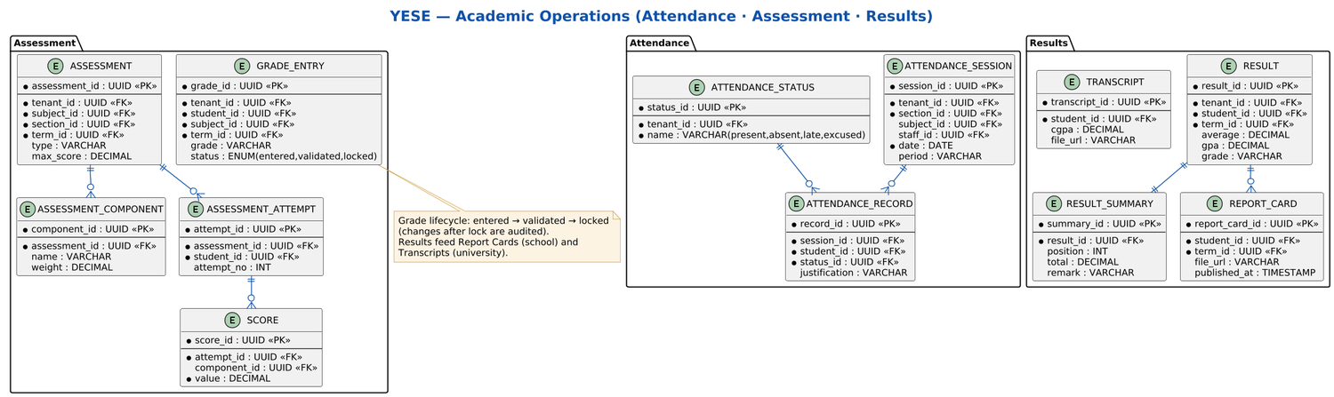
Figure 5 — Academic operations ERD.

7. Finance Domain
The Finance domain defines fee structures and items, generates invoices and invoice items, records payments (including Mobile Money channels) and issues uniquely-numbered receipts, and maintains an immutable financial-transaction ledger with discounts and scholarships. Financial records are never deleted — corrections use void, reversal or cancellation with an audit trail.
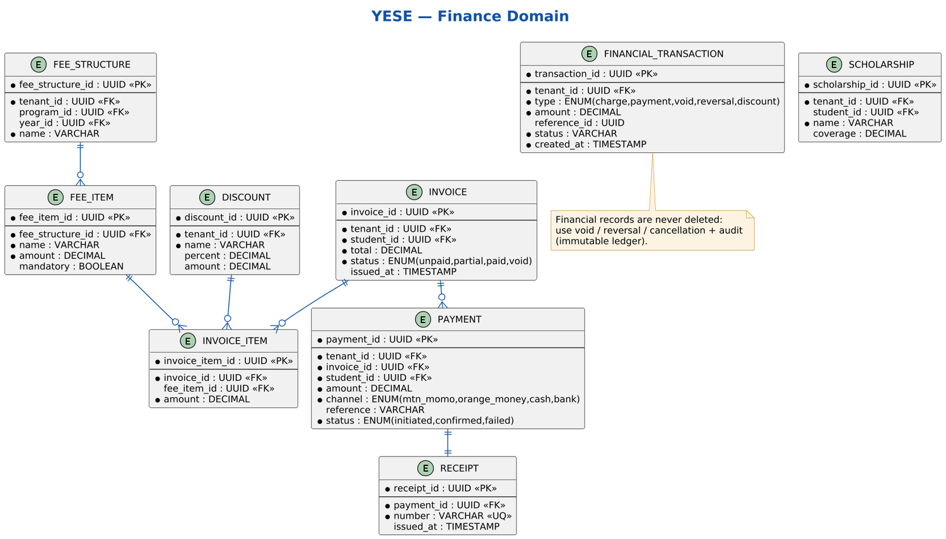
Figure 6 — Finance domain ERD.

8. HR & Payroll Domains
The HR domain manages leave types and requests with approvals, staff attendance and staff performance. The Payroll domain manages salary structures, payroll runs and per-staff payroll items with their deductions, bonuses and generated payslips. Both depend on the Staff domain.
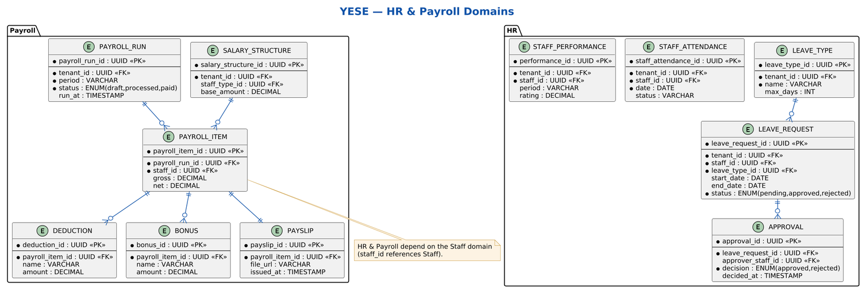
Figure 7 — HR & Payroll domains ERD.

9. Communication & Notifications
The Communication domain models conversations and their participants, messages, announcements, and — critically — Communication_Rule, which encodes the communication firewall enforced at the backend (for example, Parent→Student and Student→Admin direct messaging are blocked). The Notifications domain records notifications and their multi-channel delivery (in-app, email, SMS, WhatsApp).
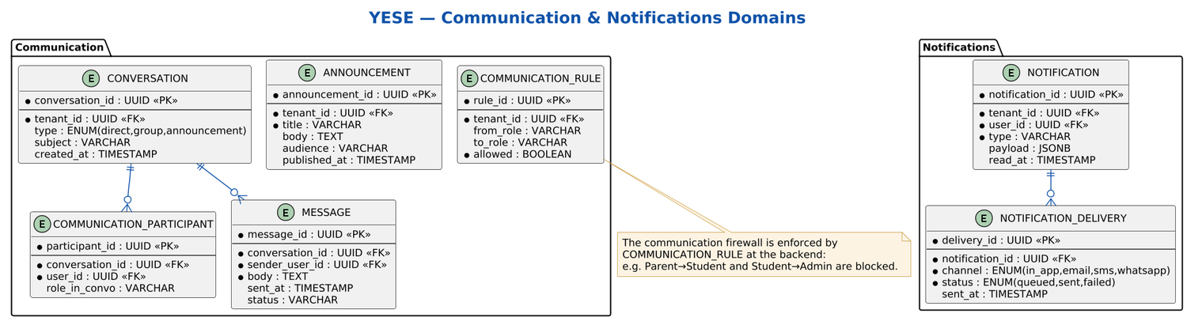
Figure 8 — Communication & Notifications ERD.

10. Data Dictionary
A consolidated reference of the principal entities by domain. Tenant-owned entities additionally carry tenant_id (omitted below for brevity).

10.1 Core Platform
Entity | Purpose
Tenant | One institution (tenant); root of all tenant-scoped data.
User | An account belonging to a tenant.
Identity | Authentication identity/provider linkage and MFA for a user.
Role | A role — a fixed archetype (admin/staff/parent/student) or a tenant-defined custom role.
Permission | A discrete permission (module · resource · action).
User_Role / Role_Permission | Junctions assigning roles to users and permissions to roles.
Module | A registered platform module.
Module_Version / Module_Dependency | Module version metadata and inter-module dependencies.
Tenant_Module | Per-tenant activation of a module (the modularity engine).
Module_Configuration | Per-tenant module settings.
Audit_Log | Immutable record of critical actions.

10.2 Student & Staff
Entity | Purpose
Student / Student_Profile / Student_Status | Student record, extended profile, and lifecycle status.
Guardian / Student_Guardian | Guardian record and the many-to-many student-guardian link.
Student_Document | Documents attached to a student.
Staff / Staff_Profile / Staff_Type / Staff_Status | Staff record, profile, type and status.
Staff_Assignment | A staff member's assignment (e.g. to a department).

10.3 Academic & Enrollment
Entity | Purpose
Academic_Year / Term | The academic calendar.
Department / Program / Class / Section | The structural hierarchy of the institution.
Subject / Course / Curriculum | Subjects, credit-bearing courses and program curricula.
Teacher_Assignment | Binds a staff member to a subject within a section for a year.
Enrollment | Places a student into a section for an academic year.

10.4 Academic Operations
Entity | Purpose
Attendance_Session / Attendance_Record / Attendance_Status | Attendance per session, per student, with status.
Assessment / Assessment_Component | An assessment and its weighted components.
Assessment_Attempt / Score | A student's attempt and the scores recorded.
Grade_Entry | A validated/locked grade for a student in a subject and term.
Result / Result_Summary / Report_Card / Transcript | Consolidated results, summaries and generated documents.

10.5 Finance
Entity | Purpose
Fee_Structure / Fee_Item | Fee definitions and their line items.
Invoice / Invoice_Item | A student's invoice and its lines.
Payment / Receipt | Payments (incl. Mobile Money) and issued receipts.
Financial_Transaction | Immutable ledger entry (charge/payment/void/reversal/discount).
Discount / Scholarship | Fee reductions and scholarship coverage.

10.6 HR & Payroll
Entity | Purpose
Leave_Type / Leave_Request / Approval | Leave configuration, requests and approvals.
Staff_Attendance / Staff_Performance | Staff attendance and performance records.
Salary_Structure | Salary basis per staff type.
Payroll_Run / Payroll_Item | A payroll cycle and its per-staff items.
Deduction / Bonus / Payslip | Payroll item deductions, bonuses and generated payslips.

10.7 Communication & Notifications
Entity | Purpose
Conversation / Communication_Participant / Message | Threads, their participants and messages.
Announcement | Broadcast announcements to an audience.
Communication_Rule | Backend-enforced messaging firewall rules.
Notification / Notification_Delivery | Notifications and their multi-channel delivery.

— End of YESE Data Model (ERDs & Data Dictionary), Version 1.0 —

