”Toryo” .NET application framework
user guide (index edition)

5/4/2014

Introduction

Scope of this document
Manager/SE/Developers considering .NET application development with Toryo.
SE/Developers who performs the .NET application development using the Toryo.

Overview of this document
This document compiles the details of “Toryo” (Configuration, development procedure, functions/tools etc.), and the user guides, reference materials etc. describing them.

Use of copyrights and trademarks of other companies
The company names and product names used in this document are the trademarks or registered trademarks of the respective companies.

License
This document is licensed under the Creative Commons Attribution 2.1 Japan License.
http://creativecommons.org/licenses/by/2.1/jp/legalcode

Table of Contents

１． What is [Toryo]? 4
２． Configuration and Processing 8
３． Development procedure 11
４． Each Function/Tool 12

What is [Toryo]?
[Toryo] is an application development framework for Microsoft .NET Framework, with a variety of functions added to the [Standard framework] that provides a framework for standardizing the architecture.

  - Runtime framework
Uses Microsoft .NET Framework standard runtime
- P layer: ASP.NET, ASP.NET MVC, Windows Forms etc.
- D layer: ADO.NET

  - Full stack framework
This is a full stack framework comprising framework of each of the P/B/D layers.

  - Standard frame (framework)
- Standardization of the application structure across the P/B/D layers is possible.
- Physical architecture (C/S, Web, Web API, handy, cloud) is irrelevant.
- There are partial prerequisites for the logical architecture and the development technology used.

  - All types of development support functions
- SQL creation support
  - Dynamic parameterized query
Editing function of external SQL definition (XML format), and dynamic SQL.
  - Batch SQL creation utility
Function that creates the SQL batch for addition/update from DataTable.

- Auto generation tool
Auto generation of code that uses DBMS schema information
  - D layer (Dao) auto generation
  - Table maintenance screen auto generation (ASP.NET)

- Communication control functions
  - Support for ASP.NET Web service, WCF (HTTP, TCP/IP)
  - Configured from client library and service interface, automation of
.NET object binary transfer (serialization/reverse serialization) to B layer call.
  - This enables easy implementation of physical 3 layer architecture of C/S3 layer etc.
  - Provision of generic service interface of SOAP/ REST formats in case of cross platform (link with other development technologies)

- Others,
Globalization support, streamlining of common components etc.
  - Handling of fitting problem of standard frame (framework)
Fitting problem is prevented by deploying the following architecture.
- Use of 3 layer configuration of class inheritance of base class 1/2, sub class,
enables PJ-wise customization of customizable layer (base class 2).
- By using a design considering the generic nature of object model, method signature, I / F, external parameterization etc., fitting problems that occurred in the earlier standard frame (framework) will almost not occur.

  - Handling of small scale projects
[Toryo] does not put together the API set from 0 by itself, but sets up the project easily by using templates that are compatible with each architecture. Hence, this can be easily used for small sized projects of around 20KS.

The non-standardized applications and the problems associated with them are described as follows.
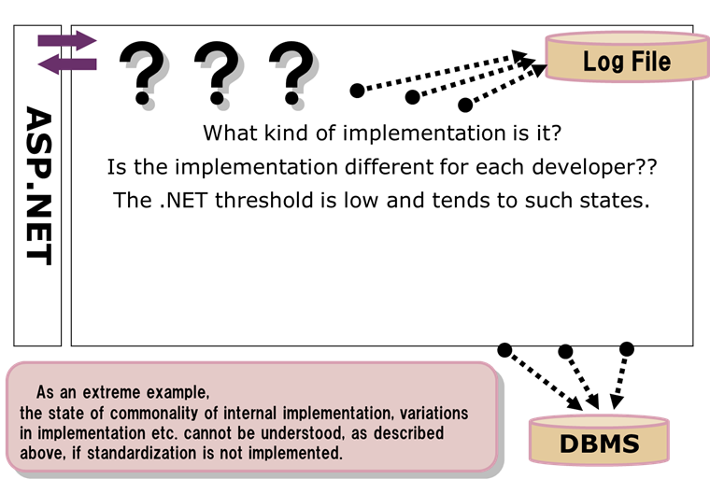
Figure 1-1 Non-standardized applications

Table 1-1 Problems and effects of non-standardized applications
Sl. No. | Problem | Effect
1 | ・ Non-compliance to Common processing method (Basic)  ・ Program structure is not uniform | Deterioration of productivity/maintainability
2 | Redundant processes used in development | Deterioration of productivity
3 | Oversight or mistakes in implementation of all types of check process, exclusion process etc. | Deterioration of quality
4 | ・ Implementation fault of SQL assembly  ・ Oversight of steps like input value sanitizing etc. | Vulnerability problems

These problems can be solved by standardizing applications using [Toryo] as shown below.

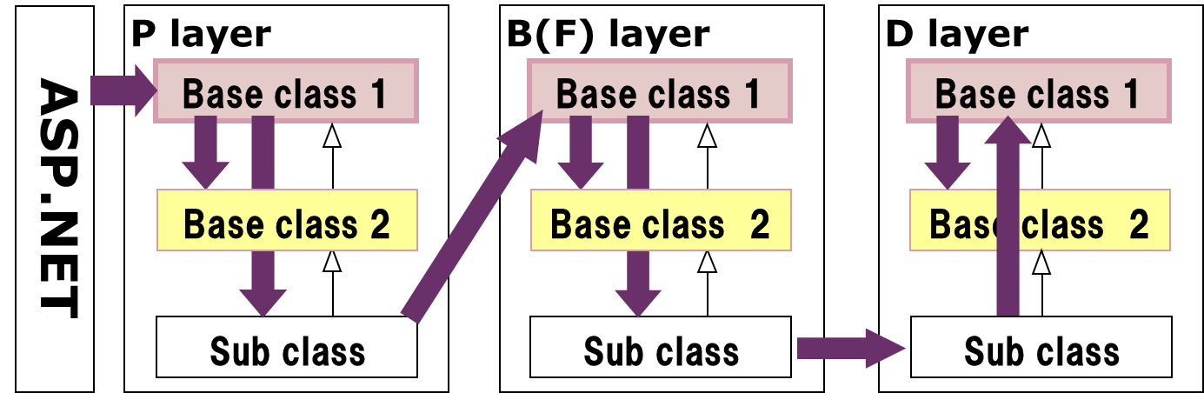
Figure 1-2 Application standardized by [Toryo]

Table 1-2 The resolution of issues by application standardization and the effects
Sl. No. | Solution | Effect
1 | ・ Compliance to Common processing methods (Basic)  ・ Program structure is unified | Improvement of productivity/maintainability
2 | Elimination of redundant processes | Improvement of productivity
3 | Prevention of implementation oversights/faults  (authentication, obstruction, time stamp check) | Improvement of quality
4 | Prevention of implementation oversights/faults related to security vulnerability  (compliance with use of custom control, use of parameterized query etc.) | Elimination of vulnerability

The following functions are available.
- Screen transition control function
  - Screen transition, transition check function
  - Prevention of duplicate transmission and incorrect operation
- Session management function
  - Scope handling for all types of sessions
  - Auto cancellation function of session
  - Session time-out detection
- Multiple window display/control function
  - Modal screen, modeless screen
- Data access
  - Transaction control function
  - Dynamic parameterized query function
  - D layer auto generation tool
- Log output function
  - Access trace log
  - SQL trace log
- RIA: 3 layer C/S, Ａｊａｘ support
  - Communication control function
  - ASP.NET asynchronous post back
    - Ｃｌｉｅｎｔ Ｃａｌｌｂａｃｋ
    - Ｅｘｔｅｎｓｉｏｎｓ
    - Ｗｅｂ service bridge
- Utility functions
  - Performance measurement function
  - Character string editing function
  - Shared information, message definition
- Support for other, various process formats
  - 2 layer C/S format, assembly
  - Ｍｏｂｉｌｅ Ｗｅｂ application

- etc.

Figure 1-3 Functions of [Toryo]

Configuration and Processing
[Toryo] operates according to the following configuration/process flow.
Client Browser
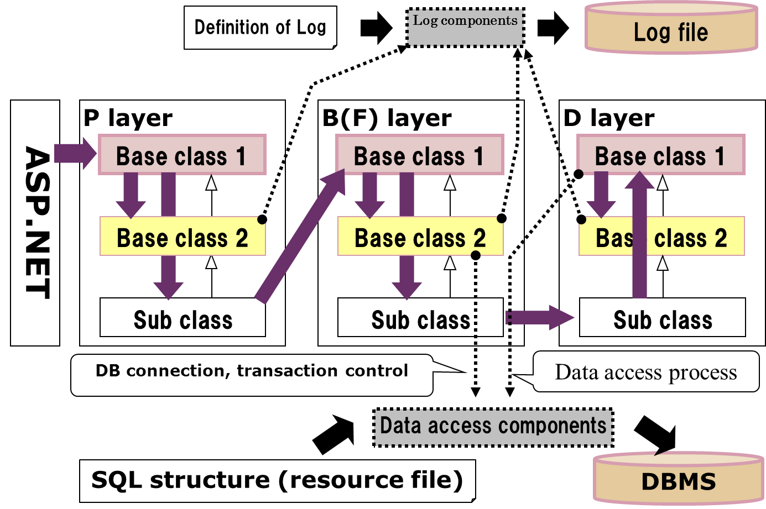

Figure 2-1 Configuration and process flow
＜Note＞
In case of ASP.NET, the [web.config] file compiling the ASP.NET configuration, and the [app.config] file compiling the [Toryo] configuration are files to be used in addition to the above mentioned [log definition]/[SQL definition file]. Also, additional files may have to be defined depending on the functions used.

The layer configuration of [Toryo] is described here. [Toryo] is formed of the 3 layers (horizontal) of P/B/D, and furthermore each layer is configured from the 3 layers (vertical) of [base class 1/2], [sub class]. The roles of each vertical layer are described as follows.
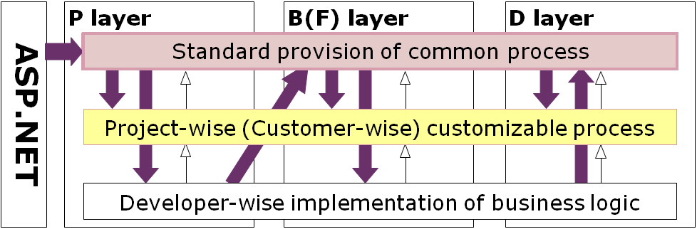

Figure 2-2 Configuration of each layer

Table 2-1 Roles of each layer
Sl. No. | Direction | Layer | Roles
1 | Horizontal layers |  | Logical layers that are divided according to the classification of process logic.
1-1 |  | P layer | Presentation layer that handles screen display process logic.
1-2 |  | B layer | Business logic layer that handles the business process logic.
1-3 |  | D layer | Data access layer that handles the data access process logic.
2 | Vertical layers |  | In the Toryo development model, development is implemented by inheriting the class provided.
2-1 |  | Base class 1 | Framework class related to the application structure, processing method.  Provides functions that specifies the application structure controls process flow.
2-2 |  | Base class 2 | Inherits [base class 1], and implements domain specific process.  Domain specific process corresponds to the common base process of each project.  In addition, also manages DB connection, transaction, log output.
2-3 |  | Sub class | Inherits the above mentioned [base class 2], and implements business logic.

The table above shows the roles of the vertical layers. Hence, the table below indicates the person to implement each layer.

Table 2-2 Implementation in charge for each layer
Sl. No. | Layer | Implementation in charge
1 | Base class 1 | Basically no revisions.
2 | Base class 2 | Implementation by [Manager] who understands processing method.
3 | Sub class | Implementation by [Developer] who implements business logic.
The following processes are implemented in [base class 2].
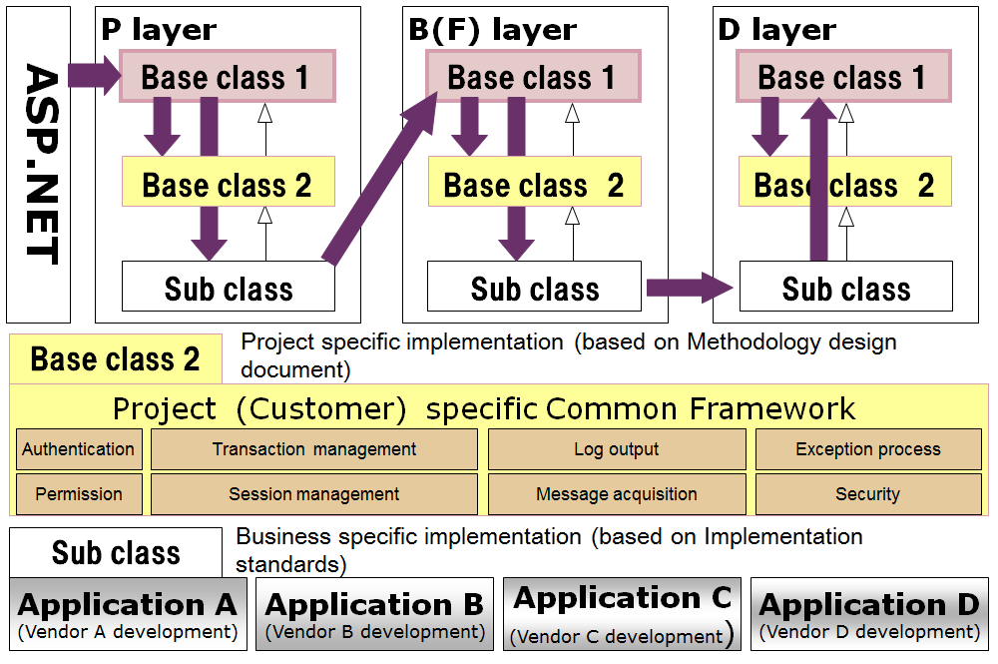

Figure 2-3 Example of process implemented in [Base class 2]

The correlation between the [User guides] used in development and [Users] is shown as follows.

Table 2-2 User guides and users
Sl. No. | User guide name | User
1 | Common (General) guide | Manager, developer
2 | Manager guide | Manager
3 | Developer guide | Developer

Also, the following formal names are used for classes in the User guides.

Table 2-3 Class names (Formal names)
Sl. No. | Vertical layer  Horizontal layer | Base class 1 | Base class 2 | Sub class
1 | P layer | Screen code parent class 1 | Screen code parent class 2 | Screen code class
2 | B layer | Business code parent class 1 | Business code parent class 2 | Business code class
3 | D layer | Data access parent class 1 | Data access parent class 2 | Data access class (Ｄａｏ)
4 | Parameter | Parameter parent class 1 | Parameter parent class 2 | Parameter class
5 | Return value | Return value parent class 1 | Return value parent class 2 | Return value class
6 | Derived information | User information parent class | User information class | －

Development procedure
The development procedure involves the [Tailoring, Formulation] of document standards like the following and proceeding further.
Screen/Report list
Screen/ Report layout definition document
Table definition document
Event details definition document
Use case scenario
Screen transition diagram
Event list
Event definition document (event outline)
(Ｐ layer) method definition document (including event handler)
(Ｂ layer) method definition document
(Ｄ layer) method definition document
Screen items definition document
(List of method/property member variables etc.)
Ｐ layer, parameter, return value, Ｂ layer, Ｄ layer etc., and respective class definition documents
Reverse (auto generation with tool)
Breakdown the event details definition document into 3 layers according to need.
(Parameter) class definition document
(Return value) class definition document
Physical data model
ＣＲＵＤ fig.
Focused streamlining of check process, data transfer process of screen/report, ＤＢ item, rotation data etc.
ＣＲＵＤ diagram.
(Ｓｅｓｓｉｏｎ)
Confirm excess or deficiency of process and prevent leak
Creating screen as mock up is also fine.
(auto generation of definition document using tool is possible)
Confirm excess or deficiency of process from ＣＲＵＤ fig. and event list,
Basic design document
Detailed design document
Legend
Work contents
Detailed design document (reverse)
Ｐ layer, parameter, return value, Ｂ layer, Ｄ layer etc., and respective class lists
Logical data model
ＤＢ design
ER/Studio can be used
While creating the event details definition document, use lock sequence as standard.
Internal design
External design
Class diagram
Member information etc. detailed definition is unnecessary.
Show class relationship only
Programming

Figure 3 Example of Document standardization workflow

Reverse process using the document creation tool of [Doxygen]/[A Hot Document] etc. is provided in [Toryo]. In this case, the [event details definition document] in the figure shown above needs to be designed, , and the [class/method definition document] is auto generated by the document creation tool, which is supplementary to the [event details definition document].

Each Function/Tool
[Toryo] has functions and tools like those shown below. In addition to usable functions as add-ons basis, the tools provided by framework can be used while using the Visual Studio designer, which is a RAD tool. As a result, the project QCDF can be enhanced.
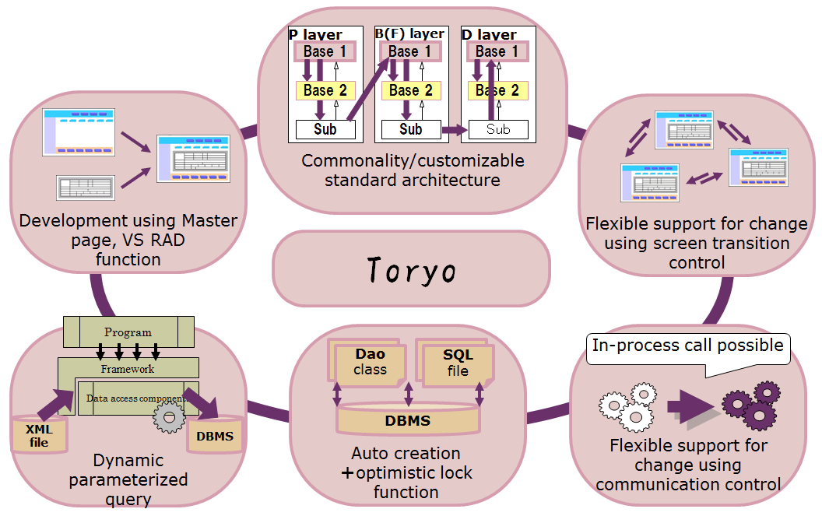

Figure 4-1 Every function/tool

These functions and tools can be used in the development of each layer. Also, there are no specific restrictions in the development sequence of each layer. Either the Bottom up format (D layer → B layer → P layer) or the Top down format (P layer → B layer → D layer) can be applied.
Bottom up
Document auto generation
Top down
Method definition document
Screen items definition document definition document
Class definition document

【Visual Studio designer】 【Communication control】【Dynamic parameterized query】
【Screen transition control】 【D layer auto generation】

Figure 4-2 Development procedure and tools
The following table shows the relationship between the documents used in development and [Functions/tools].

Table 4-1 User guides and related [Functions/tools]
Sl. No. | User guide name | Functions/tools
1 | Dynamic parameterized query guide | ・ Dynamic parameterized query (Function)  ・ Dynamic parameterized query analysis tool
2 | D layer auto generation guide | D layer auto generation tool (SUMI TSUBO)
3 | Each function guide | ・ Shared information  ・ Message acquisition function  ・ Screen transition control function  ・ Transaction control function  ・ Communication control function  ・ Ａｊａｘ link function
4 | Better usage, FAQ guide | ・ Application development of C/S2 layer  ・ ASP.NET Mobile Web development
5 | API reference manual | Class library

－END－

