”Toryo” .NET application framework
user guide
(Dynamic parameterized query edition)

5/4/2014

Introduction

Scope of this document
SE/Developers who performs the .NET application development using the Toryo.

Overview of this document
This document describes the usage method of the dynamic parameterized query function of the framework.

Use of copyrights and trademarks of other companies
The company names and product names used in this document are the trademarks or registered trademarks of the respective companies.

License
This document is licensed under the Creative Commons Attribution 2.1 Japan License.
http://creativecommons.org/licenses/by/2.1/jp/legalcode

Table of Contents

１． Description Method of Dynamic Parameterized Query 4
１．１ Outline 4
１．２ Description Rules 7
２． Usage Method of Dynamic Parameterized Query Analytical Tool 15
２．１ Outline 15
２．２ Basic Usage Method 16
２．３ Others, GUI Panel Operation Method 19
２．４ Static parameterized Query Execution Function 22
３． Implementation Method of Data Access Process 23

Description Method of Dynamic Parameterized Query

Outline
”Toryo” dynamic parameterized query uses the query description rule with XML tag, and by describing the query according to this query description rule, and setting the parameter from API, enabling/disabling etc. of JOIN/WHERE statement and conditional expression can be controlled.

The detailed example of ”Toryo” dynamic parameterized query is shown as follows.
<?xml version="1.0" encoding="shift_jis" ?>
<ROOT>
SELECT DISTINCT ctm.companyname, ctm.contactname, ctm.contacttitle FROM orders AS o
INNER JOIN customers AS ctm ON o.customerid = ctm.customerid
<JOIN name="j1">
INNER JOIN shippers AS s ON o.shipvia = s.shipperid
</JOIN>
<JOIN name="j2">
INNER JOIN [order details] AS od ON o.orderid = od.orderid
INNER JOIN products AS p ON od.productid = p.productid
INNER JOIN categories AS cgy ON p.categoryid = cgy.categoryid
</JOIN>
<WHERE>WHERE<IF>s.companyname=@p1</IF><IF>AND cgy.categoryname=@p2</IF></WHERE>
ORDER BY [<VAL name="COLUMN"/>] <VAL name="SEQUENCE"/)
</ROOT>

Fig. １．１－１ Detailed example of ”Toryo” dynamic parameterized query

Thus, Visual Studio can be used to create dynamic parameterized query (XML). If there are more than 200 tags, note that the load on performance increases.

The overview of dynamic parameterized query part is described as follows.

<?xml version="1.0" encoding="shift_jis" ?>
<ROOT>
SELECT DISTINCT ctm.companyname, ctm.contactname, ctm.contacttitle FROM orders AS o
INNER JOIN customers AS ctm ON o.customerid = ctm.customerid
<JOIN name="j1">
INNER JOIN shippers AS s ON o.shipvia = s.shipperid
</JOIN>
<JOIN name="j2">
INNER JOIN [order details] AS od ON o.orderid = od.orderid
INNER JOIN products AS p ON od.productid = p.productid
INNER JOIN categories AS cgy ON p.categoryid = cgy.categoryid
</JOIN>
<WHERE>WHERE<IF>s.companyname=@p1</IF><IF>AND cgy.categoryname=@p2</IF></WHERE>
ORDER BY [<VAL name="COLUMN"/>] <VAL name="SEQUENCE"/>
</ROOT>
【ＪＯＩＮ statement control is possible】
<JOIN> tag controls the enabling/disabling of JOIN statement.
【ＷＨＥＲＥstatement control is possible】
<IF> tag controls the enabling/disabling of search criteria.
Also, <WHERE> tag deletes the WHERE statement itself, in case all search conditions are invalid.
【Insertion of any character string is possible】
<VAL> tag can be compatible with SQL formatting of any pattern, as any character string can be inserted. However, it is necessary to ensure that SQL injection does not occur during use (It is necessary to confirm that there is no problem from SQL trace etc.).
this.SetSqlByFile2("ファイル名");

// パラメタ ライズド クエリのパラメタに対して, 動的に値を設定する.
this.SetParameter("j1", true);
this.SetParameter("j2", true);
this.SetParameter("p1", "United Package");
this.SetParameter("P2", "Beverages");

// ユーザ定義パラメタを置換する.
this. SetUserParameter("COLUMN", "ctm.companyname");
this. SetUserParameter("SEQUENCE", "DESC");
In case of specifying parameter from program, use API as follows and set.
Example in case of using the above mentioned SQL definition from program.
Execution
SELECT DISTINCT ctm.companyname, ctm.contactname, ctm.contacttitle FROM orders AS o
INNER JOIN customers AS ctm ON o.customerid = ctm.customerid
INNER JOIN shippers AS s ON o.shipvia = s.shipperid
INNER JOIN [order details] AS od ON o.orderid = od.orderid
INNER JOIN products AS p ON od.productid = p.productid
INNER JOIN categories AS cgy ON p.categoryid = cgy.categoryid

WHERE s.companyname=@p1 AND cgy.categoryname=@p2
ORDER BY ctm.[companyname] DESC
SQL that is formatted according to parameter specification

Fig. １．１－２ Overview of ”Toryo” dynamic parameterized query (1)

SELECT * FROM PRODUCTS WHERE
CATEGORYID IN(SELECT CATEGORYID FROM CATEGORIES
WHERE CATEGORYID IN(SELECT CATEGORYID FROM CATEGORIES
WHERE CATEGORYID IS NOT NULL) AND CATEGORYID IS NOT NULL)

AND CATEGORYID IS NOT NULL
AND CATEGORYID IN(@PLIST_1, @PLIST_2, @PLIST_3, @PLIST_4, @PLIST_5, @PLIST_6, @PLIST_7, @PLIST_8)
AND DISCONTINUED = @BIT

ORDER BY [SUPPLIERID] DESC
<?xml version="1.0" encoding="shift_jis" ?>
<ROOT>
SELECT * FROM PRODUCTS
<WHERE>WHERE
<SUB name="SUB1">CATEGORYID IN(SELECT CATEGORYID FROM CATEGORIES
<WHERE>WHERE
<SUB name="SUB2">CATEGORYID IN(SELECT CATEGORYID FROM CATEGORIES
<WHERE>WHERE
<IF name="ISNOTNULL1">CATEGORYID IS NOT NULL
<ELSE>CATEGORYID IS NULL</ELSE>
</IF>
</WHERE>)
</SUB>
<IF name="ISNOTNULL2">AND CATEGORYID IS NOT NULL
<ELSE>AND CATEGORYID IS NULL</ELSE>
</IF>
</WHERE>)
</SUB>
<IF name="ISNOTNULL3">AND CATEGORYID IS NOT NULL
<ELSE>AND CATEGORYID IS NULL</ELSE>
</IF>
<LIST>AND CATEGORYID IN(@PLIST)</LIST>
AND DISCONTINUED = @BIT
</WHERE>
ORDER BY [<VAL name="COLUMN"/>] <VAL name="SEQUENCE"/>
</ROOT>
【Sub-query control is possible】
Sub-query can be controlled by using <SUB> tag.
Within the sub-query, <IF> tag, <WHERE> tag etc. can be nested as usual.
【ＥＬＳＥ condition can be specified】
<ELSE>tag can be nested in <IF>tag (Mainly used to implement IS NULL condition).
Refer to the description of <IF>, <ELSE> tag in Section１．２ for the setting method of ELSE condition that enables <ELSE> tag.
【ＩＮ statement parameter list can be specified】
Automatic extraction of ＩＮ statement parameter list can be implemented by specifying ArrayList in <LIST> tag.
this.SetSqlByFile2("ファイル名");

// パラメタ ライズド クエリのパラメタに対して, 動的に値を設定する.
this.SetParameter("SUB1", true);
this.SetParameter("SUB2", true);

this.SetParameter("ISNOTNULL1", true);
this.SetParameter("ISNOTNULL2", true);
this.SetParameter("ISNOTNULL3", true);

this.SetParameter("PLIST", new ArrayList(new short[] { 1, 2, 3, 4, 5, 6, 7, 8 }));
this.SetParameter("BIT", true);

// ユーザ定義パラメタを置換する.
this. SetUserParameter("COLUMN", "SUPPLIERID");
this. SetUserParameter("SEQUENCE", "DESC");
Example in case of using the above mentioned SQL definition from program.
In case of specifying parameter from program, use API as follows and set.
Execution
SQL that is formatted according to parameter specification

Fig. １．１－３ Overview of ”Toryo” dynamic parameterized query (2)

Description Rules
XML tag used in ”Toryo” dynamic parameterized query is shown in Table １．２－１.

Table １．２－１ ＸＭＬ tag used in ”Toryo” dynamic parameterized query
Sl.No. | Tag name | Tag notation | Description
Sl.No. | Tag name | Tag notation | Nesting of tags
１ | ＲＯＯＴ tag | <ROOT>  ・・・Query definition・・・  </ROOT> | All query definitions are contained within this tag.
１ | ＲＯＯＴ tag | <ROOT>  ・・・Query definition・・・  </ROOT> | ROOT tag, can nest all tags other than ROOT tag.
２ | ＶＡＬ tag | <VAL name="xxx"/> | VAL tag is used to substitute with the character string that is set in parameter. Hence, any character string can be inserted, and can be compatible with all patterns of SQL formatting. Specify pattern name in name attribute (This is called parameter within tag).  If character string is set in parameter within tag of VAL tag, VAL tag is substituted with the set character string. In case null is set in parameter value, VAL tag is disabled when parameter is not set, and is deleted.  As SQL injection is possible in VAL tag, ensure user input is not specified directly in VAL tag (In case of specifying directly, implement single quotation escape etc.).
２ | ＶＡＬ tag | <VAL name="xxx"/> | VAL tag cannot nest tags.  Cannot be used in formats other than <VAL name="xxx"/>.
３ | ＩＮＳＣＯＬ  tag | <INSCOL name="xxx">  ＩｎｓｅｒｔColumn ,  </INSCOL> | INSCOL tag is designed for dedicated use of column list of INSERT statement (Normally, used only in auto generated SQL). If column information in column list of INSERT statement is included in INSCOL tag, and if VALUES parameter list of INSERT statement is included in IF tag (described later), dynamic INSERT statement can be created.  INSCOL tag specifies parameter within tag in name attribute. In case parameter with same name as parameter within tag is set, enable column information in INSCOL tag. In case parameter with same name as parameter within tag is not set, INSCOL tag is disabled and deleted.
３ | ＩＮＳＣＯＬ  tag | <INSCOL name="xxx">  ＩｎｓｅｒｔColumn ,  </INSCOL> | INSCOL tag can nest column information and VAL tag only.

Sl.No. | Tag name | Tag notation | Description
Sl.No. | Tag name | Tag notation | Nesting of tags
４ | ＩＦ tag | Example 1 – parameter within text  <IF>  ・・・[Operator] Condition expression・・・  </IF>  Example 2- parameter within tag  <IF name="xxx">  ・・・[Operator] Conditional expression・・・  </IF> | IF tag controls enabling/disabling of conditional expression, by enclosing conditional expression that is in normal WHERE statement with IF tag.  In case of applying IF tag in conditional expression that uses parameter of parameterized query, use parameter of parameterized query in IF tag as parameter that controls enabling/disabling of conditional expression (This is called parameter within text, and authenticates 1 parameter of parameterized query that leads the character string in IF tag as parameter within text). In case parameter is set in parameter within text, IF tag and parameter are enabled, and in case it is not set, IF tag and parameter are disabled.  In case parameter within text does not exist, specify parameter within tag in name attribute of IF tag. Parameter within tag allows true/false as parameter values, IF tag is enabled if true is set. In case false is set, error if ELSE tag is not there, and ELSE tag is enabled if ELSE tag is there.  In case null is set, for both parameters within text/within tag, error if ELSE tag is not there, and ELSE tag is enabled if ELSE tag is there.  Example 1: <IF>AND XXX=@P1<ELSE>AND XXX IS NULL</ELSE></IF>  Example 2: <IF name="xxx">AND XXX IS NOT NULL</IF>
４ | ＩＦ tag |  | IF tag allows nesting of conditional expression, ELSE tag and VAL tag only.
５ | ＥＬＳＥ tag | <ELSE>  ・・・[Operator] Conditional expression・・・  </ELSE> | ELSE tag can describe the conditional expression etc. in case ELSE tag is enabled due to parameter setting of IF tag. Also, note that both parameters within text/within tag cannot be described in ELSE tag. Thus, XXX IS NULL，XXX IS NOT NULL etc. conditional expressions are described in ELSE tag.  Example 1: <IF>AND XXX=@P1<ELSE>AND XXX IS NULL</ELSE></IF>  Example 2: <IF name="xxx">AND XXX IS NOT NULL<ELSE>AND XXX IS NULL</ELSE></IF>
５ | ＥＬＳＥ tag | <ELSE>  ・・・[Operator] Conditional expression・・・  </ELSE> | ELSE tag allows nesting of conditional expression and VAL tag only.
６ | ＳＥＬＥＣＴ  ＣＡＳＥ  ＤＥＦＡＵＬＴ tag | <SELECT name="xxx">  <CASE value="A">・・・</CASE>  <CASE value="B">・・・</CASE>  <DEFAULT>・・・</DEFAULT>  </SELECT> | SELECT-CASE-DEFAULT tag specifies parameter within tag in name attribute of SELECT tag. Depending on the parameter value that is specified in parameter within tag, enable statement in any CASE tag or DEFAULT tag.  In case parameter value matches the character string in value attribute of CASE tag, enable statement in relevant CASE tag. In case there is no matching CASE tag, enable statement in DEFAULT tag (DEFAULT tag can be omitted).  In case of setting null, if parameter is not set, SELECT tag is disabled and deleted.
６ | ＳＥＬＥＣＴ  ＣＡＳＥ  ＤＥＦＡＵＬＴ tag |  | SELECT-CASE-DEFAULT tag can nest VAL tag only.
７ | ＬＩＳＴ tag | <LIST>  ・・・[Operator] ＩＮ statement Conditional expression・・・  </LIST> | Control specification of parameter list and enabling/disabling of IN statement, by including conditional expression of IN statement with LIST tag.  Normally use parameter within text of parameterized query in LIST tag in parameter name. In case there is no parameter within text, it results in error.  Parameter value is set with ArrayList type (In case of 1 parameter, setting is possible with value type). In case of setting with ArrayList type, the parameters during execution are extracted as @parametername_1, @parametername_2, @parametername_3 ・・・.  In case number of elements of ArrayList is ０, when null is set, if parameter is not set, LIST tag is disabled and deleted.
７ | ＬＩＳＴ tag |  | LIST tag can nest ＩＮ statement conditional expression and VAL tag only.
８ | ＪＯＩＮ tag | <JOIN name="xxx">  ・・・ＪＯＩＮ statement・・・  </JOIN> | Control enabling/disabling of JOIN statement by enclosing JOIN statement in JOIN tag. JOIN tag specifies parameter within tag in name attribute.  In case of enabling JOIN statement, set true in parameter value. In case false and null are set in parameter value, if parameter is not set, JOIN tag is disabled and deleted.  Also, it results in error in case values other than true, false, null are set.
８ | ＪＯＩＮ tag | <JOIN name="xxx">  ・・・ＪＯＩＮ statement・・・  </JOIN> | JOIN tag can nest all tags other than ROOT, PARAM, DIV tags.
９ | ＳＵＢ tag | <SUB name="xxx">  ・・・[Operator]  Conditional expression of sub-query・・・  </SUB> | Control enabling/disabling of conditional expression of sub-query by enclosing conditional expression of sub-query that is used in WHERE statement with SUB tag. Specify parameter within tag in name attribute of SUB tag.  In case of enabling conditional expression of sub-query, set true in parameter value. In case false and null are set, if parameter is not set, SUB tag is disabled and deleted.  Also, it results in error in case values other than true, false, null are set.
９ | ＳＵＢ tag |  | SUB tag can nest all tags other than ROOT, PARAM, DIV tags.
１０ | ＷＨＥＲＥ tag | <WHERE>  ・・・ＷＨＥＲＥ statement・・・  </WHERE> | By enclosing WHERE statement in WHERE tag, in case conditional expression is missing in WHERE statement due to IF，LIST，SUB tag processes, or in case it results in incorrect status of [WHERE AND conditional expression] etc., unnecessary WHERE statement and operators (AND, OR) are deleted.  【WHERE statement deletion】  SELECT<WHERE>WHERE</WHERE> → SELECT  【Operator (AND) deletion】  SELECT<WHERE>WHERE AND conditional expression </WHERE> → SELECT WHERE conditional expression  【Operator (OR) deletion】  SELECT<WHERE>WHERE OR conditional expression </WHERE> → SELECT WHERE conditional expression  【Restriction items】  SELECT<WHERE>WHERE OR</WHERE> ┐  SELECT<WHERE>WHERE AND</WHERE> ┴→ does not become SELECT.  (・・・Thus, <IF> tag becomes ・・・[Operator] conditional expression・・・. )
１０ | ＷＨＥＲＥ tag | <WHERE>  ・・・ＷＨＥＲＥ statement・・・  </WHERE> | WHERE tag can nest all tags other than ROOT, PARAM, DIV tags.
１１ | ＤＥＬＣＭＡ tag | <DELCMA>  ・・・Comma delimited list・・・  </ DELCMA > | In case DELCMA tag generates comma delimited list with program, deletes extra commas before/after the generated character string (Normally, used with SQL of auto generated update system only).  【Comma deletion】  , aaa, bbb, ccc, ddd, eee, fff, ggg, → aaa, bbb, ccc, ddd, eee, fff, ggg
１１ | ＤＥＬＣＭＡ tag | <DELCMA>  ・・・Comma delimited list・・・  </ DELCMA > | DELCMA tag can nest all tags other than ROOT, PARAM, DIV tags.
１２ | ＰＡＲＡＭ tag | <PARAM>  ・・・Parameter information・・・  </PARAM> | Dynamic parameterized query analytical tool is used in test execution of dynamic parameterized query with parameter value that is specified within PARAM tag. Parameter description rule is shown as follows.  【User defined parameter (VAL tag)】  Rule : Parameter name, substitution character string <DIV/>  Example : P1, xxx<DIV/>  【Normal parameter】  Rule : Parameter name, character string that shows type, character string that shows value <DIV/>  Example : P1, String, xxx<DIV/>  P2, Int32, 123<DIV/>  【Array parameter】  Rule : Parameter name, character string that shows .NET type[], comma delimited value list <DIV/>  Example : P1, String[], xxx, yyy, zzz<DIV/>  P2, Int32[], 123, 456, 789<DIV/>  【ArrayList type parameter】  Rule : Parameter name, character string that shows type, comma delimited value list <DIV/>  Example : P1, String, xxx, yyy, zzz<DIV/>  ※ In case value lists are more than 2, it becomes ArrayList type parameter.  【DBNull type parameter】  Rule : Parameter name, DBNull[, Any]<DIV/>  ※ [Character string that shows value] may or may not be there.  【null parameter】  Rule : Parameter name, (Any), null<DIV/>  ※[Character string that shows value] may or may not be there.  Refer to table on the following page for details about the above mentioned [Character string that shows type]/[Character string that shows value].
１２ | ＰＡＲＡＭ tag | <PARAM>  ・・・Parameter information・・・  </PARAM> | PARAM tag can nest parameter description and ＤＩＶ tag that delimits parameter only.
１３ | ＤＩＶ tag | <DIV/> | Used to delimit parameter within PARAM tag.
１３ | ＤＩＶ tag | <DIV/> | DIV tag cannot nest tags.  Cannot be used in formats other than <DIV/>.

Note 1:

- Parameter within text (DBMS parameter of @p etc.) is left as it is after tag process
(in parameter correction) (As DBMS parameter is used in multiple locations).
- Parameter within tag (parameter of tag name attribute) is deleted after tag process
(from parameter correction) (As it is unnecessary in execution of generated static SQL).

Therefore,
- Parameter within text is used in all tags.
- Parameter within tag is used in first tag only.
Support of character string and type that are used in PARAM tag is shown in Table １．２－２.

Table １．２－２ Character string used in ＰＡＲＡＭ tag
Sl.No. | Parameter type name | Character string that shows type |  | (Restriction of) character string that shows value
Sl.No. | Parameter type name | Normally | In array | (Restriction of) character string that shows value
１ | System.Boolean | Boolean | Boolean[] | Can specify [true] or [false] character strings only
２ | System.Byte | Byte | Byte[] | Character included in Byte
３ | System.UInt16 | UInt16 | UInt16[] | Character string that shows numerical value included in UInt16
４ | System.UInt32 | UInt32 | UInt32[] | Character string that shows numerical value included in UInt32
５ | System.UInt64 | UInt64 | UInt64[] | Character string that shows numerical value included in UInt64
６ | System.SByte | SByte | SByte[] | Character included in SByte
７ | System.Int16 | Int16 | Int16[] | Character string that shows numerical value included in Int16
８ | System.Int32 | Int32 | Int32[] | Character string that shows numerical value included in Int32
９ | System.Int64 | Int64 | Int64[] | Character string that shows numerical value included in Int64
１０ | System.Decimal | Decimal | Decimal[] | Character string that shows numerical value included in Decimal
１１ | System.Single | Single | Single[] | Character string that shows numerical value included in Single
１２ | System.Double | Double | Double[] | Character string that shows numerical value included in Double
１３ | System.Char | Char | Char[] | Character included in Char
１４ | System.String | String | String[] | Any arbitrary character string
１５ | System.DateTime | DateTime | DateTime[] | Character string that can be converted to DateTime (Date type)
１６ | System.DBNull | DBNull | Not supported | －
１７ | In case of null value | － | Not supported | Can specify [null] character string only

In case of specifying null value in DB field, set [DBNull] in parameters of Insert and Update queries.
Note that [DBNull] cannot be used in parameter of Where statement condition (Normally, specify IS NULL in SQL).
Also, in case of using [null] in parameter of dynamic parameterized query, tag is disabled (In IF-ELSE tag, ELSE is enabled).
- Specification example of Sl.No.16
P1 , DBNull ,
P1 , DBNull , xxx
P1 , DBNull , yyy

- Specification example of Sl.No.17
P1 , , null
P1 , xxx , null
P1 , yyy , null

Note 2:
If [<, >] operators are present in XML of [Dynamic parameterized query], these are authenticated as XML tags, and results in error during XML syntax check. Therefore, in case of describing [<, >] operators in XML, use &lt; &gt; (In the latest version, CDATA section: <![CDATA[・・・]]> can also be used).

Usage Method of Dynamic Parameterized Query Analytical Tool

Outline
In dynamic parameterized query, query execution can be tested using a dedicated tool (Dynamic parameterized query analytical tool) that implements 2WAY-SQL, based on embedded parameter information in dynamic parameterized query.

Dynamic parameterized query analytical tool requires .NET Framework2.0 during runtime (It occurs in VS2008, but specifies .NET Framework2.0 during runtime).

Installation is unnecessary and can be used from folder copy. Double click and execute [DPQuery_Tool.exe] which is directly under the deployed folder.

As DLL of data provider is included in the package, it is possible to use even if all data providers (SQLClient, ODP.NET, DB2.NET) are not installed in operating environment. However, in case of selecting uninstalled data provider, or in case of connecting to DB, application cannot be loaded, resulting in error.

Basic Usage Method
Basic usage methods are as follows.
          - Select data provider from combo box.
          - Enter connection character string in text box.
          - Click the connection button and connect to DB.
          - Either directly enter the query to be executed, or create (specify) query file.
          - Execute the entered query (specified query file).

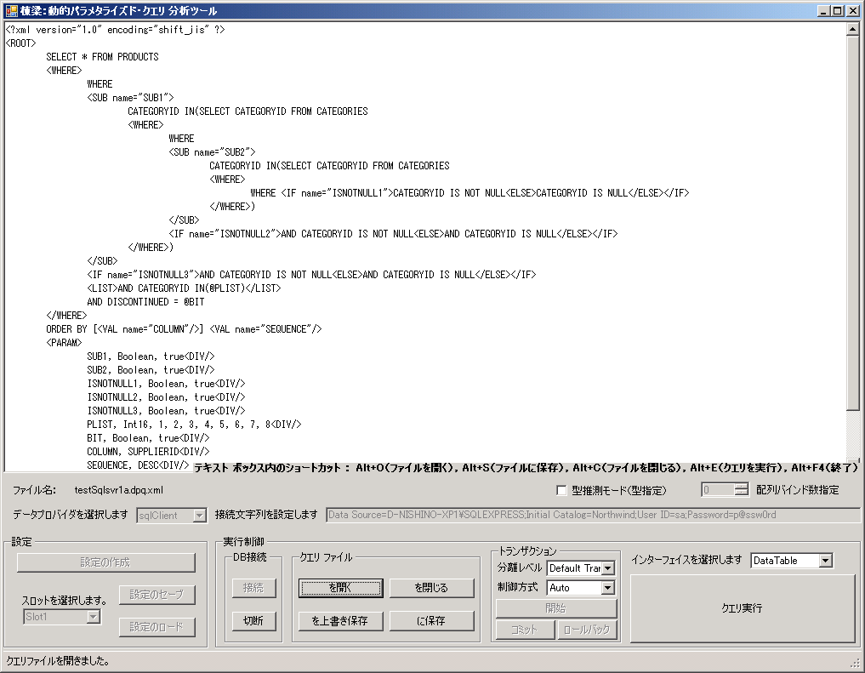
Select data provider
③Connection to DB
④Operation of query file
④In case of entering query directly.
⑤Execute target query
②Enter connection character string
【Parameter information】
<PARAM> tag enables test execution of SQL definition, by setting from analytical tool the parameter that is normally set from program.

Fig. ２．２－１ Dynamic parameterized query analytical tool

Thus, it is necessary to embed parameter information in dynamic parameterized query with <PARAM> tag, as shown below.

<?xml version="1.0" encoding="shift_jis" ?>
<ROOT>
SELECT DISTINCT ctm.companyname, ctm.contactname, ctm.contacttitle FROM orders AS o
INNER JOIN customers AS ctm ON o.customerid = ctm.customerid
<JOIN name="j1">INNER JOIN shippers AS s ON o.shipvia = s.shipperid</JOIN>
<JOIN name="j2">
INNER JOIN [order details] AS od ON o.orderid = od.orderid
INNER JOIN products AS p ON od.productid = p.productid
INNER JOIN categories AS cgy ON p.categoryid = cgy.categoryid
</JOIN>
<WHERE>WHERE s.companyname=@p1</IF><IF>AND cgy.categoryname=@p2</IF></WHERE>
ORDER BY [<VAL name="COLUMN"/>] <VAL name="SEQUENCE"/>
<PARAM>
j1, Boolean, true<DIV/>
j2, Boolean, true<DIV/>
p1, String, United Package<DIV/>
p2, String, Beverages<DIV/>
COLUMN, ctm.companyname<DIV/>
SEQUENCE, DESC<DIV/>
</PARAM>
</ROOT>
<?xml version="1.0" encoding="shift_jis" ?>
<ROOT>
SELECT * FROM PRODUCTS
<WHERE>WHERE
<SUB name="SUB1">CATEGORYID IN(SELECT CATEGORYID FROM CATEGORIES
<WHERE>WHERE
<SUB name="SUB2">CATEGORYID IN(SELECT CATEGORYID FROM CATEGORIES
<WHERE>WHERE
<IF name="ISNOTNULL1">CATEGORYID IS NOT NULL
<ELSE>CATEGORYID IS NULL</ELSE>
</IF>
</WHERE>)
</SUB>
<IF name="ISNOTNULL2">AND CATEGORYID IS NOT NULL
<ELSE>AND CATEGORYID IS NULL</ELSE>
</IF>
</WHERE>)
</SUB>
<IF name="ISNOTNULL3">AND CATEGORYID IS NOT NULL
<ELSE>AND CATEGORYID IS NULL</ELSE>
</IF>
<LIST>AND CATEGORYID IN(@PLIST)</LIST>
AND DISCONTINUED = @BIT
</WHERE>
ORDER BY [<VAL name="COLUMN"/>] <VAL name="SEQUENCE"/>
<PARAM>
SUB1, Boolean, true<DIV/>
SUB2, Boolean, true<DIV/>
ISNOTNULL1, Boolean, true<DIV/>
ISNOTNULL2, Boolean, true<DIV/>
ISNOTNULL3, Boolean, true<DIV/>
PLIST, Int16, 1, 2, 3, 4, 5, 6, 7, 8<DIV/>
BIT, Boolean, true<DIV/>
COLUMN, SUPPLIERID<DIV/>
SEQUENCE, DESC<DIV/>
</PARAM>
</ROOT>
【Embedding parameter information】
<PARAM> tag enables test execution of SQL definition, by setting from analytical tool the parameter that is normally set from program.
【Embedding parameter information】
<PARAM> tag enables test execution of SQL definition, by setting from analytical tool the parameter that is normally set from program.

Fig. ２．２－２ Embedding parameter information with <ＰＡＲＡＭ> tag

During query execution, whether SQL is dynamic parameterized query, or static parameterized query, is automatically determined, and automatically executed with method that matches query definition.
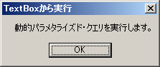 ・ 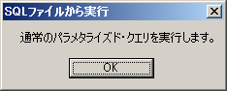
Fig. ２．２－３ Automatic execution with method matching definition
Execution results are displayed in the next dialog box.

There are 3 tabs in the dialog box. The following can be checked.
  - Result tab : SQL execution results
  - SQL tab : Executed SQL
  - LOG tab : Log output SQL

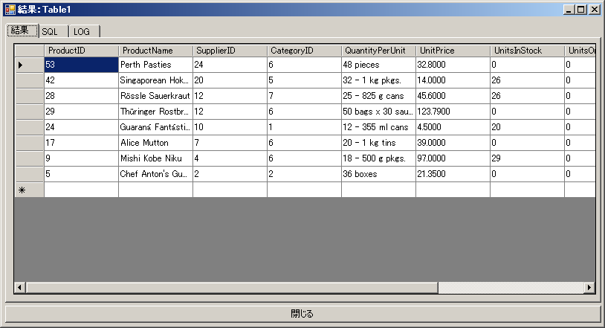 Fig. ２．２－４ ＳＱＬ execution results
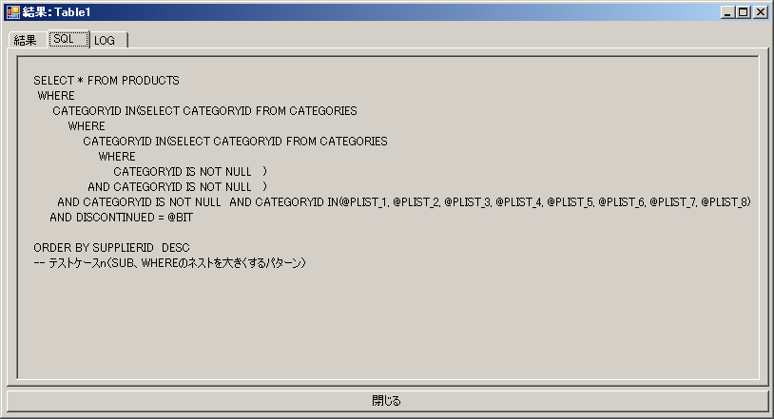 Fig. ２．２－５ Executed ＳＱＬ
In the latest version, performance information is also displayed.
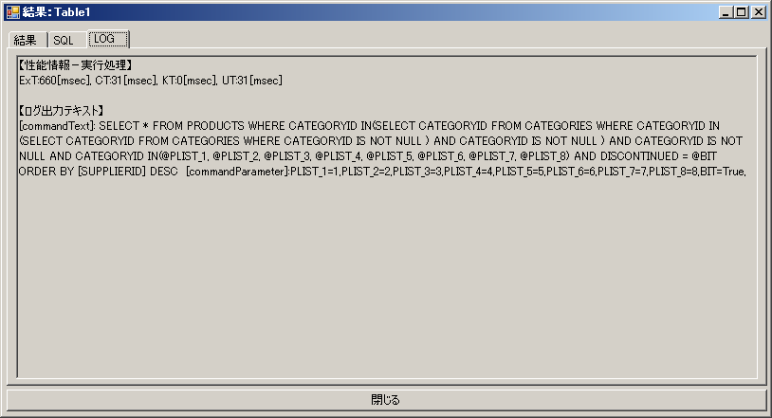 Fig. ２．２－６ Log output ＳＱＬ

Others, GUI Panel Operation Method
- Connection management
In [Settings] group box, save/load can be implemented from new creation of setting. Slots 1 to 5 are prepared as save/load destination, and slots can be selected in [Slot selection] combo box.

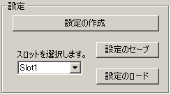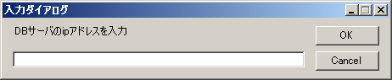
Fig. ２．３－１ [Settings] group box Fig. ２．３－２ Input dialog box during new creation

After new creation of settings, if data provider is changed in [Data provider selection] combo box, example of connection character string is automatically assembled, and set in text box. Modify this connection character string as necessary, and check connection to DB from [Connection] button. After cutting connection using [Cut] button, it is better to save settings by clicking [Save settings] button.

- Transaction control
In [Transaction] group box, advance control of transaction is possible.
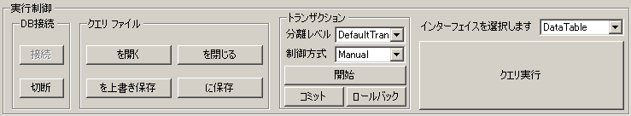
Fig. ２．３－３ [Transaction] group box

          - Segregation level can be selected in [Segregation level] combo box. There are unsupported segregation levels depending on DBMS, but in that case, error occurs and error message is displayed.

          - In [Control format] combo box, transaction control format can be selected from [Auto]/[Manual].

    - In case of [Auto], transaction is started whenever query is executed, and committed (Roll back in case of error) automatically after query execution.

    - In case of [manual], regardless of query execution, manually control transaction, by using [Start] - [Commit]/[Roll back] button.

Also, in [Interface] combo box, select API (described later) that is used when query is executed.
- Creating and Editing the Query File
SQL can be created newly and edited in [Query file] group box.
Fig. ２．３－４ [Query file] group box

The 4 buttons query file・・・[Open], [Close], [Save as], [Save in] can be used. Hence, [Open] button can be substituted with drag and drop operation of SQL file in Form. Also, this can also be used as short cut is allocated as well.

Also, dynamic parameterized query sample, template and tag can be inserted from the right-click context menu.
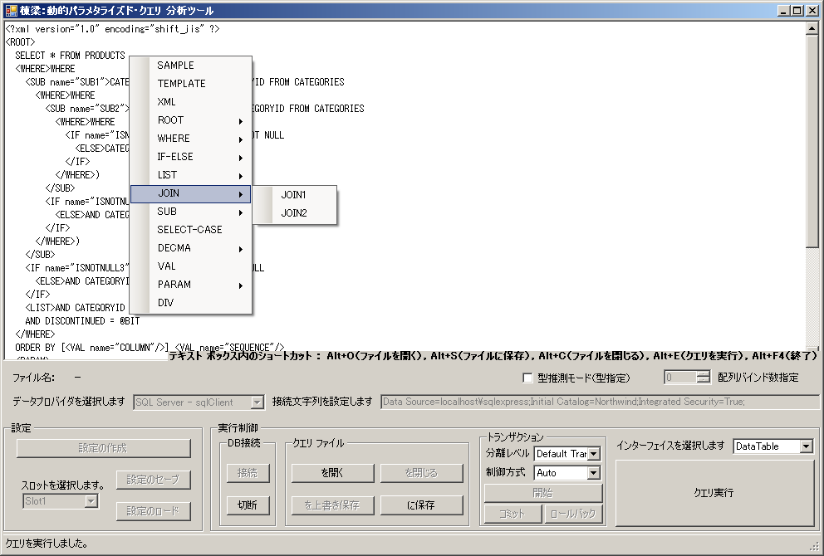
Fig. ２．３－５ Insertion of dynamic parameterized query sample, template and tag

- Execution option
Also, the following 2 setting items in the upper part of [Interface] combo box are execution options.

Fig. ２．３－６ Execution option

Check the [Type supposition mode (Type specification)] check box, during test of method for type specification (Normally, it is not necessary to use method for type specification). Therefore, SetParameter method (Over load with type specification) of DB components are executed. Specified type information is based on default type supposition (.NET type → DBMS type) of each data provider.

Also, in case of using array binding that can be used in ODP.NET, [Specification of array binding numbers] spin box (Up-down control) specifies a value of 0 or more. This value is set in OracleCommand.ArrayBindCount as maximum number of array element that is bound with array binding .

Static parameterized Query Execution Function
In dynamic parameterized query analytical tool, execution of static parameterized query, SQL is supported, in addition to dynamic parameterized query.

In case of static parameterized query, parameter can be set by using SQL comment for parameter setting. Example of parameter setting for static parameterized query is as follows.

SELECT * FROM Employees
WHERE
FirstName=@FN
AND LastName=@LN1
AND EmployeeID IN (SELECT EmployeeID FROM Employees WHERE LastName=@LN2)
AND ReportsTo IN ( @P1 , @P2 )
ORDER BY %COLUMN% %SEQUENCE%

/*PARAM* FN, String, Nancy *PARAM*/
/*PARAM* LN1, String, Davolio *PARAM*/
/*PARAM* LN2, String, Davolio *PARAM*/
/*PARAM* P1, String, 2 *PARAM*/
/*PARAM* P2, String, 5 *PARAM*/
/*PARAM* COLUMN, EmployeeID *PARAM*/
/*PARAM* SEQUENCE, DESC *PARAM*/
Parameter setting example
Normal parameterized query

Fig. ２．４ Parameter setting method to static parameterized query

Implementation Method of Data Access Process
Whether the query SQL is dynamic parameterized query, or static parameterized query, is automatically determined, and automatically executed with method that matches definition. Therefore, query execution method does not differ even for dynamic parameterized query.

Example: API that sets query
In case of reading query from file.
// -- ファイルから読み込む場合.
this.SetSqlByFile(
Path.Combine(GetConfigParameter.GetConfigValue("sqlTextFilePath"), "ファイル名"));

// -- ファイル, 埋め込まれたリソースから読み込む場合.
// 埋め込まれたリソースからの読み込む場合, 次の設定が必要になる.
// MyBaseDao.UseEmbeddedResource = true;
this.SetSqlByFile2("ファイル名");

Fig. ３－１ ＡＰＩ that reads query from file

In case of specifying query directly.
// -- 直接指定する場合.
this.SetSqlByCommand("動的パラメタライズド・クエリ");

Fig. ３－２ ＡＰＩ that specifies query directly

Example: API that sets parameter
Setting method of normal parameter (It is not necessary to set the leading symbol of parameter)
// パラメタ ライズド クエリのパラメタに対して, 動的に値を設定する.
this.SetParameter("P1", testParameter.ShipperID);

Fig. ３－３ ＡＰＩ that sets parameter

Setting method of user defined parameter (Substitute %XXXX% and VAL tag with specified character string)
// ユーザ定義パラメタを置換する.
this. SetUserParameter("UP1", "XXXXX");

Fig. ３－４ ＡＰＩ that sets user parameter

Example: API that executes SQL
The following 5 methods can be used in SQL execution.
// -- 追加, 更新, 削除の場合(件数を確認できる)
obj = this.ExecInsUpDel_NonQuery();

// -- １セル分の情報を返すSELECTクエリを実行する場合
obj = this.ExecSelectScalar();

// -- テーブル(or レコード)の情報を返す
// SELECTクエリを実行する場合(引数 = データテーブル)
obj = new DataTable();
this.ExecSelectFill_DT((DataTable)obj);

// -- テーブル(or レコード)の情報を返す
// SELECTクエリを実行する場合(引数 = データセット)
obj = new DataSet();
this.ExecSelectFill_DS((DataSet)obj);

// -- データリーダを返す
IDataReader idr = (IDataReader)this.ExecSelect_DR();

Fig. ３－５ ＡＰＩ that executes ＳＱＬ

Hence, even in case of dynamic parameterized query, it does not differ from API used for static parameterized query, SQL.

－End－

All tags can nest comment and CDATA section.
Specification becomes difficult if Can it be used across many kinds of tags? Can parameter within tag and parameter within text co-exist? etc. are considered too.
2WAY-SQL has the characteristic of being able to be executed (Test) as normal SQL, if binding information is embedded in SQL comment.
As [Type supposition mode] check box is provided for API test of type specification, it is not necessary to use it normally. Type information that is specified in API is automatically inferred from fixed type supposition algorithm (.NET type → DBType specific to each data provider ).
In the message box caption, retrieved source information of SQL to be executed (From TextBox? Or from open file?) is displayed. In case of execution from open file, if the information in TextBox is not saved in file before execution, note that SQL that differs from the information in TextBox is executed.
DB2 data provider differs from other data providers (Oracle, SQL Server) and requires inclusion of the leading symbol in parameter name. As this difference is contained by D layer component, DB2 can also be used in the same way other data providers. Also, HiRDB data provider (In current version) supports sequence binding only, and cannot implement name binding. However, only name binding is possible in this framework.
Refer to section 3 : [Usage method of Ｄ layer framework] of [”Toryo” .NET framework user guide (Developers edition)] for details about API.

