Toryo Tutorial
(Dynamic Parameterized Query
Analytical Tool version)

5/4/2014

Introduction

Objective of this document
The objective is to learn the confirmation method etc. of execution results and generation method of dynamic parameterized query, by using the [Dynamic Parameterized Query Analytical Tool] of Toryo, following the exercises in this tutorial.

Scope of this document
SE/Developers incharge of generation of query file with applications that use Toryo

Overview of this document
This tutorial describes, the generation method of dynamic parameterized query using the [Dynamic Parameterized Query Analytical Tool] of Toryo and the confirmation method etc. of execution results, in sequence.

Use of copyrights and trademarks of other companies
The company names and product names used in this document are the trademarks or registered trademarks of the respective companies.

License
This document is licensed under the Creative Commons Attribution 2.1 Japan License.
http://creativecommons.org/licenses/by/2.1/jp/legalcode

Table of Contents

1. Overview of Toryo 1
2. Environment Setting 2
2.1 Visual C# 2010 Express Setup 2
2.2 Toryo templatebase Setup 5
2.3 DB Setup 5
3. Exercises 7
3.1 Starting the Analytical Tool 7
3.2 Connection to DB 7
3.3 Generation and Execution of Dynamic SQL 8
3.3.1 Execution of Condition Unspecified Dynamic SQL 8
3.3.2 Execution of Condition Specified Dynamic SQL 9
3.3.3 Execution of Dynamic SQL with Search Criteria Parameterization 9
3.4 Generation and Execution of Dynamic SQL 10
3.4.1 Dynamicity of Query 10
3.4.2 Addition of Search Criteria for Where Statement 11
3.4.3 Listing of Search Criteria 14
3.5 Use of Dynamic Parameterized Query from Application 15
3.5.1 Saving the Query File 15
3.5.2 Query File Call from Application 16

Overview of Toryo
Toryo is the application framework for .NET. Toryo can be used in a various applications like C/S (Windows Forms, WPF), Web (ASP.NET), RIA (Silverlight) etc. in addition to .NET Framework 2.0.

Fig. 1-1 shows the class configuration of Toryo
Screen design
(*.aspx)
Screen
Code class
(*.
aspx.cs
)
Master page
(*.master)
P
layer
Web
control
Business Code class
Data access class
Screen Parent class 2
Screen
Parent class 1
Business
Parent class 2
Business
Parent class 1
Data access
Parent class 2
Data access
Parent class 1
Parameter class
Parameter
Parent class 2
Parameter
Parent class 1
Return value class
Return value Parent class 2
Return value Parent class 1
Legend
Class created by developer
Class provided by Toryo
.NET Framework
Standard class
F
layer
(B) layer
D
layer
Fig. 1-1 Toryo class configuration digram

Toryo dynamic parameterized query function can define dynamic SQL with XML format file.
Also, Toryo provides the [Dynamic Parameterized Query Analytical Tool] to implement generation/syntax check/run test etc. of the XML format file. This tutorial shows the usage method of dynamic parameterized query analytical tool, in sequence.
The dynamic parameterized query analytical tool is abbreviated to [Analytical Tool] in this tutorial.

Environment Setting
Table 2-1 shows the prerequisite environment for this tutorial

Table 2-1 Prerequisite environment for this tutorial
# | Category |  | Prerequisite environment
1 | Development environment | IDE | Visual C# 2010 Express
2 | Development environment | Application framework | OpenToryo templatebase  (/root_VS2010_TemplateBase/)
3 | Operating environment | Runtime | .NET Framework 4
4 | Operating environment | DB | SQL Server Express 2008 R2
5 | Other | OS | Windows 7

The installation/setup sequence for the development environment/operating environment shown in Table 2-1 is shown as follows.

Visual C# 2010 Express Setup
- Open the Microsoft website (http://www.microsoft.com/japan/msdn/vstudio/express/) on the browser, press the Visual C# 2010 Express (Henceforth abbreviated as C# Express) [Web installation (download)] link, and download. | 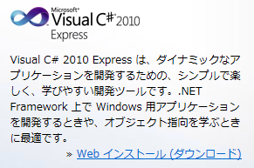
- Run the downloaded vcs_web.exe.
- C# Express setup starts.  In the Welcome to setup screen, set whether to send the feedback of the setup to Microsoft, and press the [Next] button. | 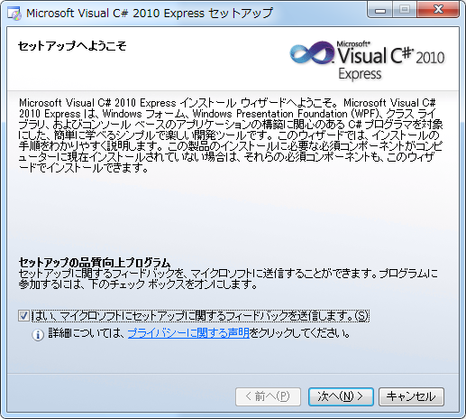
- In the License terms screen, select [Accept], and press the [Next] button. | 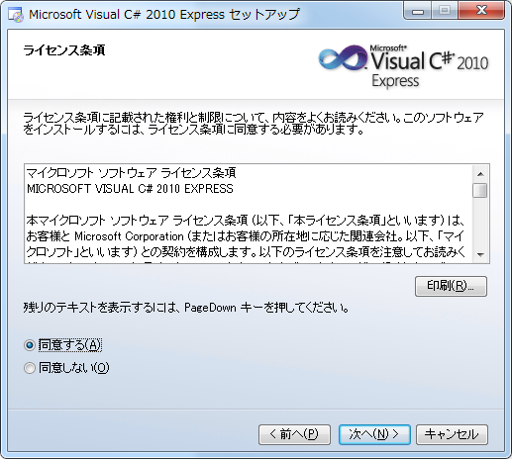
- In the Installation options screen, select and add the products to be installed. Set as follows, and press the [Next] button.  Microsoft Silverlight : Not selected  Microsoft SQL Server 2008 Express Service Pack 1 : Selected | 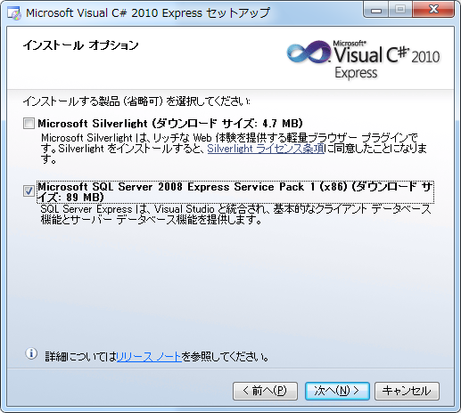
- In the Copy destination folder screen, set the folder to install C# Express. Do not change the default options. Press the [Install] button. | 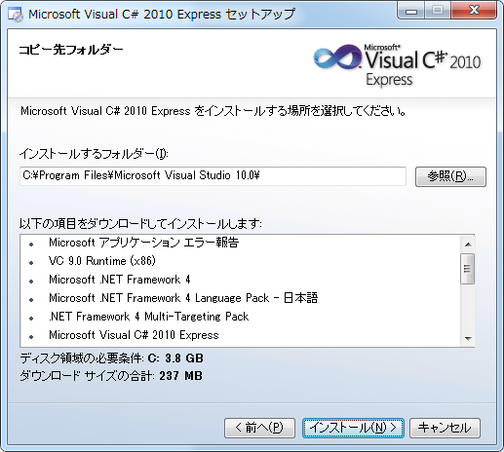
- When the download and installation starts, wait till the installation is completed. | 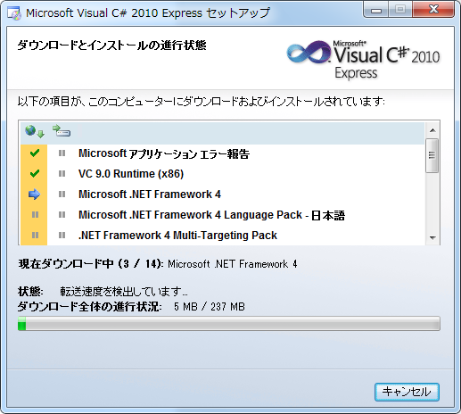
- Confirm that all installations are completed, and press the [Complete] button. | 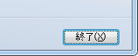

Toryo templatebase Setup
- Deploy directly Toryo templatebase(/root_VS2010_TemplateBase/) under C drive.  you do setup following the instructions in the Readme.txt of /root_VS2010_TemplateBase/ just below. | 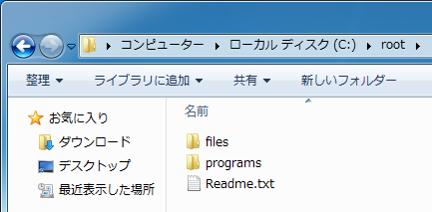

DB Setup
SQL Server Express is installed in accordance with C# Express. Hence, create the database, table, and view, used in the sample programs, in the installed SQL Server Express.
- Download and install SQL file for [Northwind] database and [Pubs] database creation from the Microsoft website (http://www.microsoft.com/en-us/download/details.aspx?id=23654).  (Though it says ‘for SQL Server 2000’, it can also be used for SQL Server 2008.) | 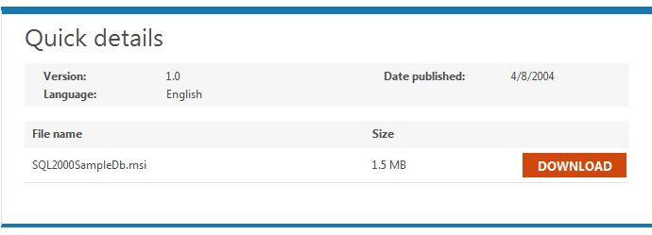
- Run the following command using command prompt, and create the Northwind database.

"C:\Program Files\Microsoft SQL Server\100\Tools\Binn\SQLCMD.EXE" -S localhost\SQLExpress -E -i "C:\SQL Server 2000 Sample Databases\instnwnd.sql"

- Run the following command using command prompt, and confirm that the Northwind database is created normally.

"C:\Program Files\Microsoft SQL Server\100\Tools\Binn\SQLCMD.EXE" -S localhost\SQLExpress -E -d Northwind -Q "Select * From Customers"

Exercises
This section describes the usage method of the analytical tool, in sequence.
This tutorial does not describe the details of the Toryo dynamic parameterized query function. Refer to the Toryo user guide (dynamic parameterized query version) as necessary.

Starting the Analytical Tool
- Run C:\root\programs\C#\Frameworks\DPQuery_Tool\bin\Debug\DPQuery_Tool.exe. | 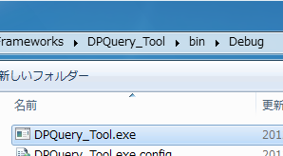
- Confirm the start of the analytical tool. | 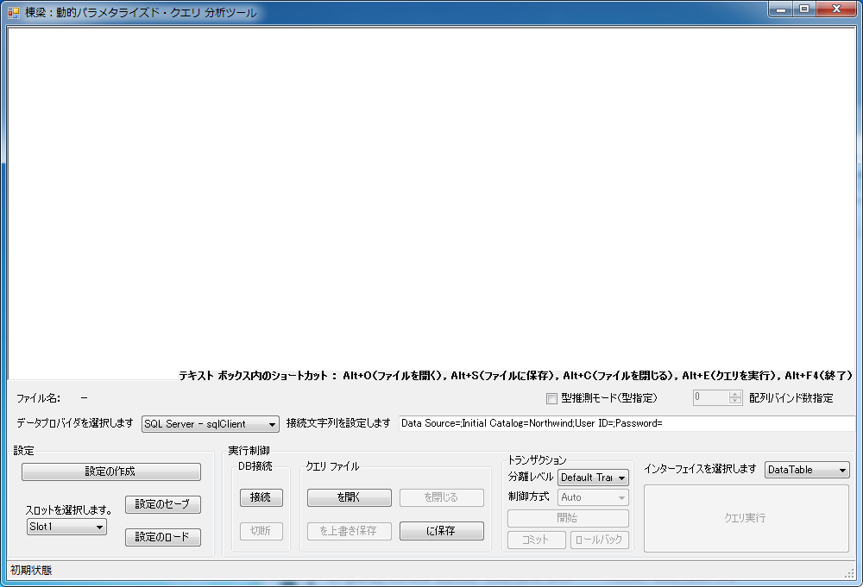

Connection to DB
- Confirm that the [Select Data Provider] drop-down list of the analytical tool is set to [SQL Server - sqlClient]. | 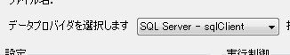
- In the [Set the Connection Character String] text box, set the following connection character string.
Data Source=localhost\sqlexpress;Initial Catalog=Northwind;Integrated Security=True;
- Press the [Connect] button, and connect to DB. | 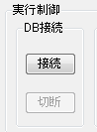
- When the DB connection is successful, confirm that [Connect] button get disble and [Run Query] button get enbale. | 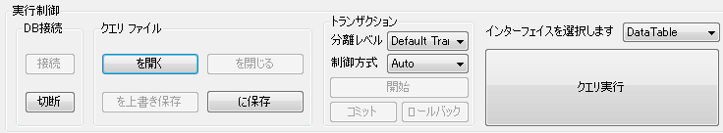

Generation and Execution of Dynamic SQL

Execution of Condition Unspecified Dynamic SQL
- In the text box on the top part of the analytical tool, enter the following SQL statement.

SELECT * FROM SHIPPERS

- Press the [Run Query] button to confirm behavior when parameter is specified. | 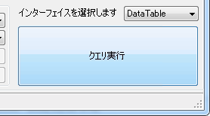
- When the Run dialog box is displayed from TextBox, press the [OK]button. | 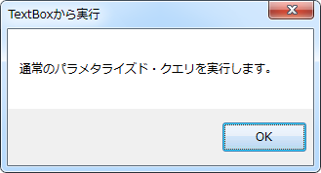
- When the Results dialog box is displayed, confirm that all records of Shippers table are retrived. | 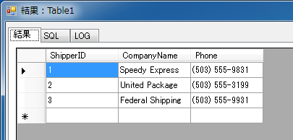
- Press the [Close] button, and close the dialog box. | 

Execution of Condition Specified Dynamic SQL
- Modify the SQL statement in the text box on the top part of the analytical tool as follows, to run query with search criteria.

SELECT * FROM SHIPPERS WHERE SHIPPERID = 1

- Similar to item 3.3.1, press the [Run Query] button, and run the query. Confirm that only the record of ShipperId “1” is retrieved from the Shippers table this time. | 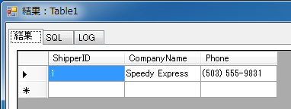
- Press the [Close] button, and close the dialog box.

Execution of Dynamic SQL with Search Criteria Parameterization
- Parameterize the SQL statement in the text box on the top part of the analytical tool as follows.

SELECT * FROM SHIPPERS WHERE SHIPPERID = @p1
/*PARAM* p1, Int32, 1 *PARAM*/

- Press the [Run Query] button, and similar to item 3.3.2, confirm that only the record of ShipperId “1” is retrieved from the Shippers table.
- Press the [Close] button, and close the dialog box.

Generation and Execution of Dynamic SQL

Dynamicity of Query
This section dynamizes the dynamic SQL, with search criteria parameterization, generated in item 3.3.3, by following the description of Toryo dynamic parameterized query.
- Clear the contents of the text box on the top part of the analytical tool.
- Right-click the text box, and from the tab list, select [TEMPLATE]. | 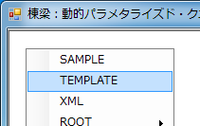
- When the XML template is displayed in the text box, define the query statement as follows.

<?xml version="1.0"?>
<ROOT>
SELECT * FROM SHIPPERS
<WHERE>
WHERE
<IF>SHIPPERID = @p1</IF>
</WHERE>
<PARAM>
p1, Int32, 1
</PARAM>
</ROOT>

【Caution】Toryo dynamic parameterized query is defined in the XML format as shown above, and the query statement is defined in the XML tag. For example,
・WHERE tag… Describe the search criteria (Where statement)
・IF/ELSE tag… If necessary, use to change the specification method of search criteria
・PARAM tag… Describe the value to be specified in the parameter
Refer to the Toryo user guide (dynamic parameterized query version) for details about the use methods and defining methods of these tags.
- Press the [Run Query] button to confirm the behavior when parameter is specified.
- When the Run dialog box is displayed from TextBox, press the [OK] button. | 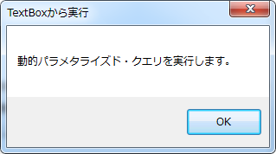
- When the Results dialog box is displayed, confirm that only the record of ShipperId “1” is retrieved from the Shippers table.
- Press the [SQL] tab, and confirm the executed SQL statement. | 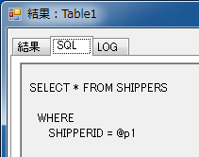
- Press the [LOG] tab, and confirm the execution log of SQL statement. | 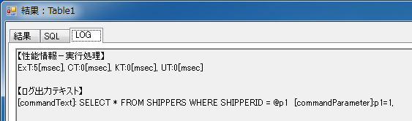
- Press the [Close] button, and close the dialog box.

Addition of Search Criteria for Where Statement
- Modify the SQL statement in the text box on the top part of the analytical tool as follows, to enable search of the Shippers table based on ShipperId and CompanyName.

<?xml version="1.0"?>
<ROOT>
SELECT * FROM SHIPPERS
<WHERE>
WHERE
<IF>SHIPPERID = @p1</IF>
<IF>AND COMPANYNAME = @p2</IF>
</WHERE>
<PARAM>
p1, Int32, 1<DIV/>
p2, String, Speedy Express
</PARAM>
</ROOT>

- Press the [Run Query] button. Confirm that the record of ShipperId is “1” and CompanyName is ”Speedy Express” is retrieved from the Shippers table.
- Press the [SQL] tab, and confirm the executed SQL statement. | 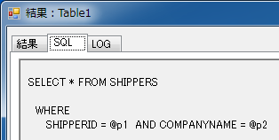
- Press the [LOG] tab, and confirm the execution log of SQL statement. | 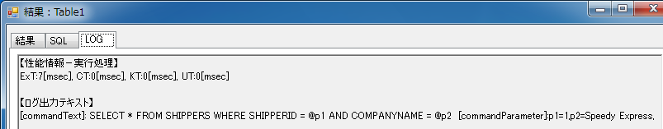
- Next, comment out the condition specification components for parameter [p1], to confirm behavior when parameter is not specified.

<?xml version="1.0"?>
<ROOT>
SELECT * FROM SHIPPERS
<WHERE>
WHERE
<IF>SHIPPERID = @p1</IF>
<IF>AND COMPANYNAME = @p2</IF>
</WHERE>
<PARAM>
<!--p1, Int32, 1<DIV/>-->
p2, String, Speedy Express
</PARAM>
</ROOT>

- Press the [Run Query] button, and run the query.
- Press the [SQL] tab, and confirm that search is implemented with CompanyName only and that ShipperId is not included in search criteria. | 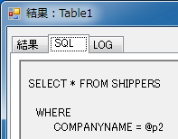
- Press the [LOG] tab, and here as well, confirm that ShipperId is not included in search criteria. | 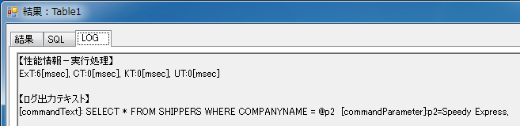
- Press the [Close] button, and close the dialog box.
- On the contrary, comment out the condition specification components for parameter [p2] this time.

<?xml version="1.0"?>
<ROOT>
SELECT * FROM SHIPPERS
<WHERE>
WHERE
<IF>SHIPPERID = @p1</IF>
<IF>AND COMPANYNAME = @p2</IF>
</WHERE>
<PARAM>
p1, Int32, 1<!--<DIV/>
p2, String, Speedy Express-->
</PARAM>
</ROOT>

- Press the [Run Query] button, and run the query.
- Press the [SQL] tab. This time, confirm that search is implemented with ShipperId only and that CompanyName is not included in search criteria. | 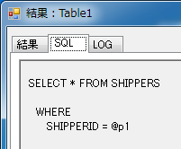
- Press the [LOG] tab, and here as well, confirm that only ShipperId is included in search criteria. | 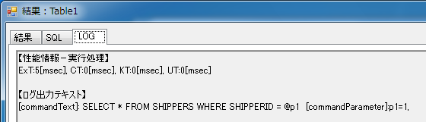
- Press the [Close] button, and close the dialog box.

Listing of Search Criteria
This section shows the method for searching, based on the listed criteria, using In statement.
- Modify the SQL statement as follows, to search ShipperId from the listed conditions, using In statement. Hence, delete or comment out to exclude parameter [p2] from the search criteria.

<?xml version="1.0"?>
<ROOT>
SELECT * FROM SHIPPERS
<WHERE>
WHERE
<LIST>SHIPPERID IN (@p1)</LIST>
<IF>AND COMPANYNAME = @p2</IF>
</WHERE>
<PARAM>
p1, Int32, 1, 2
</PARAM>
</ROOT>

- Press the [Run Query] button, confirm that only the records of ShipperId “1” or “2” is retrieved from the Shippers table. | 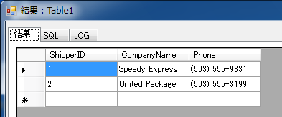
- Press the [SQL] tab, and confirm that the query using In statement is executed. | 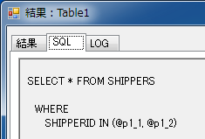
- Press the [LOG] tab. Here too, the search criteria is confirming that the query using In statement is executed. | 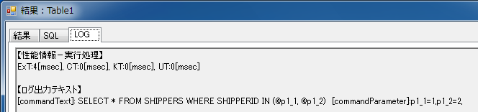

Use of Dynamic Parameterized Query from Application

Saving the Query File
- From the [Query File] group, press the [Save in] button. | 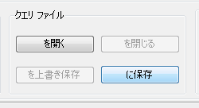
- When the Save as dialog box is displayed, set as follows, and save the query file.
Path : Path specified in the path to the folder where SQL is saved in the application configuration file
Filename : GetShippers.xml
【Caution】For applications that use Toryo, set the path, to the folder where SQL is saved, in Web.config or app.config as follows. Refer to the Toryo user guide (manager version) for details.

<?xml version="1.0"?>
<configration>
<appSettings>
<add key="SqlTextFilePath" value="SQLを保存するフォルダへのパス" />
</appSettings>
</configuration>

Query File Call from Application
- Develop applications that use Toryo.
【Caution】This document does not describe the development method of applications that use Toryo. Refer to the Toryo tutorial (ASP.NET version, 2 layer C/S version).
- Implement as follows, because the saved query file is used in D layer class.

public DataTable GetShippers()
{
// クエリファイルを指定する
this.SetSqlByFile2("GetShippers.xml");

// パラメタを指定する (リスト化されたパラメタのため, ArrayListで指定する)
this.SetParameter("p1", new ArrayList(new int[] { 1, 2 }));

// クエリを実行する
DataTable dt = new DataTable();
this.ExecSelectFill_DT(dt);

// クエリの実行結果を返す
return dt;
}

- Run the application, and confirm behavior.

－End－

What type of content is there in the XML tag which is used in sql file , meaning of each tag and how to write etc.
From Toryo 3.5, it is possible to insert comments in XML.

