Touryo Tutorial on
Workflow Functionality

20/10/2014

Introduction

Objective of this document
Workflow is the series of activities that are necessary to complete a task.
The objective is to learn the functionality of the Workflow using the Workflow Simulator Tool. The Workflow Simulator Tool is developed using Touryo framework.

Scope of this document
SE/Developers considering C#.NET application development with Touryo

Overview of this document
This tutorial describes the functionality of Workflow step by step with an example.

Use of copyrights and trademarks of other companies
The company names and product names used in this document are the trademarks or registered trademarks of the respective companies.

Table of Contents
1. Overview of Touryo 1
2. Environment Setting 2
2.1 Visual C# 2010 Express Setup 2
2.2 Touryo Assessment version Setup 5
2.3 DB Setup 5
3. Exercises in this tutorial 6
4. Prerequisites 8
4.1 Creating a Database 8
4.2 Creating Tables in the Workflow Database 9
4.3 Inserting Sample Data In The Workflow Database 10
4.4 Verifying the Inserted Data in the Workflow Database 10
4.5 Functionality of Workflow with An Example. 10
4.6 Common Functions 14
4.7 Executing workflow simulator 14
4.8 Creating a New Workflow 15
4.9 Starting a New Workflow 17
4.10 Receiving a Workflow Request 19
4.11 Accepting the Workflow Request 19
4.12 Accepting the Workflow Being Processed 20
4.13 Retrieving the Next Workflow Request 21
4.14 Finishing or Terminating the Current Workflow. 22
4.15 Processing Workflow to End State 22

Overview of Touryo
Touryo is an application framework in.NET developed by (HISOL). Touryo can be used in a various
applications like Client-Server (Windows Forms, WPF), Web (ASP.NET), RIA (Silverlight) etc. in
addition to .NET Framework 2.0.

Screen design
(*.aspx)
Screen
Code class
(*.
aspx.cs
)
Master page
(*.master)
P
layer
Web
control
Business Code class
Data access class
Screen Parent class 2
Screen
Parent class 1
Business
Parent class 2
Business
Parent class 1
Data access
Parent class 2
Data access
Parent class 1
Parameter class
Parameter
Parent class 2
Parameter
Parent class 1
Return value class
Legend
Class created by developer
Class provided by Touryo
.NET Framework
Standard class
F
layer
B/D layer
D
layer
Return value Parent class 2
Return value Parent class 1
Fig. 1-1 - Touryo class configuration diagram

This tutorial describes the generation method of screen or work logic class or DB access class
implemented by developers following the class configuration diagram defined in Fig. 1-1 in sequence.

Environment Setting

Table 2-1 - Prerequisite environment for this tutorial
# | Category |  | Prerequisite environment
1 | Development environment | IDE | Visual C# 2010 Express
2 | Development environment | Application framework | Touryo assessment version
3 | Operating environment | Runtime | .NET Framework 4
4 | Operating environment | Web server | ASP.NET development server
5 | Operating environment | DB | SQL Server Express 2008 R2
6 | Other | OS | Windows 7
7 | Other | Development language | C#
8 | Other | PDF display | Adobe Reader
9 | Other | Web Browser | Internet Explorer 9

The installation/setup sequence for the development environment/operating environment shown in
Table 2-1 is shown as follows.

Visual C# 2010 Express Setup
- Open the homepage (http://www.microsoft.com/japan/msdn/vstudio/express/) of Microsoft Corporation in the browser, and press the [Web installation (Download)] link of Visual C# 2010 Express（Henceforth abbreviated as C# Express ）and download. | 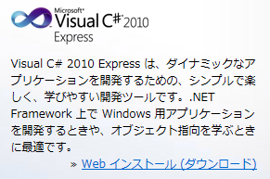
- Run downloaded vcs_web.exe.
- The setup of C# Express will begin.  In the "Welcome to setup" screen, select "Whether the feedback related to setup in Microsoft has been sent or not" and press the [Next] button. | 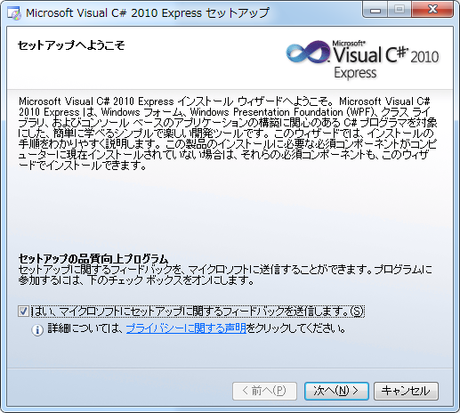
- Select [Agree] in the license provision screen and then press the [Next] button. | 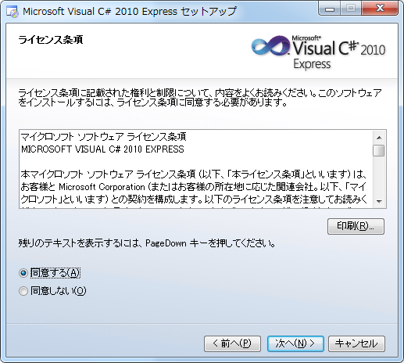
- In the copy destination folder screen, set the folder in which C# Express is to be installed. Here press [Install] button by default. | 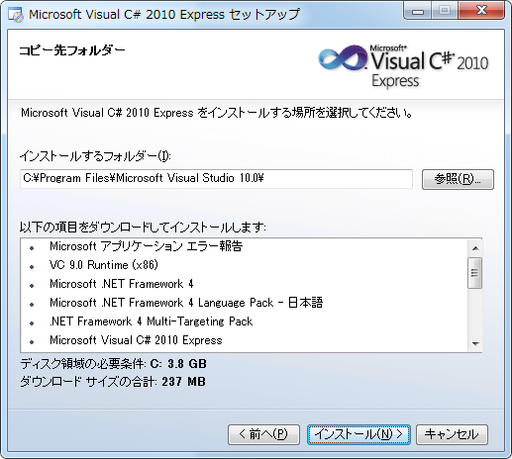
- Since download and install will get started, wait until installation gets completed. | 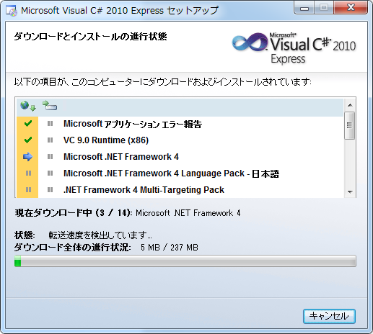
- Check whether all the installations are completed and then press [End] button. | 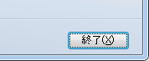

Touryo Assessment version Setup
- Extract root_hyoka.zip, included in the  Touryo assessment version, directly under C drive.  (root folder is created directly under C  drive) | 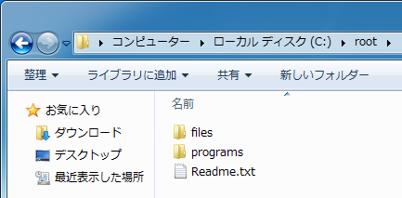

DB Setup
SQL Server 2008 R2 RTM - Express with Management Tools is installed using the link ‘https://www.microsoft.com/en-us/download/details.aspx?id=23650’. Hence, create the database and tables used in the sample programs, in the installed SQL Server.

- Refer section 4.1 for creating the database and tables
- From the Start menu, go to [All Programs]-  [Microsoft Visual Studio 2010 Express]-  [Microsoft Visual C# 2010 Express], and start C# EXPRESS. | 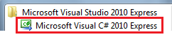

Exercises in this tutorial
Exercises in this tutorial involve the creation of database, database tables, inserting sample data
into tables, running the Workflow simulator application and demonstrating the functionality of Workflow through an example.
The simulator application is included in the Touryo assessment version. Fig. 3-1 shows the configuration of the sample programs and Fig. 3-2 shows the screen transition flow of the tutorial.

.NET Framework 4
SQL
Server
AnyWarp
Touryo
Framework
Application framework
Components
Log
DB access

…
C#.NET Development server
C#.NET
Business program (UOC)
Business screen
Business logic
DB
Access
DAO
summary
class
Auto generation
DAO
Common
DAO
Screen transition control
Web/DB server
Fig. 3-2 - Configuration of sample programs

Main screen
Click Tab1
Workflow preparing information List screen

Click Tab2
Workflow preparing information List screen

Starts new Workflow
Click Tab3
Workflow preparing information List screen

Click Tab4
Workflow preparing information List screen

Click Tab5
Workflow preparing information List screen

Click Tab6
Workflow preparing information List screen

Click Tab7
Workflow preparing information List screen

Gets Workflow request information
Accepts Workflow request
Gets Workflow request information being processed
Gets next Workflow request information
Approves Workflow request information by replying or terminating

Preparing Workflow

Fig. 3-3 - Screen transition of tutorial

The number of the sections in this manual, describing the steps follow when using Touryo, is shown inTable 3-2.

Table 3-2 - Development flow when using Touryo
# | Category | Operation | Description | Remarks
1 | Database | Database creation | Create database in SQL Server with the name Workflow | Description in section 4.1
2 | Database | Tables creation | Create tables using the scripts available in the location ‘C:\OpenTouryo\root\files\resource\Sql\sqlserver\Workflow\SQL\Table’ | Description in section 4.2
3 | Database | Sample data insertion | Insert sample data of Workflow by using the scripts available in the above mentioned location | Description in section 4.3
4 | Database | Checking the data inserted | Check the data inserted by using the scripts available in the location’’ C:\OpenTouryo\root\files\resource\Sql\sqlserver\Workflow\SQL\Table\Check’ | Description in section 4.4
5 | Execution | Behavior confirmation | Run debugger using Visual Studio, and confirm the main screen display | Description in section 4.7
6 | Demo | Demonstrating the functionality of Workflow | Explaining the Workflow functionality step by step with an example | Description in section 4.8

Prerequisites
This section provides information on the pre-requisites to use the workflow simulator. The pre-requisites are as follows:
- Creating a Database
- Creating Tables in the Workflow Database

Creating a Database
Perform the following steps to create a new database Workflow:
    - Open SQLServer Management Studio.
    - Right click [Databases] and Select [New Database].

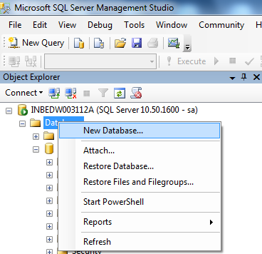

    - Enter value for [Database] Name as [Workflow].
    - Click [OK] to create the Workflow database.

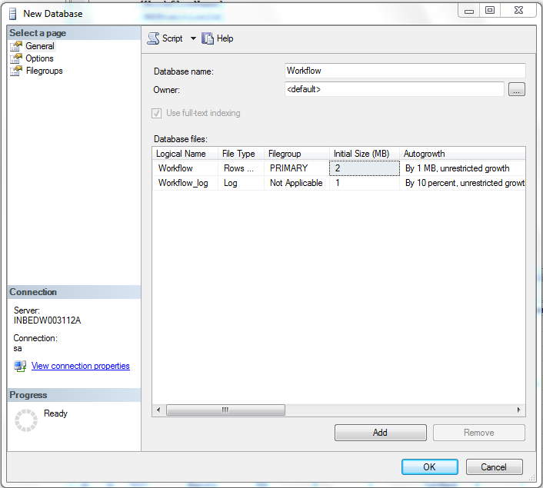

Creating Tables in the Workflow Database
Perform the following steps to create tables in the Workflow database:
- Navigate to the following directory:
C:\OpenTouryo\root\files\resource\Sql\sqlserver\Workflow\SQL\Table
- Run the scripts, which are highlighted in following figure.
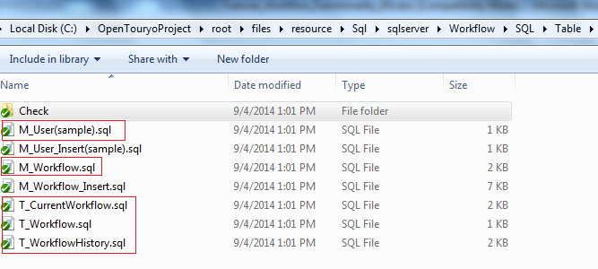
The scripts are displayed as the following figure when they are executed.
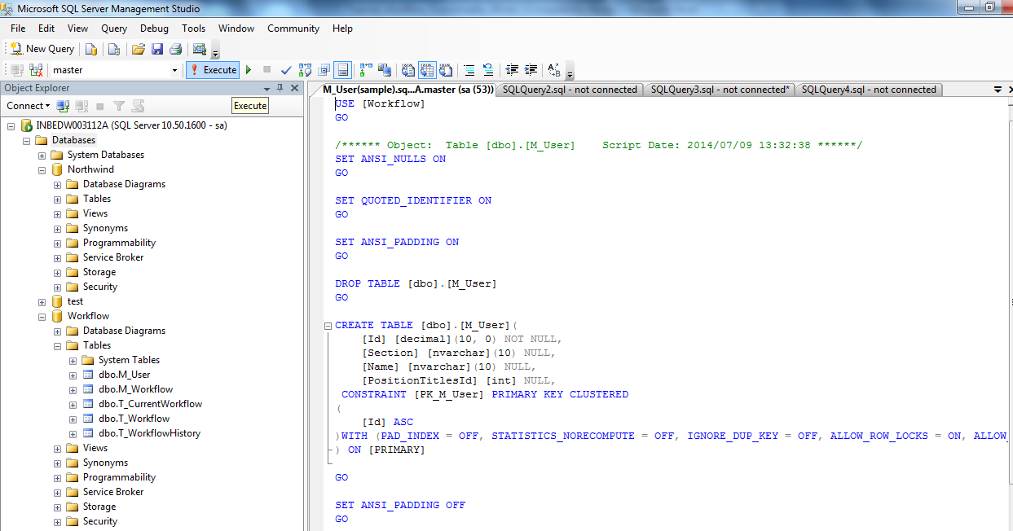

Inserting Sample Data In The Workflow Database
Perform the following steps to insert sample data to the workflow database:
- Navigate to the folder
C:\OpenTouryo\root\files\resource\Sql\sqlserver\Workflow\SQL\Table
- Run the scripts, which are highlighted in the following figure.

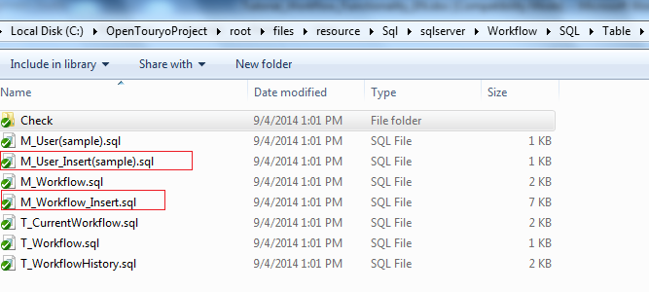

Verifying the Inserted Data in the Workflow Database
Perform the following step to verify the inserted data in the workflow database
- Run scripts for cross check which are highlighted in the following figure.

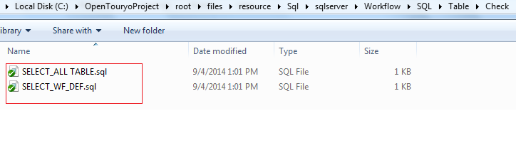

Functionality of Workflow with An Example.
Consider an organization having sections as ‘A’, ‘B’, ‘C’, ‘D’, ‘E’ and ‘F’. Employees or users as ‘a’, ‘b’, ‘c’, ‘d’, ‘e’ and f’ with IDs ‘1’, ‘2’,’3’, ‘4’, ‘5’ and ‘6’.

A
1
B
2
①
⑩
b
a
D
4
C
3
E
5
c
d
e
f
②

⑨

②

⑧

④
⑦
③

⑦
F
6

⑤

⑥

⑦
6

The following table lists the flow to be designed in the Workflow simulator.

ID | Subsystem name | Workflow name | Workflow position ID | Workflow number | From user ID | Action Type | To user ID | Positions of the To user | Workflow Position ID of the next | Workflow number next | Workflow number corresponding to Reply | Mail template ID | Reserve area
 | TEST | Branch2 | 100 | 1 | 1 | Start | 2 | 1 | 200 | 2 | NULL | 1
 | TEST | Branch2 | 200 | 2 | 2 | Request | 3 | 1 | 300 | 3 | NULL | 1
 | TEST | Branch2 | 200 | 2 | 2 | Request | 4 | 1 | 400 | 4 | NULL | 1
 | TEST | Branch2 | 300 | 3 | 3 | Request | 5 | 1 | 500 | 5 | NULL | 1
 | TEST | Branch2 | 400 | 4 | 4 | Request | 5 | 1 | 500 | 5 | NULL | 1
 | TEST | Branch2 | 500 | 5 | 5 | TurnBack | 3 | 1 | 300 | 3 | NULL | 1
 | TEST | Branch2 | 500 | 5 | 5 | TurnBack | 4 | 1 | 400 | 4 | NULL | 1
 | TEST | Branch2 | 500 | 5 | 5 | Request | 6 | 1 | 600 | 6 | NULL | 1
 | TEST | Branch2 | 600 | 6 | 6 | Reply | 5 | 1 | 500 | 7 | 5 | 1
 | TEST | Branch2 | 500 | 7 | 5 | Reply | 3 | 1 | 300 | 8 | 3 | 1
 | TEST | Branch2 | 500 | 7 | 5 | Reply | 4 | 1 | 400 | 9 | 4 | 1
 | TEST | Branch2 | 300 | 8 | 3 | Reply | 2 | 1 | 200 | 10 | 2 | 1
 | TEST | Branch2 | 400 | 9 | 4 | Reply | 2 | 1 | 200 | 10 | 2 | 1
 | TEST | Branch2 | 200 | 10 | 2 | Reply | 1 | 1 | 100 | 11 | 1 | 1
 | TEST | Branch2 | 100 | 11 | 1 | End | NULL | NULL | NULL | NULL | NULL | 1
Figure 4.5.1
Following steps describe the process of sending request from user ‘a’ to ‘f’
- User ‘a’ wants to send a request to user ‘f’. However, as per the hierarchy, user ‘a’ cannot send
requests directly to ‘f’.
- When user ‘a’ sends request, it first goes to user ’b’. This is represented using the Workflow number 1
in the above table. This is the starting point of the Workflow (Start).
- Then user ‘b’ has two possibilities of sending the request to user ‘f’. Through user ‘c’ as well as through user ‘d’ as shown in the above table with workflow number 2. If we want to branch based on the
user's intention, it is necessary to define multiple workflows with the same workflow number.
- Due to this, the workflow of both possibilities b to c and b to d are represented with same workflow
number.
- In next workflow, user ‘c’ sends the request to user ‘e’ as represented with workflow number 3.
- User ‘d’ sends the request came from user ‘b’ to user ‘e’ with workflow number 4.
- Similarly User ‘e’ sends the request to user ‘f’ by representing the workflow with the number 5. This
workflow is called as TurnBack.
Following steps describe the process of sending response or reply from user ‘f’ to user ‘a’
- User ‘f’ processes the request that came from user ‘e’ and sends the response back to ‘e’. This is
represented by workflow number 6
- User ‘e’ sends the response to user ‘c’ if request came from user ‘c’. Otherwise sends to user ‘d’ if user ‘d’ sends the request. This is called workflow Reply and TurnBack of confluence. It is defined in the workflow the same number as the workflow to move forward. That is workflow number 7. This
workflow is called as Reply
- User ‘c’ sends the response came from user ‘e’ to user ‘b’ which is of workflow number 8
- Similarly, user ‘d’ sends the response came from ‘e’ to user ‘b’ having workflow number as 9
- Finally, user ‘b’ sends the response to user ‘a’ who has initiated the request. This workflow is
represented by the workflow number 10. This is the End of workflow (End).

Workflow at branch:
If we want to branch in the user's intention, it is necessary to define multiple workflows in the same
workflow number.
Reply and TurnBack workflow:
This workflow is represented with the same workflow number of branches.
This is also called as Reply and TurnBack of confluence. This is defined with the same workflow number as the workflow to move forward.

Common Functions
Perform the following steps to start the C# EXPRESS:
- Navigate to the following folder then open the Workflow_Tool.sln file in C# EXPRESS.
C:\root\programs\C#frameworks\Tools\Workfow_Tool
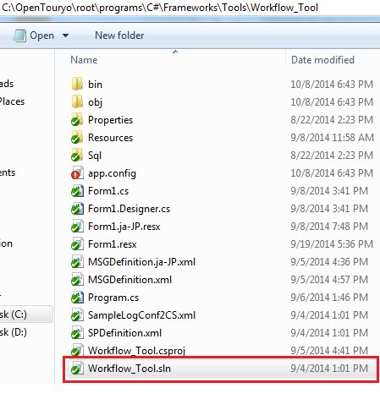

Executing workflow simulator
- In the C# EXPRESS, Press F5 or click the Start button to run Workflow simulator application. 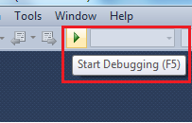
Workflow simulator screen is displayed as shown in the following figure.
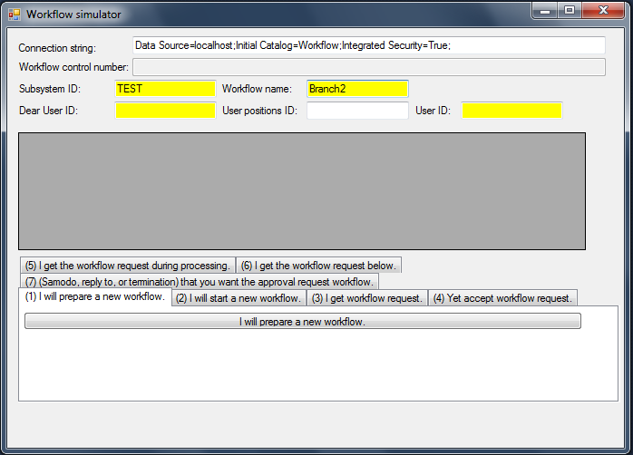

Creating a New Workflow
Perform the following steps to create a new workflow:
- Select the (1) I will prepare a new workflow. tab
- Check the connection string value in the Connection string textbox. If the connection string is wrong, then edit the connection string. For connecting to the database Workflow, created earlier in Creating a Database.
- Specify the following values:
  - [Subsystem ID]: TEST
  - [Workflow name]: Branch2
  - [Dear User ID]: 1
  - [User positions ID]: 1
  - [User ID]: 2
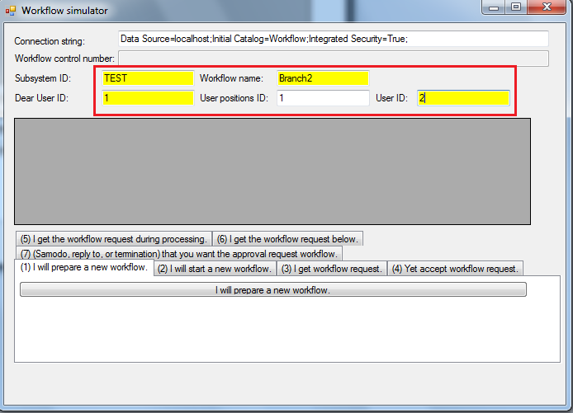
- Click the I will prepare a new workflow. button. The Workflow simulator dialog appears as
follows:
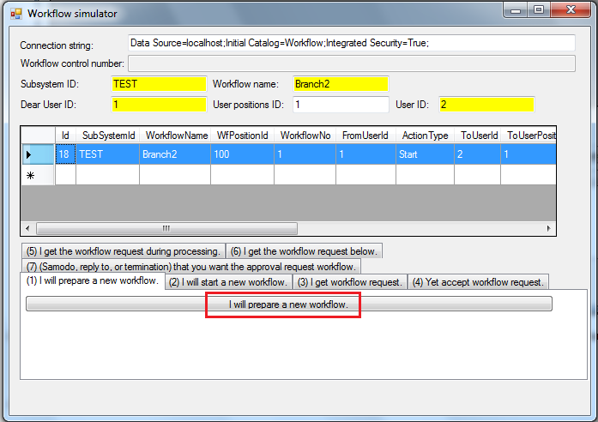

Starting a New Workflow
Perform the following steps to start a new workflow
- Select the (1) I will start a new workflow. tab
- Specify the following values:
  - User ID: 3
  - WF reserved area: aaa [optional]
  - Current WF reserved area: bbb [optional]
  - To User ID:2[optional]
- Select a Respondents preferred date: from the calendar [optional]
- Click I will start a new workflow Button
It will generate the Workflow control number.
- Specify To User ID to freely select the user for sending workflow request

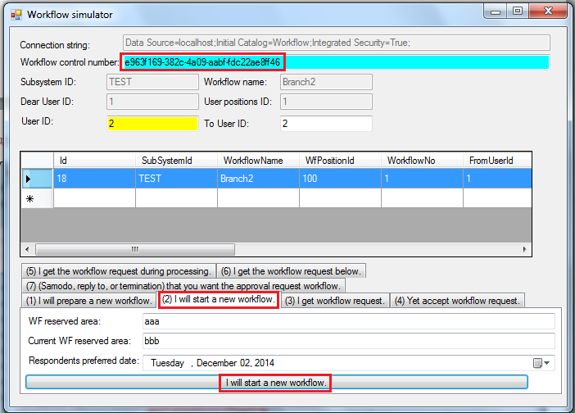

Receiving a Workflow Request
Perform the following steps to receive the workflow request
- Select the (3) I get workflow request. tab
- Ensure that you have selected the row from the data grid
- Click the I get the workflow request. button
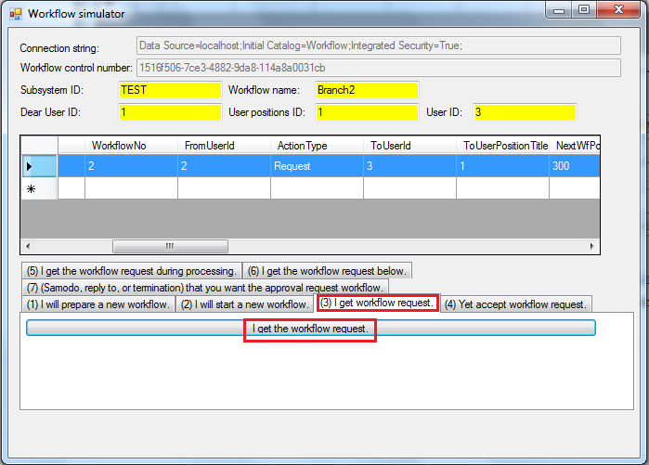

Accepting the Workflow Request
Perform the following steps to accept the workflow request from user ‘2’:
- Select the (4) Yet accept workflow request. tab
- Click the Yet accept workflow request. button
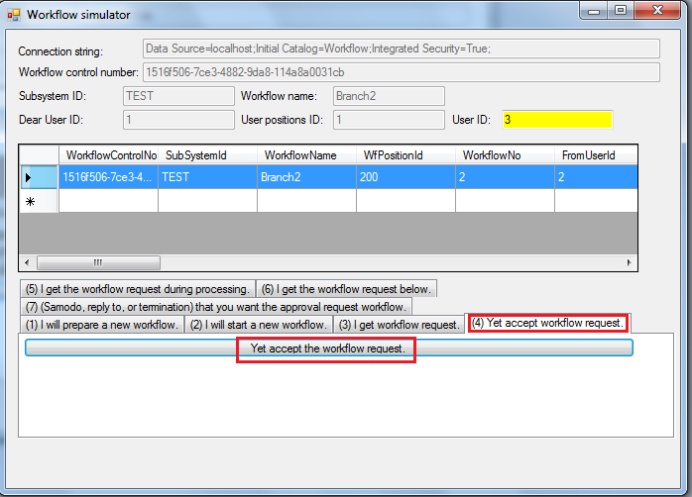

Accepting the Workflow Being Processed
Perform the following steps to get the workflow being processed from user ‘2’:
- Select the (5) I get the workflow request during processing. tab
- Click the I get the workflow request being processed. button
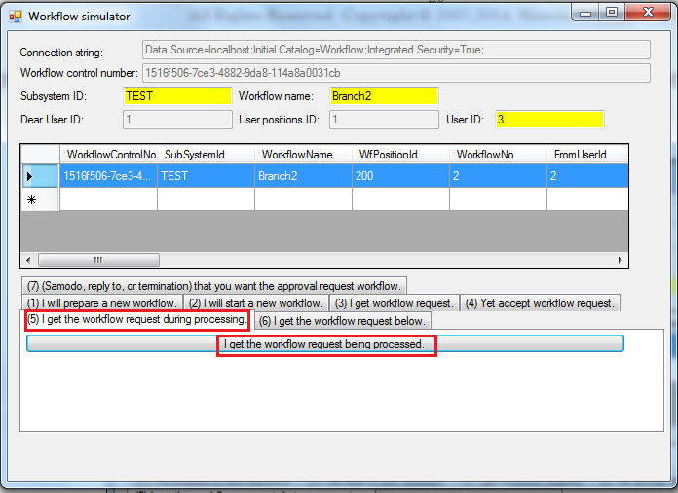

Retrieving the Next Workflow Request
Perform the following steps to get the next workflow request from user ‘2’:
- Select (6) I get the workflow request below. tab
- Click I get the workflow the next request. button

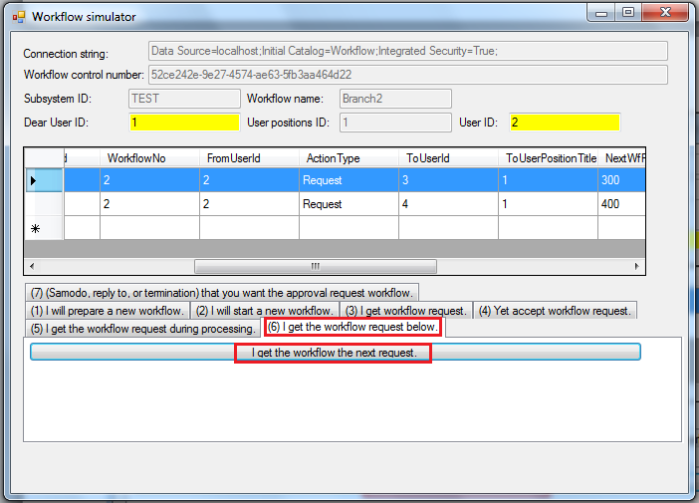
In the preceding image, User ID ‘2’ can send request to either User ID ‘3’ or User ID ‘4’. Select first row in the datagrid since we are sending workflow request from User ID ‘2’ to User ID ‘3’

Finishing or Terminating the Current Workflow.
Perform the following steps to finish or terminate the current workflow
- Select the (7) (Samodo, reply to, or termination) that you want the approval request workflow. Tab.
- Click the (Samodo, reply to, or termination) that will request the approval of the workflow.
button.
- Select the Samodo when replying to return to the original user check box. If want to send
response or reply to the original user.
- Specify To User ID to freely select the user for sending workflow request
- Click the TurnBack Into First to Turnback to person issuing the voucher
- Click the Forced Termination to terminate the workflow forcefully
- Click Switch Person In Charge to change the person in charge for accepting workflow and also to accept the workflow by other person
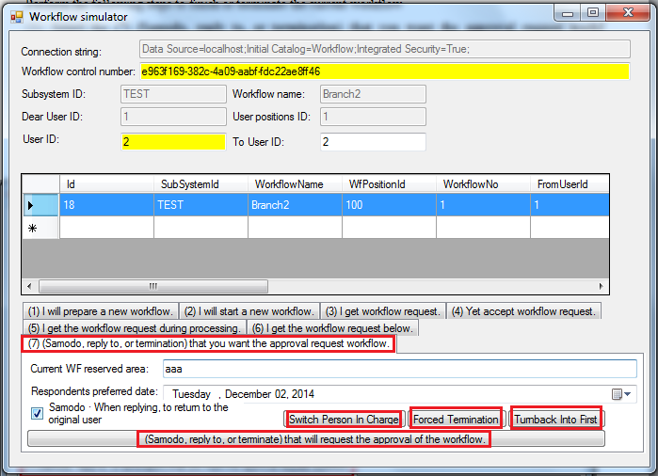

Processing Workflow to End State
Repeat the sections from 4.10 to 4.14 to process workflow to End state

