Open Touryo Tutorial
(ASP.NET Web Forms Application (VB))

xx/xx/2016

Introduction

Objective of this document
The objective is to learn the development of ASP.NET Web Forms application when using Open Touryo, by developing sample programs following the exercises in this tutorial.
This tutorial explains the generation of scripts and class files by using the tool, development flow, and program debugging method.

Scope of this document
This tutorial targets system engineers and developers who consider developing ASP.NET Web Forms application using Open Touryo.

Overview of this document
This tutorial describes the development flow for ASP.NET Web Forms application by using Open Touryo. The sample program attached to Open Touryo Visual Studio 2010 template base (root_VS2010) is used as the material of this tutorial.

Use of copyrights and trademarks of other companies
The company names and product names used in this document are the trademarks or registered trademarks of the respective companies.

License
This document is licensed under the Creative Commons Attribution 2.1 Japan License.
http://creativecommons.org/licenses/by/2.1/jp/legalcode

Table of Contents

1. Overview of Open Touryo 1
2. Set up the environment 2
2.1 Install Visual Web Developer 2010 Express 2
2.2 Set up Open Touryo template base 5
2.3 Set up database environment 6
3. Exercises in this tutorial 7
4. Exercises 9
4.1 Launch VWD 9
4.2 Create web forms 9
4.2.1 Create master page 9
4.2.2 Create order list form 11
4.2.3 Generation of Order Information Details Screen 13
4.2.4 Setting of the PDF file displayed in the dialog screen 13
4.2.5 Modification of Menu Screen 14
4.3 Configure Screen Transition 15
4.3.1 Configure Application Configuration File (app.config) 15
4.3.2 Configure Screen Transition Definition File (SCDefinitions.xml) 15
4.4 Create Parameter and Return value class 16
4.4.1 Create Parameter Value Class 16
4.4.2 Create Return Value Class 17
4.5 Create data access class 18
4.5.1 Generate data access class and SQL files 18
4.5.2 Arrange sql files 22
4.5.3 Add generated data access classes to sample application 22
4.5.4 Create SQL file for the List of Orders 22
4.5.5 Create DAO Summary Class 23
4.6 Create business logic class 26
4.7 Implement code behind 28
4.7.1 Implement code behind of Master Page 28
4.7.2 Implement code behind of Menu Page 29
4.7.3 Implement code behind of Order List Page 29
4.7.4 Implement code behind of Order Details Page 31
4.8 Confirm the setting information 35
4.8.1 Confirm the setting of application configuration file (Web.config) 35
4.9 Check operations 35
4.9.1 Start ASP.NET Status Service 35
4.9.2 Set up Intranet Security Settings 36
4.9.3 Debug the sample application 36
4.9.4 Confirm Trace Log 40

Overview of Open Touryo
Open Touryo is the application framework for .NET. Open Touryo targets .NET Framework 3.5 SP1 and above and can be used in various applications like C/S (Windows Forms, WPF), Web (ASP.NET), RIA (Silverlight), and more.

Fig. 1-1 shows the class diagram of Open Touryo
D Layer
B Layer
P Layer
Data access control class
Data access control parent class

System.Web.UI.Page
System.Web.UI.Control
Data access control class property-wise

*
1
1
Screen parent class 1

Business logic parent class 1

Master page parent class

Data access class
Master page
WebCustomControl
Data access parent class 1

Screen parent class 2
Business logic parent class2
*
1

1
1
*
1
1…n
Data access parent class 2
Visual Element
Code behind

Business logic class

1…n
1
Data access class

1
1
1
1
1
1

1
1
1…n
1…n
Legend

Return value

Parameter value
Parameter value class

Return value class

Class created by developer.
Parameter value parent class 2
Return value parents class 2

Class provided by Open Touryo.
Parameter value parent class1
Return value parents class 1

.NET Framework standard Class.

Fig. 1-1 Open Touryo class digram

This tutorial explains how to create Screen / Business logic class / Data access class implemented by developers according to class configuration diagram - Fig. 1-1.

Set up the environment
Table 2-1 shows the prerequisites for this tutorial.

Table 2-1 Prerequisites for this tutorial
# | Category |  | Prerequisite environment
1 | Development  environment | IDE | Visual Web Developer 2010 Express
2 | Development  environment | Application framework | Open Touryo template base  (/root_VS2010)
3 | Operating  environment | Runtime | .NET Framework 4
4 | Operating  environment | Web server | ASP.NET development server
5 | Operating  environment | DB | SQL Server Express 2008 R2
6 | Other | OS | Windows 7
7 | Other | Development language | VB
8 | Other | PDF viewer | Adobe Reader
9 | Other | Browser | Internet Explorer 11

The following section explains how to set up prerequisites.

Install Visual Web Developer 2010 Express
- Download disk image (iso) file from Microsoft Website (http://go.microsoft.com/?linkid=9709969). | 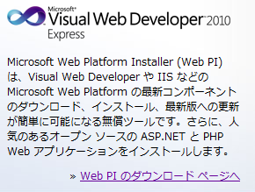
- Mount the downloaded disk image file on the Windows drive using mount tool.
- Execute Setup.hta located under the mounted drive.
- In Welcome to Visual Studio 2010 Express Setup screen, select Visual Web Developer 2010 Express (Abbreviated as VWD). | 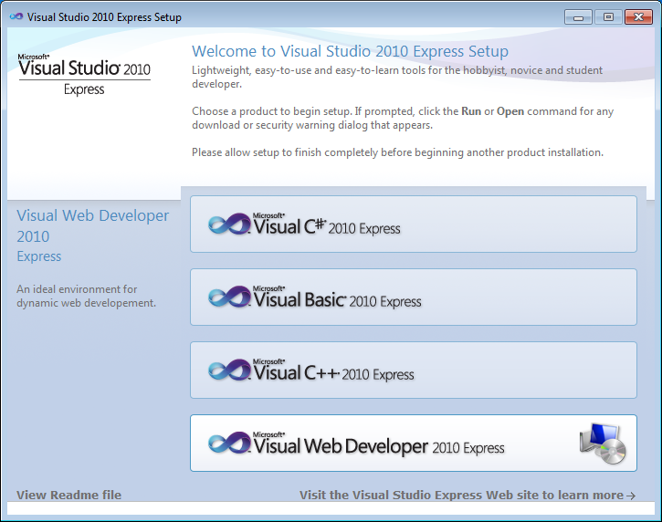
- In Welcome to setup screen, uncheck the box "Yes, send information about my setup experiences to Microsoft Corporation."  - Click Next. | 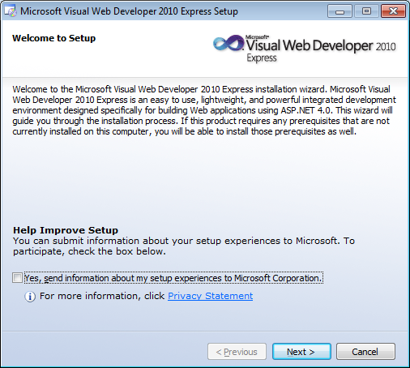
- In License Terms screen, select I have read and accept the license terms.  - Click Next. | 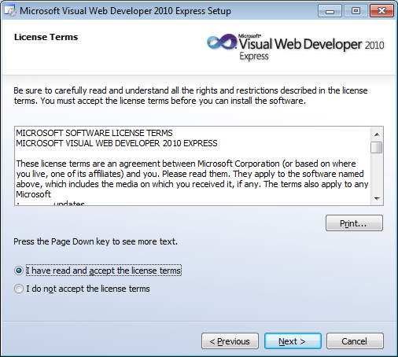
- In Installation Options screen, check the Microsoft SQL Server 2008 Express Service Pack 1 box.  - Click Next. | 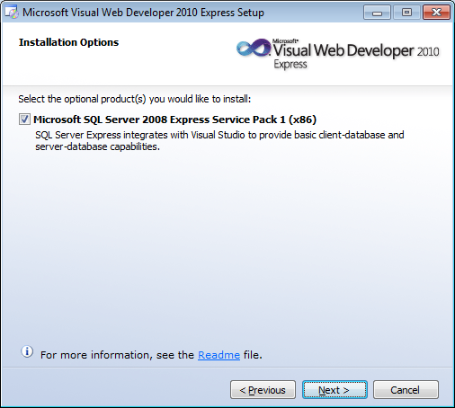
- In Destination Folder screen, set the install folder of VB Express.  - Click Install. | 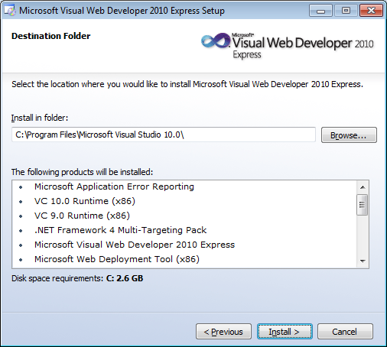
- Since download and install begins, wait till the installation is complete. | 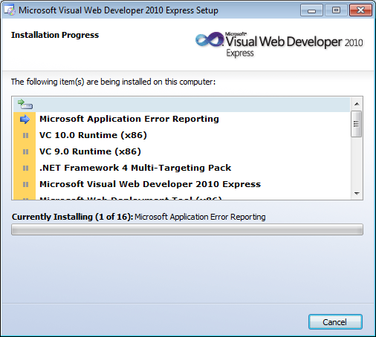
- Make sure that the installation is successful.  - Click Exit. | 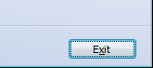

Set up Open Touryo template base
- Click Clone or download and  then Download ZIP in the  following site.  Obtain OpenTouryoTemplates.zip.  Unzip the zip file and acquire Open Touryo template base (/root_VS2010/).  /OpenTouryoProject/OpenTouryoTemplates.  https://github.com/OpenTouryoProject/OpenTouryoTemplates | 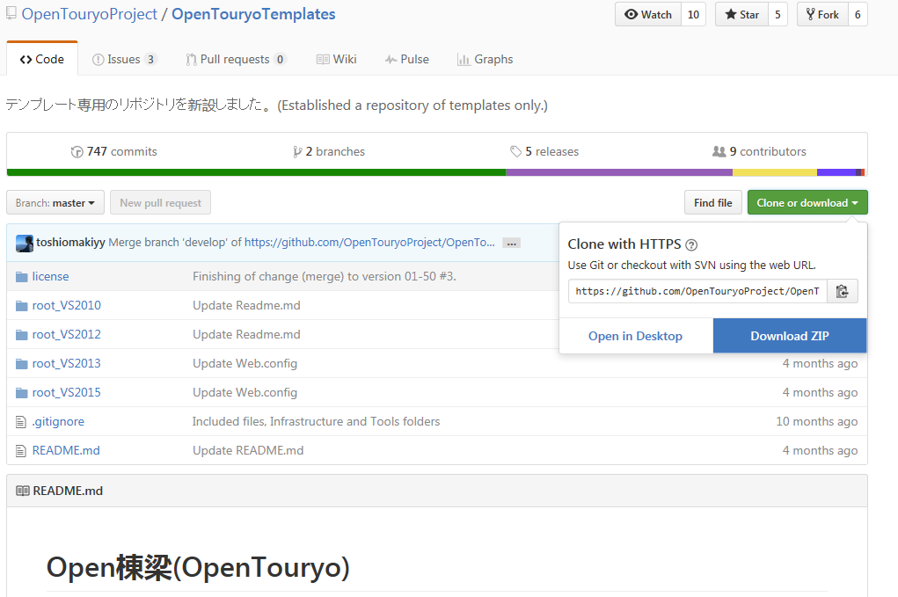
- Copy Open Touryo template base (/root_VS2010/) directly to C drive and rename root_VS2010 folder to root folder. | 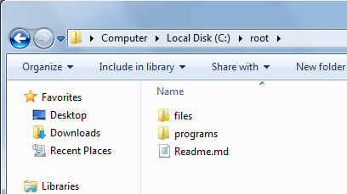
- Build programs of Open Touryo using Readme.md as a reference.

Set up database environment
SQL Server Express is installed along with VWD. Perform the following steps to create database, table and view that are used in the sample program.

- Download SQL file from Microsoft website (http://www.microsoft.com/en-us/download/details.aspx?id=23654) and install to create Northwind database and Pubs database. | 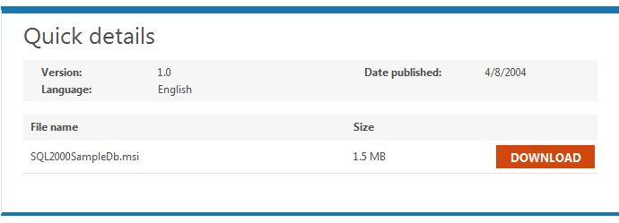
- Execute the following command using command prompt to create Northwind database.

"C:\Program Files\Microsoft SQL Server\100\Tools\Binn\SQLCMD.EXE" -S localhost\SQLExpress -E -i "C:\SQL Server 2000 Sample Databases\instnwnd.sql"

- Execute the following command using command prompt to make sure that Northwind database has been created successfully.

"C:\Program Files\Microsoft SQL Server\100\Tools\Binn\SQLCMD.EXE" -S localhost\SQLExpress -E -d Northwind -Q "Select * From Customers"

Exercises in this tutorial
Users of this tutorial can practice by adding web form or logic to the sample program that bundled with Open Touryo template base (/root_VS2010/). Fig. 3-2 shows the configuration of the sample programs and Fig. 3-3 shows the screen transition image of the tutorial.

Web Server / AP Server

DB Server

Open Touryo

Library
Framework
Application Framework

Screen transition

Log
DBAccess
・・・
Business Program ( UOC：User Own Coding )
Business
Screen
Business
Logic
DB Access
Dao
Collective
Class
Commno Dao
Auto Generation Dao
SQL
Server

.NET Framework 4
ASP.NET

ASP.NET Development Server (IIS)

Fig. 3-2 Configuration of sample programs

When the exercise of this tutorial is completed, three types of class, indicated in Error: Reference source not found, are created for data access class. For details on these classes, refer User guide of Open Touryo (Better use and FAQ Edition).

Table 3-2 Types of data access class
Data access class | Description
Auto generation DAO | DAO class that is generated by D layer auto generation tool bundled with Open Touryo template base. This class is used while performing simple CRUD process in table/view.
Common DAO | DAO class that is provided by Open Touryo framework.  This class is used when D layer auto generation tool can not be used, such as the case of obtaining the result based on joined tables.
DAO summary class | Façade class in D layer.  This class is used for summarizing requests from business logic class when using multiple DAO classes in one transaction.

Menu form
Pop-up
Display
Modal dialog
Show PDF file
Order list form
Order details form
Edit order information and refrect changes to database.
Display order details
Display order list
Fig. 3-3 Screen transition diagram of tutorial

The number of the section in this manual, describing the development flow when using Open Touryo, is shown in Table 3-2.

Table 3-3 Development flow when using Open Touryo
# | Category | Operation | Description | Remarks
1 | P layer | Create web form | Create web form (*.aspx) using Visual Studio. | Description in section Error: Reference source not found
2 | P layer | Define screen transition | Define screen transition in xml file. | Description in section 4.3
3 | Common | Create parameter and return value class | Create storage area for data transferred between web form and business logic class. | Description in section 4.4
4 | D layer | Create data access class | Create data access class shown in Table 3-2. | Description in section 4.5
5 | B layer | Create business logic class | Implement business logic. | Description in section 4.6
6 | P layer | Implement code behind | Implement code behind for events like Page_Load, Button_Click etc. | Description in section 4.7
7 | P layer | Confirm the settings of application configuration file(Web.config) | Confirm the settings of Web.config and modify them if necessary. | Description in section Error: Reference source not found
8 | Common | Check operations | Execute debug with Visual Studio.  Check log that is output by Open Touryo framework. | Description in section Error: Reference source not found

Exercises
The following section describes development flow of ASP.NET Web Form application using Open Touryo.

Launch VWD
- Open C:\root\programs\VB\Samples\WebApp_sample\ProjectX_sample\ProjectX_sample.sln. | 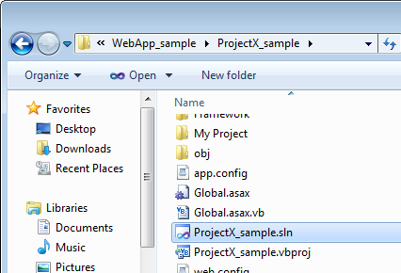

Create web forms

Create master page
- In the Solution Explorer, right-click Aspx - Common folder and select Add - New Item option. | 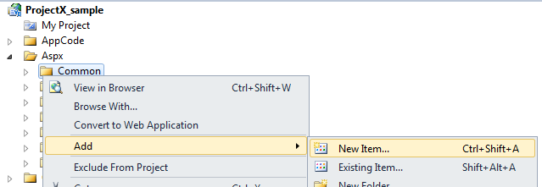
- In the Add New item screen, select Master page, and enter TouryoMaster.master in the Name field.  - Click Add. | 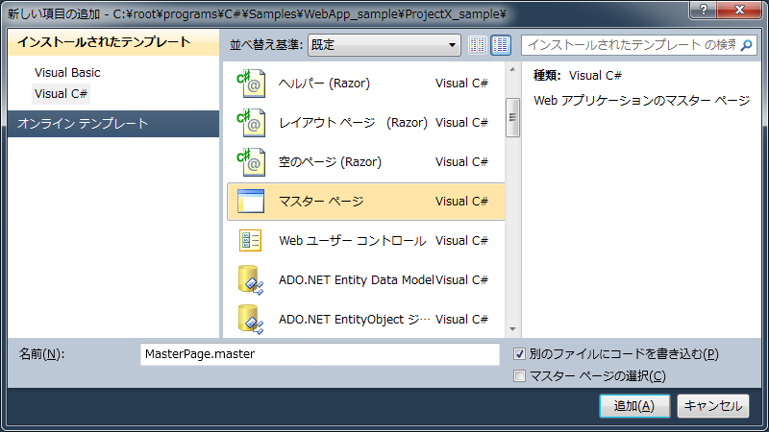
- Implement TouryoMaster.master as shown below using TestBlankScreen.master as a reference.

<%@ Master Language="VB" AutoEventWireup="true" Inherits="ProjectX_sample.Aspx_Common_testBlankScreen" Codebehind="testBlankScreen.master.vb" %>

<!-- All Rights Reserved, Copyright (C) 2007,2012 Hitachi Solutions,Ltd. -->
<!DOCTYPE html PUBLIC "-//W3C//DTD XHTML 1.0 Transitional//EN" "http://www.w3.org/TR/xhtml1/DTD/xhtml1-transitional.dtd">

<html xmlns="http://www.w3.org/1999/xhtml" >

<head id="Head1" runat="server">
<title>Untitled</title>
<!--Uncomment below line when using jQuery-->
<!--<script src="http://code.jquery.com/jquery-3.1.0.min.js"></script>-->

<!--FxCode：add-start-->
<script type="text/javascript" src="<%= Me.ResolveClientUrl("~/Framework/js/common.js") %>"></script>
<script type="text/javascript" src="<%= Me.ResolveClientUrl("~/Framework/js/ie_key_event.js") %>"></script>

<!-- Resolve URL in the javascript-->
<script type="text/javascript">
var baseUrl = "<%= ResolveUrl("~/") %>";
</script>

<!-- Run IE8 with IE7 compatible mode -->
<!--meta http-equiv="X-UA-Compatible" content="IE=EmulateIE7" /-->

<link rel="stylesheet" type="text/css" href="<%= Me.ResolveClientUrl("~/Css/style.css") %>"/>

<!--FxCode：add-end-->
</head>

<!--FxCode：add-js-event-->
<body onload="Fx_Document_OnLoad();" onunload="Fx_Document_OnClose();">

<!-- Enable autocomplete -->
<form id="form1" runat="server" autocomplete="on">
<!-- Common header of this master page -->
<h1>Open Touryo sample</h1>

<!--SampleCode：add-start-->

<a href="<%= Me.ResolveUrl("~/Aspx/start/menu.aspx") %>">Menu page</a><br />
<!--SampleCode：Contents-->
<asp:contentplaceholder id="ContentPlaceHolder_A" runat="Server">
This is Default Content -- Override on Page
</asp:contentplaceholder>
<!--SampleCode：add-end-->

<!--FxCode：add-start-->
<asp:HiddenField ID="ChildScreenType" runat="server" Value="0" />
<asp:HiddenField ID="ChildScreenUrl" runat="server" Value="0" />
<asp:HiddenField ID="CloseFlag" runat="server" Value="0" />
<asp:HiddenField ID="SubmitFlag" runat="server" Value="0" />
<asp:HiddenField ID="ScreenGuid" runat="server" Value="0" />
<asp:HiddenField ID="FxDialogStyle" runat="server" Value="0" />
<asp:HiddenField ID="BusinessDialogStyle" runat="server" Value="0" />
<asp:HiddenField ID="NormalScreenStyle" runat="server" Value="0" />
<asp:HiddenField ID="NormalScreenTarget" runat="server" Value="0" />
<asp:HiddenField ID="DialogFrameUrl" runat="server" Value="0" />
<asp:HiddenField ID="WindowGuid" runat="server" Value="0" />
<asp:HiddenField ID="RequestTicketGuid" runat="server" Value="0" />
<!--FxCode：add-end-->

</form>
</body>
</html>

- Save TouryoMaster.master.

Create order list page
Create web form using the master page created in section Error: Reference source not found.

- In the Solution Explorer, right-click Aspx - sample folder, and select Add - New Item option. | 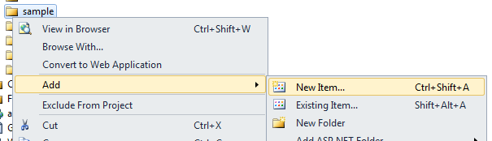
- In the Add New Item screen, select Web form using Master Page and enter OrdersList.aspx in the Name field.  - Click Add. | 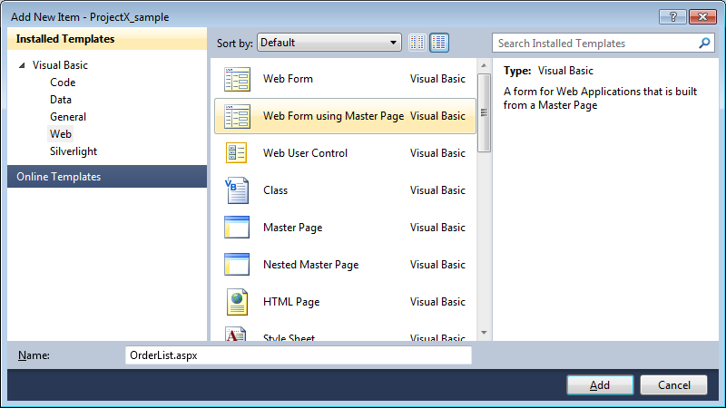
- In the Select a Master Page screen, select TouryoMaster.master under Aspx - Common folder.  - Click OK. | 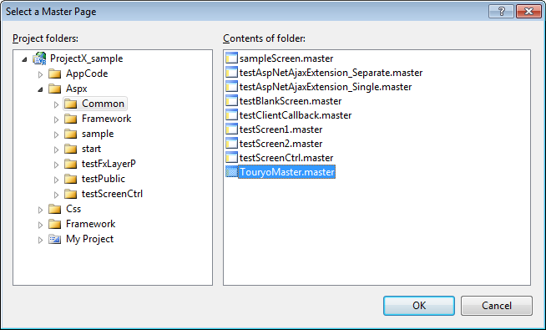
- Add GridView control to OrdersList.aspx.  - Set the property respectively as follows.  ID: gvwOrdersList  Note: If the prefix of control name, such as ”gvw”, is not set appropriately, the control is not recognized correctly by Open Touryo. (For details, refer to the Open Touryo user guide (common version)) | 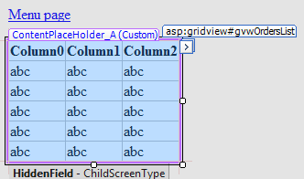
- Select Edit Column in GridView Tasks to add Button control to each row of this GridView. | 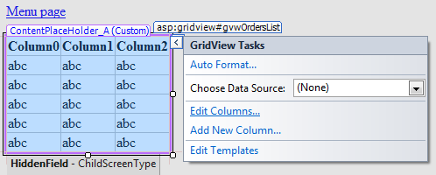
- Select ButtonField in Available fields: list  - Click Add. | 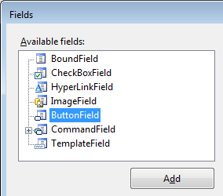
- In ButtonField properties, set the value as follows.  ButtonType: Button  Text: Select  Leave all other fields with default values.  - Click OK. | 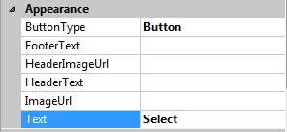
- In GridView, confirm Select buttons are added. | 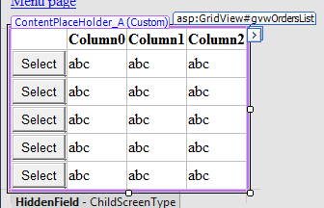

Create order details page
- In the same way to section 4.2.2, create web form to display order details, under Aspx - sample folder. Set the form name as follows.
Name: OrderDetails.aspx
- Add two Label controls, two GridView controls and Button control in OrderDetails.aspx as in the right figure.  - Set is as below respectively.  Label (Upper part)  Text: Order information (Summary)  Label (Lower part)  Text: Order information (Details)  GridView (Upper part)  ID: gvwOrderSummary  AutoGenerateEditButton: true  GridView (Lower part)  ID: gvwOrderDetails  AutoGenerateEditButton: true  Button  ID: btnUpdateOrder  Text: Update order information | 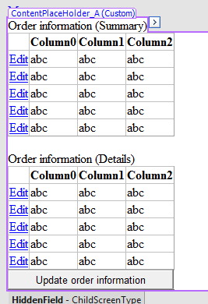

Configure PDF file that is displayed in modal dialog
- In the Solution Explorer, right-click Aspx - sample folder, and select Add - Existing Item option. | 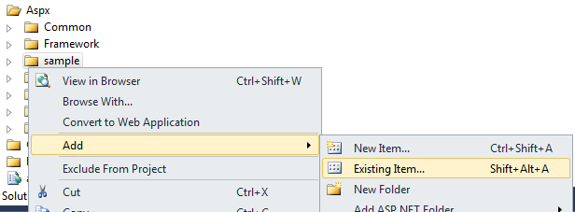
- In the Add Existing Item dialog, select C:\root\files\resource\Test\test.pdf.  - Click Add. | 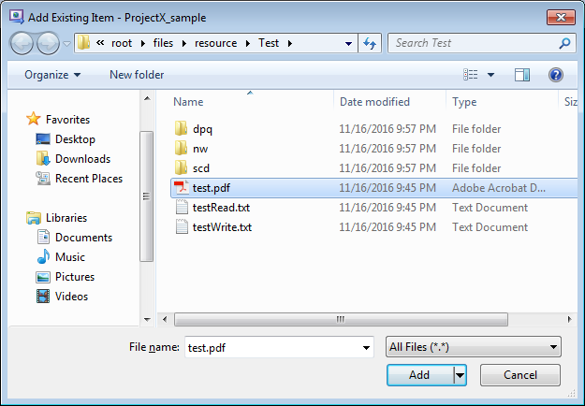
- Confirm test.pdf file has been added. | 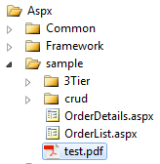

Modify Menu Page
- In the Solution Explorer, open Aspx - sample - menu.aspx. | 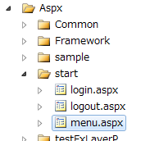
- Add the following code somewhere in menu.aspx.

・ Tutorial<br />
－
<asp:LinkButton ID="lbnGetOrdersList" runat="server">Get order list</asp:LinkButton>
<br />
－
<asp:LinkButton ID="lbnShowDialog" runat="server">Show modal dialog box</asp:LinkButton>
<br />
<br />

- Click Design to switch to design view. | 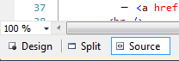
- Confirm that two links have been added. | 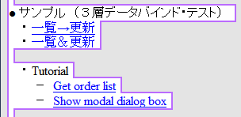

Configure Screen Transition

Configure Application Configuration File (app.config)
- In the Solution Explorer, open app.config. | 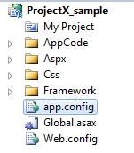
- Modify the value of FxScreenTransitionMode property to R.

<!-- Specify screen transition method (T：Transfer, R：Redirect, off) -->
<add key="FxScreenTransitionMode" value="R"/>

Configure Screen Transition Definition File (SCDefinitions.xml)
Define screen transition in the SCDefinitions.xml file.
- Open the C:\root\files\resource\Xml\SCDefinition.xml file.
- Modify the definition of menu.aspx as follows.

<Screen value="/ProjectX_sample/Aspx/start/menu.aspx" directLink="allow">
<!-- Define transition to order information list screen -->
<Transition value="/ProjectX_sample/Aspx/sample/OrdersList.aspx" label="List"/>
</Screen>

- Add the following settings to define order list form and order details form in SCDefinition.xml.

<!-- Define order list form -->
<Screen value="/ProjectX_sample/Aspx/sample/OrdersList.aspx" directLink="deny">
<!-- Define transition to order details form -->
<Transition value="/ProjectX_sample/Aspx/sample/OrderDetails.aspx" label="Detail"/>
</Screen>

<!-- Define order details form -->
<Screen value="/ProjectX_sample/Aspx/sample/OrderDetail.aspx" directLink="deny">
</Screen>

Note: More information about the description method of SCDefinition.xml and the screen transition function of Open Touryo can be found in the Open Touryo user guide (for each function).

Create Parameter and Return value class

Create Parameter Value Class
- In the Solution Explorer, right-click AppCode - sample - Common folder and select Add - Class option. | 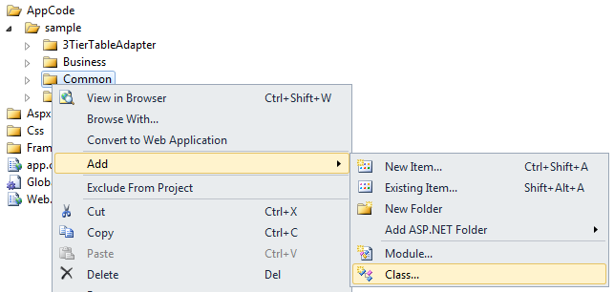
- In the Add New Item screen, enter OrderParameterValue.vb in the Name field.  - Click Add | 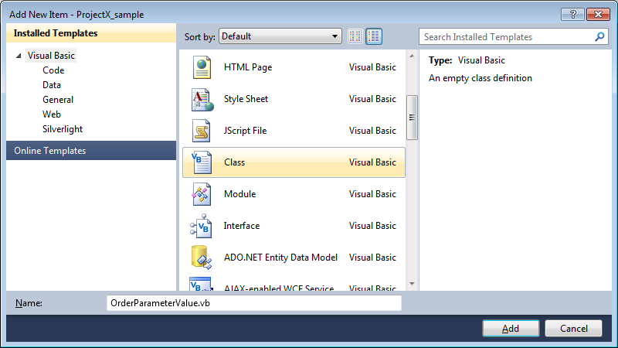
- Add the following namespaces in OrderParameterValue.vb to use the classes provided by Open Touryo.

Imports Touryo.Infrastructure.Business.Util
Imports Touryo.Infrastructure.Business.Common

- Inherit Parameter Value Parent Class of Open Touryo to OrderParameterValue class as shown below.

Public Class OrderParameterValue
Inherits MyParameterValue

- Create OrderParameterValue constructor with the following code.

Public Sub New(screenId As String, controlId As String, methodName As String, _
actionType As String, user As MyUserInfo)

MyBase.New(screenId, controlId, methodName, actionType, user)
End Sub

- Create the following properties in OrderParameterValue class to transfer data from page to data access class.

''' <summary>Order Id</summary>
Public OrderId As String

''' <summary>Order information</summary>
Public Orders As System.Data.DataTable

''' <summary>Order details information</summary>
Public OrderDetails As System.Data.DataTable

Create Return Value Class
- In the Solution Explorer, right-click Common folder and select Add - Class option. | 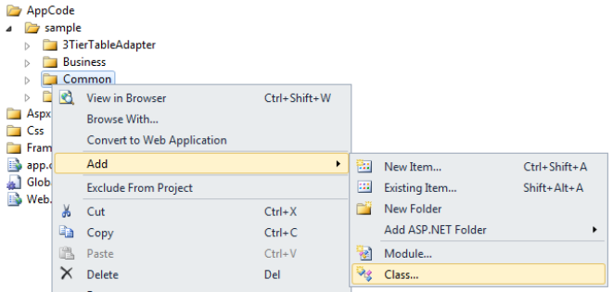
- In the Add New Item screen, enter OrderReturnValue.vb in the Name field.  - Click Add. | 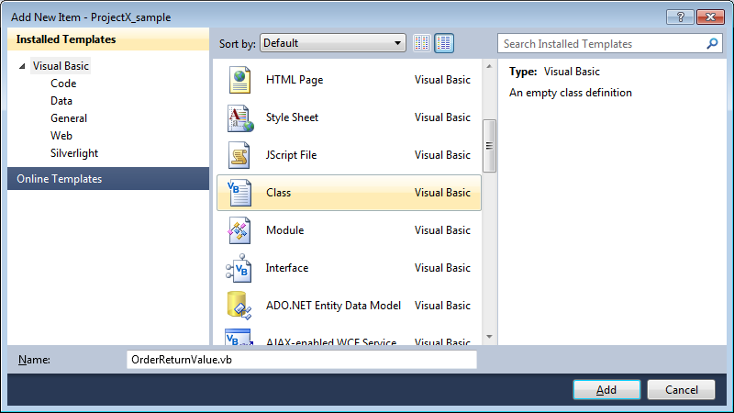
- Add the following namespace in OrderReturnValue.vb to use the classes provided by Open Touryo.

Imports Touryo.Infrastructure.Business.Common

- Inherit the Return Value Parent Class of Open Touryo to OrderReturnValue class as shown below.

Public Class OrderReturnValue
Inherits MyReturnValue

- Create the following properties in OrderReturnValue class to transfer the resultant data from data access class to page.

''' <summary>Order information</summary>
Public Orders As System.Data.DataTable

''' <summary>Order details information</summary>
Public OrderDetails As System.Data.DataTable

Create data access class

Generate data access class and SQL files
Perform the following steps to generate data access class and SQL files that implement simple CRUD operation for table or view, using the D layer auto generation tool (DaoGen_Tool) bundled with Open Touryo template base.
- Open C:\root\programs\C#\Frameworks\Tools\DaoGen_Tool\bin\Debug\DaoGen_Tool.exe. | 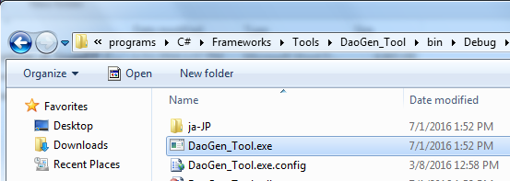
- In the STEP1 screen, set database information as follows:  - Select SQL Server Client in the Select Data Provider: radiobutton list.  - Enter Data Source=localhost\sqlexpress; Initial Catalog=Northwind; Integrated Security=true; in the Connection String: field.  - Select Summary Information in the Schema Info: dropdown list.  - Click acquisition. | 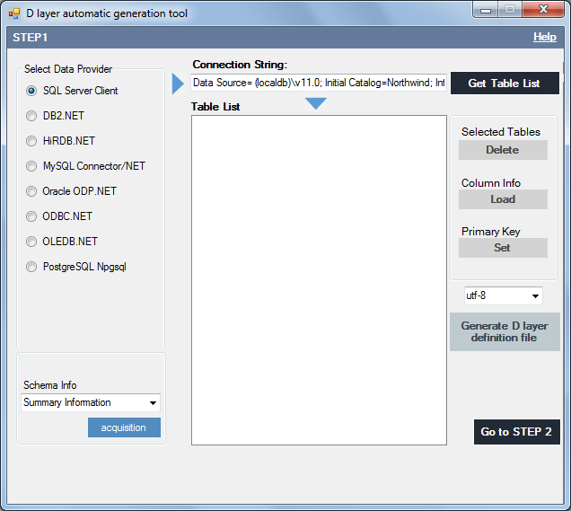
- In the Display (Summary Information) dialog of schema information of DBMS screen, confirm that database information, such as connection string, are correct.  - Click Close to close the dialog box. | 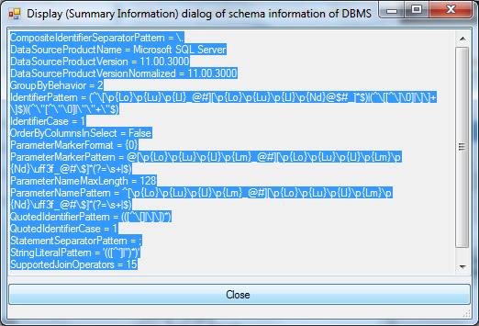
- Click Get Table List. | 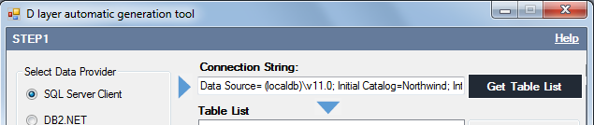
- In the Note– (prerequisites) dialog box, click OK. | 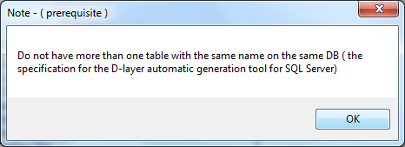
- Delete the following list of views that are displayed in the Table List field (Dao/SQL file generation will fail if view does not have a primary key). | 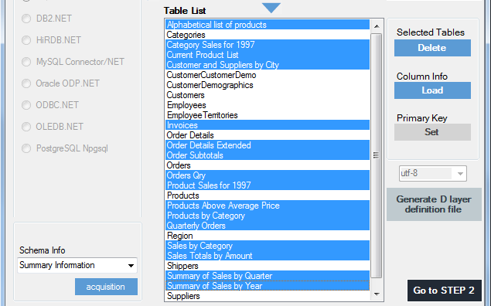
  Alphabetical list of products
  Category Sales for 1997
  Current Product List
  Customer and Suppliers by City
  Invoices
  Order Details Extended
  Order Subtotals
  Orders Qry
  Product Sales for 1997
  Products Above Average Price
  Products by Category
  Quarterly Orders
  Sales by Category
  Sales Totals by Amount
  Summary of Sales by Quarter
  Summary of Sales by Year
- Confirm whether Table List contains only the list of tables that are displayed on the right figure.  - Click Load. | 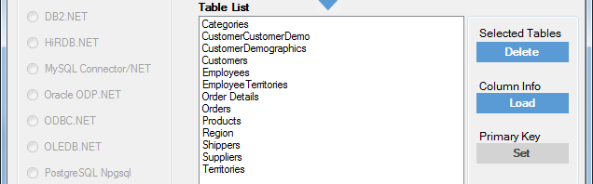
- The Generate D layer definition file button is activated. Select utf-8 as file encoding.  - Click Generate D layer definition file. | 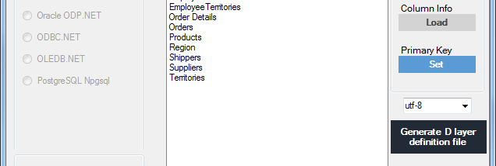
- In the D layer definition information file screen:  Navigate to the C:\root folder  Enter Info.csv in the File name: field.  - Click Save. | 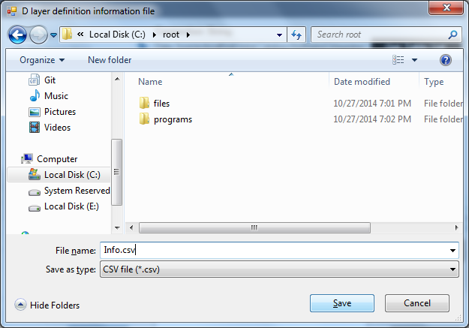
- Click OK, when the dialog box displaying the message Completion of generation of the D-layer definition information! appears. | 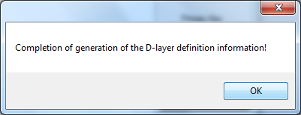
- Click Go to STEP 2. | 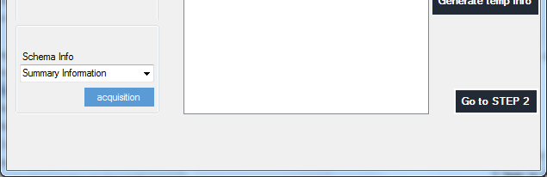
- In the STEP2 screen, enter input / output settings as follows:  - VB in the Language: field.  - C:\root\Info.csv in the D layer definition information file: field.  - C:\root\files\tools\DGenTemplates in the Source Template Folder: field.  - C:\root in the Output File: field.  - Leave all other fields with default values.  - Click Generate Program. | 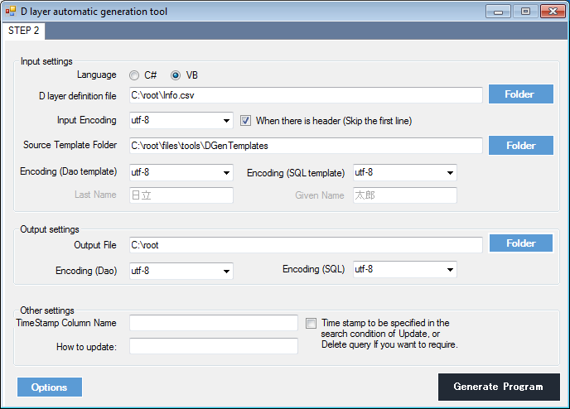
- Click OK, when the dialog box displaying the Automatic Generation Completed ! message appears. | 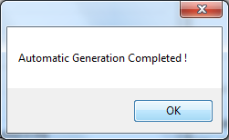
- Confirm that data access classes and SQL files are generated in C:\root folder.  Note: In the Open Touryo framework, the files with extensions .sql and .xml are SQL files. (For more details, refer to the Open Touryo framework user guide) | 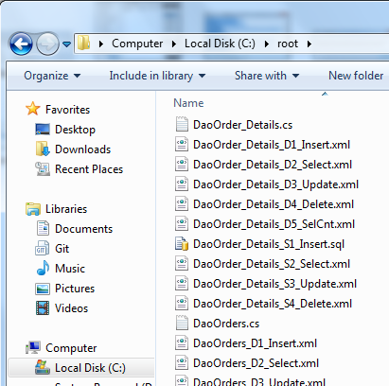
- Click the X button to close D layer auto generation tool. | 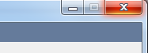

Arrange sql files
Copy the generated SQL and XML files (sql files) to C:\root\files\resource\Sql folder.  Note: If the dialog box appears while copying sql files, select Copy and Replace option for all the files. | 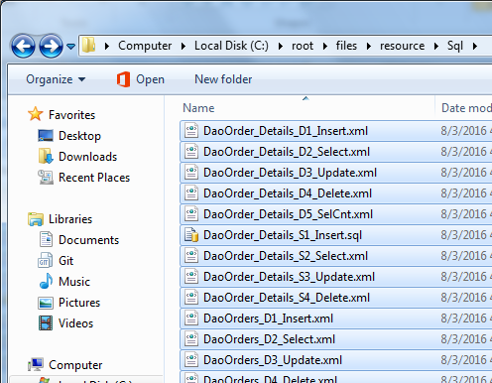

Add generated data access classes to sample application
- In the Solution Explorer, right-click the Dao folder.  - Select the Add - Existing Item option. | 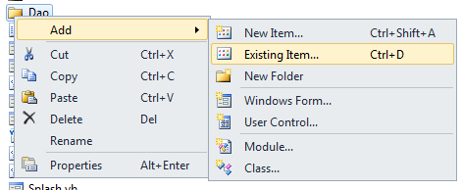
- In the Add Existing Item screen, select DaoOrders.vb and DaoOrder_Details.vb in C:\root folder.  - Click Add. | 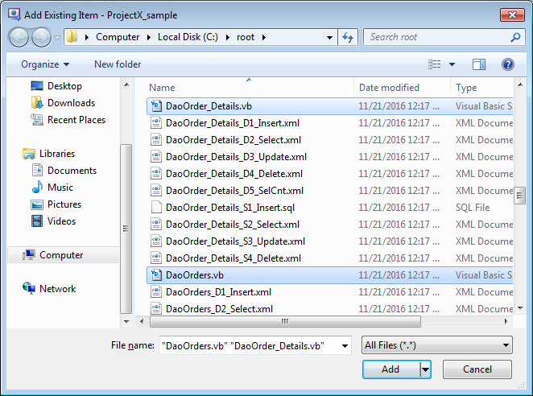

Create SQL file for the List of Orders
Perform the following steps to create SQL file for the List of Orders.
- Create SelectOrders.sql file in C:\root\files\resource\Sql folder.
- Add the following SQL scripts in SelectOrders.sql to get the list of orders.

SELECT
Orders.OrderID, Customers.CompanyName, Customers.ContactName, Employees.LastName As EmployeeLastName, Employees.FirstName As EmployeeFirstName, Orders.OrderDate
FROM
Orders
INNER JOIN Customers ON Orders.CustomerID = Customers.CustomerID
INNER JOIN Employees ON Orders.EmployeeID = Employees.EmployeeID

Create DAO Summary Class
Perform the following steps to create DAO Summary class to get / update order information.
- In the Solution Explorer, right-click the Dao folder.  - Select the Add - Class option. | 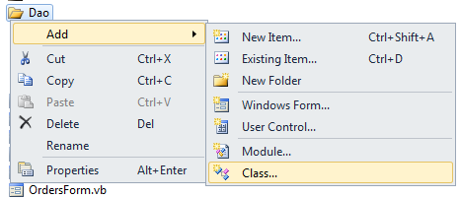
- In the Add New Item screen, enter ConsolidatedLayerD.vb in the Name: field.  - Click Add. | 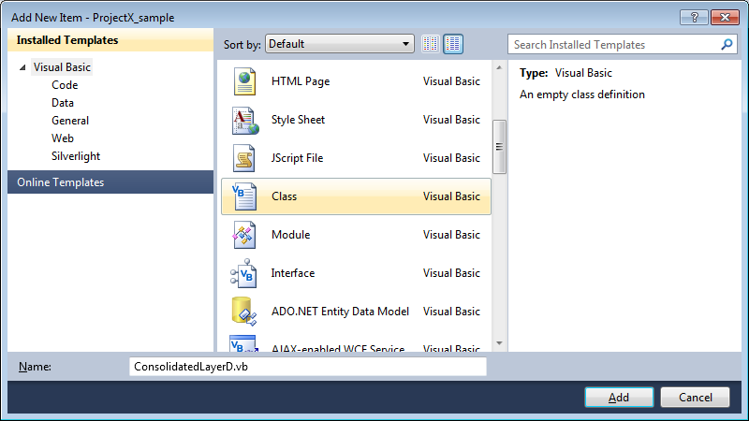
- Add the following namespaces to ConsolidatedLayerD.vb to use the classes provided by Open Touryo, and parameter and return value class created in section 4.3.

' Open Touryo
Imports Touryo.Infrastructure.Business.Dao
Imports Touryo.Infrastructure.Public.Db

- Inherit Data Access Parent Class of Open Touryo framework to ConsolidatedLayerD class as shown below.

Public Class ConsolidatedLayerD
Inherits BaseConsolidateDao

- Create ConsolidatedLayerD constructor with the following code.

Public Sub New(dam As BaseDam)
MyBase.New(dam)
End Sub

- Create GetOrders method to get the list of orders with the following code.

Public Function GetOrders(orderParameter As OrderParameterValue) As OrderReturnValue
' Create an object of Return Value class
Dim returnValue As New OrderReturnValue()

' Create an object of common DAO and assign SQL file
Dim dao As New CmnDao(Me.Dam)
dao.SQLFileName = "SelectOrders.sql"

' Create an object of DataTable
Dim table As New System.Data.DataTable()

' Get the list of orders information from the database and stored in a DataTable
dao.ExecSelectFill_DT(table)

' Store the orders information to the Return Value class and return to the B layer
returnValue.Orders = table
Return returnValue
End Function

- Create GetOrderById method to get the details of specific order summary and order details information based on the Order ID with the following code.

Public Function GetOrderById(orderParameter As OrderParameterValue) As OrderReturnValue
' Create an object of Return Value class
Dim returnValue As New OrderReturnValue()

' Create an object of auto generated DAO classes
Dim orderDao As New DaoOrders(Me.Dam)
Dim orderDetailsDao As New DaoOrder_Details(Me.Dam)

' Create objects of DataTable to store the details of specified order information
Dim orderTable As New System.Data.DataTable()
Dim orderDetailsTable As New System.Data.DataTable()

' Set the required parameters
orderDao.PK_OrderID = orderParameter.OrderId
orderDetailsDao.PK_OrderID = orderParameter.OrderId

' Get the details of specific order information from the database and stored in the DataTable
orderDao.D2_Select(orderTable)
orderDetailsDao.D2_Select(orderDetailsTable)

' Store the details of specific order information to the Return Value class and return to the B layer
returnValue.Orders = orderTable
returnValue.OrderDetails = orderDetailsTable
Return returnValue
End Function

- Create UpdateOrder method to update the details of specified order summary and order details information with the following code.

Public Function UpdateOrder(orderParameter As OrderParameterValue) As OrderReturnValue
' Create an object of Return Value class
Dim returnValue As New OrderReturnValue()

' Create an object of auto generated DAO classes
Dim orderDao As New DaoOrders(Me.Dam)
Dim orderDetailsDao As New DaoOrder_Details(Me.Dam)

' Create an object of DataTable to store order information and order details information
Dim orderTable As System.Data.DataTable = orderParameter.Orders
Dim orderDetailsTable As System.Data.DataTable = orderParameter.OrderDetails

' Judge the state of DataRow, and update database if DataRow is modified
If orderTable.Rows(0).RowState = System.Data.DataRowState.Modified Then
' Set the parameters of the order information
orderDao.PK_OrderID = orderTable.Rows(0)("OrderId")
orderDao.Set_OrderDate_forUPD = orderTable.Rows(0)("OrderDate")
orderDao.Set_RequiredDate_forUPD = orderTable.Rows(0)("RequiredDate")
orderDao.Set_ShippedDate_forUPD = orderTable.Rows(0)("ShippedDate")
orderDao.Set_ShipVia_forUPD = orderTable.Rows(0)("ShipVia")
orderDao.Set_Freight_forUPD = orderTable.Rows(0)("Freight")
orderDao.Set_ShipName_forUPD = orderTable.Rows(0)("ShipName")
orderDao.Set_ShipAddress_forUPD = orderTable.Rows(0)("ShipAddress")
orderDao.Set_ShipCity_forUPD = orderTable.Rows(0)("ShipCity")
orderDao.Set_ShipRegion_forUPD = orderTable.Rows(0)("ShipRegion")
orderDao.Set_ShipPostalCode_forUPD = orderTable.Rows(0)("ShipPostalCode")
orderDao.Set_ShipCountry_forUPD = orderTable.Rows(0)("ShipCountry")
' Update the order information to the database
orderDao.D3_Update()
End If

For Each row As System.Data.DataRow In orderDetailsTable.Rows
' Judge the state of DataRow, and update database if DataRow is modified
If row.RowState = System.Data.DataRowState.Modified Then
' Set the parameters of the order details information
orderDetailsDao.PK_OrderID = row("OrderId")
orderDetailsDao.PK_ProductID = row("ProductId")
orderDetailsDao.Set_UnitPrice_forUPD = row("UnitPrice")
orderDetailsDao.Set_Quantity_forUPD = row("Quantity")
orderDetailsDao.Set_Discount_forUPD = row("Discount")

' Update the order details information to the database
orderDetailsDao.D3_Update()
End If
Next
' Return the object of Return Value Class to business logic class
Return returnValue
End Function

⁷ In this tutorial, the SQL file is deployed as an external file of the program. In Open Touryo, the SQL file is embedded in the program (assembly) as a resource file, and the SQL file can be read from the embedded resource file. Refer to the Open Touryo user guide (developer version) for the read method of the SQL file from the embedded resource.

Create business logic class
- In the Solution Explorer, right-click the Business folder.  - Select the Add - Class option. | 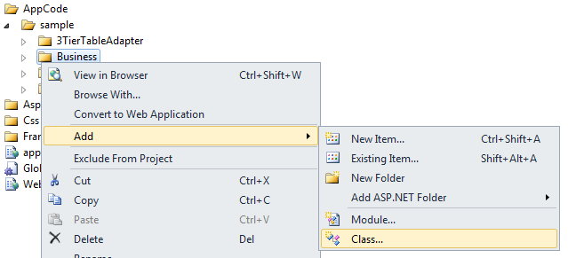
- In the Add New Item screen, enter OrdersLogic.vb in the Name: field.  - Click Add. | 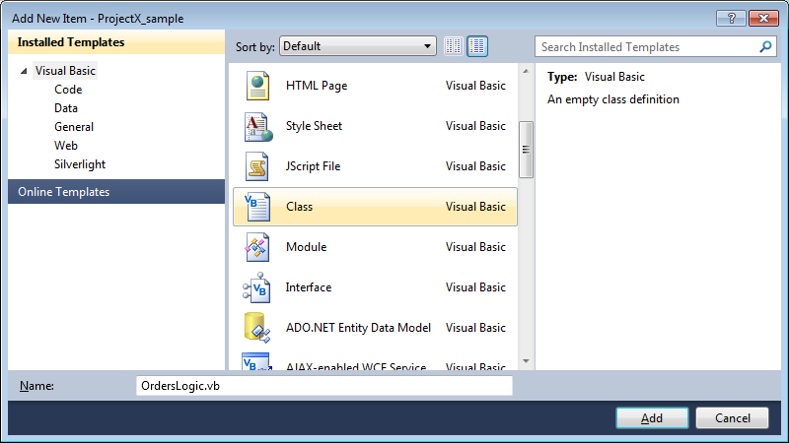
- Add the following namespaces to OrdersLogic.vb to use the classes provided by Open Touryo, and parameter and return value class, and data access class.

' Open Touryo
' Business
Imports Touryo.Infrastructure.Business.Business
Imports Touryo.Infrastructure.Business.Common
Imports Touryo.Infrastructure.Business.Dao
Imports Touryo.Infrastructure.Business.Exceptions
Imports Touryo.Infrastructure.Business.Presentation
Imports Touryo.Infrastructure.Business.Util
Imports Touryo.Infrastructure.Business.RichClient.Asynchronous
Imports Touryo.Infrastructure.Business.RichClient.Business
Imports Touryo.Infrastructure.Business.RichClient.Presentation

' Framework
Imports Touryo.Infrastructure.Framework.Business
Imports Touryo.Infrastructure.Framework.Common
Imports Touryo.Infrastructure.Framework.Dao
Imports Touryo.Infrastructure.Framework.Exceptions
Imports Touryo.Infrastructure.Framework.Presentation
Imports Touryo.Infrastructure.Framework.Util
Imports Touryo.Infrastructure.Framework.Transmission
Imports Touryo.Infrastructure.Framework.RichClient.Presentation

' Public
Imports Touryo.Infrastructure.Public.Db
Imports Touryo.Infrastructure.Public.IO
Imports Touryo.Infrastructure.Public.Log
Imports Touryo.Infrastructure.Public.Str
Imports Touryo.Infrastructure.Public.Util

- Inherit Business Parent Class of Open Touryo framework to OrdersLogic class as shown below.

Public Class OrdersLogic
Inherits MyFcBaseLogic

- Create UOC_GetOrders method to get the list of orders with the following code.

Private Sub UOC_GetOrders(orderParameter As OrderParameterValue)
' Create an object DAO Summary class
Dim facade As new ConsolidatedLayerD(Me.GetDam())

' Get the list of orders information
Dim returnValue As OrderReturnValue = facade.GetOrders(orderParameter)

' Return the object of Return Value class
Me.ReturnValue = returnValue
End Sub

Note: The method to be called from the Controller class is required to be created as UOC_xx (xx is arbitrary string). When controller sends xx as parameter, Open Touryo framework allocates the processing to UOC_xx method in business logic class.
- Create UOC_GetOrderById method to get the details of specific order summary and order details information based on the Order ID with the following code.

Private Sub UOC_GetOrderById(orderParameter As OrderParameterValue)
' Create an object DAO Summary class
Dim facade As new ConsolidatedLayerD(Me.GetDam())

' Get the details of specific order information and order details information based on Order ID
Dim returnValue As OrderReturnValue = facade.GetOrderById(orderParameter)

' Return the object of Return Value class
Me.ReturnValue = returnValue
End Sub

- Create UOC_UpdateOrder method to update the details of specified order summary and order details information with the following code.

Private Sub UOC_UpdateOrder(orderParameter As OrderParameterValue)
' Create an object DAO Summary class
Dim facade As new ConsolidatedLayerD(Me.GetDam())

' Update the specified order information and order details information
Dim returnValue As OrderReturnValue = facade.UpdateOrder(orderParameter)

' Return the object of Return Value class
Me.ReturnValue = returnValue
End Sub

Implement code behind

Implement code behind of Master Page
- In the Solution Explorer, right-click Aspx - Common - TouryoMaster.master.vb and View Code option. | 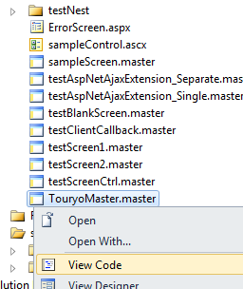
- Add the following namespace to TouryoMaster.master.vb, to use the classes provided by Open Touryo.

Imports Touryo.Infrastructure.Framework.Presentation

- Inherit Master Page Parent Class of Open Touryo to Aspx_Common_TouryoMaster class as shown below.

Public Class TouryoMaster
Inherits BaseMasterController

Note: Open Touryo provides the utility method to find control in master page or contents page. If the master page has not inherited Master Page Parent Class, the utility method cannot find control normally. Therefore, it is necessary for each master page to inherit Master Page Parent Class to use this utility method. (For details, refer to the Open Touryo user guide (manager version).)

Implement code behind of Menu Page
- In the Solution Explorer, right-click Aspx - start - menu.aspx and select View Code option. | 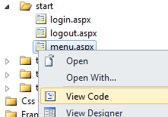
- Add the click event handler for LinkButton added in section 4.2.5.

Protected Function UOC_lbnGetOrdersList_Click(eventArgs As FxEventArgs) As String
' Transit to order list page with the label that is defined in SCDefinitions.xml
Return "List"
End Function

Protected Function UOC_lbnShowDialog_Click(eventArgs As FxEventArgs) As String
' Show dialog
Me.ShowNormalScreen("/ProjectX_sample/Aspx/sample/test.pdf")

' Return an empty string
Return String.Empty
End Function

Note: When using Open Touryo, the method name of event handlers should be UOC_[control name]_[event name]. (For details, refer to the Open Touryo user guide (common version).)

Implement code behind of Order List Page
- In the Solution Explorer, right-click Aspx - sample - OrdersList.aspx and View Code option. | 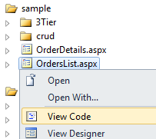
- Add the following namespaces to OrdersList.aspx.vb to use the classes of Open Touryo.

' Open Touryo
' Business

Imports Touryo.Infrastructure.Business.Business
Imports Touryo.Infrastructure.Business.Common
Imports Touryo.Infrastructure.Business.Dao
Imports Touryo.Infrastructure.Business.Exceptions
Imports Touryo.Infrastructure.Business.Presentation
Imports Touryo.Infrastructure.Business.Util

' Framework
Imports Touryo.Infrastructure.Framework.Business
Imports Touryo.Infrastructure.Framework.Common
Imports Touryo.Infrastructure.Framework.Dao
Imports Touryo.Infrastructure.Framework.Exceptions
Imports Touryo.Infrastructure.Framework.Presentation
Imports Touryo.Infrastructure.Framework.Util
Imports Touryo.Infrastructure.Framework.Transmission

' Public
Imports Touryo.Infrastructure.Public.Db
Imports Touryo.Infrastructure.Public.IO
Imports Touryo.Infrastructure.Public.Log
Imports Touryo.Infrastructure.Public.Str
Imports Touryo.Infrastructure.Public.Util

- Inherit Screen Parent Class of Open Touryo to Aspx_sample_OrdersList class as shown below.

Public Class OrdersList
Inherits MyBaseController

- Delete Page_Load method generated automatically.
- To get the order list during displaying OrdersList page, override UOC_FormInit method and UOC_FormInit_PostBack method as follows.

Protected Overrides Sub UOC_FormInit()
' Create an object of Parameter Value class
Dim param As New OrderParameterValue( _
Me.ContentPageFileNoEx, "", "GetOrders", String.Empty, Me.UserInfo)

' Define a variable for Return Value class
Dim returnValue As OrderReturnValue

' Call business logic
Dim logic As New OrdersLogic()
returnValue = DirectCast(logic.DoBusinessLogic(param), OrderReturnValue)

' Display the result in GridView
Me.gvwOrdersList.DataSource = returnValue.Orders
Me.gvwOrdersList.DataBind()
End Sub

Protected Overrides Sub UOC_FormInit_PostBack()
End Sub

- Add the click event handler for the buttons on each row of GridView to show order details page.

Protected Function UOC_gvwOrdersList_RowCommand(eventArgs As FxEventArgs) As String
' Get an index of the selected row
Dim RowIndex As Integer = Integer.Parse(eventArgs.PostBackValue)

' Get the value of order id of the selected row
Dim orderId As String = Me.gvwOrdersList.Rows(RowIndex).Cells(1).Text

' Store the value of order id in the session
Session("OrderId") = OrderId

' Transit to order details page with the label that is defined in SCDefinitions.xml
Return "Detail"
End Function

Implement code behind of Order Details Page
- In the Solution Explorer, right-click Aspx - sample - OrderDetails.aspx and View Code option. | 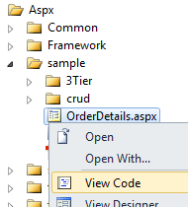
- In the same way to steps (1) to Error: Reference source not found of section 4.7.3, inherit Screen Parent Class of Open Touryoto OrderDetails.aspx class.
- Delete Page_Load method generated automatically.
- To get order details during displaying OrderDetails page, override the UOC_FormInit method and UOC_FormInit_PostBack method as follows.

Protected Overrides Sub UOC_FormInit()
' Get the value of order id that is stored in the session
Dim OrderId As String = Session("OrderId").ToString()

' Create an object of Parameter Value class
Dim param As New OrderParameterValue( _
Me.ContentPageFileNoEx, "", "GetOrderById", String.Empty, Me.UserInfo)

' Set the parameter to the value of order id as a search criteria
param.OrderId = OrderId

' Define a variable for Return Value class
Dim returnValue As OrderReturnValue

' Call business logic
Dim logic As New OrdersLogic()
returnValue = DirectCast(logic.DoBusinessLogic(param), OrderReturnValue)

' Store the order information in the session
Session("Orders") = returnValue.Orders
Session("OrderDetails") = returnValue.OrderDetails

' Display the result in GridView
Me.gvwOrderSummary.DataSource = returnValue.Orders
Me.gvwOrderSummary.DataBind()
Me.gvwOrderDetails.DataSource = returnValue.OrderDetails
Me.gvwOrderDetails.DataBind()
End Sub

Protected Overrides Sub UOC_FormInit_PostBack()
End Sub

- In the Solution Explorer, open Aspx - sample - OrderDetails.aspx. | 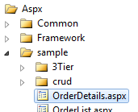
- Select the gvwOrderSummary control, and click Event icon in the property window. | 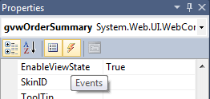
- Double-click RowEditing event and RowCancelingEdit event. | 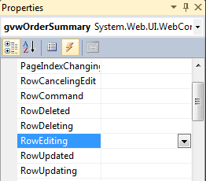
- Implement gvwOrderSummary_RowEditing method and gvwOrderSummary_RowCancelingEdit method with the following code.

Protected Sub gvwOrderSummary_RowEditing(sender As Object, _
e As System.Web.UI.WebControls.GridViewEditEventArgs) Handles gvwOrderSummary.RowEditing

' Display order information (summary) in edit mode
Me.gvwOrderSummary.EditIndex = e.NewEditIndex
Me.gvwOrderSummary.DataSource = DirectCast(Session("Orders"), System.Data.DataTable)
Me.gvwOrderSummary.DataBind()

' Make the value of primary key and foreign key uneditable
DirectCast(Me.gvwOrderSummary.Rows(e.NewEditIndex).Cells(1).Controls(0), TextBox).Enabled = False
DirectCast(Me.gvwOrderSummary.Rows(e.NewEditIndex).Cells(2).Controls(0), TextBox).Enabled = False
DirectCast(Me.gvwOrderSummary.Rows(e.NewEditIndex).Cells(3).Controls(0), TextBox).Enabled = False
End Sub

Protected Sub gvwOrderSummary_RowCancelingEdit(sender As Object, _
e As System.Web.UI.WebControls.GridViewCancelEditEventArgs) _
Handles gvwOrderSummary.RowCancelingEdit

' Display order information (summary) in display mode
Me.gvwOrderSummary.EditIndex = -1
Me.gvwOrderSummary.DataSource = DirectCast(Session("Orders"), System.Data.DataTable)
Me.gvwOrderSummary.DataBind()
End Sub

Note: Event handling function of Open Touryo does not support RowEditing event and RowCancelingEdit event of GridView control. Therefore, use default event handler of .NET for these events. In this case, the flow control function of Open Touryo, such as pre-process, post-process, and exception handling, cannot be used. To make correspondent these event to Open Touryo, it is necessary to customize Screen Parent Class. (For details, refer to the Open Touryo user guide (common version).)
- Add the RowUpdating event handler for gvwOrderSummary to save the edited order information.

Protected Function UOC_gvwOrderSummary_RowUpdating( _
eventArgs As FxEventArgs, e As GridViewUpdateEventArgs) As String

' Save changes of order information (summary)
Dim orders As System.Data.DataTable = DirectCast(Session("Orders"), System.Data.DataTable)
Dim row As GridViewRow = Me.gvwOrderSummary.Rows(e.RowIndex)
For colIndex As Integer = 0 To row.Cells.Count - 1
If TypeOf row.Cells(colIndex).Controls(0) Is TextBox Then
Dim txt As TextBox = DirectCast(row.Cells(colIndex).Controls(0), TextBox)
orders(e.RowIndex)(colIndex - 1) = txt.Text
End If
Next

' Display order information (summary) in display mode
Me.gvwOrderSummary.EditIndex = -1
Me.gvwOrderSummary.DataSource = DirectCast(Session("Orders"), System.Data.DataTable)
Me.gvwOrderSummary.DataBind()

' Return empty string (Not transit the screen)
Return String.Empty
End Function

- In the same way to steps (6) to (9), add RowEditing event handler, RowCancelingEdit event handler and UOC_gvwOrderDetails_RowUpdating method for gvwOrderDetails control, and implement with the following code.

Protected Sub gvwOrderDetails_RowEditing(sender As Object, _
e As System.Web.UI.WebControls.GridViewEditEventArgs) Handles gvwOrderDetails.RowEditing
' Display order information (details) in edit mode
Me.gvwOrderDetails.EditIndex = e.NewEditIndex
Me.gvwOrderDetails.DataSource = DirectCast(Session("OrderDetails"), System.Data.DataTable)
Me.gvwOrderDetails.DataBind()

' Make the value of primary key and foreign key uneditable
DirectCast(Me.gvwOrderDetails.Rows(e.NewEditIndex).Cells(1).Controls(0), TextBox).Enabled = False
DirectCast(Me.gvwOrderDetails.Rows(e.NewEditIndex).Cells(2).Controls(0), TextBox).Enabled = False
End Sub

Protected Sub gvwOrderDetails_RowCancelingEdit(sender As Object, _
e As System.Web.UI.WebControls.GridViewCancelEditEventArgs) _
Handles gvwOrderDetails.RowCancelingEdit

' Display order information (details) in display mode
Me.gvwOrderDetails.EditIndex = -1
Me.gvwOrderDetails.DataSource = DirectCast(Session("OrderDetails"), System.Data.DataTable)
Me.gvwOrderDetails.DataBind()
End Sub

Protected Function UOC_gvwOrderDetails_RowUpdating( _
eventArgs As FxEventArgs, e As GridViewUpdateEventArgs) As String

' Save changes of order information (details)
Dim OrderDetails As System.Data.DataTable = _
DirectCast(Session("OrderDetails"), System.Data.DataTable)
Dim row As GridViewRow = Me.gvwOrderDetails.Rows(e.RowIndex)
For colIndex As Integer = 0 To row.Cells.Count - 1
If TypeOf row.Cells(colIndex).Controls(0) Is TextBox Then
Dim txt As TextBox = DirectCast(row.Cells(colIndex).Controls(0), TextBox)
OrderDetails(e.RowIndex)(colIndex - 1) = txt.Text
End If
Next

' Display order information (details) in display mode
Me.gvwOrderDetails.EditIndex = -1
Me.gvwOrderDetails.DataSource = DirectCast(Session("OrderDetails"), System.Data.DataTable)
Me.gvwOrderDetails.DataBind()

' Return empty string (Not transit the screen)
Return String.Empty
End Function

- Add the click event handler for btnUpdateOrder to reflect changes to database.

Protected Function UOC_btnUpdateOrder_Click(eventArgs As FxEventArgs) As String
' Get order information from the session
Dim orderTable As System.Data.DataTable = _
DirectCast(Session("Orders"), System.Data.DataTable)
Dim orderDetailTable As System.Data.DataTable = _
DirectCast(Session("OrderDetails"), System.Data.DataTable)

' Create an object of Parameter Value class
Dim param As New OrderParameterValue(Me.Title, "", "UpdateOrder", String.Empty, Me.UserInfo)

' Set the parameter to order information
param.Orders = orderTable
param.OrderDetails = orderDetailTable

' Define a variable for Return Value class
Dim returnValue As OrderReturnValue

' Call business logic
Dim logic As New OrdersLogic()
returnValue = DirectCast(logic.DoBusinessLogic(param), OrderReturnValue)

' Return empty string (Not transit the screen)
Return String.Empty
End Function

Confirm the setting information

Confirm the setting of application configuration file (Web.config)
- In the Solution Explorer, open web.config. | 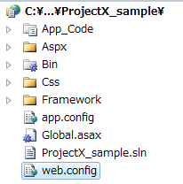
- Check connectionStrings section, and confirm that the connection string is correct.

<connectionStrings>
<!-- for SQL Server / SQL Client -->
<add name="ConnectionString_SQL" connectionString="Data Source=localhost\sqlexpress;Initial Catalog=Northwind;Integrated Security=True;"/>
</connectionStrings>

Check operations

Start ASP.NET State Service
- In the Start menu, enter services.msc in Search programs and files text box.  - Press ENTER. | 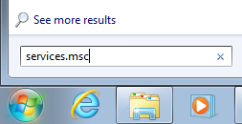
- In the Services window, right-click ASP.NET State Service, and select Start option. | 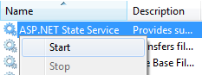
- Confirm that the status of ASP.NET State Service changes into Started. | 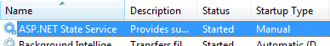

Set up Intranet Security Settings
- In the Start menu, enter inetcpl.cpl in Search programs and files text box.  - Press ENTER. | 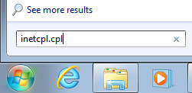
- In the Internet properties window, select Security tab.  - Select Local intranet, and click Sites. | 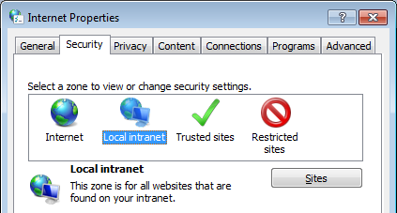
- In the Local intranet window, set as follows, and click OK.  Automatically detect intranet network: uncheck the box  Other than that above: check the box | 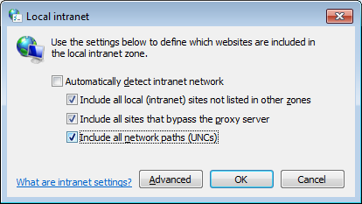
- Click OK. | 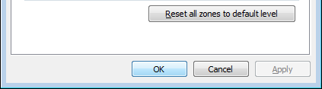

Debug the sample application
- In the Solution Explorer, right-click Aspx - start - menu.aspx, and select Set As Start Page option. | 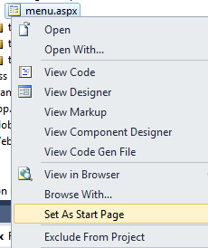
- Press F5 to start debugging. | 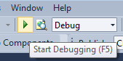
- At the login page, enter the arbitrary alphanumeric characters. (By default, the password authentication is not executed.)  Note: “ユーザID” means User Id in Japanese. And “パスワード” means Password in Japanese.  - Click ログイン (“ログイン” means Login in Japanese) | 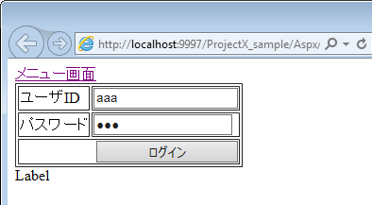
- In the menu screen, click Get order list. | 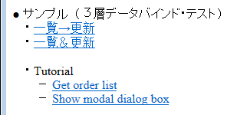
- Confirm that order list is shown.  - Click Select in any row. | 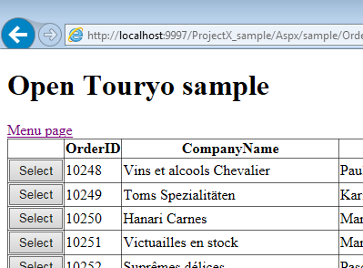
- Confirm that order details are shown.  - Click Edit in the row that you want to edit. | 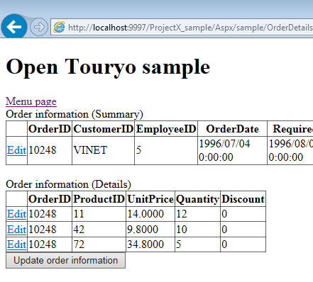
- When clicking Edit, the row becomes editable.  - Feel free to edit values.  - When completing editing, click Update to save the modification. | 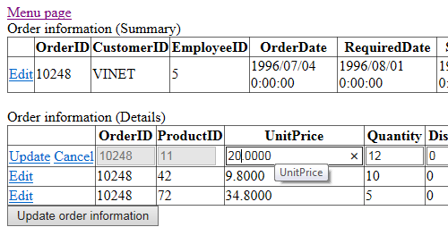
- Click Update order information to reflect changes to database. | 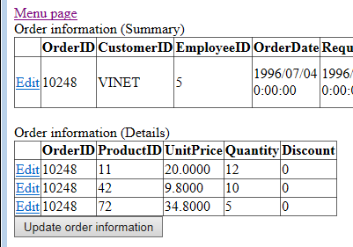
- Execute the following command and confirm that database is updated successfully. In the following command, replace order number (OrderId) that has been selected in step (7) from [Selected Order Number].

"C:\Program Files\Microsoft SQL Server\100\Tools\Binn\SQLCMD.EXE" -S localhost\SQLExpress -E -d Northwind -Q "Select * From Orders Inner Join [Order Details] On Orders.OrderId=[Order Details].OrderId Where Orders.OrderId=[Selected Order Number]"

- Click Menu page to return to menu page. | 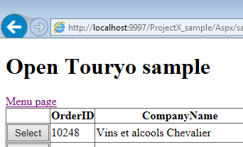
- Click Show modal dialog box. | 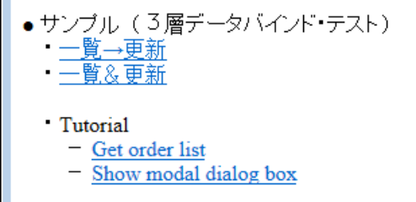
- Confirm that modal dialog is opened and PDF file is shown on the dialog box.  - Close the modal dialog. | 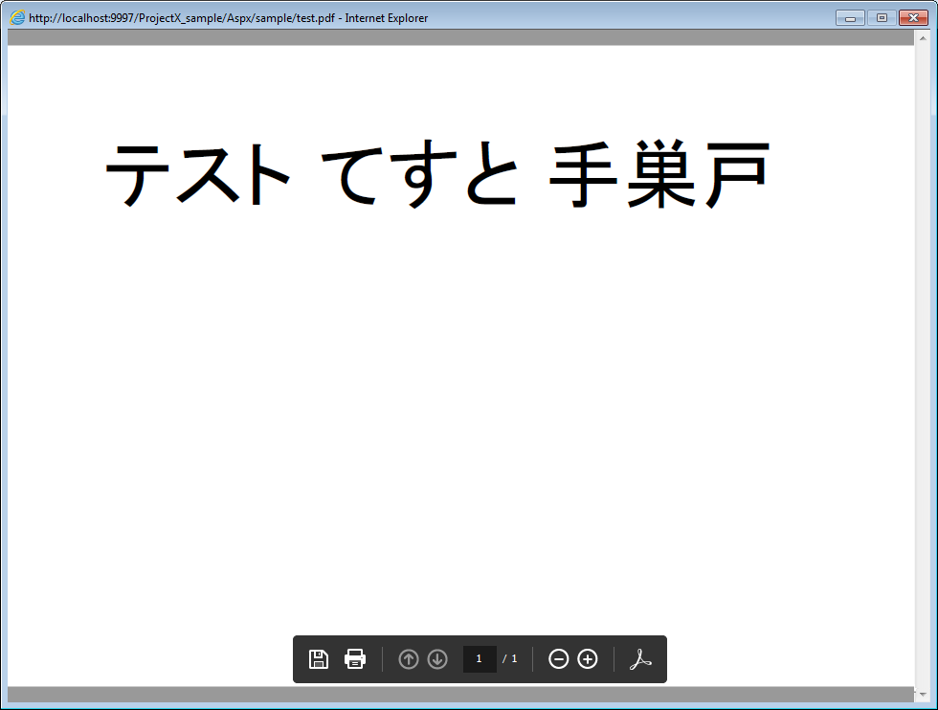
- Enter the following URL in the browser, and press ENTER.  http://localhost:9997/ProjectX_sample/Aspx/sample/OrdersList.aspx | 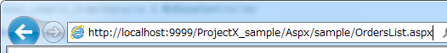
- Confirm that the error message of Open Touryo is shown.  Note: In steps (3) in section 4.3.2, directLink=”deny” setting is implemented in SCDefinitions.xml. Therefore, screen transition function of Open Touryo prohibits to direct link to OrdersList.aspx and this error occurs.  (For details, refer to the Open Touryo user guide (for each function).) | 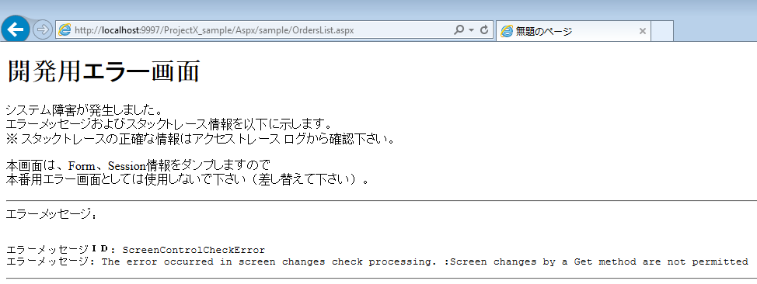

Confirm Trace Log
- Open C:\root\files\resource\Log\ACCESS.yyyy-mm-dd.log. (where, yyyy-mm-dd is executed date.)
- Confirm that the access to OrdersList and OrderDetails is logged. (An example of the trace log is as follows. The underlined part shows the log of Load event of each page.)

[2012/08/07 11:36:32,663],[DEBUG],[5],,－,127.0.0.1,-----↓,Global.asax,Application_OnPreRequest
[2012/08/07 11:36:32,664],[INFO ],[5],,aaa,127.0.0.1,init,OrdersList
[2012/08/07 11:36:32,670],[INFO ],[5],,aaa,127.0.0.1,----->>,OrdersList,,GetOrders,
[2012/08/07 11:36:32,892],[INFO ],[5],,aaa,127.0.0.1,<<-----,OrdersList,,GetOrders,,221,0
[2012/08/07 11:36:32,935],[DEBUG],[5],,－,127.0.0.1,-----↑,Global.asax,Application_OnPostRequest,－,－,271,63
[2012/08/07 11:36:46,756],[DEBUG],[18],,－,127.0.0.1,-----↓,Global.asax,Application_OnPreRequest
[2012/08/07 11:36:46,814],[INFO ],[18],,aaa,127.0.0.1,postback,OrdersList
[2012/08/07 11:36:46,815],[INFO ],[18],,aaa,127.0.0.1,----->,OrdersList,gvwOrdersList
[2012/08/07 11:36:46,816],[INFO ],[18],,aaa,127.0.0.1,<-----,OrdersList,gvwOrdersList,,1,0
[2012/08/07 11:36:46,912],[DEBUG],[17],,－,127.0.0.1,-----↓,Global.asax,Application_OnPreRequest
[2012/08/07 11:36:46,914],[INFO ],[17],,aaa,127.0.0.1,init,OrderDetails
[2012/08/07 11:36:46,914],[INFO ],[17],,aaa,127.0.0.1,----->>,OrderDetails,,GetOrderById,
[2012/08/07 11:36:47,044],[INFO ],[17],,aaa,127.0.0.1,<<-----,OrderDetails,,GetOrderById,,129,0
[2012/08/07 11:36:47,055],[DEBUG],[17],,－,127.0.0.1,-----↑,Global.asax,Application_OnPostRequest,－,－,142,0
[2012/08/07 11:36:50,343],[DEBUG],[5],,－,127.0.0.1,-----↓,Global.asax,Application_OnPreRequest
[2012/08/07 11:36:50,344],[INFO ],[5],,aaa,127.0.0.1,postback,OrderDetails
[2012/08/07 11:36:50,345],[INFO ],[5],,aaa,127.0.0.1,----->,OrderDetails,gvwOrderDetails
[2012/08/07 11:36:50,345],[INFO ],[5],,aaa,127.0.0.1,<-----,OrderDetails,gvwOrderDetails,,0,0
[2012/08/07 11:36:50,350],[DEBUG],[5],,－,127.0.0.1,-----↑,Global.asax,Application_OnPostRequest,－,－,4,0
[2012/08/07 11:36:55,690],[DEBUG],[5],,－,127.0.0.1,-----↓,Global.asax,Application_OnPreRequest
[2012/08/07 11:36:55,692],[INFO ],[5],,aaa,127.0.0.1,postback,OrderDetails
[2012/08/07 11:36:55,693],[INFO ],[5],,aaa,127.0.0.1,----->,OrderDetails,gvwOrderDetails
[2012/08/07 11:36:55,693],[INFO ],[5],,aaa,127.0.0.1,<-----,OrderDetails,gvwOrderDetails,,0,0
[2012/08/07 11:36:55,693],[INFO ],[5],,aaa,127.0.0.1,----->,OrderDetails,gvwOrderDetails
[2012/08/07 11:36:55,694],[INFO ],[5],,aaa,127.0.0.1,<-----,OrderDetails,gvwOrderDetails,,1,0
[2012/08/07 11:36:55,695],[DEBUG],[5],,－,127.0.0.1,-----↑,Global.asax,Application_OnPostRequest,－,－,4,0
[2012/08/07 11:36:57,281],[DEBUG],[9],,－,127.0.0.1,-----↓,Global.asax,Application_OnPreRequest
[2012/08/07 11:36:57,283],[INFO ],[9],,aaa,127.0.0.1,postback,OrderDetails
[2012/08/07 11:36:57,283],[INFO ],[9],,aaa,127.0.0.1,----->,OrderDetails,btnUpdateOrder
[2012/08/07 11:36:57,286],[INFO ],[9],,aaa,127.0.0.1,----->>,,,UpdateOrder,
[2012/08/07 11:36:57,362],[INFO ],[9],,aaa,127.0.0.1,<<-----,,,UpdateOrder,,76,16
[2012/08/07 11:36:57,372],[INFO ],[9],,aaa,127.0.0.1,<-----,OrderDetails,btnUpdateOrder,,88,16
[2012/08/07 11:36:57,373],[DEBUG],[9],,－,127.0.0.1,-----↑,Global.asax,Application_OnPostRequest,－,－,91,16

- Open C:\root\files\resource\Log\SQLTRACE.yyyy-mm-dd.log. (where, yyyy-mm-dd is executed date.)
- Confirm the executed SQL text for Orders and OrderDetails table with the following SQL trace log.

[2012/08/07 11:36:32,892],[INFO ],[5],19,0,[commandText]:SELECT Orders.OrderID, Customers.CompanyName, Customers.ContactName, Employees.LastName As EmployeeLastName, Employees.FirstName As EmployeeFirstName, Orders.OrderDate FROM Orders INNER JOIN Customers ON Orders.CustomerID = Customers.CustomerID INNER JOIN Employees ON Orders.EmployeeID = Employees.EmployeeID [commandParameter]:
[2012/08/07 11:36:46,983],[INFO ],[17],3,0,[commandText]: -- DaoOrders_D2_Select -- 2012/8/6 日立 太郎 SELECT [OrderID], [CustomerID], [EmployeeID], [OrderDate], [RequiredDate], [ShippedDate], [ShipVia], [Freight], [ShipName], [ShipAddress], [ShipCity], [ShipRegion], [ShipPostalCode], [ShipCountry] FROM [Orders] WHERE [OrderID] = @OrderID [commandParameter]:OrderID=10248,
[2012/08/07 11:36:47,043],[INFO ],[17],1,0,[commandText]: -- DaoOrder_Details_D2_Select -- 2012/8/6 日立 太郎 SELECT [OrderID], [ProductID], [UnitPrice], [Quantity], [Discount] FROM [Order Details] WHERE [OrderID] = @OrderID [commandParameter]:OrderID=10248,

Dao/SQL file can be generated by setting primary key (not the actual primary key, but a uniquely identifiable view record like the primary key) for each view using the [Primary key - Set] button for the selected tables. However, view is not used in this tutorial. Hence, it is handled by removing Dao/SQL file generation from the scope.
On specifying the name of the time stamp column, the Dao/SQL file that implements optimism exclusion control using that time stamp column name is generated in this Dao/SQL file generation dialog box. Refer to Open Toryo framework user guide (D layer auto generation version) for details.
In this tutorial, SQL files are deployed as external files of the program. In OpenTouryo framework, SQL files are embedded in the programs (assembly) as resource files, and the SQL files can be read from the embedded resource. Refer to the Touryo user guide (developer version) for the method of reading the SQL files from the embedded resource.
The ASP.NET status service can also be started by running the following batch file, included in Open Touryo, with administrator rights. C:\root\files\bat\iis_aspnet\aspnet_state-stat.bat

