Open Touryo Tutorial
(Template Development version)

27/11/2014

Introduction

Objective of this document
Open Touryo supports various architectures such as the application forms C/S and Web etc., and DBMS such as SQL Server and Oracle. Unnecessary functions are deleted from this main part of Open Touryo according to the architecture of the project, and the function that is uniquely added to the project will be called as [Template].
The objective of this tutorial is to master the procedure of template development of Open Touryo.

Scope of this document
The architect who understands the Open Touryo's architecture.
(Person who has read the Open Touryo user guide can understand the content)

Overview of this document
Open Touryo provides the evaluation version for the SQL Server by default. This tutorial describes the development procedure of the template tailored to the project with the evaluation version as the subject.

Use of copyrights and trademarks of other companies
The company names and product names used in this document are the trademarks or registered trademarks of the respective companies.

License
This document is licensed under the Creative Commons Attribution 2.1 Japan License.
http://creativecommons.org/licenses/by/2.1/jp/legalcode

Table of contents

1. Overview of Open Touryo 1
2. Environment Setting 2
2.1 Visual Studio Express 2012 for Web Setup 2
2.2 Open Touryo template-based setup 4
2.3 DB Setup 4
3. Exercises in this tutorial 8
4. Exercises 9
4.1 Change in the data provider (Frame work main body) 9
4.1.1 Download and Installation of Oracle Data Access Components(ODAC) 9
4.1.2 Replacement of Open Touryo data access parts (Frame work main body) 13
4.1.3 Replacement of Open Touryo's data access parts (Framework for rich client) 18
4.1.4 Replacement of Open Touryo data access parts (Dynamic parameterized query analytical tool) 19
4.1.5 Replacement of Open Touryo data access parts (D layer auto-generation tool) 21
4.2 Addition of logic to be executed commonly with project 21
4.2.1 Addition of common process of P layer (screen) frame work 21
4.2.2 Addition of common process of frame work of F layer (Business logic) 22
4.2.3 Addition of common process of D layer (DB access) frame work 22
4.3 Change in configuration of Open Touryo template 23
4.3.1 Deletion of unnecessary functions 23
4.3.2 Change in the folder configuration 24
4.4 Change in the data provider (sample program) 26
4.5 Settings of application configuration file 32
4.6 Behavior confirmation of a sample program 33

Overview of Open Touryo
Open Touryo is an application framework for .NET. Open Touryo can be used in a various applications like C/S (Windows Forms, WPF), Web (ASP.NET), RIA (Silverlight) etc. in addition to .NET Framework 3.5.
Fig. 1-1 shows the class configuration of Open Touryo. As shown in Fig 1-1, Open Touryo's architecture inherits the respective Open Touryo provision class based on 3 layer configuration of P/F/D. The developer can concentrate on the development of an individual business process by entrusting the common process in application to Open Touryo. Hence, it is possible to minify the coding amount and variance in coding quality caused due to developer's skill can be controlled.
D Layer
B Layer
P Layer
Data access class
Data access control class
Screen design
Screen code parent class1

Screen code class

Business code class

Business code parent class1

Data access control class
※Prepare separately property-wise

Data access control parent class

Data access parent class1

Data access class

Screen code parent class2
Business code parent class2
System.Web.UI.Page
Master page
WebCustomControl
System.Web.UI.Control
＊
1
＊
1
＊
1
1
1
1…ｎ
1…ｎ
1
1…ｎ
1
1
1
1
1
1…ｎ
1
Design department Aspx
Code behind
1
Data access parent class2
1
Master base page

1

Legend
Class provided by Toryo.
Class created by developer.
.NET Framework standard Class.

Return value

Parameter
parameter parent class2
Return value parents class2

Parameter class

parameter parent class1
Return value parents class1
Return value class

Fig. 1-1 Configuration diagram of Open Touryo class

Open Touryo can be obtained in source form rather than binary format. Due to which, unnecessary functions tailored for the project's architecture are deleted for each Open Touryo application project, and the functions unique to the project can be added. The Open Touryo class ([Class provided by Open Touryo] part in Fig. 1-1), customized as per project's architecture will be called as [Template].
Development member of a project can advance the development by adding business function ([Class
created by developer] part in Fig. 1-1) for the class that inherited this template.
Open Touryo provides the evaluation version for the application to be used in SQL Server by default. The method to develop the template used for relevant applications from existing Open Touryo template base (/root_VS2010/) by assuming 2 layer application that uses Oracle in DB, is described in this
tutorial.

Environment Setting
Table 2-1 shows the prerequisite environment for this tutorial.

Table 2-1 Prerequisite environment for this tutorial
# | Category |  | Prerequisite environment
1 | Development environment | IDE | Visual Studio Express 2012 for Web
2 | Development environment | Application framework | Open Touryo templatebase  (/root_VS2010/)
3 | Operating environment | Run time | .NET Framework 4
4 | Operating environment | DB | Oracle Database Express Edition 11g Release 2
5 | Other | OS | Windows 7 (32 bit)
6 | Other | Development language | C#

The installation/setup sequence for the development environment/operating environment shown in Table 2-1 is shown as follows.

Visual Studio Express 2012 for Web Setup
- Access the download page (http://www.microsoft.com/visualstudio/jpn/downloads#d-express-web), of Visual Studio Express 2012 for Web and click the [Install now] link. | 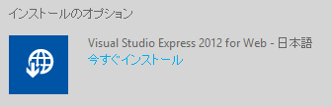
- Visual Studio Express 2012 for Web can be obtained through Microsoft Web Platform Installer(Henceforth abbreviated as Web PI). Hence, Web PI has to be installed beforehand.  Press the [GET THE Web Platform Installer] button in the installation page of Web PI. | 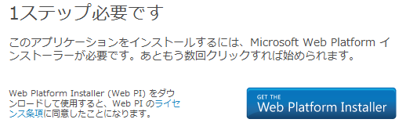
- Run the downloaded VWD11AzurePack.exe and install Web PI.
Here, a detailed installation procedure is omitted because it is OK to have default installation.
- Once installation is complete, Web PI starts automatically. Confirm the display of Visual Studio Express 2012 for Web, and press the [Install] button. | 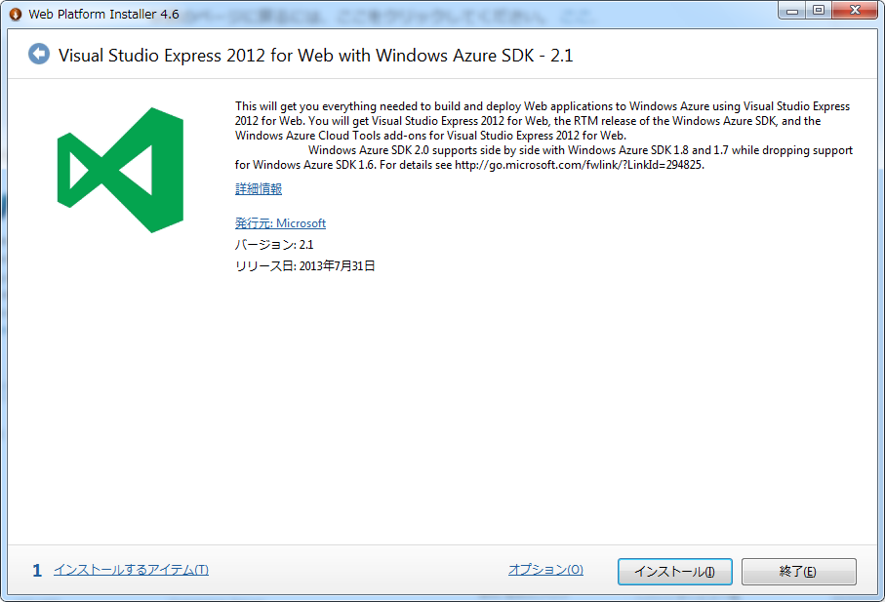
- When the installation dialog of Web PI is displayed, confirm the display of [Visual Studio Express 2012 for Web with Windows Azure SDK – 2.1 [Japanese]], press the [Accept] button. | 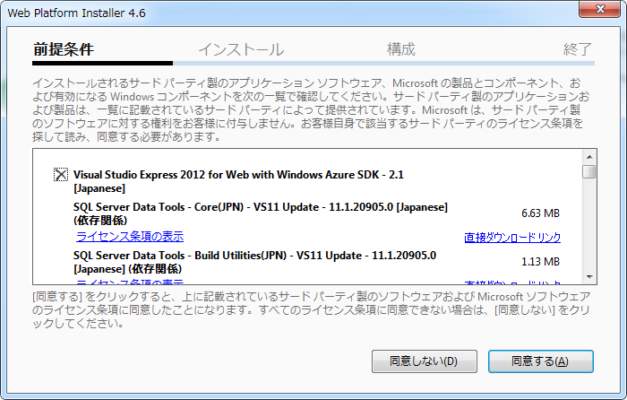
- Installation gets started. Please wait for it to complete. | 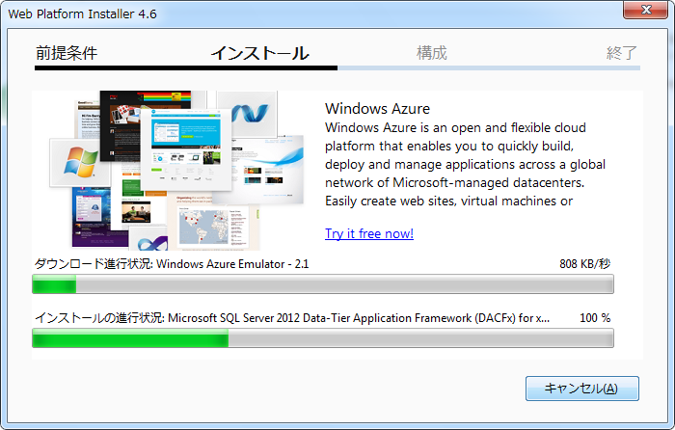
- Confirm the display of the installation success message, and press the [Complete] button.  (Windows Update is recommended here as security patches etc. are provided for some products.) | 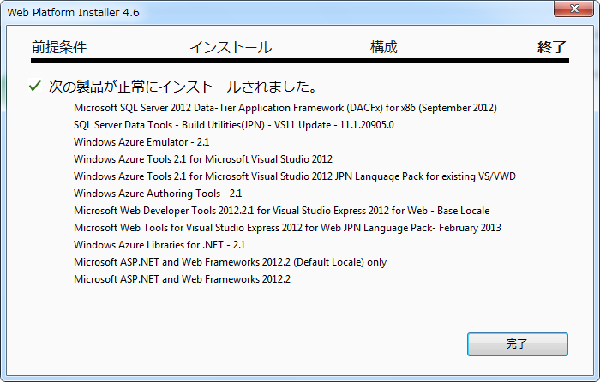
- Press the [End] button, and close the Web PI. | 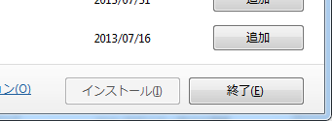

Open Touryo template-based setup
- By pressing the [Download ZIP] button on the following site to obtain the OpenTouryoTemplates.zip, to get the Open Touryo template-based(/root_VS2010/) Unzip this.
/OpenTouryoProject/OpenTouryoTemplates.
https://github.com/OpenTouryoProject/OpenTouryoTemplates
- Deploy directly Open Touryo templatebase (/root_VS2010/) under C drive.  It is set up according to the procedures of Readme.md right under/root_VS2010/ | 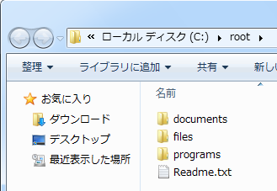

DB Setup
Since Oracle should be used as DBMS, this tutorial explains about the installation of Oracle Database for confirming the operation of template and creates the sample table.

- Download Oracle Database Express Edition from Oracle site (http://www.oracle.com/technetwork/jp/products/express-edition/downloads/index.html)  [Note] For downloading, it is necessary to register with Oracle (free registration). | 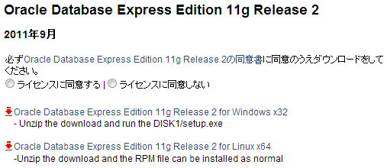
- Unzip the downloaded zip file and run setup.exe to install the Oracle Database. (Installation procedure is omitted because it is OK to have default installation.) | 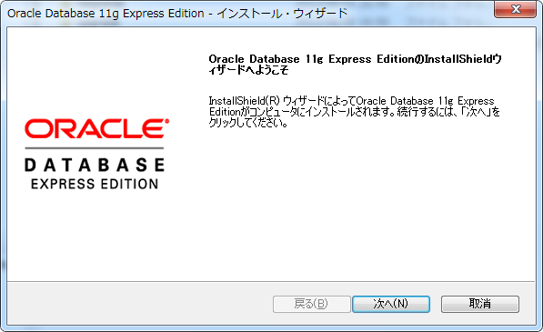
- Double-click the [Start guide of Oracle Database 11g Express Edition] available on desktop. | 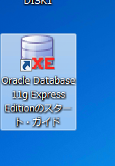
- In the homepage of Oracle Database Express Edition, press the [Application Express] button. | 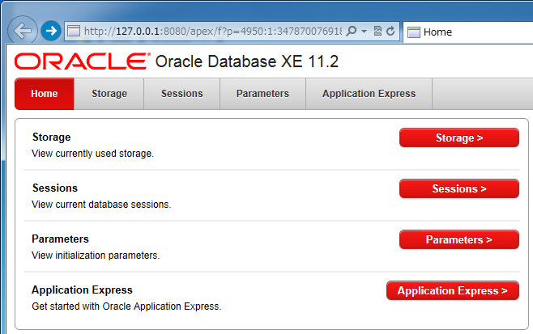
- Login with user with DBA role. | 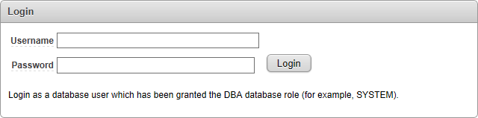
- Since the Application Express Workspace create screen will be displayed, set the value as shown below and press the [Create Workspace]button.  Database User :  Create New  Database Username :  Login user name for the database  Application Express Username :  Login user name for Application Express  workspace  Password / Confirm Password :  Login password to Application Express  workspace | 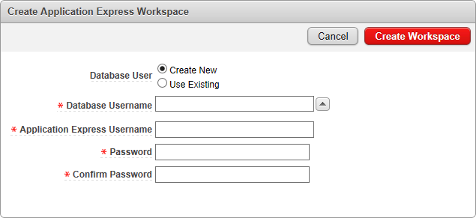
- Confirm whether work space has been created normally and press the [Click here] link. | 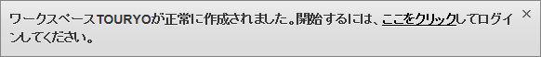
- Enter the user name and password that were configured in (6) and press the [Login] button. | 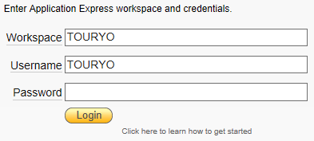
- Confirm the possibility of log-in to Work space and press the [SQL Workshop] button. | 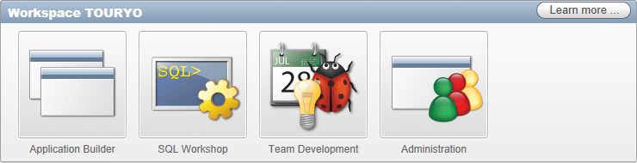
- Press the [SQL Commands] button from SQL Workshop screen. | 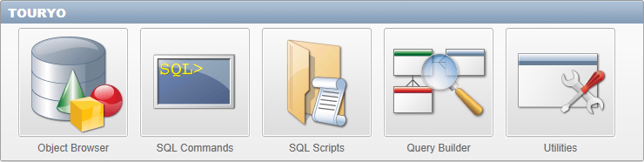
- Open [C:\root\files\resource\Sql\oracle\Test table.txt].
- Copy the statements from 6th line to 12th line of Test table.txt, paste in the text box of SQL Commands screen and press the [Run] button. | 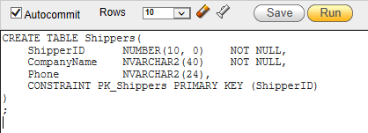
- [Table created.] will be displayed in the Results at the bottom of the screen and confirm that the table has been generated normally. | 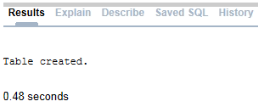
- Similarly, run the remaining Test table.txt - Create Table, Create Sequence, Insert
[Note] Multiple statements cannot be executed at a time in SQL Commands screen. Hence, the commands given in Test table.txt should be executed for each statement.
- To confirm that the table and data are created normally, press the [Object Browser] icon present on the upper right of the screen. | 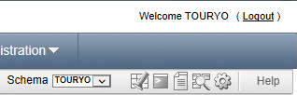
- Confirm the existence of Shippers table, Orders table, Orders2 table in the Table list present at the left side of the Object Browser screen and select Shippers table. | 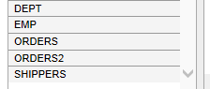
- Confirm that three data are available in Shippers table. | 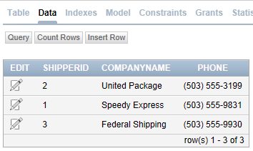

Exercises in this tutorial
As shown in Fig 3-1, carry out the exercises for creating the template targeted for Web 2 layer (ASP.NET) application that uses Oracle in DB from the existing Open Touryo templatebase (/root_VS2010/). Development procedure of Open Touryo template is shown in Table 3-1.
Open Touryo(Main framework)
Components
Framework
Application framework
Screen transition control
Log
DBAccess
（SQL Server）
・・・
Sample program (for Open Touryo operation check)

ASP.NET
Existing Open Touryo evaluation version
WindowsForms
WPF
Silverlight
・・・
Open Touryo(Main framework)
Components
Framework
Application framework
Screen transition control
Log

DBAccess
（Oracle）
・・・
Sample program (for Open Touryo operation check)

ASP.NET
Template developed in this tutorial
#1
#2
#3
#3
#4
#5

Fig 3-1 Existing evaluation version and this tutorial's Open Touryo template
(Numerals in figure corresponds to item numbers in Table 3-1)

Table 3-2 Development procedure of Open Touryo template
# | Category | Operation | Description | Remarks
1 | Frame work  main body | Change in data provider | Change the data provider of the existing Open Touryo template to the data provider of the DBMS to be used. | Explained in the section 4.1
2 | Frame work  main body | Addition of logic that has to be executed commonly in the project. | Describe the logic to be executed commonly in the project in Open Touryo's [Parent class 2]. | Explained in the section 4.2
3 | Common | Configuration change of Open Touryo template | Delete the unnecessary functions, change the folder configuration etc., depending on the development standards and architecture of the Open Touryo application project. | Explained in the section 4.3
4 | Sample program | Change in data provider | Change the data provider of the sample program to the data provider of DBMS to be used. | Explained in the section 4.4
5 | Sample program | Setting of application configuration file | Set each parameter of the application configuration file as per the process method of the Open Touryo application project. | Explained in the section 4.5
6 | Common | Confirming the operation of sample program | Run the sample programs and confirm that execution can be done normally. | Explained in the section 4.6

Exercises
Step-by-step instructions about development procedure of Open Touryo template.

Change in the data provider (Frame work main body)
Change the data provider of the existing Open Touryo template to the data provider of the DBMS to be used. By assuming Oracle to be the DBMS, procedure for establishing an access from .NET application through ODP.NETis shown here.

Download and Installation of Oracle Data Access Components(ODAC)
When accessing Oracle Database from .NET application, installation of ODP.NET will be necessary for using ODP.NET as data provider.

[Note] However, ODP.NET is included even in the Oracle Database that has been installed in section 2.3. Hence, machine to run the application and DB server are same. Further, this operation will not be necessary if ODP.NET that is included in Oracle Database is used.
When a machine to run application and DB server are different or when a version of ODP.NET varying from ODP.NET included in Oracle Database has to be used etc., when ODP.NET included in Oracle Database is not used, then this work is necessary.

- Download [Oracle Data Access Components .NET and Windows client data access and tools] from Oracle site (http://www.oracle.com/technetwork/jp/database/windows/downloads/index.html)  [Note] If the operating environment is of 64 bit, then select [ODAC (64-bit)]. | 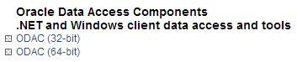
- Press the [Here(US site)] link from ODAC download page | 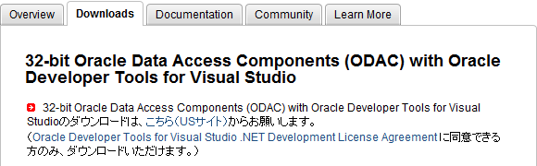
- Insert check mark in [Accept License Agreement] and download the latest ODAC.  [Note] Sign-in from Oracle Web account registered in the section 2.3 is necessary for the download. | 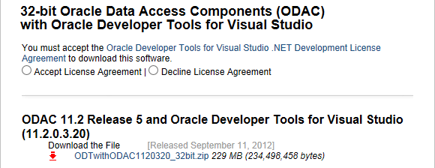
- Extract the downloaded zip file, run setup.exe, and start Oracle Universal Installer. Press the [Next] button. | 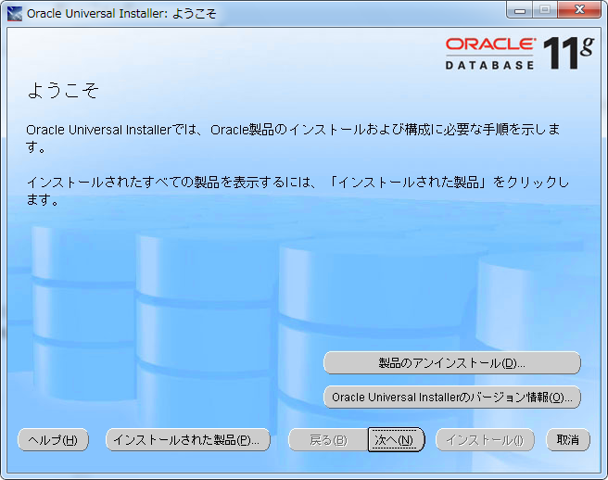
- Confirm that [Oracle Data Access Components for Oracle Client] is being selected as a product to be installed and press the [Next] button. | 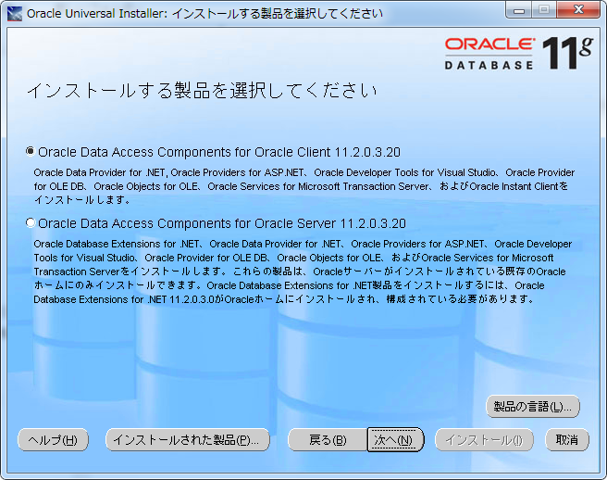
- Specify the location for installation and press the [Next] button. | 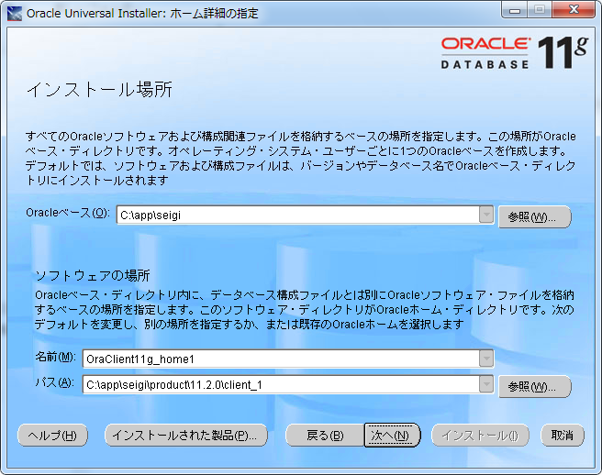
- Since the components possible for use will be displayed, remove the check mark from [Oracle Developer Tools for Visual Studio 11.2.0.3.20] and press the [Next] button.  [Note] Oracle Developer Tools for Visual Studio (ODT.NET) is the development tool for Oracle that can carry out add-on in Visual Studio (product version). For using Visual Studio Express instead of Visual Studio (product version), ODT.NET is not installed in this tutorial. | 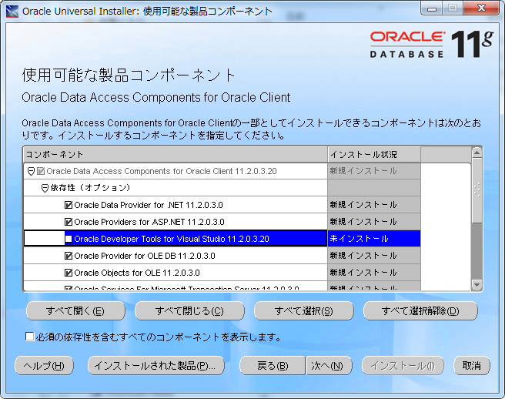
- Message related to Oracle Providers for ASP.NET will be displayed. Press the [Next] button. | 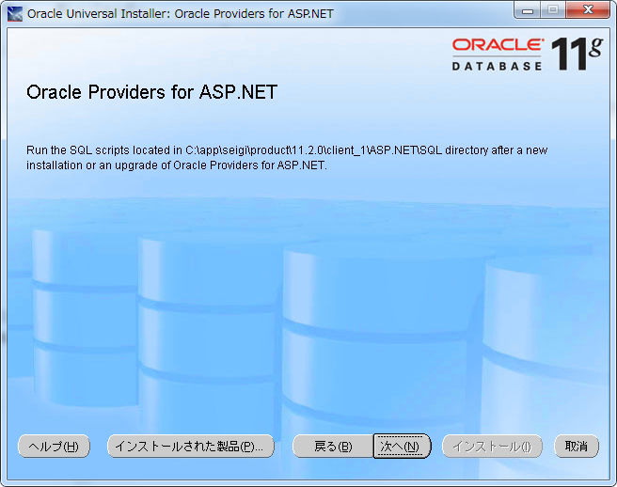
- On the summary screen, confirm the installed components and press the [Install] button. | 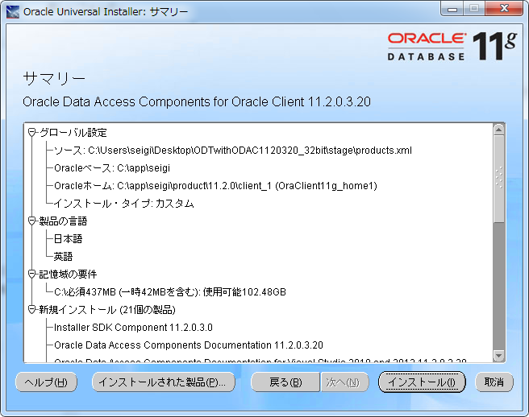
- Installation gets started. Please wait for it to complete. | 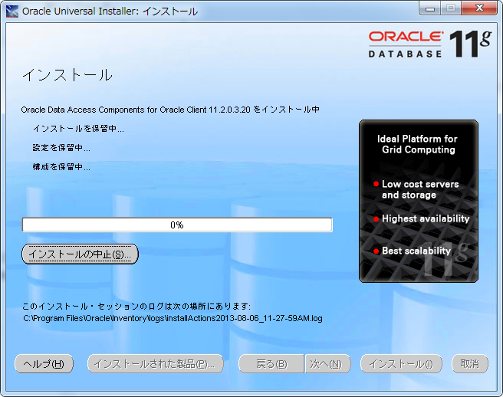
- Confirm the display of the installation success message, and press the [Complete] button. | 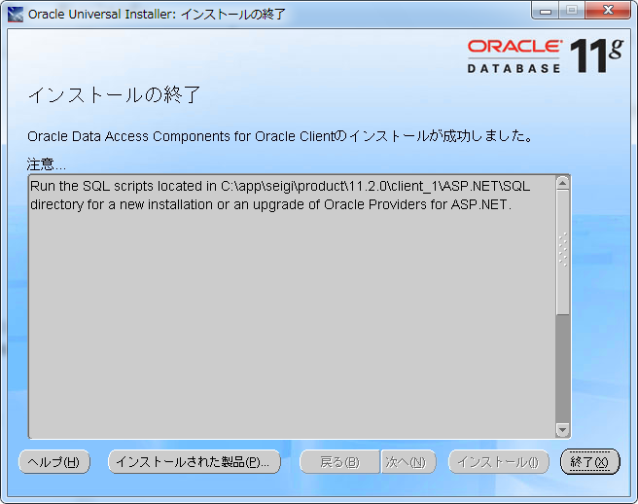
- Press the [Yes] button in complete dialog box. | 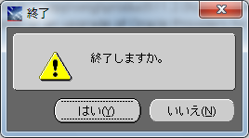

Replacement of Open Touryo data access parts (Frame work main body)
Open Touryo supports data access parts for DBMS such as SQL Server or Oracle. Since the data access parts are used for SQL server in the existing Open Touryo template, this is replaced with data access parts for Oracle.

- Open [C:\root\programs\C#\Frameworks\Infrastructure\AllComponent.sln].
- Confirm that [Microsoft Visual Studio Express 2012 for Web] is being selected with selection dialog of the application and press the [OK] button. | 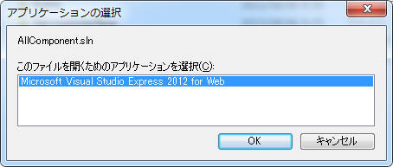
- For starting Visual Studio Express 2012 for Web initially, make online registration to Microsoft from the [Register online] link and get the product key.  Paste the product key in the text box and press the [OK] button.  [Note] For online registration to Microsoft, Microsoft account (Free of charge) is required. | 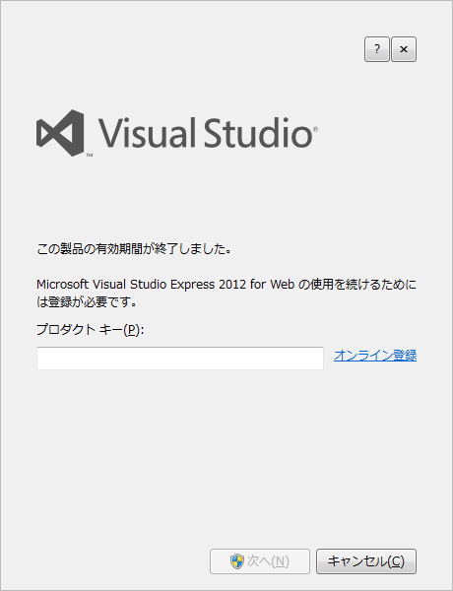
- Confirm that the inserted product key is normally working and press the [Close] button. | 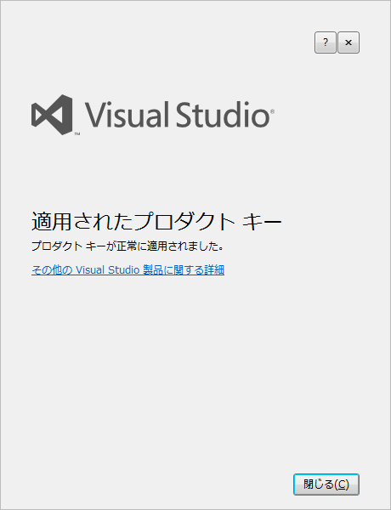
- Since Visual Studio Express 2012 for Web is started, right-click on the AllComponent solutions from the Solution Explorer and select [Add(D)] - [Existing project(E)]. | 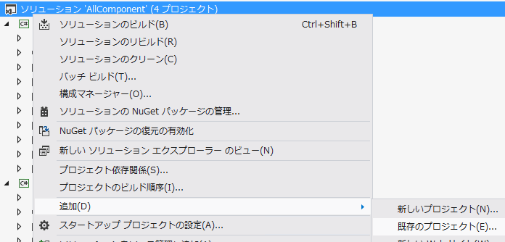
- In the Add dialogue of existing project, select [C:\root\programs\C#\Frameworks\Infrastructure\Public\Db\DamOraOdp\DamOraOdp.csproj] and add data access parts for Oracle in the Solution.
- Since the existing DamOraOdp.csproj is being created in Visual Studio 2010, it is necessary to upgrade to the Visual Studio 2012. Confirm that there is check mark in DamOraOdp.csproj and press the [OK] button. | 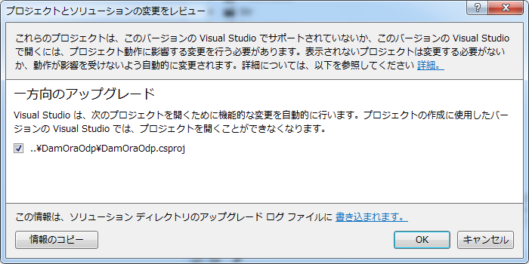
- From the Solution Explorer, delete the [Reference setup]-[Oracle.DataAccess] of DamOraOdp project. | 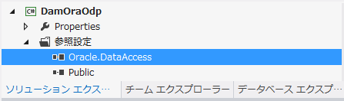
- Right-click the DamOraOdp project from Solution Explorer and select the [Add Reference(R)]. | 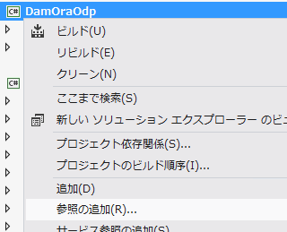
- Select [Browse] from browse manager dialogue and press the [Browse(B)] button.. | 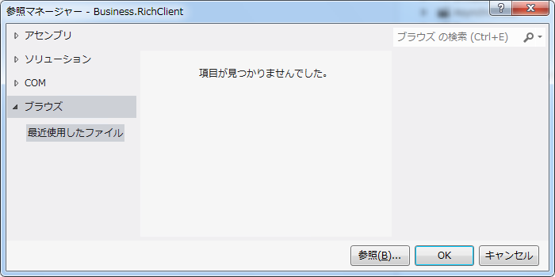
- In the selection dialogue of the file to be browsed, select Oracle.DataAccess.dll present in the ODAC installation folder and press the [Add] button.
- Confirm that check mark is inserted in Oracle.DataAccess.dll and press the [OK] button. | 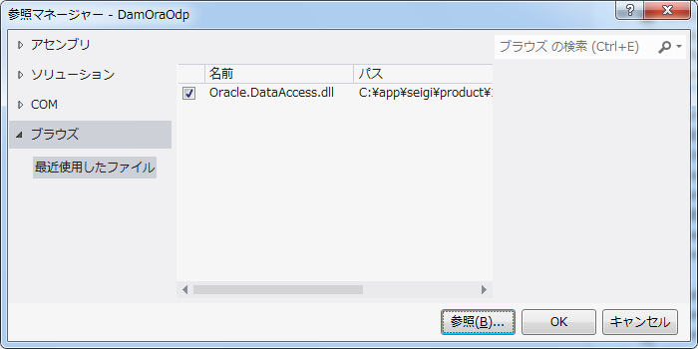
- From Solution Explorer, right-click on the Business project and select the [Add browse(R)]. | 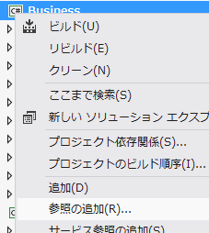
- In the Browse manager dialogue, select [Solution] and insert check in [DamOraOdp] that has been added recently from the list. Press the [OK] button. | 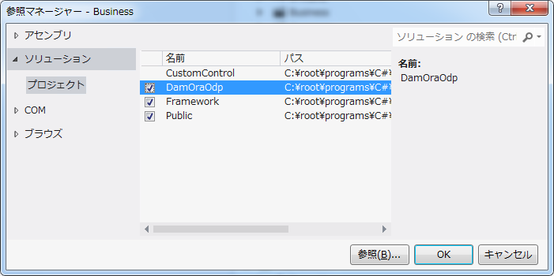
- From Solution Explorer, open Business project's [Business]-[MyFcBaseLogic.cs]. | 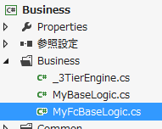
- From 178th line to 245th line of MyFcBaseLogic.cs, logic that selects the data provider according to the input value from the screen is written.
Since it is ok to establish connection with only Oracle here, 178th line to 245th line of MyFcBaseLogic.cs is re-written as shown below. (if sentence of the condition branching is lost leave only the part that uses data access parts of Oracle)

#region data provider selection

// Oracle / Generate Dam for ODP.NET
dam = new DamOraOdp();

// Load connection character string (Instant Client)
connstring = GetConfigParameter.GetConnectionString("ConnectionString_ODP2");

#endregion

- Delete Business project's [Business]-[MyBaseLogic.cs].
[Note] MyBaseLogic class is defined as the class that has been left-out for backward compatibility with older version of Open Touryo. Hence, for using only the MyFcBaseLogic class compatible with the new function in the new application development, MyBaseLogic class can be deleted without any problem.
- Press the [Save all] icon in the tool bar and save the changed content. | 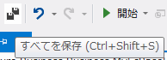
- Open [C:\root\programs\C#\z_Common.bat] with notepad etc.,
- z_Common.bat file will have the information about either path or configuration (Debug build and Release build) whenever build is carried out in command line. In the previous build command, build that uses devenv.com (Build file of Visual Studio product ver.) is executed. However, devenv.com file does not exist due to usage of Visual Studio Express in this tutorial. Therefore, it is re-written to the build that uses MSBuild.exe (Build engine associated with .NET Framework) as shown below.

@rem --------------------------------------------------
@rem Run common process
@rem --------------------------------------------------

@rem --------------------------------------------------
@rem Specify build file
@rem --------------------------------------------------
set BUILDFILEPATH="C:\Windows\Microsoft.NET\Framework\v4.0.30319\MSBuild.exe"
Sets the path to MSBuild.exe
@echo --------------------------------------------------
@echo Select build configuration (Debug / Release)
@echo --------------------------------------------------
set BUILD_CONFIG=Debug

@echo --------------------------------------------------
@echo Build/command creation
Re-writes to run parameter of MSBuild.exe
@echo --------------------------------------------------
set COMMANDLINE=/p:Configuration=%BUILD_CONFIG%

- Run [C:\root\programs\C#\1_DeleteDir.bat] and delete the assembly file storage folder of Open Touryo's frame work main body.
- Run [C:\root\programs\C#\2_DeleteFile.bat] and delete the temporary files such as *.tmp file.
- Run [C:\root\programs\C#\3_Build_Framework.bat] and build the frame work main body of Open Touryo.
[Note] 3_Build_Framework.bat is the batch file to build the frame work for rich client and frame work for the main body of Open Touryo. However, the frame work for rich client is incorrect at this stage and due to which there is an outbreak of errors when building the frame work for rich client. Therefore, ignore that here and confirm that only the frame work of the Open Touryo's main body is possible.

Replacement of Open Touryo's data access parts (Framework for rich client)
Even the frame work for Open Touryo's rich client is similarly replaced with data access parts for Oracle. Currently, the ASP.NET application development project is targeted and among the group of tools provided by Open Touryo, frame work for this rich client might be used. Hence, (even here) it is necessary to replace with data access parts for Oracle.

- Open [C:\root\programs\C#\Frameworks\Infrastructure\RichClient.sln].
- Confirm that [Microsoft Visual Studio Express 2012 for Web] has been selected in application selection dialogue and press the [OK] button. | 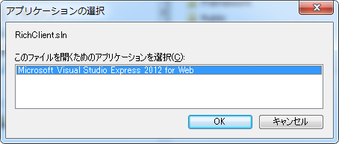
- In the Solution Explorer, right-click on the Business.RichClient project and select the [Add Reference(R)]. | 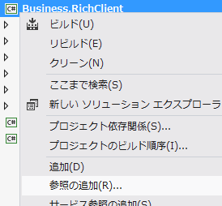
- In the Browse manager dialog, select the [Browse] and press the [Browse(B)] button.
- In the Selection dialogue of the browsing file, select [C:\root\programs\C#\Frameworks\Infrastructure\Build\DamOraOdp.dll] and press the [Add] button. | 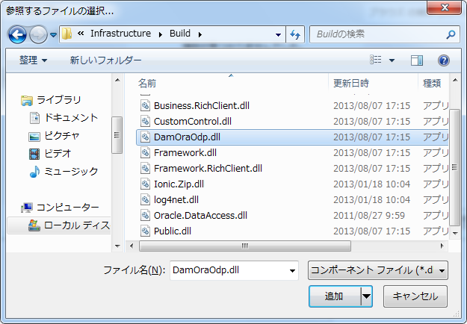
- In the Browse manager dialog, confirm that check has been inserted in DamOraOdp.dll and press the [OK] button. | 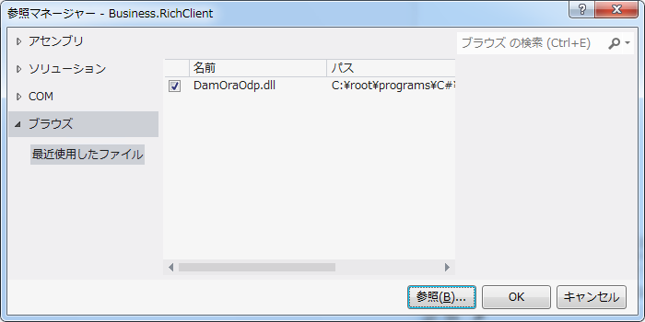
- With reference of (16) in section 4.1.2, it is rewritten such that the access parts of Oracle can be used from 178th line to 245 line of [Business]-[MyFcBaseLogic2CS.cs] of Business.RichClient project.
- Delete [Business]-[MyBaseLogic2CS.cs] in Business.RichClient project.
[Note] Similar to the frame work main body, MyBaseLogic2CS class can be deleted without any problem since it is the class that has been left-out for backward compatibility with older version of Open Touryo.
- Press the [Save all] icon in the tool bar and save the changed content.
- Run the [C:\root\programs\C#\3_Build_Framework.bat] again and build the frame work main body (rich client) of the Open Touryo.
[Note] This time, confirm that build proceeds along with frame work for main body and frame work for rich client.

Replacement of Open Touryo data access parts (Dynamic parameterized query analytical tool)
- Open [C:\root\programs\C#\Frameworks\Tools\DPQuery_Tool\DPQuery_Tool.sln].
- In the Application selection dialogue, confirm that [Microsoft Visual Studio Express 2012 for Web] has been selected and press the [OK] button. | 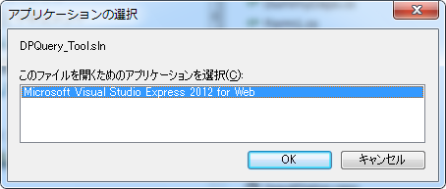
- In the Solution Explorer, right-click on the DPQuery_Tool project and select [Add Reference(R)]. | 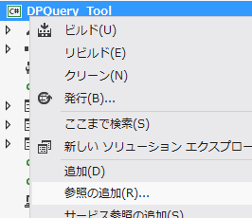
- In the Browse manager dialogue, if [Browse] is selected then there will be a display of [Recently used file] for section 4.1.2 and Oracle.DataAccess.dll, DamOraOdp.dl referring to section 4.1.3. Hence, insert check for both and press the [OK] button. | 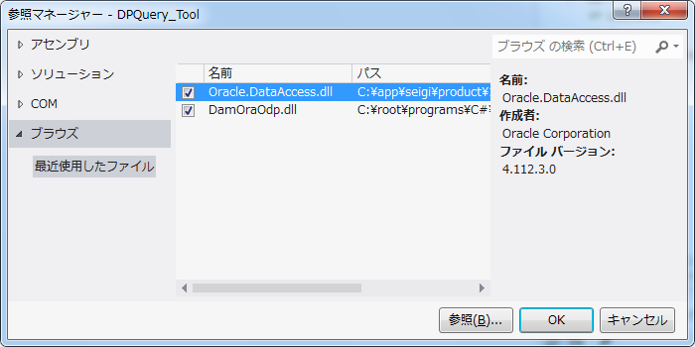
- From Solution Explorer, open [DummyDaps.cs], either delete or comment out the rows from 21 to 27 (DamOraOdp class part) and 53 to 105 (Oracle.DataAccess.Client name empty space part).
[Note] Open Touryo supports multiple DBMS such as SQL Server, Oracle etc., and refers to the data provider corresponding to each DBMS from main body of the network. However, it is recommended to refer to the data provider who is in use during actual development and other data providers need not be referred.
This DummyDaps.cs is the representative object (Stub) for the data provider for whom the reference is not required. This time, use the actual ODP.NET and DamOraOdp project and since the representative object is not required, delete the corresponding stub code.
- Press the [Save all] icon in the Tool bar and save the changed content.

Replacement of Open Touryo data access parts (D layer auto-generation tool)
- Open [C:\root\programs\C#\Frameworks\Tools\DaoGen_Tool\DaoGen_Tool.sln].
- By referring the procedure from (3)～(4) of section 4.1.4, add reference to Oracle.DataAccess, DamOraOdp.dll even from DaoGen_Tool project.
- Press the [Save all] icon in the Tool bar and save the changed content.
- Run [C:\root\programs\C#\4_Build_Framework_Tool.bat] and build the tool associated with Open Touryo.

Addition of logic to be executed commonly with project
Open Touryo will be a layered configuration as shown in Fig 1-1, and logic can be executed commonly with project by adding logic to class called as [Parent class 2]. (For details, refer to Open Touryo user guide (Process flow described in common version and manager version) and the sheets [Customize], [Reference material_Frame work requirements] of [C:\root\documents\2_User_Guide\Atypical_work_list.xlsx].)

Addition of common process of P layer (screen) frame work
- Open [C:\root\programs\C#\Frameworks\Infrastructure\AllComponent.sln].
- In the Application selection dialogue, confirm that [Microsoft Visual Studio Express 2012 for Web] has been selected and press the [OK] button.
- Open [Presentation]-[MyBaseController.cs] in Business project.
- Add common process in the method of MyBaseController class. By referring to the process flow described in the Open Touryo user guide (Common ver.), add the common process to the below methods respectively as per the timing for process execution.
Timing in which process to be executed | Method for adding the process
At the time of screen initial loading | MyBaseController.UOC_CMNFormInit
During post back | MyBaseController.UOC_CMNFormInit_PostBack
Before executing the event handler | MyBaseController.UOC_PreAction
After executing the event handler | MyBaseController.UOC_AfterAction
When exception is generated | MyBaseController.UOC_ABEND
End of all events | MyBaseController.UOC_Finally

Considering this as example, add the process in such a way that log is output during screen initial loading.

protected override void UOC_CMNFormInit()
{
// Implement the process that is executed during frame initialization(Initial load)
// TODO:
LogIF.InfoLog("ACCESS", "P層共通処理サンプル");

// Form initialization common process
this.CMN_FormInit("init");
}

Addition of common process of frame work of F layer (Business logic)
- Open [Business]-[MyFcBaseLogic.cs] in the Business project.
- Add the common process in the method of MyBaseLogic class. By referring to the process flow described in the Open Touryo user guide (Common ver.), add the common process to the below methods respectively as per the timing for process execution.

Timing in which process to be executed | Method for adding the process
Before running the business logic | MyBaseLogic.UOC_PreAction
After running the business logic | MyBaseLogic.UOC_AfterAction
After the transaction ends | MyBaseLogic.UOC_AfterTransaction
When exception is generated | MyBaseLogic.UOC_ABEND

As an example, add the process in such a way that log is output before executing the business logic.

protected override void UOC_PreAction(BaseParameterValue parameterValue)
{
LogIF.InfoLog("ACCESS", "F層共通処理サンプル");

// ACCESS log output-----------------------------------------------
(Omission)
}

Addition of common process of D layer (DB access) frame work
- Open [Dao]-[MyBaseDao.cs] in Business project.
- Add the common process in MyBaseDao class method. By referring to the process flow described in the Open Touryo user guide (Common ver.), add the common process to the below methods respectively as per the timing for process execution.
Timing in which process to be executed | Method for adding the process
Before SQL execution | MyBaseDao.UOC_PreQuery
After SQL execution | MyBaseDao.UOC_AfterQuery

As an example, after executing SQL, add the process in such a way that the executed SQL is output to the log.

protected override void UOC_AfterQuery(string sql)
{
LogIF.InfoLog("ACCESS", "D層共通処理サンプル: " + sql);

// Performance measurement end
(omission)
}

- Press the [Save all] icon in the tool bar and save the changed content.
- Run [C:\root\programs\C#\3_Build_Framework.bat] and build the Open Touryo frame work for main body.
- Run [C:\root\programs\C#\4_Build_Framework_Tool.bat] and build the tool associated with Open Touryo.

Change in configuration of Open Touryo template

Deletion of unnecessary functions
Open Touryo frame work for main body and sample program are the functions provided for each architecture such as Web or C/S. Delete unnecessary functions in accordance with architecture of the Open Touryo application project.

- By referring to the sheet [Sources (C#)] of [C:\root\documents\2_User_Guide\Atypical_work_list.xlsx], delete the folders that has sample/ unnecessary function present in the architecture of Open Touryo application project.|
(Example)
Since it is ASP.NET application, delete the components for Silverlight
Since it is ASP.NET application, delete the sample program for 2 layer C/S
Since it is Web 2 layer application, delete communication control (service I/F) parts
Since it is Web 2 layer application, delete sample program for 3 layer application
Since development language is C#, delete the VB version program
[Note] Similar to explanation given in section 4.1.3, frame work for Open Touryo rich client and tools associated with Open Touryo are also used. Hence, do not delete the framework for this rich client even if it is Web application development project.

- By referring to the sheet [Sources (C#)] of [C:\root\documents\2_User_Guide\Atypical_work_list.xlsx], delete the functions unnecessary in the architecture of Open Touryo application project, from the sample program.
(Example)
Since Ajax is not used, delete the master page that uses Ajax.
Since the nest of the master page is not carried out, delete the sample for nest.
- By referring to the sheet [list of build batch files] of [C:\root\documents\2_User_Guide\Content_list.xlsx], delete the unnecessary things in the architecture of Open Touryo application project in the build batch file saved in [C:\root\programs\C#] folder.
(Example)
Since it is ASP.NET application, delete the build batch file(5_Build_2CS_sample.bat)for 2 layer C/S sample program
Since it is ASP.NET application, delete the build batch file 11_Build_silverlight_sample.bat)for Silverlight sample program
Since it is Web 2 layer application, delete build batch file (6_Build_WSSrv_sample.bat, 7_Build_Framework_WS.bat, 8_Build_WSClnt_sample.bat, 9_Build_WSClnt_sample.bat) for 3 layer application

Change in the folder configuration
As shown in chapter 1, development need to be advanced by adding a real function to the sample program included in the template to carry out the development with Open Touryo template. Hence, it is necessary to have match between actual development standards and the project name/folder configuration etc., of Visual Studio associated with sample program.
It is recommended to use the text replacement tool for this operation to avoid any omission of corrections. Text replacement tool [Grep and Replace] is used in this tutorial. (Since it is just to unzip the compressed files in the appropriate folders, description on procedure is omitted for installing the Grep and Replace)

- By default, the sample program for ASP.NET is [C:\root\programs\C#\Samples\WebApp_sample\ProjectX_sample\ProjectX_sample.sln]. In accordance with actual development standards, change the folder name, solution name and project name. Here, changes have been done as shown below.
(For the Sample folder, delete the [_sample] included in the folder or solution name in App folder)
C:\root\programs\C#\App\WebApp\ProjectX\ProjectX.sln
- Correct the sample program in accordance with the folder name, solution name, project name that were changed in (1). Run GrepRplc.exe of unzipped folder of Grep and Replace and then activate Grep and Replace.
[Notes] Since there is a change in the virtual directory of the ASP.NET application depending on the changes performed on folder name from [ProjectX_sample] to [ProjectX]. Change all the locations that were browsed for [ProjectX_sample] in sample program to [ProjectX].
- Select operation settings and remove check from [Create back-up while saving] [Confirm the saving]. | 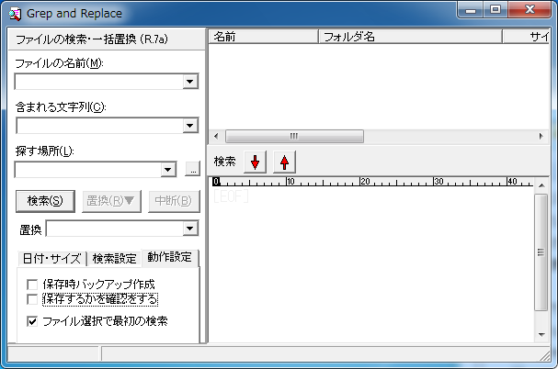
- Set the values as shown below and press the [Search] button.  File name: Empty space  String to be included: ProjectX_sample  Search location: C:\root\programs | 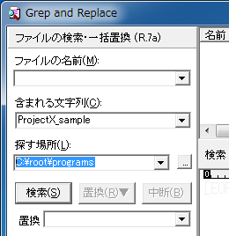
- Confirm that the file has been found and press the [OK] button. | 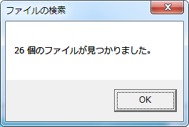
- Set the value as shown below and press the [Replace] button. Select [Replace files in the list as a batch] from menu.  Replacement: ProjectX | 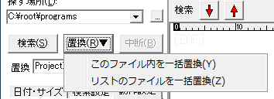
- Since there will be a display of confirmation dialogue, check the content and press the [Yes] button. | 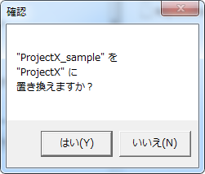
- Confirm that the replacement has ended and press the [OK] button. | 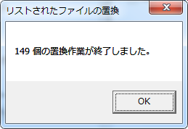
- Similarly replace [Samples\WebApp_sample] with [App\WebApp].
- Open [C:\root\programs\C#\10_Build_WebApp_sample.bat] in notepad.
- There is a copy command [copy “Samples\WS_sample\Build” …] in 28th line. This copies the assembly file of the Web service for 3 layer application. Since this tutorial targets the Web 2 layer, this copy command has been deleted here.
- Press the [Save all] icon in the tool bar and save the changed content.
- Run [C:\root\programs\C#\10_Build_WebApp_sample.bat] and build the sample program.

Change in the data provider (sample program)
Change the data provider that has been in use in the existing sample program, to the data provider of DBMS to be used.
- Run [C:\root\programs\C#\Frameworks\DaoGen_Tool\bin\Debug\DaoGen_Tool.exe] and start the Open Touryo's D layer auto-generation tool. | 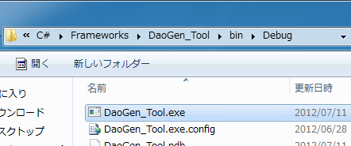
- Set the below values and press the [Get schema information] button.  Data provider: Oracle ODP.NET  Connection string: Connection string to Oracle  database  Pull-down: Overview information | 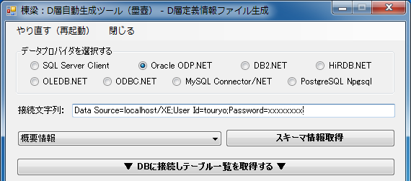
- If there are no errors in information such as connection string then [Display (overview information) dialogue of DBMS schema information] will be displayed.  Confirm that this dialogue is displayed and close it by pressing the [Close] button. | 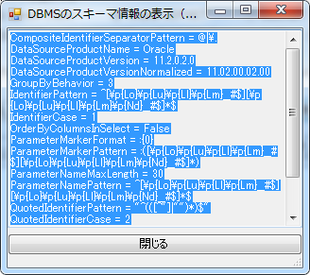
- Press the [Connect to DB and list the table] button.
- Since message dialogue about the displaying table will be displayed, press the [OK] button and close. | 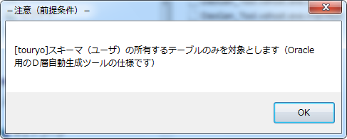
- Since the list of tables possessed by the specified schema are displayed, select table other than SHIPPERS table and press the [Delete the selected table] button. | 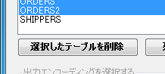
- Confirm that the items in list form only the SHIPPERS table, press the [Load row information] button. | 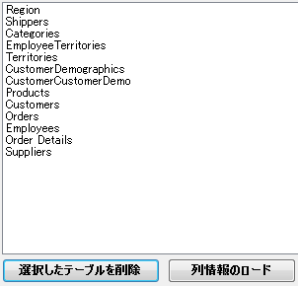
- Since the [Generate the information of D layer definition] button gets activated, select [Shift_JIS] as output encoding and press the [Generate the information of D layer definition] button.  Since Save dialogue of D layer definition information file will be displayed, save the files as shown below.  Save location: C:\root  File name: Info.csv | 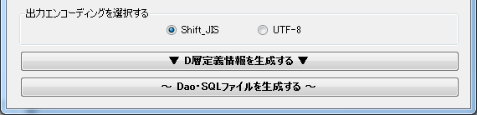
- Since there is a display of the dialogue that shows that D layer definition information file has been successfully generated, press the [OK] button and close. | 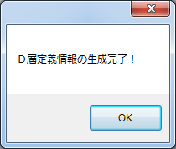
- Press the [Generate Dao/SQL file] button.
- Since Dao/SQL file generated dialogue is displayed, set the values as shown below and press the [Generate Dao/SQL file] button.  Select the data provider:  Oracle ODP.NET  D layer definition information file:  C:\root\Info.csv  Source template file:  C:\root\files\tools\DGenTemplates  Output file  C:\root  Other than the above-mentioned are as such  default. | 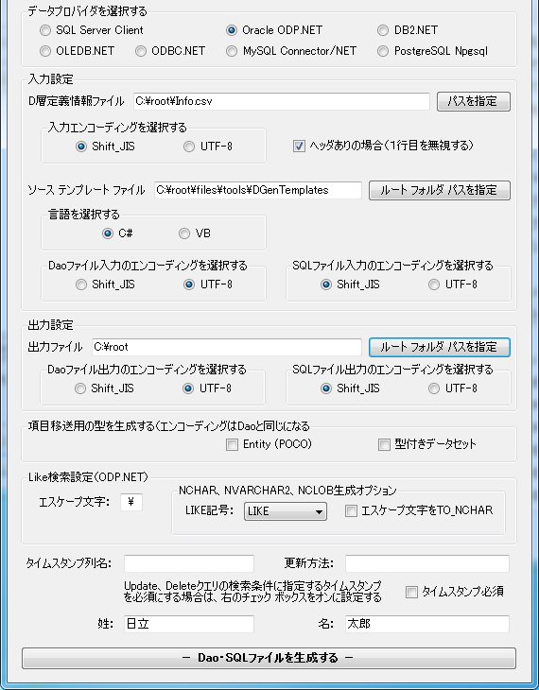
- Since there is a display of the dialogue that shows that Dao/SQL file has been successfully generated, press the [OK] button and close. | 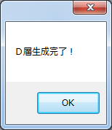
- Confirm that Dao file and SQL file are generated with respect to SHIPPERS table under the C:\root folder.  [Note] When Open Touryo's D layer auto-generated tool is used, files with extension [.sql] will be generated for static parametrized query and files with extension [.xml] will be generated for dynamic parameterized query. | 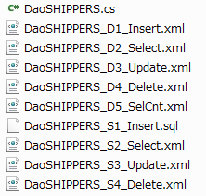
- Open [C:\root\programs\C#\App\WebApp\ProjectX\ProjectX.sln].
- Confirm that [Microsoft Visual Studio Express 2012 for Web] has been selected in selection dialogue of the application and press the [OK] button. | 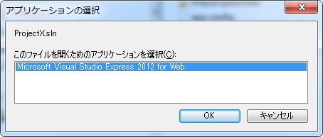
- Since the auto-generated Dao class is included in the sample program, open the sample program in Visual Studio Express 2012 for Web and right-click on the [Dao] folder, select [Add(D)] - [Existing item(G)]. | 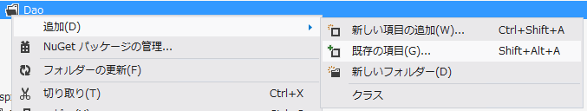
- In add dialogue of the existing items, select [C:\root\DaoSHIPPERS.cs] and press the [Add] button. Since the file DaoSHIPPERS.cs has been included in the sample program from the beginning, there will be a display of confirmation dialogue here, that confirms whether file has been replaced or not. In order to replace with the file that is auto-generated here, press the [Yes(Y)] button.
- From Solution Explorer, open [App_Code]-[sample]-[Business]-[LayerB.cs].
- In Visual Studio Express 2012 for Web, press [Ctrl]+[H] key, and display replacement window. Set as shown below and press the [Replace all] icon.  Search string (Upper part of the pull-down):  DaoShippers  Replacing string (Lower part of the pull-down):  DaoSHIPPERS  Capital letters and the small letters are  distinguished:  ON (Blue frame attached to the icon)  Only the match with single unit is searched::  OFF (No frame attached to the icon)  Search scope::  Current documents | 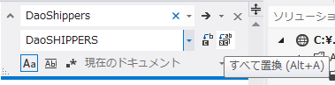
- Although all the replacing dialogues will be displayed, there is no need to return the changes to the back based on the replacement. Press the [Yes] button without inserting check in the [Open all the files changed with all replacements in edit mode]. | 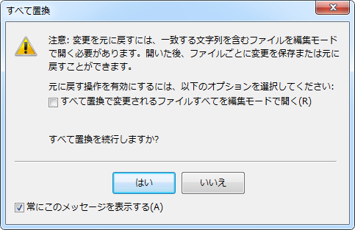
- Confirm that replacement is done normally and press the [OK] button. | 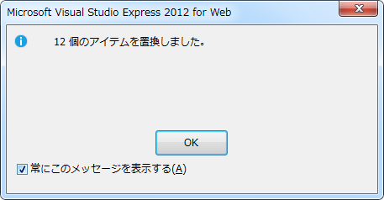
- Similarily, replace for the below strings.
Search string | Replacing string
genDao.PK_ShipperID | genDao.PK_SHIPPERID
genDao.CompanyName | genDao.COMPANYNAME
genDao.Phone | genDao.PHONE
genDao.Set_CompanyName_forUPD | genDao.Set_COMPANYNAME_forUPD
genDao.Set_Phone_forUPD | genDao.Set_PHONE_forUPD

- Press the [Save all] in the tool bar and save the changed content.
- Run [C:\root\programs\C#\10_Build_WebApp_sample.bat] and build the sample program.
- Transfer the auto generated SQL file/XML file to the following folder.
C:\root\files\resource\Sql
Since former sample program has SQL file/XML file with same name, the confirmation dialog whether to replace the file or not will be displayed even here. Even here, there will be a replacement with all the auto-generated files.
- Press the [Close] button and end the Dao/SQL file generation dialogue. | 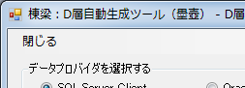
- Press the [Close] button and end the D layer auto-generated tool. | 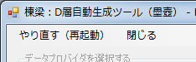

Settings of application configuration file
Set each parameter of application configuration file (Web.config or app.config) as per the process method of the Open Touryo application project. (For details, refer to [Configuration] sheet of [C:\root\documents\2_User_Guide\Atypical_work_list.xlsx])
- Design the process method of the application and consolidate the decided process methods in the document.
- Open [C:\root\programs\C#\App\WebApp\ProjectX\ProjectX.sln].
- In the application selection dialogue, confirm that [Microsoft Visual Studio Express 2012 for Web] has been selected and press the [OK] button
- Open [web.config] from Solution Explorer.
- As per process method of application, set the application in <system.web> tag of Web.config.
(Since the explanation for each setting item of Web.config is given as comment in Web.config of sample program, it is possible to use them as reference when setting the values in Web.config)
- Set the connection string to DB in connectionStrings tag.
<connectionStrings>
<!—For Oracle -->
<add name="ConnectionString_ODP2" connectionString="Data Source=localhost/XE;
User Id=scott;Password=tiger;"/>
</connectionStrings>
[Note] Previously, the key name to set the connection string is [ConnectionString_SQL] targeted for SQL Server. Change this to the key name (previously [ConnectionString_ODP2] in case of Oracle) specified as an argument of GetConnectionString method in the section 4.1.2
- From Solution Explorer, open the [app.config].
- Set Open Touryo as per the application process method.
[Note] Refer to Open Touryo user guide for the Open Touryo setting items and setting value.
- Press [Save all] in the tool bar and save the changed content.

Behavior confirmation of a sample program
Run a sample program and confirm that the developed Open Touryo template is working normally.
- Run [C:\root\programs\C#\10_Build_WebApp_sample.bat] and build a sample program associated with Open Touryo.
- Open [C:\root\programs\C#\App\WebApp\ProjectX\ProjectX.sln].
- In the selection dialogue of the application, confirm that [Microsoft Visual Studio Express 2012 for Web] has been selected and press the [OK] button.
- In the Solution Explorer, right-click on the  ProjectX project and select the [Property page]. | 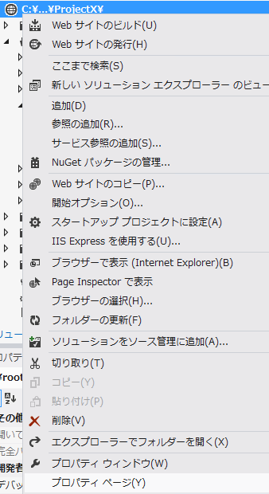
- In the Property page, select the [Start option] and remove check mark from [NTLM authentication] of [Server]. Press the [OK] button. | 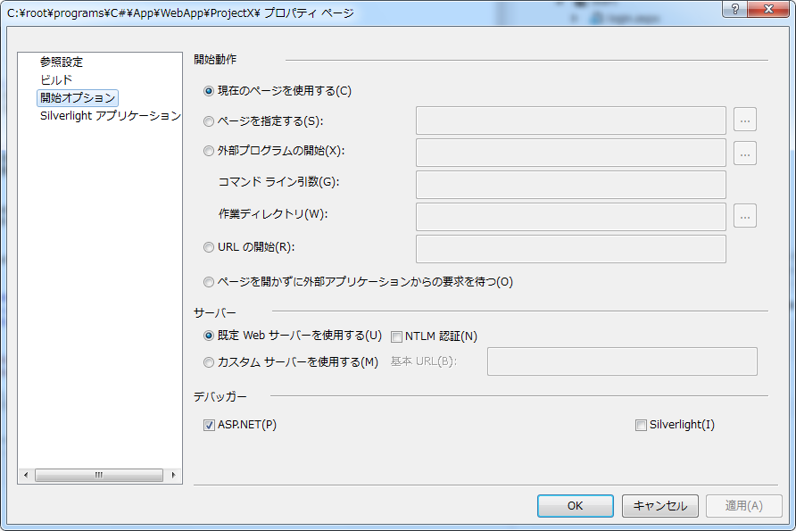
- In the Solution Explorer, right-click on the ProjectX project's [Aspx]-[start]-[menu.aspx] and select the [Display in browser(Internet Explorer)]. | 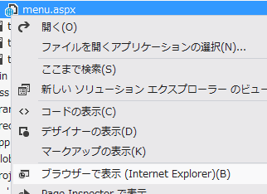
- Since there will be a display of log-in screen, enter user ID, password (optional values) and press the [Login] button.  (Previously, check was not done as per user ID and password. So, optional values can be used(Password field can be empty)) | 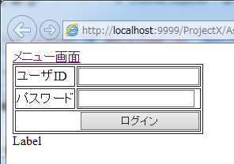
- From the Menu screen, press the [Normal] link. | 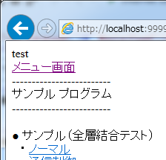
- In Sample screen, press the [Number of acquisitions] button present at the lower part of the screen.  [Note] Although there is a pull-down for selecting data provider at the upper part of the screen, it is used for confirming the operation while switching the DB in the previous Open Touryo templatebase (/root_VS2010/). Here, this template will not be used as it is corrected to be accessible to only Oracle in (16)th point of 4.1.2 section. | 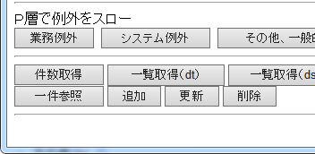
- There will be display of no.of data in message area and confirm the normal access to DB. | 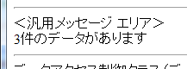
- Open [C:\root\files\resource\Log\ACCESS.yyyy-mm-dd.log] in notepad etc.,
(Enter the execution date in yyyy-mm-dd)
- It is confirmed that the log added to Open Touryo's [Parents class 2] is the output of section 4.2.

[2013/08/08 15:04:19,263],[DEBUG],[10],,－,127.0.0.1,-----↓,Global.asax,Application_OnPreRequest
[2013/08/08 15:04:19,310],[INFO ],[10],P層共通処理サンプル
[2013/08/08 15:04:19,326],[INFO ],[10],,未認証,127.0.0.1,init,login
[2013/08/08 15:04:19,373],[DEBUG],[10],,－,127.0.0.1,-----↑,Global.asax,Application_OnPostRequest,－,－,102,78
[2013/08/08 15:04:19,592],[DEBUG],[9],,－,127.0.0.1,-----↓,Global.asax,Application_OnPreRequest
[2013/08/08 15:04:19,592],[INFO ],[9],P層共通処理サンプル
[2013/08/08 15:04:19,592],[INFO ],[9],,未認証,127.0.0.1,init,login
[2013/08/08 15:04:19,592],[DEBUG],[9],,－,127.0.0.1,-----↑,Global.asax,Application_OnPostRequest,－,－,2,0
[2013/08/08 15:04:21,814],[DEBUG],[9],,－,127.0.0.1,-----↓,Global.asax,Application_OnPreRequest
[2013/08/08 15:04:21,814],[INFO ],[9],,未認証,127.0.0.1,postback,login
[2013/08/08 15:04:21,814],[INFO ],[9],,未認証,127.0.0.1,----->,login,btnButton1
[2013/08/08 15:04:21,830],[INFO ],[9],,aaa,127.0.0.1,<-----,login,btnButton1,,10,0
[2013/08/08 15:04:21,830],[DEBUG],[9],,－,127.0.0.1,-----↑,Global.asax,Application_OnPostRequest,－,－,17,0
[2013/08/08 15:04:21,892],[DEBUG],[10],,－,127.0.0.1,-----↓,Global.asax,Application_OnPreRequest
[2013/08/08 15:04:21,908],[INFO ],[10],P層共通処理サンプル
[2013/08/08 15:04:21,908],[INFO ],[10],,aaa,127.0.0.1,init,menu
[2013/08/08 15:04:21,908],[DEBUG],[10],,－,127.0.0.1,-----↑,Global.asax,Application_OnPostRequest,－,－,18,16
[2013/08/08 15:04:21,955],[DEBUG],[5],,－,127.0.0.1,-----↓,Global.asax,Application_OnPreRequest
[2013/08/08 15:04:21,955],[DEBUG],[5],,－,127.0.0.1,-----↑,Global.asax,Application_OnPostRequest,－,－,0,0
[2013/08/08 15:04:24,799],[DEBUG],[9],,－,127.0.0.1,-----↓,Global.asax,Application_OnPreRequest
[2013/08/08 15:04:24,845],[INFO ],[9],P層共通処理サンプル
[2013/08/08 15:04:24,845],[INFO ],[9],,aaa,127.0.0.1,init,sampleScreen
[2013/08/08 15:04:24,845],[DEBUG],[9],,－,127.0.0.1,-----↑,Global.asax,Application_OnPostRequest,－,－,55,47
[2013/08/08 15:04:27,541],[DEBUG],[10],,－,127.0.0.1,-----↓,Global.asax,Application_OnPreRequest
[2013/08/08 15:04:27,556],[INFO ],[10],,aaa,127.0.0.1,postback,sampleScreen
[2013/08/08 15:04:27,556],[INFO ],[10],,aaa,127.0.0.1,----->,sampleScreen,btnMButton1
[2013/08/08 15:04:27,978],[INFO ],[10],F層共通処理サンプル
[2013/08/08 15:04:27,978],[INFO ],[10],,aaa,127.0.0.1,----->>,sampleScreen,btnMButton1,SelectCount,SQL%individual%static%-
[2013/08/08 15:04:27,994],[INFO ],[10],D層共通処理サンプル: [commandText]:SELECT COUNT(*) FROM Shippers [commandParameter]:
[2013/08/08 15:04:28,010],[INFO ],[10],,aaa,127.0.0.1,<<-----,sampleScreen,btnMButton1,SelectCount,SQL%individual%static%-,30,31
[2013/08/08 15:04:28,010],[INFO ],[10],,aaa,127.0.0.1,<-----,sampleScreen,btnMButton1,,461,47
[2013/08/08 15:04:28,010],[DEBUG],[10],,－,127.0.0.1,-----↑,Global.asax,Application_OnPostRequest,－,－,467,63

-The end-

For example, the function targeted for Open Touryo C/S application is not required in the Web application development project.
Web application development project is considered in this tutorial. Therefore, use Visual Studio Express 2012 for Web as IDE considering that the handling of C/S application of the Windows form etc. is not required. If the template is made for the C/S application development project, then use the IDE that can handle the C/S application such as Visual Studio Express 2012 for Windows Desktop.
The download page of Visual Studio Express 2012 for Web might not be correctly displayed in browsers other than IE9/10 and IE. Hence, use IE8 or use IE developer tool for having browser mode in "IE8" and document mode in "IE8 standard" in advance.
Free tool to obtain the latest component in Web platform of Microsoft
In this tutorial, exercises are carried out in such a way that functions can be added for the existing sample programs. Hence, exercises are started right from the point where existing projects are opened. If it is necessary to create a new project then refer to Open Touryo user guide (common version).
.NET data provider of Oracle make.
Component group including Oracle client and ODP.NET, etc.
Web server in case of ASP.NET and each client machine in case of C/S.
If ODP.NET that is much newer than ODP.NET(which is included Oracle Database) is need to be used.
Collection of ASP.NET 2.0 provider in order to use Oracle database as data source for each service of ASP.NET such as ASP.NET membership or session state management. When these services are used with the application, then it is necessary to execute SQL sentence displayed in the message. For details, refer to the below link. Overview on Oracle Providers for ASP.NET http://otndnld.oracle.co.jp/document/products/oracle11g/111/windows/E06106-01/IntroOverview.htm
For the types of DBMS supported by Open Touryo, refer to user guide (common ver.) of Open Touryo.
Previously, there was no display of line number in Visual Studio Express 2012 for Web editor. For displaying the line number in the editor, refer to the below link. Method: Displays the line number in the editor http://msdn.microsoft.com/ja-jp/library/ms165340.aspx
The [Parent class 1] is the class of framework related to application configuration and process method. Hence, there are no corrections.
In case of C/S application, refer to Open Touryo user guide (rich client version).
A free software for replacing the strings as a batch for multiple files. Download from http://apps.tpot.tk/win:greprplc
If time stamp row name is specified in this Dao・SQL file generated dialogue then Dao/SQL that has optimistic exclusive control using this time-stamp row name, will be generated. For details, refer to Open Touryo user guide (D layer auto-generation ver.)
In this tutorial, SQL files are deployed as external files of the program. In Open Touryo, SQL files are embedded in the programs (assembly) as resource files, and the SQL files can be read from the embedded resources. Refer to the Open Touryo user guide (developer version) for the method of reading the SQL files from the embedded resources.
However, there is difference in user guide to be referred depending on the Method design items such as screen transition method and log output method. Hence, it is possible to look for the corresponding user guide by searching the [C:\root\documents\2_User_Guide] folder with key words such as [Screen transition] [Log output].

