Open Transit Middleware API
why Swagger (Open I/O) make sense for MOD

MOD has requirements to show route, stop and schedule data (in addition to trip plans and trip profiles). Here’s one picture of what is being asked for:
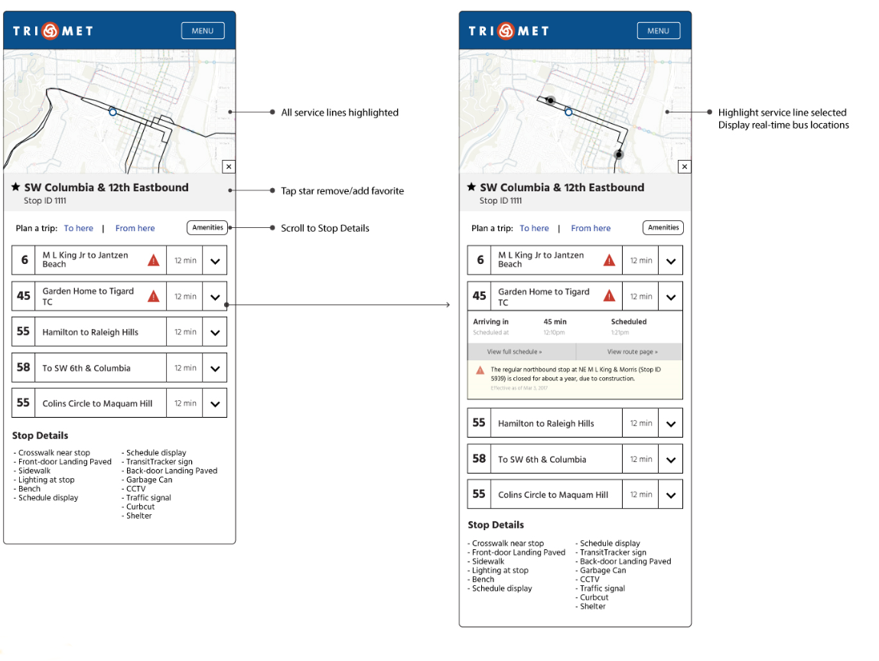
Extended GTFS data:
Look at this image closer, and it’s pretty obvious that TriMet’s requirements require an extra level of data beyond that defined in the GTFS spec (https://developers.google.com/transit/gtfs/reference/). First you probably notice the Stop Details section. Then you might notice there’s a direction (“Eastbound”), and then maybe the “to Raleigh Hills” on the route name fields. The simple image above implies a lot of data that isn’t defined in GTFS without using extensions to the spec. Luckily, the spec was designed for just such extensibility. Further good news it that TriMet’s GTFS has the extensions that are necessary for the above requirements.

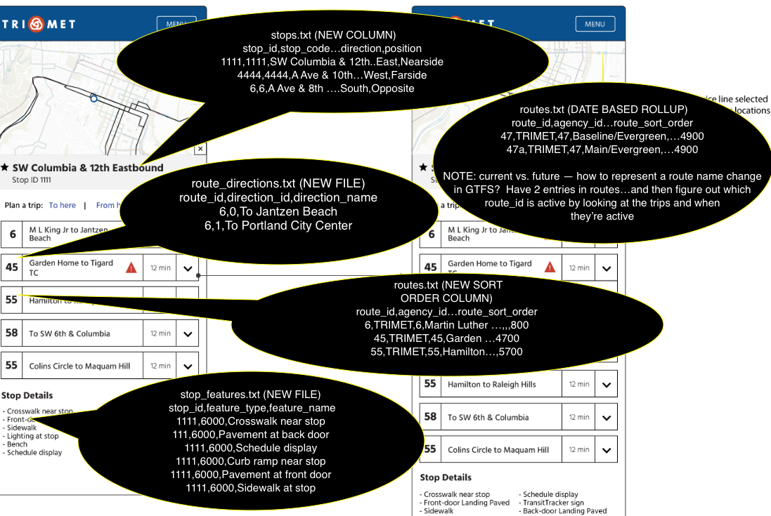

A lot of the GTFS extensions have been in proposal for years (decades almost):
- Stop Features: https://sites.google.com/site/gtfschanges/proposals/stop-amenity, https://groups.google.com/forum/#!topic/gtfs-changes/EzC5m9k45pA
- Stop Directions: https://groups.google.com/forum/#!topic/gtfs-changes/LlduFqXj9pg (well, this is relative direction, ala Nearside Farside, direction shows up in places in the thread).
- Route Directions: https://groups.google.com/forum/#!topic/gtfs-changes/Dx9nRwQo6rQ, https://transitfeeds.com/p/petaluma-transit-gtfs/675/20170105/file/route_directions.txt, etc…
- Route Sort: https://groups.google.com/forum/#!topic/gtfs-changes/73resybBoc0

we need a backend that can expose things like route direction, route sort order, route stops and stop amenities, among others (all GTFS extensions). We also need a way ‘roll up’ the GTFS data in a date-range based view of the data, so that a UI will (mostly) show a logical ‘current’ view of the data, but also have the ability to show a ‘future’ view — what can’t be done is to ignore date and show all GTFS data in the roll up, since there are routes and stops (at least in TriMet’s GTFS data) that are not currently active, and can not be shown w/out confusion.

