Celindra Therapeutics (fictional)
Protocol TORIVUMAB-NSCLC-301
Output T-DM-01 | TABLE
Demographic and Baseline Characteristics
Population: Intent-to-Treat Population (N=450)

 | Torivumab 200mg  (N=300) | Placebo  (N=150) | Total  (N=450)
Age (years) | xxx | xxx | xxx
n | xxx | xxx | xxx
Mean (SD) | xx.x (xx.x) | xx.x (xx.x) | xx.x (xx.x)
Median (Min, Max) | xx.x (xx.x, xx.x) | xx.x (xx.x, xx.x) | xx.x (xx.x, xx.x)
< 65, n (%) | xxx (xx.x%) | xxx (xx.x%) | xxx (xx.x%)
≥ 65, n (%) | xxx (xx.x%) | xxx (xx.x%) | xxx (xx.x%)
Sex
Female, n (%) | xxx (xx.x%) | xxx (xx.x%) | xxx (xx.x%)
Male, n (%) | xxx (xx.x%) | xxx (xx.x%) | xxx (xx.x%)
Race
Asian, n (%) | xxx (xx.x%) | xxx (xx.x%) | xxx (xx.x%)
Black or African American, n (%) | xxx (xx.x%) | xxx (xx.x%) | xxx (xx.x%)
White, n (%) | xxx (xx.x%) | xxx (xx.x%) | xxx (xx.x%)
Other / Not reported, n (%) | xxx (xx.x%) | xxx (xx.x%) | xxx (xx.x%)
Region
North America, n (%) | xxx (xx.x%) | xxx (xx.x%) | xxx (xx.x%)
Europe, n (%) | xxx (xx.x%) | xxx (xx.x%) | xxx (xx.x%)
Asia-Pacific, n (%) | xxx (xx.x%) | xxx (xx.x%) | xxx (xx.x%)
Histology
Squamous, n (%) | xxx (xx.x%) | xxx (xx.x%) | xxx (xx.x%)
Non-squamous, n (%) | xxx (xx.x%) | xxx (xx.x%) | xxx (xx.x%)
ECOG PS at baseline
0, n (%) | xxx (xx.x%) | xxx (xx.x%) | xxx (xx.x%)
1, n (%) | xxx (xx.x%) | xxx (xx.x%) | xxx (xx.x%)
PD-L1 TPS group
50–74%, n (%) | xxx (xx.x%) | xxx (xx.x%) | xxx (xx.x%)
≥ 75%, n (%) | xxx (xx.x%) | xxx (xx.x%) | xxx (xx.x%)
Number of prior lines
0 (first-line), n (%) | xxx (xx.x%) | xxx (xx.x%) | xxx (xx.x%)

Methodology: Descriptive — Categorical; Descriptive — Continuous
Source: ADSL
SAP reference: §3.1
Notes: Descriptive: n (%) for categorical; n, mean (SD), median, min, max for continuous.
DRAFT SHELL — 2026-09-20

Programmer's notes (not part of CSR output):
Row | Dataset | Where | Variable | Derivation
Age (n, mean, SD, median, min, max) | ADSL | ITTFL='Y' | AGE | n/mean/SD/median/min/max
Age group < 65 / >= 65, n (%) | ADSL | ITTFL='Y' | AGEGR1 | n(%)
Sex (Female/Male), n (%) | ADSL | ITTFL='Y' | SEX | n(%)
Race, n (%) | ADSL | ITTFL='Y' | RACE | n(%)
Ethnicity, n (%) | ADSL | ITTFL='Y' | ETHNIC | n(%)
Region, n (%) | ADSL | ITTFL='Y' | REGION1 | n(%)
Histology category, n (%) | ADSL | ITTFL='Y' | HISTSCAT † | n(%)
ECOG PS at baseline, n (%) | ADSL | ITTFL='Y' | BECOG † | n(%)
PD-L1 TPS group, n (%) | ADSL | ITTFL='Y' | PDL1GR † | n(%)

Celindra Therapeutics (fictional)
Protocol TORIVUMAB-NSCLC-301
Output T-DS-01 | TABLE
Subject Disposition
Population: Intent-to-Treat Population (N=450)

 | Torivumab 200mg  (N=300) | Placebo  (N=150)
Screened | xxx | —
Screen failures | xxx | —
Randomised / ITT (N=450) | xxx | —
Torivumab 200mg | xxx | —
Placebo | — | xxx
Safety population | xxx | xxx
Per-Protocol population | xxx | xxx
Response Evaluable population | xxx | xxx
Completed study treatment | xxx (xx.x%) | xxx (xx.x%)
Discontinued treatment | xxx (xx.x%) | xxx (xx.x%)
Disease progression | xxx (xx.x%) | xxx (xx.x%)
Adverse event | xxx (xx.x%) | xxx (xx.x%)
Withdrawal by subject | xxx (xx.x%) | xxx (xx.x%)
Death | xxx (xx.x%) | xxx (xx.x%)
Other | xxx (xx.x%) | xxx (xx.x%)
Ongoing at data cutoff | xxx (xx.x%) | xxx (xx.x%)
Died on study | xxx (xx.x%) | xxx (xx.x%)

Methodology: Descriptive — Categorical
Source: ADSL
SAP reference: §3
Notes: Counts and percentages for each category.
DRAFT SHELL — 2026-09-20

Programmer's notes (not part of CSR output):
Row | Dataset | Where | Variable | Derivation
Randomised / ITT | ADSL | ITTFL='Y' | USUBJID | n()
Safety population | ADSL | SAFFL='Y' | USUBJID | n()
Per-Protocol population | ADSL | PPROTFL='Y' | USUBJID | n()
Response Evaluable population | ADRS | EFFFL='Y' | USUBJID | n() distinct
Ongoing at data cutoff | ADSL | EOSSTT='ONGOING' | USUBJID | n(%)
Completed study treatment | ADSL | EOSSTT='COMPLETED' | USUBJID | n(%)
Discontinued (by reason) | ADSL | EOSSTT='DISCONTINUED' | DCSREAS | n(%) by level
Died on study | ADSL | DTHFL='Y' | DTHFL | n(%)

Celindra Therapeutics (fictional)
Protocol TORIVUMAB-NSCLC-301
Output T-DS-02 | TABLE
Major Protocol Deviations
Population: Intent-to-Treat Population (N=450)

 | Torivumab 200mg  (N=300) | Placebo  (N=150) | Total  (N=450)
Subjects with ≥ 1 major deviation, n (%) | xxx (xx.x%) | xxx (xx.x%) | xxx (xx.x%)
Eligibility criteria violated | xxx (xx.x%) | xxx (xx.x%) | xxx (xx.x%)
Randomised but never dosed | xxx (xx.x%) | xxx (xx.x%) | xxx (xx.x%)
Prohibited concomitant medication | xxx (xx.x%) | xxx (xx.x%) | xxx (xx.x%)
≥ 2 consecutive missed tumour assessments | xxx (xx.x%) | xxx (xx.x%) | xxx (xx.x%)
Other | xxx (xx.x%) | xxx (xx.x%) | xxx (xx.x%)

Methodology: Descriptive — Categorical
Source: ADSL, SDTM.DS
SAP reference: §3.2
Notes: n (%) subjects with ≥1 major deviation by category. Source: SDTM.DS where DSDECOD='PROTOCOL DEVIATION' AND DSSCAT='MAJOR'.
DRAFT SHELL — 2026-09-20

Programmer's notes (not part of CSR output):
Row | Dataset | Where | Variable | Derivation
Subjects with >= 1 major deviation | ADSL | PPROTFL='N' | USUBJID | n(%)
Eligibility criteria violated | SDTM.DS | DSDECOD='PROTOCOL DEVIATION' AND DSSCAT='MAJOR' | DSTERM | n(%) by category
Randomised but never dosed | ADSL | SAFFL='N' AND ITTFL='Y' | USUBJID | n(%)
Prohibited concomitant medication | SDTM.DS | DSDECOD='PROTOCOL DEVIATION' AND DSSCAT='MAJOR' | DSTERM | n(%) by category
>= 2 consecutive missed tumour assessments | SDTM.DS | DSDECOD='PROTOCOL DEVIATION' AND DSSCAT='MAJOR' | DSTERM | n(%) by category

Celindra Therapeutics (fictional)
Protocol TORIVUMAB-NSCLC-301
Output T-DS-03 | TABLE
Intercurrent Events Summary
Population: Intent-to-Treat Population (N=450)

 | Torivumab 200mg  (N=300) | Placebo  (N=150) | Total  (N=450)
Treatment discontinuation (any reason) | xxx (xx.x%) | xxx (xx.x%) | xxx (xx.x%)
Treatment discontinuation due to AE | xxx (xx.x%) | xxx (xx.x%) | xxx (xx.x%)
Initiation of subsequent anti-cancer therapy | xxx (xx.x%) | xxx (xx.x%) | xxx (xx.x%)
>= 2 consecutive missed tumour assessments | xxx (xx.x%) | xxx (xx.x%) | xxx (xx.x%)
No post-baseline tumour assessment | xxx (xx.x%) | xxx (xx.x%) | xxx (xx.x%)
Death before first response assessment | xxx (xx.x%) | xxx (xx.x%) | xxx (xx.x%)
Withdrawal of consent | xxx (xx.x%) | xxx (xx.x%) | xxx (xx.x%)

Methodology: Descriptive — Categorical
Source: ADSL, ADAE, ADTTE, SDTM.CM
SAP reference: §13.3
Notes: n (%) subjects experiencing each pre-specified IE. Supports reviewer judgement of whether the chosen IE handling strategies (§13.3) remain appropriate given observed IE frequencies.
DRAFT SHELL — 2026-09-20

Programmer's notes (not part of CSR output):
Row | Dataset | Where | Variable | Derivation
Treatment discontinuation (any reason) | ADSL | DCSREAS is not missing | USUBJID | n(%) distinct subjects
Treatment discontinuation due to AE | ADSL | DCSREAS='ADVERSE EVENT' | USUBJID | n(%) distinct subjects
Initiation of subsequent anti-cancer therapy | SDTM.CM | CMCAT='ANTI-CANCER' AND CMSTDTC > TRTEDT | USUBJID | n(%) distinct subjects (requires SDTM.CM linkage; placeholder for ADCM if available)
>= 2 consecutive missed scheduled tumour assessments | ADTTE | PARAMCD='PFS' AND EVNTDESC contains 'missed' | USUBJID | n(%) — flag derivable from PFS censoring reason
No post-baseline tumour assessment | ADSL | EFFFL='N' AND ITTFL='Y' | USUBJID | n(%) — composite IE → counted as ORR non-responder
Death before first response assessment | ADSL | DTHFL='Y' AND DTHDT < first_RSDT | USUBJID | n(%) — composite IE for ORR
Withdrawal of consent | ADSL | DCSREAS='WITHDRAWAL BY SUBJECT' | USUBJID | n(%) distinct subjects

Celindra Therapeutics (fictional)
Protocol TORIVUMAB-NSCLC-301
Output T-EX-01 | TABLE
Study Drug Exposure
Population: Safety Population (N=450)

 | Torivumab 200mg  (N=300) | Placebo  (N=150)
Treatment duration (months)
Median (Min, Max) | xx.x (xx.x, xx.x) | xx.x (xx.x, xx.x)
Mean (SD) | xx.x (xx.x) | xx.x (xx.x)
≥ 6 cycles, n (%) | xxx (xx.x%) | xxx (xx.x%)
≥ 12 cycles, n (%) | xxx (xx.x%) | xxx (xx.x%)
≥ 24 cycles, n (%) | xxx (xx.x%) | xxx (xx.x%)
Number of cycles received
Mean (SD) | xx.x (xx.x) | xx.x (xx.x)
Median (Min, Max) | xx.x (xx.x, xx.x) | xx.x (xx.x, xx.x)
Relative dose intensity (%)
Mean (SD) | xx.x (xx.x) | xx.x (xx.x)

Methodology: Descriptive — Continuous; Descriptive — Categorical
Source: ADSL
SAP reference: §5.5
Notes: Exposure summaries computed from ADSL (TRTDURD, N_CYCLES, CUMDOSE) — no separate ADEX dataset in scope.
DRAFT SHELL — 2026-09-20

Programmer's notes (not part of CSR output):
Row | Dataset | Where | Variable | Derivation
Treatment duration (months) — median (min, max) | ADSL | SAFFL='Y' | TRTDURD | median/min/max (TRTDURD/30.4375)
Treatment duration — mean (SD) | ADSL | SAFFL='Y' | TRTDURD | mean/SD
>= 6 / 12 / 24 cycles, n (%) | ADSL | SAFFL='Y' | N_CYCLES † | n(%) where N_CYCLES >= threshold
Cumulative dose (mg) — mean (SD) | ADSL | SAFFL='Y' | CUMDOSE † | mean/SD
Relative dose intensity (%) — mean (SD) | ADSL | SAFFL='Y' | RDOSE † | mean/SD (actual/planned x 100)

Celindra Therapeutics (fictional)
Protocol TORIVUMAB-NSCLC-301
Output T-EFF-01 | TABLE
Overall Survival Analysis (Primary)
Population: Intent-to-Treat Population (N=450)

 | Torivumab 200mg  (N=300) | Placebo  (N=150)
Number of subjects | xxx | xxx
Events (OS or death), n (%) | xxx (xx.x%) | xxx (xx.x%)
Censored, n (%) | xxx (xx.x%) | xxx (xx.x%)
Median OS (months)
Estimate | xx.x | xx.x
95% CI (Brookmeyer-Crowley) | (xx.x, xx.x) | (xx.x, xx.x)
OS probability at 12 months (95% CI) | xx.x (xx.x, xx.x) | xx.x (xx.x, xx.x)
OS probability at 24 months (95% CI) | xx.x (xx.x, xx.x) | xx.x (xx.x, xx.x)
Hazard Ratio (Torivumab / Placebo)
Estimate (stratified Cox) | x.xxx | —
95% CI | (xx.x, xx.x) | —
Stratified log-rank p-value | x.xxx | —

Methodology: Stratified Log-Rank Test; Stratified Cox Proportional Hazards; Kaplan-Meier Median
Source: ADTTE
SAP reference: §5.1 | Estimand: E1
Notes: Primary analysis. Triggered at ~320 OS events (event-driven, Protocol §8.1). Strata: histology (STRAT2), region (STRAT3).
DRAFT SHELL — 2026-09-20

Programmer's notes (not part of CSR output):
Row | Dataset | Where | Variable | Derivation
Number of subjects | ADTTE | PARAMCD='OS' | USUBJID | n() distinct
Events (deaths), n (%) | ADTTE | PARAMCD='OS' AND CNSR=0 | CNSR | sum(1-CNSR) / N
Censored, n (%) | ADTTE | PARAMCD='OS' AND CNSR=1 | CNSR | sum(CNSR) / N
Median OS (months) | ADTTE | PARAMCD='OS' | AVAL | survfit(Surv(AVAL,1-CNSR)~TRT01P+strata(STRAT2,STRAT3)) -> median / 30.4375
95% CI (Brookmeyer-Crowley) | ADTTE | PARAMCD='OS' | AVAL | survfit(..., conf.type='log-log') -> lower/upper
Hazard Ratio (Cox stratified) | ADTTE | PARAMCD='OS' | AVAL,CNSR | coxph(Surv(AVAL,1-CNSR)~TRT01P+strata(STRAT2,STRAT3)) -> exp(coef)
HR 95% CI | ADTTE | PARAMCD='OS' | AVAL,CNSR | coxph(...) -> confint -> exp
Stratified log-rank p-value | ADTTE | PARAMCD='OS' | AVAL,CNSR | survdiff(Surv(AVAL,1-CNSR)~TRT01P+strata(STRAT2,STRAT3), rho=0) -> p

Celindra Therapeutics (fictional)
Protocol TORIVUMAB-NSCLC-301
Output T-EFF-02 | TABLE
Kaplan-Meier Survival Probabilities — OS
Population: Intent-to-Treat Population (N=450)

 | Prob | 95% CI | Prob | 95% CI
6 months | xx.x | (xx.x, xx.x) | xx.x | (xx.x, xx.x)
12 months | xx.x | (xx.x, xx.x) | xx.x | (xx.x, xx.x)
18 months | xx.x | (xx.x, xx.x) | xx.x | (xx.x, xx.x)
24 months | xx.x | (xx.x, xx.x) | xx.x | (xx.x, xx.x)

Methodology: Kaplan-Meier Survival Probability
Source: ADTTE
SAP reference: §5.1 | Estimand: E1
Notes: Greenwood 95% CI.
DRAFT SHELL — 2026-09-20

Programmer's notes (not part of CSR output):
Row | Dataset | Where | Variable | Derivation
Survival probability at 6 months | ADTTE | PARAMCD='OS' | AVAL,CNSR | summary(survfit(...), times=6*30.4375) -> surv
Survival probability at 12 months | ADTTE | PARAMCD='OS' | AVAL,CNSR | summary(survfit(...), times=12*30.4375) -> surv
Survival probability at 18 months | ADTTE | PARAMCD='OS' | AVAL,CNSR | summary(survfit(...), times=18*30.4375) -> surv
Survival probability at 24 months | ADTTE | PARAMCD='OS' | AVAL,CNSR | summary(survfit(...), times=24*30.4375) -> surv
95% CI (Greenwood, log-log) | ADTTE | PARAMCD='OS' | AVAL,CNSR | survfit(..., conf.type='log-log') -> lower/upper at each timepoint

Celindra Therapeutics (fictional)
Protocol TORIVUMAB-NSCLC-301
Output T-EFF-03 | TABLE
Progression-Free Survival Analysis (BICR)
Population: Intent-to-Treat Population (N=450)

 | Torivumab 200mg  (N=300) | Placebo  (N=150)
Number of subjects | xxx | xxx
Events (PFS or death), n (%) | xxx (xx.x%) | xxx (xx.x%)
Censored, n (%) | xxx (xx.x%) | xxx (xx.x%)
Median PFS (months)
Estimate | xx.x | xx.x
95% CI (Brookmeyer-Crowley) | (xx.x, xx.x) | (xx.x, xx.x)
PFS probability at 12 months (95% CI) | xx.x (xx.x, xx.x) | xx.x (xx.x, xx.x)
PFS probability at 24 months (95% CI) | xx.x (xx.x, xx.x) | xx.x (xx.x, xx.x)
Hazard Ratio (Torivumab / Placebo)
Estimate (stratified Cox) | x.xxx | —
95% CI | (xx.x, xx.x) | —
Stratified log-rank p-value | x.xxx | —

Methodology: Stratified Log-Rank Test; Stratified Cox Proportional Hazards; Kaplan-Meier Median
Source: ADTTE
SAP reference: §5.2 | Estimand: E2
Notes: Same structure as T-EFF-01 for PFS.
DRAFT SHELL — 2026-09-20

Programmer's notes (not part of CSR output):
Row | Dataset | Where | Variable | Derivation
Number of subjects | ADTTE | PARAMCD='PFS' | USUBJID | n() distinct
Events (PD or death), n (%) | ADTTE | PARAMCD='PFS' AND CNSR=0 | CNSR | sum(1-CNSR) / N
Censored, n (%) | ADTTE | PARAMCD='PFS' AND CNSR=1 | CNSR | sum(CNSR) / N
Median PFS (months) | ADTTE | PARAMCD='PFS' | AVAL | survfit(Surv(AVAL,1-CNSR)~TRT01P+strata(STRAT2,STRAT3)) -> median / 30.4375
95% CI (Brookmeyer-Crowley) | ADTTE | PARAMCD='PFS' | AVAL | survfit(..., conf.type='log-log') -> lower/upper
Hazard Ratio (Cox stratified) | ADTTE | PARAMCD='PFS' | AVAL,CNSR | coxph(Surv(AVAL,1-CNSR)~TRT01P+strata(STRAT2,STRAT3)) -> exp(coef)
HR 95% CI | ADTTE | PARAMCD='PFS' | AVAL,CNSR | coxph(...) -> confint -> exp
Stratified log-rank p-value | ADTTE | PARAMCD='PFS' | AVAL,CNSR | survdiff(..., rho=0) -> p

Celindra Therapeutics (fictional)
Protocol TORIVUMAB-NSCLC-301
Output T-EFF-04 | TABLE
Kaplan-Meier Probabilities — PFS
Population: Intent-to-Treat Population (N=450)

 | Prob | 95% CI | Prob | 95% CI
6 months | xx.x | (xx.x, xx.x) | xx.x | (xx.x, xx.x)
12 months | xx.x | (xx.x, xx.x) | xx.x | (xx.x, xx.x)
18 months | xx.x | (xx.x, xx.x) | xx.x | (xx.x, xx.x)
24 months | xx.x | (xx.x, xx.x) | xx.x | (xx.x, xx.x)

Methodology: Kaplan-Meier Survival Probability
Source: ADTTE
SAP reference: §5.2 | Estimand: E2
Notes: Greenwood 95% CI.
DRAFT SHELL — 2026-09-20

Programmer's notes (not part of CSR output):
Row | Dataset | Where | Variable | Derivation
PFS probability at 6 months | ADTTE | PARAMCD='PFS' | AVAL,CNSR | summary(survfit(...), times=6*30.4375) -> surv
PFS probability at 12 months | ADTTE | PARAMCD='PFS' | AVAL,CNSR | summary(survfit(...), times=12*30.4375) -> surv
PFS probability at 18 months | ADTTE | PARAMCD='PFS' | AVAL,CNSR | summary(survfit(...), times=18*30.4375) -> surv
PFS probability at 24 months | ADTTE | PARAMCD='PFS' | AVAL,CNSR | summary(survfit(...), times=24*30.4375) -> surv
95% CI (Greenwood, log-log) | ADTTE | PARAMCD='PFS' | AVAL,CNSR | survfit(..., conf.type='log-log') -> lower/upper at each timepoint

Celindra Therapeutics (fictional)
Protocol TORIVUMAB-NSCLC-301
Output T-EFF-05 | TABLE
Objective Response Rate (BICR)
Population: Response Evaluable Population (N=440)

 | Torivumab 200mg  (N=300) | Placebo  (N=140)
N (Response Evaluable) | xxx | xxx
Responders (CR + PR), n (%) | xxx (xx.x%) | xxx (xx.x%)
95% CI (Clopper-Pearson) | (xx.x, xx.x) | (xx.x, xx.x)
95% CI (Wilson — sensitivity) | (xx.x, xx.x) | (xx.x, xx.x)
Risk Difference (Torivumab − Placebo, %) | xx.x | —
95% CI (Mantel-Haenszel) | (xx.x, xx.x) | —
Stratified CMH p-value | x.xxx | —
Best Overall Response
Complete Response (CR), n (%) | xxx (xx.x%) | xxx (xx.x%)
Partial Response (PR), n (%) | xxx (xx.x%) | xxx (xx.x%)
Stable Disease (SD), n (%) | xxx (xx.x%) | xxx (xx.x%)
Progressive Disease (PD), n (%) | xxx (xx.x%) | xxx (xx.x%)
Not Evaluable (NE), n (%) | xxx (xx.x%) | xxx (xx.x%)

Methodology: Stratified Cochran-Mantel-Haenszel; Clopper-Pearson Exact 95% CI; Wilson Score 95% CI
Source: ADRS, ADSL
SAP reference: §5.3 | Estimand: E3
Notes: Clopper-Pearson 95% CI primary; Wilson as sensitivity row. Subjects with no post-baseline assessment counted as non-responders (§4.3).
DRAFT SHELL — 2026-09-20

Programmer's notes (not part of CSR output):
Row | Dataset | Where | Variable | Derivation
N (Response Evaluable) | ADRS | PARAMCD='CBOR' AND EFFFL='Y' | USUBJID | n() distinct
Responders (confirmed CR+PR), n (%) | ADRS | PARAMCD='CBOR' AND ANL01FL='Y' AND AVALC IN ('CR','PR') | ORRFL † | n(%) — ORRFL='Y'
95% CI (Clopper-Pearson) | ADRS | PARAMCD='CBOR' | ORRFL † | binom.test(x,n) -> conf.int
95% CI (Wilson — sensitivity) | ADRS | PARAMCD='CBOR' | ORRFL † | BinomCI(x,n,method='wilson')
Risk Difference (MH) | ADRS | PARAMCD='CBOR' | ORRFL † | mantelhaen.test -> estimate
Stratified CMH p-value | ADRS | PARAMCD='CBOR' | ORRFL † | mantelhaen.test -> p.value
BOR breakdown (CR/PR/SD/PD/NE) | ADRS | PARAMCD='CBOR' AND ANL01FL='Y' | AVALC | n(%) by AVALC level

Celindra Therapeutics (fictional)
Protocol TORIVUMAB-NSCLC-301
Output T-EFF-06 | TABLE
Disease Control Rate
Population: Response Evaluable Population (N=440)

 | Torivumab 200mg  (N=300) | Placebo  (N=140)
N (Response Evaluable) | xxx | xxx
Subjects with CR + PR + SD (≥ 8 wks), n (%) | xxx (xx.x%) | xxx (xx.x%)
95% CI (Clopper-Pearson) | (xx.x, xx.x) | (xx.x, xx.x)
Risk Difference (Torivumab − Placebo, %) | xx.x | —
95% CI (Mantel-Haenszel) | (xx.x, xx.x) | —
Stratified CMH p-value | x.xxx | —

Methodology: Stratified Cochran-Mantel-Haenszel; Clopper-Pearson Exact 95% CI
Source: ADRS, ADSL
SAP reference: §5.3 | Estimand: E5
Notes: Uses DCRFL. SD requires duration ≥8 weeks from randomisation.
DRAFT SHELL — 2026-09-20

Programmer's notes (not part of CSR output):
Row | Dataset | Where | Variable | Derivation
N (Response Evaluable) | ADRS | PARAMCD='CBDCR' AND EFFFL='Y' | USUBJID | n() distinct
DCR (CR+PR+SD>=8wks), n (%) | ADRS | PARAMCD='CBDCR' AND ANL01FL='Y' AND AVALC IN ('CR','PR','SD') | DCRFL † | n(%) — DCRFL='Y'
95% CI (Clopper-Pearson) | ADRS | PARAMCD='CBDCR' | DCRFL † | binom.test(x,n) -> conf.int
Risk Difference + CMH p-value | ADRS | PARAMCD='CBDCR' | DCRFL † | mantelhaen.test -> estimate, p.value

Celindra Therapeutics (fictional)
Protocol TORIVUMAB-NSCLC-301
Output T-EFF-07 | TABLE
Duration of Response
Population: Confirmed Responders Population (N=xxx)

 | Torivumab 200mg  (N=300) | Placebo  (N=150)
Confirmed Responders, n | xxx | xxx
Median DoR (months)
Estimate | xx.x | xx.x
95% CI (Brookmeyer-Crowley) | (xx.x, xx.x) | (xx.x, xx.x)
DoR ≥ 6 months, n (%) | xxx (xx.x%) | xxx (xx.x%)
DoR ≥ 12 months, n (%) | xxx (xx.x%) | xxx (xx.x%)

Methodology: Kaplan-Meier Median; Kaplan-Meier Survival Probability
Source: ADTTE
SAP reference: §5.4 | Estimand: E4
Notes: No formal between-arm test (hypothesis-generating).
DRAFT SHELL — 2026-09-20

Programmer's notes (not part of CSR output):
Row | Dataset | Where | Variable | Derivation
Confirmed responders, n | ADTTE | PARAMCD='DOR' | USUBJID | n() distinct
Median DoR (months) | ADTTE | PARAMCD='DOR' | AVAL | survfit(Surv(AVAL,1-CNSR)~TRT01P) -> median / 30.4375
95% CI (Brookmeyer-Crowley) | ADTTE | PARAMCD='DOR' | AVAL | survfit(..., conf.type='log-log') -> lower/upper
DoR >= 6 months, n (%) | ADTTE | PARAMCD='DOR' AND CNSR=0 | AVAL | n(%) where AVAL >= 6*30.4375
DoR >= 12 months, n (%) | ADTTE | PARAMCD='DOR' AND CNSR=0 | AVAL | n(%) where AVAL >= 12*30.4375

Celindra Therapeutics (fictional)
Protocol TORIVUMAB-NSCLC-301
Output T-EFF-08 | TABLE
OS in Per-Protocol Population (Sensitivity)
Population: Per-Protocol Population (N=405)

 | Torivumab 200mg  (N=300) | Placebo  (N=150)
Number of subjects | xxx | xxx
Events (OS or death), n (%) | xxx (xx.x%) | xxx (xx.x%)
Censored, n (%) | xxx (xx.x%) | xxx (xx.x%)
Median OS (months)
Estimate | xx.x | xx.x
95% CI (Brookmeyer-Crowley) | (xx.x, xx.x) | (xx.x, xx.x)
OS probability at 12 months (95% CI) | xx.x (xx.x, xx.x) | xx.x (xx.x, xx.x)
OS probability at 24 months (95% CI) | xx.x (xx.x, xx.x) | xx.x (xx.x, xx.x)
Hazard Ratio (Torivumab / Placebo)
Estimate (stratified Cox) | x.xxx | —
95% CI | (xx.x, xx.x) | —
Stratified log-rank p-value | x.xxx | —

Methodology: Stratified Log-Rank Test; Stratified Cox Proportional Hazards; Kaplan-Meier Median
Source: ADTTE
SAP reference: §11
Notes: Sensitivity — primary OS re-run on PP population.
DRAFT SHELL — 2026-09-20

Programmer's notes (not part of CSR output):
Row | Dataset | Where | Variable | Derivation
Number of subjects | ADTTE | PARAMCD='OS' (PP: PPROTFL='Y') | USUBJID | n() distinct
Events (deaths), n (%) | ADTTE | PARAMCD='OS' AND CNSR=0 | CNSR | sum(1-CNSR) / N
Censored, n (%) | ADTTE | PARAMCD='OS' AND CNSR=1 | CNSR | sum(CNSR) / N
Median OS (months) | ADTTE | PARAMCD='OS' | AVAL | survfit -> median / 30.4375
HR (Cox stratified) + 95% CI | ADTTE | PARAMCD='OS' | AVAL,CNSR | coxph -> exp(coef), confint
Stratified log-rank p-value | ADTTE | PARAMCD='OS' | AVAL,CNSR | survdiff -> p

Celindra Therapeutics (fictional)
Protocol TORIVUMAB-NSCLC-301
Output T-EFF-09 | TABLE
OS Landmark Analysis
Population: Intent-to-Treat Population (N=450)

 | Prob | 95% CI | Prob | 95% CI | Difference | 95% CI
12 months | xx.x | (xx.x, xx.x) | xx.x | (xx.x, xx.x) | xx.x | (xx.x, xx.x)
24 months | xx.x | (xx.x, xx.x) | xx.x | (xx.x, xx.x) | xx.x | (xx.x, xx.x)

Methodology: Landmark Survival Comparison
Source: ADTTE
SAP reference: §11
Notes: Difference in survival probability with 95% CI (log-log).
DRAFT SHELL — 2026-09-20

Programmer's notes (not part of CSR output):
Row | Dataset | Where | Variable | Derivation
OS probability at 12 months per arm | ADTTE | PARAMCD='OS' | AVAL,CNSR | summary(survfit(...), times=365.25) -> surv per TRT01P
OS probability at 24 months per arm | ADTTE | PARAMCD='OS' | AVAL,CNSR | summary(survfit(...), times=730.5) -> surv per TRT01P
Difference (Torivumab - Placebo), 95% CI | ADTTE | PARAMCD='OS' | AVAL,CNSR | surv_diff = surv_arm1 - surv_arm2; CI via Greenwood log-log

Celindra Therapeutics (fictional)
Protocol TORIVUMAB-NSCLC-301
Output T-EFF-10 | TABLE
Restricted Mean Survival Time (OS)
Population: Intent-to-Treat Population (N=450)

 | Estimate / 95% CI
RMST at τ = 36 months (months)
Torivumab 200mg  (N=300) | xx.x
Placebo  (N=150) | xx.x
RMST Difference (Torivumab − Placebo)
Estimate | xx.x
95% CI | (xx.x, xx.x)
p-value | x.xxx

Methodology: Restricted Mean Survival Time
Source: ADTTE
SAP reference: §11 | Estimand: E1a
Notes: τ = 36 months.
DRAFT SHELL — 2026-09-20

Programmer's notes (not part of CSR output):
Row | Dataset | Where | Variable | Derivation
RMST Torivumab (tau=36 months) | ADTTE | PARAMCD='OS' | AVAL,CNSR | rmst2(AVAL, 1-CNSR, arm, tau=36*30.4375) -> RMST arm 1 / 30.4375
RMST Placebo (tau=36 months) | ADTTE | PARAMCD='OS' | AVAL,CNSR | rmst2(...) -> RMST arm 0 / 30.4375
RMST Difference + 95% CI | ADTTE | PARAMCD='OS' | AVAL,CNSR | rmst2(...) -> unadjusted diff, lower, upper
p-value | ADTTE | PARAMCD='OS' | AVAL,CNSR | rmst2(...) -> p-value

Celindra Therapeutics (fictional)
Protocol TORIVUMAB-NSCLC-301
Output T-EFF-11 | TABLE
PFS by Investigator (Sensitivity)
Population: Intent-to-Treat Population (N=450)

 | Torivumab 200mg  (N=300) | Placebo  (N=150)
Number of subjects | xxx | xxx
Events (PFS or death), n (%) | xxx (xx.x%) | xxx (xx.x%)
Censored, n (%) | xxx (xx.x%) | xxx (xx.x%)
Median PFS (months)
Estimate | xx.x | xx.x
95% CI (Brookmeyer-Crowley) | (xx.x, xx.x) | (xx.x, xx.x)
PFS probability at 12 months (95% CI) | xx.x (xx.x, xx.x) | xx.x (xx.x, xx.x)
PFS probability at 24 months (95% CI) | xx.x (xx.x, xx.x) | xx.x (xx.x, xx.x)
Hazard Ratio (Torivumab / Placebo)
Estimate (stratified Cox) | x.xxx | —
95% CI | (xx.x, xx.x) | —
Stratified log-rank p-value | x.xxx | —

Methodology: Stratified Log-Rank Test; Stratified Cox Proportional Hazards; Kaplan-Meier Median
Source: ADTTE
SAP reference: §4.2 | Estimand: E2a
Notes: Requires PARAMCD='PFSINV' in ADTTE.
DRAFT SHELL — 2026-09-20

Programmer's notes (not part of CSR output):
Row | Dataset | Where | Variable | Derivation
Number of subjects | ADTTE | PARAMCD='PFSINV' | USUBJID | n() distinct
Events (PD or death), n (%) | ADTTE | PARAMCD='PFSINV' AND CNSR=0 | CNSR | sum(1-CNSR) / N
Censored, n (%) | ADTTE | PARAMCD='PFSINV' AND CNSR=1 | CNSR | sum(CNSR) / N
Median PFS-INV (months) | ADTTE | PARAMCD='PFSINV' | AVAL | survfit -> median / 30.4375
HR (Cox stratified) + 95% CI | ADTTE | PARAMCD='PFSINV' | AVAL,CNSR | coxph -> exp(coef), confint
Stratified log-rank p-value | ADTTE | PARAMCD='PFSINV' | AVAL,CNSR | survdiff -> p

Celindra Therapeutics (fictional)
Protocol TORIVUMAB-NSCLC-301
Output T-EFF-12 | TABLE
Overall Survival — While-on-Treatment Sensitivity
Population: Intent-to-Treat Population (N=450)

 | Torivumab 200mg  (N=300) | Placebo  (N=150) | Total  (N=450)
Number of subjects | xxx | xxx | xxx
Events (deaths on/within 30d of last dose), n (%) | xxx (xx.x%) | xxx (xx.x%) | xxx (xx.x%)
Censored — alive at TRTEDT + 30d, n (%) | xxx (xx.x%) | xxx (xx.x%) | xxx (xx.x%)
Censored — at subsequent anti-cancer therapy, n (%) | xxx (xx.x%) | xxx (xx.x%) | xxx (xx.x%)
Median OS — WOT, months (95% CI) | xx.x (xx.x, xx.x) | xx.x (xx.x, xx.x)
Hazard ratio (stratified Cox) (95% CI) | x.xxx
p-value (stratified log-rank) | x.xxx

Methodology: Stratified Log-Rank Test; Stratified Cox Proportional Hazards; Kaplan-Meier Median
Source: ADTTE
SAP reference: §13.4 | Estimand: E1b
Notes: Requires PARAMCD='OSWOT' in ADTTE — censors OS at min(start of subsequent anti-cancer therapy, TRTEDT + 30 days). Phase 5 ADaM gap: add OSWOT parameter to ADTTE via admiral::derive_param_tte with revised censor_conditions.
DRAFT SHELL — 2026-09-20

Programmer's notes (not part of CSR output):
Row | Dataset | Where | Variable | Derivation
Number of subjects | ADTTE | PARAMCD='OSWOT' | USUBJID | n() distinct
Events (deaths on/within 30d of treatment), n (%) | ADTTE | PARAMCD='OSWOT' AND CNSR=0 | CNSR | sum(1-CNSR) / N
Censored (incl. censored at subsequent therapy start), n (%) | ADTTE | PARAMCD='OSWOT' AND CNSR=1 | CNSR | sum(CNSR) / N
Median OS-WOT (months) | ADTTE | PARAMCD='OSWOT' | AVAL | survfit -> median / 30.4375
HR (Cox stratified) + 95% CI | ADTTE | PARAMCD='OSWOT' | AVAL,CNSR | coxph -> exp(coef), confint
Stratified log-rank p-value | ADTTE | PARAMCD='OSWOT' | AVAL,CNSR | survdiff -> p

Celindra Therapeutics (fictional)
Protocol TORIVUMAB-NSCLC-301
Output T-EFF-13 | TABLE
Objective Response Rate — ITT Denominator (Sensitivity)
Population: Intent-to-Treat Population (N=450)

 | Torivumab 200mg  (N=300) | Placebo  (N=150) | Total  (N=450)
Subjects in ITT, N | xxx | xxx | xxx
Responders (confirmed CR/PR), n (%) | xxx (xx.x%) | xxx (xx.x%) | xxx (xx.x%)
Non-responders (incl. no post-baseline assessment), n (%) | xxx (xx.x%) | xxx (xx.x%) | xxx (xx.x%)
Risk difference TRT - PBO (stratified MH) (95% CI) | xx.x (xx.x, xx.x)
95% CI per arm (Clopper-Pearson) | (xx.x, xx.x) | (xx.x, xx.x)

Methodology: Stratified Cochran-Mantel-Haenszel; Clopper-Pearson Exact 95% CI
Source: ADSL, ADRS
SAP reference: §13.6 | Estimand: E3a
Notes: Sensitivity estimand E3a — removes implicit selection in Response Evaluable by using ITT denominator. More conservative read.
DRAFT SHELL — 2026-09-20

Programmer's notes (not part of CSR output):
Row | Dataset | Where | Variable | Derivation
Subjects in ITT, N | ADSL | ITTFL='Y' | USUBJID | n() distinct
Responders (confirmed CR/PR), n (%) | ADSL | ITTFL='Y' AND ORRFL='Y' | ORRFL | sum(ORRFL='Y') / N_ITT
Non-responders (incl. no post-baseline assessment), n (%) | ADSL | ITTFL='Y' AND (ORRFL='N' OR ORRFL is missing) | ORRFL | complement of responders
Risk difference TRT - PBO (stratified MH) + 95% CI | ADSL | ITTFL='Y' | ORRFL,TRT01PN,STRAT2,STRAT3 | mantelhaen.test -> RD, 95% CI
Clopper-Pearson 95% CI per arm | ADSL | ITTFL='Y' | ORRFL | binom.test by TRT01PN

Celindra Therapeutics (fictional)
Protocol TORIVUMAB-NSCLC-301
Output T-AE-01 | TABLE
Overall Summary of AEs
Population: Safety Population (N=450)

 | Torivumab 200mg  (N=300) | Placebo  (N=150) | Total  (N=450)
Any AE | xxx (xx.x%) | xxx (xx.x%) | xxx (xx.x%)
Any treatment-emergent AE (TEAE) | xxx (xx.x%) | xxx (xx.x%) | xxx (xx.x%)
Grade 1–2 TEAE | xxx (xx.x%) | xxx (xx.x%) | xxx (xx.x%)
Grade ≥ 3 TEAE | xxx (xx.x%) | xxx (xx.x%) | xxx (xx.x%)
Any serious AE (SAE) | xxx (xx.x%) | xxx (xx.x%) | xxx (xx.x%)
Any TEAE leading to discontinuation | xxx (xx.x%) | xxx (xx.x%) | xxx (xx.x%)
Any immune-related AE (irAE) | xxx (xx.x%) | xxx (xx.x%) | xxx (xx.x%)
Grade ≥ 3 irAE | xxx (xx.x%) | xxx (xx.x%) | xxx (xx.x%)
Any adverse event of special interest (AESI) | xxx (xx.x%) | xxx (xx.x%) | xxx (xx.x%)
Any AE leading to death | xxx (xx.x%) | xxx (xx.x%) | xxx (xx.x%)

Methodology: Descriptive — Categorical; Exposure-Adjusted Incidence Rate
Source: ADSL, ADAE
SAP reference: §5.5
Notes: n (%) of subjects. Final three rows are exposure-adjusted (estimand S2); rate numerator counts events, not subjects.
DRAFT SHELL — 2026-09-20

Programmer's notes (not part of CSR output):
Row | Dataset | Where | Variable | Derivation
Any AE | ADAE | SAFFL='Y' | USUBJID | n(%) with >= 1 AE
Any TEAE | ADAE | TRTEMFL='Y' | USUBJID | n(%) with >= 1 TRTEMFL='Y'
Any Grade >= 3 TEAE | ADAE | TRTEMFL='Y' AND AETOXGRN >= 3 | USUBJID | n(%) with >= 1 such event
Any Grade 5 (fatal) TEAE | ADAE | TRTEMFL='Y' AND AETOXGRN = 5 | USUBJID | n(%) with >= 1 such event
Any SAE | ADAE | AESER='Y' | USUBJID | n(%) with >= 1 AESER='Y'
Any irAE | ADAE | IRAEFL='Y' † | USUBJID | n(%) IRAEFL='Y'
Any TEAE -> discontinuation | ADAE | TRTEMFL='Y' AND AEACN='DRUG WITHDRAWN' | USUBJID | n(%)
Any TEAE -> dose modification | ADAE | TRTEMFL='Y' AND AEACN IN ('DOSE REDUCED','DRUG INTERRUPTED') | USUBJID | n(%)
Total exposure (patient-years) | ADSL | SAFFL='Y' | TRTDURD | sum(TRTDURD) / 365.25; TRTDURD = TRTEDT - TRTSDT + 1
TEAE events (n) | ADAE | TRTEMFL='Y' | USUBJID | event count (rows), not distinct subjects
Exposure-adjusted TEAE rate | ADAE + ADSL | TRTEMFL='Y' | USUBJID | events per 100 patient-years = 100 * events / sum(TRTDURD)/365.25 (M-EAIR, estimand S2)

Celindra Therapeutics (fictional)
Protocol TORIVUMAB-NSCLC-301
Output T-AE-02 | TABLE
TEAEs by SOC and PT (≥5% any arm)
Population: Safety Population (N=450)

 | Torivumab 200mg  (N=300) | Placebo  (N=150)
Any TEAE | xxx (xx.x%) | xxx (xx.x%)
System Organ Class 1 (e.g. Respiratory) | xxx (xx.x%) | xxx (xx.x%)
Preferred Term 1 (e.g. Pneumonitis) | xxx (xx.x%) | xxx (xx.x%)
Preferred Term 2 | xxx (xx.x%) | xxx (xx.x%)
System Organ Class 2 (e.g. Gastrointestinal) | xxx (xx.x%) | xxx (xx.x%)
Preferred Term 1 (e.g. Diarrhoea) | xxx (xx.x%) | xxx (xx.x%)
Preferred Term 2 | xxx (xx.x%) | xxx (xx.x%)
System Organ Class 3 (e.g. Endocrine) | xxx (xx.x%) | xxx (xx.x%)
Preferred Term 1 (e.g. Hypothyroidism) | xxx (xx.x%) | xxx (xx.x%)
[Additional SOC/PTs...] | ... | ...

Methodology: Descriptive — Categorical
Source: ADAE
SAP reference: §5.5
Notes: Filtered to TRTEMFL='Y'. Include PTs where incidence ≥5% in either arm. Within SOC, PTs sorted by maximum incidence across arms (descending).
DRAFT SHELL — 2026-09-20

Programmer's notes (not part of CSR output):
Row | Dataset | Where | Variable | Derivation
Any TEAE (header) | ADAE | TRTEMFL='Y' | USUBJID | n(%) with >= 1 event
System Organ Class (SOC) | ADAE | TRTEMFL='Y' | AEBODSYS | n(%) subjects with >= 1 PT in SOC; sorted by AEBODSYS
Preferred Term (PT) | ADAE | TRTEMFL='Y' | AEDECOD | n(%) subjects with >= 1 occurrence; threshold >= 5% either arm; sorted by max incidence across arms desc

Celindra Therapeutics (fictional)
Protocol TORIVUMAB-NSCLC-301
Output T-AE-03 | TABLE
Grade ≥3 TEAEs by SOC and PT
Population: Safety Population (N=450)

 | Torivumab 200mg  (N=300) | Placebo  (N=150)
Any TEAE (Grade ≥ 3) | xxx (xx.x%) | xxx (xx.x%)
System Organ Class 1 (e.g. Respiratory) | xxx (xx.x%) | xxx (xx.x%)
Preferred Term 1 (e.g. Pneumonitis) | xxx (xx.x%) | xxx (xx.x%)
Preferred Term 2 | xxx (xx.x%) | xxx (xx.x%)
System Organ Class 2 (e.g. Gastrointestinal) | xxx (xx.x%) | xxx (xx.x%)
Preferred Term 1 (e.g. Diarrhoea) | xxx (xx.x%) | xxx (xx.x%)
Preferred Term 2 | xxx (xx.x%) | xxx (xx.x%)
System Organ Class 3 (e.g. Endocrine) | xxx (xx.x%) | xxx (xx.x%)
Preferred Term 1 (e.g. Hypothyroidism) | xxx (xx.x%) | xxx (xx.x%)
[Additional SOC/PTs...] | ... | ...

Methodology: Descriptive — Categorical
Source: ADAE
SAP reference: §5.5
Notes: Filtered to TRTEMFL='Y' AND AETOXGR ∈ {3,4,5}.
DRAFT SHELL — 2026-09-20

Programmer's notes (not part of CSR output):
Row | Dataset | Where | Variable | Derivation
Grade >= 3 TEAE by SOC | ADAE | TRTEMFL='Y' AND AETOXGR IN (3,4,5) | AEBODSYS | n(%) subjects per SOC
Preferred Term (PT) | ADAE | TRTEMFL='Y' AND AETOXGR IN (3,4,5) | AEDECOD | n(%) subjects with >= 1 Grade 3+ PT

Celindra Therapeutics (fictional)
Protocol TORIVUMAB-NSCLC-301
Output T-AE-04 | TABLE
Serious Adverse Events by SOC and PT
Population: Safety Population (N=450)

 | Torivumab 200mg  (N=300) | Placebo  (N=150)
Any TEAE (Serious) | xxx (xx.x%) | xxx (xx.x%)
System Organ Class 1 (e.g. Respiratory) | xxx (xx.x%) | xxx (xx.x%)
Preferred Term 1 (e.g. Pneumonitis) | xxx (xx.x%) | xxx (xx.x%)
Preferred Term 2 | xxx (xx.x%) | xxx (xx.x%)
System Organ Class 2 (e.g. Gastrointestinal) | xxx (xx.x%) | xxx (xx.x%)
Preferred Term 1 (e.g. Diarrhoea) | xxx (xx.x%) | xxx (xx.x%)
Preferred Term 2 | xxx (xx.x%) | xxx (xx.x%)
System Organ Class 3 (e.g. Endocrine) | xxx (xx.x%) | xxx (xx.x%)
Preferred Term 1 (e.g. Hypothyroidism) | xxx (xx.x%) | xxx (xx.x%)
[Additional SOC/PTs...] | ... | ...

Methodology: Descriptive — Categorical
Source: ADAE
SAP reference: §5.5
Notes: Filtered to AESER='Y'.
DRAFT SHELL — 2026-09-20

Programmer's notes (not part of CSR output):
Row | Dataset | Where | Variable | Derivation
SAE by SOC | ADAE | AESER='Y' | AEBODSYS | n(%) subjects per SOC
Preferred Term (PT) | ADAE | AESER='Y' | AEDECOD | n(%) subjects with >= 1 SAE PT

Celindra Therapeutics (fictional)
Protocol TORIVUMAB-NSCLC-301
Output T-AE-05 | TABLE
Immune-Related AEs by Category
Population: Safety Population (N=450)

 | Torivumab 200mg  (N=300) | Placebo  (N=150)
Any irAE | xxx (xx.x%) | xxx (xx.x%)
Pneumonitis | xxx (xx.x%) | xxx (xx.x%)
Grade 1–2 | xxx (xx.x%) | xxx (xx.x%)
Grade 3–4 | xxx (xx.x%) | xxx (xx.x%)
Colitis / Diarrhoea | xxx (xx.x%) | xxx (xx.x%)
Grade 1–2 | xxx (xx.x%) | xxx (xx.x%)
Grade 3–4 | xxx (xx.x%) | xxx (xx.x%)
Hepatitis | xxx (xx.x%) | xxx (xx.x%)
Grade 1–2 | xxx (xx.x%) | xxx (xx.x%)
Grade 3–4 | xxx (xx.x%) | xxx (xx.x%)
Endocrinopathies (any) | xxx (xx.x%) | xxx (xx.x%)
Hypothyroidism | xxx (xx.x%) | xxx (xx.x%)
Hyperthyroidism | xxx (xx.x%) | xxx (xx.x%)
Adrenal insufficiency | xxx (xx.x%) | xxx (xx.x%)
Diabetes mellitus type 1 | xxx (xx.x%) | xxx (xx.x%)
Infusion-related reaction | xxx (xx.x%) | xxx (xx.x%)
Grade 1–2 | xxx (xx.x%) | xxx (xx.x%)
Grade 3–4 | xxx (xx.x%) | xxx (xx.x%)
Other irAE | xxx (xx.x%) | xxx (xx.x%)

Methodology: Descriptive — Categorical; Time-to-Onset / Resolution (KM)
Source: ADAE
SAP reference: §5.5
Notes: n (%) by category × grade; median time to onset and resolution (KM). Filtered to IRAEFL='Y'.
DRAFT SHELL — 2026-09-20

Programmer's notes (not part of CSR output):
Row | Dataset | Where | Variable | Derivation
Any irAE | ADAE | IRAEFL='Y' † | USUBJID | n(%)
irAE category x grade (n, %) | ADAE | IRAEFL='Y' | IRAECAT † | n(%) by IRAECAT x AETOXGR
Median time to onset (months) | ADAE | IRAEFL='Y' | ASTDT | survfit on ASTDT - TRTSDT; KM median
Median time to resolution (months) | ADAE | IRAEFL='Y' AND AEOUT IN ('RECOVERED','RESOLVED') | AENDT | survfit on AENDT - ASTDT; KM median

Celindra Therapeutics (fictional)
Protocol TORIVUMAB-NSCLC-301
Output T-AE-06 | TABLE
AESIs by Category
Population: Safety Population (N=450)

 | Torivumab 200mg  (N=300) | Placebo  (N=150)
Any AESI | xxx (xx.x%) | xxx (xx.x%)
AESI Category 1 (per Protocol §7.4) | xxx (xx.x%) | xxx (xx.x%)
Grade 1–2 | xxx (xx.x%) | xxx (xx.x%)
Grade ≥ 3 | xxx (xx.x%) | xxx (xx.x%)
AESI Category 2 | xxx (xx.x%) | xxx (xx.x%)
Grade 1–2 | xxx (xx.x%) | xxx (xx.x%)
Grade ≥ 3 | xxx (xx.x%) | xxx (xx.x%)
AESI Category 3 | xxx (xx.x%) | xxx (xx.x%)
Grade 1–2 | xxx (xx.x%) | xxx (xx.x%)
Grade ≥ 3 | xxx (xx.x%) | xxx (xx.x%)
[Categories per Protocol §7.4 AESI list — to be finalised at SAP lock] | — | —

Methodology: Descriptive — Categorical
Source: ADAE
SAP reference: §5.5
Notes: Category flag from sponsor AESI MedDRA PT codelist `raw/codelists/aesi_meddra_pts.csv` (56 PTs across 12 categories: Pneumonitis, Colitis, Hepatitis, Endocrine, Dermatologic, Renal, Cardiac, Neurologic, Infusion Reaction, Ocular, Hematologic, Musculoskeletal) per Protocol §7.4. Per-PT grade rule: most PTs are AESI at any grade; selected lab/symptom PTs require Grade≥3 (e.g. ALT/AST, AKI, rash, diarrhoea, pruritus); IRR requires Grade≥2.
DRAFT SHELL — 2026-09-20

Programmer's notes (not part of CSR output):
Row | Dataset | Where | Variable | Derivation
Any AESI | ADAE | AESI='Y' † | USUBJID | n(%)
AESI category x grade (n, %) | ADAE | AESI='Y' | AESICAT † | n(%) by AESICAT x AETOXGR

Celindra Therapeutics (fictional)
Protocol TORIVUMAB-NSCLC-301
Output T-AE-07 | TABLE
Deaths
Population: Safety Population (N=450)

 | Torivumab 200mg  (N=300) | Placebo  (N=150)
All on-study deaths, n (%) | xxx (xx.x%) | xxx (xx.x%)
Within 30 days of last dose | xxx (xx.x%) | xxx (xx.x%)
Due to adverse event | xxx (xx.x%) | xxx (xx.x%)
Due to disease progression | xxx (xx.x%) | xxx (xx.x%)
Other / Unknown | xxx (xx.x%) | xxx (xx.x%)
Deaths after data cutoff (not counted) | — | —
[Source: ADSL DTHFL='Y'; DTHCAUS]

Methodology: Descriptive — Categorical
Source: ADSL, ADAE
SAP reference: §5.5
Notes: Mixed population: on-treatment denominator = Safety; all deaths denominator = ITT (noted per row).
DRAFT SHELL — 2026-09-20

Programmer's notes (not part of CSR output):
Row | Dataset | Where | Variable | Derivation
All on-study deaths, n (%) | ADSL | DTHFL='Y' | DTHFL | n(%)
Within 30 days of last dose | ADSL | DTHFL='Y' AND DTHDT-TRTEDT<=30 | DTHDT | n(%) where DTHDT-TRTEDT <= 30
Due to adverse event | ADAE | AESDTH='Y' | USUBJID | n(%)
Due to disease progression | ADSL | DTHFL='Y' | DTHCAUS | n(%) where DTHCAUS='DISEASE PROGRESSION'
Other / Unknown | ADSL | DTHFL='Y' | DTHCAUS | n(%) remaining causes

Celindra Therapeutics (fictional)
Protocol TORIVUMAB-NSCLC-301
Output T-LB-01 | TABLE
Laboratory Abnormalities (Shift Table)
Population: Safety Population (N=450)

Baseline | Normal | Low | High | Total
Normal | xxx | xxx | xxx | xxx
Low | xxx | xxx | xxx | xxx
High | xxx | xxx | xxx | xxx
Total | xxx | xxx | xxx | xxx

Methodology: Shift Table (Baseline → Worst Post-Baseline)
Source: ADLB
SAP reference: §5.5
Notes: One panel per PARAMCD.
DRAFT SHELL — 2026-09-20

Programmer's notes (not part of CSR output):
Row | Dataset | Where | Variable | Derivation
Baseline NCI status (Normal/Low/High) | ADLB | SAFFL='Y' AND ABLFL='Y' | BNRIND | Cross-tab BNRIND x worst post-baseline ANRIND
Worst post-baseline NCI status (Normal/Low/High) | ADLB | SAFFL='Y' AND ANL01FL='Y' | ANRIND | max(ATOXGR) post-baseline -> ANRIND
PARAMCD filter (one panel per test) | ADLB | PARAMCD = <lab test> | PARAMCD | Loop over selected PARAMCDs

Celindra Therapeutics (fictional)
Protocol TORIVUMAB-NSCLC-301
Output T-LB-02 | TABLE
Laboratory CTCAE Grade ≥3
Population: Safety Population (N=450)

 | Torivumab 200mg  (N=300) | Placebo  (N=150)
Haemoglobin | xxx (xx.x%) | xxx (xx.x%)
Neutrophils | xxx (xx.x%) | xxx (xx.x%)
Platelets | xxx (xx.x%) | xxx (xx.x%)
ALT | xxx (xx.x%) | xxx (xx.x%)
AST | xxx (xx.x%) | xxx (xx.x%)
Alkaline Phosphatase | xxx (xx.x%) | xxx (xx.x%)
Bilirubin (total) | xxx (xx.x%) | xxx (xx.x%)
Creatinine | xxx (xx.x%) | xxx (xx.x%)
Sodium | xxx (xx.x%) | xxx (xx.x%)
Potassium | xxx (xx.x%) | xxx (xx.x%)
TSH | xxx (xx.x%) | xxx (xx.x%)
[Additional parameters...]

Methodology: Descriptive — Categorical
Source: ADLB
SAP reference: §5.5
Notes: n (%) with ≥1 post-baseline ATOXGR ≥ 3 per PARAMCD.
DRAFT SHELL — 2026-09-20

Programmer's notes (not part of CSR output):
Row | Dataset | Where | Variable | Derivation
Lab test (PARAMCD), n (%) | ADLB | SAFFL='Y' AND ATOXGR >= 3 AND ANL01FL='Y' | PARAMCD,ATOXGR | n(%) subjects with >= 1 post-baseline Grade 3+ per PARAMCD

Celindra Therapeutics (fictional)
Protocol TORIVUMAB-NSCLC-301
Output F-EFF-01 | FIGURE
Kaplan-Meier Curve — OS
Population: Intent-to-Treat Population (N=450)

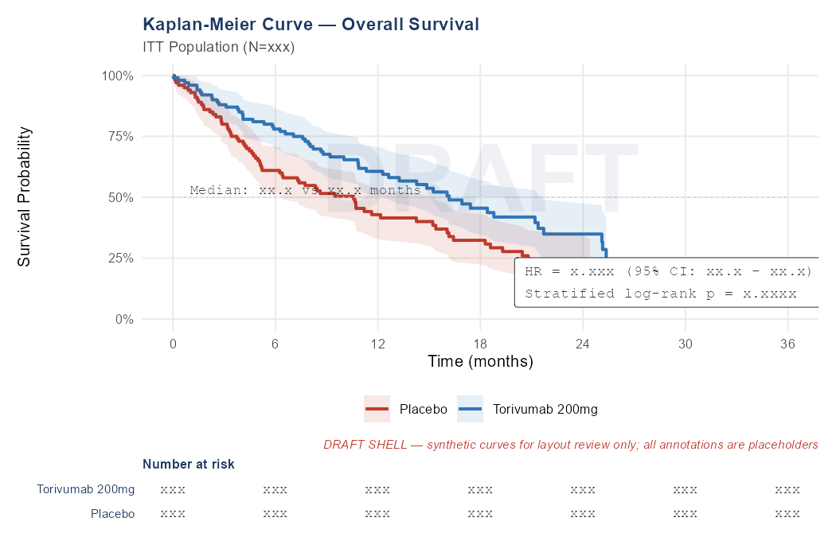

Methodology: Kaplan-Meier Median
Source: ADTTE
SAP reference: §5.1
Notes: One curve per TRT01P.
DRAFT SHELL — 2026-09-20

Programmer's notes (not part of CSR output):
Row | Dataset | Where | Variable | Derivation
x-axis: time in months | ADTTE | PARAMCD='OS' | AVAL | AVAL / 30.4375
y-axis: survival probability | ADTTE | PARAMCD='OS' | AVAL,CNSR | survfit(Surv(AVAL,1-CNSR)~TRT01P+strata(STRAT2,STRAT3)) -> surv
95% CI bands (shaded) | ADTTE | PARAMCD='OS' | AVAL,CNSR | survfit(..., conf.type='log-log') -> lower/upper
Number-at-risk table | ADTTE | PARAMCD='OS' | AVAL | summary(survfit, times=seq(0,36,6)*30.4375) -> n.risk per arm
HR + 95% CI annotation | ADTTE | PARAMCD='OS' | AVAL,CNSR | coxph -> exp(coef) / confint
Stratified log-rank p annotation | ADTTE | PARAMCD='OS' | AVAL,CNSR | survdiff -> p-value

Celindra Therapeutics (fictional)
Protocol TORIVUMAB-NSCLC-301
Output F-EFF-02 | FIGURE
Kaplan-Meier Curve — PFS
Population: Intent-to-Treat Population (N=450)

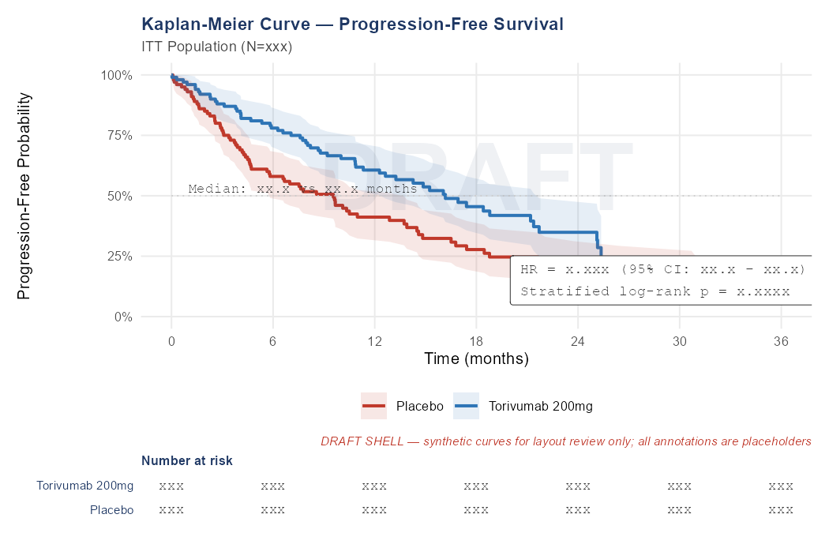

Methodology: Kaplan-Meier Median
Source: ADTTE
SAP reference: §5.2
Notes: Same structure as F-EFF-01 for PFS.
DRAFT SHELL — 2026-09-20

Programmer's notes (not part of CSR output):
Row | Dataset | Where | Variable | Derivation
x-axis: time in months | ADTTE | PARAMCD='PFS' | AVAL | AVAL / 30.4375
y-axis: PFS probability | ADTTE | PARAMCD='PFS' | AVAL,CNSR | survfit(Surv(AVAL,1-CNSR)~TRT01P+strata(STRAT2,STRAT3)) -> surv
95% CI bands (shaded) | ADTTE | PARAMCD='PFS' | AVAL,CNSR | survfit(..., conf.type='log-log') -> lower/upper
Number-at-risk table | ADTTE | PARAMCD='PFS' | AVAL | summary(survfit, times=seq(0,24,6)*30.4375) -> n.risk per arm
HR + 95% CI annotation | ADTTE | PARAMCD='PFS' | AVAL,CNSR | coxph -> exp(coef) / confint
Stratified log-rank p annotation | ADTTE | PARAMCD='PFS' | AVAL,CNSR | survdiff -> p-value

Celindra Therapeutics (fictional)
Protocol TORIVUMAB-NSCLC-301
Output F-EFF-03 | FIGURE
Waterfall — Best Percent Change in SLD
Population: Response Evaluable Population (N=440)

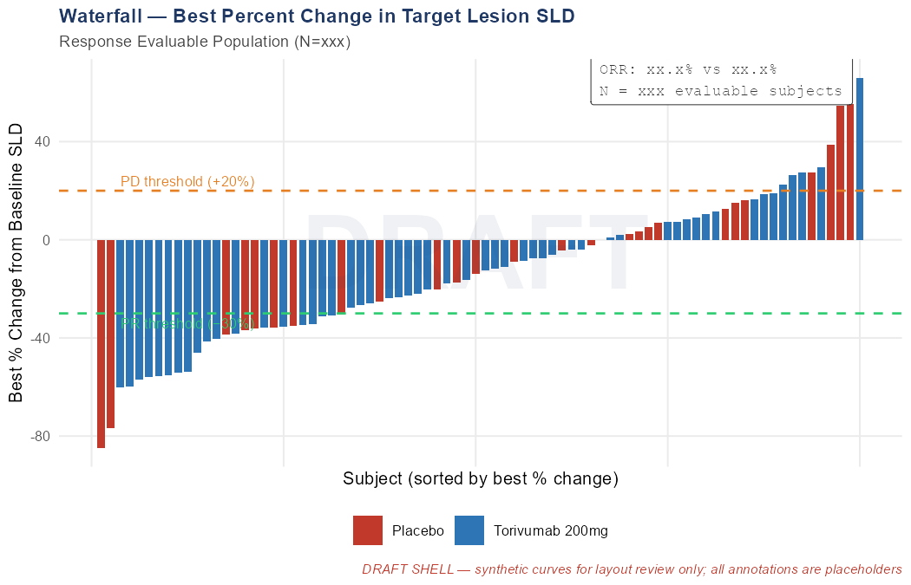

Methodology: Waterfall (Best % Change)
Source: ADTR
SAP reference: §5.3
Notes: Restricted to subjects with measurable disease at baseline.
DRAFT SHELL — 2026-09-20

Programmer's notes (not part of CSR output):
Row | Dataset | Where | Variable | Derivation
x-axis: subject (sorted by best % change desc) | ADTR | PARAMCD='PCHG' AND ANL01FL='Y' | USUBJID | order by AVAL ascending (most negative = best response)
y-axis: best % change from baseline SLD | ADTR | PARAMCD='PCHG' AND ANL01FL='Y' | AVAL | PCHG = (SLD_nadir - SLD_baseline) / SLD_baseline * 100
Bar colour by treatment arm | ADTR | PARAMCD='PCHG' | TRT01P | fill = TRT01P
Reference line at -30% (PR threshold) | — | — | — | geom_hline(yintercept=-30)
Reference line at +20% (PD threshold) | — | — | — | geom_hline(yintercept=20)

Celindra Therapeutics (fictional)
Protocol TORIVUMAB-NSCLC-301
Output F-EFF-04 | FIGURE
Spider — SLD Change Over Time
Population: Response Evaluable Population (N=440)

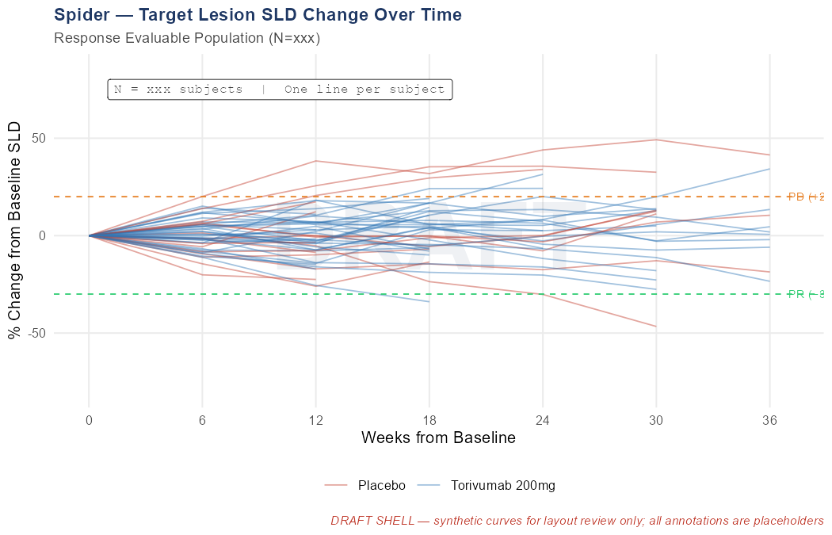

Methodology: Spider (Longitudinal % Change)
Source: ADTR
SAP reference: §5.3
DRAFT SHELL — 2026-09-20

Programmer's notes (not part of CSR output):
Row | Dataset | Where | Variable | Derivation
x-axis: weeks from baseline | ADTR | PARAMCD='PCHG' | ADY | ADY / 7
y-axis: % change from baseline SLD | ADTR | PARAMCD='PCHG' | AVAL | PCHG per visit (not restricted to nadir)
One line per subject | ADTR | PARAMCD='PCHG' | USUBJID | group = USUBJID
Line colour by treatment arm | ADTR | PARAMCD='PCHG' | TRT01P | colour = TRT01P

Celindra Therapeutics (fictional)
Protocol TORIVUMAB-NSCLC-301
Output F-EFF-05 | FIGURE
Forest — OS HR by Subgroup
Population: Intent-to-Treat Population (N=450)

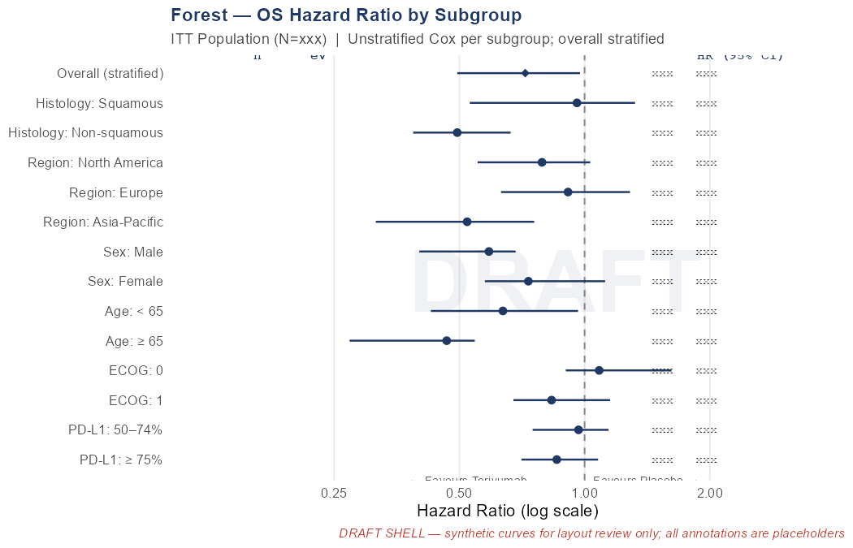

Methodology: Subgroup Forest (Unstratified Cox)
Source: ADSL, ADTTE
SAP reference: §10
Notes: Per-subgroup unstratified Cox HR; overall stratified HR at top. Square size ∝ subgroup n.
DRAFT SHELL — 2026-09-20

Programmer's notes (not part of CSR output):
Row | Dataset | Where | Variable | Derivation
Per-subgroup HR + 95% CI | ADTTE+ADSL | PARAMCD='OS' | AVAL,CNSR,HISTSCAT,REGION1,SEX,AGEGR1,BECOG,PDL1GR † | coxph(Surv(AVAL,1-CNSR)~TRT01P) per subgroup level (unstratified)
n and events per subgroup level | ADTTE+ADSL | PARAMCD='OS' | USUBJID,CNSR | n() and sum(1-CNSR) per subgroup level
Overall HR (diamond) | ADTTE | PARAMCD='OS' | AVAL,CNSR | coxph -> exp(coef) stratified overall (same as T-EFF-01)
x-axis: log-scale HR (0.1 to 10) | — | — | — | scale_x_log10()

Celindra Therapeutics (fictional)
Protocol TORIVUMAB-NSCLC-301
Output F-EFF-06 | FIGURE
Swimmer — Responders
Population: Confirmed Responders Population (N=xxx)

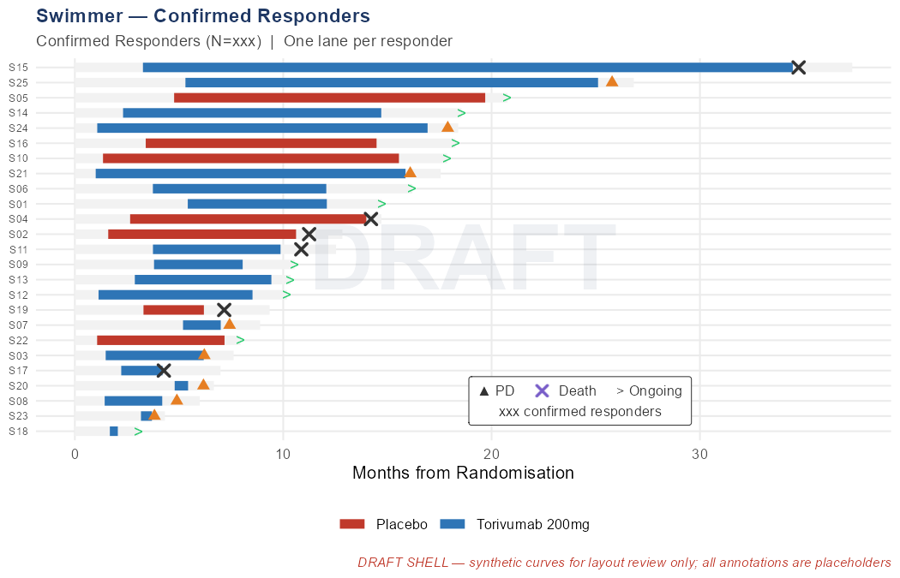

Methodology: Swimmer Lane (Responders)
Source: ADSL, ADRS, ADTTE
SAP reference: §5.4
Notes: Confirmed responders only.
DRAFT SHELL — 2026-09-20

Programmer's notes (not part of CSR output):
Row | Dataset | Where | Variable | Derivation
x-axis: time from randomisation (months) | ADSL | ITTFL='Y' | RANDDT | ADT - RANDDT converted to months
Lane per responder (y-axis) | ADSL | ORRFL='Y' † | USUBJID | one horizontal bar per responder
Response bar start | ADRS | AVALC IN ('CR','PR') AND ANL01FL='Y' | ADT | first response date
Response bar end (PD or censored) | ADTTE | PARAMCD='DOR' | AVAL | start + AVAL days; open arrow if censored
PD event marker | ADRS | AVALC='PD' | ADT | triangle marker at PD date
Death marker | ADSL | DTHFL='Y' | DTHDT | X marker at DTHDT

Celindra Therapeutics (fictional)
Protocol TORIVUMAB-NSCLC-301
Output L-AE-01 | LISTING
Serious Adverse Events
Population: Safety Population (N=450)

USUBJID | TRT01A | AEBODSYS | AEDECOD | ASTDT | AENDT | AETOXGR | AESER | AEACN | AEREL | AEOUT
— | — | — | — | — | — | — | — | — | — | —
— | — | — | — | — | — | — | — | — | — | —
— | — | — | — | — | — | — | — | — | — | —

Source: ADAE
SAP reference: §5.5
Notes: Filtered to AESER='Y'.
DRAFT SHELL — 2026-09-20

Programmer's notes (not part of CSR output):
Row | Dataset | Where | Variable | Derivation
USUBJID | ADAE | AESER='Y' | USUBJID | Subject identifier; sort key 1
TRT01A | ADAE | AESER='Y' | TRT01A | Actual treatment arm
AEBODSYS | ADAE | AESER='Y' | AEBODSYS | MedDRA System Organ Class
AEDECOD | ADAE | AESER='Y' | AEDECOD | MedDRA Preferred Term
ASTDT | ADAE | AESER='Y' | ASTDT | AE start date (ISO 8601); sort key 2
AENDT | ADAE | AESER='Y' | AENDT | AE end date
AETOXGR | ADAE | AESER='Y' | AETOXGR | CTCAE grade at worst severity
AEACN | ADAE | AESER='Y' | AEACN | Action taken with study drug
AEREL | ADAE | AESER='Y' | AEREL | Causal relationship to study drug
AEOUT | ADAE | AESER='Y' | AEOUT | AE outcome

Celindra Therapeutics (fictional)
Protocol TORIVUMAB-NSCLC-301
Output L-AE-02 | LISTING
Deaths
Population: Safety Population (N=450)

USUBJID | TRT01A | DTHDT | DTHCAUS | TRTEDT | RANDDT | EOSSTT
— | — | — | — | — | — | —
— | — | — | — | — | — | —
— | — | — | — | — | — | —

Source: ADSL
SAP reference: §5.5
Notes: Computed columns: days from last dose to death; days from randomisation to death.
DRAFT SHELL — 2026-09-20

Programmer's notes (not part of CSR output):
Row | Dataset | Where | Variable | Derivation
USUBJID | ADSL | DTHFL='Y' | USUBJID | Subject identifier
TRT01A | ADSL | DTHFL='Y' | TRT01A | Actual treatment arm
DTHDT | ADSL | DTHFL='Y' | DTHDT | Date of death (ISO 8601)
DTHCAUS | ADSL | DTHFL='Y' | DTHCAUS | Primary cause of death
TRTEDT | ADSL | DTHFL='Y' | TRTEDT | Last dose date (for days-since-last-dose computation)
RANDDT | ADSL | DTHFL='Y' | RANDDT | Randomisation date (for OS computation)
EOSSTT | ADSL | DTHFL='Y' | EOSSTT | End-of-study status
Computed: days from last dose to death | ADSL | DTHFL='Y' | DTHDT-TRTEDT | DTHDT - TRTEDT (days)
Computed: days from randomisation to death | ADSL | DTHFL='Y' | DTHDT-RANDDT | DTHDT - RANDDT (days)

Celindra Therapeutics (fictional)
Protocol TORIVUMAB-NSCLC-301
Output L-AE-03 | LISTING
AEs Leading to Discontinuation
Population: Safety Population (N=450)

USUBJID | TRT01A | AEDECOD | ASTDT | AETOXGR | AEREL | TRTEDT
— | — | — | — | — | — | —
— | — | — | — | — | — | —
— | — | — | — | — | — | —

Source: ADAE
SAP reference: §5.5
Notes: Filtered to AEACN='DRUG WITHDRAWN'.
DRAFT SHELL — 2026-09-20

Programmer's notes (not part of CSR output):
Row | Dataset | Where | Variable | Derivation
USUBJID | ADAE | AEACN='DRUG WITHDRAWN' | USUBJID | Subject identifier
TRT01A | ADAE | AEACN='DRUG WITHDRAWN' | TRT01A | Actual treatment arm
AEDECOD | ADAE | AEACN='DRUG WITHDRAWN' | AEDECOD | MedDRA Preferred Term
ASTDT | ADAE | AEACN='DRUG WITHDRAWN' | ASTDT | AE start date
AETOXGR | ADAE | AEACN='DRUG WITHDRAWN' | AETOXGR | CTCAE grade at worst severity
AEREL | ADAE | AEACN='DRUG WITHDRAWN' | AEREL | Causal relationship
TRTEDT | ADSL | SAFFL='Y' | TRTEDT | Last dose date

Celindra Therapeutics (fictional)
Protocol TORIVUMAB-NSCLC-301
Output L-LB-01 | LISTING
Grade ≥3 Laboratory Abnormalities
Population: Safety Population (N=450)

USUBJID | TRT01A | PARAMCD | AVISIT | ADT | AVAL | ANRLO | ANRHI | ATOXGR
— | — | — | — | — | — | — | — | —
— | — | — | — | — | — | — | — | —
— | — | — | — | — | — | — | — | —

Source: ADLB
SAP reference: §5.5
Notes: Filtered to ATOXGR ≥ 3.
DRAFT SHELL — 2026-09-20

Programmer's notes (not part of CSR output):
Row | Dataset | Where | Variable | Derivation
USUBJID | ADLB | ATOXGR >= 3 AND ANL01FL='Y' | USUBJID | Subject identifier
TRT01A | ADLB | ATOXGR >= 3 | TRT01A | Actual treatment arm
PARAMCD | ADLB | ATOXGR >= 3 | PARAMCD | Lab test code (e.g. ALT, HGB)
AVISIT | ADLB | ATOXGR >= 3 | AVISIT | Analysis visit label
ADT | ADLB | ATOXGR >= 3 | ADT | Analysis date
AVAL | ADLB | ATOXGR >= 3 | AVAL | Lab result value
ANRLO | ADLB | ATOXGR >= 3 | ANRLO | Normal range lower limit
ANRHI | ADLB | ATOXGR >= 3 | ANRHI | Normal range upper limit
ATOXGR | ADLB | ATOXGR >= 3 | ATOXGR | NCI CTCAE toxicity grade

Celindra Therapeutics (fictional)
Protocol TORIVUMAB-NSCLC-301
Output L-DS-01 | LISTING
Major Protocol Deviations
Population: Intent-to-Treat Population (N=450)

USUBJID | TRT01P | DSSTDTC
— | — | —
— | — | —
— | — | —

Source: SDTM.DS
SAP reference: §3.2
Notes: Filtered to DSDECOD='PROTOCOL DEVIATION' AND DSSCAT='MAJOR'. Shows deviation category and description.
DRAFT SHELL — 2026-09-20

Programmer's notes (not part of CSR output):
Row | Dataset | Where | Variable | Derivation
USUBJID | SDTM.DS | DSDECOD='PROTOCOL DEVIATION' AND DSSCAT='MAJOR' | USUBJID | Subject identifier
TRT01P | ADSL | ITTFL='Y' | TRT01P | Planned treatment arm (from ADSL)
DSSTDTC | SDTM.DS | DSDECOD='PROTOCOL DEVIATION' AND DSSCAT='MAJOR' | DSSTDTC | Deviation date (ISO 8601)
DSDECOD | SDTM.DS | DSDECOD='PROTOCOL DEVIATION' | DSDECOD | Standardised disposition term
DSSCAT | SDTM.DS | DSSCAT='MAJOR' | DSSCAT | Subcategory (MAJOR)
DSTERM | SDTM.DS | DSDECOD='PROTOCOL DEVIATION' AND DSSCAT='MAJOR' | DSTERM | Verbatim deviation description

Celindra Therapeutics (fictional)
Protocol TORIVUMAB-NSCLC-301
Output T-CM-01 | TABLE
Concomitant Medications by Class and Preferred Term
Population: Safety Population (N=450)

[ Mock layout not yet implemented for this output ]

Methodology: Descriptive — Categorical
Source: ADCM
SAP reference: §5.5
Notes: Includes preferred terms with on-treatment incidence >= 5% in either arm. Class grouping from ADCM.CMINDC (curated ATC indication class).
DRAFT SHELL — 2026-09-20

Celindra Therapeutics (fictional)
Protocol TORIVUMAB-NSCLC-301
Output T-VS-01 | TABLE
Vital Signs — Mean Change from Baseline at Key Visits
Population: Safety Population (N=450)

[ Mock layout not yet implemented for this output ]

Methodology: Descriptive — Continuous
Source: ADVS
SAP reference: §5.5
Notes: Change from baseline (ADVS.CHG) at C1D1, C4D1, and End of Treatment.
DRAFT SHELL — 2026-09-20

Celindra Therapeutics (fictional)
Protocol TORIVUMAB-NSCLC-301
Output T-VS-02 | TABLE
Weight Change Categories — Worst On-Treatment % Change
Population: Safety Population (N=450)

[ Mock layout not yet implemented for this output ]

Methodology: Descriptive — Categorical
Source: ADVS
SAP reference: §5.5
Notes: Per-subject worst (most extreme) post-baseline % weight change.
DRAFT SHELL — 2026-09-20

Celindra Therapeutics (fictional)
Protocol TORIVUMAB-NSCLC-301
Output T-MH-01 | TABLE
Medical History by Category and Term
Population: Safety Population (N=450)

[ Mock layout not yet implemented for this output ]

Methodology: Descriptive — Categorical
Source: ADMH
SAP reference: §5.5
Notes: Synthetic-data note — MHDECOD is title-case verbatim, not MedDRA-coded.
DRAFT SHELL — 2026-09-20

Celindra Therapeutics (fictional)
Protocol TORIVUMAB-NSCLC-301
Output T-DV-01 | TABLE
Protocol Deviations — Detail
Population: Intent-to-Treat Population (N=450)

[ Mock layout not yet implemented for this output ]

Methodology: Descriptive — Categorical
Source: ADDV
SAP reference: §3.2
Notes: Supersedes the sparser T-DS-02 view; uses ADDV instead of raw ADSL.PPROTFL.
DRAFT SHELL — 2026-09-20

