SIMULATED-TORIVUMAB-2026
TFL Outputs — Phase 6a pilot

Celindra Therapeutics (fictional)
Protocol TORIVUMAB-NSCLC-301
Data cutoff: 2025-01-31

Contents (43 outputs):
• T-DM-01 — Demographic and Baseline Characteristics
• T-DS-01 — Subject Disposition
• T-DS-02 — Major Protocol Deviations
• T-DS-03 — Intercurrent Events Summary
• T-EX-01 — Study Drug Exposure
• T-EFF-01 — Overall Survival Analysis (Primary)
• T-EFF-02 — Kaplan-Meier Survival Probabilities — OS
• T-EFF-03 — Progression-Free Survival Analysis (BICR)
• T-EFF-04 — Kaplan-Meier Survival Probabilities — PFS
• T-EFF-05 — Objective Response Rate
• T-EFF-06 — Disease Control Rate
• T-EFF-07 — Duration of Response
• T-EFF-08 — OS in Per-Protocol Population (Sensitivity)
• T-EFF-09 — OS Landmark Analysis (Sensitivity)
• T-EFF-10 — Restricted Mean Survival Time — OS (E1a)
• T-EFF-11 — PFS by Investigator (Sensitivity, E2a)
• T-EFF-12 — OS — While-on-Treatment Sensitivity (E1b)
• T-EFF-13 — ORR — ITT Denominator (Sensitivity, E3a)
• F-EFF-01 — Kaplan-Meier Curve — Overall Survival
• F-EFF-02 — Kaplan-Meier Curve — Progression-Free Survival
• F-EFF-03 — Waterfall — Best % Change in Sum of Diameters
• F-EFF-04 — Spider — Sum of Diameters Over Time
• F-EFF-05 — Forest — OS HR by Subgroup
• F-EFF-06 — Swimmer — Responder Timelines
• T-AE-01 — Overall Summary of Adverse Events
• T-AE-02 — TEAEs by SOC and PT (≥5% any arm)
• T-AE-03 — Grade ≥3 TEAEs by SOC and PT
• T-AE-04 — Serious Adverse Events by SOC and PT
• T-AE-05 — Immune-Related Adverse Events
• T-AE-06 — Adverse Events of Special Interest
• T-AE-07 — Deaths
• T-LB-01 — Laboratory Abnormalities Shift
• T-LB-02 — Laboratory CTCAE Grade ≥3
• L-AE-01 — Listing of Serious Adverse Events
• L-AE-02 — Listing of Deaths
• L-AE-03 — Listing of AEs Leading to Discontinuation
• L-LB-01 — Listing of Grade ≥3 Lab Abnormalities
• L-DS-01 — Listing of Major Protocol Deviations
• T-CM-01 — Concomitant Medications by Class and PT
• T-VS-01 — Vital Signs — Mean Change at Key Visits
• T-VS-02 — Weight Change Categories
• T-MH-01 — Medical History by Category and Term
• T-DV-01 — Protocol Deviations — Detail

DRAFT — produced 2026-09-20 — synthetic data, NOT for regulatory submission

Celindra Therapeutics (fictional)
Protocol TORIVUMAB-NSCLC-301
T-DM-01
Demographic and Baseline Characteristics

→ See tfl/tables/T-DM-01.docx for the formatted table.

DRAFT — produced 2026-09-20 — synthetic data, NOT for regulatory submission

Celindra Therapeutics (fictional)
Protocol TORIVUMAB-NSCLC-301
T-DS-01
Subject Disposition

→ See tfl/tables/T-DS-01.docx for the formatted table.

DRAFT — produced 2026-09-20 — synthetic data, NOT for regulatory submission

Celindra Therapeutics (fictional)
Protocol TORIVUMAB-NSCLC-301
T-DS-02
Major Protocol Deviations

→ See tfl/tables/T-DS-02.docx for the formatted table.

DRAFT — produced 2026-09-20 — synthetic data, NOT for regulatory submission

Celindra Therapeutics (fictional)
Protocol TORIVUMAB-NSCLC-301
T-DS-03
Intercurrent Events Summary

→ See tfl/tables/T-DS-03.docx for the formatted table.

DRAFT — produced 2026-09-20 — synthetic data, NOT for regulatory submission

Celindra Therapeutics (fictional)
Protocol TORIVUMAB-NSCLC-301
T-EX-01
Study Drug Exposure

→ See tfl/tables/T-EX-01.docx for the formatted table.

DRAFT — produced 2026-09-20 — synthetic data, NOT for regulatory submission

Celindra Therapeutics (fictional)
Protocol TORIVUMAB-NSCLC-301
T-EFF-01
Overall Survival Analysis (Primary)

→ See tfl/tables/T-EFF-01.docx for the formatted table.

DRAFT — produced 2026-09-20 — synthetic data, NOT for regulatory submission

Celindra Therapeutics (fictional)
Protocol TORIVUMAB-NSCLC-301
T-EFF-02
Kaplan-Meier Survival Probabilities — OS

→ See tfl/tables/T-EFF-02.docx for the formatted table.

DRAFT — produced 2026-09-20 — synthetic data, NOT for regulatory submission

Celindra Therapeutics (fictional)
Protocol TORIVUMAB-NSCLC-301
T-EFF-03
Progression-Free Survival Analysis (BICR)

→ See tfl/tables/T-EFF-03.docx for the formatted table.

DRAFT — produced 2026-09-20 — synthetic data, NOT for regulatory submission

Celindra Therapeutics (fictional)
Protocol TORIVUMAB-NSCLC-301
T-EFF-04
Kaplan-Meier Survival Probabilities — PFS

→ See tfl/tables/T-EFF-04.docx for the formatted table.

DRAFT — produced 2026-09-20 — synthetic data, NOT for regulatory submission

Celindra Therapeutics (fictional)
Protocol TORIVUMAB-NSCLC-301
T-EFF-05
Objective Response Rate

→ See tfl/tables/T-EFF-05.docx for the formatted table.

DRAFT — produced 2026-09-20 — synthetic data, NOT for regulatory submission

Celindra Therapeutics (fictional)
Protocol TORIVUMAB-NSCLC-301
T-EFF-06
Disease Control Rate

→ See tfl/tables/T-EFF-06.docx for the formatted table.

DRAFT — produced 2026-09-20 — synthetic data, NOT for regulatory submission

Celindra Therapeutics (fictional)
Protocol TORIVUMAB-NSCLC-301
T-EFF-07
Duration of Response

→ See tfl/tables/T-EFF-07.docx for the formatted table.

DRAFT — produced 2026-09-20 — synthetic data, NOT for regulatory submission

Celindra Therapeutics (fictional)
Protocol TORIVUMAB-NSCLC-301
T-EFF-08
OS in Per-Protocol Population (Sensitivity)

→ See tfl/tables/T-EFF-08.docx for the formatted table.

DRAFT — produced 2026-09-20 — synthetic data, NOT for regulatory submission

Celindra Therapeutics (fictional)
Protocol TORIVUMAB-NSCLC-301
T-EFF-09
OS Landmark Analysis (Sensitivity)

→ See tfl/tables/T-EFF-09.docx for the formatted table.

DRAFT — produced 2026-09-20 — synthetic data, NOT for regulatory submission

Celindra Therapeutics (fictional)
Protocol TORIVUMAB-NSCLC-301
T-EFF-10
Restricted Mean Survival Time — OS (E1a)

→ See tfl/tables/T-EFF-10.docx for the formatted table.

DRAFT — produced 2026-09-20 — synthetic data, NOT for regulatory submission

Celindra Therapeutics (fictional)
Protocol TORIVUMAB-NSCLC-301
T-EFF-11
PFS by Investigator (Sensitivity, E2a)

→ See tfl/tables/T-EFF-11.docx for the formatted table.

DRAFT — produced 2026-09-20 — synthetic data, NOT for regulatory submission

Celindra Therapeutics (fictional)
Protocol TORIVUMAB-NSCLC-301
T-EFF-12
OS — While-on-Treatment Sensitivity (E1b)

→ See tfl/tables/T-EFF-12.docx for the formatted table.

DRAFT — produced 2026-09-20 — synthetic data, NOT for regulatory submission

Celindra Therapeutics (fictional)
Protocol TORIVUMAB-NSCLC-301
T-EFF-13
ORR — ITT Denominator (Sensitivity, E3a)

→ See tfl/tables/T-EFF-13.docx for the formatted table.

DRAFT — produced 2026-09-20 — synthetic data, NOT for regulatory submission

Celindra Therapeutics (fictional)
Protocol TORIVUMAB-NSCLC-301
F-EFF-01
Kaplan-Meier Curve — Overall Survival

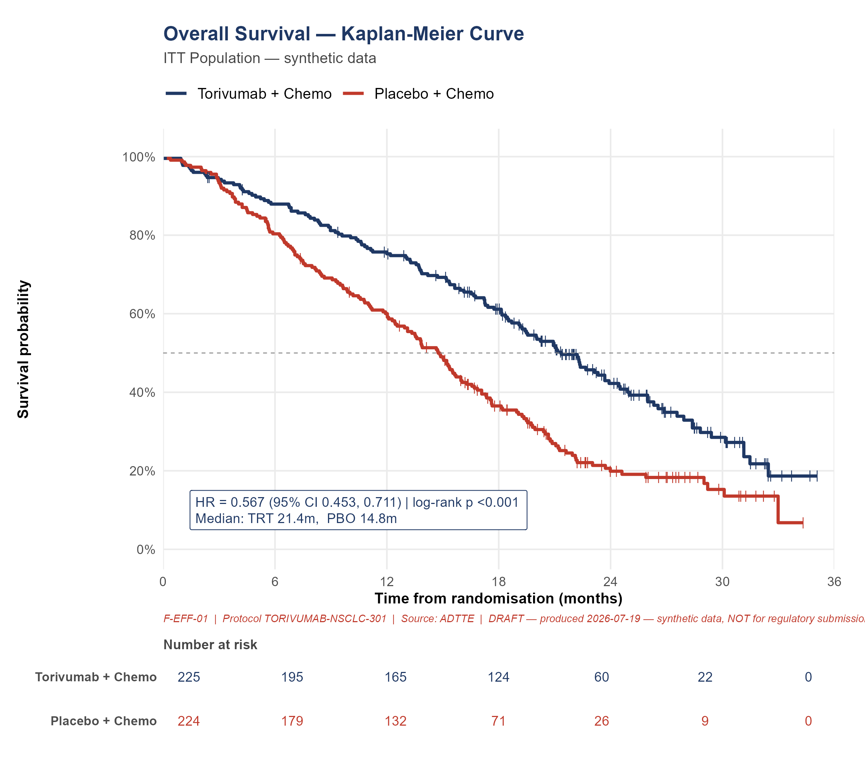

DRAFT — produced 2026-09-20 — synthetic data, NOT for regulatory submission

Celindra Therapeutics (fictional)
Protocol TORIVUMAB-NSCLC-301
F-EFF-02
Kaplan-Meier Curve — Progression-Free Survival

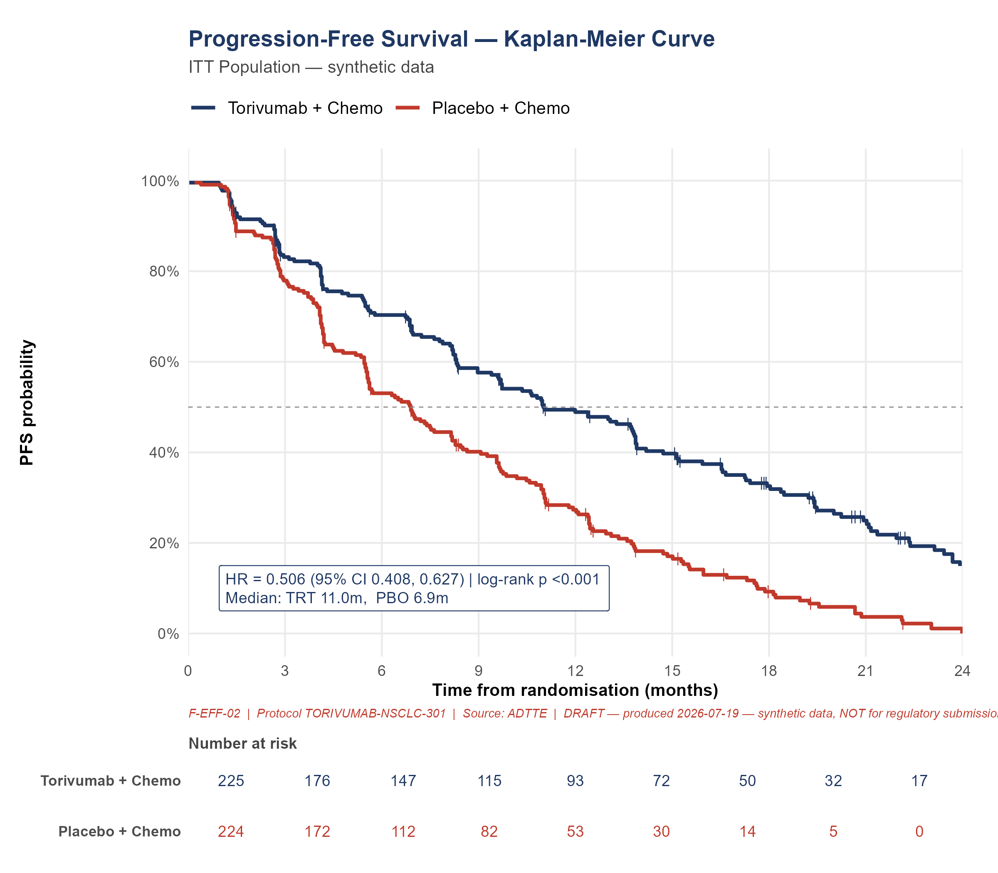

DRAFT — produced 2026-09-20 — synthetic data, NOT for regulatory submission

Celindra Therapeutics (fictional)
Protocol TORIVUMAB-NSCLC-301
F-EFF-03
Waterfall — Best % Change in Sum of Diameters

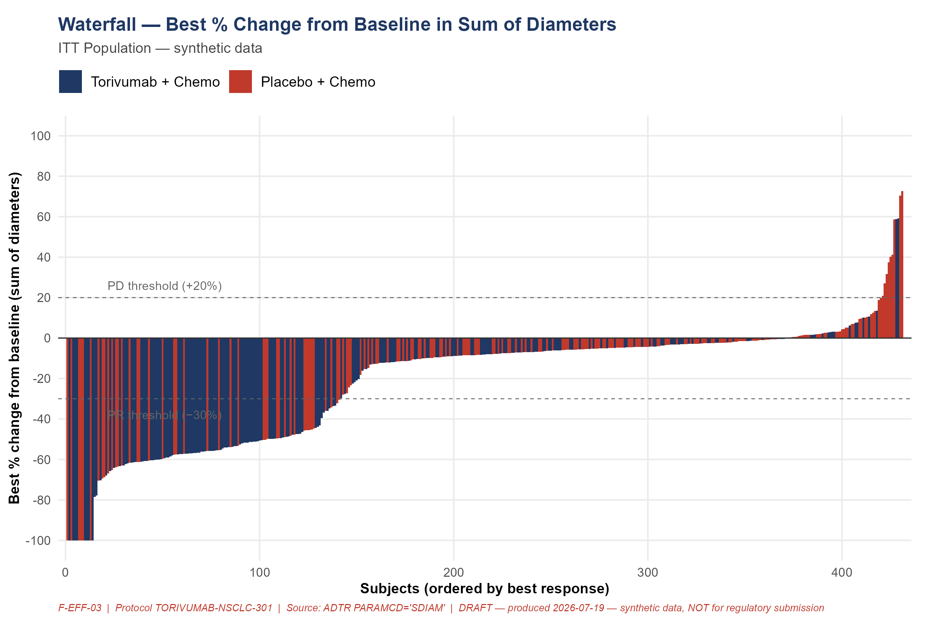

DRAFT — produced 2026-09-20 — synthetic data, NOT for regulatory submission

Celindra Therapeutics (fictional)
Protocol TORIVUMAB-NSCLC-301
F-EFF-04
Spider — Sum of Diameters Over Time

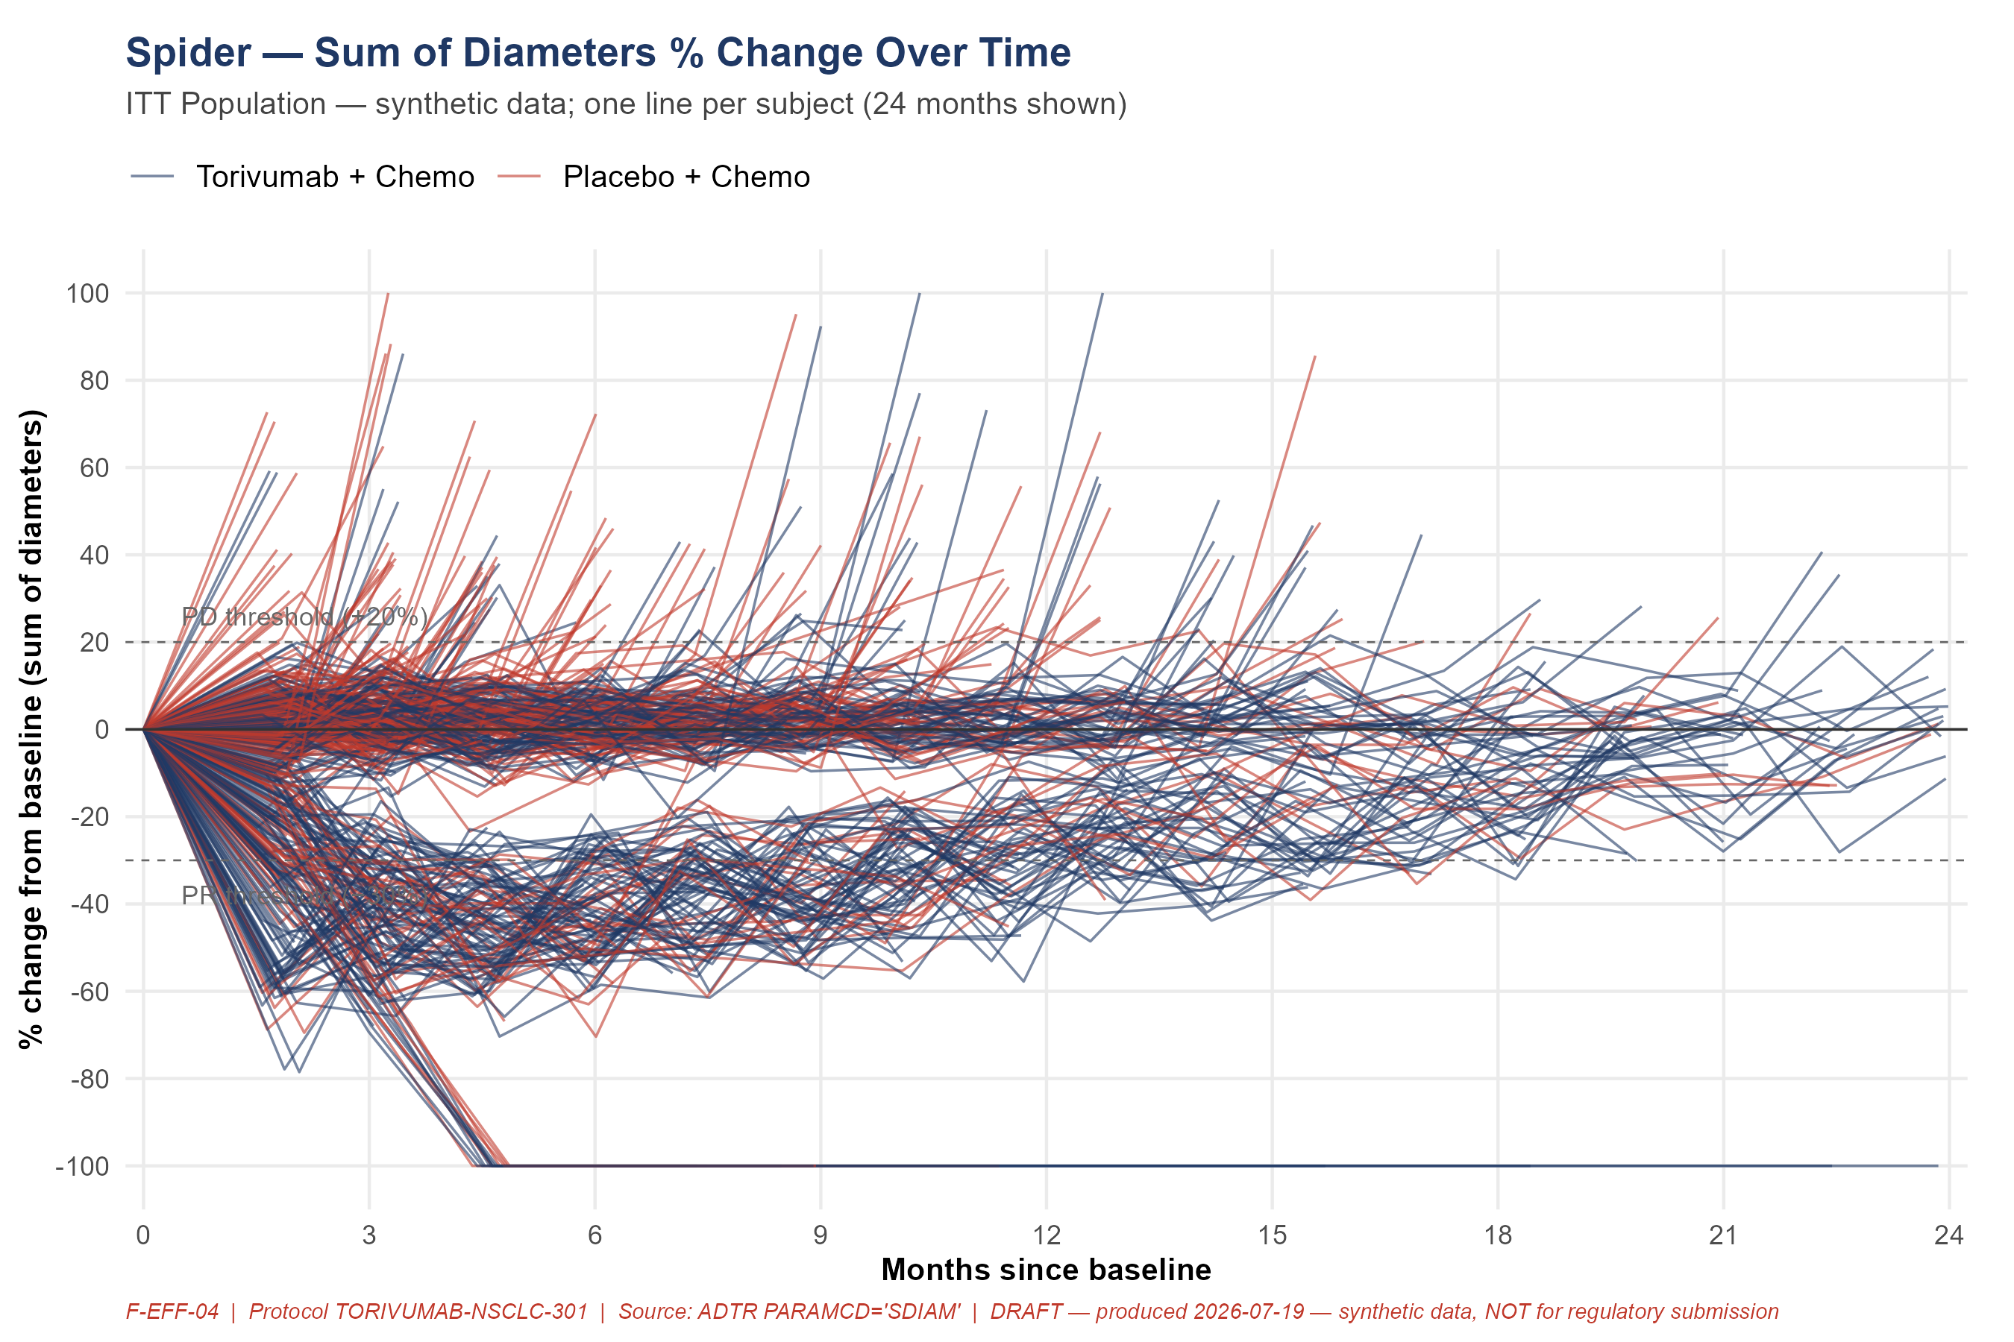

DRAFT — produced 2026-09-20 — synthetic data, NOT for regulatory submission

Celindra Therapeutics (fictional)
Protocol TORIVUMAB-NSCLC-301
F-EFF-05
Forest — OS HR by Subgroup

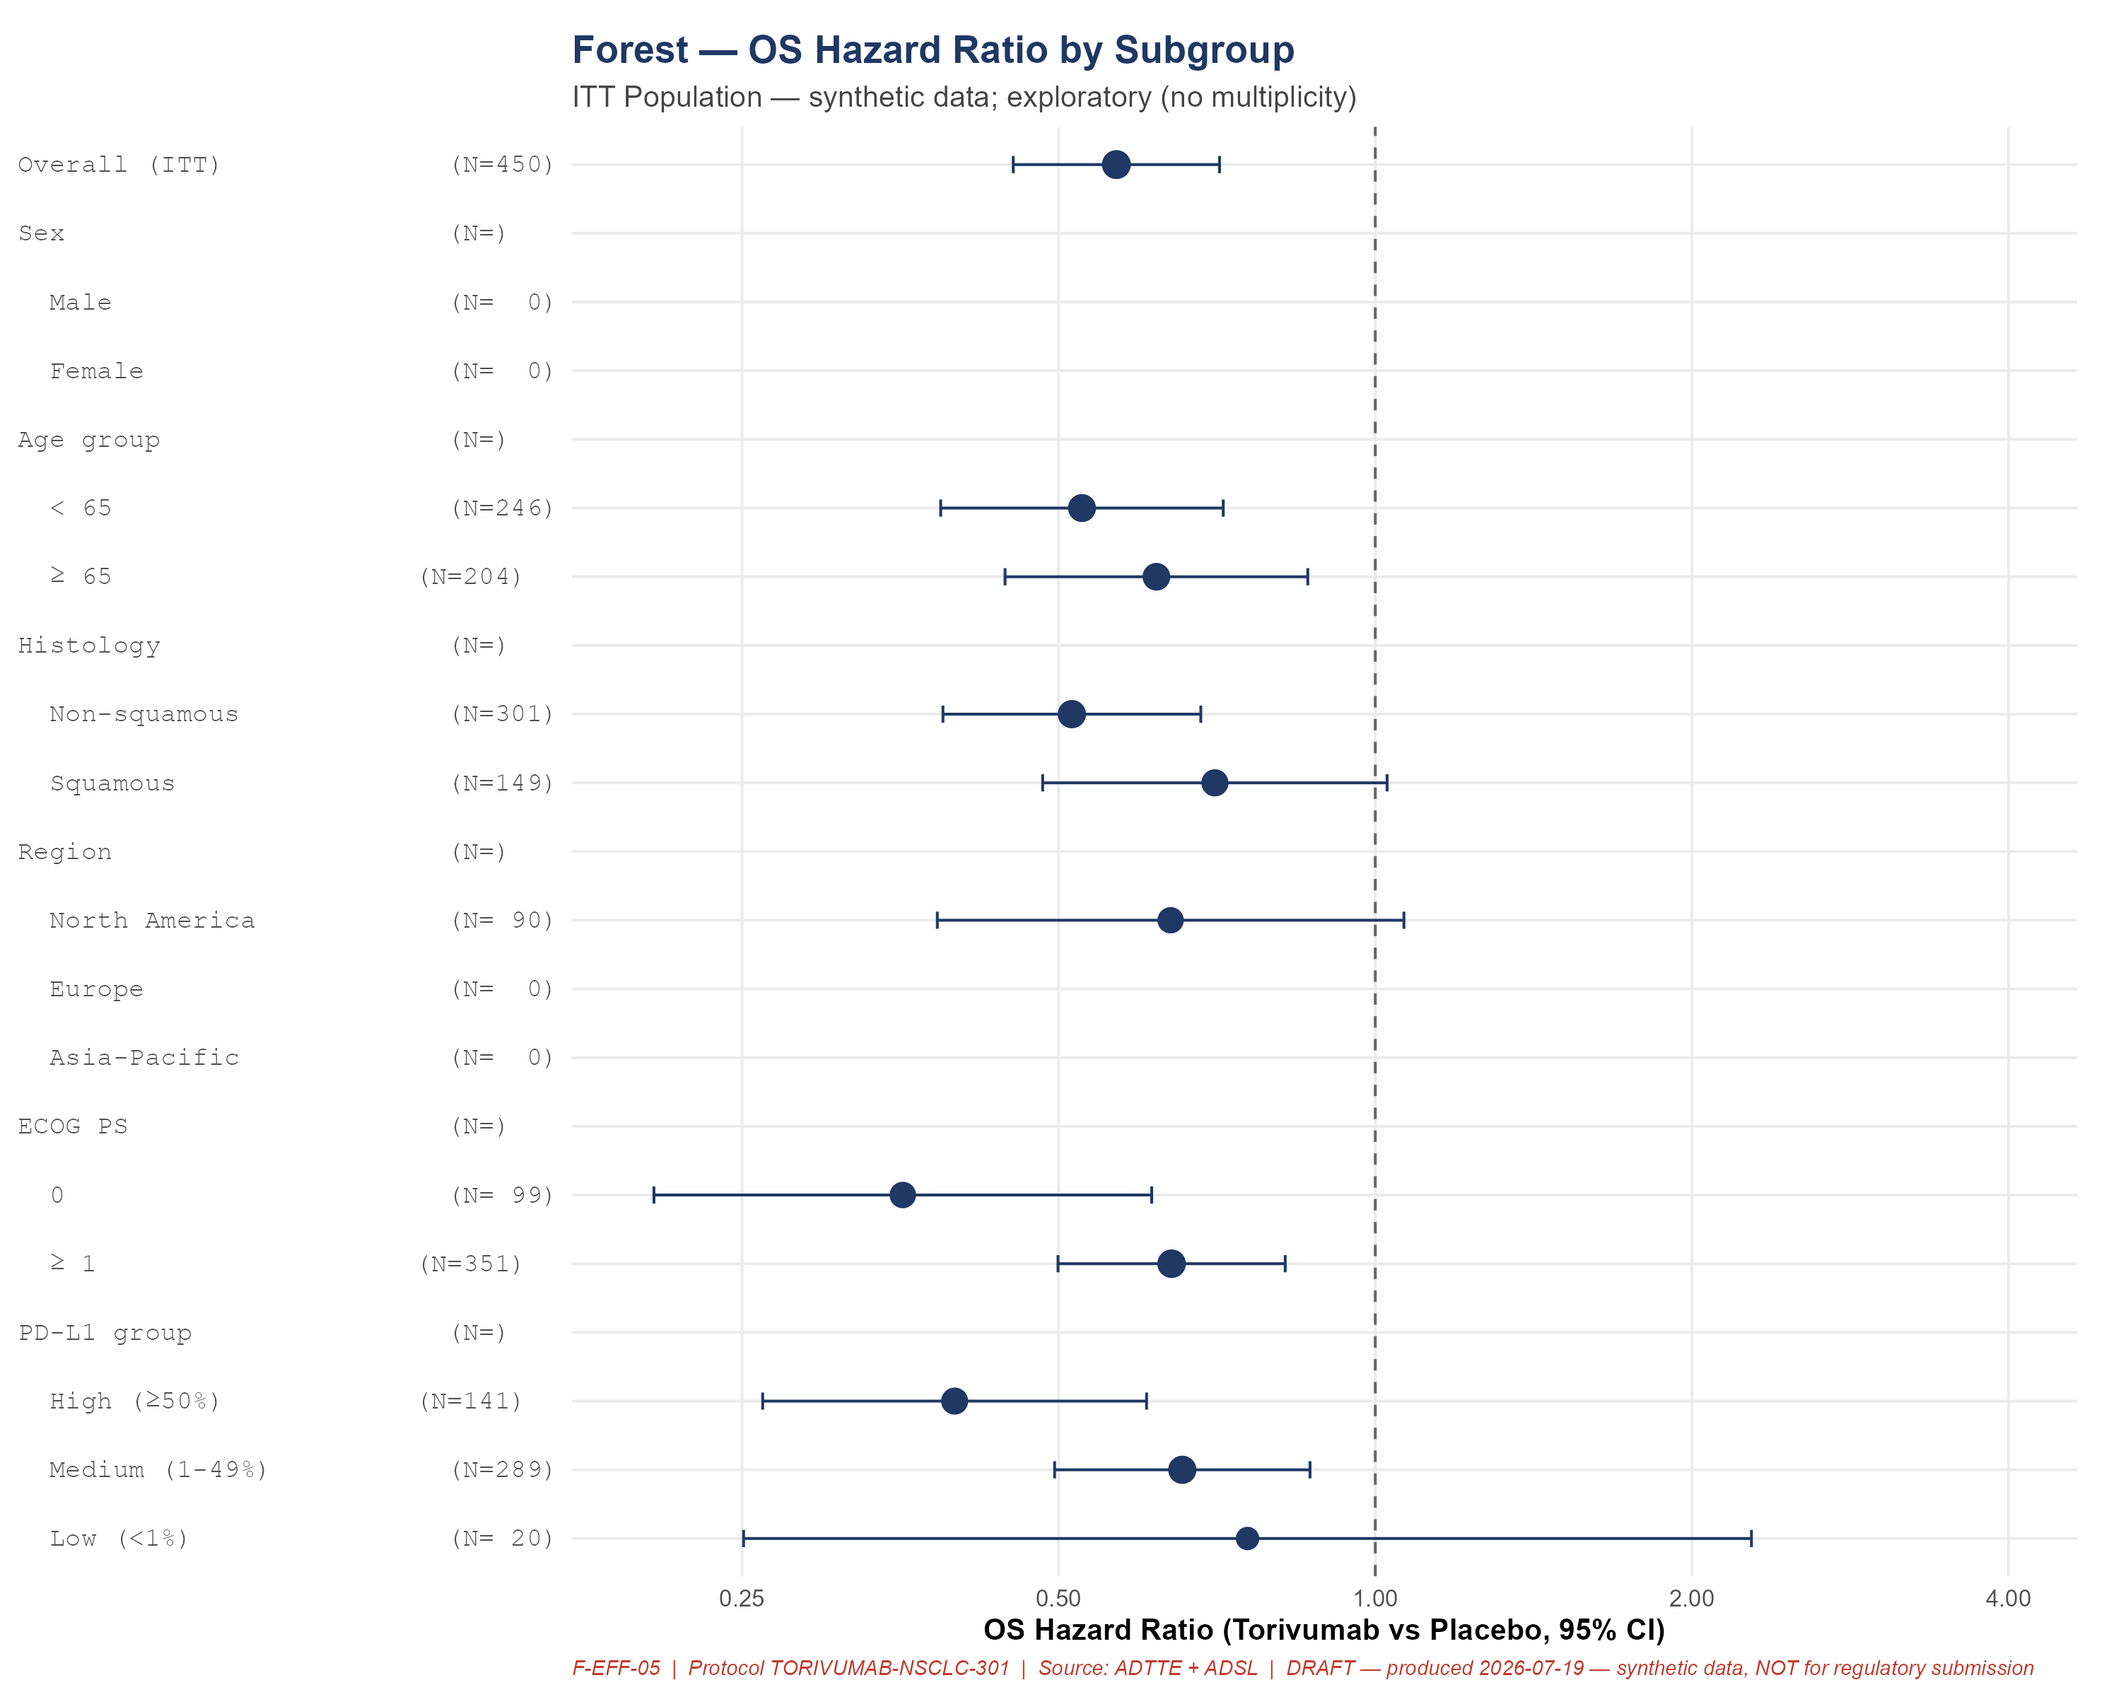

DRAFT — produced 2026-09-20 — synthetic data, NOT for regulatory submission

Celindra Therapeutics (fictional)
Protocol TORIVUMAB-NSCLC-301
F-EFF-06
Swimmer — Responder Timelines

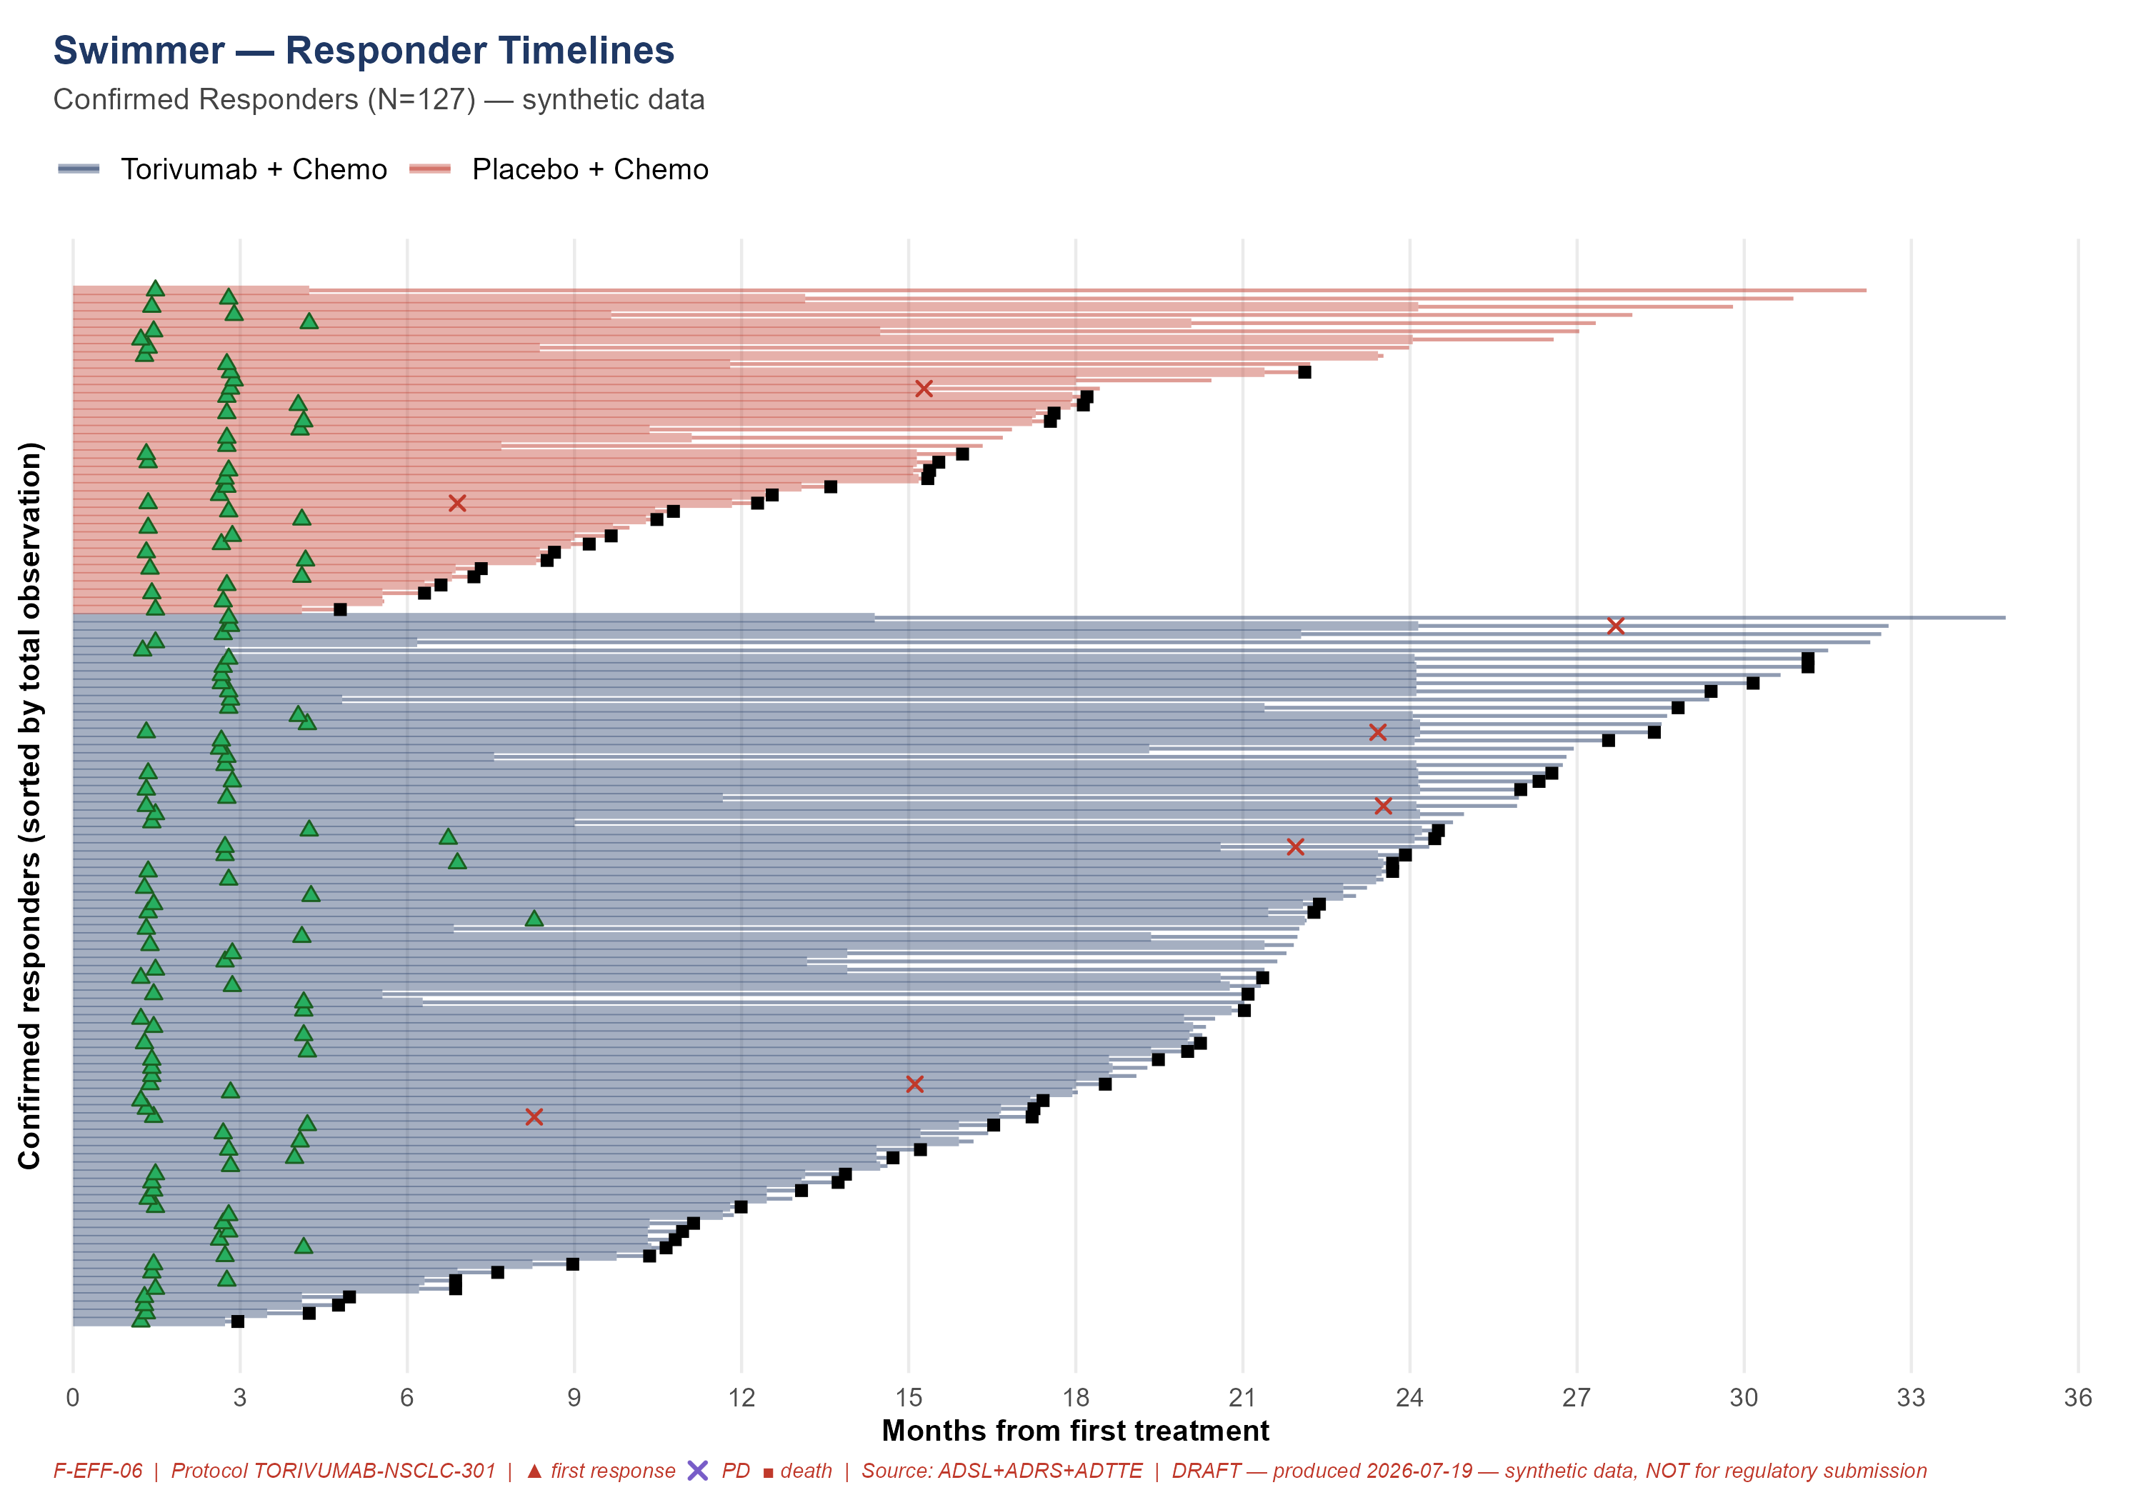

DRAFT — produced 2026-09-20 — synthetic data, NOT for regulatory submission

Celindra Therapeutics (fictional)
Protocol TORIVUMAB-NSCLC-301
T-AE-01
Overall Summary of Adverse Events

→ See tfl/tables/T-AE-01.docx for the formatted table.

DRAFT — produced 2026-09-20 — synthetic data, NOT for regulatory submission

Celindra Therapeutics (fictional)
Protocol TORIVUMAB-NSCLC-301
T-AE-02
TEAEs by SOC and PT (≥5% any arm)

→ See tfl/tables/T-AE-02.docx for the formatted table.

DRAFT — produced 2026-09-20 — synthetic data, NOT for regulatory submission

Celindra Therapeutics (fictional)
Protocol TORIVUMAB-NSCLC-301
T-AE-03
Grade ≥3 TEAEs by SOC and PT

→ See tfl/tables/T-AE-03.docx for the formatted table.

DRAFT — produced 2026-09-20 — synthetic data, NOT for regulatory submission

Celindra Therapeutics (fictional)
Protocol TORIVUMAB-NSCLC-301
T-AE-04
Serious Adverse Events by SOC and PT

→ See tfl/tables/T-AE-04.docx for the formatted table.

DRAFT — produced 2026-09-20 — synthetic data, NOT for regulatory submission

Celindra Therapeutics (fictional)
Protocol TORIVUMAB-NSCLC-301
T-AE-05
Immune-Related Adverse Events

→ See tfl/tables/T-AE-05.docx for the formatted table.

DRAFT — produced 2026-09-20 — synthetic data, NOT for regulatory submission

Celindra Therapeutics (fictional)
Protocol TORIVUMAB-NSCLC-301
T-AE-06
Adverse Events of Special Interest

→ See tfl/tables/T-AE-06.docx for the formatted table.

DRAFT — produced 2026-09-20 — synthetic data, NOT for regulatory submission

Celindra Therapeutics (fictional)
Protocol TORIVUMAB-NSCLC-301
T-AE-07
Deaths

→ See tfl/tables/T-AE-07.docx for the formatted table.

DRAFT — produced 2026-09-20 — synthetic data, NOT for regulatory submission

Celindra Therapeutics (fictional)
Protocol TORIVUMAB-NSCLC-301
T-LB-01
Laboratory Abnormalities Shift

→ See tfl/tables/T-LB-01.docx for the formatted table.

DRAFT — produced 2026-09-20 — synthetic data, NOT for regulatory submission

Celindra Therapeutics (fictional)
Protocol TORIVUMAB-NSCLC-301
T-LB-02
Laboratory CTCAE Grade ≥3

→ See tfl/tables/T-LB-02.docx for the formatted table.

DRAFT — produced 2026-09-20 — synthetic data, NOT for regulatory submission

Celindra Therapeutics (fictional)
Protocol TORIVUMAB-NSCLC-301
L-AE-01
Listing of Serious Adverse Events

→ See tfl/tables/L-AE-01.docx for the formatted table.

DRAFT — produced 2026-09-20 — synthetic data, NOT for regulatory submission

Celindra Therapeutics (fictional)
Protocol TORIVUMAB-NSCLC-301
L-AE-02
Listing of Deaths

→ See tfl/tables/L-AE-02.docx for the formatted table.

DRAFT — produced 2026-09-20 — synthetic data, NOT for regulatory submission

Celindra Therapeutics (fictional)
Protocol TORIVUMAB-NSCLC-301
L-AE-03
Listing of AEs Leading to Discontinuation

→ See tfl/tables/L-AE-03.docx for the formatted table.

DRAFT — produced 2026-09-20 — synthetic data, NOT for regulatory submission

Celindra Therapeutics (fictional)
Protocol TORIVUMAB-NSCLC-301
L-LB-01
Listing of Grade ≥3 Lab Abnormalities

→ See tfl/tables/L-LB-01.docx for the formatted table.

DRAFT — produced 2026-09-20 — synthetic data, NOT for regulatory submission

Celindra Therapeutics (fictional)
Protocol TORIVUMAB-NSCLC-301
L-DS-01
Listing of Major Protocol Deviations

→ See tfl/tables/L-DS-01.docx for the formatted table.

DRAFT — produced 2026-09-20 — synthetic data, NOT for regulatory submission

Celindra Therapeutics (fictional)
Protocol TORIVUMAB-NSCLC-301
T-CM-01
Concomitant Medications by Class and PT

→ See tfl/tables/T-CM-01.docx for the formatted table.

DRAFT — produced 2026-09-20 — synthetic data, NOT for regulatory submission

Celindra Therapeutics (fictional)
Protocol TORIVUMAB-NSCLC-301
T-VS-01
Vital Signs — Mean Change at Key Visits

→ See tfl/tables/T-VS-01.docx for the formatted table.

DRAFT — produced 2026-09-20 — synthetic data, NOT for regulatory submission

Celindra Therapeutics (fictional)
Protocol TORIVUMAB-NSCLC-301
T-VS-02
Weight Change Categories

→ See tfl/tables/T-VS-02.docx for the formatted table.

DRAFT — produced 2026-09-20 — synthetic data, NOT for regulatory submission

Celindra Therapeutics (fictional)
Protocol TORIVUMAB-NSCLC-301
T-MH-01
Medical History by Category and Term

→ See tfl/tables/T-MH-01.docx for the formatted table.

DRAFT — produced 2026-09-20 — synthetic data, NOT for regulatory submission

Celindra Therapeutics (fictional)
Protocol TORIVUMAB-NSCLC-301
T-DV-01
Protocol Deviations — Detail

→ See tfl/tables/T-DV-01.docx for the formatted table.

DRAFT — produced 2026-09-20 — synthetic data, NOT for regulatory submission

