SIMULATED-TORIVUMAB-2026
TFL Outputs — Phase 6a pilot

Celindra Therapeutics (fictional)
Protocol TORIVUMAB-NSCLC-301
Data cutoff: 2025-01-31

Contents (5 outputs):
• T-DM-01 — Demographic and Baseline Characteristics
• T-EFF-01 — Overall Survival Analysis (Primary)
• T-EFF-03 — Progression-Free Survival Analysis (BICR)
• F-EFF-01 — Kaplan-Meier Curve — Overall Survival
• F-EFF-02 — Kaplan-Meier Curve — Progression-Free Survival

DRAFT — produced 2026-05-16 — synthetic data, NOT for regulatory submission

Celindra Therapeutics (fictional)
Protocol TORIVUMAB-NSCLC-301
T-DM-01
Demographic and Baseline Characteristics

→ See tfl/tables/T-DM-01.docx for the formatted table.

DRAFT — produced 2026-05-16 — synthetic data, NOT for regulatory submission

Celindra Therapeutics (fictional)
Protocol TORIVUMAB-NSCLC-301
T-EFF-01
Overall Survival Analysis (Primary)

→ See tfl/tables/T-EFF-01.docx for the formatted table.

DRAFT — produced 2026-05-16 — synthetic data, NOT for regulatory submission

Celindra Therapeutics (fictional)
Protocol TORIVUMAB-NSCLC-301
T-EFF-03
Progression-Free Survival Analysis (BICR)

→ See tfl/tables/T-EFF-03.docx for the formatted table.

DRAFT — produced 2026-05-16 — synthetic data, NOT for regulatory submission

Celindra Therapeutics (fictional)
Protocol TORIVUMAB-NSCLC-301
F-EFF-01
Kaplan-Meier Curve — Overall Survival

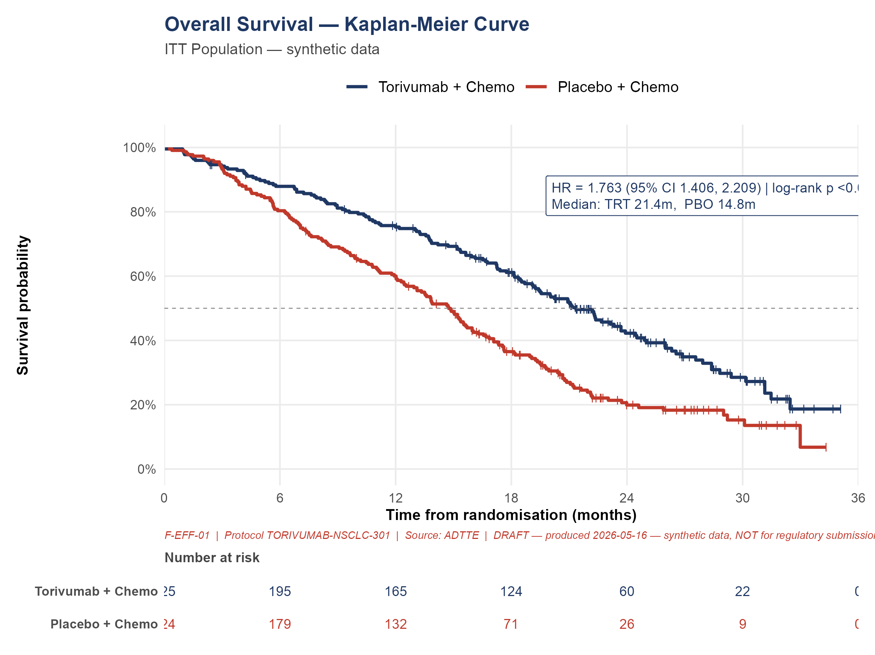

DRAFT — produced 2026-05-16 — synthetic data, NOT for regulatory submission

Celindra Therapeutics (fictional)
Protocol TORIVUMAB-NSCLC-301
F-EFF-02
Kaplan-Meier Curve — Progression-Free Survival

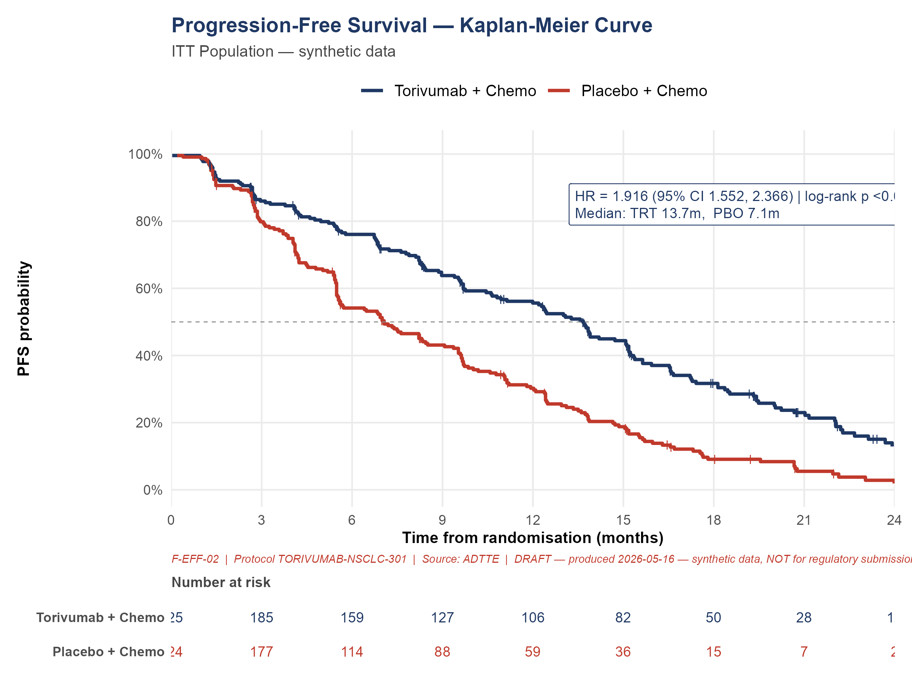

DRAFT — produced 2026-05-16 — synthetic data, NOT for regulatory submission

