OpenVALE Documentation

Table of Contents

- User Guide
- Configuration Settings
- Command List
- Error Codes

User Guide

Contents of the OpenVALE folder:
- OpenVALE.exe
- OpenVALE executable
- OpenVALE_Data
- Folder containing the runtime files for OpenVALE, must be in the same folder as OpenVALE.exe
- UnityPlayer.dll
- Runtime library for the Unity Player, must be in the same folder as OpenVALE.exe
- OpenVALEConfig.xml
- Contains configuration settings for OpenVALE
- DemoServer
- Contains AudioServer3 with settings for running with OpenVALE.

When you first open OpenVALE.exe you should see :

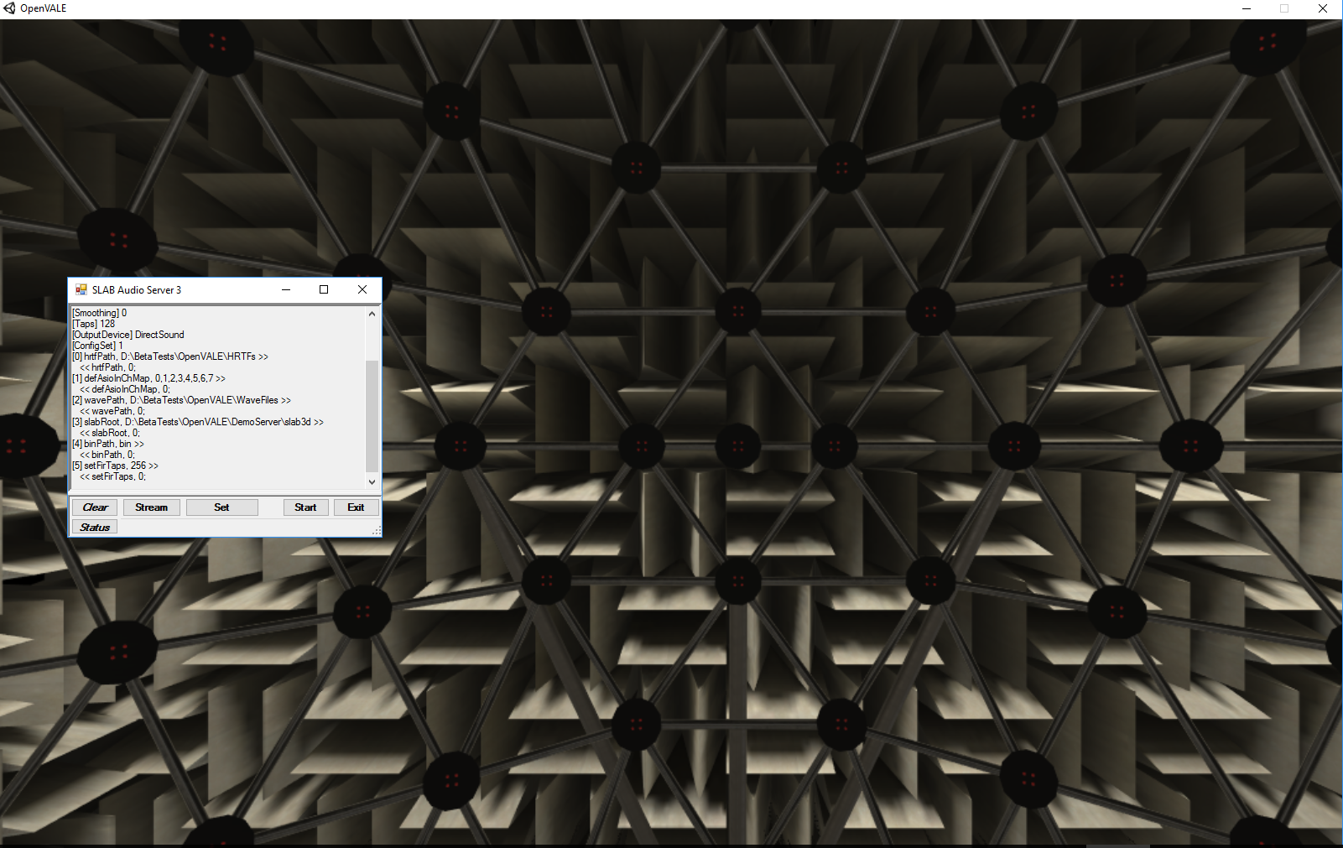
To test whether OpenVALE is working, run the demo script included (Matlab and Python formats).

All coordinate values for position should be passed and returned as Front,Left,Top (FLT). Positive forward,left,up.

Configuration Settings

Filename:
OpenVALEConfig.xml

Format example:
<setting name="SpatialAudioServerRootDir" serializeAs="string">
<value>./DemoServer</value>
</setting>

List of values:
SpatialAudioServerRootDir
- Only supports absolute path or relative subfolders

SpatialAudioEngineType
- Possible values "AudioServer3" or "SlabServer"

HRTFDirectory
- Absolute path to folder containing HRTFs

WavPath
- Absolute path to folder containing .wav files

ASIOInputChannels
- Comma seperated list of integers.
- Zero based
- Example : 0,1,2,3

LevelName
- Name of a level built in the OpenVALE
- If blank will use Virtual ALF

HMDType
- Possible values "Rift", “Vive”, or "None"
      - If blank will default to Rift

Command List

All commands that the return format of commandname,status code,return values. (ie AddAudioSource will return AddAudioSource,0,1)

Pre-render

hrtfID = loadHRTF(filename)
- Loads an HRTF file
- if successful will return the OpenVALE ID for the HRTF which can be used for future calls
- Example 1: loadHRTF(KEMAR.slh)

srcID = addAudioSource(Type, initialPosition, HRTFid, extraParams)
- Initializes source in the sound engine and returns the OpenVALE reference for the source
- Current supported values for Type are: wav, noiseGen, ASIO
- InitialPosition is of format [f,l,t]
- extraParams for wav source filename=wavname.wav
- extraParams for asio source number of channels integer
- Example 1: addAudioSource(wav,[2,0,1],0,filename=wavname.wav)
- Example 2: addAudioSource(noiseGen,[3,1,3],0)
- Example 3: addAudioSource(asio,[3,1,3],0,6)

err = startRendering
- Sets the sound engine to render mode
- All unmuted and enabled source begin play
- Example startRendering()

err = defineFront
- define the origin of position and azimuth based on the HMDs current orientation and position

During Render Commands

err = enableSrc(srcID,T/F)
- Enable or disable a source based on the boolean passed
- Example enableSrc(1,T)

err = setHRTF(sourceNumber,HRTFid)
- Assign an HRTF to the source
- Example setHRTF(0,0)

err = adjustSourceLevel(srcID,relativeLevel)
- Adjust the relative level of an audio source
- srcID is the OpenVALE audio source ID
- relative level is in dB
- Example adjustSourceLevel(1,5)

err =adjustOverallLevel(relativeLevel)
- Adjust the relative level of all sources
- relative level is in dB
- Example adjustOverallLevel(5)

err =adjustSourcePosition(srcID, Position = [x,y,z] or SpkID)
- Moves a source to a new position
- srcID is the OpenVALE audio source ID
- Position of the format [f,l,t]
- spkID is the ID of the speaker in ALF
- Example 1: adjustSourcePosition(1,[1,2,3])
- Example 2: adjustSourcePosition(1,274)

err =muteAudioSource(srcID,T/F)
- Mutes an audio source
- Example muteAudioSource(1,T)

err =setLEDs(Position = [x,y,z] or SpkID, LEDMask = [1,0,0,1])
- Set LEDs on/off based on nearest speaker to position or speaker ID
- For LEDMask 1 = turn LED on, 0 = turn LED off
- Example setLEDs([f,l,t],[1,0,1,0])
- Example setLEDs(1,[1,0,1,0])

err =showFreeCursor(whichCursor = {‘head’,’hand’}, T/F)
- Shows the cursor attached to chosen object
- Example showFreeCursor(head,T)

err =showSnappedCursor(whichCursor = {‘head’,’hand’}, T/F)
- Turns on the LEDs of the speaker the user is pointing toward
- Example showSnappedCursor(head,T)

Runtime Queries

spkID, respTime = waitForResponse()
- Waits for the user to press the trigger on the right hand controller
- Returns nearest speaker ID to the currently active cursor
- if no cursor is active, returns the nearest speaker to free cursor attached to the head

err =waitForReCenter(spkID or position,tolerance)
- Waits for the user to face a specified position or speaker
- Tolerance is in radians
- Example 1 : waitForReCenter(1,.1)
- Example 2 : waitForReCenter([1,2,3], .1)

[orientation] = getHeadOrientation()
- returns the heads current orientation in Yaw Pitch Roll Radians

[position],[orientation] = getHead6DOF()
- returns the position in FLT meters
- returns orientation in YPR Radians

spkID,errorDistance = getNearestSpeaker(position)
- Returns the nearest speaker to the given position
- error distance in is meters
- Example : getNearestSpeaker([1,2,3])

[position] = getSpeakerPosition(spkID)
- Returns the FLT position of the speaker ID
- Example : getSpeakerPosition(1)

err = highlightlocation(spkID or position,color)
- Shows a highlighted location with a specified color
- Color format [r,g,b] where r g b are between 0,1
- Calling highlightLocation() will hide the highlight
- Example : highlightlocation(274,[1,.5,1])
- Example : highlightlocation([2,1.7,4],[1,.5,1])

Error Codes

0 = No Error
1 = Command Syntax,
2 = Command not recognize
3 = Failed to parse XYZ values
4 = Failed to parse mask
5 = Failed to parse boolean
6 = Parameter out of range
7 = Speaker number not found
8 = Failed to parse color value
9 = Failed to load HRTF
10 = AudioServer3 error
11 = Source ID must be an integer
12 = HRTF ID muse be an integer
13 = Failed to parse AudioServer3 response
14 = Failed to initialize location
15 = Failed to start render

