

OpenSource Ventilator Pakistan

Part of Pakistan’s National Engineering Volunteer Response to COVID-19



April 5, 2020

Authors: Umair Arif & Bilal siddiqui

# Introduction

The Covid-19 novel coronavirus epidemic has taken the world by storm. From humble beginnings in Wuhan, China at the end of 2019, it has gone on to infect more than a million people with a case fatality rate of more than 5%. Complications may include pneumonia and acute respiratory distress syndrome (ARDS). There is no known vaccine or specific antiviral drug treatment. It is estimated that 30% of Covid-19 hospitalized patients are likely to require mechanical ventilation [1]. However, there is a huge gap which appears to be widening every day between supply and demand of ventilators, so much so that doctors are forced to make life and death decisions due to shortage thereof [2]. The price of ventilators has jumped by 150% due to unbridled free market mechanics [3]. This has driven engineers across to world to find cheap, affordable and quick solutions to expensive branded ventilators where traditional manufacturers are struggling to meet demand. Many, but not all, of these efforts are open sourced by the inventors, meaning that they can be manufactured and improved upon without the fuss and commercial greed associated with patents and licenses in this hour of need for humanity.

With the advent of this pandemic in Pakistan, a small group of engineers started preparing the technological response of this nation with limited resources on volunteer basis. What started off as disparate and isolated efforts soon gathered steam and snowballed into Pakistan Against Corona – Volunteers (PAC-V), a coalition of volunteers searching for engineering solutions in the fight against corona virus. The central ethos is

**“Requirement → Design, Build, Test → Opensource, Disseminate, Replicate → Repeat”**

Opensource Ventilator Pakistan (OSVP) is an outgrowth of the same central theme. In the span of a few days, starting on 15th of March 20202, literally hundreds of engineers, medics, programmers and manufacturers combined forces in the opensource spirit to serve the suffering humanity. The authors claim neither credit nor ownership and freely transfer all rights to replicate, improve, make and provide to the World Citizen. We are compatriots of humanity and believe in the fundamental right to life and happiness without recourse to profiteering.

OpenVentPk is archived at GitLab and GitHub. When we started, we were perhaps the only team working on ventilators in the country. In a meeting called by the engineering council (PEC) on the 24th of April, there were six teams (including two existing products patented in the USPTO). In another week, the initiative we took had mushroomed to 50 teams nationwide. While we wholeheartedly welcome this outpouring of engineering vigor, we are happy to be precursors of this rapid development, and readily incorporate all opensource projects on ventilators in the country that have joined forces with us.

# Engineering Design Specifications (preliminary and subject to change)

## Overall design philosophy

* Open source for use worldwide and contributions from others worldwide
* Adult ventilator (older adults at higher risk)
* Positive pressure volume control ventilation for intubated patients who are not spontaneously breathing. Later, we will add assisted modes as well.
* The designs will be modular allowing improvising components depending on local availability
* Unboxed design – all parts directly accessible
* Design will be inexpensive to build and assembled quickly with readily accessible parts
* Dissemination via Git.

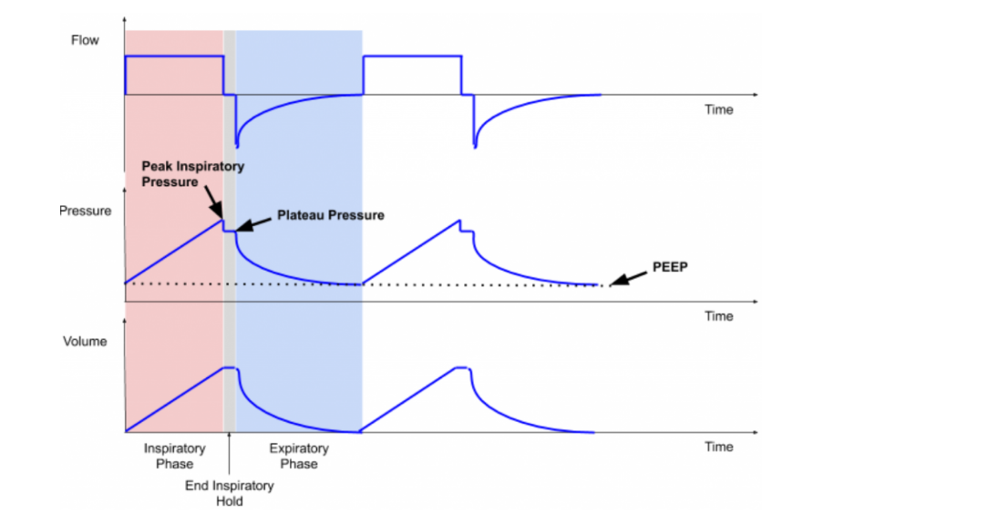

Figure 1Typical flowrate, pressure and tidal volume profiles during breathing

## Minimal Ventilator Specifications [4-5]:

This is a specification of the minimally clinically acceptable ventilator to be used in hospitals to confer therapeutic benefit on a patient suffering with ARDS, used in the initial care of patients requiring urgent ventilation. It is proposed these ventilators would be for short-term stabilisation for a few hours, but this may be extended up to 1-day use for a patient in extremis as the bare minimum function. Ideally it would also be able to function as a broader function ventilator which could support a patient through a number of days, when more advanced ventilatory support becomes necessary [5].

At least 1, optionally 2 modes of ventilation:

* Must have mandatory ventilation (for the deeply sedated and paralysed). The user can set a tidal volume and the output is a pressure regulated flow to achieve this volume, for example, pressure regulated volume control (PRVC), SIMV-PC
* ~~Optional pressure support mode for those patients breathing to some extent themselves, for example, BIPAP. The user sets an inspiratory pressure and an expiratory pressure. The ventilator can sense when a patient starts to breathe in and apply the inspiratory pressure, then sense when the patient starts to breathe out and apply the expiratory pressure (this pressure is still positive but lower than the inspiratory pressure). If the patient stops breathing in pressure support mode, it must failsafe automatically onto mandatory ventilation.~~

|  |  |  |  |
| --- | --- | --- | --- |
|  | **Range** | **Accuracy** | **Settings** |
| **Volume Controlled Intermittent Mechanical Ventilation** |  |  |  |
| Tidal volume (TV) | 350-450 ml  (Optionally 250-600 ml)  (optionally 250-800 ml) | ± 10 ml | Increments of 50 ml |
| Respiratory rate (RR) | 10 – 30 bpm | 1 bpm | Increments of 2 bpm |
| I:E ratio | 1:2  (1:1 and 1:3 optional) | * --- | 1 fixed and 2 optional setting |
| PEEP valve | 5 – 25 cm H2O;  Default setting 5 cm H2O | ± 1 cm H2O | Can either be adjustable in 5 cmH2O increments or continuously adjustable |
| Oxygen concentration | 0.21 or 1.0 |  |  |
| Anti-asphyxia valve (optional) | Opens at –3 ± 1 cm H2O |  |  |
| Over-Pressure Valve | Opens at 40cm default |  |  |
| Plateau pressure | Limited to 35 cmH2O |  |  |
| Peak pressure | < 2cmH2O + Plateau |  |  |
| Spontaneous breathing |  |  | Ventilation mode |
| In-built blender | 0.21 – 1.0 FiO2 |  | 3 fixed FiO2 settings: 0.21, 0.5, 1.0  Variable between 30% and 100% in 10% steps preferred |

## Sensors and Displays

The following should be continuously displayed so the user can verify:

* current settings of tidal volume, frequency, PEEP, FiO2, ventilation mode
* actual achieved rates of tidal volume, breathing rate, PEEP, plateau pressure, FiO2
* ~~if it exists, in pressure support mode there must be real-time confirmation of each patient breath and an alarm if below acceptable range~~
* ~~optionally CO2 monitoring include~~

## Monitoring and alarms

* gas or electricity supply failure
* machine switched off while in mandatory ventilation mode
* inspiratory airway pressure exceeded
* inspiratory and PEEP pressure not achieved (equivalent to disconnection alarm)
* tidal volume not achieved or exceeded

## Electrical supply:

* Ability to connect to 120-240V mains
* Must have 30 minutes backup battery in case of mains electricity failure

## Infection Control:

* All parts in contact with pathogens must be either disposable or able to be decontaminated between patients
* All external surfaces must be cleanable in the likely event that they get respiratory secretions or blood splatter on them. Cleaning would be by healthcare workers manually wiping using an approved surface wipe with disinfectant or cloths and approved surface cleaning liquid
* Ability to add in line, replaceable HEPA and HME filters to inspiratory circuit.

## Miscellaneous:

* It must have 100% duty cycle (100% up time) for up to 14 days. Optionally it can be used beyond 14 days, the expected durability must be specified
* must not require more than 30 minutes training for a doctor with some experience of ventilator use

# Design Approaches

Most of the designs in opensource are based on mechanical compression of bag valve mechanism (BVM) also known as ambubag, based on a seminal student project at MIT [6].

# References

1. Ferguson N, Laydon D, Nedjati-Gilani G, et al. “Impact of non-pharmaceutical interventions (NPIs) to reduce COVID-19 mortality and healthcare demand United Kingdom2020” [Available from: <https://www.imperial.ac.uk/media/imperial-college/medicine/sph/ide/gidafellowships/Imperial-College-COVID19-NPI-modelling-16-03-2020.pdf> (Accessed on 05 April 2020).
2. “I’ve Never Seen Anything Like This”: Doctors Without Enough Ventilators Are Being Told Whom To Save During The Coronavirus Pandemic'”, Buzzfeed, Apr 4, 2020 <https://www.buzzfeednews.com/article/kadiagoba/ventilator-shortage-new-york-hospitals-coronavirus>
3. “Cuomo says ventilators cost $50,000—up from $20,000—as states compete for the devices”, Forbes, 30 Mar 2020, <https://www.forbes.com/sites/lisettevoytko/2020/03/30/cuomo-says-ventilators-cost-50000-up-from-20000-as-states-compete-for-the-devices/#143c42c378b3>
4. “Notification PEC/CH/INVNNT 104 “Composite Tests/Trials Team (Ventilators)”, Pakistan Engineering Council, 03 April 2020.
5. Rapidly manufactured ventilator system specification. (2020, March 20). Retrieved March 24, 2020, from <https://www.gov.uk/government/publications/coronavirus-covid-19-ventilator-supply-specification/rapidly-manufactured-ventilator-system-specification>
6. A.M. Al Husseini et al, “Design and Prototyping of a Low-cost Portable Mechanical Ventilator”, Design of Medical Devices Conference, April 13-15, 2010, Minneapolis, MN, USA