Open Source Ventilator

Pakistan

Modeling of C-7 Open Lung Ventilator

Radial Arm De-pressor

March 27, 2020

[Page Left Blank]

Contents

1. Kinematics Modeling 4

1.1 Example case 6

## Kinematics Modeling

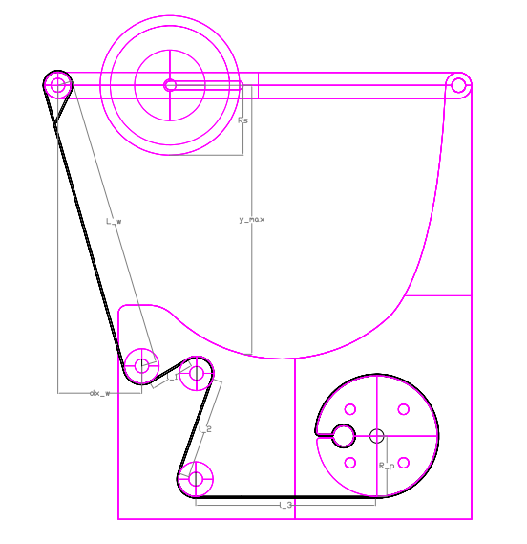

Assuming linearity and establishing cartesian kinematics, the geometry above provides the equation:

$$θ°=\frac{180(y_{max}-R_{S})}{πR_{M}*cos⁡(α_{web})}$$

where,

$$α_{web}= \sin^{-1}\left(\frac{dx_{w}}{L_{w}}\right)=16.67°$$

$$R_{S}=Radius of Sticky Roller$$

$$R_{M}=Radius of Motor Roller$$

Since the sticky roller is free to roller, we can neglect large adhesion; hence, approximating using Hertz’s equation, and assuming incompressibility for the given temperature and pressure withing BVM, the following equations can be used to estimate the belt velocity and hence the required angular velocity from the time derivation of equation (1), assuming steady state:

$$v_{b}=\frac{Q_{BVM}}{A_{cont}}$$

$$A_{cont}=2a*w_{S}$$

where,

$$Q=Volume flow rate from BVM$$

$$w_{S}=width of sticky roller$$

$$A_{cont}=Contact area$$

$$a=\frac{4FR_{S}}{πE^{*}}$$

where,

$$F=m_{s}g=ρ_{s}*∀_{s}*g$$

$$E^{*}=\frac{1-υ_{S}}{E_{S}}+\frac{1-υ_{BVM}}{E_{BVM}}$$

thus, the rotational velocity at motor is given by:

$$v_{b}=R_{M}\frac{dθ}{dt}$$

$$ω=\frac{v_{b}}{R_{M}}$$

where,

$$v_{b}=approx. belt velocity$$

### Example case

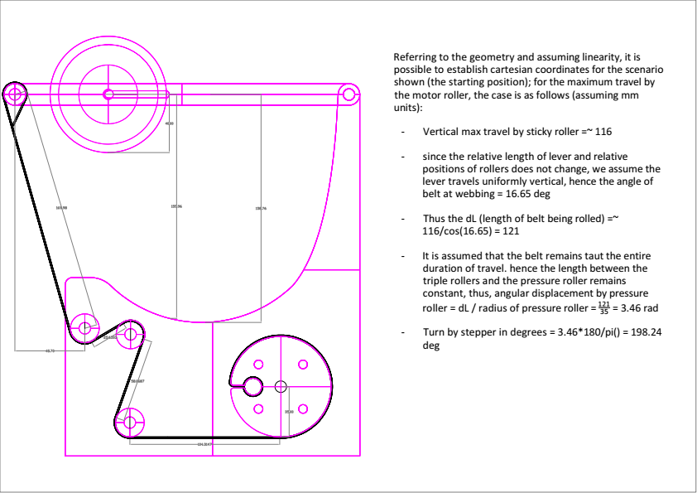

Notes:

* The model only provides an approximation and since the fluid dynamics consists of non-linearity, it is best to create a prototype and measure the appropriate flow, pressure and volume that is being output for various cases. This should then be tabulated for the purpose of calibration and further testing.